Supplemental table 1. Maternal and neonatal characteristics of participating and non-participating children at five years, among survivors at 5, n=3609.

 | Included population analysis with complete assessment at 5 years (n=2157) | Non-participating at 5 years (n=1090) or incomplete assessment (n=362)
 | n/N (%) | n/N (%) | p-value
Exposition
Maternal autoimmune diseases | 93/2157 (5.5) | 62/1452 (5.3) | 0.89
Maternal characteristics at birth
Maternal age
<25 years | 284/2157 (11.4) | 324/1452 (20.9) | 0.001
25-34 years | 1375/2157 (64.4) | 812/1452 (59.0)
>35 years | 498/2157 (24.3) | 316/1452 (20.2)
Primiparous | 1233/2141 (56.8) | 731/1432 (52.3) | 0.084
Birth in France | 1782/2155 (85.1) | 1024/1422 (74.5) | <0.001
Level of education
Less than high school | 186/2094 (8.3) | 219/1251 (16.5) | <0.001
High school | 762/2094 (36.5) | 580/1251 (45.5)
1-2 years of graduate studies | 518/2094 (24.0) | 218/1251 (17.5)
3+ years of graduate studies | 628/2094 (31.1) | 234/1251 (20.5)
Parents’ socio-economic statusª
Executive | 540/2076 (27.3) | 225/1351 (17.4) | <0.001
Intermediate | 521/2076 (25.8) | 209/1351 (16.6)
Administration | 546/2076 (25.6) | 407/1351 (30.3)
Service, trade | 235/2076 (11.2) | 242/1351 (17.3)
Worker, unemployed | 234/2076 (10.0) | 268/1351 (18.4)
Tobacco use during pregnancy | 380/2096 (16.6) | 356/1406 (25.7) | <0.001
Maternal obstetrical characteristics
Gestational diabetes | 179/2015 (10.0) | 108/1339 (9.3) | 0.68
Hypertension during pregnancy | 391/2030 (16.3) | 245/1346 (16.5) | 0.89
Preeclampsia | 436/2111 (16.2) | 261/1423 (15.9) | 0.84
Placental abruption | 97/2116 (3.0) | 65/1409 (4.2) | 0.11
Cause of preterm birth
Preterm labor group | 867/2157 (42.9) | 589/1452 (44.5) | 0.57
Preterm premature rupture of membranes | 393/2157 (18.9) | 281/1452 (19.7)
Hypertensive disorders or Placental abruption | 562/2157 (21.4) | 334/1452 (19.7)
Isolated fetal growth restriction | 150/2157 (6.2) | 108/1452 (7.4)
Other | 185/2157 (10.6) | 140/1452 (8.7)
Multiple pregnancy | 757/2157 (37.7) | 482/1452 (33.9) | 0.17
Neonatal characteristics
Gestational age groups (weeks)
23-26 | 200/2157 (3.2) | 124/1452 (2.7) | 0.006
27-31 | 1350/2157 (29.0) | 846/1452 (24.6)
32-34 | 607/2157 (67.8) | 482/1452 (72.8)
Sex male | 1159/2157 (55.6) | 751/1452 (50.2) | 0.07
Small for gestational age ^{b} | 830/2157 (35.6) | 521/1451 (33.6) | 0.37
Severe neonatal morbidities | 254/2058 (6.6) | 154/1357 (5.4) | 0.13
Data are No./total (%), unless otherwise indicated. Denominators vary according to the number of missing data for each variable. Percentages are weighted to consider the differences in survey design between gestational age groups.

ª Defined as the highest occupational status between occupations of the mother and the father, or mother only if living alone.
^{b} Small for GA was defined as birth weight less than the 10th percentile for gestational age and sex based on French intrauterine “EPOPé” growth curves

Supplemental table 2. Behavior and communication mean score outcome at 2 and 5 years according to maternal autoimmune disease exposure, among survivors at 5, n=3609.
 | Maternal autoimmune diseases |  |  | Exposed vs Unexposed,
 | Unexposed (n=3454) | Exposed (n=155) |  | mean difference (95% CI) | Adjusted mean difference (95% CI)ª | Adjusted mean difference (95% CI)ª, after multiple Imputation
 | mean (sd) | mean (sd) | p-value | mean difference (95% CI) | Adjusted mean difference (95% CI)ª
At 2 years’ corrected age
Total ASQ score^{b} | 231.8 (45.3) | 228.6 (47.7) | 0.78 | -3.3 (-15.9 to 9.3) | -0.7 (-10.6 to 9.2) | 0.7 (-9.6 to 11.0)
By domain^{b},
Communication | 44.1 (16.1) | 43.1 (16.9) | 0.78 | -1.0 (-5.2 to 3.3) | -0.4 (-4.1 to 3.3) | -0.5 (-4.3 to 3.3)
Gross motor | 51.6 (11.0) | 50.8 (9.4) | 0.15 | -0.8 (-3.4 to 1.7) | 0.3 (-1.7 to 2.3) | 0.5 (-2.7 to 3.8)
Fine motor | 48.4 (9.4) | 48.9 (8.5) | 0.85 | 0.5 (-1.7 to 2.8) | 0.2 (-1.6 to 2.1) | 0.5 (-1.5 to 2.6)
Problem solving | 42.6 (12.0) | 42.2 (12.2) | 0.88 | -0.4 (-3.3 to 2.6) | 0.0 (-2.3 to 2.3) | 0.4 (-2.0 to 2.8)
Personal-social | 45.2 (11.4) | 44.0 (13.3) | 0.83 | -1.1 (-4.8 to 2.6) | -0.6 (-3.3 to 2.0) | -0.2 (-3.5 to 3.0)
At 5 years of age
Behavioural difficulties
Total SDQ score^{c} | 10.0 (5.6) | 8.9 (5.3) | 0.190 | -1.1 (-2.6 to 0.3) | -0.2 (-1.4 to 1.0) | 0.0 (-1.1 to 1.2)
By domain^{c},
Emotional symptoms | 2.5 (2.1) | 2.1 (2.2) | 0.11 | -0.4 (-1.0 to 0.2) | -0.1 (-0.5 to 0.4) | 0.0 (-0.5 to 0.4)
Conduct problems | 2.1 (1.6) | 1.8 (1.6) | 0.17 | -0.3 (-0.8 to 0.1) | -0.2 (-0.5 to 0.1) | -0.1 (-0.4 to 0.2)
Hyperactivity | 3.9 (2.7) | 3.8 (2.6) | 0.81 | -0.1 (-0.7 to 0.5) | 0.2 (-0.3 to 0.8) | 0.2 (-0.3 to 0.7)
Peer problems | 1.4 (1.6) | 1.1 (1.5) | 0.11 | -0.3 (-0.7 to 0.1) | -0.2 (-0.5 to 0.2) | 0.0 (-0.4 to 0.3)
Social communication difficulties
Total SCQ score^{c} | 5.6 (3.7) | 4.5 (3.2) | 0.039 | -1.0 (-1.8 to -0.3) | 0.1 (-0.7 to 0.9) | 0.0 (-0.7 to 0.8)
By domain^{c},
Reciprocal Social Interaction | 1.1 (1.3) | 0.8 (1.1) | 0.033 | -0.3 (-0.6 to -0.1) | 0.0 (-0.2 to 0.3) | 0.0 (-0.3 to 0.3)
Communication | 2.4 (1.8) | 2.3 (1.7) | 0.66 | -0.1 (-0.6 to 0.4) | 0.1 (-0.4 to 0.5) | 0.0 (-0.3 to 0.4)
Restricted, Repetitive, and  Stereotyped Patterns of Behavior | 1.8 (1.9) | 1.3 (1.8) | 0.033 | -0.5 (-1.0 to 0.0) | 0.0 (-0.4 to 0.5) | 0.0 (-0.4 to 0.5)
Data are No./total (weighted %), unless otherwise indicated. Denominators vary according to the number of missing data for each variable. Mean are weighted to consider the differences in survey design between gestational age groups.
Abbreviations: ASQ, Ages & Stages Questionnaire; M-CHAT, Modified Checklist for Autism in Toddlers; SCQ, Social Communication Questionnaire; SDQ, Strengths and difficulties questionnaire.
ª Logistic regression analysis with cluster robust variance estimates to account for non-independence of twins, adjusted on maternal age, primiparity, maternal birth in France, maternal level of education, parents’ socio-economic status, tobacco use during pregnancy, gestational age and child sex. ^{b} Higher scores correspond to better development assessment. ^{c} Higher scores correspond to more difficulties.

Supplemental figure 1. Covariable balance in the propensity score-matched sample.

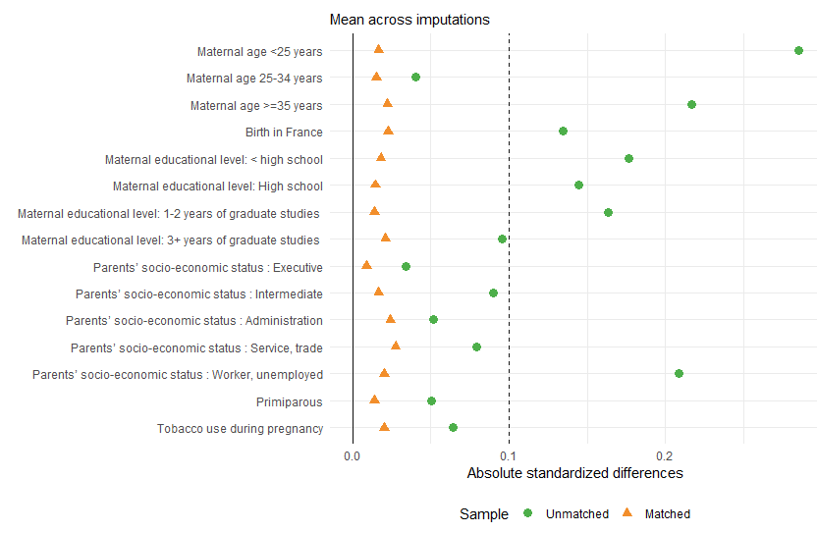
Each point illustrates the standardized difference for each variable in the full sample (green circle) and the propensity score-matched sample (orange triangle). The vertical dotted line at 10% illustrates the standard cut-off for acceptable imbalance between groups. 155 children in exposed group are matched to 155 non-exposed.

Supplemental table 3. Behavior and communication outcome at 2 and 5 years according to maternal autoimmune disease exposure for children without maternal immunosuppressive therapy, n=3498.
 | Without immunosuppressive therapy
 | Exposed vs Unexposed
 | aOR (95% CI), after multiple Imputation
At 2 years’ corrected age
Global developmental delay (ASQ score ª) | 0.99 (0.66 to 1.50)
By domain,
Communication | 1.11 (0.64 to 1.93)
Gross motor | 0.91 (0.47 to 1.74)
Fine motor | 0.85 (0.45 to 1.60)
Problem solving | 0.87 (0.49 to 1.55)
Personal-social | 1.49 (0.81 to 2.74)
Autistic traits (M-CHAT ^{b}) | 0.61 (0.34 to 1.09)
At 5.5 years of age
Behavioural difficulties
Total SDQ score >90th percentile ^{c} | 0.93 (0.44 to 1.96)
By domain,
Emotional symptoms | 0.99 (0.58 to 1.69)
Conduct problems | 0.82 (0.45 to 1.47)
Hyperactivity | 1.28 (0.78 to 2.08)
Peer problems | 0.90 (0.48 to 1.70)
Social communication difficulties ^{d} | 0.95 (0.48 to 1.86)
Logistic regression analysis with cluster robust variance estimates to account for non-independence of twins, adjusted on maternal age, primiparity, maternal birth in France, maternal level of education, parents’ socio-economic status, tobacco use during pregnancy, and gestational age. Result after multiple imputation.
Abbreviations: ASQ, Ages & Stages Questionnaire; M-CHAT, Modified Checklist for Autism in Toddlers; SCQ, Social Communication Questionnaire; SDQ, Strengths and difficulties questionnaire.

ª Risk of developmental delay is defined by an ASQ score < 2 SDs from the mean in any of the five ASQ domains.
^{b} Positive M-CHAT is defined by at least 3 of the 23 items failed.
^{c} Cut-off > 90th percentile of the reference group of term-born children, corresponds to SDQ score ≥ 19.
^{d} Defined by total SCQ score > 90th percentile of the reference group of term-born children, corresponds to SCQ score ≥ 11.

