Treatment details of the CCLG-APL 2018 protocol
Risk Stratification
1. Standard-risk group: WBC < 10×10⁹/L and without FLT3-ITD mutation.
2. High-risk group: WBC ≥ 10×10⁹/L; or presence of FLT3-ITD mutation; or failure to achieve molecular complete remission (MCR) before maintenance therapy.

Standard-Risk Group
- Induction: Arsenic (ATO/RIF) + ATRA
- Realgar-Indigo naturalis formula (RIF) 60 mg/kg/d orally or arsenic trioxide (ATO) 0.15 mg/kg/d (max. dose 10 mg/day) IV infusion, day 1 to day 28.
- all-trans retinoic acid (ATRA) 25 mg/m²/d orally, day 1 to day 28.
- Consolidation: Arsenic (ATO/RIF) + ATRA
- RIF 60 mg/kg/d orally or ATO 0.15 mg/kg/d IV infusion, day 1 to day 14.
- ATRA 25 mg/m²/d, day 1 to day 14.
Note: Upon achieving molecular negativity, the patients proceeded to the maintenance therapy. If MCR was not achieved, the consolidation therapy course was repeated once.
- Maintenance: Arsenic (ATO/RIF) + ATRA
- RIF 60 mg/kg/d or ATO 0.15 mg/kg/d, 2 weeks on and 2 weeks off, 8 weeks per cycle, for four cycles in total.
- ATRA 25 mg/m²/d, 1 week on and 1 week off, 8 weeks per cycle, for four cycles in total.
High-Risk Group
- Induction: Arsenic (ATO/RIF) + ATRA + Anthracycline
- RIF 60 mg/kg/d or ATO 0.15 mg/kg/d, day 1 to day 28.
- ATRA 25 mg/m²/d, day 1 to day 28.
- Anthracycline: idarubicin 10 mg/m²/d or daunorubicin 40 mg/m²/d, once every other day for 2 to 3 days.
- Consolidation: Arsenic (ATO/RIF) + ATRA + Anthracycline (if MCR is achieved after induction therapy, anthracyclines may be omitted)
- RIF 60 mg/kg/d or ATO 0.15 mg/kg/d, day 1 to day 14.
- ATRA 25 mg/m²/d, day 1 to day 14.
- Anthracycline: idarubicin 10 mg/m²/d or daunorubicin 40 mg/m²/d, once every other day, for 1-2 days.
Note: Upon achieving molecular negativity, the patients proceeded to the maintenance therapy. If MCR was not achieved, the consolidation therapy course was repeated once.
- Maintenance: Arsenic (ATO/RIF) + ATRA
- RIF 60 mg/kg/d or ATO 0.15 mg/kg/d, 2 weeks on and 2 weeks off, 8 weeks per cycle, for four cycles.
- ATRA 25 mg/m²/d, 1 week on and 1 week off, 8 weeks per cycle, for four cycles.

Cytoreductive Therapy During Induction
If the WBC count was > 10 × 10⁹/L before or during induction, one of the following drugs was added:
1.Hydroxyurea: 10-40 mg/kg/d in two or three divided oral doses for < 2 weeks;
2.Cytarabine: 40-100 mg/m², IV, once daily or every 12 hours for less than 1 week;
3.Homoharringtonine: 1 mg/m², IV, once daily for fewer than 5 days;
4.High-risk group: anthracycline added;

Bone Marrow Smear and PML::RARA Fusion Gene Detection
1.Induction: day 0, day 28.
2.Consolidation: day 28.
3.Maintenance (two times): every 4 months.
4.After the cessation of therapy: at the cessation of therapy, then every 6 months for 2 years.

Multicenter Data Quality Control and Management
In this open-label trial, eligible participants were centrally registered and assigned a unique number. Case report forms were used to record the treatment response, and the main outcome indicators were also collected from multiple centers before each annual collaboration working group meeting. An access database was established for the entry of the data from the case report forms. Two persons trained by the project manager were responsible for all data input, and another person corrected any mismatched data and updated the outcomes from multiple centers every 6 months.

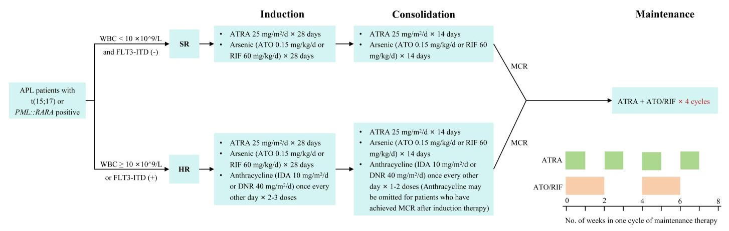Supplementary figure 1 CCLG-APL2018 Protocol. If patients fail to get MCR before maintenance therapy, they were removed from the trial. APL: acute promyelocytic leukemia; SR: standard risk; HR: high risk；ATO: arsenic trioxide; ATRA: all-trans retinoic acid; DNR: daunorubicin; IDA: idarubicin; RIF: realgar-indigo naturalis formula; MCR: molecular complete remission.

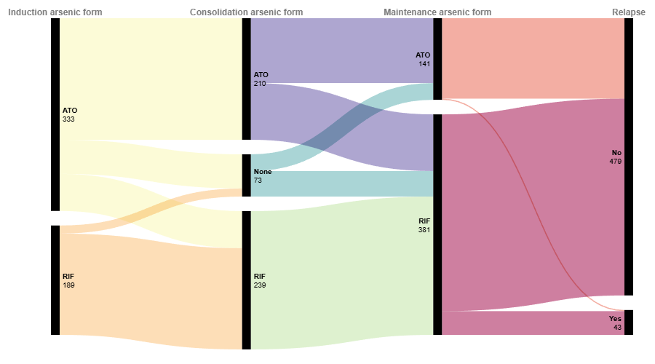
Supplementary figure 2 Distribution of arsenic forms used by APL patients across treatment phases.
Note: Patients who received both ATO and RIF within the same treatment period were excluded.

Supplementary table 1 Demographic and baseline characteristics of different protocol
Clinical information | CCLG-APL 2016 protocol (n=181) | CCLG-APL 2018 protocol (n=385) | P value
Age [years, M (P25, P75)] | 9.0 (6.0, 11.0) | 9.0 (6.0, 11.0) | 0.675
Gender [n, (%)]
Male | 105 (58.0) | 218 (56.6)
Female | 76 (42.0) | 167 (43.4) | 0.756
Complex karyotype¹ [n, (%)]
Yes | 3 (1.7) | 12 (3.2)
No | 172 (98.3) | 367 (96.8) | 0.486
PML::RARA isoform [n, (%)]
Long | 96 (53.0) | 169 (43.9)
Short | 35 (19.3) | 85 (22.1)
Variant | 8 (4.4) | 22 (5.7)
Not differentiated | 42 (23.2) | 109 (28.3) | 0.238
Risk stratification [n, (%)]
SR | 106 (58.6) | 224 (58.2)
HR | 75 (41.4) | 161 (41.8) | 0.932
¹: Karyotype results were unavailable for 12 patients. SR: standard risk; HR: high risk

