Supplementary File S1: Original gel pictures of Figure 3H and I, Figure 5G and H, and Figure S2.
Original agarose gel images used to create manuscript figures. All the gel images are shown as a grayscale-inverted version for improved visualization; no other image processing was performed.

Original, uncropped gel image from which the cropped and rearranged panels shown in Figure 3H and 3I were derived.
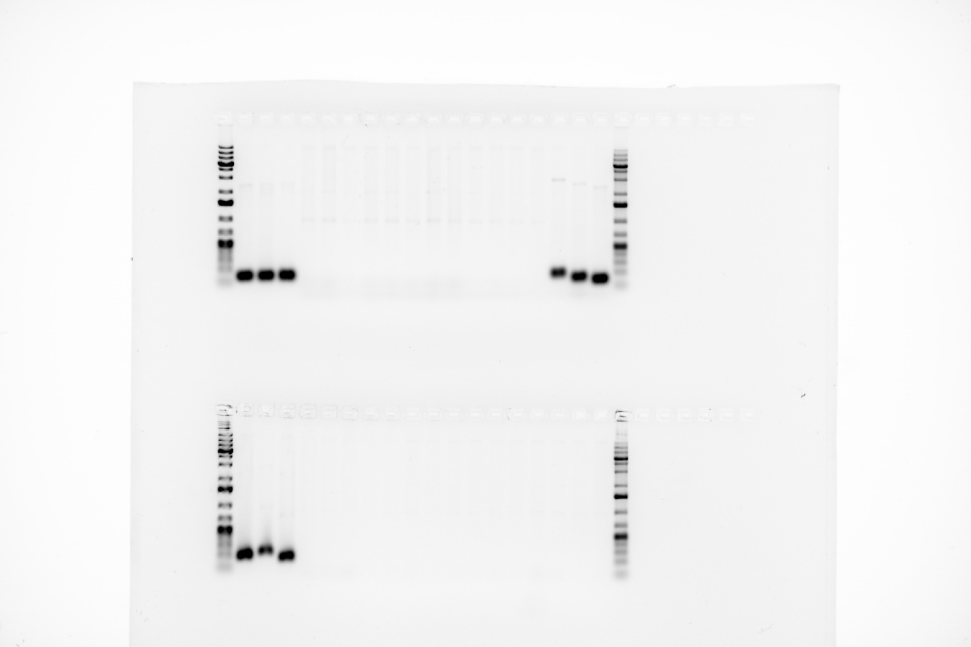

Original, uncropped gel image from which the cropped and rearranged panels shown in Figure 5G and 5H were derived.

Original, uncropped gel image from which the cropped and rearranged panels shown in Figure S2.
