Electronic Supplementary Information
Development of a covalent organic framework/graphene oxide aptasensor for electrochemical penicillin detection

Zhenglin Lu¹, Meixin Huang¹, Xinxin Liu², Zhipeng Liang³, Ziao Zong³, Feng Guo^{3*}, Xiang Chen^{2*}

¹ Key Laboratory of Biomedical Material Research of Guangxi (Cultivation), Affiliated Hospital of Youjiang Medical University for Nationalities, Baise 533000 Guangxi, P. R. China.
² The affiliated Liuzhou Hospital of Youjiang Medical University for Nationalities, Liuzhou 545007 Guangxi, P. R. China.
³ School of Medical Technology and Artificial Intelligence, Youjiang Medical University for Nationalities, Baise, 533000, Guangxi, P. R. China.

1. Experimental section
1.1. Materials and methods
Chemicals and solvents were purchased from commercial resource. The aptamer is 5′-GGG TCT GAG GAG TGC GCG GTG CCA GTG AGT-3′, which was obtained from Shanghai Sangon Biotechnology Co., Ltd. Powder X-ray diffraction (PXRD) tests were collected on D8 ADVANCE. Fourier transform infrared (FT-IR) spectra were performed on Nicolet iS20. N₂ sorption isotherms were carried out on Micromeritics ASAP2020. Scanning electron microscope (SEM) images were acquired using Nova NanoSEM 230. X-ray photoelectron spectroscopy (XPS) analysis was collected on Thermo Scientific K-Alpha‌.
1.2. Electrochemical measurements
In a three-electrode system, a phosphate-buffered saline (PBS) solution was used as the electrolyte, with a silver/silver chloride (Ag/AgCl) electrode serving as the reference electrode and a platinum (Pt) sheet electrode as the counter electrode. Prepare the electrolyte by dissolving 0.242 g KH₂PO₄, 1.445 g Na₂HPO₄, 0.2 g KCl, 8.003 g NaCl, 1.650 g K₃[Fe(CN)₆], and 2.11 g K₄[Fe(CN)₆] in 1.0 L deionized water, then adjust pH to 7.0. Differential pulse voltammetry was collected on Shanghai Chenhua CHI760E workstation.
1.3. PCL identification in real milk samples
Real milk samples require pre-treatment. The specific process is as follows: Firstly, 1.0 mL of milk was diluted to 10 mL using ultrapure water, which was further treated by a 10.0 mL mixture of 10% trichloroacetic acid and chloroform for 20 minutes under ultrasonication conditions. Then, the sample was centrifuged at 12,000 rpm for 10 minutes to collect the upper supernatant. Finally, the upper liquid was diluted 100-fold using deionized water.
- Characterization
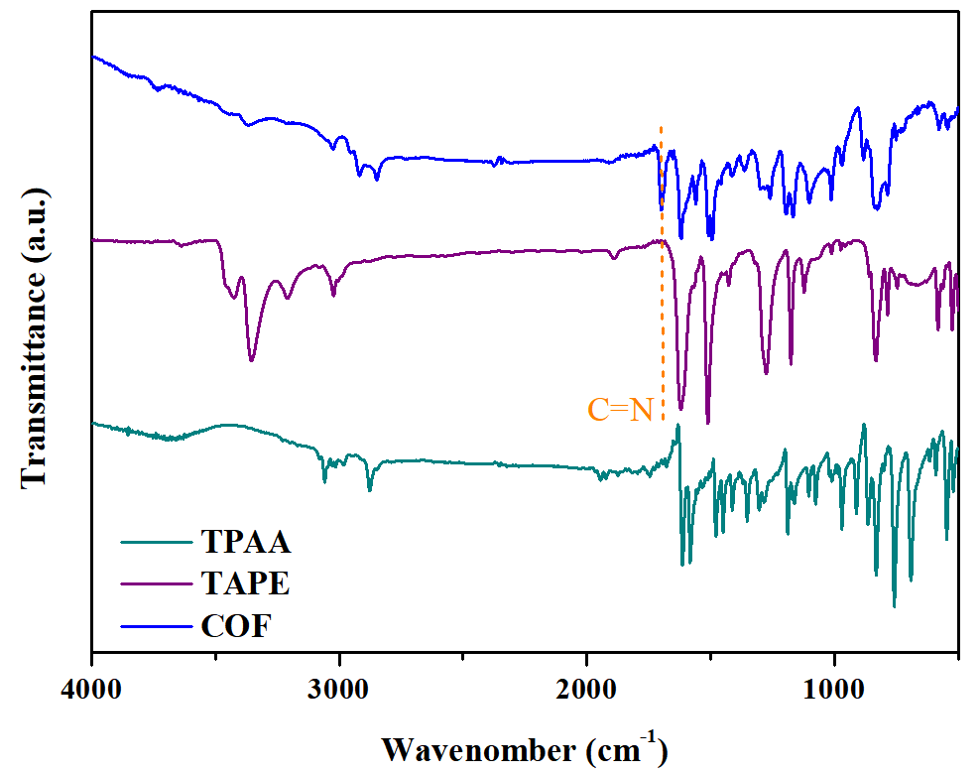
Fig. S1. The FT-IR spectra of TPAA, TAPE, and COF.

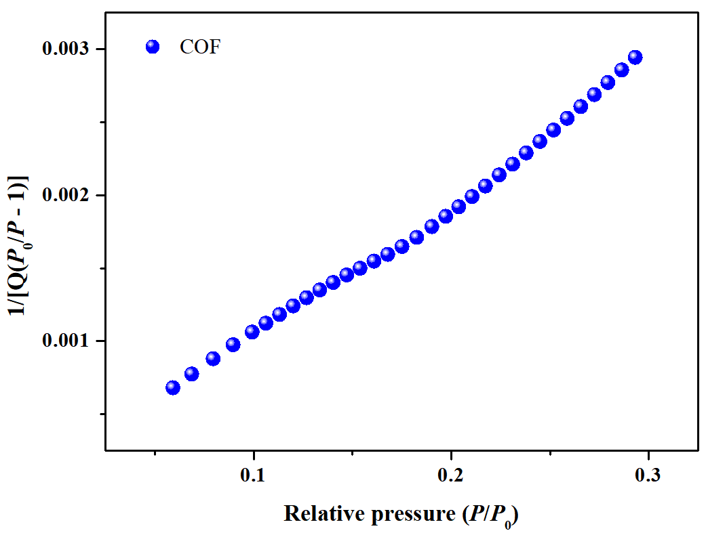
Fig. S2. The BET plots of the activated COF sample.
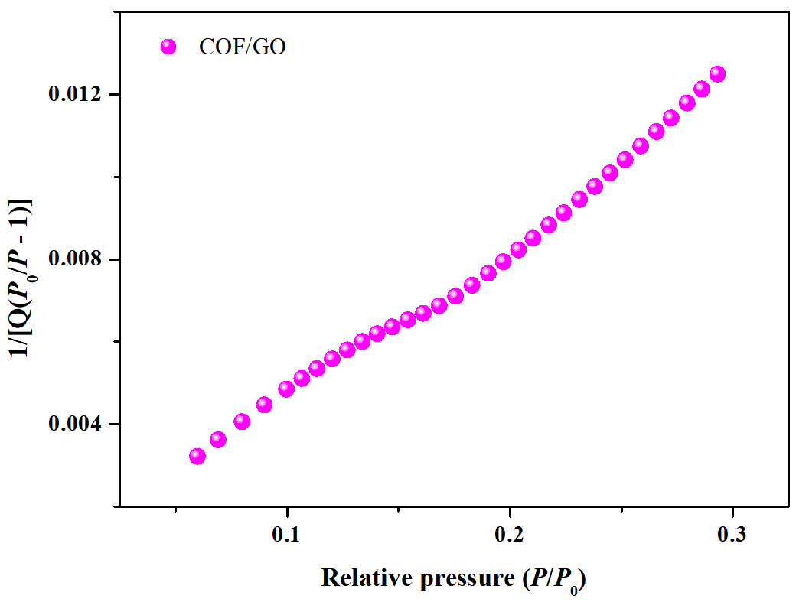
Fig. S3. The BET plots of the activated COF/GO sample.

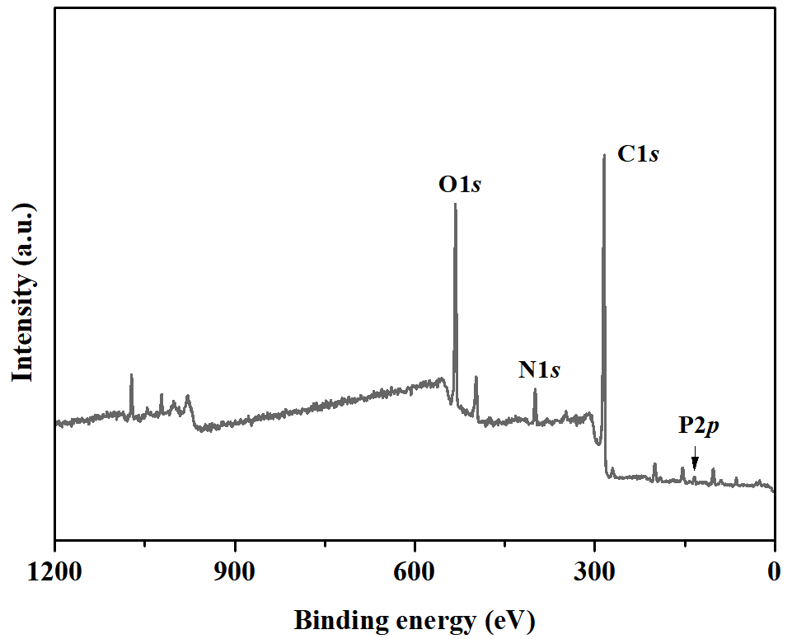
Fig. S4. The full XPS signal of COF/GO after immersing in the aptamer solution.

Table S1 Comparation of the detection performance of different materials.
 | Detection method | Linear range | LOD | Ref.
  Material | Absorbance spectra
polypyrrole film | CV | 0.04-3.2 mM | 8.0 pg mL⁻¹ | [1]
HRP-PePAb | CV and EIS | 5.20-41.6 nM | 1.82 pg mL⁻¹ | [2]
rGO/Pen-Ab | CV | 1.82-60 pM | 66.8 fg mL⁻¹ | [3]
TiN | EIS | 0.04-3.2 mM | 20 ng mL⁻¹ | [4]
PtTi/GR-Fe₃O₄/MWCNT-Fe₃O₄ | DPV and EIS | 0.05-100 ng mL⁻¹ | 253 fg mL⁻¹ | [5]
SDS/Acetate | CV | 0.25-2.5 mM | 25 pg mL⁻¹ | [6]
cysteine-β-Lactamase | CV | 10-50 nM | 4.5 μg mL⁻¹ | [7]
COF/GO | Differential pulse voltammetry | 1×10⁻² - 10 ng mL⁻¹ | 2.9 pg mL⁻¹ | This work

- Reference
[1] N.A. Karaseva, T.N. Ermolaeva, Piezoelectric immunosensors for the detection of individual antibiotics and the total content of penicillin antibiotics in foodstuffs, Talanta 120 (2014) 312-317.
[2] H. Wu, S. Fan, W. Zhang, H. Chen, L. Peng, J. Ma, H. Zhang, Amperometric immunosensor based on covalent immobilization of new methylene blue and penicillin polyclonal antibody for determination of penicillin G in milk, Anal. Methods 6 (2014) 497-502.
[3] M. Shah, P. Kolhe, A. Roberts, N.S. Shrikrishna, Ultrasensitive immunosensing of penicillin G in food samples using reduced graphene oxide (rGO) decorated electrode surface, Colloid. Surface. B. 219 (2022) 112812.
[4] Y.Y. Sun, S.F. Lu, H.N. Wang, Electrochemical detection of penicillin based on titanium nitride nanoparticles carbon paste electrode, Chem. J. Chinese U. 38 (2017) 541-546.
[5] W. Guo, A. Umar, M.A. Alsaiari, L. Wang, M. Pei, Ultrasensitive and selective label-free aptasensor for the detection of penicillin based on nanoporous PtTi/graphene oxide-Fe₃O₄/MWCNT-Fe₃O₄ nanocomposite, Microchem. J. 158 (2020) 105270.
[6] J.M. Sila, P.M. Guto, I.N. Michira, F.B. Mwaura, Electrochemical determination of penicillin G in cow milk and pharmaceuticals in SDS/Acetate buffer, Int. J. Sc. 16 (2021) 210444.
[7] L.M. Goncalves, W.F.A. Callera, M.D.P.T. Sotomayor, P.R. Bueno, Penicillinase-based amperometric biosensor for penicillin G, Electrochem. Commun. 38 (2014) 131-133.

