Design Optimization of Rain Gardens for Effective Stormwater Management Using the Response Surface Method

Phuong Phi Pham¹, Byungyun Lee¹*
¹School of Architecture, Soongsil University, Seoul, 06978, South Korea
*Corresponding author at:
E-mail address: ecoville@ssu.ac.kr (B.Y. Lee)

Supplementary material-
List of Supplementary Sections
Section S 1; Rainfall Data and Representative Scenario Definition
Section S 2; Soil Hydraulic Parameterization
Section S 3; Adaptive Design Strategy for Extreme Rainfall Conditions
Section S 4; Optimization of TSS Removal Efficiency
Section S 5; Design Ranges for Soil Physical Properties
List of Supplementary Figures
Fig S 1; Rainfall data of Hue city from 2021 to 2024
List of Supplementary Tables
Table S 1; Clustering results and representative rainfall events identified using the Gap Statistic Method
Table S 2; Design variables for soil texture
Table S 3; Range of input parameters
Table S 4; Sensitivity of runoff reduction to RG area ratio across eight scenarios under light- and moderate-intensity rainfall conditions.
Table S 5; Visual representation of proposed pond locations at Site A and Site B
Table S 6; Effects of berm height and soil thickness on TSS removal performance across scenarios
Table S 7; Effects of hydraulic conductivity and wilting point on TSS removal performance across scenarios

Supplementary Text
Section S 1 Rainfall Data and Representative Scenario Definition
To comprehensively evaluate precipitation patterns under climate change, rainfall data for the 2021–2024 period were obtained from the Phu Son gauging station (located 30 km from the study area) via the VRAIN monitoring network (https://vrain.vn), operated by the Water Resources Development and Consulting Joint Stock Company, to develop representative rainfall scenarios (VRAIN 2024). The orographic effects of Hue’s complex topography result in significant anomalies in rainfall patterns, particularly regarding spatial distribution, intensity, and duration (Dang et al., 2017). Typical long-duration events last 2–4 days, with cumulative totals ranging from 200 to 700 mm. Seasonal variations are pronounced; the heaviest rainfall is concentrated between October and December. Early-year events (January–May) are often brief (4–6 hours) and range from light (5–14 mm/h) to moderate (14–23 mm/h) intensity. In contrast, mid-year events typically last longer (8–18 hours) and reach higher intensities (25–100 mm/h). Late-year periods frequently experience extreme events exceeding 150 mm/h, as illustrated in Fig S1. Over the four-year period, extreme precipitation was frequent, including 138 events within the 151–233 mm range and three recent catastrophic events with intensities of 655–727 mm/h.
Section S 2 Soil Hydraulic Parameterization
The physical properties of the soil media, specifically those used to identify the hydraulic parameters of the RG system, were determined based on their constituent percentages of sand, silt, and clay. These proportions were classified using the United States Department of Agriculture (USDA) soil texture triangle. Furthermore, bulk density values were assigned according to the corresponding USDA soil textural classes. These parameters are critical for defining the hydraulic conductivity and storage capacity of the filter media within the optimization model. Detailed classifications and the adopted physical values are summarized in Table S 2.
Section S 3 Adaptive Design Strategy for Extreme Rainfall Conditions
This section details the integrated functioning of the Rain Garden (RG) and the detention pond system. To address the risks associated with extreme rainfall in Hue City, four storage capacities (100, 300, 500, and 750 m³) were analyzed. The integration aims to optimize the peak flow attenuation and provide a buffer for the urban drainage system during high-intensity events. The bottom and sides of the pond were lined with impermeable concrete to prevent water from seeping into the natural soil, thereby ensuring that the storage capacity remained effective throughout the detention period. This is important for two reasons: (1) it ensures that the hydrological simulation results accurately reflect the pond's actual operating conditions, and (2) reduced soil infiltration helps prevent localized settlement and damage to nearby underground infrastructure. The impermeable design not only helps prevent these issues but also enables the pond to function as a multifunctional public space during dry periods, enhancing the park's landscape. The technical specifications, including the proposed site locations, required surface area, and the footprint ratio relative to the total drainage area, are summarized in Table S 5.
Section S 4 Optimization of TSS Removal Efficiency
Berm height and soil thickness were identified as the most influential geometric parameters affecting TSS removal. Table S 6 demonstrates that the highest reduction efficiency was consistently achieved at the respective optimal configurations. The dotted lines in the provided graphs represent the overall TSS trends across simulated scenarios that vary in boundary conditions, including soil media composition, rainfall patterns, and surface characteristics ( Table S 6 and S 7).
Trend analysis indicated that loamy sand soil provided superior TSS removal efficiency compared to loamy soil. For instance, in the A_R3 scenarios where berm height was the controlling factor, TSS reduction decreased from 0.07 to 0.062 in loamy sand, while in loamy soil it decreased from 0.07 to 0.068. This performance gap is primarily due to the media's physical properties; a higher sand content enhances hydraulic conductivity and facilitates more effective physical filtration of suspended particles.
Furthermore, moderate- to high-intensity rainfall events triggered the most significant TSS wash-off, underscoring the strong correlation between total precipitation volume and TSS transport (refer to Tables S 6 and S 7). While rainfall above a certain threshold generates sufficient runoff to transport accumulated solids, TSS tends to remain on the surface under low-intensity conditions. Interestingly, under prolonged extreme rainfall (R3 and R4), the effectiveness of wash-off diminished as particles reached a settling equilibrium rather than being further transported.
Notably, the site-specific surface composition dictates the threshold for pollutant transport. At Site A, the 100% impervious surface ratio creates a direct runoff-driven system in which the lack of natural soil-water interaction limits initial filtration, particularly during the first flush of minor rainfall events (R1). In contrast, the spatial integration of permeable surfaces at Site B acts as a pre-filter, reducing the initial TSS load before it reaches the primary RG unit, thereby significantly enhancing cumulative TSS reduction performance, as detailed in the comparative performance metrics in Table S 6.
Section S 5 Design Ranges for Soil Physical Properties
The recommended design thresholds for saturated conductivity and Wilting Point (WP) are derived from a series of scenario-based simulations. These simulations revealed that conductivity significantly influences the balance between infiltration capacity and pollutant contact time. Specifically, conductivity values between 10 and 24 mm/h define a critical intermediate hydraulic zone. Within this range, the system maintains sufficient drainage to prevent surface ponding while ensuring slow enough percolation for effective physical filtration. As documented in Table S 7, this range yielded TSS removal efficiencies that consistently met performance targets, maintaining residue levels at approximately 0.06 kg and 0.05 kg under the A_R2 and B_R2 scenarios, respectively.
The second parameter, WP, governs the soil's internal suction and particle adhesion during inter-event periods, which is vital for long-term pollutant retention. The sensitivity analysis results summarized in Table S 7 indicate that a threshold range of 0.08 to 0.083 effectively captures the transition in moisture retention characteristics between loamy sand and loamy soil. Maintaining the WP within this window ensures consistent TSS reduction (approx. 0.05 kg in A_R2 and 0.01 kg in B_R2). Detailed performance variations for these parameters are documented in Table S 7.

Supplementary Figures

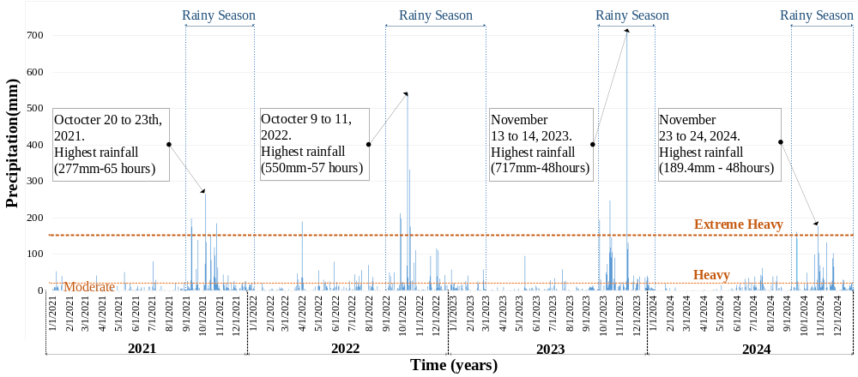
Fig. S 1 Rainfall data of Hue city from 2021 to 2024

Supplementary Tables
Table S 1 Clustering results and representative rainfall events identified using the Gap Statistic
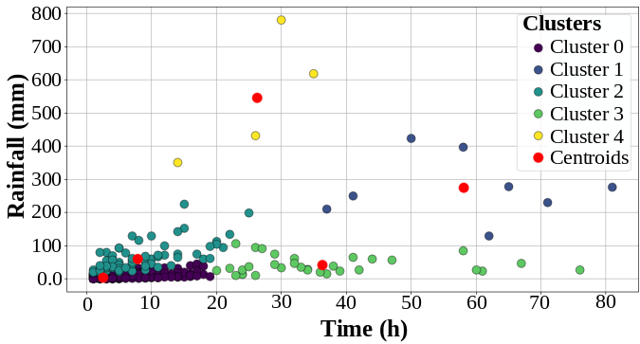 | Clus. | Event | Cumulative rainfall (%) | Mean (hours)
 | 0 | 1285 | 27.01% | 2.5
 | 1 | 8 | 15.71% | 58
 | 2 | 75 | 32.23% | 7.8
 | 3 | 32 | 9.43% | 36.4
 | 4 | 4 | 15.6% | 26.2
(a) K-means clustering with optimal K = 5 | (b) Summary of cluster characteristics
Mean- Average duration of rainfall events within each cluster.

Table S 2 Soil texture classification and bulk density values based on USDA standards
USDA Soil Texture Triangle | Design Variables | Range |  |  |  | Step
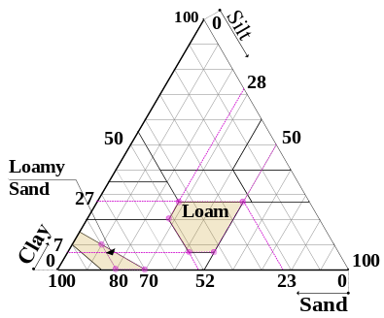 | Design Variables | Loam |  | Loamy Sand |  | Step
 | Design Variables | From | To | From | To | Step
 | % Sand | 23 | 52 | 70 | 80 | 1.5
 | % Clay | 7 | 27 | 1 | 10 | 1
 | % Silt | 28 | 50 | 10 | 30 | 1
 | Bulk Density | 1.32 | 1.4 | 1.48 | 1.59 | 0.01

Table S 3 Input parameter ranges in modeFRONTIER
Input parameters | Unit | Range |  | Step | Supporting Source
Input parameters | Unit | From | To | Step | Supporting Source
- Area ratio | % | 0.5 | 2 | 0.1 | Adapted
- Berm height | mm | 100 | 400 | 50 | Zhou et al. (2020), Hou et al. (2020), adapted
- Soil thickness | mm | 300 | 900 | 50 | Rossman (2015), adapted
- Porosity | - | Soil-texture-based input parameters |  |  | USDA soil texture triangle
- Field Capacity | - |  |  |  | USDA soil texture triangle
- Wilting Point | - |  |  |  | USDA soil texture triangle
- Conductivity | mm/h |  |  |  | USDA soil texture triangle
- Conductivity slope |  |  |  |  | USDA soil texture triangle
- Suction Head | mm |  |  |  | USDA soil texture triangle
- Storage thickness | mm | 300 | 600 | 50 | Rossman (2015), adapted

Table S 4 Sensitivity of runoff reduction to RG area ratio across eight scenarios under light- and moderate-intensity rainfall conditions.
Loamy Sand
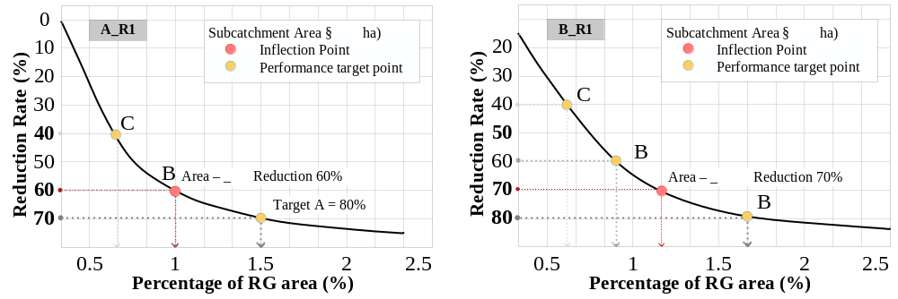
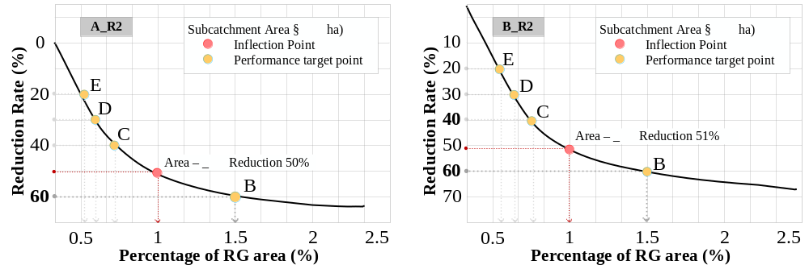
Loamy soil
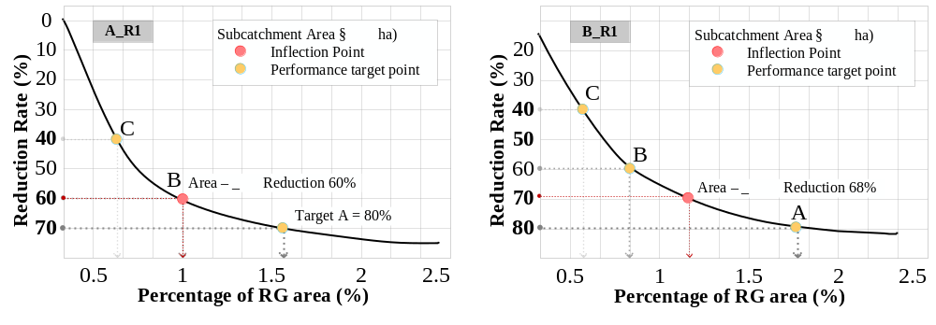
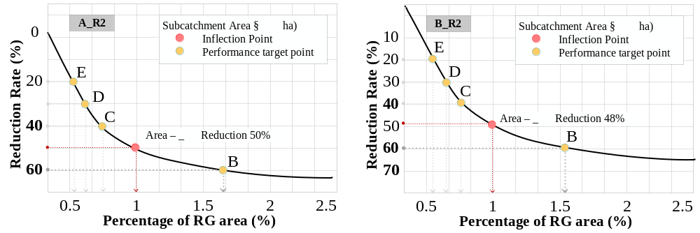

Table S 5 Visual representation of proposed pond locations at Site A and Site B
Pond Volume  (m³) | Proposed Pond Dimension  (Height = 1500 mm) |  | 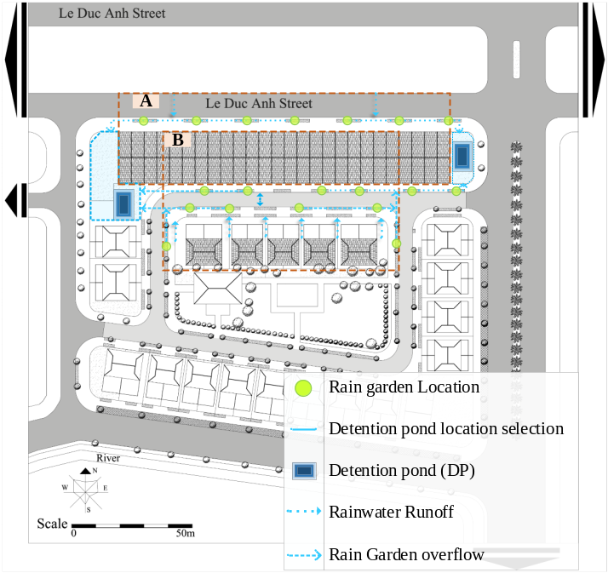
Pond Volume  (m³) | Area (m²) | Ratio (%)
100 | 66.7 | 1.3%
300 | 200 | 4%
500 | 333 | 7%
750 | 500 | 10%
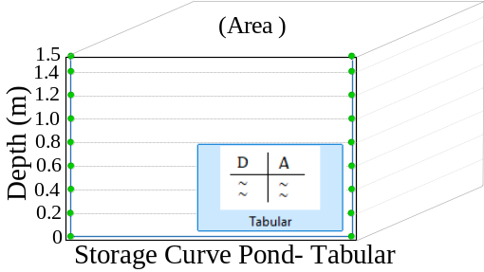
(a) Setup of storage geometry in SWMM |  |  | (b) Proposed detention pond location map

Table S 6 Effects of berm height and soil thickness on TSS removal performance across scenarios
Loamy Sand
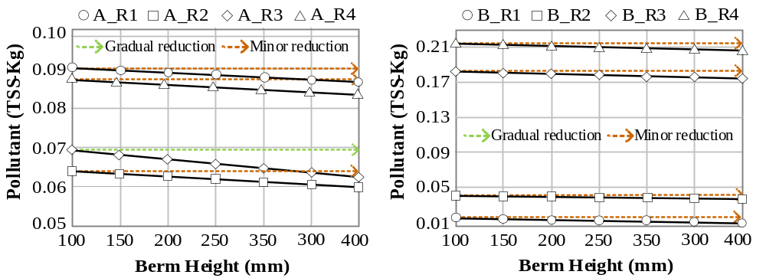
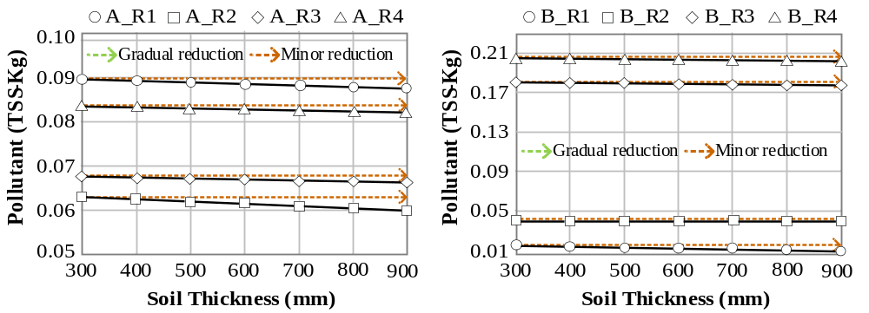
Loamy Soil
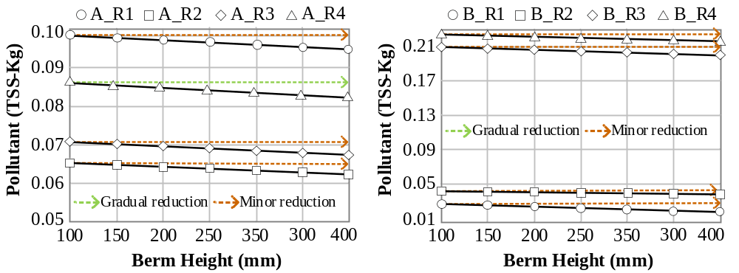
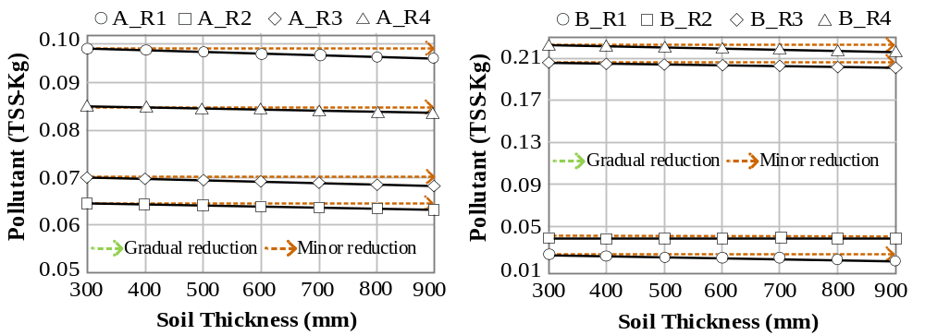
Table S 7 Effects of hydraulic conductivity and WP on TSS removal performance across scenarios
Loamy Sand
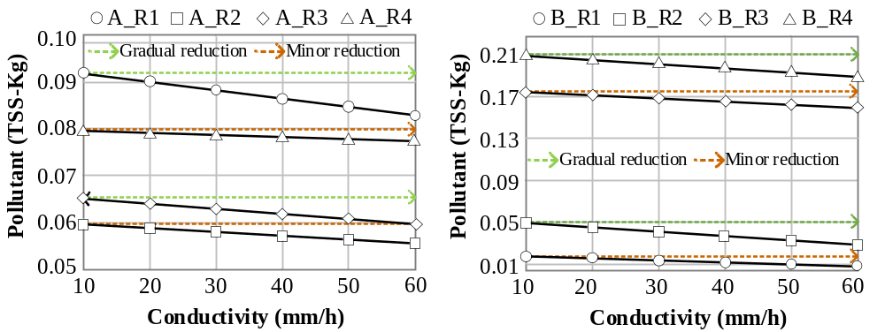
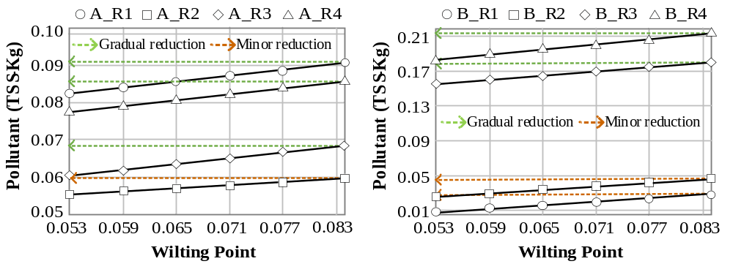
Loamy Soil
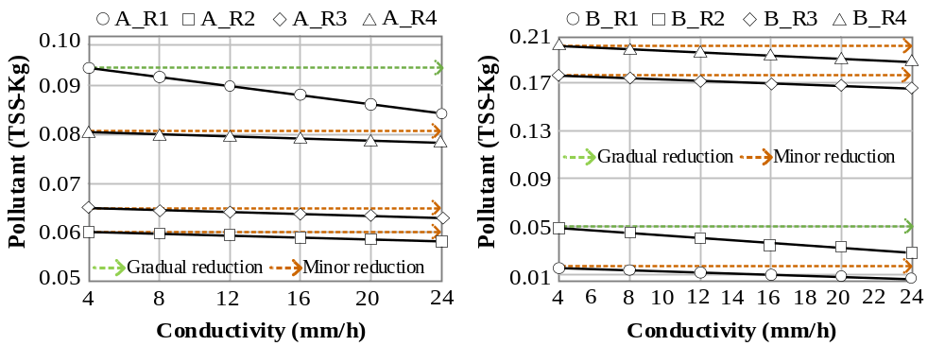
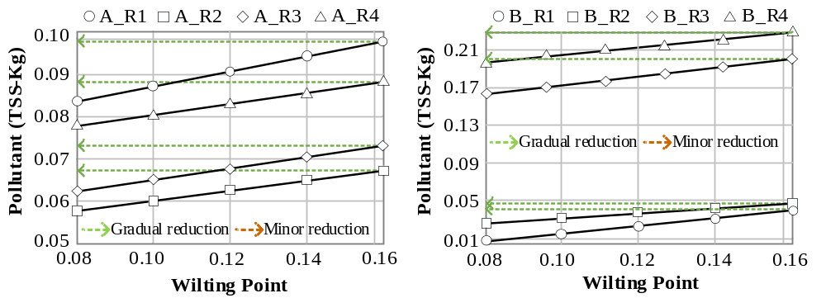
References
Dang TA, Nguyen IT, Hiroshi I (2017) Assessment of rainfall variability and orographic effects on water resources in the Huong River Basin, Central Vietnam. Journal of Water Resources and Environmental Engineering 58:24–33. https://doi.org/10.3390/w9110879
Hou J, Liu F, Tong Y, Guo K, Ma L, Li D (2020) Numerical simulation for runoff regulation in rain garden using 2D hydrodynamic model. Ecol Eng 153:105794. https://doi.org/10.1016/j.ecoleng.2020.105794
Rossman LA (2015) Storm water management model user’s manual, version 5.1, vol 276. National Risk Management Research Laboratory, Office of Research and Development, United States Environmental Protection Agency, Cincinnati, OH. (Revised 2015)
Zhou PL, Han JQ, Zhang HX (2020) A review of research on plant configuration and decontamination efficiency of rain gardens in china. In: IOP Conf S: Earth Environ Sci (Vol. 510, No. 3, p. 032029) 510(3):032029. https://doi.org/10.1088/1755-1315/510/3/032029
VRAIN (2024). Real-Time Rainfall Monitoring Data for Hue City, Vietnam. Operated by Water Resources Development and Consulting Joint Stock Company. https://vrain.vn Accessed Aug 14, 2025

