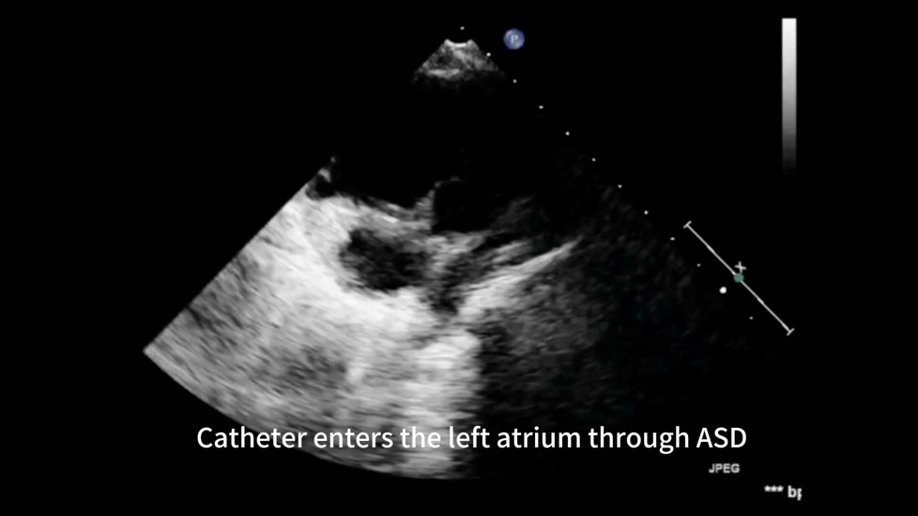

Video 1: UCG guided closure of ASD process

