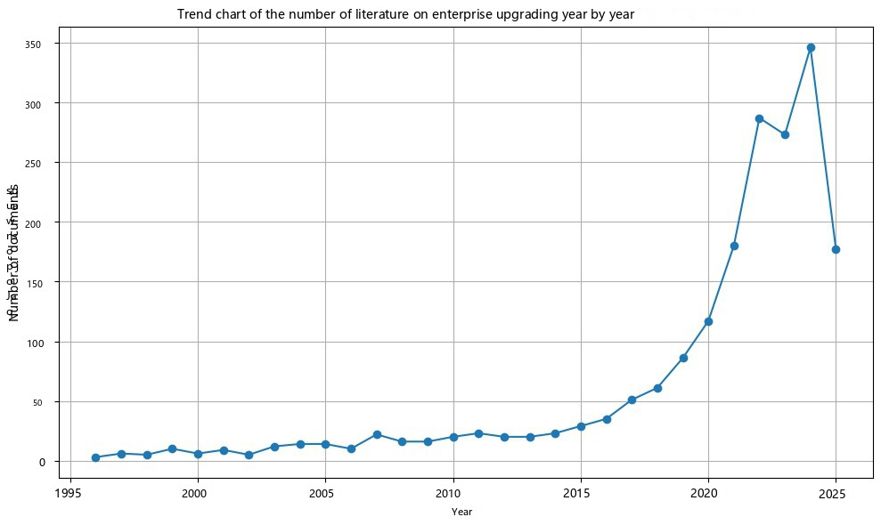
Figure 1: Number of documents published by enterprise upgrades

Serial number | Keywords | Frequency × Betweenness Centrality
1 | green innovation | 187
2 | total factor productivity | 186
3 | digital transformation | 165
4 | innovation | 163
5 | multidisciplinary sciences | 91
6 | technology | 85
7 | energy & fuels | 81
8 | computer science, information systems | 74
9 | model | 72
10 | business, finance | 69
Table 1 Statistics of high-frequency keywords (TOP10) in literature

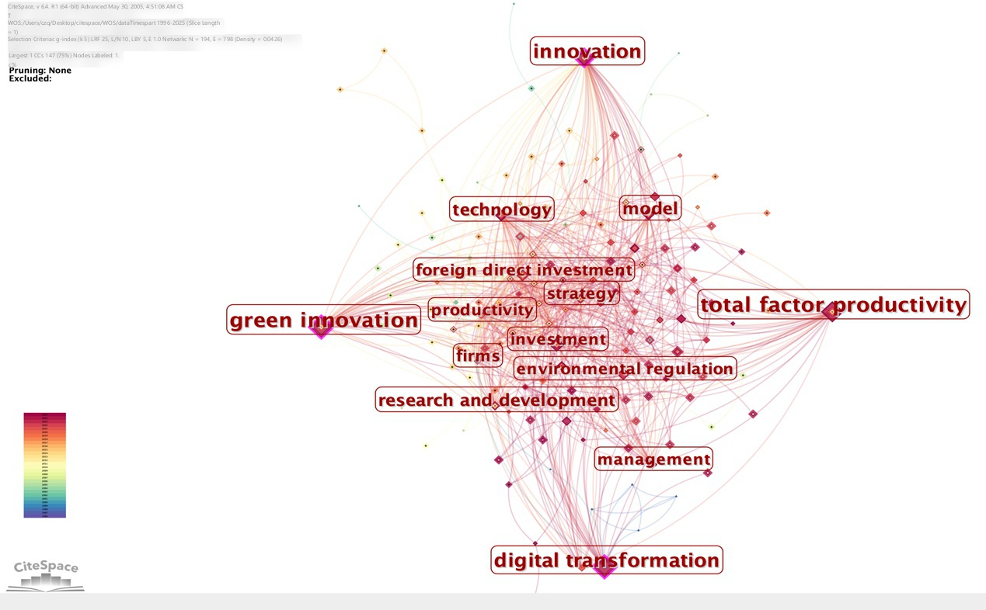
Figure 2 Study co-occurrence
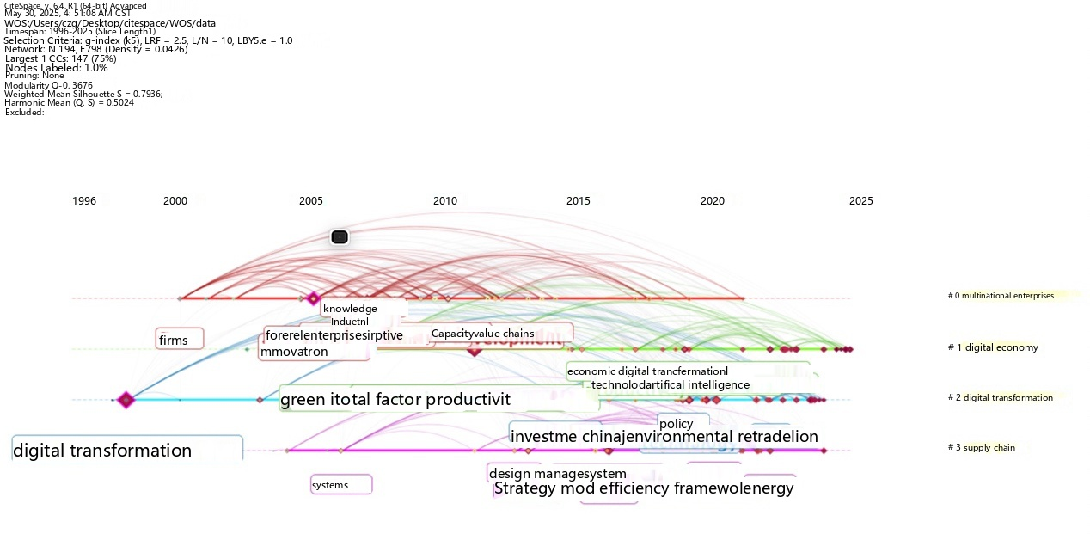
Fig3 Research timeline

Category | Variable | Symbol | Definition、Measurement | Primary data source
Dependent variable | Enterprise upgrading | EU | Coupling–coordination degree constructed from GT, DT, and TFP (details in Section 3.1.3). | Constructed by authors
EU component | Green transformation | GT | Number of granted green patents | SIPO、Global patent database
EU component | Digital transformation | DT | Text-based index from firms’ annual reports using a dictionary of digital keywords. | Annual reports
EU component | Total factor productivity | TFP | Firm-level TFP estimated by the Levinsohn–Petrin (LP) method. | WIND、CSMAR
DID core | Post-policy period | Post | Dummy = 1 for years ≥ 2018, 0 otherwise. | Policy timing
DID core | Treated firm | Treat | Dummy = 1 if pre-policy “digital exposure to Thailand” is high. | Customs
DID core | DID term | Post×Treat | Interaction term capturing the policy effect. | Constructed by authors
Controls | Firm age | AGE | Years since establishment | CSMAR
Controls | Firm size | SIZE | Firm size | WIND、CSMAR
Controls | Ownership | OWN | Dummy = 1 for SOE/central SOE, 0 otherwise. | CSMAR
Controls | Innovation | INNO | Innovation intensity . | CSMAR
Controls | Profitability | ROA | Return on assets = net profit、total assets. | WIND、CSMAR
Controls | Market position | MS | Market share. | WIND、CSMAR
Controls | Environmental legislation | ENV_LAW | Region-year environmental regulation stringency index | regional statistics
Controls | Environmental enforcement | ENV_ENF | Region-year enforcement intensity | regional statistics

Table 2 summarizes the definitions and data sources of all variables used in the analysis. This study next describe the construction of the enterprise-upgrading index (EU), which integrates green transformation, digital transformation, and productivity.
Table 2 Variable definitions and data sources
Table 3 Enterprise Upgrading Index System
Dimensions | Indicator Description | References
Green transformation of enterprises | Measured by the number of green patents granted by enterprises | Guo et al.(2024),Niu et al. (2022),Lu et al. (2022),Wang et al. (2024),Shanyong et al. (2020),Ge et al. (2023)
Enterprise Digital Transformation | Using text mining methods, constructing a dictionary of enterprise digital transformation to measure | Zhang et al. (2022),Li et al. (2022),Cherepanov et al. (2022),Luo et al. (2023),Zhao et al. (2023),Chen et al. (2024)
Total factor productivity of enterprises | Using LP method to measure | Ren et al. (2023),Ai et al. (2020),Pan et al. (2021),Liu et al. (2023),Wu et al. (2023),Teng et al. (2024)
Table 3 Enterprise Upgrading Index System
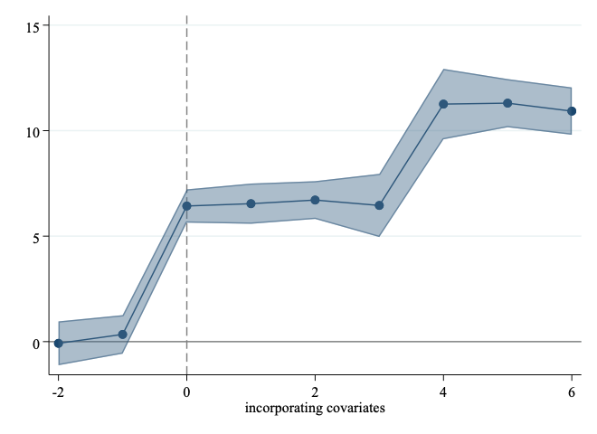
Figure 4 Parallel trend test

variable | Explained variable: Enterprise upgrading
variable | （1） | （2） | （3） | (4)
Post×Treat | 0.0519*** | 0.0536*** | 0.0774*** | 0.0697***
Post×Treat | [3.9329] | [3.7318] | [4.6583] | [3.7410]
Control variables | NO | NO | YES | YES
Firm fixed effects | YES | YES | YES | YES
Time fixed effects | NO | YES | NO | YES

Note: *, **, *** represent the significance levels of 10%, 5% and 1% respectively, and the numbers in parentheses represent t values.
Table 4 Benchmark regression results
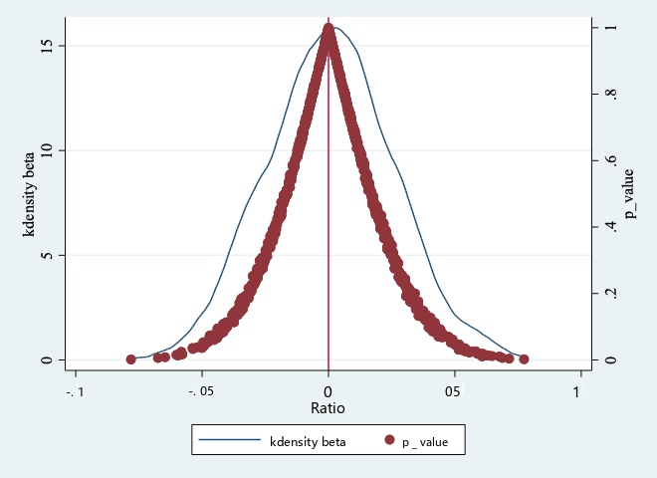
Figure 5 Placebo test

variable | (1) Export≥12% | (2) Export≥15% | (3) Orders Top20% | (4) Revenue≥8%
Post×Treat | 0.0621*** | 0.0657*** | 0.0647*** | 0.0718***
Post×Treat | [3.3147] | [3.9258] | [5.2178] | [4.2681]
Control variables | Yes | Yes | Yes | Yes
Firm fixed effects | Yes | Yes | Yes | Yes
Time fixed effects | Yes | Yes | Yes | Yes

Table 5 Robustness: Tightened Treatment Thresholds

Variable | (1) Z = DigCap | (2) Z = SOE
Post × Treat | 0.0201*** | 0.3579***
 | [4.4821] | [3.2161]
Post × Treat × Z | 0.0574*** | 0.0726***
 | [4.1258] | [3.2169]
Post × Z | 0.0261*** | 0.0409***
 | [5.0597] | [3.9754]
Controls | Yes | Yes
Firm FE | Yes | Yes
Year FE | Yes | Yes
Table 6 Heterogeneity analysis 1

Variable | (1) Z = HighCarbon | (2) Z = HighSkill
Post × Treat | 0.0212*** | 0.0154***
 | [3.1257] | [3.4269]
Post × Treat × Z | 0.0749*** | 0.0825***
 | [4.9625] | [4.5187]
Post × Z | 0.0142*** | 0.0291***
 | [3.4951] | [4.0684]
Controls | Yes | Yes
Firm FE | Yes | Yes
Year FE | Yes | Yes
Table 7 Heterogeneity analysis 2

