Diminishing Delinquency: Social Support as a Moderator Between
Exposure to Community Violence and Delinquency in Adolescents
Child & Youth Care Forum

Leonardo Dominguez Ortega,¹ Gabriel A. León ,¹
Alexandra Sturm, Ph.D.² & Diana E. Santacrose, Ph.D.³

Department of Psychology, University of Southern California¹
Department of Psychological Science, Loyola Marymount University²
Child Resilience Center, Santa Barbara, CA³

Correspondence concerning this article should be addressed to Leonardo Dominguez Ortega, Department of Psychology, University of Southern California, 3620 McClintock Ave, Los Angeles, CA 90089, United States. Email: L.DominguezOrtega@usc.edu Phone: (323) 580-411
Supplemental Materials

Table 1
Items From the NatSCEV III Used to Measure ECV, Delinquency, and Social Support
Present Study Variable | NatSCEV III  Measure | NatSCEV III Item ID | Item
Primary Exposure to Community Violence | Juvenile Victimization Questionnaire | C2 | At any time in your life, did anyone steal something from you and never give it back? Things like a backpack, money, watch, clothing, bike, cell phone, computer, or anything else?
Primary Exposure to Community Violence | Juvenile Victimization Questionnaire | C3 | At any time in your life, did anyone break or ruin any of your things on purpose?
Primary Exposure to Community Violence | Juvenile Victimization Questionnaire | C4 | Sometimes people are attacked with sticks, rocks, guns, knives, or other things that would hurt. At any time in your life did anyone hit or attack you on purpose with an object or weapon? Somewhere like: at home, at school, at a store, in a car, on the street, or anywhere else?
Primary Exposure to Community Violence | Juvenile Victimization Questionnaire | C5 | At any time in your life, did anyone hit or attack you WITHOUT using an object or weapon?
Primary Exposure to Community Violence | Juvenile Victimization Questionnaire | C6 | At any time in your life, did someone start to attack you, but for some reason, it didn’t happen? For example, someone helped you or you got away?
Primary Exposure to Community Violence | Juvenile Victimization Questionnaire | C7 | At any time in your life, did someone threaten to hurt you when you thought they might really do it?
Primary Exposure to Community Violence | Juvenile Victimization Questionnaire | P1 | Sometimes groups of kids or gangs attack people. At any time in your life, did a group of kids or a gang hit, jump, or attack you?
Primary Exposure to Community Violence | Juvenile Victimization Questionnaire | P3 | At any time in your life, did any kids try to hurt your private parts on purpose by hitting or kicking you there?
Primary Exposure to Community Violence | Juvenile Victimization Questionnaire | S4 | At any time in your life, did anyone TRY to force you to have sex, that is sexual intercourse of any kind, even if it didn’t happen?
Primary Exposure to Community Violence | Juvenile Victimization Questionnaire | S5 | At any time in your life, did anyone make you look at their private parts by using force or surprise, or by “flashing” you?
Primary Exposure to Community Violence | Juvenile Victimization Questionnaire | S7 | At any time in your life, did you do sexual things with anyone 18 or older, even things you wanted?
Primary Exposure to Community Violence | Juvenile Victimization Questionnaire | S8 | Has anyone ever had sex or tried to have sex with you when you didn’t want it, when you were very high, drunk, or drugged?
Primary Exposure to Community Violence | Juvenile Victimization Questionnaire | W5 | At any time in your life, did anyone steal something from your house that belongs to your family or someone you live with? Things like a TV, stereo, car, or anything else?
Primary Exposure to Community Violence | Juvenile Victimization Questionnaire | G1 | At any time in your life, did anyone hurt or threaten you with a real gun?
Secondary Exposure to Community Violence | Juvenile Victimization Questionnaire | W3 | At any time in your life, in real life, did you SEE anyone get attacked or hit on purpose WITH a stick, rock, gun, knife, or other thing that would hurt? Somewhere like: at home, at school, at a store, in a car, on the street, or anywhere else?
Secondary Exposure to Community Violence | Juvenile Victimization Questionnaire | W4 | At any time in your life, in real life, did you SEE anyone get attacked or hit on purpose WITHOUT using a stick, rock, gun, knife, or something that would hurt?
Secondary Exposure to Community Violence | Juvenile Victimization Questionnaire | W6 | At any time in your life, was anyone close to you murdered, like a friend, neighbor, or someone in your family?
Secondary Exposure to Community Violence | Juvenile Victimization Questionnaire | W8 | At any time in your life, were you in any place in real life where you could see or hear people being shot, bombs going off, or street riots?
Secondary Exposure to Community Violence | Juvenile Victimization Questionnaire | W9 | At any time in your life, were you in the middle of a war where you could hear real fighting with guns or bombs?
Secondary Exposure to Community Violence | Juvenile Victimization Questionnaire | G2 | At any time in your life, did you see someone else get hurt or threatened with a real gun?
Secondary Exposure to Community Violence | Community Disorder Variable Area | CD1 | At any time in your life, did you ever see someone selling marijuana, cocaine, meth, or other illegal drugs to someone else in her neighborhood or school?
Secondary Exposure to Community Violence | Community Disorder Variable Area | CD2 | At any time in your life, did you ever see the police arrest someone in your neighborhood and take that person to jail in a police car?
Secondary Exposure to Community Violence | Community Disorder Variable Area | CD3 | Have you ever lived in a neighborhood where there were gangs?
Secondary Exposure to Community Violence | Community Disorder Variable Area | CD5 | At any time in your life, have you ever seen the police raid or enter a house in your neighborhood looking for a criminal or block off a place in your neighborhood because a crime happened there?
Secondary Exposure to Community Violence | Community Disorder Variable Area | CD9 | Gangs or crews are groups that use a name, colors, or signs to let people know which kids are in the gang. Sometimes they get in fights and sell drugs. Have you ever gone to a school where there were kids in gangs?
Secondary Exposure to Community Violence | Community Disorder Variable Area | CD10 | Have you ever gone to a school where a kid brought a gun or knife to school?
Delinquency | Delinquency Variable Area | D1 | On purpose break, damage or destroy something that belonged to someone else?
Delinquency | Delinquency Variable Area | D2 | Hit, slap, or push other kids or get into a physical fight with them?
Delinquency | Delinquency Variable Area | D3 | Hit, slap, or push a parent or other grown-up?
Delinquency | Delinquency Variable Area | D4 | Take anything at school from other kids or a teacher that did not belong to you?
Delinquency | Delinquency Variable Area | D5 | Take money at home that did not belong to you like from your mother’s purse or a parent’s dresser?
Delinquency | Delinquency Variable Area | D6 | Take something from a store without paying for it?
Delinquency | Delinquency Variable Area | D7 | Cheat on school tests?
Delinquency | Delinquency Variable Area | D8 | Skip school without an excuse?
Delinquency | Delinquency Variable Area | D9 | Write things or spray paint on walls or sidewalks or cars, where you were not supposed to do that?
Delinquency | Delinquency Variable Area | D10 | Carry a weapon with you?
Delinquency | Delinquency Variable Area | D11 | Avoid paying for things such as movies, bus or subway rides, or food?
Delinquency | Delinquency Variable Area | D12 | Smoke or chew tobacco?
Delinquency | Delinquency Variable Area | D13 | Smoke marijuana
Delinquency | Delinquency Variable Area | D14 | Take any other drugs (that were not prescribed medication)?
Delinquency | Delinquency Variable Area | D15 | Hurt someone badly enough to need bandages or care from a doctor?
Delinquency | Delinquency Variable Area | D16 | Get arrested or taken into custody by police?
Delinquency | Delinquency Variable Area | D17 | Pick on another kid by chasing or grabbing him or her or by making him or her do something he or she didn’t want to do?
Delinquency | Delinquency Variable Area | D18 | Try to scare or make another kid feel bad by calling him or her names, saying mean things to him or her, or saying you didn’t want him or her around?
Delinquency | Delinquency Variable Area | D19 | Drink alcohol?
Family Social Support | Social Support Variable Area | SS1 | My family really tries to help me.
Family Social Support | Social Support Variable Area | SS2 | My family lets me know that they care about me.
Family Social Support | Social Support Variable Area | SS3 | I can talk about my problems with my family.
Family Social Support | Social Support Variable Area | SS4 | My family is willing to help me make decisions.
Friend Social Support | Social Support Variable Area | SS5 | My friends really try to help me.
Friend Social Support | Social Support Variable Area | SS6 | I can count on my friends when things go wrong.
Friend Social Support | Social Support Variable Area | SS7 | I have friends with whom I can share my good times and bad times.
Friend Social Support | Social Support Variable Area | SS8 | I can talk about my problems with my friends.
Adult Social Support | Social Support Variable Area | SS12 | I have adults other than my parents that I can talk to.
Adult Social Support | Social Support Variable Area | SS13 | I have adults other than my parents who would give good suggestions and advice about problems.
Adult Social Support | Social Support Variable Area | SS14 | I have adults other than my parents who would help with practical problems, like helping to get somewhere or help with a project.

Table 2
Negative Binomial Regression with Family Social Support Predicting Delinquency
 | Coeff. | IRR | CI |  | p-value
 |  |  | LL | UL
Family Social Supp. | -0.287 | 0.751 | 0.700 | 0.804 | <0.001***
Age | 0.287 | 1.332 | 1.264 | 1.405 | <0.001***
Gender¹ |  |  |  |  | <0.001***
Female | -0.521 | 0.594 | 0.501 | 0.704 | <0.001***
Family Income¹ |  |  |  |  | 0.355
< $20,000 | 0.133 | 1.142 | 0.834 | 1.575 | 0.408
$20,000 - < $40,000 | -0.208 | 0.812 | 0.604 | 1.093 | 0.159
$40,000 - <$75,000 | 0.023 | 1.023 | 0.831 | 1.263 | 0.831
Race¹ |  |  |  |  | 0.100
Black | 0.208 | 1.231 | 0.893 | 1.708 | 0.201
Asian | -0.602 | 0.548 | 0.274 | 1.100 | 0.098
American Indian | 0.630 | 1.878 | 0.881 | 4.440 | 0.123
Mixed Race | -0.386 | 0.680 | 0.290 | 1.628 | 0.390
Hispanic | 0.188 | 1.207 | 0.909 | 1.612 | 0.196
Note. * < .05, ** < .01, *** <.001.
¹Categorical variables’ significance was calculated using a Likelihood Ratio Test to assess contribution to model fit.

Table 3
Negative Binomial Regression with Friend Social Support Predicting Delinquency
 | Coeff. | IRR | CI |  | p-value
 |  |  | LL | UL
Friend Social Supp. | -0.121 | 0.886 | 0.836 | 0.937 | <0.001***
Age | 0.319 | 1.376 | 1.303 | 1.454 | <0.001***
Gender¹ |  |  |  |  | <0.001***
Female | -0.421 | 0.656 | 0.552 | 0.780 | <0.001***
Family Income¹ |  |  |  |  | 0.079
< $20,000 | 0.363 | 1.437 | 1.050 | 1.987 | 0.025*
$20,000 - < $40,000 | -0.109 | 0.897 | 0.667 | 1.211 | 0.468
$40,000 - <$75,000 | 0.080 | 1.083 | 0.876 | 1.342 | 0.467
Race¹ |  |  |  |  | 0.181
Black | 0.062 | 1.064 | 0.767 | 1.487 | 0.710
Asian | -0.627 | 0.534 | 0.265 | 1.087 | 0.089
American Indian | 0.456 | 1.587 | 0.722 | 3.88 | 0.288
Mixed Race | -0.619 | 0.539 | 0.226 | 1.326 | 0.182
Hispanic | 0.164 | 1.178 | 0.883 | 1.583 | 0.272
Note. * < .05, ** < .01, *** <.001.
¹Categorical variables’ significance was calculated using a Likelihood Ratio Test to assess contribution to model fit.

Table 4
Negative Binomial Regression with Adult Social Support Predicting Delinquency
 | Coeff. | IRR | CI |  | p-value
 |  |  | LL | UL
Adult Social Supp. | -0.132 | 0.876 | 0.827 | 0.927 | <0.001***
Age | 0.307 | 1.360 | 1.289 | 1.436 | <0.001***
Gender¹ |  |  |  |  | <0.001***
Female | -0.440 | 0.644 | 0.542 | 0.765 | <0.001***
Family Income¹ |  |  |  |  | 0.057
< $20,000 | 0.409 | 1.505 | 1.101 | 2.076 | 0.011*
$20,000 - < $40,000 | -0.063 | 0.939 | 0.699 | 1.266 | 0.672
$40,000 - <$75,000 | 0.058 | 1.060 | 0.857 | 1.313 | 0.599
Race¹ |  |  |  |  | 0.154
Black | 0.054 | 1.056 | 0.762 | 1.475 | 0.744
Asian | -0.639 | 0.528 | 0.263 | 1.069 | 0.079
American Indian | 0.337 | 1.400 | 0.644 | 3.431 | 0.431
Mixed Race | -0.793 | 0.452 | 0.184 | 1.138 | 0.096
Hispanic | 0.151 | 1.163 | 0.871 | 1.562 | 0.311
Note. * < .05, ** < .01, *** <.001.
¹Categorical variables’ significance was calculated using a Likelihood Ratio Test to assess contribution to model fit.

Fig. 1 Distribution of Primary Exposure to Community Violence
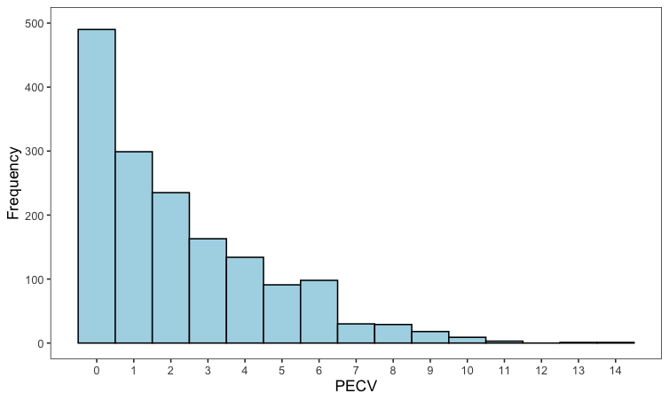

Fig. 2 Distribution of Secondary Exposure to Community Violence
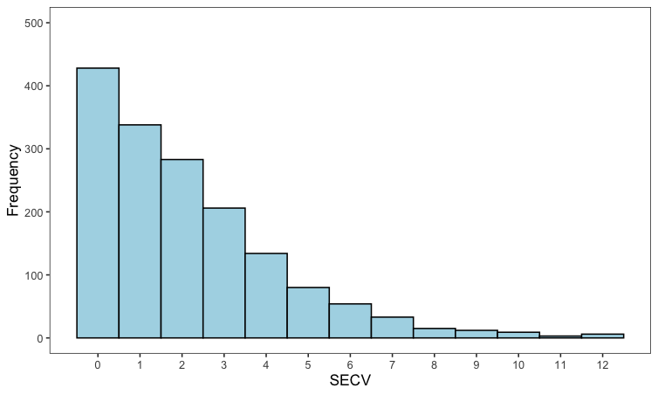

Fig. 3 Distribution of Adolescent Delinquent Engagement
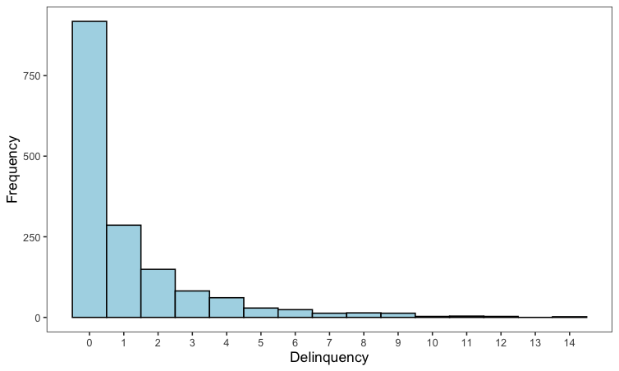

Fig. 4 Distribution of Family Social Support
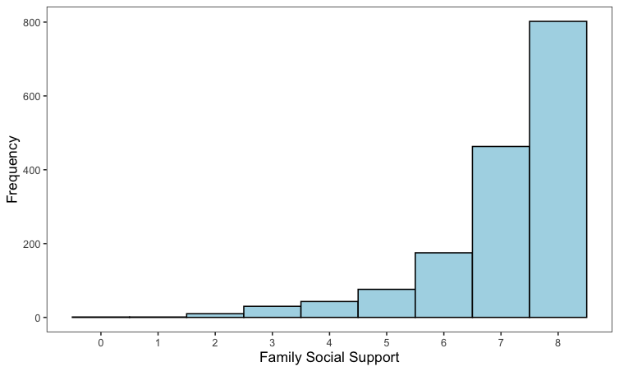

Fig. 5 Distribution of Friend Social Support
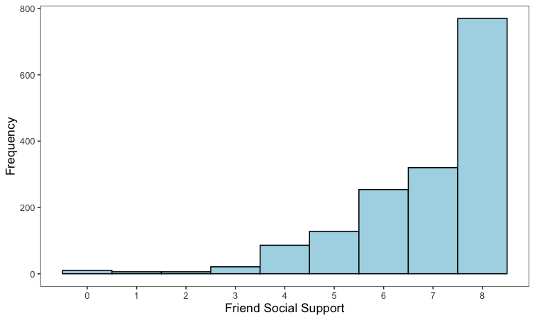

Fig. 6 Distribution of Adult Social Support
