Supplementary Information for Uncropped Original Blot Images
This file contains the original, full-length, uncropped images for all Western blot analyses presented in the main figures. Images are grouped by figure panel for clarity. The corresponding cropped versions used in the main figures are derived directly from these originals. All images are presented as captured from the imaging system without manipulation, aside from consistent brightness/contrast adjustment applied uniformly across the entire image for visibility.

- Figure 1F – RBM15B Expression in NC vs. URSA Tissues
Full-length uncropped blot:
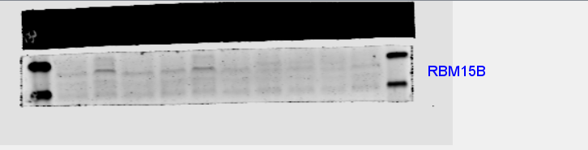
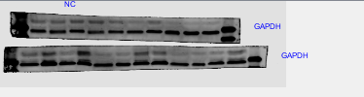
Corresponding cropped region shown in main Figure 1F: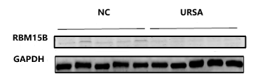
Notes:
- Lanes 1–5: Normal control (NC) samples.
- Lanes 6–10: Unexplained recurrent spontaneous abortion (URSA) samples.
- The red box indicates the region cropped for presentation in main Figure 1F.
- Adjacent lanes contain molecular weight markers and samples from pilot experiments.

- Figure 2B – RBM15B Knockdown Validation：
Full-length uncropped blot for RBM15B:
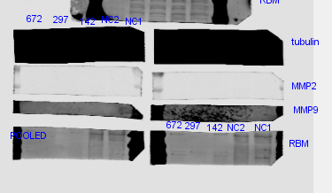
Full-length uncropped blot for β-tubulin (loading control):

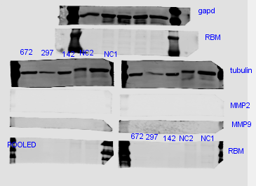
Corresponding cropped image shown in main Figure 2B: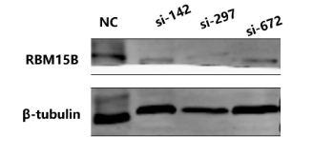
Notes:
- Lanes: si-NC, si-RBM15B-142,297,672.
- Cropping was performed to align RBM15B and β-tubulin signals for comparative analysis.

- Figure 2D – RBM15B Overexpression Validation
Full-length uncropped blot:
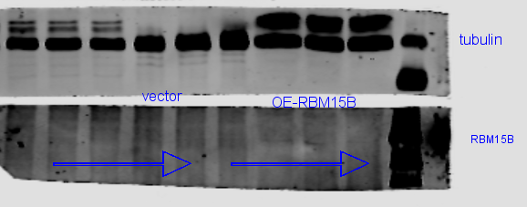
Notes:
- Lanes 1–6: Vector control, lanes 7-9: RBM15B overexpression (OE-RBM15B).
- The red box indicates the region cropped for presentation in main Figure 2D.

Corresponding cropped image shown in main Figure 2D:
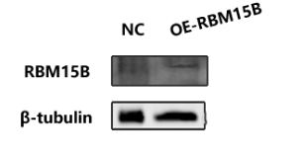

- Figure 5B – IGF2BP2 Knockdown Validation
Full-length uncropped blot:
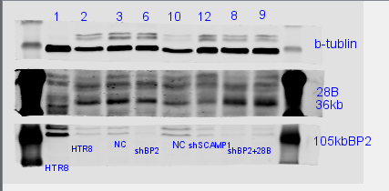
Corresponding cropped image shown in main Figure 5B: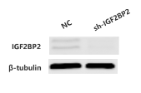
Notes:
- Lanes 1–8: HTR-8/SVneo empty control, HTR-8/SVneo empty control, Vector control, short hairpin RNAs (shRNAs) targeting IGF2BP2 (sh-IGF2BP2), Vector control, short hairpin RNAs (shRNAs) targeting SCAMP1 (sh-SCAMP1), IGF2BP2 knockdown with LIN28B overexpression (sh-IGF2BP2 + LIN28B), sh-IGF2BP2 + LIN28B.
- The red box indicates the region cropped for presentation in main Figure 5B.

- Figure 5C – LIN28B Expression after IGF2BP2 or SCAMP1 Knockdown
Full-length uncropped blot (LIN28B), same membrane as in Figure 5B:
Corresponding cropped image for LIN28B and β-tubulin in main Figure 5C:
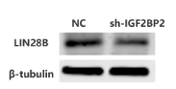
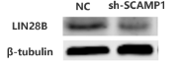
Notes:
- Lanes 1–8: HTR-8/SVneo empty control, HTR-8/SVneo empty control, Vector control, short hairpin RNAs (shRNAs) targeting IGF2BP2 (sh-IGF2BP2), Vector control, short hairpin RNAs (shRNAs) targeting SCAMP1 (sh-SCAMP1), IGF2BP2 knockdown with LIN28B overexpression (sh-IGF2BP2 + LIN28B), sh-IGF2BP2 + LIN28B.
- The red box indicates the region cropped for presentation in main Figure 5C.

- Figure 5F – LIN28B Rescue Experiment
Full-length uncropped blot (LIN28B and β-tubulin)
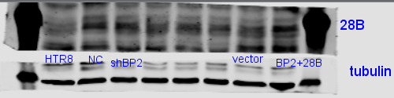
Notes:
- Panel A (LIN28B blot) lanes 1-8: HTR-8/SVneo empty control, vector control, sh-IGF2BP2, sh-IGF2BP2, sh-SCAMP1, sh-SCAMP1, vector control, sh-IGF2BP2+LIN28B
- The red box indicates the region cropped for presentation in main Figure 5F.

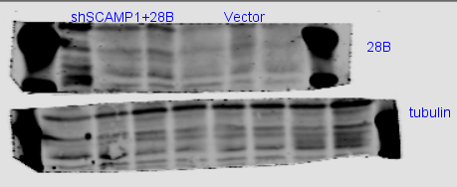
Notes:
- Panel A (LIN28B blot) lanes 1-3: sh-IGF2BP2+LIN28B, lanes 4-6: vector control.
- Panel B (β-tubulin blot) lanes 1-4: sh-IGF2BP2+LIN28B, 5-10: vector control.
- The red box indicates the region cropped for presentation in main Figure 5F.

Corresponding cropped composite image shown in main Figure 5F: