Fabrication of engineered cuboid chip and its application in cell culture
The engineered cuboid chips are fabricated based on 3D printed templates and PDMS replica molding, with their overall dimensions and configurations customizable according to the well size and format of standard culture plates. Dissociated anterior foregut endoderm (AFE) cells were seeded into the cuboid chips at low density (5,000 cells/mL), medium density (10,000 cells/mL), and high density (20,000 cells/mL). After 7 days of culture, the lung progenitor cells (LPCs) spheroids generated under all three seeding densities exhibited high cell viability. Upon further culture for 14 days, the resulting human lung organoids remained viable without the appearance of "dead cores." The average size of LPC spheroids under low and medium density conditions was approximately 55 μm, while under high density conditions, the average size was 35 μm. qPCR results indicated that the expression of the LPC marker NKX2.1 gradually decreased as the cell seeding density increased. Regarding cell viability, only the low-density condition showed a slight advantage over the high-density condition, with minimal difference observed.
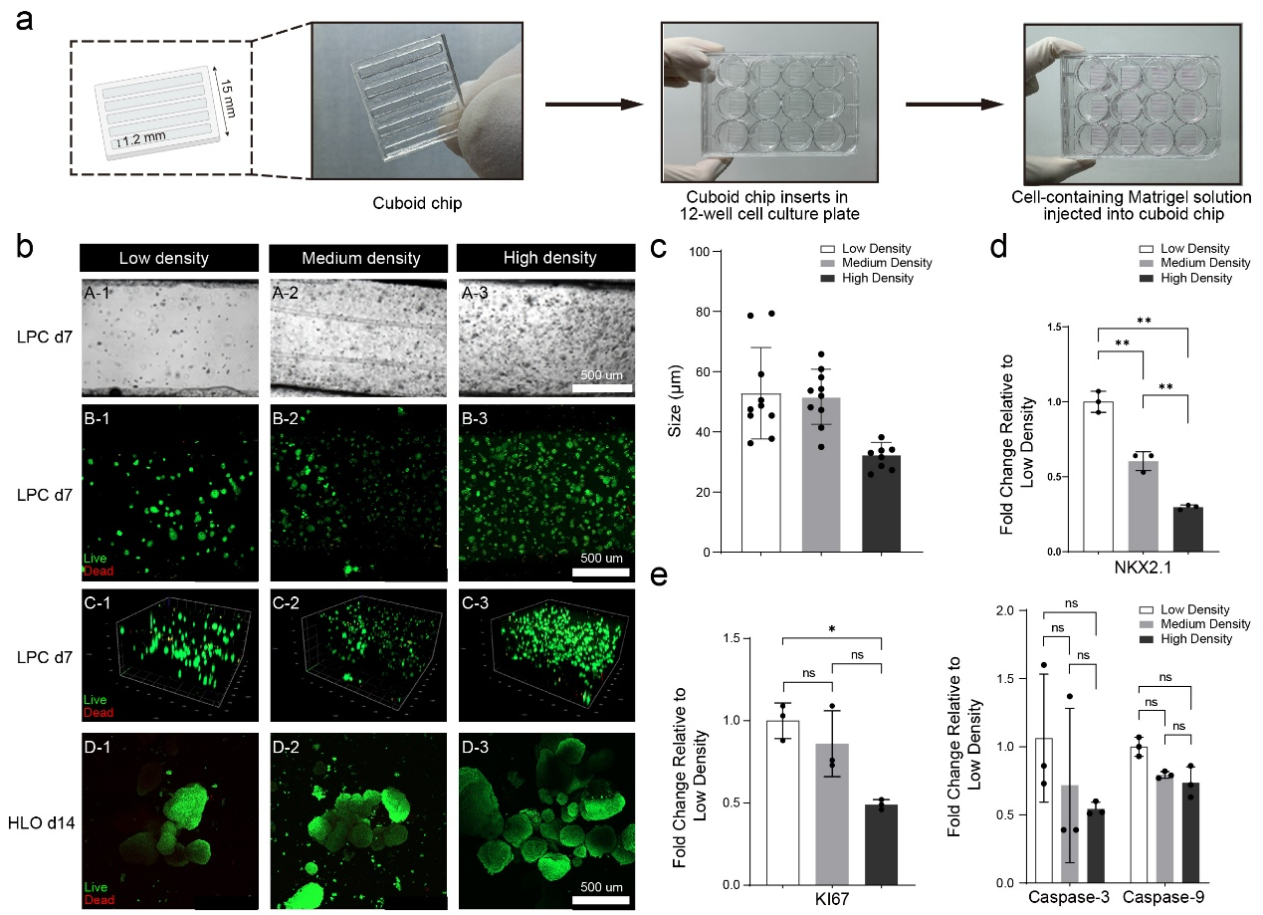
Supplementary Fig. 1 Application of engineered cuboid chip for organoid culture. a Experimental procedure for culturing organoids in engineered cuboid chips. b Organoids cultured in cuboid chips keep viability under different cell seeding density. c Average size of lung organoids under different cell seeding density. d NKX2.1 expression of lung organoids under different cell seeding density. e Cell viability in cuboid chips under different cell seeding density.

Optimization of cuboid chips
The dimensions of cuboid chips affect the viability and gene expression of cultured organoids. Therefore, we optimized their width and depth. qPCR results showed that width had little effect on NKX2.1 expression, but cell proliferation activity decreased as width increased. When the depth was 0.5 mm or 1 mm, the expression of NKX2.1 showed little difference. However, when the depth reached 1.5 mm, the expression of NKX2.1 decreased significantly. Depth had minimal impact on cell viability, which may be because after seeding, the chips were inverted, causing cells to concentrate relatively within a certain range near the top. After comprehensively considering factors such as ease of pipetting during sample loading, cell viability, organoid yield, and gene expression, we selected a width of 1.2 mm and a depth of 1 mm.
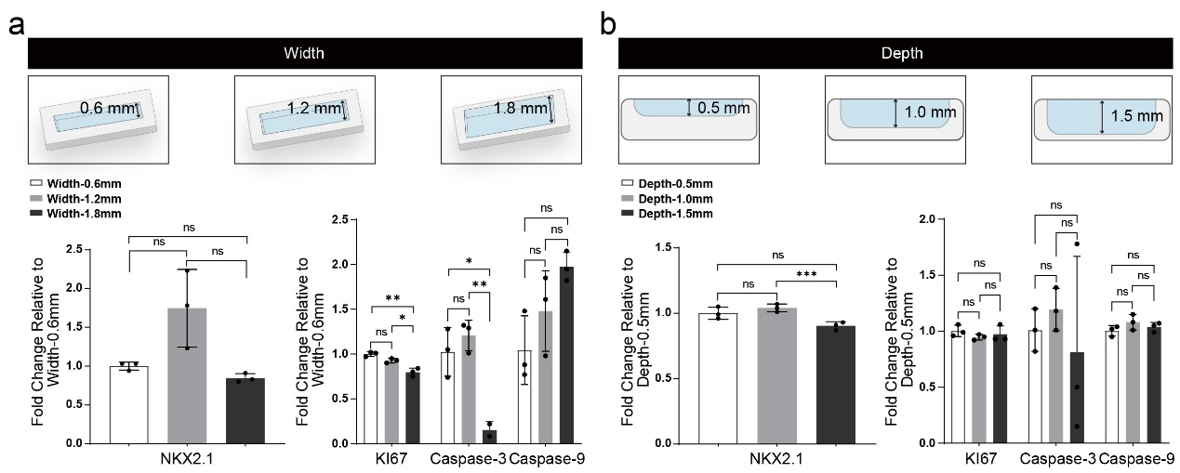
Supplementary Fig. 2 Optimization of the width and depth of cuboid chips. a NKX2.1 expression and cell viability of lung organoids under different widths of cuboid chip. b NKX2.1 expression and cell viability of lung organoids under different depths of cuboid chip.

Generation and Characterization of Airway Organoids
After 7 days of culture, the LPC medium was replaced with a specialized proximal differentiation medium DCKI (Advanced DMEM/F12 supplemented with the following components: 2.5% BSA (Proliant, 69760), 100 U/mL penicillin-streptomycin, 1x GlutaMax, 1x B27, and 1x ITS-X (Reprocell, pb180431) and key inducing factors: 50 nM dexamethasone (MCE, HY-14648), 100 nM 8-bromo-cAMP (MCE, HY-12306), 10 ng/mL KGF, 100 nM IBMX (MCE, HY-12318)).
Bright-field images showed that compared to organoids generated in the traditional dome structure Matrigel (droplet group), the airway organoids generated in the cuboid chips exhibited more uniform sizes and maintained good viability after 7 days culture (Supplementary Fig. 3a). As the culture duration extended, the size of airway organoids in the cuboid chips gradually increased (Supplementary Fig. 3b). qPCR results indicated no significant difference in the expression of LPC markers (NKX2.1, SOX2, and SOX9) between the cuboid chip group and the droplet group. However, the expression of FoxJ1 (a ciliated cell marker), SCGB1A1 (a club cell marker), and MUC5AC (a goblet cell marker) was lower in the engineered chip group compared to the droplet group. This may be attributed to the hypoxic environment in the droplets promoting differentiation toward airway organoids.
Single-cell RNA sequencing (scRNA-seq) revealed that airway organoids in both the cuboid chip group and the droplet group contained the same cell types, primarily including DRA-transition cells, DRA cells, neuroendocrine cells, ciliated cells, mesenchymal cells, neural-Like cells, DRA-like cells, and basal cells. The proportions of DRA cells, neuroendocrine cells, neural-Like cells, DRA-like cells, and basal cells were similar between the cuboid chip group and the droplet group. However, the cuboid chip group had a higher proportion of DRA-transition cells, while the proportions of ciliated cells and mesenchymal cells were lower compared to the droplet group.
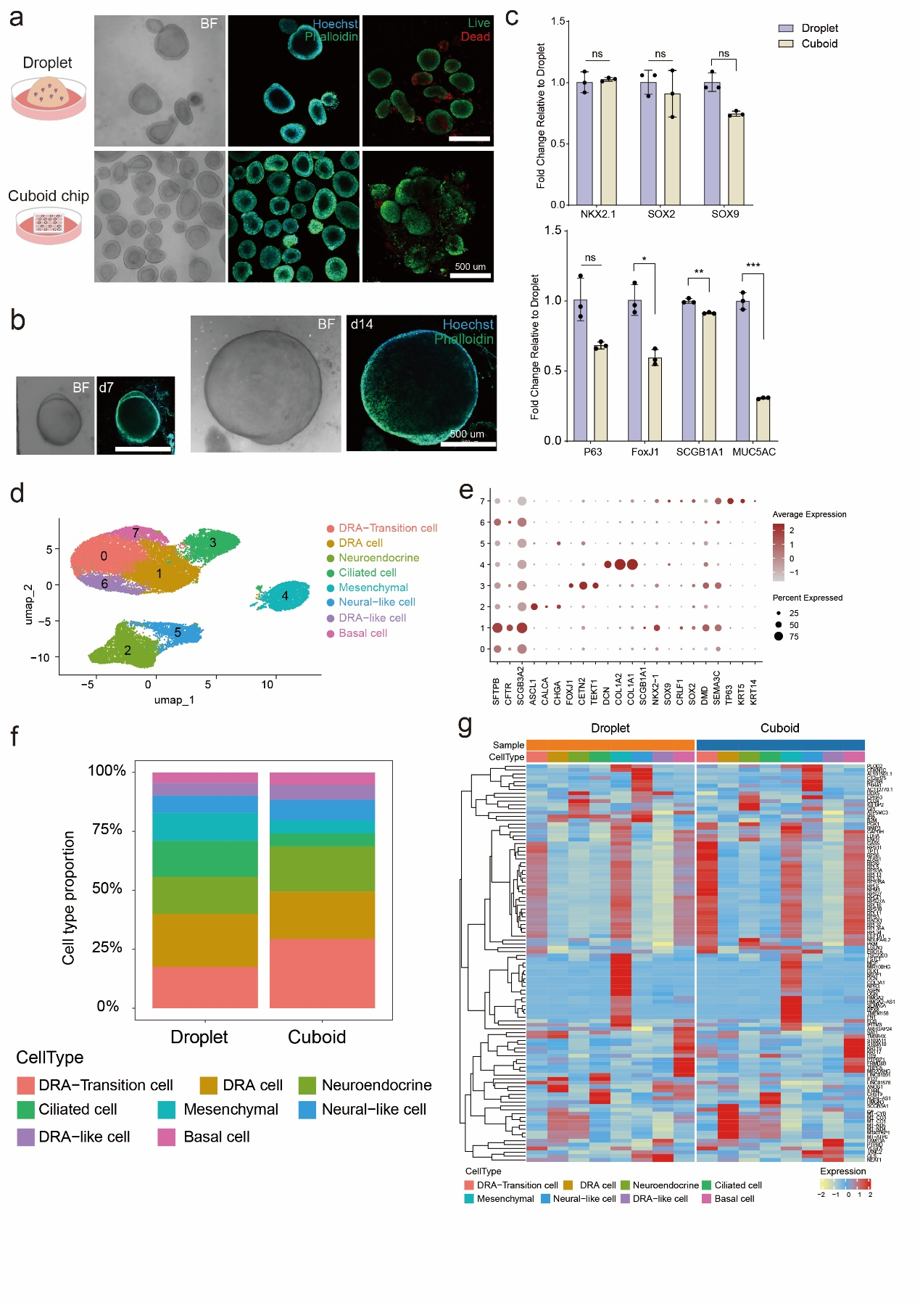
Supplementary Fig. 3 Airway organoid cultures from cuboid and droplet methods show minimal differences. a Bright-field and immunofluorescent images of airway organoids over 7 days under cuboid and droplet method. b Airway organoids continuously increased in size over 14 days within the cuboid chip. c mRNA expression for indicated markers of airway organoid under cuboid and droplet method. d UMAP plots of scRNA-seq in airway organoids. e Dot plots showing the expression of indicated markers in scRNA-seq of airway organoids. f Stacked bar plots of the relative abundance for the 8 main cell types in airway organoids. g Heatmap illustrating altered expression pattern in airway organoid.

Supplementary Table 1 qRT-PCR primers

GENE | Forward 5' - 3' | Reverse 5' - 3'
GAPDH | ACAACTTTGGTATCGTGGAAGG | GCCATCACGCCACAGTTTC
NKX2-1 | CTCATGTTCATGCCGCTC | GACACCATGAGGAACAGCG
SOX2 | GCTTAGCCTCGTCGATGAAC | AACCCCAAGATGCACAACTC
SOX9 | GTACCCGCACTTGCACAAC | GTGGTCCTTCTTGTGCTGC
PAX6 | CGAATTCTGCAGGTGTCCAA | ACAGACCCCCTCGGACAGTAAT
PAX8 | TGCCTCACAACTCCATCAGA | CAGGTCTACGATGCGCTG
CDX2 | GGGCTCTCTGAGAGGCAGGT | GGTGACGGTGGGGTTTAGCA
HHEX | CCTCTGTACCCCTTCCCG | GGGGCTCCAGAGTAGAGGTT
PDX1 | CGTCCGCTTGTTCTCCTC | CCTTTCCCATGGATGAAGTC
SCGB3A2 | GGCTAAGGAAGTGTGTAAATGAGC | CCATCCACCTCCGCTCTTTATC
TP63 | CCACAGTACACGAACCTGGG | CCGTTCTGAATCTGCTGGTCC
MUC5AC | GCACCAACGACAGGAAGGATGAG | CACGTTCCAGAGCCGGACAT
SCGB1A1 | ATGAAACTCGCTGTCACCCT | GTTTCGATGACACGCTGAAA
FOXJ1 | CAACTTCTGCTACTTCCGCC | CGAGGCACTTTGATGAAGC
SFTPB | TGCCTGGACCACCTCATCCTTG | GTCCTCACACTCTTGGCATAGG
AGER | GCCACTGGTGCTGAAGTGTA | TGGTCTCCTTTCCATTCCTG
SFTPC | AGCAAAGAGGTCCTGATGGA | CGATAAGAAGGCGTTTCAGG
LAMP3 | ACCGATGTCCAACTTCAAGC | TGACACCTTAGGCGGATTTT
ABCA3 | CAGTGGACGGGCATACATCA | CCTTCAGCTGGGCGTAGAAA
HOPX | ATTCCACCACGCTGTGCCTCAT | AGTCTGTGACGGATCTGCACTC
CAV | AACCAACAACCTCAACTGCCT | GGCTGCTGACCTAAAGCGAG

