Marine Invasion in the Era of Shipping Growth and Regulation
Supplementary Information
Zhaojun Wang ^{a*}, Zhe Dong ^{b}, Sarah A. Bailey ^{c}
a. Department of Marine and Coastal Environmental Sciences, College of Marine Sciences and Maritime Studies, Texas A&M University, Galveston, Texas 77554, United States
b. 101 Saratoga Ave, Santa Clara, CA 95051, United States
c. Great Lakes Laboratory for Fisheries and Aquatic Sciences, Fisheries and Oceans Canada, 867 Lakeshore Road, Burlington, ON, L7S 1A1, Canada
*Corresponding author

1. Methodology

1.1. Data and Key Features
Our predictive model is built upon a comprehensive dataset integrating global shipping activities with key economic, geographical, and relational indicators. Below are our incorporated several crucial data sources:
- Shipping Data: Historical voyages are obtained from Lloyd’s List and aggregated to a country-to-country level by vessel type.
- Economic Data: Historical and future Gross Domestic Product (GDP) and population figures for countries are sourced from the World Bank OECD ENV-Growth 2023 (World Bank, 2024).
- Geopolitical and Relational Data: information pertaining to inter-country relationships is drawn from Centre d’Études Prospectives et d’Informations Internationales, CEPII (CEPII, 2025).
We organize the original historical information (2002, 2005, 2008, 2012, 2015, and 2018) into structured features and labels. The key input features used in our model draw inspiration from established economic theories and network science. These include:
- Basic Economic Features. Core economic indicators for both origin and destination countries, namely their Gross Domestic Product, population size, and inter-country shipping distance, are included. These features are theoretically grounded in the gravity model of trade, which predicts that bilateral flows increase with economic size and decrease with geographic distance (Anderson & van Wincoop, 2003).
- Basic Geopolitical Information. Geopolitical variables such as common language, shared borders, and colonial history are incorporated to capture socio-political frictions that influence trade and shipping flows. The inclusion of these variables follows both the theoretical reasoning in Anderson & van Wincoop (2003) and the empirical modeling approach of Sardain et al. (2019).
- Network Structural Features. The global maritime shipping network exhibits complex structural properties that can significantly influence vessel traffic patterns. Recent research by Song et al. (2024) demonstrated that these centrality measures are positively correlated with shipping flows, highlighting the importance of network topology in maritime traffic forecasting. To mitigate potential inaccuracies arising from future changes in shipping routes, we construct the network as an unweighted, undirected graph with deduplicated edges. This approach focuses on the structural connectivity of countries, reducing sensitivity to fluctuations in route frequencies and ensuring the robustness of centrality-based features.
- Derived Economic Indicators. To capture more nuanced aspects of economic interaction and development levels, additional features were from the basic economic indicators. Ratios of Gross Domestic Product and population between origin and destination countries were computed to represent relative economic mass and demographic differentials. Products of these core economic variables were also generated to reflect combined market potential. Furthermore, per capita GDP for both origin and destination countries was included as a proxy for economic development and productivity, factors that can significantly shape trade composition and intensity.

1.2 Data Characteristics and Modeling Approach
A key characteristic of our target variable, shipping volume (i.e., the number of voyages), is its significant skewness, as illustrated in Figure S1 (left panel). The distribution is heavily concentrated at lower volumes with a long tail towards higher volumes. While a logarithmic transformation (Figure S1, right panel) alleviates some of this skewness, a notable rightward skew remains. Initial analyses indicated that such transformations did not sufficiently normalize the distribution or improve model performance adequately. Consequently, we opted not to transform the target variable.
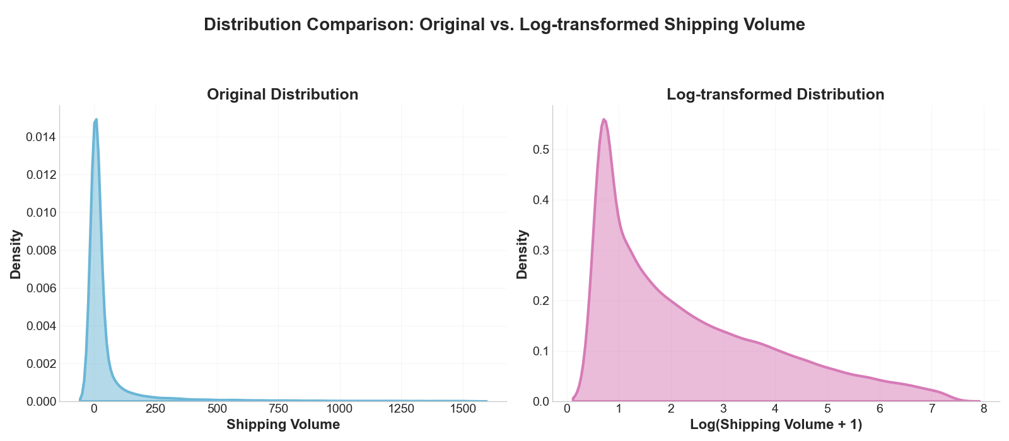
Figure S1. Distribution Comparison: Original vs. Log-transformed Shipping Volume
Furthermore, a critical challenge arises from the input data for future predictions: projected Gross Domestic Product (GDP) values often extend significantly beyond the range observed in our historical training dataset (2002-2018), as visualized in Figure S2. Figure S2 compares the distribution of historical GDP used for model training against several future GDP projections under different Shared Socioeconomic Pathways (SSPs), clearly highlighting the substantial extrapolation range the model must address. This necessitates a modeling approach capable of handling both the skewed target variable (discussed earlier) and the extrapolation required for these out-of-distribution GDP inputs.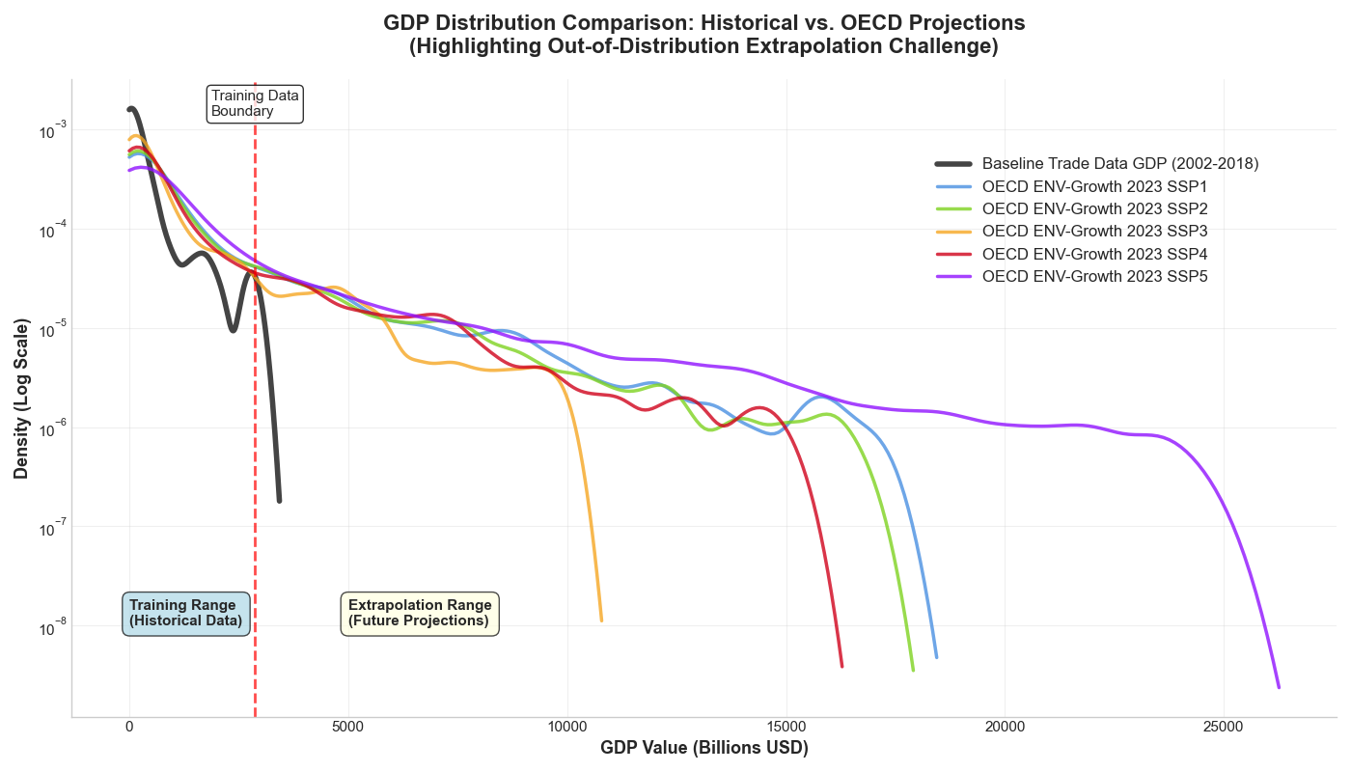Figure S2. GDP Distribution Comparison: Historical vs. OECD Projections

To address these challenges—namely, the skewed distribution of the target variable (shipping volume) and the out-of-distribution nature of projected GDP inputs—we employed an integrated Neural Network and Random Forest model.
The Random Forest algorithm, an ensemble learning method based on decision trees, was chosen for several key reasons. Firstly, it is well-suited to manage skewed data distributions of the target variable without requiring data transformation, and it can effectively capture complex, non-linear relationships between features and the outcome (Breiman, 2001). Secondly, for input features like future GDP that extend significantly beyond the training range (as shown in Figure S2), the Random Forest applies rules learned from the most similar instances observed within the training data's feature space. While traditional Random Forests have limitations in extrapolating the target variable beyond its observed training range, our approach leverages a neural network as a sophisticated feature engineering front-end to enhance the robustness of predictions under these out-of-distribution conditions. The overall architecture of the NNERF model, illustrating how the neural network provides features to the Random Forest, is depicted in Figure S3.
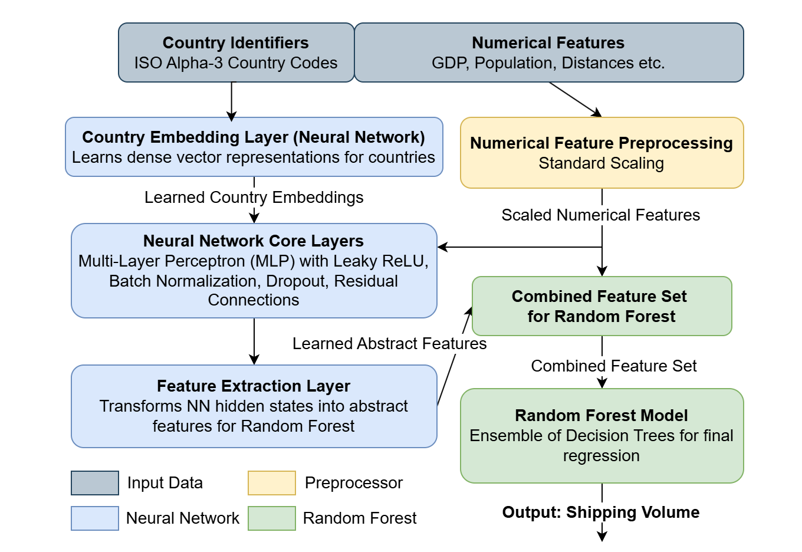Figure S3. Overview of the NNERF Model
Specifically, our model architecture first processes inputs through a neural network designed to learn rich feature representations. Categorical identifiers, such as origin and destination country names, are converted into dense vector embeddings via a dedicated embedding layer. These learned country embeddings, along with the pre-processed numerical features (such as GDP, population, distance, and engineered metrics), are then passed through neural network layers to learn more complex, interactive representations. This technique allows the model to capture latent relationships and similarities between countries in a low-dimensional space, a more effective approach for high-cardinality categorical data than traditional feature engineering techniques such as one-hot encoding (which can lead to excessively high dimensionality for numerous categories) or label encoding (which can introduce artificial and misleading ordinal relationships between categories) (Bengio et al., 2013). These learned country embeddings, along with the original scaled numerical features, are then passed through further neural network layers.
Crucially, the neural network component is trained with an internal mechanism that considers linear extrapolation trends for its own predictive task, which involves a weighted combination of a main network prediction and a linear projection. While the direct output of this internal extrapolation component is not fed into the Random Forest, its presence during the neural network's training phase influences the characteristics of the feature representations learned by the network. This enables the neural network to develop features that are not only descriptive of the historical data but are also more aligned with potential future trends, particularly when confronted with out-of-distribution inputs like projected GDP.
The final set of features input to the Random Forest therefore consists of: (i) the original, pre-processed numerical features (including the raw projected GDP values, which allow the RF to directly see the scale of future economic indicators), and (ii) the abstract, interaction-rich features extracted from the trained neural network. This hybrid approach aims to combine the Random Forest's strength in handling complex, tabular data with the neural network's capacity for learning potent, task-relevant feature representations that indirectly carry the "imprint" of having been optimized in a context that considered extrapolation. This design is intended to make the Random Forest's predictions as reasonable as possible when faced with future economic scenarios that differ substantially from historical precedent.

2. Model Performance and Key Findings

2.1. Predictive Accuracy
The predictive accuracy of our NNERF model was rigorously evaluated on a held-out test dataset. We focused on metrics that illustrate the model's ability to explain variance in shipping volumes and the magnitude of errors relative to the data's characteristics. The performance was assessed for overall shipping traffic and further broken down by specific vessel types.
As presented in Table S1, our model demonstrates a strong overall predictive capability. For all vessel types combined, it achieved an R² of 0.928. This robust overall performance compares favorably with benchmarks in the field; for example, it outperforms the aggregate R² (MSE-based) of 0.897 reported by Sardain et al. (2019) and the effective R² (derived from Corr.²) of approximately 0.778 from Song et al. (2024) for their respective overall model evaluations. Furthermore, the Normalized Root Mean Squared Error by range (NRMSE Range) for all vessel types in our model was exceptionally low at 0.0104 (or 1.04%), suggesting that the typical error magnitude is very small relative to the overall spread of shipping volumes.
When examining performance by specific vessel categories, our model consistently yields high R² values, often exceeding those reported in comparable studies For instance, our model achieved an R² of 0.9366 for Container ships and 0.906 for Oil tankers. These figures indicate a higher degree of explained variance compared to Kramel et al. (2024), who reported R² values of 0.83 and 0.68 for Container ships and Oil tankers, respectively, and also compared to Sardain et al. (2019) (who reported R² (MSE-based) values of 0.875 and 0.741 for the same categories). Similar trends of strong relative performance are observed for other key vessel types such as Bulk carriers and Chemical tankers when compared against these studies. While Sardain et al. (2019) report a particularly high R² (MSE-based) for General Cargo (0.931), our model also performs strongly in this category with an R² of 0.8821. The consistently low NRMSE Range values across different segments in our model further underscore the robust performance.
It is worth noting that metrics such as Mean Absolute Percentage Error (MAPE) or Symmetric Mean Absolute Percentage Error (SMAPE) were not prioritized in this evaluation. Due to the highly skewed distribution of shipping volumes (Figure S1), where many routes exhibit very low traffic, percentage-based errors can become disproportionately large and potentially misleading, even with small absolute prediction errors. Instead, R² and NRMSE Range offer a more stable and interpretable assessment of the model's effectiveness in capturing overall trends and the magnitude of actual shipping volumes. The strong R² values, coupled with low NRMSE Range, affirm the model's utility for accurately forecasting shipping volumes.

2.2. What Drives Shipping Volume? Insights from Feature Importance
To understand the primary factors influencing global shipping volumes for all vessel types (“All”), we conducted a feature importance analysis. The importance scores were derived using a hybrid methodology that integrates feature contributions identified by the Random Forest with an advanced attribution of influences within the neural network component. This approach employs a sensitivity analysis to trace the impact of original input features (numerical variables and country identities) through the neural network's learned representations, ultimately providing a comprehensive measure of each feature's overall predictive impact. A comprehensive list of feature importances is provided in Table S1.
Table S1. Feature Importance
Features | Importance
Origin × Destination Population Product | 0.1189
Weighted Average Inter-port Distance | 0.1085
Origin GDP | 0.1076
Origin × Destination Centrality Product | 0.1009
Destination Country Identity Vector | 0.0663
Origin/Destination Population Ratio | 0.0627
Destination GDP | 0.0622
Origin Country Identity Vector | 0.0565
Destination GDP per Capita | 0.0521
Geographic Contiguity | 0.0502
Origin × Destination GDP Product | 0.0425
Origin - Destination Centrality Difference | 0.0363
Free Trade Agreement/WTO Relationship | 0.0307
Origin Shipping Network Centrality | 0.0273
Origin Population | 0.0165
Destination Population | 0.0124
Common Colonial History | 0.0101
Origin/Destination GDP Ratio | 0.0088
Origin GDP per Capita | 0.0086
Common Official Language | 0.0081
Post-1945 Colonial Relationship | 0.0073
Destination Shipping Network Centrality | 0.0057
Our analysis reveals an interplay of demographic, geographic, economic, and network-structural factors in determining overall shipping volume. The five most influential features identified are:
Origin × Destination Population Product (0.1189): This feature, representing the multiplicative effect of the populations of the origin and destination countries, emerged as the most critical driver. It suggests that the combined demographic scale, indicative of total market size, labor availability, and aggregate demand/supply potential between two trading nations, is a primary determinant of shipping volume.
Weighted Average Inter-port Distance (0.1085): The geographical separation between countries, quantified as a weighted average of distances between their active ports, ranks as the second most important feature. This underscores the enduring significance of distance as a factor influencing transportation costs, transit times, and overall trade friction, a core tenet in trade models.
Origin GDP (0.1076): The Gross Domestic Product of the origin country is the third leading factor. This highlights the strong relationship between a nation's economic output, its production capacity, and its propensity to export goods, thereby generating shipping demand.
Origin × Destination Centrality Product (0.1009): The combined network centrality of both the origin and destination countries within the global shipping network is also highly influential. This indicates that it's not merely individual country prominence but the mutual embeddedness and structural importance of a trading dyad that significantly impacts shipping flows between them. Countries that are both central within the network tend to engage in or facilitate more substantial maritime trade.
Destination Country Identity Vector (0.0663): The learned embedding representing the unique characteristics of the destination country ranks fifth. This is a noteworthy finding, suggesting that complex, latent attributes of a destination nation—beyond its raw GDP or population figures (which are also important, with Destination GDP at 0.0622)—play a distinct role. These attributes, captured by the neural network's representation learning (Bengio et al., 2013), could encompass factors like specific import demands, port efficiency, regulatory environments, or specialized industrial structures not explicitly measured by other variables.
Beyond these top five, other features such as the Origin/Destination Population Ratio (0.0627), Destination GDP (0.0622), and the Origin Country Identity Vector (0.0565) also demonstrate considerable influence, as detailed in Table S1. The importance of these "identity vectors" (country embeddings) further validates the NNERF model's ability to extract meaningful, data-driven representations of country-specific effects.

3. Descriptions of SSPs (Leimbach et al., 2017)
SSP1: Sustainability, emphasizing inclusive development, reduced inequality, and rapid adoption of clean technologies. Shipping may shift toward greener logistics and improved infrastructure. SSP2: Middle of the Road, reflecting a continuation of historical trends with moderate growth and uneven sustainability efforts. Shipping volumes grow steadily with global trade. SSP3: Regional Rivalry, which is characterized by nationalism, limited cooperation, and slow economic growth. Global trade contracts, favoring regional shipping. SSP4: Inequality. High disparities in development and access to technology. Trade concentrates among wealthy nations, with uneven port development. SSP5: Fossil-Fueled Development, with rapid economic growth driven by fossil fuels, high energy demand and emissions. Shipping volumes increase significantly, but with elevated environmental impacts (Leimbach et al., 2017)

4. Results for individual countries

4.1 Predicted traffic to individual countries
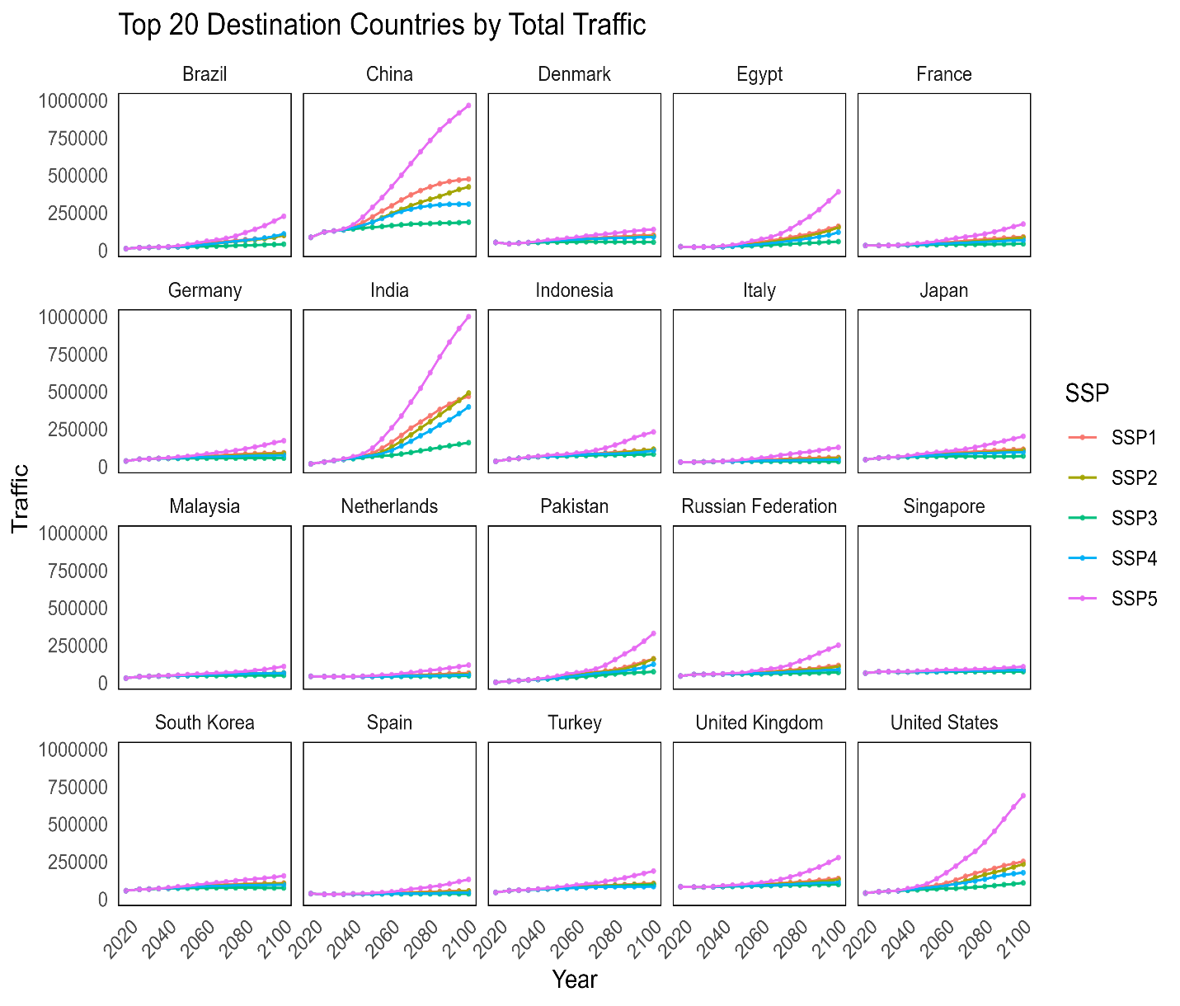
Figure S4 Top 20 destination countries’ predicted traffic (number of voyages) (2018-2100)
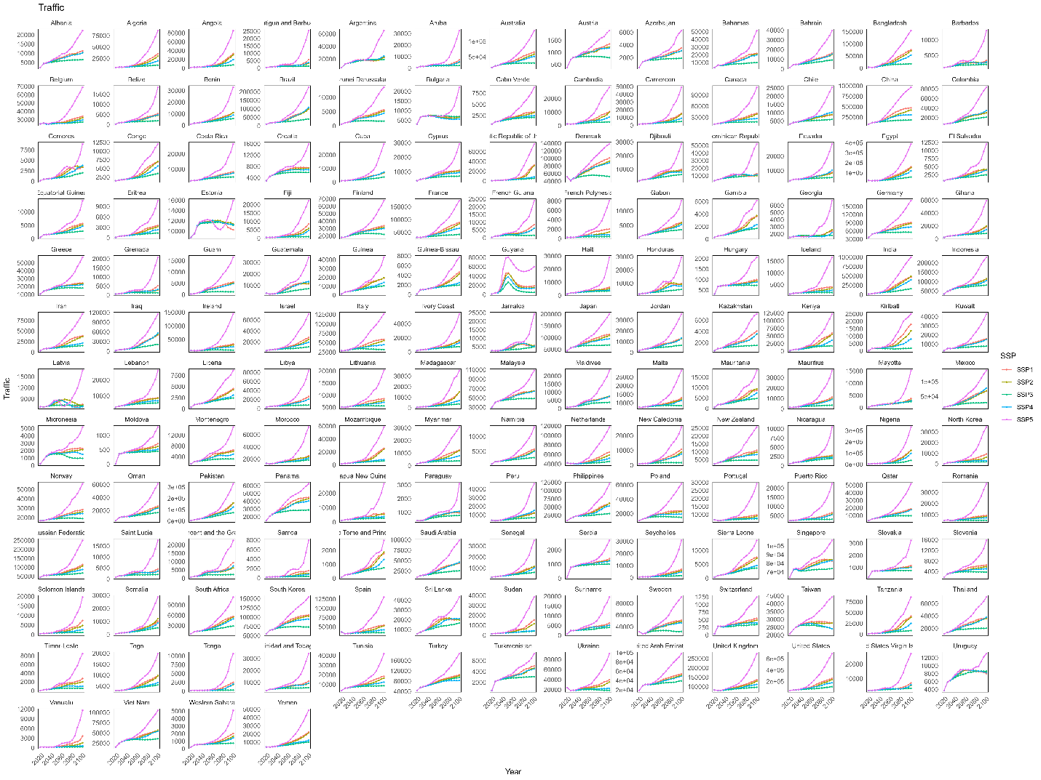
Figure S5 Destination countries’ predicted traffic (2018-2100)

4.2 Risk changes to individual countries
Risk changes to individual countries under different policy scenarios.

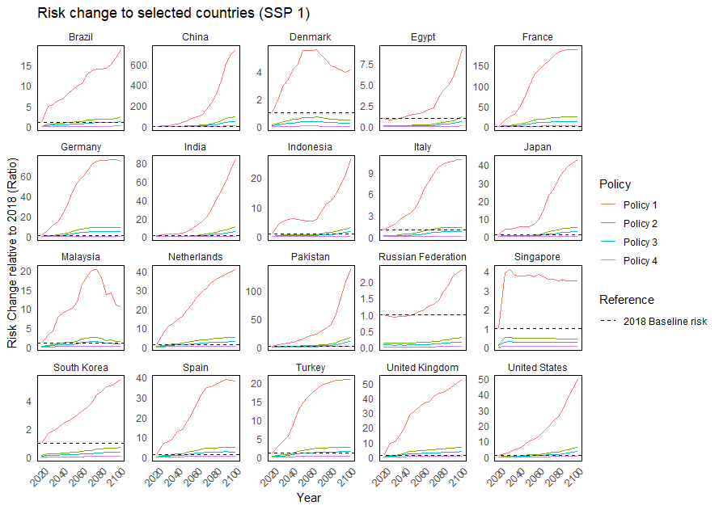
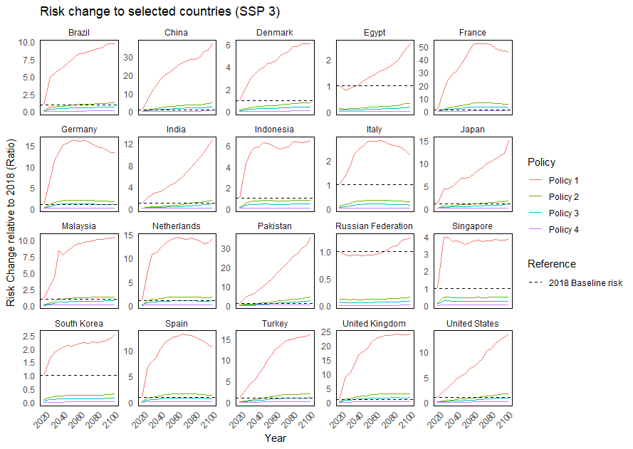
Figure S6 Risk changes to individual countries under SSP1 and SSP3

5. Baseline NIS spread risk by country and port
Baseline NIS risk results are available at:
https://github.com/msaebi1993/Scenario_SF_HON/tree/v.0.0/Data
=

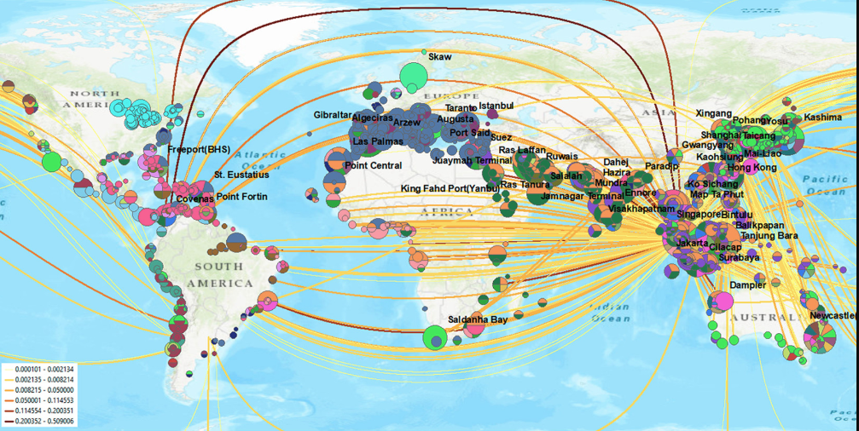
Figure S7. The baseline risks by port and voyages. Source : (Wang et al., 2021).
Table S2 Top 10 Port Receiving Risks
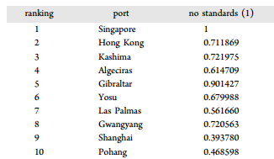

6. References
Anderson, J. E., & van Wincoop, E. (2003). Gravity with gravitas: A solution to the border puzzle. American Economic Review, 93(1), 170–192.
Breiman, L. (2001). Random forests. Machine learning, 45(1), 5-32.
Bengio, Y., Courville, A., & Vincent, P. (2013). Representation learning: A review and new perspectives. IEEE transactions on pattern analysis and machine intelligence, 35(8), 1798-1828.
CEPII, 2025. World Economy Databases. https://www.cepii.fr/CEPII/en/bdd_modele/bdd_modele.asp.
Kramel, D., Franz, S. M., Klenner, J., Muri, H., Münster, M., & Strømman, A. H. (2024). Advancing SSP-aligned scenarios of shipping toward 2050. Scientific Reports, 14, 8965.
Leimbach, M., Kriegler, E., Roming, N., Schwanitz, J., 2017. Future growth patterns of world regions – A GDP scenario approach. Global Environmental Change 42, 215–225. https://doi.org/10.1016/j.gloenvcha.2015.02.005
Sardain, A., Sardain, E., & Leung, B. (2019). Global forecasts of shipping traffic and biological invasions to 2050. Nature Sustainability, 2, 274–282.
Song, R., Spadon, G., Pelot, R., Matwin, S., & Soares, A. (2024). Enhancing global maritime traffic network forecasting with gravity-inspired deep learning models. Scientific Reports, 14, 16665.
Wang, Z., Saebi, M., Corbett, J.J., Grey, E.K., Curasi, S.R., 2021. Integrated Biological Risk and Cost Model Analysis Supports a Geopolitical Shift in Ballast Water Management. Environ. Sci. Technol. 55, 12791–12800. https://doi.org/10.1021/acs.est.1c04009
World Bank, 2024. World Bank Open Data. https://data.worldbank.org.

