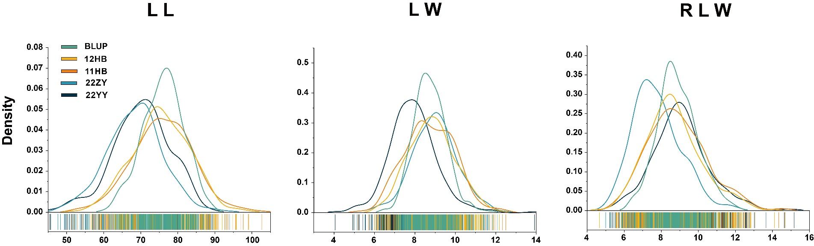
Appendix D. Density distribution of leaf morphological traits across environments and and their best linear unbiased predictor (BLUP) values. (A) Leaf length (LL). (B) Leaf width (LW). (C) Ratio of leaf length to width (RLW).
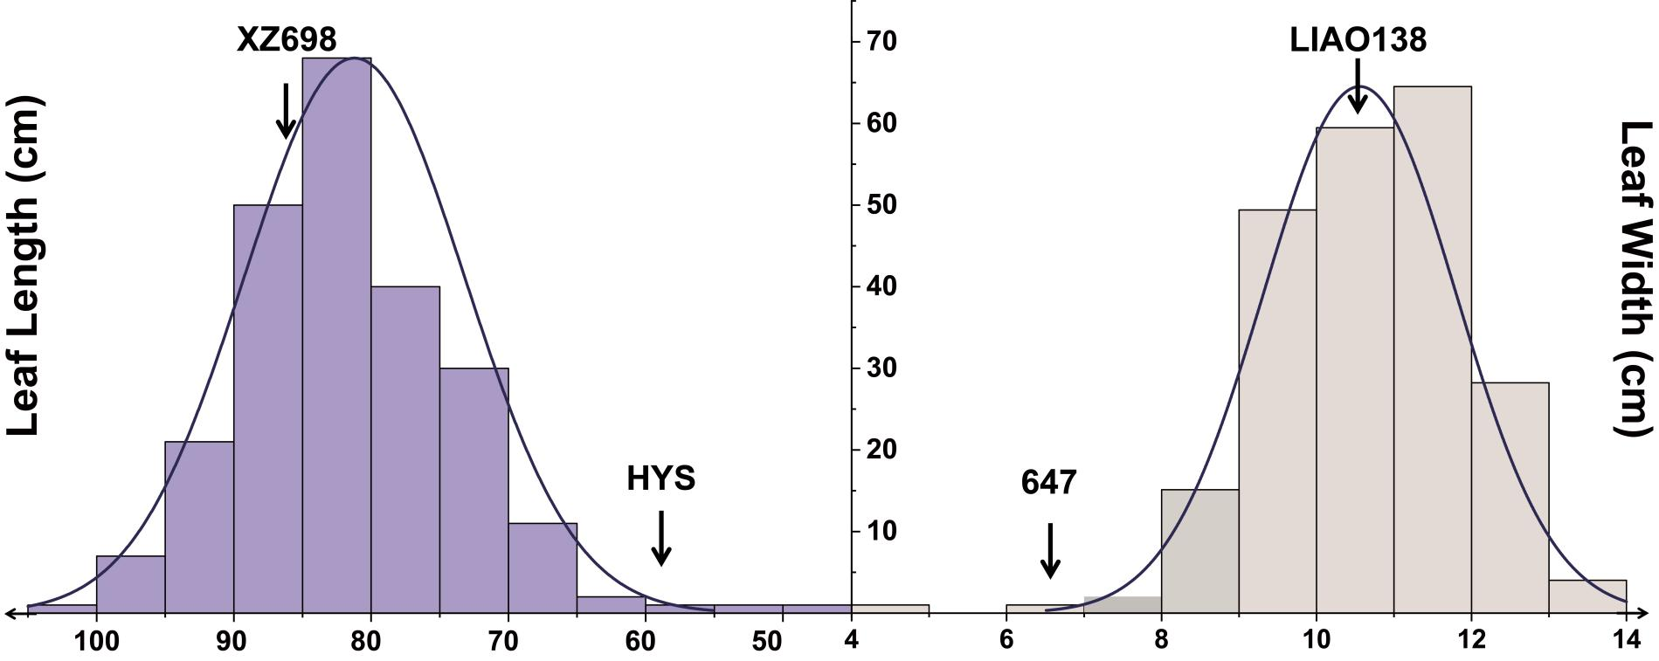

Appendix H. Phenotypic distributions of leaf length and width in the F₂ mapping population. (A) Frequency distribution of leaf length (LL, cm). The purple histogram represents observed phenotypic counts, overlaid with a density curve. Arrows indicate the parental lines XZ698 (long-leaf) and HYS (short-leaf). (B) Frequency distribution of leaf width (LW, cm). The gray histogram represents phenotypic counts, overlaid with a density curve. Arrows indicate the parental lines LIAO138 (wide-leaf) and 647 (narrow-leaf).
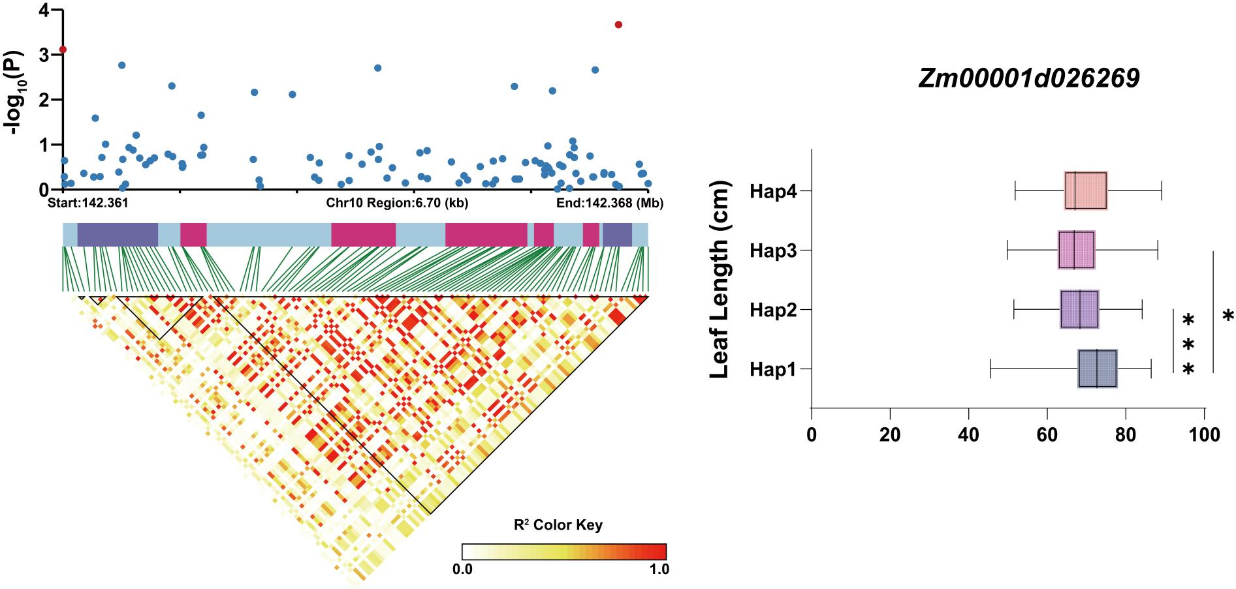

Appendix L. Candidate gene association analysis of Zm00001d026269 for leaf length (LL) in maize. (A) Linkage disequilibrium (LD) heatmap showing pairwise R² values among SNPs in the genomic region; the color scale indicates LD strength. (B) Haplotype analysis of Zm00001d026269. Violin plots compare LL (cm) between Hap1 and Hap2, with asterisks denoting a statistically significant difference.

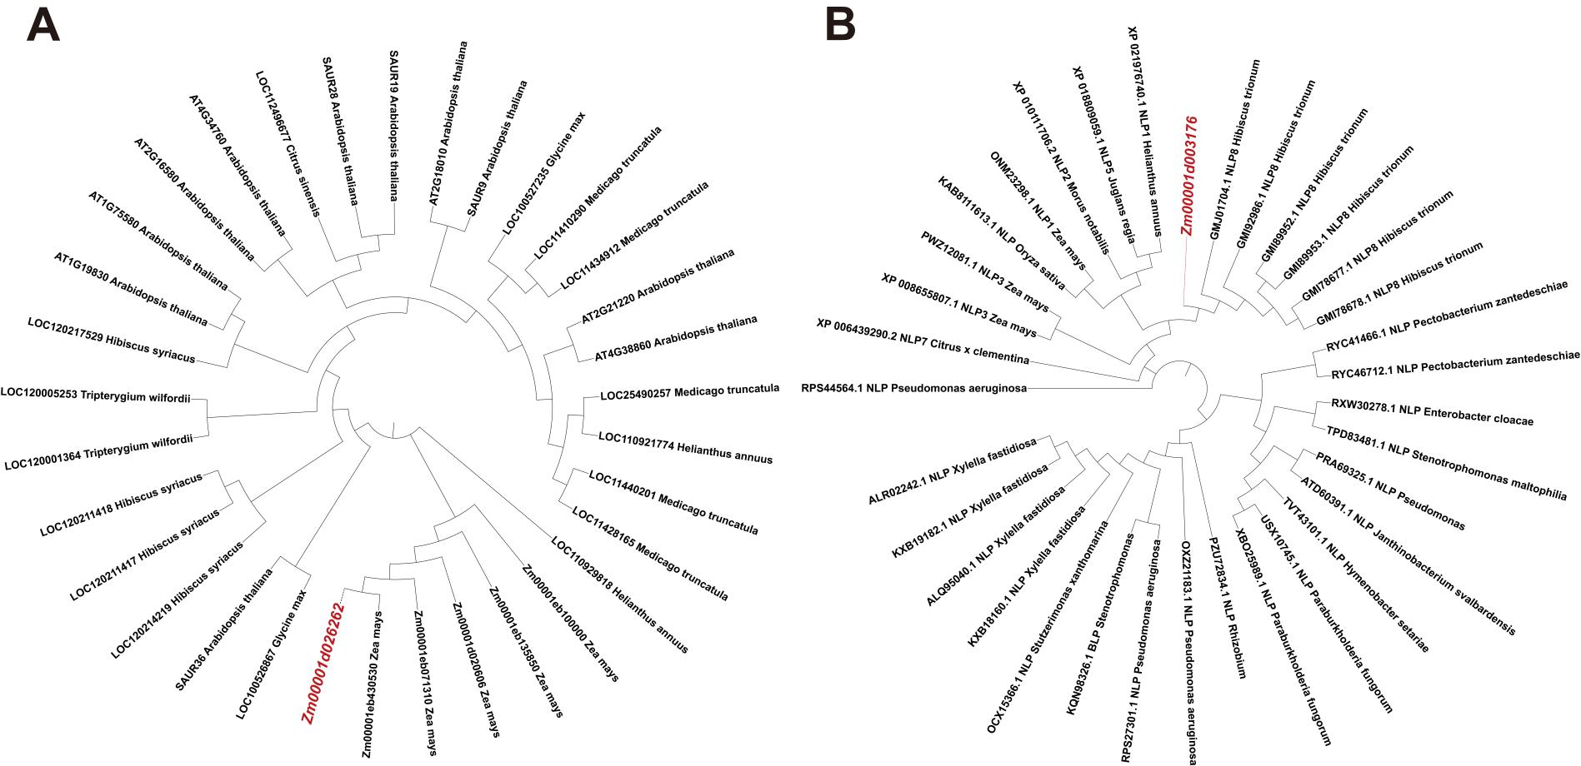

Appendix O. Phylogenetic analysis of candidate genes. (A) Evolutionary relationships of Zm00001d026262 and its homologs. (B) Evolutionary relationships of Zm00001d003176 and its orthologs from selected species, including Zea mays, Helianthus annuus and Pseudomonas aeruginosa.

