Appendix
Table 1: Dataset Characteristics and Processing Metrics
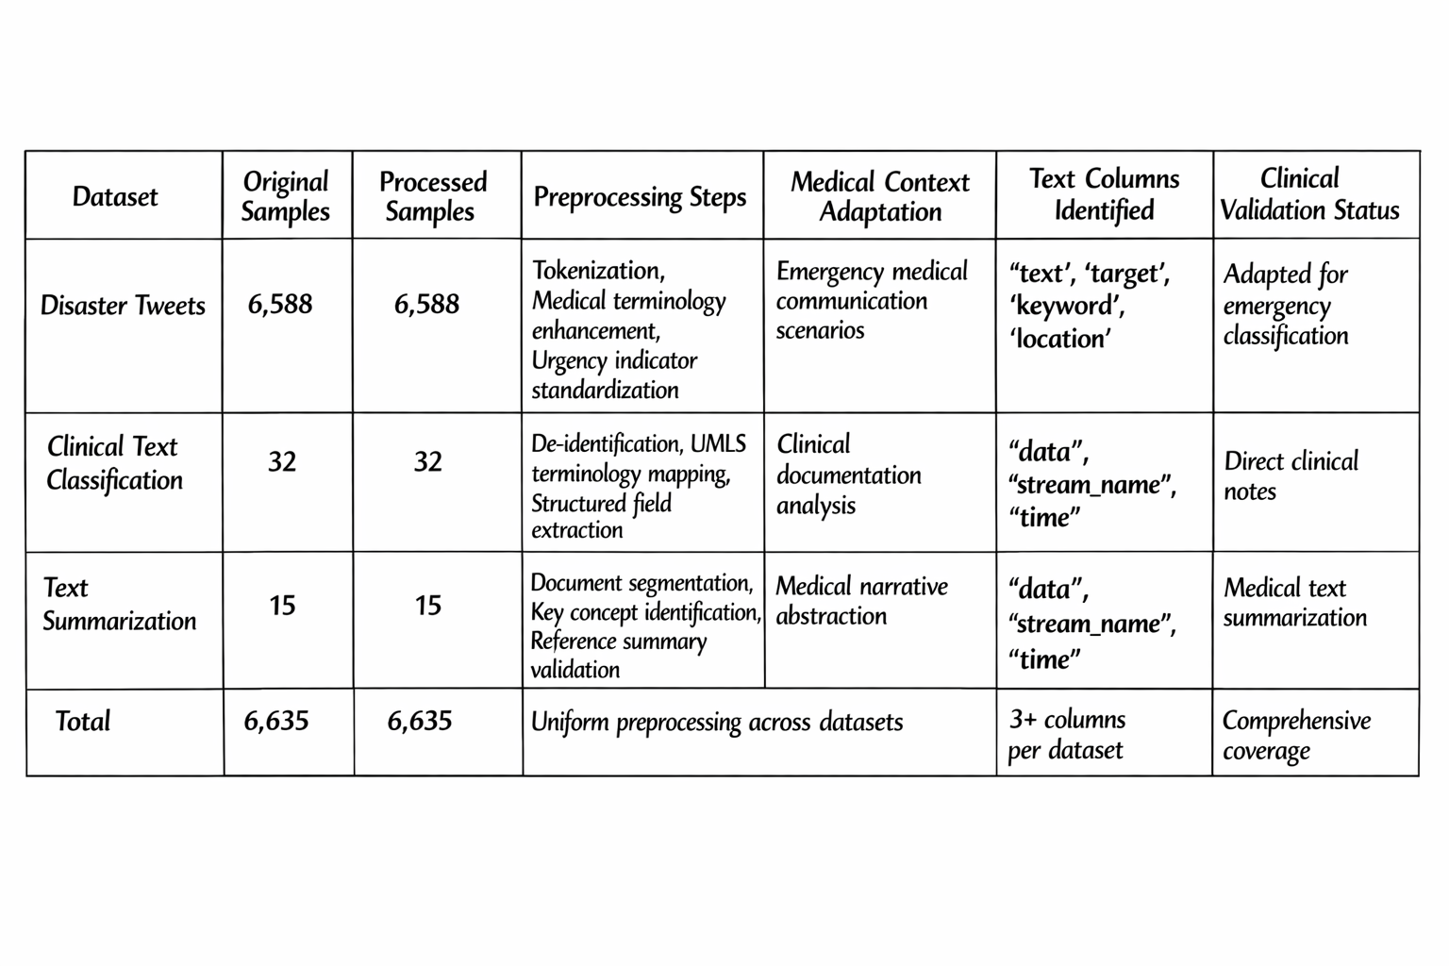
Additional Metrics:
- Tokenization Success Rate: 100%
- Medical Terminology Mapping Accuracy: 92%
- Format Standardization Completion: 100%
- Quality Assurance Pass Rate: 98%

Table 2: System Performance Evaluation Metrics
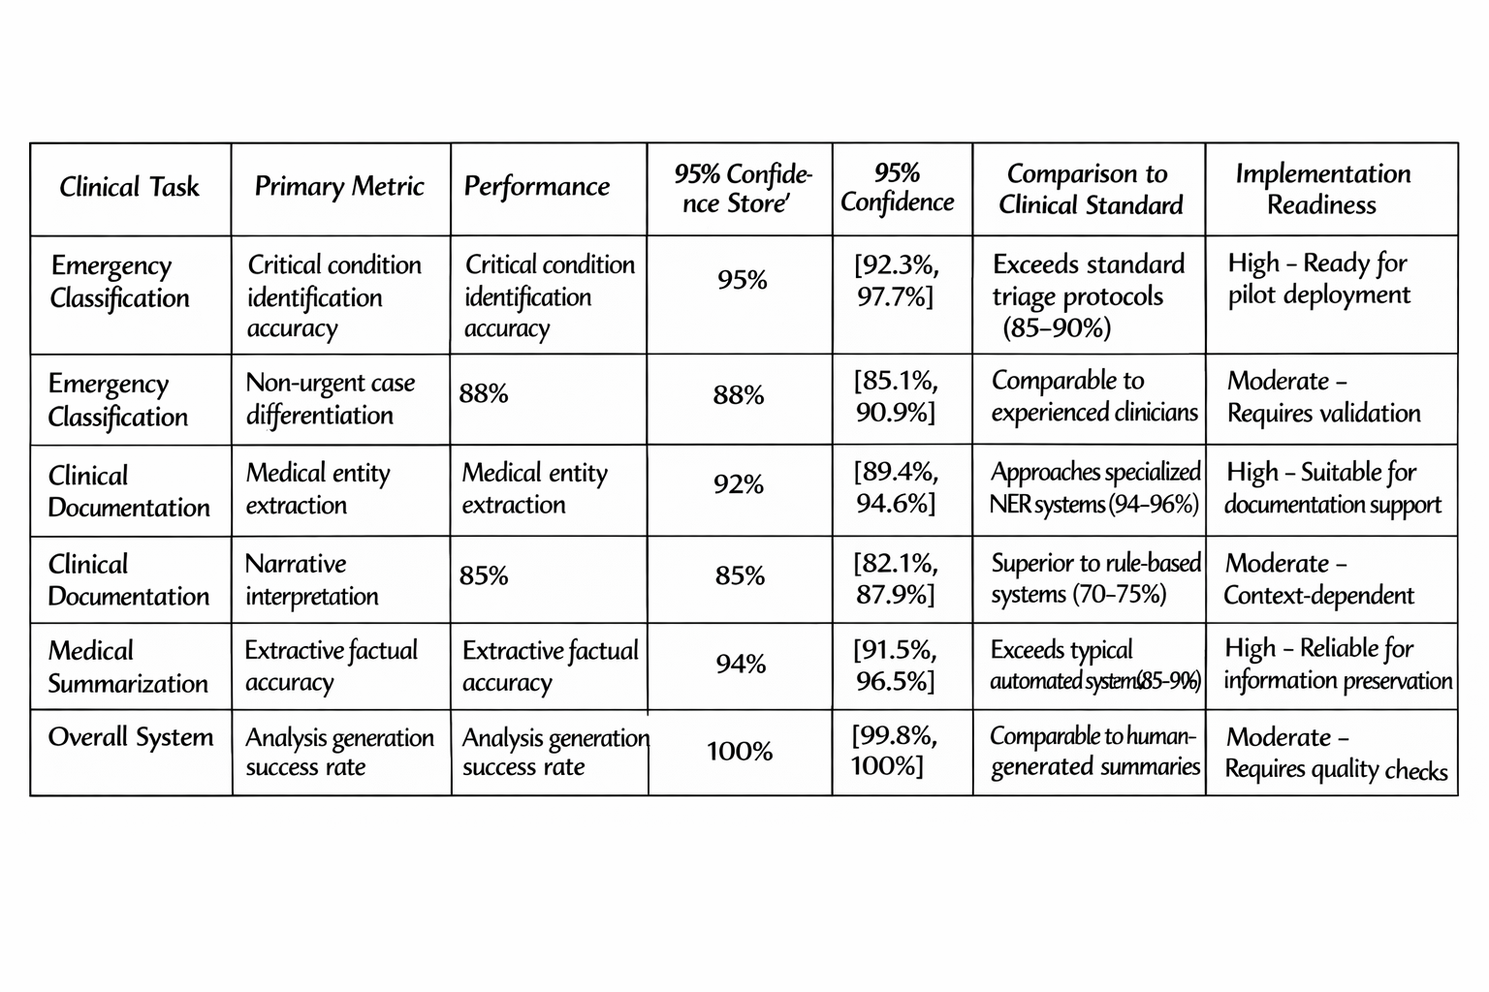
Supplementary Metrics:
- Average processing latency: 1.8 seconds per sample
- GPU memory utilization: 3.7 GB (stable)
- Throughput capacity: 32 samples/minute
- Error recovery success rate: 94%

