Development of a screening method for isolation of microalgae strains that accumulate lipids under nitrate-replete conditions

Tomoki Oyama¹, Yuichi Kato², Katsuya Satoh³, Yutaka Oono³, Tomohisa Hasunuma^{1,2*}, Akihiko Kondo^{1,2,4}

¹ Graduate School of Science, Technology and Innovation, Kobe University, 1-1 Rokkodai, Nada, Kobe 657-8501, Japan
² Engineering Biology Research Center, Kobe University, 1-1 Rokkodai, Nada, Kobe 657-8501, Japan
³ Department of Radiation-Applied Biology Research, Takasaki Advanced Radiation Research Institute, Quantum Beam Science Research Directorate, National Institutes for Quantum and Radiological Science and Technology, 1233 Watanuki, Takasaki, Gunma 370-1292, Japan
⁴ Department of Chemical Science and Engineering, Graduate School of Engineering, Kobe University, 1-1, Rokkodai, Nada-ku, Kobe, 657-8501, Japan

Table S1. Number of cells analyzed and sorted in the first-round screening.
 | Analyzed cells | Sorted cells | Sorting ratio (%)
First sorting | 1,554,028 | 1,000 | 0.06
Second sorting | 172,163 | 1,000 | 0.58
Third sorting | 358,127 | 1,000 | 0.28
Fourth sorting | 122,853 | 1,000 | 0.81
Fifth sorting | 14,124 | 1,000 | 7.08

Table S2. Number of cells analyzed and sorted in the second-round screening.
 | Analyzed cells | Sorted cells | Sorting ratio (%)
First sorting | 832,159 | 1,000 | 0.12
Second sorting | 357,806 | 1,000 | 0.28
Third sorting | 31,825 | 1,000 | 3.14
Fourth sorting | 2,418 | 1,000 | 41.36

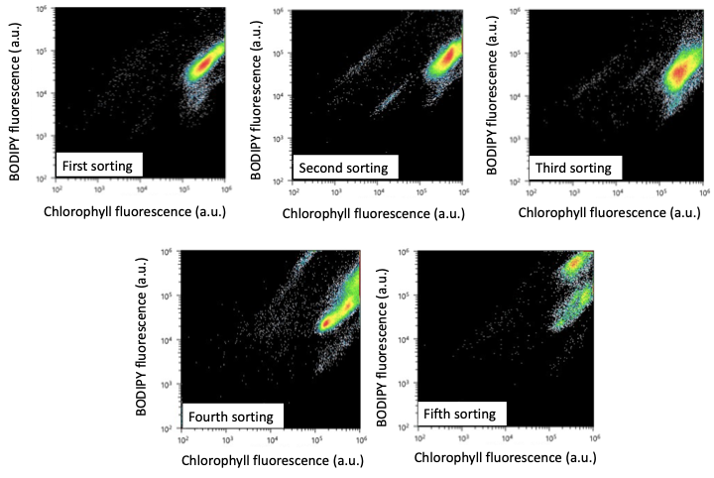
Fig. S1 Fluorescence plots for the first-round screening.
Red, yellow, green, blue, and white spots indicate increasing number of events.

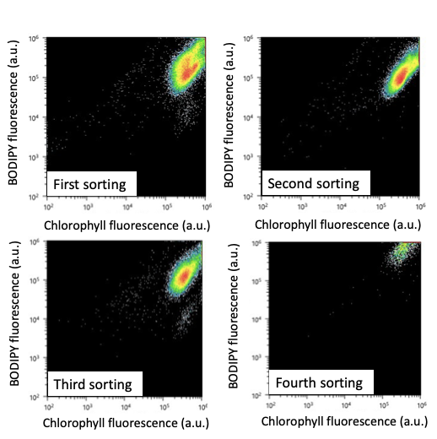
Fig. S2 Fluorescence plots for the second-round screening. Red, yellow, green, blue, and white spots indicate increasing number of events.
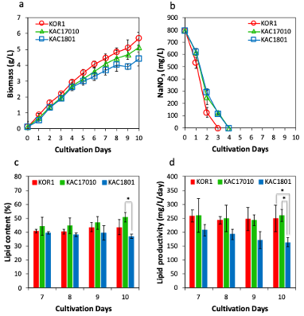
Fig. S3 Evaluation of lipid productivity in the KAC1710 and KAC1801 strains under the nitrate-depleted conditions. a Biomass concentration. b Nitrate concentration. c Lipid content. d Lipid productivity. Error bars indicate the standard deviation of three replicate experiments (*: p < 0.05, by Tukey test).

