Title: Host-directed treatments for tuberculous meningitis: A multi-platform approach across mouse and human models
​
Carlos E. Ruiz-Gonzalez^{1,2,3†#}, Medha Singh^{1,2,3†#}, Yuderleys Masias-Leon^{1,2,3†#}, Xueyi Chen^{1,2,3}, Mona O. Sarhan^{1,2,3#}, Yazmin B. Martinez-Martinez^{2,4}, Sruti Patel^{1,2,3}, Madelynn Shambles^{1,2,3}, Andres Villabona-Rueda⁵, Kadia Lissit⁶, David Tweedie⁷, Michael T. Scerba⁷​​, William R. Bishai^{2,4}, Dmitri Artemov⁸, Jin-Chong Xu^{6,9}, Franco D’Alessio⁵, Richard Hafner¹⁰, Nigel H. Greig⁷, Maura Manion¹¹, Irini Sereti¹², Sanjay K. Jain^{1,2,3,8#}*

¹Center for Infection and Inflammation Imaging Research, Johns Hopkins University School of Medicine, Baltimore, MD, USA
²Center for Tuberculosis Research, Johns Hopkins University School of Medicine, Baltimore, MD, USA
³Department of Pediatrics, Johns Hopkins University School of Medicine, Baltimore, MD, USA
⁴Department of Medicine, Johns Hopkins University School of Medicine, Baltimore, MD, USA
⁵Division of Pulmonary, Critical Care and Sleep Medicine, Miller School of Medicine, University of Miami, Miami, FL, USA
⁶Human iPSC Core for Neurodegenerative Disease Research, Johns Hopkins Alzheimer's Disease Research Center, Johns Hopkins University School of Medicine, Baltimore, MD, USA
⁷Translational Gerontology Branch, National Institute on Aging, National Institutes of Health, Baltimore, MD, USA
⁸Russell H. Morgan Department of Radiology and Radiological Science, Johns Hopkins University School of Medicine, Baltimore, MD, USA
⁹Department of Neurology, Johns Hopkins University School of Medicine, Baltimore, MD, USA.
¹⁰Division of AIDS, National Institute of Allergy and Infectious Diseases, National Institutes of Health, Bethesda, MD, USA
¹¹Office of the Clinical Director, National Institute of Allergy and Infectious Diseases, National Institutes of Health, Bethesda, MD, USA
¹²Division of Intramural Research, National Institute of Allergy and Infectious Diseases, National Institutes of Health, Bethesda, MD, USA.
†Authors contributed equally
#Current affiliation: Department of Pediatrics, Cincinnati Children’s Hospital Medical Center, Cincinnati, OH, USA
*Corresponding author. Email: sanjay.jain@cchmc.org and sjain5@jhmi.edu

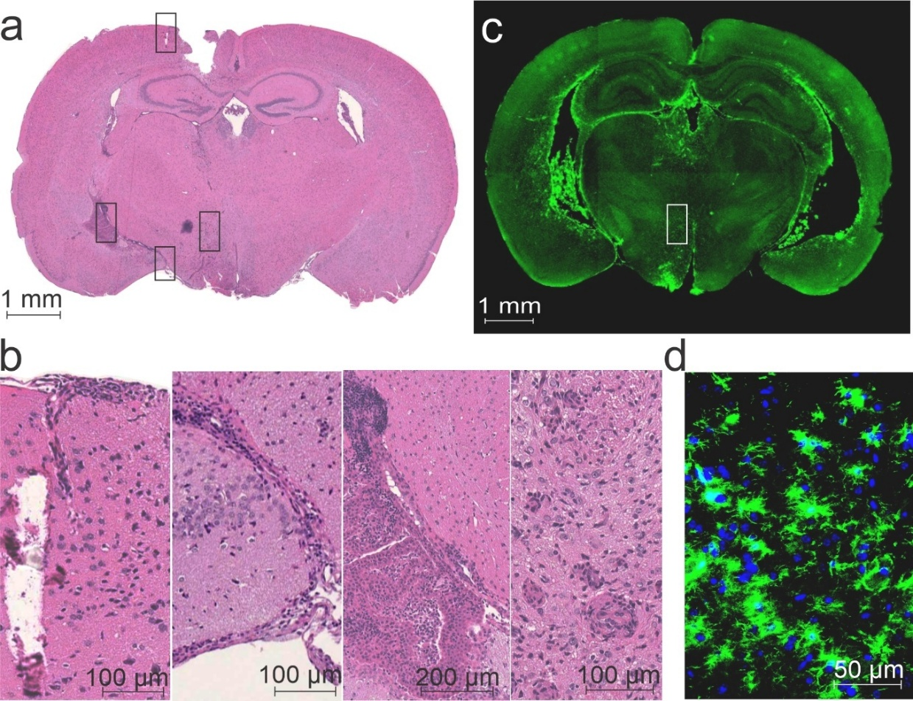
Figure S1. Hallmark histopathological features in the mouse model of TB meningitis. The animal model utilizes intraventricular injection with Mycobacterium tuberculosis (stereotactic device) with a two-week incubation, when the animals develop (a) hallmark features of TB meningitis including (b, from left to right) meningeal immune cell infiltration, basal meningitis, ventriculitis, and microglia activation (microgliosis). These findings correlate with (c-d) Iba1 (marker of microglial activation) immunofluorescent signal.

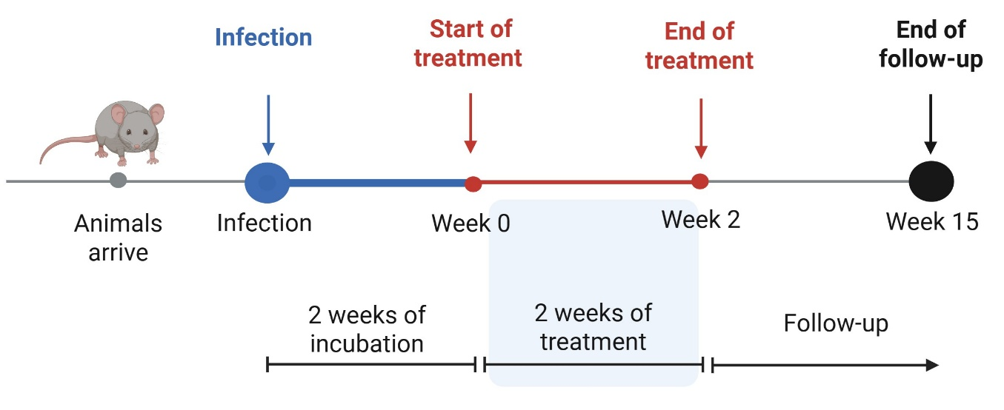
Figure S2. Experimental scheme for the mouse model of TB meningitis. Mice were intraventricularly infected with M. tuberculosis. Two weeks after infection, mice were randomly assigned to receive TB treatment (isoniazid) with or without adjunctive host-directed treatment (HDT) for two weeks at human equipotent and clinically relevant dosing for all drugs. Mice were individually labeled and monitored for an additional 15 weeks (~3 months) to evaluate mortality as well as the development of neurological deficits, with the investigators blinded to the treatment assignments. Created in BioRender. Masias, Y. (2026) https://BioRender.com/xpjcp65

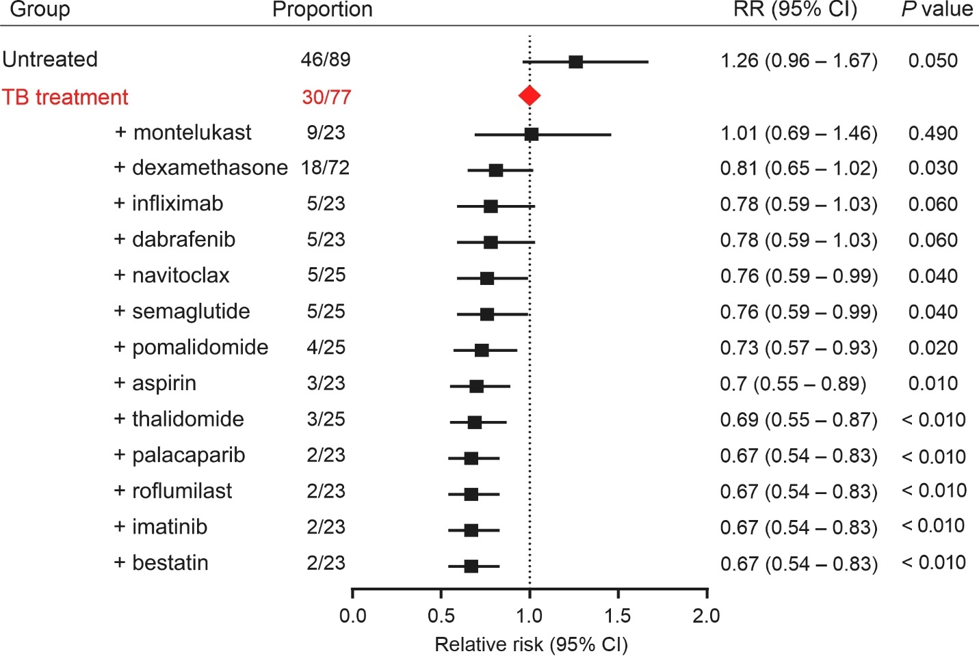
Figure S3. Mortality in the mouse model of TB meningitis using TB treatment alone as the reference arm. Two weeks after an intraventricular infection with M. tuberculosis, mice were randomly assigned to receive TB treatment (isoniazid) with or without adjunctive host-directed treatment (HDT) for two weeks at human equipotent and clinically relevant dosing for each drug. Mortality was monitored for 3 months after treatment discontinuation, with the investigators blinded to treatment assignments. Relative risk (RR) of mortality and 95% confidence intervals (CI) using TB treatment alone as the reference (control) arm. Animal numbers are indicated for each treatment arm. 95% CI and statistical significance were assessed using the Katz log-rank test and the Chi-square test.
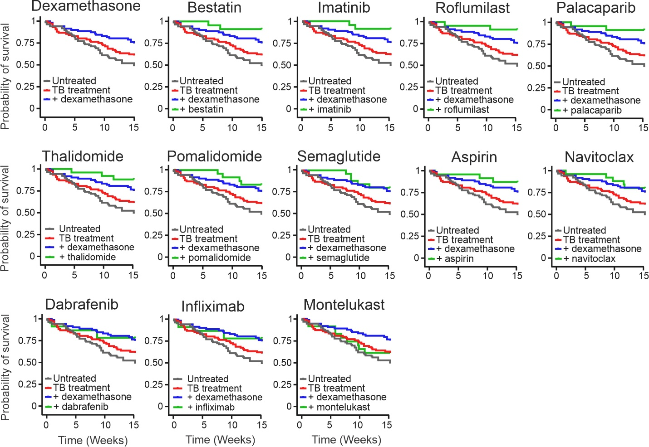
Figure S4. Kaplan-Meier survival curves in the mouse model of TB meningitis. Two weeks after an intraventricular infection with M. tuberculosis, mice were randomly assigned to receive TB treatment (isoniazid) with or without adjunctive host-directed treatment (HDT) for two weeks at human equipotent and clinically relevant dosing for each drug. Mortality was monitored for 15 weeks (~3 months) after treatment discontinuation, with the investigators blinded to treatment assignments.

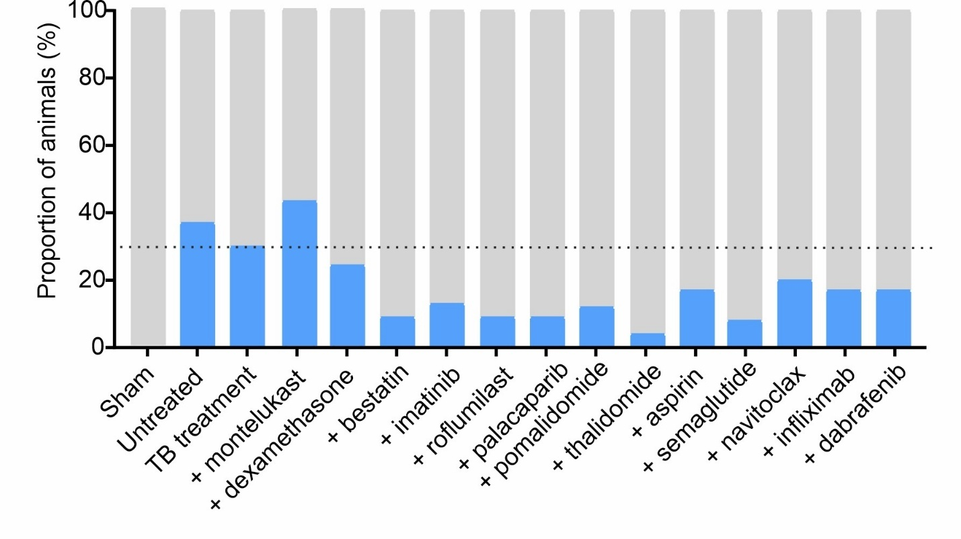
Figure S5. Development of Neurological deficits in the mouse model of TB meningitis. Two weeks after an intraventricular infection with M. tuberculosis, mice were randomly assigned to receive TB treatment (isoniazid) with or without adjunctive host-directed treatment (HDT) for two weeks at human equipotent and clinically relevant dosing for each drug. Development of severe neurological deficits (head tilt, paralysis) was monitored for 15 weeks (~3 months) after treatment discontinuation, with the investigators blinded to treatment assignments. The percentage of animals that developed neurological deficits (blue) in each treatment arm is shown.

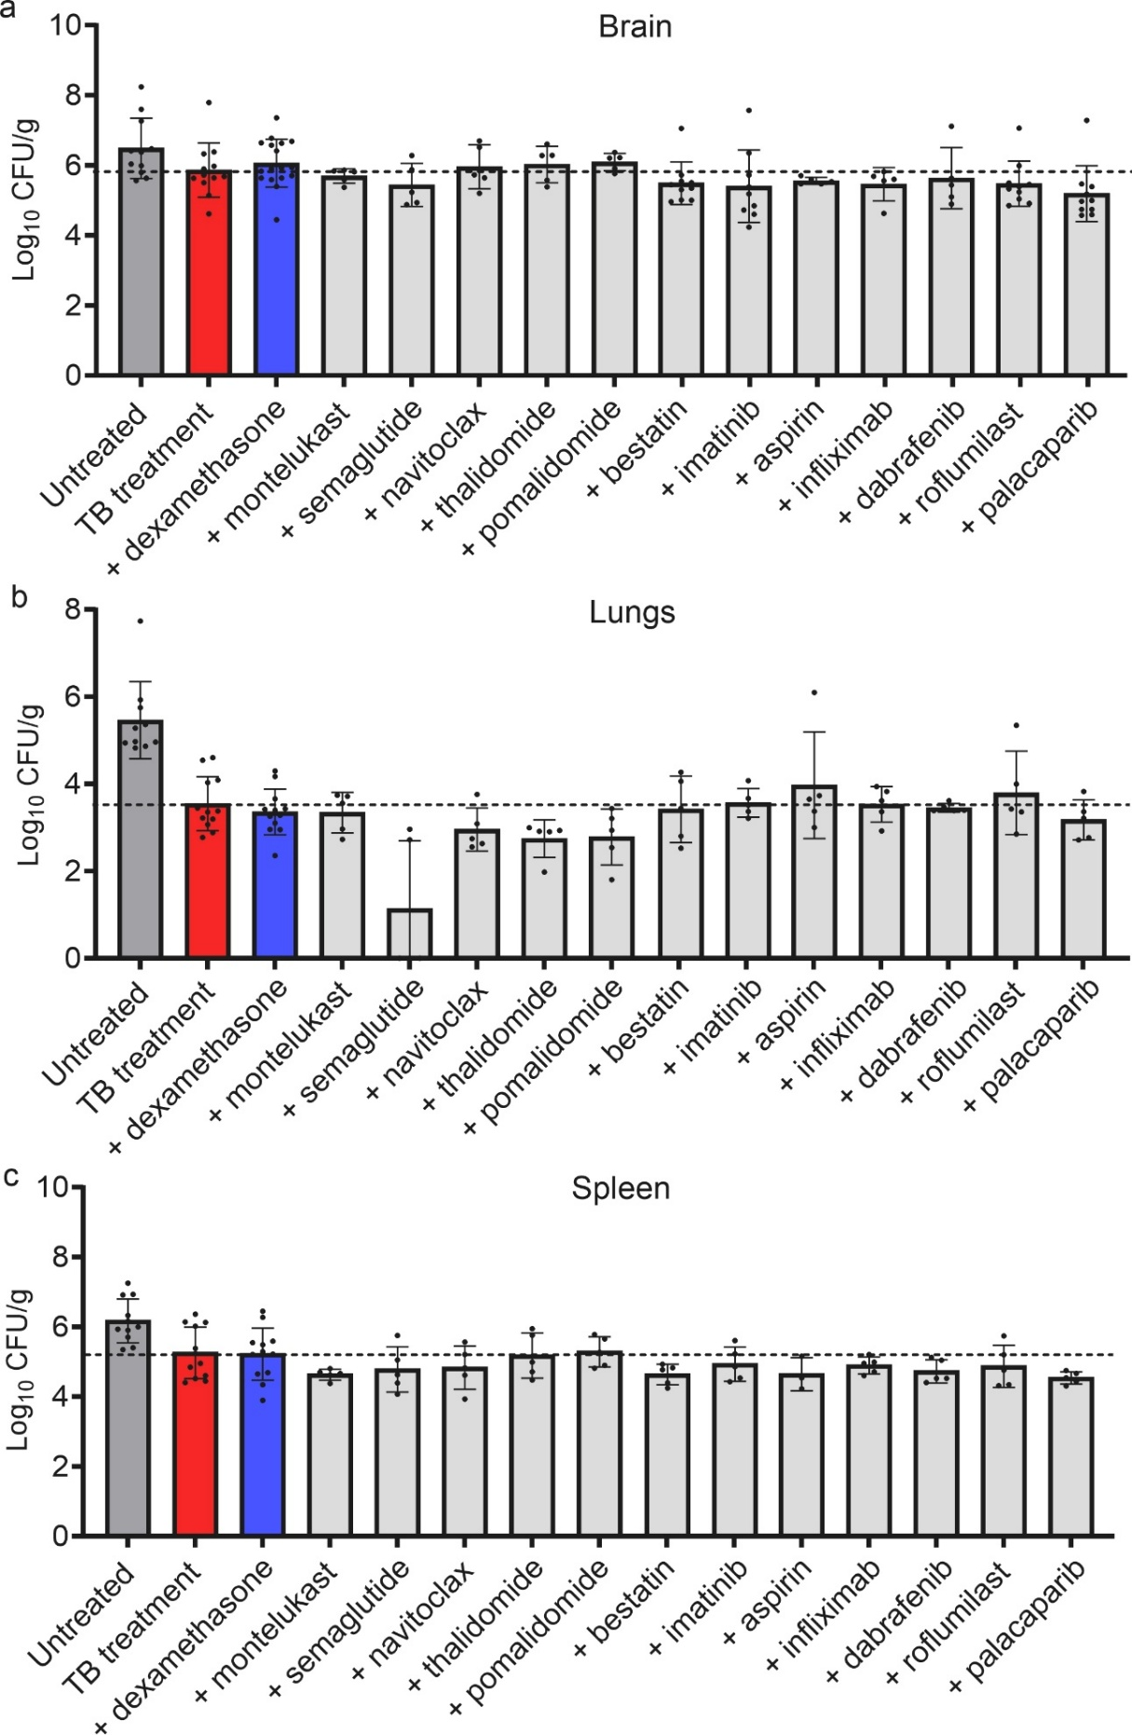
Figure S6. Organ bacterial burden in the mouse model of TB meningitis. Two weeks after an intraventricular infection with M. tuberculosis, mice were randomly assigned to receive TB treatment (isoniazid) with or without adjunctive host-directed treatment (HDT) for two weeks at human equipotent and clinically relevant dosing for each drug. Two weeks after treatment initiation, a subset of mice were sacrificed, whole organs were harvested, homogenized and colony forming unit (CFU) were enumerated to assess the bacterial burden in the (a) brain, (b) lungs, and (c) spleen. Each dot represents a single animal. Data are presented as mean ± SD on a logarithmic scale (log₁₀ bacteria per gram of tissue). The dashed line represents the mean bacterial burden for animals from the TB treatment alone arm.
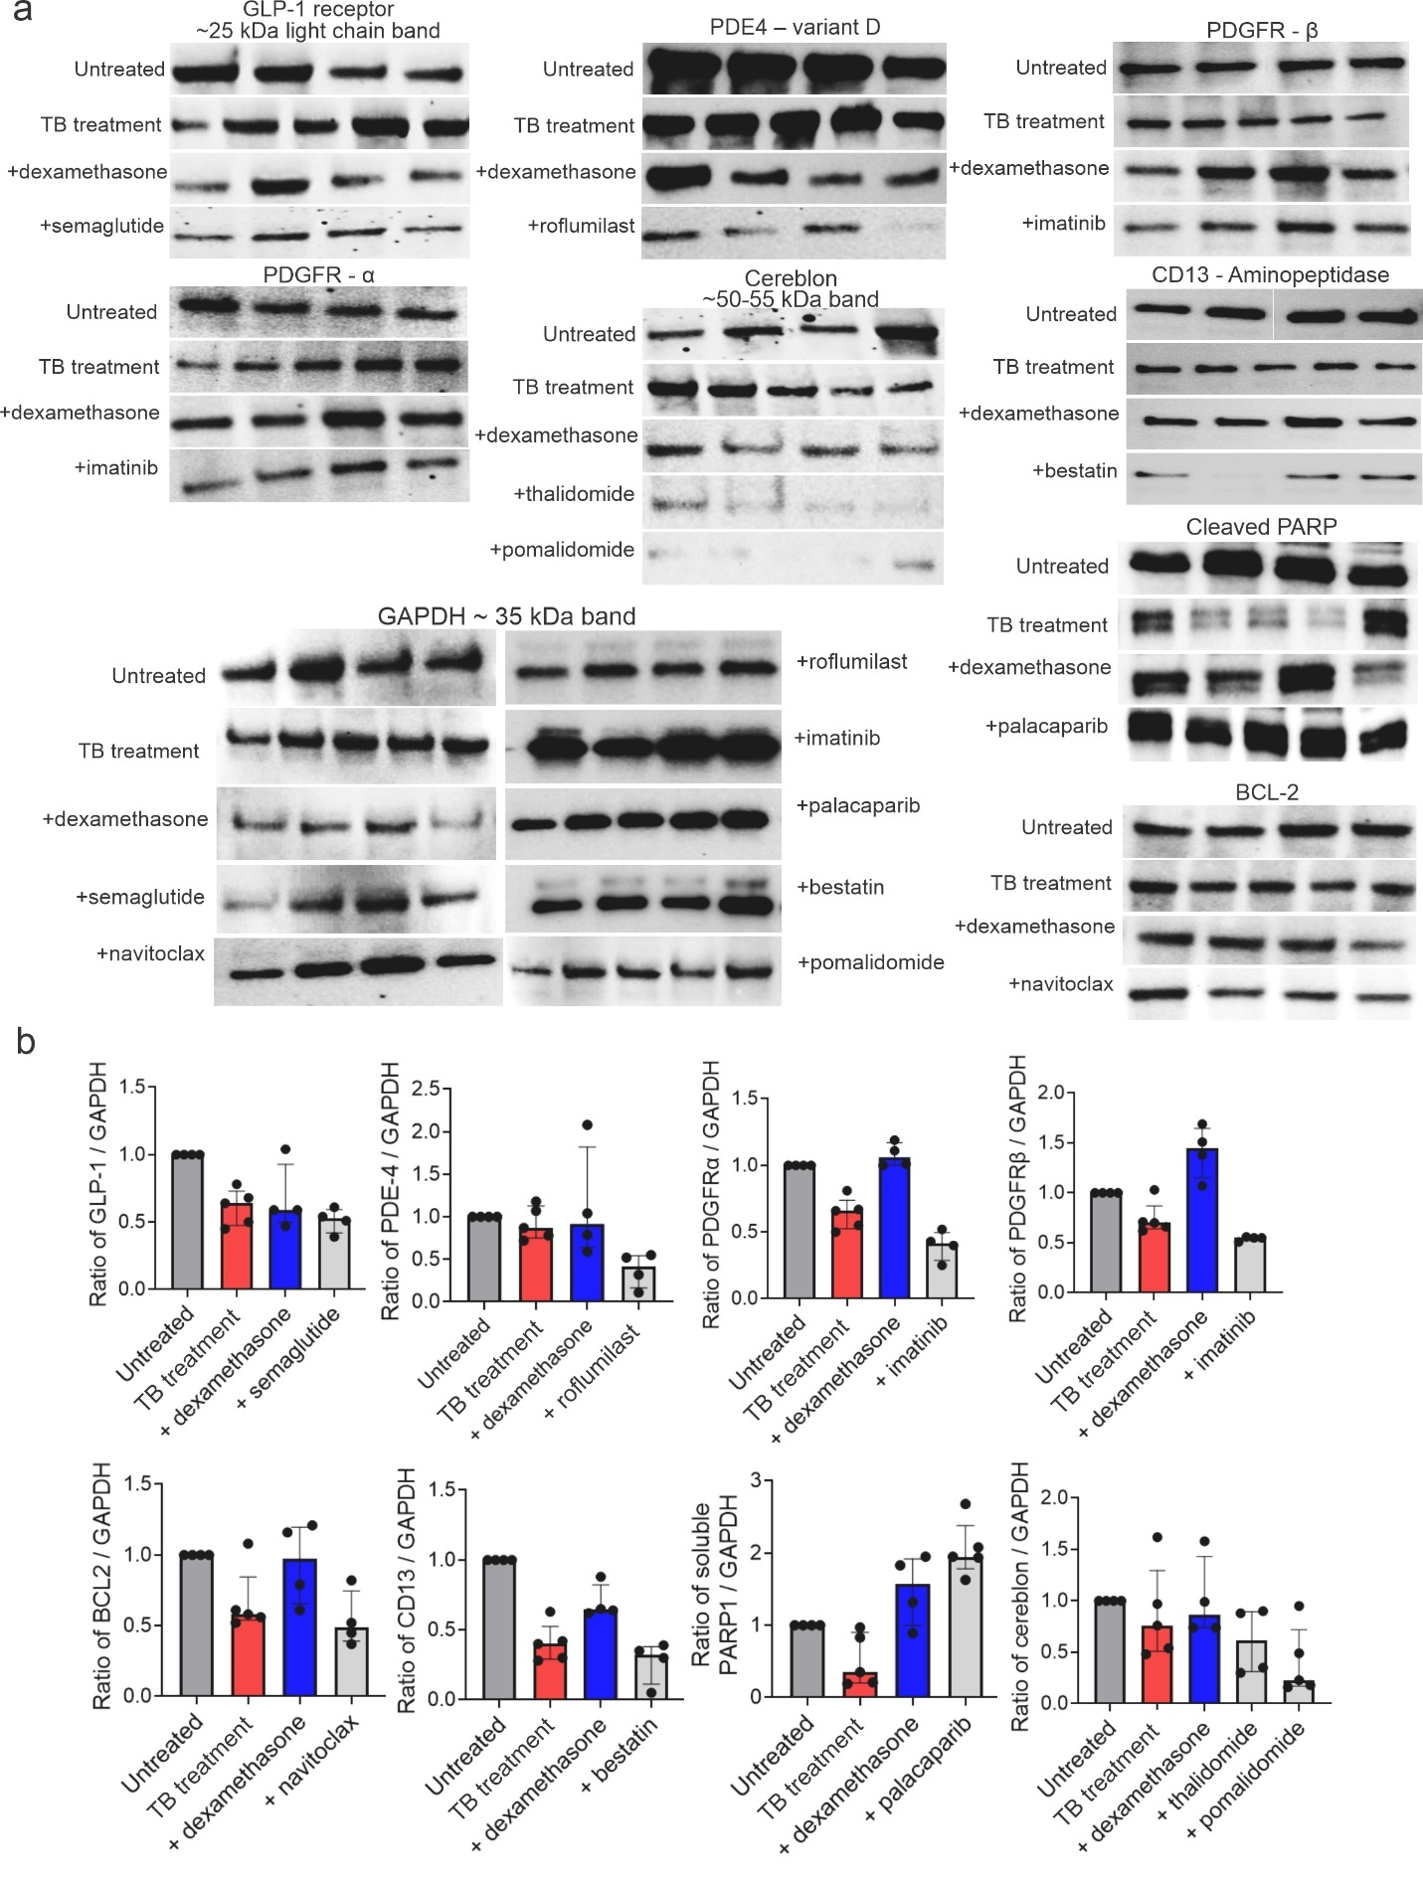
Figure S7. Target engagement in brain tissues. Cohorts of mice from studies described in Fig. 4 were used. Briefly, two weeks after initiation of TB treatment (isoniazid) with or without adjunctive HDTs, whole-brain tissue lysates were prepared for western blot analysis. Protein expression of GLP-1 receptor, PDE4 variant D, cleaved PDGFRα/β, BCL-2, CD13 (aminopeptidase N), cleaved PARP, and cereblon were assessed to evaluate on-target engagement of semaglutide, roflumilast, imatinib, navitoclax, bestatin, palacaparib, thalidomide, and pomalidomide, respectively. (a) Representative blots are shown. (b) Quantification of blots, normalized by GAPDH levels. Each lane or dot represents an individual animal (n = 4 to 5 mice per group). Data are presented as median and IQR.

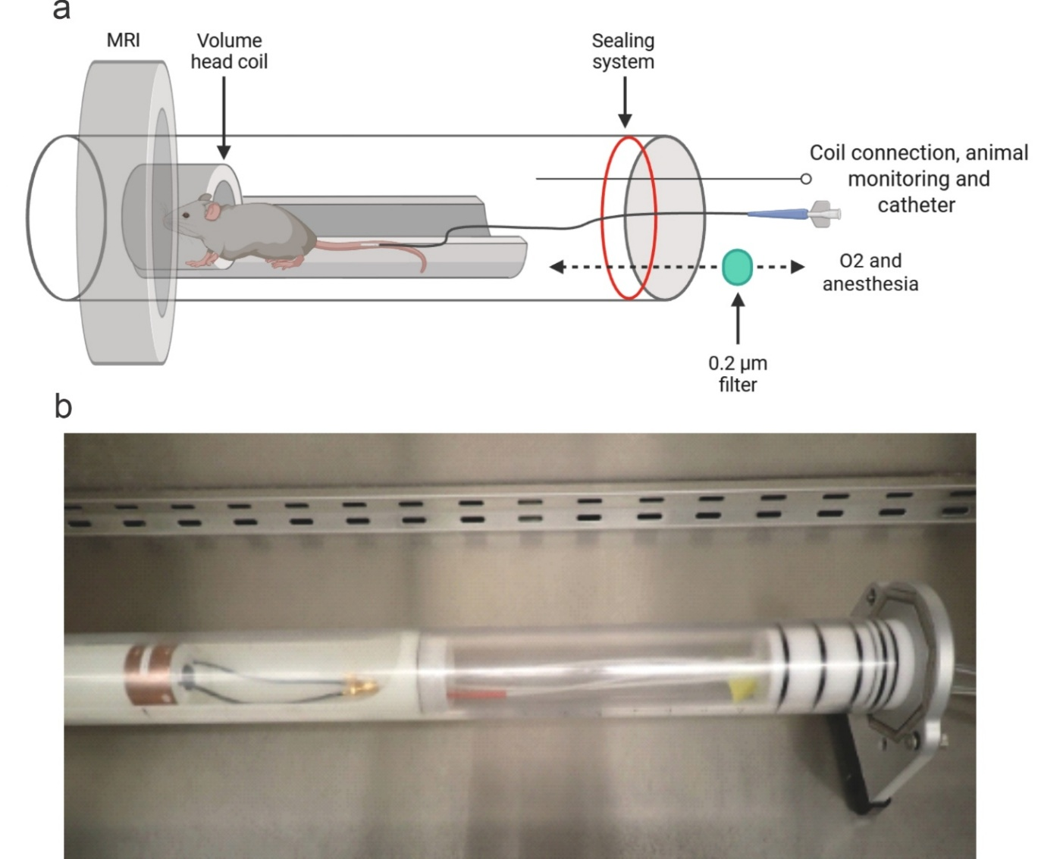
Figure S8. Custom-build, MRI compatible biocontainment beds for imaging live animals under BSL-3 containment. (a) Schematic representation of the sealed biocontainment bed, including connections for anesthesia, animal monitoring, and intravenous catheter-based injections. (b) Photograph of the custom-built biocontainment bed used for live imaging of M. tuberculosis-infected mice. Created in BioRender. Masias, Y. (2026) https://BioRender.com/dxze7mp

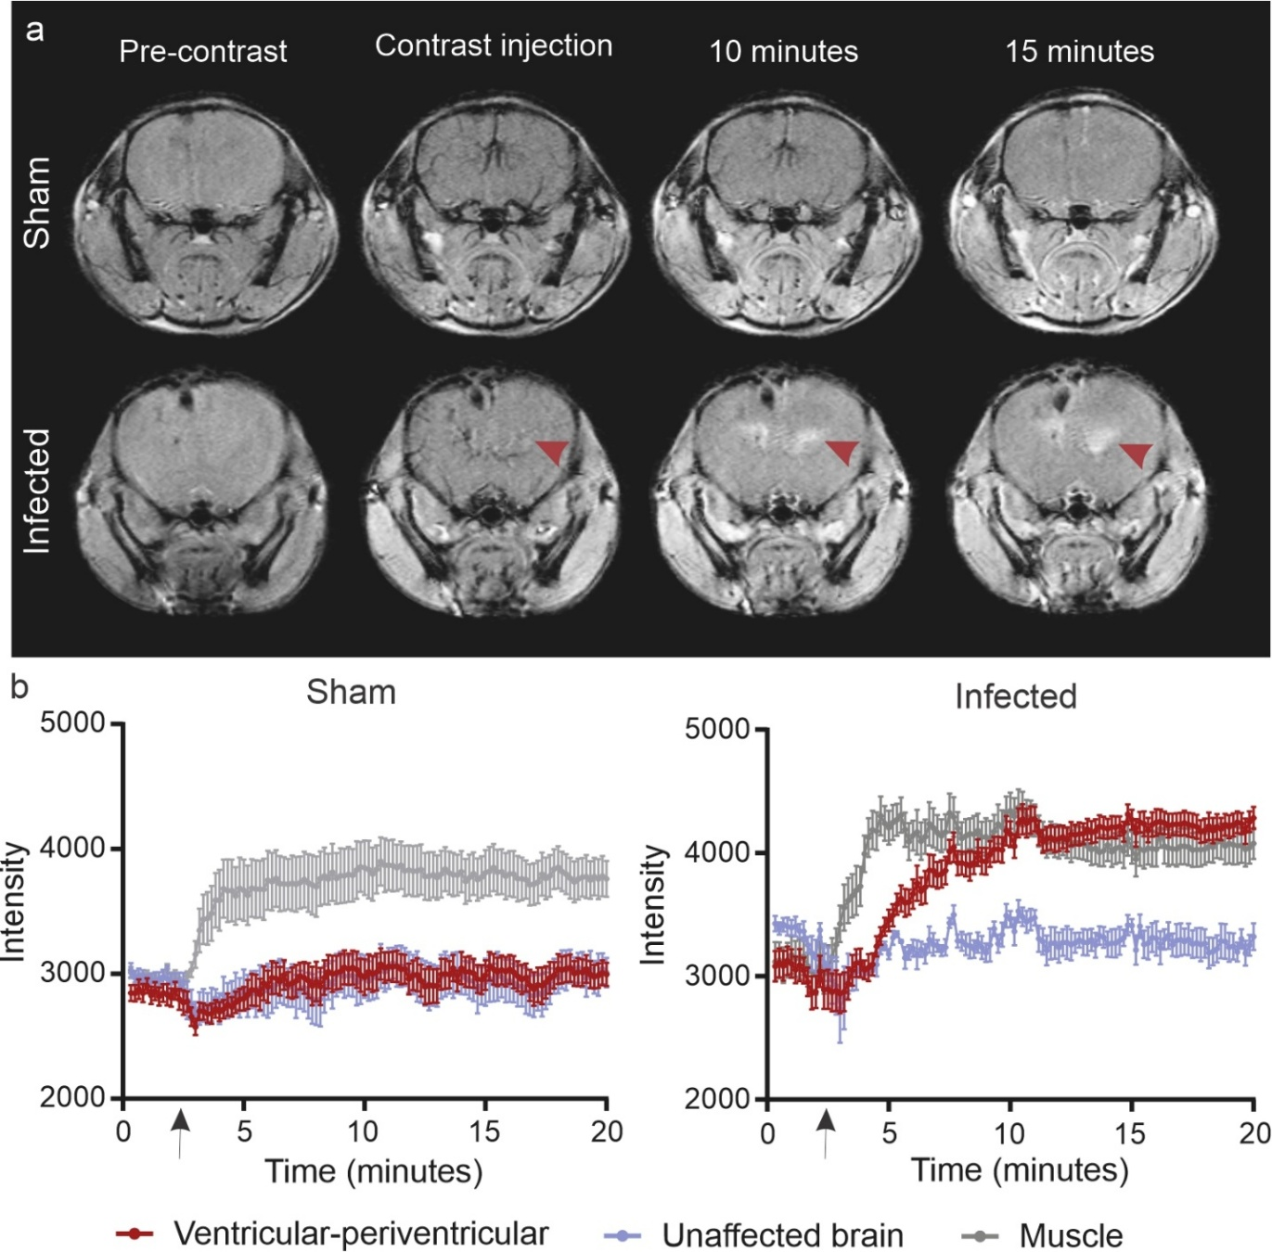
Figure S9. Dynamic gadolinium-enhanced brain MRI. (a) Representative transverse MRI images from sham control (intraventricularly injected with sterile PBS) and M. tuberculosis-infected mice before and after intravenous contrast injection. Red arrowheads indicate contrast enhancement in the periventricular region (site of infection) in infected mice. (b) Time activity curves demonstrating contrast enhancement in the periventricular region, unaffected brain, and muscle. Data is shown as mean and standard error of mean (SEM).

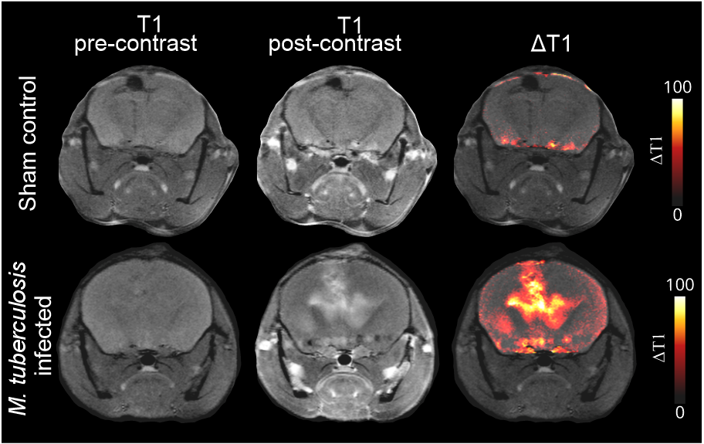
Figure S10. Brain MRI delta maps. Representative axial T1-weighted MRI images acquired pre-contrast (left column) and post-contrast injection (middle column) with corresponding delta maps (right column) of sham control animals (intraventricularly injected with sterile PBS) and M. tuberculosis-infected mice. Delta maps were created by digitally subtracting the pre-contrast image from the post-contrast image in the segmented brain slices.

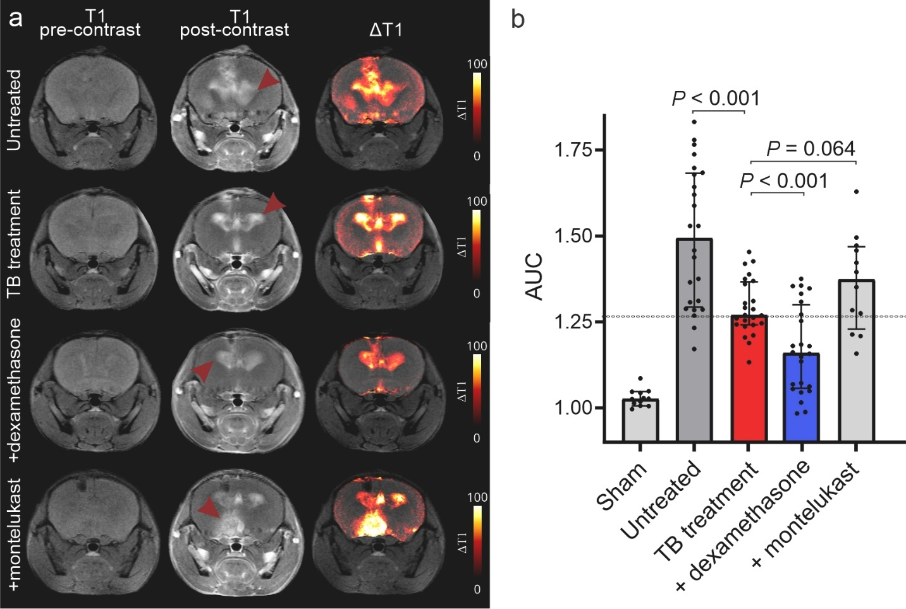
Figure S11. Dynamic gadolinium-enhanced brain MRI in the mouse model of TB meningitis. Representative axial T1-weighted MRI images acquired post-contrast injection (left column) with corresponding delta maps (right column) performed at two weeks after treatment initiation in mice showing contrast enhancement in the periventricular region. All drugs were administered at human equipotent and clinically relevant dosing. (a) TB treatment (isoniazid) with or without adjunctive HDT. (b) MRI contrast signal was quantified as the area under the curve (AUC) and normalized to background levels. Delta maps were generated by digitally subtracting the pre-contrast image from the post-contrast brain segmented image. Each dot represents a single region of interest (ROI), with 3 brain ROIs drawn for each animal. The dashed line represents the median values for the TB treatment arm. Data are presented as median and interquartile range (IQR). Statistical comparisons were made using the Mann-Whitney U test.

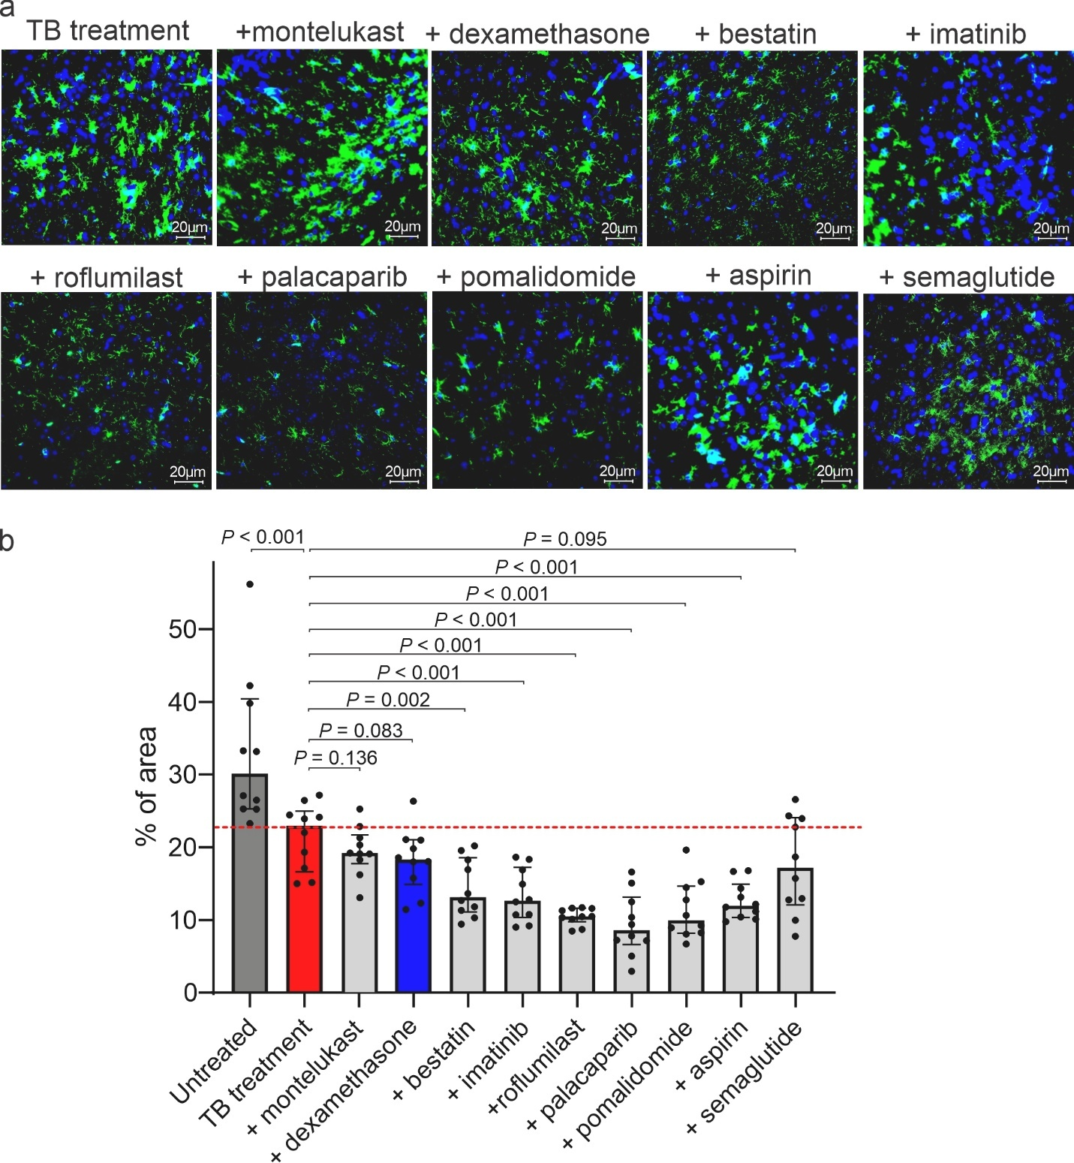
Figure S12. Brain tissue studies in the mouse model of TB meningitis. Brain tissues were collected, fixed, and stained two weeks after treatment initiation in mice receiving TB treatment (isoniazid) with or without HDTs. (a) Representative immunofluorescence images are shown. Microglia are labeled with Iba1 (green), and nuclei are counterstained with DAPI (blue) (40x magnification, scale bar = 20 μm). (b) Quantification of Iba1+ (percentage of area covered by positive staining) for each treatment arm. Each dot represents a single brain section. The dashed line represents the median value for the TB treatment arm. Data are presented as median and IQR. Statistical comparisons were performed using the Mann-Whitney U test.

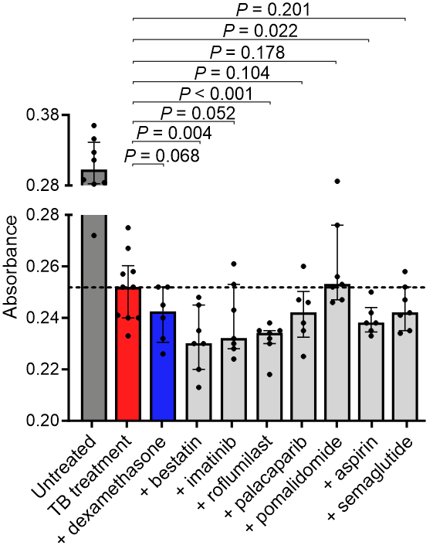
Figure S13. GFAP levels in the mouse model of TB meningitis. Two weeks after treatment initiation, a cohort of mice were sacrificed, and CSF GFAP levels were measured. Data are presented as median and IQR. The dashed line represents the median value for the TB treatment arm. Each dot represents an individual animal (n = 5 - 10 animals per group). Statistical comparisons were performed using the Mann-Whitney U test. CSF, Cerebrospinal fluid.
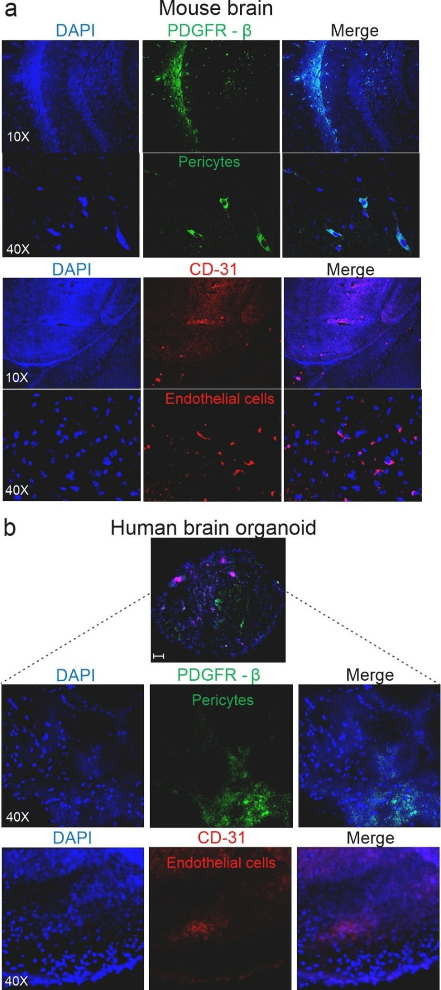
Figure S14. Pericytes and endothelial cells in mouse brain tissues and Immune-vascularized 3D human brain organoid. Representative images of tissue sections from (a) mouse brains and (b) immune-vascularized 3D human brain organoid demonstrating cell nuclei (DAPI, blue), pericytes (PDGFR-B, green), and endothelial cells (CD31, red), relevant to pathophysiology and response to TB meningitis.

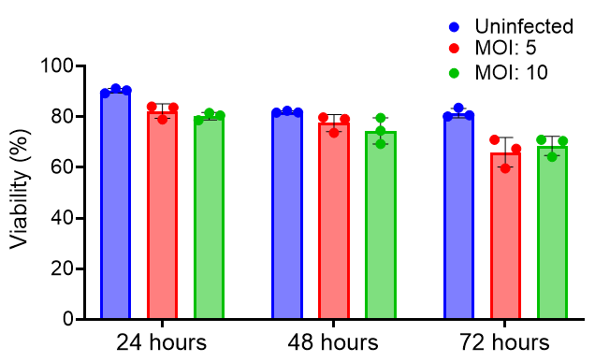
Figure S15. M. tuberculosis infection in human microglial cells. Human microglial cells were infected at multiplicity of infection (MOI) of 5 or 10. The percentage of cell viability using LDH release test was measured 24, 48 and 72 hours after infection. Each dot represents a biological replicate. Data are presented as mean and standard deviation. LDH, lactate dehydrogenase.

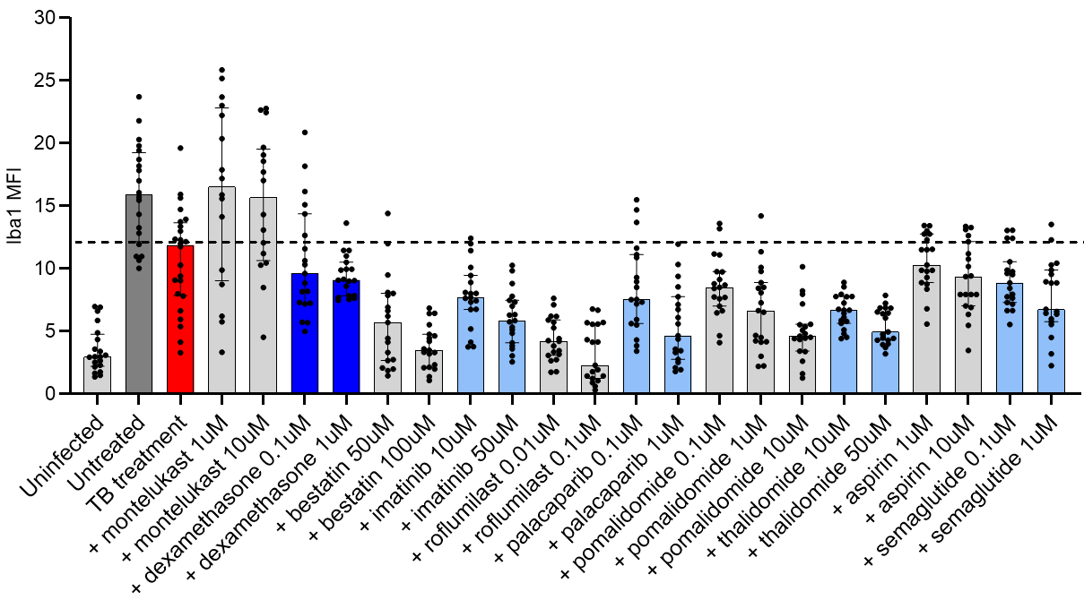
Figure S16. Dose-dependent effect of HDTs on human microglial cell cultures. Human microglia were infected with M. tuberculosis and treated with TB treatment (isoniazid) with or without HDTs at different drug concentrations. Cells were collected and monolayer slides were prepared using a cytocentrifuge system. Quantification of Iba1 mean fluorescence intensity (MFI). Each dot represents a slide. Data are presented as median and IQR.

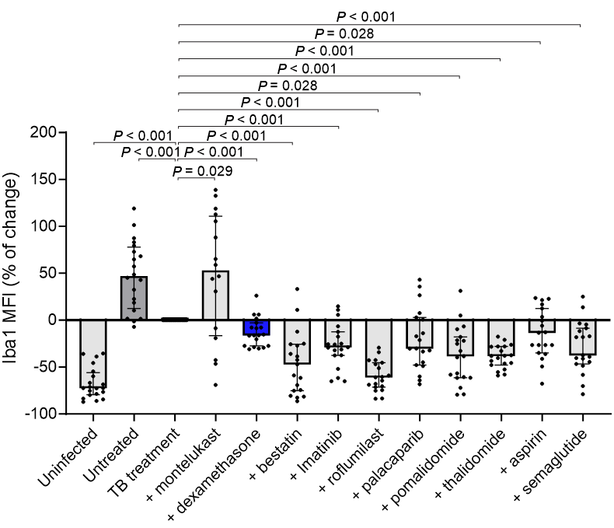Figure S17. Effect of HDTs on human microglial cell cultures. Human microglial cells were infected with M. tuberculosis and treated with TB treatment (isoniazid) with or without HDTs at the physiologically relevant, expected human brain tissue concentrations achieved with clinically relevant dosing. Cells were collected and monolayer slides were prepared using a cytocentrifuge system. Quantification of Iba1 mean fluorescence intensity (MFI) as percentage of change (% of change) compared to TB treatment. Each dot represents a slide. Data are presented as median and IQR. Statistical comparisons were made using the Mann-Whitney U test.
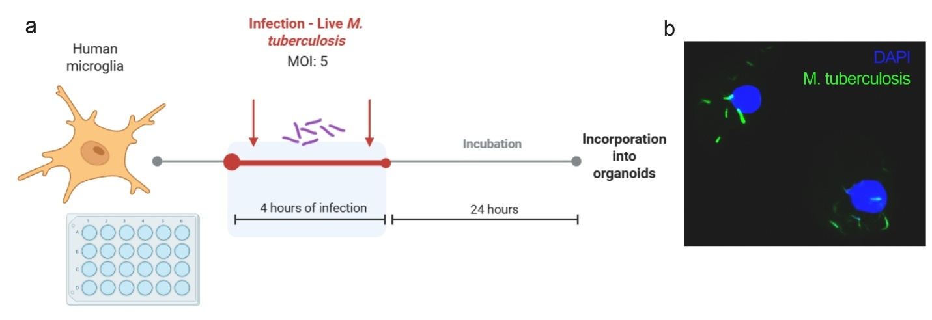
Figure S18. Experimental scheme of brain organoids infection. (a) Human microglia were infected with M. tuberculosis at a multiplicity of infection (MOI) of 5 for 4 hours (n = 10,000 cells/well). Twenty-four hours after infection, the microglial cells were transferred and incorporated into the 3D brain organoids. (b) Confocal microscopy showing the internalization of bacteria (green) by human microglial cells (blue, DAPI for nuclei). Panel a created in BioRender. Masias, Y. (2026) https://BioRender.com/325agla

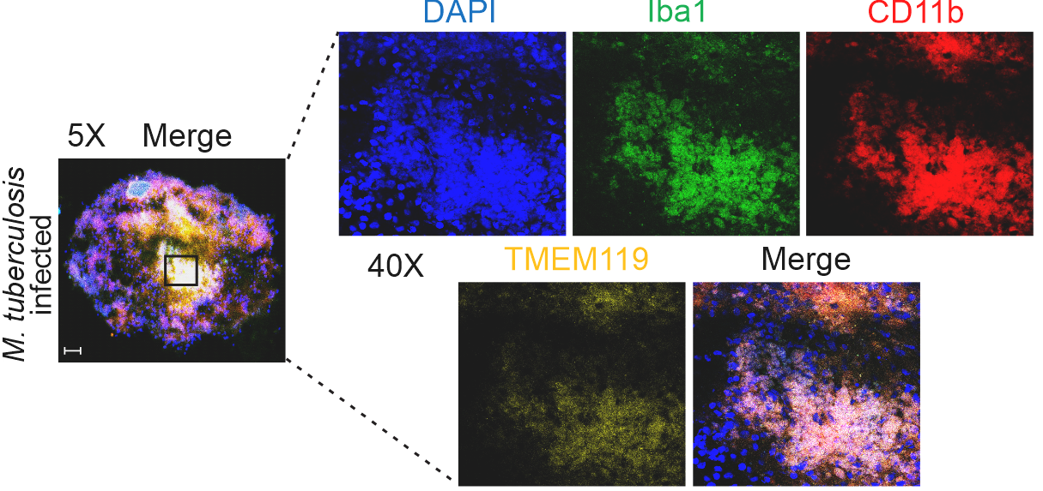Figure S19. Brain organoid immune markers. The assembled human brain organoids were incorporated with M. tuberculosis-infected microglia. Representative 5x and 40x images of M. tuberculosis-infected human brain organoids showing cell nuclei (DAPI, blue), microglial activation markers (Iba1, green and TMEM119, yellow) and myeloid cell marker (CD11b, red) are shown.
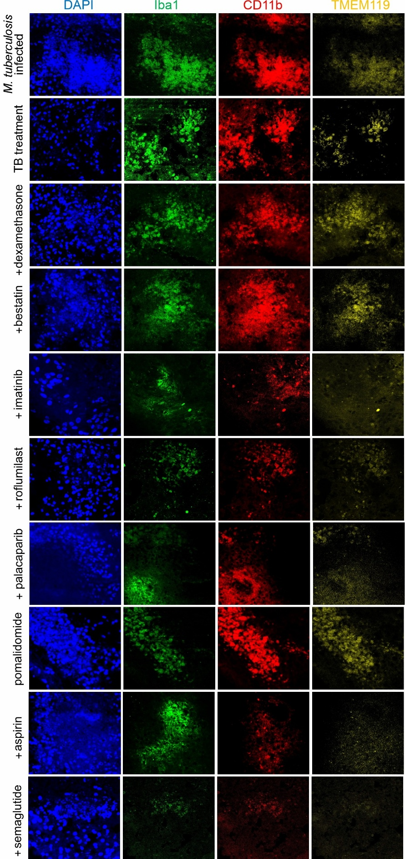
Figure S20. Microglial responses in brain organoids co-incubated with TB treatment. The assembled human brain organoids were incorporated with M. tuberculosis-infected microglia and co-incubated with TB treatment (isoniazid) with or without HDTs at the physiologically relevant, expected human brain tissue concentrations achieved with clinically relevant dosing. Representative 40x images of M. tuberculosis-infected human brain organoids showing cell nuclei (DAPI, blue), microglial activation markers (Iba1, green and TMEM119, yellow) and myeloid cell marker (CD11b, red) are shown.

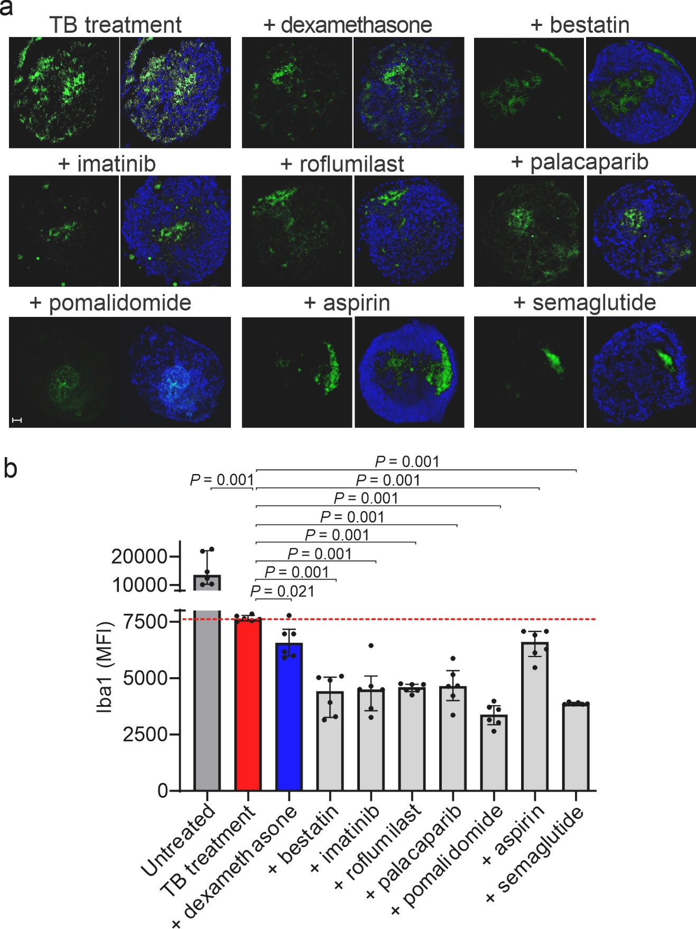
Figure S21. Human Brain organoid model of TB meningitis. M. tuberculosis-infected microglia were incorporated into the assembled human brain organoids and co-incubated with TB treatment (isoniazid), with or without HDTs. (a) Representative Iba1 immunofluorescence and merged DAPI + Iba1 images from M. tuberculosis-infected brain organoids after treatment (5x magnification, scale bar = 50 μm). (b) Quantification of Iba1 Mean Fluorescence Intensity (MFI) in organoids. The dashed line represents the median values for the TB treatment arm. Each dot represents a single brain organoid section; each group includes at least 3 organoids. Data are presented as median and IQR. Statistical comparisons were made using the Mann-Whitney U test. Panel a was created in BioRender. Masias, Y. (2026) https://BioRender.com/jpy801h

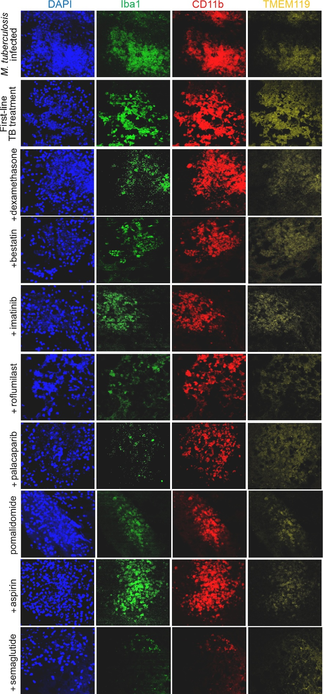
Figure S22. Microglial responses in brain organoids co-incubated with first-line TB treatment. The assembled human brain organoids were incorporated with M. tuberculosis-infected microglia and co-incubated with fist-line TB treatment (isoniazid + rifampin + pyrazinamide) with or without HDTs at the physiologically relevant, expected human brain tissue concentrations achieved with clinically relevant dosing. Representative 40x images of M. tuberculosis-infected human brain organoids showing cell nuclei (DAPI, blue), microglial activation markers (Iba1, green and TMEM119, yellow) and myeloid cell marker (CD11b, red) are shown.

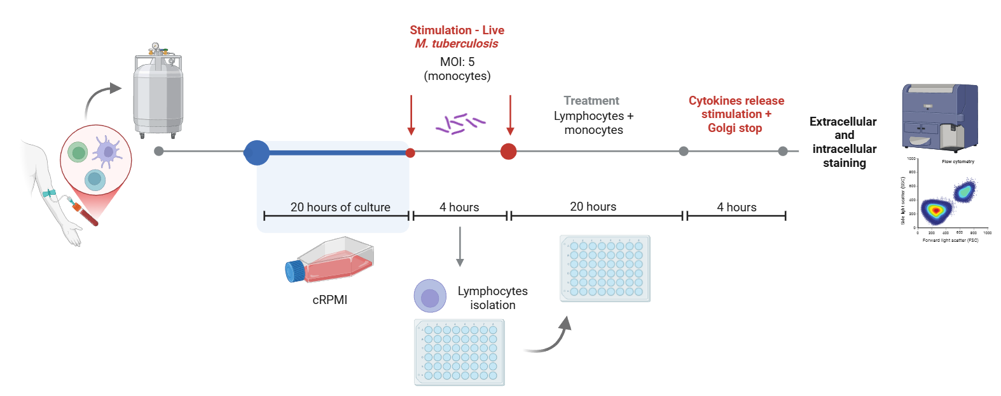Figure S23. Experimental scheme for human PBMC studies. PBMCs from patients with TB meningitis were isolated and stored in liquid nitrogen. One day before stimulation with live M. tuberculosis, PBMCs were thawed and cultured in complete RPMI (cRPMI). Lymphocytes were separated from attached cells and stored separately during monocyte infection. After infection, cells were washed, lymphocytes were returned, and the cells were co-incubated with first-line TB treatment (isoniazid + rifampin + pyrazinamide) with or without HDTs at the physiologically relevant, expected human brain tissue concentrations achieved with clinically relevant dosing for 20 hours. Afterward, cells were stimulated with Cell Stimulation Cocktail for 4 hours and treated with GolgiStop/GolgiPlug for 3 hours to block cytokine secretion. Extracellular and intracellular staining was performed to evaluate cell types and cytokines using flow cytometry. Created in BioRender. Masias, Y. (2026) https://BioRender.com/unux0w4

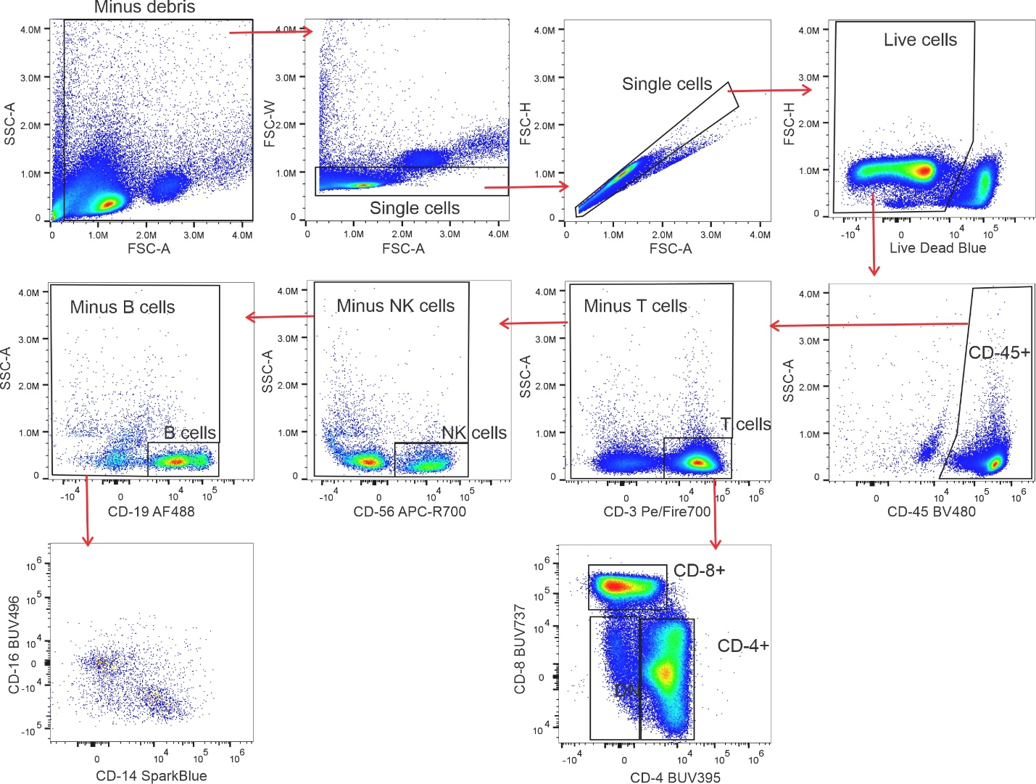
Figure S24. Flow cytometry gating strategy for human PBMC studies. Schematic representation of the flow cytometric gating strategy used for cell identification.

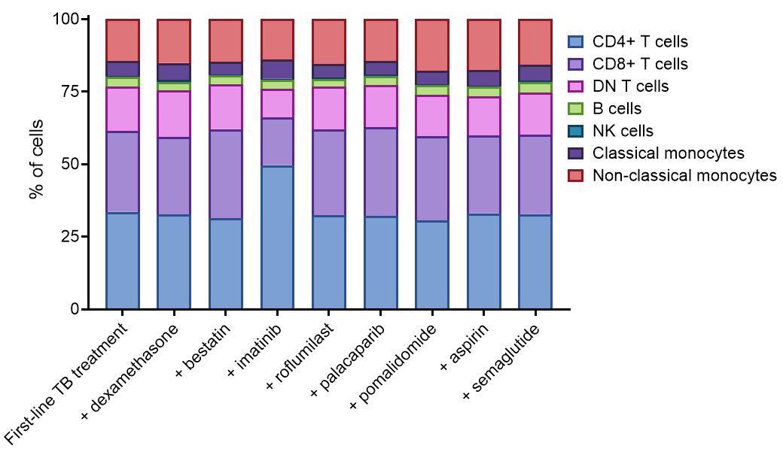Figure S25. Cellular distribution of human PBMCs. Percentage (%) of CD45+ cell population found in M. tuberculosis-infected human PBMCs after live M. tuberculosis stimulation and treatment with first-line TB treatment with and without HDTs.

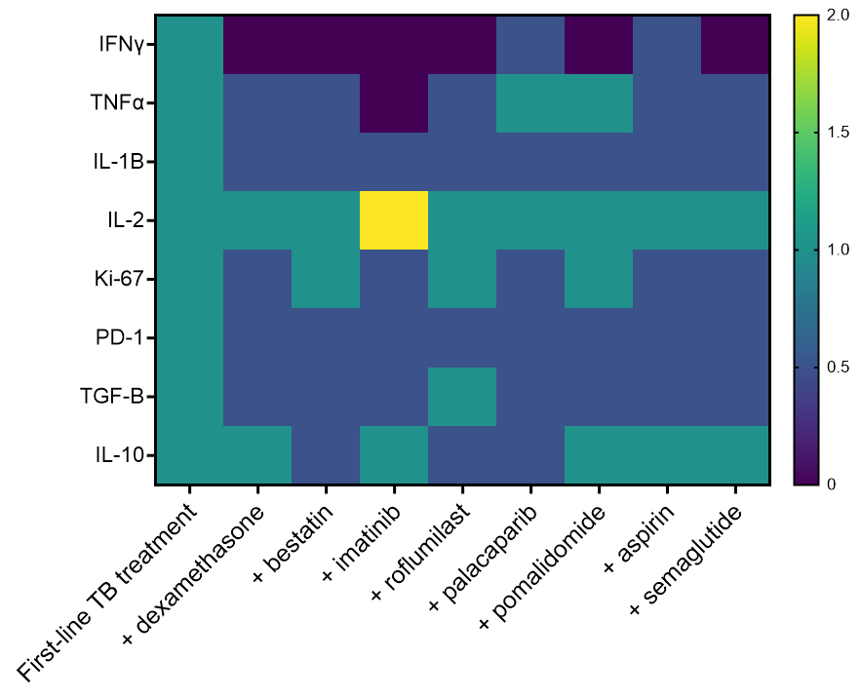Figure S26. Cytokines levels in human PBMCs. Heat-map representation of cytokine level changes in M. tuberculosis-infected human PBMCs after live M. tuberculosis stimulation and treatment with first-line TB treatment with and without HDTs, relative to the first-line TB treatment arm.

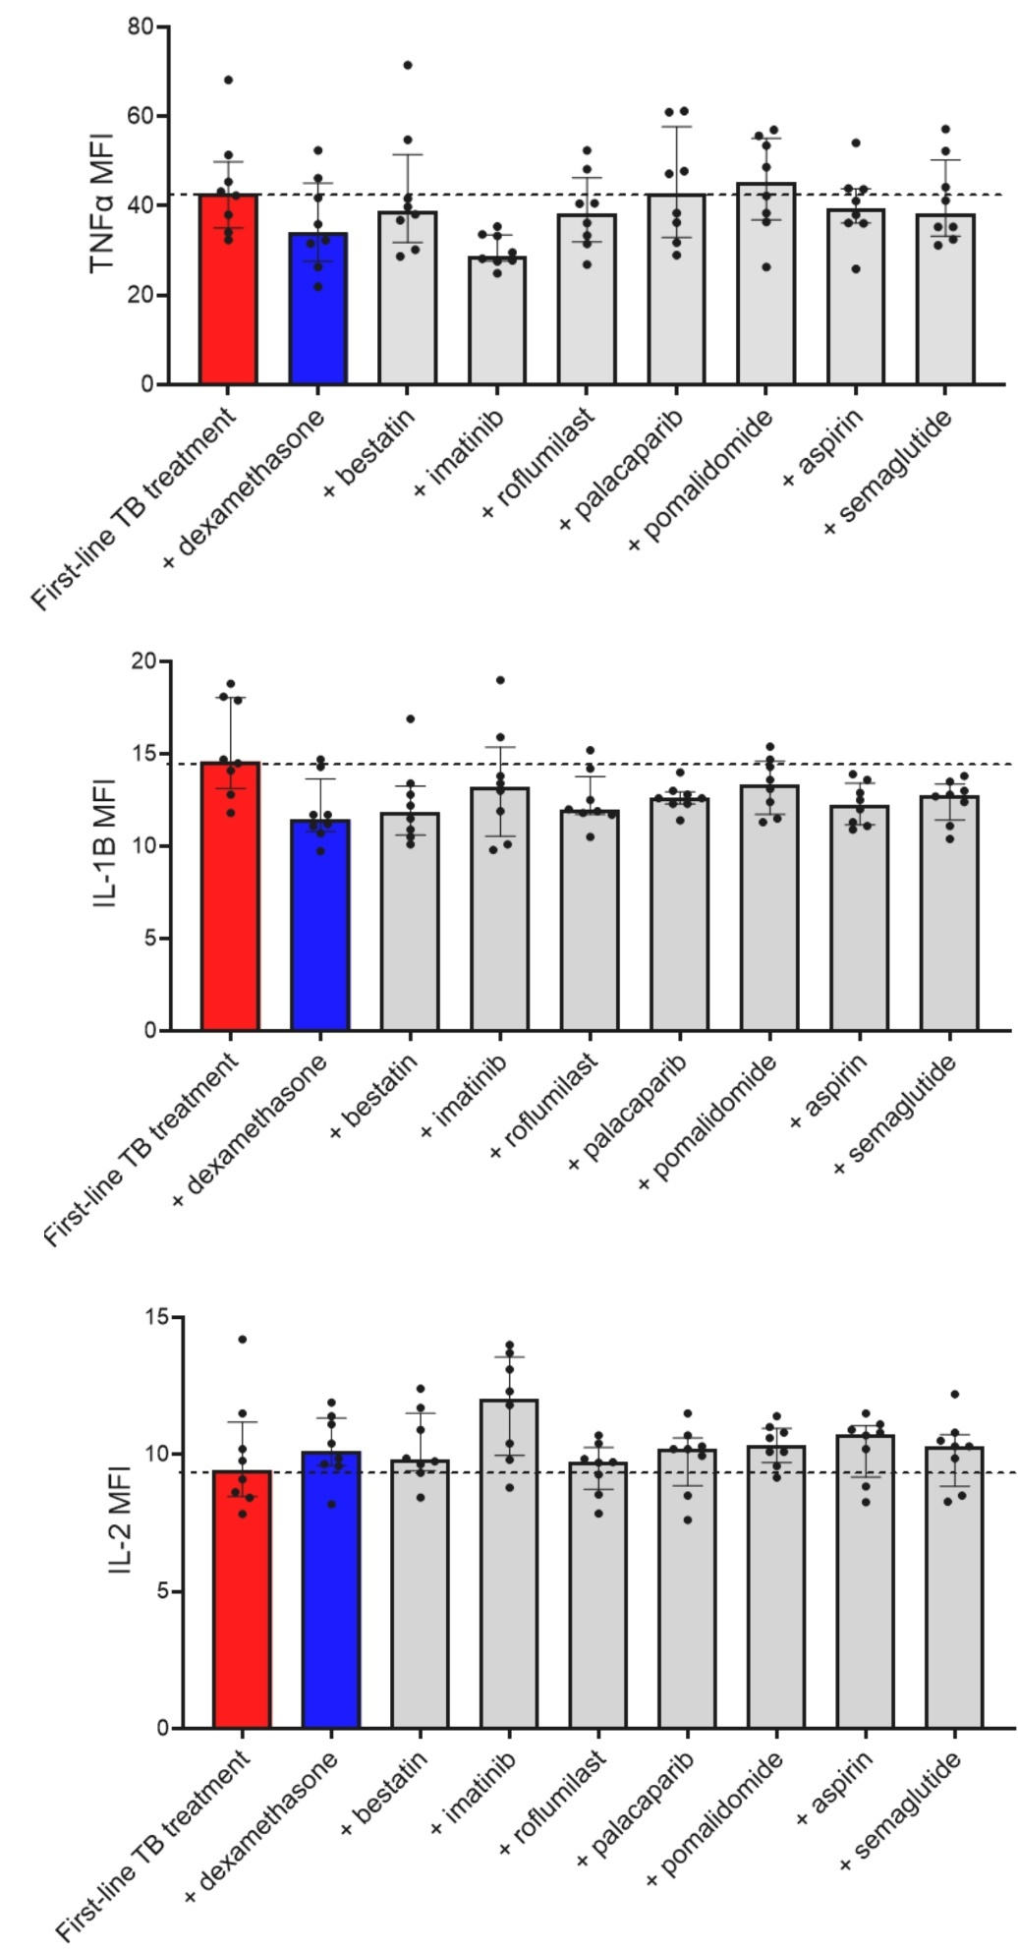
Figure S27. Cytokine expression in human PBMCs by flow cytometry. Mean fluorescence intensity (MFI) showing TNFα, IL-1β and IL-2 levels in CD4+ T-cells. Each dot represents a single patient. Data are presented as median and IQR.
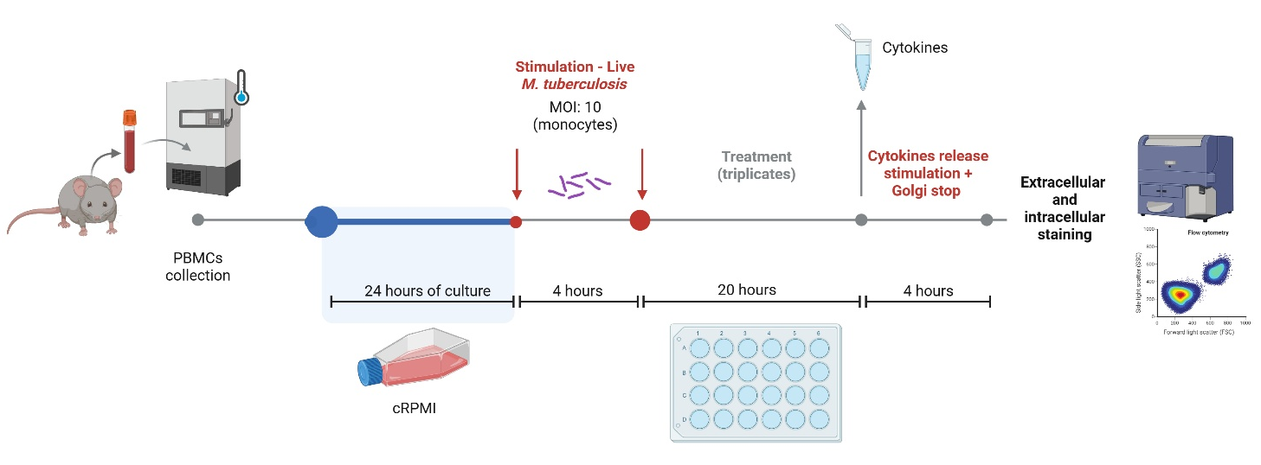
Figure S28. Experimental scheme for mouse PBMC studies. Blood was collected from the mouse model of TB meningitis (2-weeks after infection) or healthy sham controls (intraventricular injection with PBS) via cardiac puncture, and PBMCs were isolated using HISTOPAQUE®-1077 and stored at −80°C. One day before stimulation with live M. tuberculosis, PBMCs were thawed and cultured in complete RPMI (cRPMI). After infection, cells were washed, resuspended in cRPMI and co-incubated with TB treatment (isoniazid) with or without HDTs at the physiologically relevant, expected brain tissue concentrations achieved with clinically relevant dosing for 24 hours. Cell pellets were then collected for cytokine quantification from the supernatants. Afterward, cells were resuspended in fresh medium, stimulated with Cell Stimulation Cocktail for 4 hours, and treated with GolgiStop/GolgiPlug for 3 hours to block cytokine secretion. Extracellular and intracellular staining was performed to evaluate cell types and cytokines using flow cytometry. Created in BioRender. Masias, Y. (2026) https://BioRender.com/r1coh7k
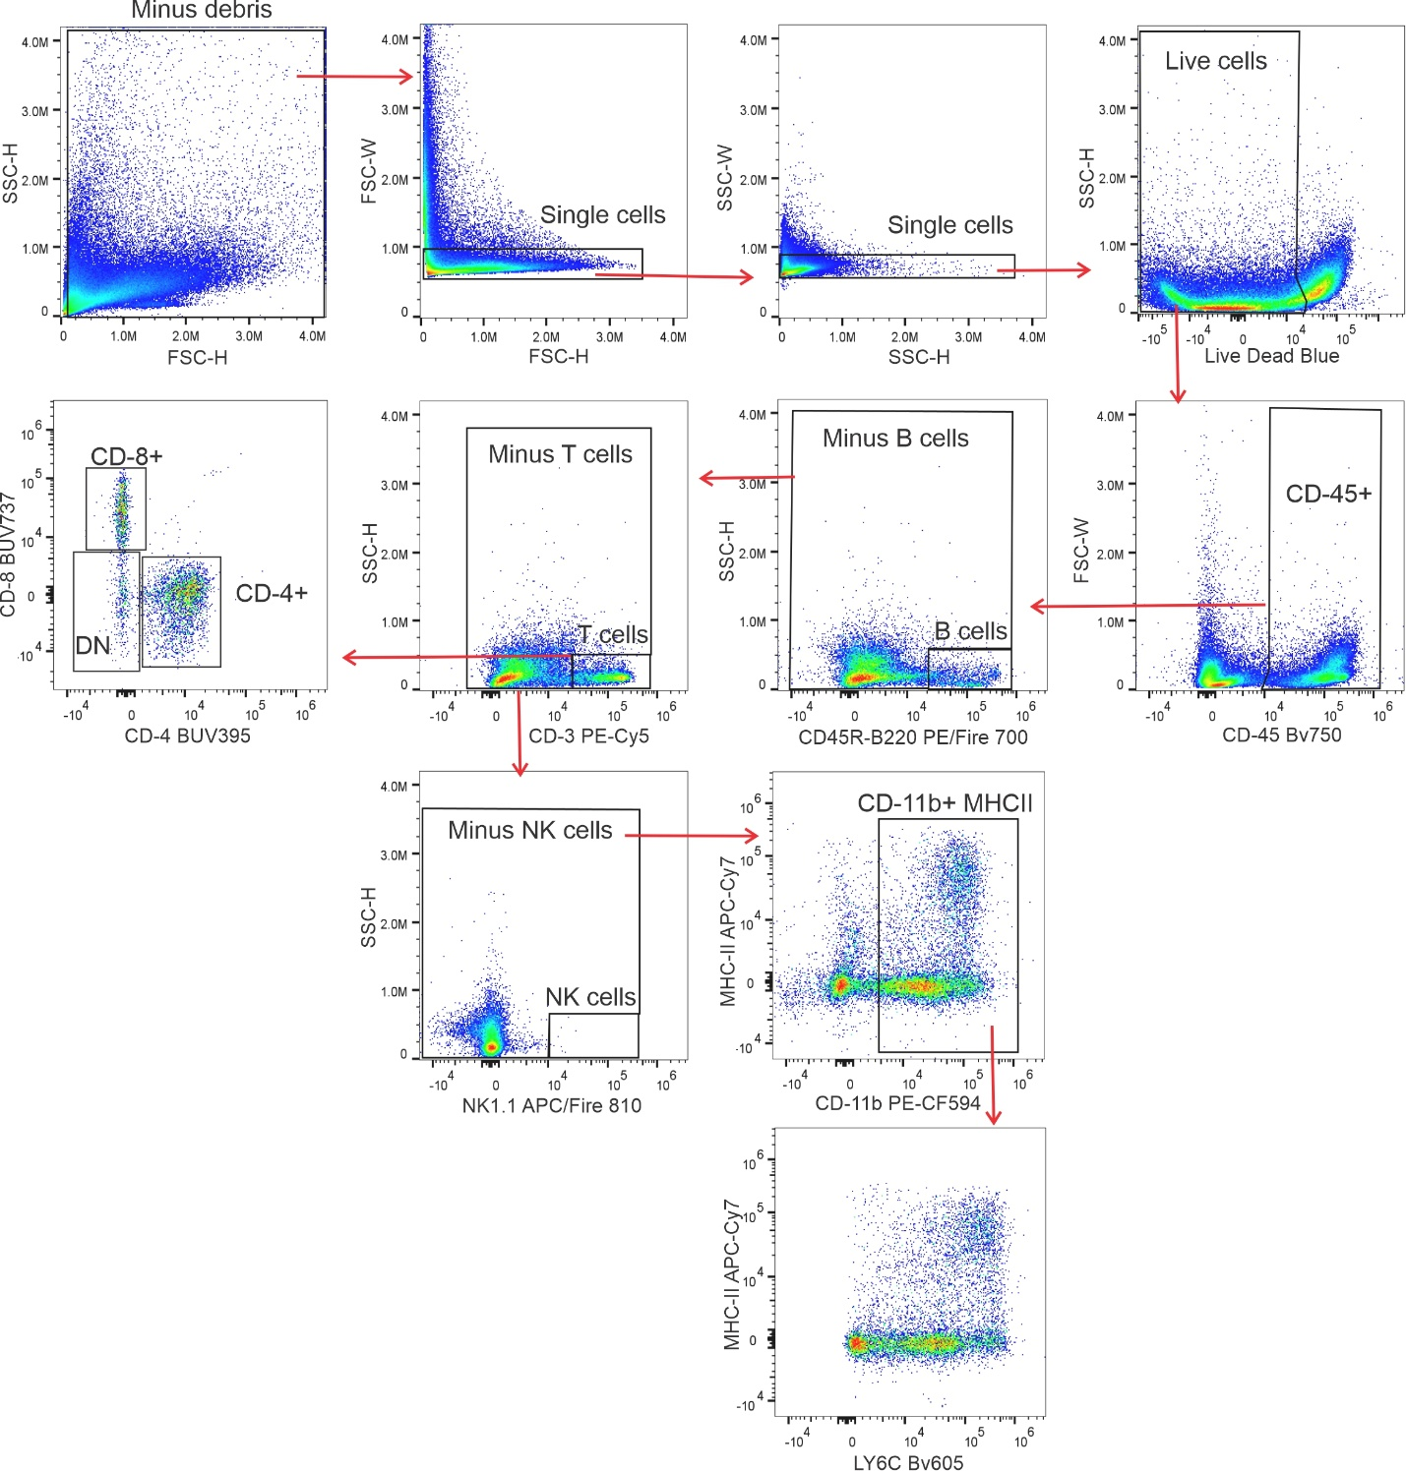
Figure S29. Flow cytometry gating strategy for mouse PBMC studies. Schematic representation of the flow cytometric gating strategy used for cell identification.

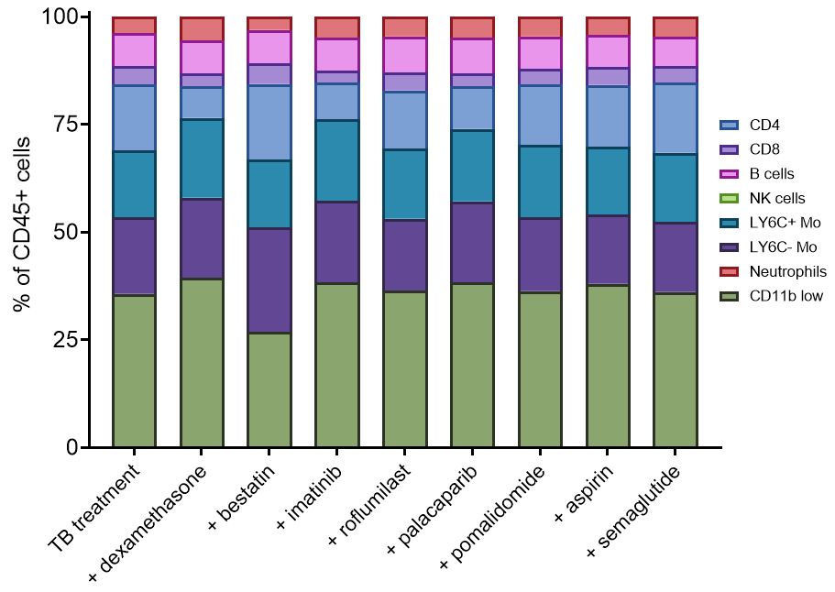Figure S30. Cellular distribution of mouse PBMCs. Percentage (%) of CD45+ cell population found in M. tuberculosis-infected mouse PBMCs after live M. tuberculosis stimulation and treatment with TB treatment (isoniazid) with and without HDTs.

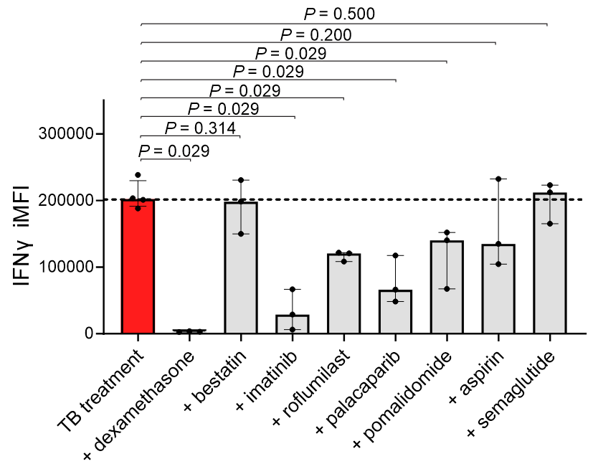
Figure S31. Effect of HDTs on mouse PBMCs IFNγ response. The effect of HDTs on immune cells that would potentially infiltrate the central nervous system during TB meningitis was evaluated using PBMCs from the mouse model of TB meningitis (n = 40 animals). PBMCs were isolated through a density gradient protocol, stimulated through exposure to live M. tuberculosis and treated with TB treatment (isoniazid) with or without adjunctive HDTs. Quantification of the IFNγ response as integrated mean fluorescence intensity (iMFI) of CD4+ T-cells is shown. The dashed line represents the median value for the TB treatment arm. Each dot represents a biological replicate. Data are represented as median and IQR. Statistical comparisons were made using the Mann-Whitney U test.

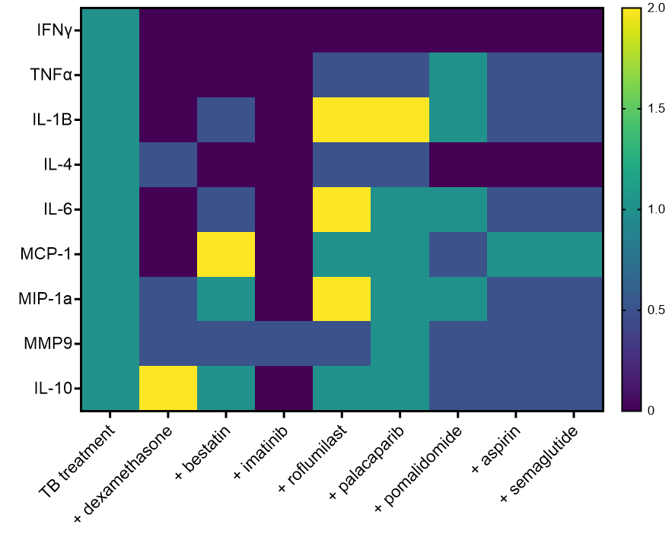Figure S32. Cytokines levels in mouse PBMCs. Heat-map representation of cytokine level changes in the supernatant of M. tuberculosis-infected mouse PBMCs after live M. tuberculosis stimulation and treatment with TB treatment (isoniazid) with HDTs, relative to the TB treatment arm.

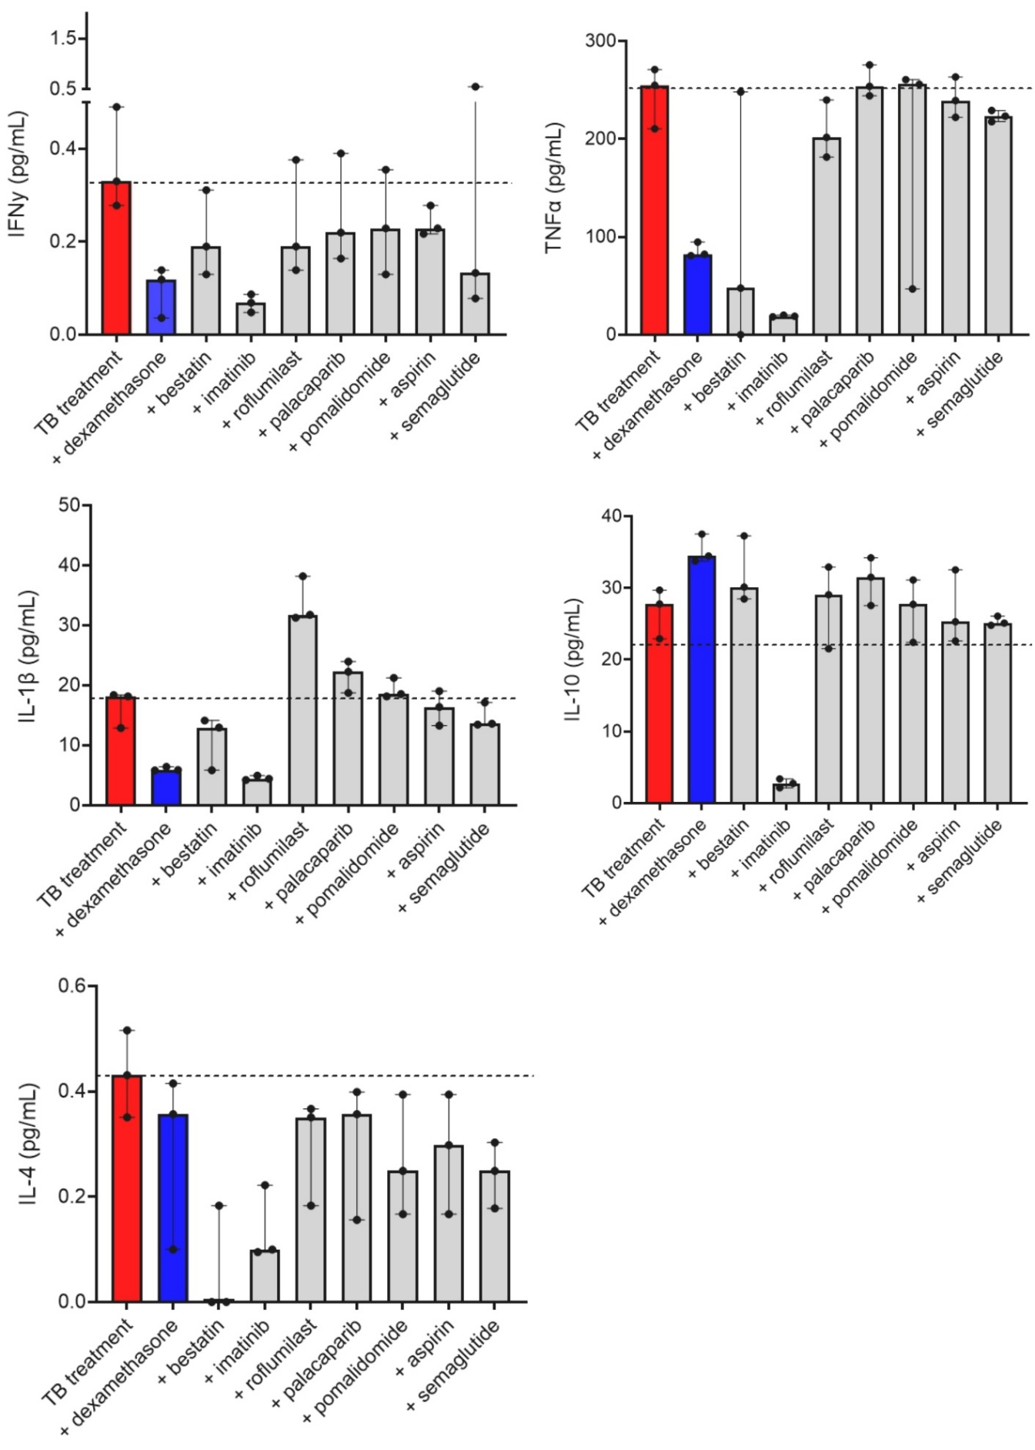
Figure S33. Cytokine quantification in mouse PBMCs. Cytokine levels in supernatant of M. tuberculosis-infected mouse PBMCs after live M. tuberculosis stimulation and co-incubation with TB treatment (isoniazid) with or without HDTs. Each dot represents a biological replicate. Data are presented as median and IQR.

SUPPLEMENTARY TABLES

Drug | Mechanism of action | FDA approved | Frequency / route of administration | Mouse dose (per day) | Human dose (per day)
Aspirin | NSAID: COX inhibitor​ | Yes | PO, 5 days / week | 50 mg/kg | 500-1000 mg
Bestatin​ | Protease inhibitor: leucine aminopeptidase (LAPi) | FDA-Orphan drug designation | IP, 5 days / week | 15 mg/kg | -
Dabrafenib | Serine/threonine protein kinase inhibitor​ | Yes | PO, 5 days / week | 30 mg/kg | -
Dexamethasone | Corticosteroid | Yes | IP, 5 days / week | 2 mg/kg | 0.4 mg/kg
Imatinib​ | Tyrosine kinase inhibition (c-Abl, c-Kit, and PDGFR)​ | Yes | PO, 5 days / week | 150 mg/kg (75 mg/kg twice daily) | 400-800 mg
Infliximab​ | Anti-TNFα monoclonal antibody​ | Yes | IP, 1 day / week | 10 mg/kg | 5 mg/kg
Montelukast | Leukotriene receptor antagonist​ | Yes | PO, 5 days / week | 50 mg/kg | 10 mg
Navitoclax​ | Bcl-2, Bcl-X_{L} and Bcl-w inhibitor (pro-apoptotic) ​ | Phase III clinical trial | PO, 5 days / week | 100 mg/kg | 325 mg
Pomalidomide​ | IMiD: TNFα mRNA inhibition, CRBN modulator​ | Yes | IP, 5 days / week | 25 mg/kg | 5 mg
Palacaparib (AZD9574) | poly (ADP-ribose) polymerase (PARP) inhibitor​ | Phase I/IIa clinical trial | Oral, 5 days / week | 3 mg/kg | -
Roflumilast​ | Phosphodiesterase 4 inhibitor (PDE4i) ​ | Yes | Oral, 5 days / week | 5 mg/kg | 0.5 mg
Semaglutide​ | GLP-1 receptor agonist​ | Yes | SC, 3 days / week | 103 μg/kg | 1 mg
Thalidomide​ | IMiD: TNFα mRNA inhibition, CRBN modulator​ | Yes | IP, 5 days / week | 50 mg/kg | 400 mg (3-5 mg/kg)
Table S1. Panel of immunomodulatory drugs evaluated. Immunomodulatory drugs that are U.S. FDA-approved (or in clinical trials) for other indications and targeting diverse immune pathways were evaluated as potential host-directed treatments for TB meningitis in the current studies. Human equipotent and clinically relevant dosing was utilized in mice. Dexamethasone, which is the standard of care for TB meningitis in patients was used as a control. All drugs were administered daily via oral gavage (PO), except dexamethasone, pomalidomide, thalidomide, infliximab, and bestatin, which were administered intraperitoneally (IP), and semaglutide, which was administered subcutaneously (SC). This 5-day-on / 2-day-off schedule is standard for treatments in the mouse models of TB to approximate continuous daily therapy while accounting for animal handling and welfare. In addition, clinical guidelines and extensive programmatic experience interpret directly observed therapy given 5 days per week as equivalent to 7-day “daily” therapy, with comparable treatment success when the total number of doses is adjusted accordingly.

Drug | In vitro |  |  | Preclinical |  |  |  | Human
Drug | Dose | Cell line | Effect | C_{max} in brain or plasma | Brain penetration | Dose per day | Effect | C_{max} in brain or plasma | Dose per day
Aspirin | 3.12 $μ$M | Microglia | Anti-inflammatory^{1,2} | 5-56 $μ$M | 20-30% | 5-100 mg/kg | Pharmacokinetics^{3,4} | 10-100 $μ$M | 100-1000 mg (7-14 mg/kg)⁵⁻⁹
Aspirin | 1-10 $μ$M | Glial, BV2 cells
Bestatin | 108 $μ$M | Human histiocytic lymphoma | Antiproliferative^{10,11} | 65 $μ$M | - | 50 mg/kg | Antiproliferative¹² | - | -
Bestatin | 500 $μ$M | A549 cell line | Antiproliferative¹³
Dabrafenib | 5.8 $μ$M | Tumor cells | Kinases¹⁴ | 7.65 $μ$M | - | 10 mg/kg | Drug-drug interactions and Anticancer properties¹⁵ | 5 $μ$M | 150 mg twice daily¹⁶
Dabrafenib | 0.457 $μ$M | Chemical analogs | Antiproliferative¹⁷
Dexamethasone | 0.02-5 $μ$M | Microglia | Nitric oxide (NO) inhibition | 0.125 $μ$M | 30 – 50% | 4 mg/kg | - | 64 $μ$g/L  (~ 0.163$μ$M) | 0.4 mg/kg¹⁸
Dexamethasone | 0.01 $μ$M |  | Anti-inflammatory¹⁹ | 0.5 $μ$M |  | 1 mg/kg | - | 64 $μ$g/L  (~ 0.163$μ$M) | 0.4 mg/kg¹⁸
Dexamethasone | 500 $μ$M | A549 cell line | Antiproliferative¹³ |  |  |  | - | 64 $μ$g/L  (~ 0.163$μ$M) | 0.4 mg/kg¹⁸
Imatinib | 32 $μ$M | BON-1, NCI8727 cell lines | Antiproliferative^{20,21} | 7.09 $μ$M | 3% | 100 mg/kg | Antiproliferative²² | 3868 ng/mL  (~ 7.84 $μ$M) | 600-800 mg daily (10 mg/kg)²³
Infliximab | 0.0067-0.67 $μ$M | HEPG2 cell lines | Viability²⁴ | 0.8-1.38 $μ$M | <1% | 10 mg/kg | TNFα inhibition²⁵ | 120 $μ$g/mL  (~ 0.805 $μ$M) | 5 mg/kg²⁶
Infliximab | 0.00061 $μ$M | Sp2/o cells | TNFα neutralization²⁷
Montelukast | 0.1-10 $μ$M | Eosinophils | Protease activity^{28,29} | 0.385-24 $μ$M | 100% | 10-50 mg/kg | Correlation studies³⁰⁻³⁵ | 0.7-1 $μ$M | 5-10 mg³⁶
Navitoclax | 0.01-4 $μ$M | Leukemia cell lines | Apoptosis³⁷ | 7 $μ$M | 2-3% | 100 mg/kg | Apoptosis³⁷⁻³⁹ | 3.9 $μ$g/mL  (~ 4 $μ$M) | 325 mg daily  (5 mg/kg)⁴⁰
Navitoclax | 0.195 $μ$M | HeLa cell lines | Activation of Caspase and Bax³⁸ | 30 $μ$M
Palacaparib  (AZD9574) | 1 $μ$M | IC₅₀ | PARP inhibition⁴¹ | 0.1 $μ$M | 20% | 3 mg/kg | PARP inhibition⁴² | - | -
Pomalidomide | 0.01-1 $μ$M | Human MM1.S (multiple myeloma) cell line | Anti-inflammatory⁴³ | 7 $μ$M | 70% | 10 mg/kg | TNFα and IL-5 reduction⁴⁴ | 75 ng/mL (~ 0.2 $μ$M) | 5 mg daily (0.07 mg/kg)⁴⁵
Roflumilast | 0.05 $μ$M | Chemical analogs | TNFα and PDE4 inhibition⁴⁶ | 0.25 $μ$M | 20% | 10 mg/kg | Decreased neuroinflammation⁴⁷ | 6-12 ng/L  (~ 0.03 $μ$M) | 0.5 mg daily  (0.007 mg/kg)⁴⁸
Semaglutide | 0.01-0.04 $μ$M | BV2 microglia | Decreases microglial activation⁴⁹ | 1.04 $μ$M | 1% | 1 mg/kg | Pharmacokinetics⁵⁰ | 10-50 nmol/L (~0.05 $μ$M) | 0.5-1 mg (7-14 $μ$g/kg)⁵¹
Semaglutide | 20-200 $μ$M | Brain organoids | Decreases Tau protein (Alzheimer)⁵²
Thalidomide | 77 $μ$M | Chemical analogs | TNFα inhibition⁵³ | 12 $μ$M | 40-80% | 20 mg/kg | Pharmacokinetics⁵⁴ | 1-6 mg/L  (~ 23 $μ$M) | 100-400 mg daily (3-5 mg/kg)⁵⁵
Thalidomide | 0.01-3 μM
Table S2. Expected human tissue concentrations of the immunomodulatory drugs evaluated. See citations at the end of this document.

Drug | Preliminary dose range testing | Final physiological dose chosen
Aspirin | 1 $μ$M, 10 $μ$M, 100 $μ$M | 10 $μ$M
Bestatin​ | 5 $μ$M, 50 $μ$M, 100 $μ$M | 50 $μ$M
Dexamethasone | 0.01 $μ$M, 0.1 $μ$M, 1 $μ$M | 1 $μ$M
Imatinib​ | 1 $μ$M, 10 $μ$M, 50 $μ$M | 10 $μ$M
Montelukast | 0.1 $μ$M, 1 $μ$M, 10 $μ$M | 1 $μ$M
Palacaparib (AZD9574)​ | 0.01 $μ$M, 0.1 $μ$M, 1 $μ$M | 0.1 $μ$M
Pomalidomide​ | 0.1 $μ$M, 1 $μ$M, 10 $μ$M | 1 $μ$M
Roflumilast​ | 0.01 $μ$M, 0.1 $μ$M, 1 $μ$M | 0.01 $μ$M
Semaglutide​ | 0.1 $μ$M, 1 $μ$M, 10 $μ$M | 1 $μ$M
Thalidomide​ | 10 $μ$M, 50 $μ$M, 100 $μ$M | 10 $μ$M
Isoniazid (H) | 2 $μ$g/mL
Rifampin (R) | 0.2 $μ$g/mL
Pyrazinamide (Z) | 20 $μ$g/mL
Table S3. Physiologically relevant tissue concentrations.

 | Group | Age (range) | Sex | Race/Ethnicity | HIV status | Time since diagnosis of TB meningitis (months) | Time since last dose of corticosteroids (months)
1 | Patients with TB meningitis | 25 to 44 years | Male | Asian (12.5%)  Hispanic or Latino (50%)  Black / not Hispanic (37.5%) | Negative | 34 | 2.5
2 | Patients with TB meningitis | 25 to 44 years | Male |  | Negative | 14 | 3
3 | Patients with TB meningitis | 25 to 44 years | Female |  | Negative | 41 | 18
4 | Patients with TB meningitis | 25 to 44 years | Female |  | Positive | 23 | 18
5 | Patients with TB meningitis | 25 to 44 years | Female |  | Positive | 19 | 14
6 | Patients with TB meningitis | 25 to 44 years | Male |  | Positive | 16 | 10
7 | Patients with TB meningitis | 25 to 44 years | Male |  | Positive | 13 | 7
8 | Patients with TB meningitis | 25 to 44 years | Female |  | Negative | 20 | 2
9 | Healthy controls | 25 to 44 years | Female | Unknown | Negative | N/A | N/A
10 | Healthy controls | 25 to 44 years | Female | Unknown | Negative | N/A | N/A
Table S4. Demographic information. Details of the human subjects used for patients derived peripheral blood mononuclear cells. N/A, non-applicable.

Assay | Antibody | Cat no / company | Established dilution
Animal studies: Western blot | Mouse IgG (H+L) Secondary Antibody | 31430  Thermo Fisher | 1:20000
Animal studies: Western blot | Goat Anti-Rabbit IgG H&L (HRP) | ab97051/ Abcam | 1:20000
Animal studies: Western blot | GLP-1 Recombinant Rabbit Monoclonal Antibody (24H1L3) | 701296  Thermo Fisher | 1:1000
Animal studies: Western blot | GAPDH Loading Control Monoclonal Antibody (GA1R), HRP | MA5-15738-HRP  Thermo Fisher | 1:1000
Animal studies: Western blot | Anti-Bcl-2 antibody | [EPR17509]/Abcam | 1:2000
Animal studies: Western blot | PDGFR alpha Recombinant Rabbit Monoclonal Antibody (BLR128H) | A700-128 Thermo Fisher | 1:1000
Animal studies: Western blot | PDGFR beta Recombinant Rabbit Monoclonal Antibody (BLR242L) | A700-242  Thermo Fisher | 1:1000
Animal studies: Western blot | PDE4 Polyclonal Antibody | PD4-101AP  Thermo Fisher | 1:1000
Animal studies: Western blot | PARP (46D11) Rabbit Monoclonal Antibody | 9532  Cell Signaling Tech | 1:1000
Animal studies: Western blot | CRBN Recombinant Rabbit Monoclonal Antibody (PSH0-69) | MA549359  Thermo Fisher | 1:1000
Animal studies: Western blot | CD13 Monoclonal Antibody (1C7D7) | MA1181  Thermo Fisher | 1:1000
Human microglia and brain organoid:  Immunofluorescence | Iba1 Recombinant Rabbit Monoclonal Antibody (HL22) | MA536257  Thermo Fisher | 1:500
Human microglia and brain organoid:  Immunofluorescence | Secondary Goat Alexa-fluor 488 antibody | A11034  Thermo Fisher | 1:200
Human microglia and brain organoid:  Immunofluorescence | Alexa Fluor(R) 647 anti-TMEM119 (Extracellular) | 853311  Biolegend | 1:800
Human microglia and brain organoid:  Immunofluorescence | PE Mouse Anti-Human CD11b | 561001  BD Pharmingen™ | 1:800
Human microglia and brain organoid:  Immunofluorescence | ProLong™ Gold Antifade Mountant with DNA Stain DAPI | P36931  Thermo Fisher
Table S5. Antibodies used for Western blot studies.

Panel | Peak channel | Marker | Fluorochrome | Catalog number
Human | UV2 | CD4 | BUV395 | 563550 BD Biosciences
Human | UV6 | Live-Dead | LIVE/DEAD™ Blue | L23105 Invitrogen™
Human | UV7 | CD16 | BUV496 | 612944 BD Biosciences
Human | UV14 | CD8 | BUV737 | 569189 BD Biosciences
Human | UV16 | Ki67 | BUV805 | 368-5698-82 Thermo Fisher
Human | V3 | IL-1β | Pacific Blue | 511710 BioLegend
Human | V5 | CD45 | BV480 | 566115 BD Biosciences
Human | V14 | TNFα | BV750 | 566359 BD Biosciences
Human | B2 | CD19 | AF488 | 557697 BD Biosciences
Human | B3 | CD14 | Spark blue | 367148 BioLegend
Human | B9 | IL-2 | BB700 | 566405 BD Biosciences
Human | R4 | CD56 | APC-R700 | 565139 BD Biosciences
Human | R7 | HLA-DR | APC-H7 | 561358 BD Biosciences
Human | YG1 | IL-10 | PE | 554498 BD Biosciences
Human | YG3 | TGF-β | PE-CF594 | 562422 BD Biosciences
Human | YG5 | PD-1 | PE-Cy5 | 329972 BioLegend
Human | YG7 | CD3 | Pe/Fire700 | 344864 BioLegend
Human | YG9 | IFN-y | Pe-Cy7 | 506518 BioLegend
Mouse | UV2 | CD4 | BUV395 | 563790 BD Biosciences
Mouse | UV6 | Live/dead | LIVE/DEAD™ Blue | L23105 Invitrogen™
Mouse | UV14 | CD8 | BUV737 | 612759 BD Biosciences
Mouse | UV16 | Ki-67 | BUV805 | 368-5698-82 Thermo Fisher
Mouse | V7 | Ly6G | BV510 | 740157 BD Biosciences
Mouse | V10 | Ly6C | BV605 | 128036 BD Biosciences
Mouse | V11 | CD25 | BV650 | 564021 BD Biosciences
Mouse | V13 | IL-10 | BV711 | 564081 BD Biosciences
Mouse | V14 | CD45 | BV750 | 103157 BD Biosciences
Mouse | V15 | CD14 | BV786 | 756774 BD Biosciences
Mouse | B9 | TNFα | BB700 | 566510 BD Biosciences
Mouse | B10 | IL-1β | PerCP-eFluor 710 | 46-7114-82 Thermo Fisher
Mouse | R7 | MHC-II | APC-Cy7 | 107628 BD Biosciences
Mouse | R8 | NK1.1 | APC/Fire 810 | 156519 BD Biosciences
Mouse | YG3 | CD11b | PE-CF594 | RM2817 Thermo Fisher
Mouse | YG5 | CD3 | PE-Cy5 | 100274 BD Biosciences
Mouse | YG7 | CD45R-B220 | PE/Fire 700 | 103280 BD Biosciences
Mouse | YG9 | IFN-y | PE-Cy7 | 557649 BD Biosciences
Table S6. Human and mouse flow cytometry panels.

REFERENCES

1. Mayer, A.M., Aviles, E. & Rodriguez, A.D. Marine sponge Hymeniacidon sp. amphilectane metabolites potently inhibit rat brain microglia thromboxane B2 generation. Bioorg Med Chem 20, 279-282 (2012).
2. Chakrabarti, S., et al. Upregulation of IL-1 Receptor Antagonist by Aspirin in Glial Cells via Peroxisome Proliferator-Activated Receptor-Alpha. J Alzheimers Dis Rep 5, 647-661 (2021).
3. Kim, J.K., Choi, M.S., Yoo, H.H. & Kim, D.H. The Intake of Coffee Increases the Absorption of Aspirin in Mice by Modifying Gut Microbiome. Pharmaceutics 14(2022).
4. Lichtenberger, L.M., et al. Bioavailability of aspirin in rats comparing the drug's uptake into gastrointestinal tissue and vascular and lymphatic systems: implications on aspirin's chemopreventive action. J Physiol Pharmacol 67, 635-642 (2016).
5. Nagelschmitz, J., et al. Pharmacokinetics and pharmacodynamics of acetylsalicylic acid after intravenous and oral administration to healthy volunteers. Clin Pharmacol 6, 51-59 (2014).
6. Dovizio, M., Bruno, A., Tacconelli, S. & Patrignani, P. Mode of action of aspirin as a chemopreventive agent. Recent Results Cancer Res 191, 39-65 (2013).
7. Rohilla, R., Shafiq, N. & Malhotra, S. Efficacy and safety of aspirin as an adjunctive therapy in tubercular meningitis: A systematic review and meta-analysis. EClinicalMedicine 34, 100819 (2021).
8. Angiolillo, D.J., et al. Pharmacokinetic and Pharmacodynamic Profile of a Novel Phospholipid Aspirin Formulation. Clin Pharmacokinet 61, 465-479 (2022).
9. H. Stevensa, M.V., ∗, L. Gowa, F. MacDougalla, G. Bieric. In-vivo disintegration and absorption of two fast acting aspirin tablet formulations compared to ibuprofen tablets using pharmacoscintigraphy. Journal of Drug Delivery Science and Technology 51, 535-541 (2019).
10. Correa, A.F., et al. The Activity of a Hexameric M17 Metallo-Aminopeptidase Is Associated With Survival of Mycobacterium tuberculosis. Front Microbiol 8, 504 (2017).
11. Grujic, M. & Renko, M. Aminopeptidase inhibitors bestatin and actinonin inhibit cell proliferation of myeloma cells predominantly by intracellular interactions. Cancer Lett 182, 113-119 (2002).
12. Abe, F., Alvord, G., Koyama, M., Matsuda, A. & Talmadge, J.E. Pharmacokinetics of bestatin and oral activity for treatment of experimental metastases. Cancer Immunol Immunother 28, 29-33 (1989).
13. Jiang, Y., et al. Discovery of BC-01, a novel mutual prodrug (hybrid drug) of ubenimex and fluorouracil as anticancer agent. Eur J Med Chem 121, 649-657 (2016).
14. Henry, J.R., et al. Discovery of 1-(3,3-dimethylbutyl)-3-(2-fluoro-4-methyl-5-(7-methyl-2-(methylamino)pyrido[2,3-d]pyrimidin-6-yl)phenyl)urea (LY3009120) as a pan-RAF inhibitor with minimal paradoxical activation and activity against BRAF or RAS mutant tumor cells. J Med Chem 58, 4165-4179 (2015).
15. Henderson, C.J., et al. An Extensively Humanized Mouse Model to Predict Pathways of Drug Disposition and Drug/Drug Interactions, and to Facilitate Design of Clinical Trials. Drug Metab Dispos 47, 601-615 (2019).
16. Balakirouchenane, D., et al. Population Pharmacokinetics/Pharmacodynamics of Dabrafenib Plus Trametinib in Patients with BRAF-Mutated Metastatic Melanoma. Cancers (Basel) 12(2020).
17. Schneider, M., et al. Structure-Based and Knowledge-Informed Design of B-Raf Inhibitors Devoid of Deleterious PXR Binding. J Med Chem 65, 1552-1566 (2022).
18. Spoorenberg, S.M., et al. Pharmacokinetics of oral vs. intravenous dexamethasone in patients hospitalized with community-acquired pneumonia. Br J Clin Pharmacol 78, 78-83 (2014).
19. Rock, R.B., et al. Mycobacterium tuberculosis-induced cytokine and chemokine expression by human microglia and astrocytes: effects of dexamethasone. J Infect Dis 192, 2054-2058 (2005).
20. Zheng, F., et al. Imatinib has the potential to exert its antileukemia effects by down-regulating hERG1 K+ channels in chronic myelogenous leukemia. Med Oncol 29, 2127-2135 (2012).
21. Yao, J.C., et al. Clinical and in vitro studies of imatinib in advanced carcinoid tumors. Clin Cancer Res 13, 234-240 (2007).
22. Wolff, N.C., Randle, D.E., Egorin, M.J., Minna, J.D. & Ilaria, R.L., Jr. Imatinib mesylate efficiently achieves therapeutic intratumor concentrations in vivo but has limited activity in a xenograft model of small cell lung cancer. Clin Cancer Res 10, 3528-3534 (2004).
23. von Mehren, M. & Widmer, N. Correlations between imatinib pharmacokinetics, pharmacodynamics, adherence, and clinical response in advanced metastatic gastrointestinal stromal tumor (GIST): an emerging role for drug blood level testing? Cancer Treat Rev 37, 291-299 (2011).
24. de Vries, H.S., et al. Infliximab exerts no direct hepatotoxic effect on HepG2 cells in vitro. Dig Dis Sci 57, 1604-1608 (2012).
25. Velasco-Velazquez, M.A., et al. Extensive preclinical evaluation of an infliximab biosimilar candidate. Eur J Pharm Sci 102, 35-45 (2017).
26. Agency, E.M. Remicade : EPAR - Product Information. (2009).
27. Song, M.Y., et al. Characterization of a novel anti-human TNF-alpha murine monoclonal antibody with high binding affinity and neutralizing activity. Exp Mol Med 40, 35-42 (2008).
28. Bandeira-Melo, C., Woods, L.J., Phoofolo, M. & Weller, P.F. Intracrine cysteinyl leukotriene receptor-mediated signaling of eosinophil vesicular transport-mediated interleukin-4 secretion. J Exp Med 196, 841-850 (2002).
29. Langlois, A., Ferland, C., Tremblay, G.M. & Laviolette, M. Montelukast regulates eosinophil protease activity through a leukotriene-independent mechanism. J Allergy Clin Immunol 118, 113-119 (2006).
30. Research, C.f.D.E.a. Pharmacology review: application number 20-829. (1998).
31. Tel, B.C., Telli, G., Onder, S., Nemutlu, E. & Bozkurt, T.E. Investigation of the relationship between chronic montelukast treatment, asthma and depression-like behavior in mice. Exp Ther Med 21, 27 (2021).
32. Han, J., et al. Montelukast during primary infection prevents airway hyperresponsiveness and inflammation after reinfection with respiratory syncytial virus. Am J Respir Crit Care Med 182, 455-463 (2010).
33. Wu, A.Y., et al. Anti-inflammatory effects of high-dose montelukast in an animal model of acute asthma. Clin Exp Allergy 33, 359-366 (2003).
34. Strempfl, K., et al. Montelukast alleviates neuroinflammation and improves motor functions in the line 61 model of Parkinson's disease: An exploratory study. Neurotherapeutics 22, e00690 (2025).
35. Michael, J., et al. The Leukotriene Receptor Antagonist Montelukast Attenuates Neuroinflammation and Affects Cognition in Transgenic 5xFAD Mice. Int J Mol Sci 22(2021).
36. Knorr, B., Holland, S., Rogers, J.D., Nguyen, H.H. & Reiss, T.F. Montelukast adult (10-mg film-coated tablet) and pediatric (5-mg chewable tablet) dose selections. J Allergy Clin Immunol 106, S171-178 (2000).
37. Varnes, J.G., et al. Towards the next generation of dual Bcl-2/Bcl-xL inhibitors. Bioorg Med Chem Lett 24, 3026-3033 (2014).
38. Tse, C., et al. ABT-263: a potent and orally bioavailable Bcl-2 family inhibitor. Cancer Res 68, 3421-3428 (2008).
39. Singh, M., et al. Proapoptotic Bcl-2 inhibitor as potential host directed therapy for pulmonary tuberculosis. Nat Commun 16, 3003 (2025).
40. Roberts, A.W., et al. Phase 1 study of the safety, pharmacokinetics, and antitumour activity of the BCL2 inhibitor navitoclax in combination with rituximab in patients with relapsed or refractory CD20+ lymphoid malignancies. Br J Haematol 170, 669-678 (2015).
41. Patel, J.S., et al. A novel (18) F-labeled brain penetrant PET ligand for imaging poly(ADP-ribose) polymerase-1. bioRxiv (2025).
42. Staniszewska, A.D., et al. Preclinical Characterization of AZD9574, a Blood-Brain Barrier Penetrant Inhibitor of PARP1. Clin Cancer Res 30, 1338-1351 (2024).
43. Tsai, Y.R., et al. 3,6'- and 1,6'-Dithiopomalidomide Mitigate Ischemic Stroke in Rats and Blunt Inflammation. Pharmaceutics 14(2022).
44. Tsai, Y.R., et al. Pomalidomide Reduces Ischemic Brain Injury in Rodents. Cell Transplant 28, 439-450 (2019).
45. FDA. POMALYST label. (2013).
46. Mancini, R.S., Barden, C.J., Weaver, D.F. & Reed, M.A. Furazans in Medicinal Chemistry. J Med Chem 64, 1786-1815 (2021).
47. Kang, D.H., Ahn, S., Chae, J.W. & Song, J.S. Differential effects of two phosphodiesterase 4 inhibitors against lipopolysaccharide-induced neuroinflammation in mice. BMC Neurosci 24, 39 (2023).
48. Huang, J., et al. Pharmacokinetics of single- and multiple-dose roflumilast: an open-label, three-way crossover study in healthy Chinese volunteers. Drug Des Devel Ther 12, 4047-4057 (2018).
49. Rong, X., et al. Microglial activation and hypothalamic structural plasticity in HFD obesity: insights from semaglutide and minocycline. J Lipid Res 66, 100736 (2025).
50. Research, C.f.D.E.a. Clinical review: Ozempic. (2017).
51. Yang, X.D. & Yang, Y.Y. Clinical Pharmacokinetics of Semaglutide: A Systematic Review. Drug Des Devel Ther 18, 2555-2570 (2024).
52. Zhang, Y., et al. Semaglutide ameliorates Alzheimer's disease and restores oxytocin in APP/PS1 mice and human brain organoid models. Biomed Pharmacother 180, 117540 (2024).
53. Ruchelman, A.L., et al. Isosteric analogs of lenalidomide and pomalidomide: synthesis and biological activity. Bioorg Med Chem Lett 23, 360-365 (2013).
54. Chung, F., et al. Thalidomide pharmacokinetics and metabolite formation in mice, rabbits, and multiple myeloma patients. Clin Cancer Res 10, 5949-5956 (2004).
55. Teo, S.K., et al. Clinical pharmacokinetics of thalidomide. Clin Pharmacokinet 43, 311-327 (2004).

