A Comparative Questionnaire Survey on the Teaching Effectiveness of Regional Anatomy
Thank you for participating in this survey. This questionnaire aims to evaluate the application effects of different teaching models in Regional Anatomy courses. Please answer honestly based on your actual learning experience. There are no right or wrong answers. This survey is anonymous, and all data will be used solely for educational research purposes.

1. Grade/Class [Single Choice] *
Clinical Medicine 2022-Class 01
Clinical Medicine 2022-Class 02
Clinical Medicine 2022-Class 03
Clinical Medicine 2022-Class 04
Clinical Medicine 2022-Class 05
Clinical Medicine 2022-Class 06
Clinical Medicine 2023-Class 01
Clinical Medicine 2023-Class 02

Clinical Medicine 2023-Class 03

Clinical Medicine 2023-Class 04

Clinical Medicine 2023-Class 05

Clinical Medicine 2023-Class 06

Clinical Medicine 2023-Class 07

Clinical Medicine-Rural Orientation 2023-Class 01

Clinical Medicine-Rural Orientation 2023-Class 02

2. After completing one course cycle, how interested are you in Regional Anatomy? [Single Choice] *
Extremely interested
Interested
Neutral

Not interested

Extremely uninterested

3. When the instructor explains complex knowledge points in Regional Anatomy, which teaching method helps you understand more easily? [Single Choice] *
Lecture with courseware (conventional teaching method)
Lecture with courseware combined with video demonstration
Lecture with synchronous blackboard drawing to illustrate core knowledge points

Lecture combined with demonstration using models or specimens

4. Please evaluate the following statements based on your actual experience in Regional Anatomy classes [Matrix Scale] *
 | Strongly Disagree | Disagree | Neutral | Agree | Strongly Agree
I can understand the structural layers, spatial relationships, and adjacent relationships in Regional Anatomy | ○ | ○ | ○ | ○ | ○
After each class, I can master more than 60% of the core knowledge points of the chapter | ○ | ○ | ○ | ○ | ○
The current teaching model makes me satisfied with Regional Anatomy learning | ○ | ○ | ○ | ○ | ○
The current teaching model helps me integrate anatomical knowledge with clinical cases | ○ | ○ | ○ | ○ | ○
Using drawing methods in class to strengthen memory is very helpful for my learning | ○ | ○ | ○ | ○ | ○
I can use Regional Anatomy knowledge to explain common clinical symptoms (e.g., limb numbness, visual field abnormalities, etc.) | ○ | ○ | ○ | ○ | ○
The course learning has stimulated my interest in related clinical disciplines such as surgery and orthopedics | ○ | ○ | ○ | ○ | ○
The classroom teaching model makes me satisfied with the overall learning of Regional Anatomy | ○ | ○ | ○ | ○ | ○

Classroom Interaction and Learning Behavior

5. I actively discuss with teachers and classmates during Regional Anatomy classes [Single Choice] *
Strongly Agree
Agree
Neutral
Disagree

Strongly Disagree

6. I feel stressed (psychological burden - learning pressure) when listening to Regional Anatomy lectures in class [Single Choice] *
Strongly Agree
Agree
Neutral
Disagree

Strongly Disagree

7. I feel anxious when reviewing Regional Anatomy knowledge [Single Choice]*
Strongly Agree
Agree
Neutral
Disagree

8. I feel psychological burden when doing course tasks, such as homework, specimen observation, and drawing [Single Choice]*
Strongly Agree
Agree
Neutral
Disagree

Strongly Disagree

Clinical Case-Based Regional Anatomy Cognition and Clinical Application Ability Perception Survey
No reference materials allowed. Tests memory and understanding only.

9. A 62-year-old male patient underwent closed thoracic drainage for massive pleural effusion. Postoperatively, the patient complained of burning pain and hyperesthesia in a whole intercostal space below the puncture site. Physical examination revealed decreased pain and temperature sensation in this area, accompanied by mild relaxation of local abdominal wall muscles. Which structure was most likely injured during the procedure, causing this complication? [Single Choice] *
A. Parietal pleura, causing pleural shock

B. Posterior intercostal artery, causing local hematoma compression

C. Intercostal nerve, causing dysfunction in its innervated area

D. Internal thoracic artery, causing postoperative hemothorax

E. Thoracic duct, causing chylothorax

10. A 25-year-old male patient suffered right knee trauma in a motorcycle accident. Physical examination revealed that the patient could not dorsiflex or evert the right foot, presenting "foot drop," and walked with a "steppage gait." Meanwhile, the skin of the anterolateral lower leg and dorsum of the foot was numb. Which nerve injury most likely caused this clinical presentation? [Single Choice]*
A. Sciatic nerve trunk injury

B. Tibial nerve injury

C. Common peroneal nerve injury

D. Femoral nerve injury

E. Obturator nerve injury

11. A 28-year-old male basketball player experienced severe pain in the posterior right shoulder after a violent collision. Several months later, he complained of weakness in shoulder abduction, numbness of the skin on the upper lateral arm, and physical examination revealed deltoid atrophy with a "squared shoulder" deformity. Which anatomical space injury most likely caused this clinical presentation due to compression of the structures passing through it? [Single Choice] *
A. Triangular space, compressing the circumflex scapular artery

B. Quadrangular space, compressing the axillary nerve and posterior circumflex humeral artery

C. Carpal tunnel, compressing the median nerve

D. Adductor canal, compressing the femoral artery and saphenous nerve

E. Cubital tunnel, compressing the ulnar nerve

12. A 45-year-old female patient was diagnosed with pituitary adenoma. Physical examination revealed bitemporal hemianopia in both eyes. Which structure was most likely compressed by the tumor growing upward, causing this symptom? [Single Choice] *
A. Cavernous sinus

B. Internal carotid artery

C. Optic chiasm

D. Oculomotor nerve

E. Trigeminal nerve

13. A 35-year-old female patient underwent subtotal thyroidectomy for thyroid adenoma. On the first postoperative day, the patient developed hoarseness and lowered voice pitch. Which structure adjacent to the thyroid was most likely injured during surgery? [Single Choice]*
A. Common carotid artery

B. Internal jugular vein

C. Recurrent laryngeal nerve

D. Internal branch of superior laryngeal nerve

E. Parathyroid gland

Long-Term Knowledge Retention Survey
No reference materials allowed. Tests memory only.

14. Which of the following indicates the lateral pectoral nerve? 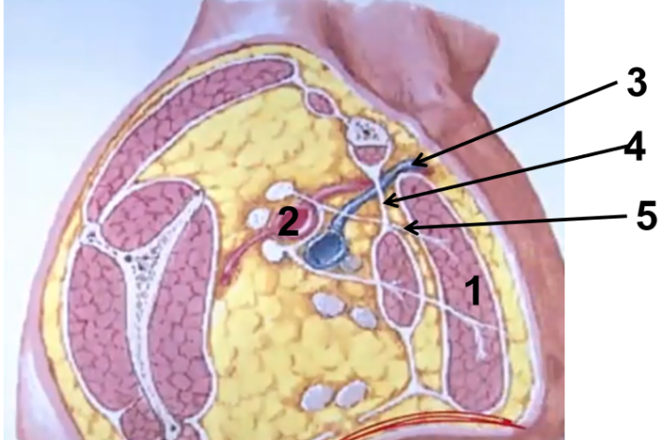 *
○1
○2
○3
○4
○5

15. Which of the following indicates the sciatic nerve?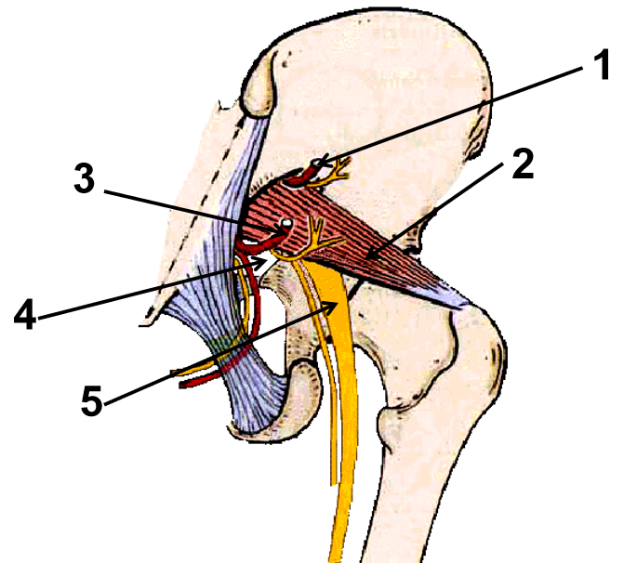 *
○1
○2
○3
○4
○5

16. Which of the following indicates the cavernous sinus?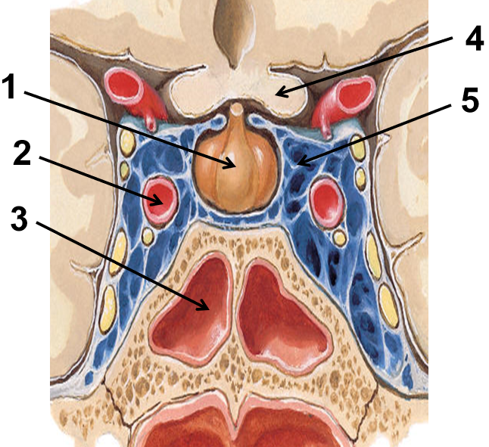 *
○1
○2
○3
○4
○5

17. Which of the following indicates the vagus nerve?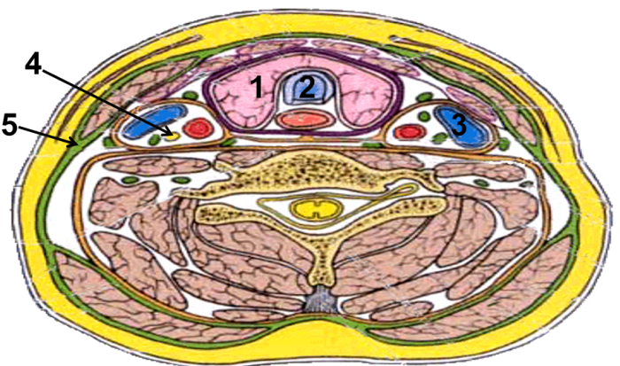 *
○1
○2
○3
○4
○5

18. Which of the following indicates the clavipectoral fascia? *
○1
○2
○3
○4
○5

19. Please provide your opinions and suggestions on how teachers can improve teaching efficiency in Regional Anatomy [Open-ended Question] *
_________________________________

