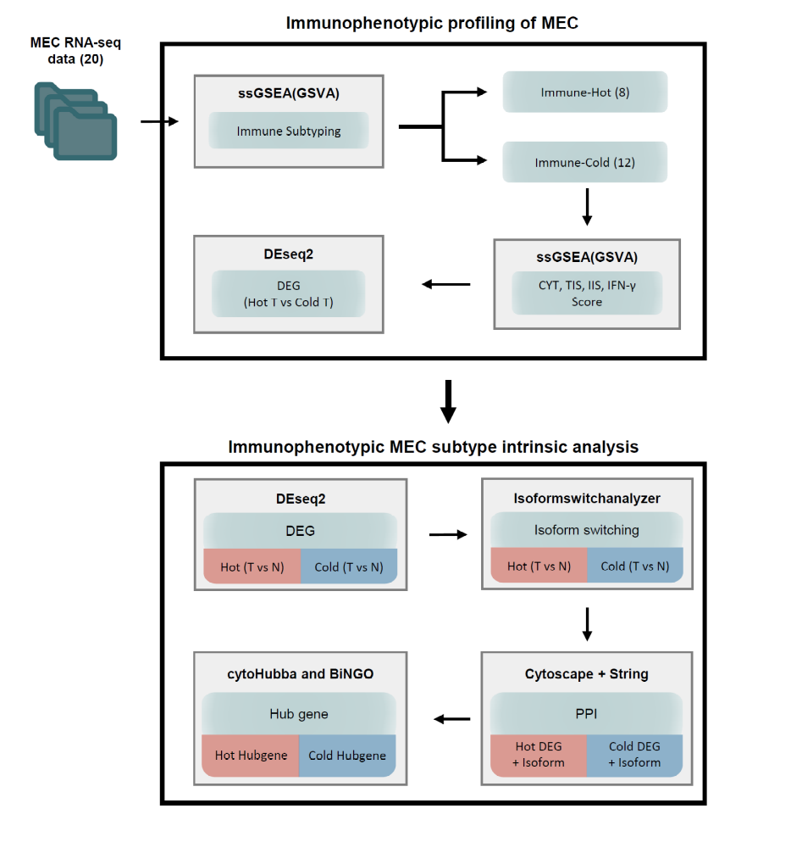
Supplementary Figure S1. Workflow of the study. General work of Tumor immune microenvironment profiling study. Study is composed of two parts. First part shows immunophenotypic profiling of mucoepidermoid carcinoma (MEC) and the second part shows tumor intrinsic analysis of immunophenotypic subgroup of MEC.

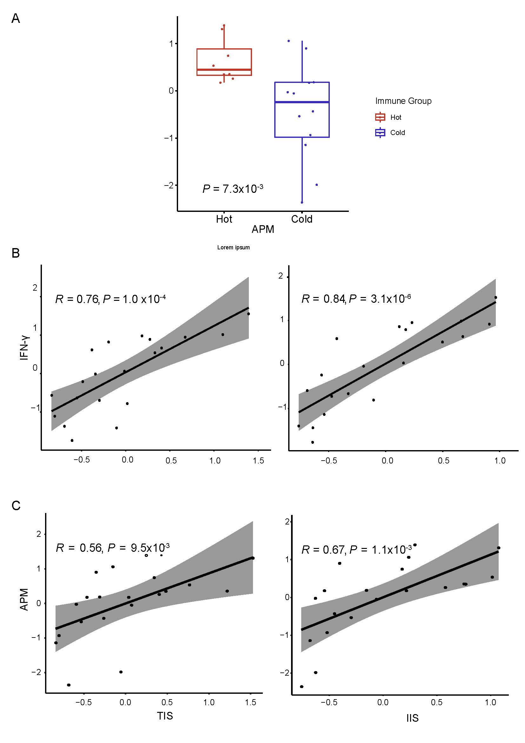
Supplementary Figure S2. Comparison of APM score and immune Correlation between immune cell infiltration and related products. (A) Antigen-presenting mechanism (APM) score between the immune hot and –cold MEC. (B) T cell infiltration score (TIS) and immune cell infiltration score (IIS) is strongly positively correlated. (C) TIS and IIS scores are strongly positively correlated with INF–γ score. Statistics in A-C: Wilcoxon test. All P values for significance (< 0.05). R values represent the Pearson correlation coefficients.
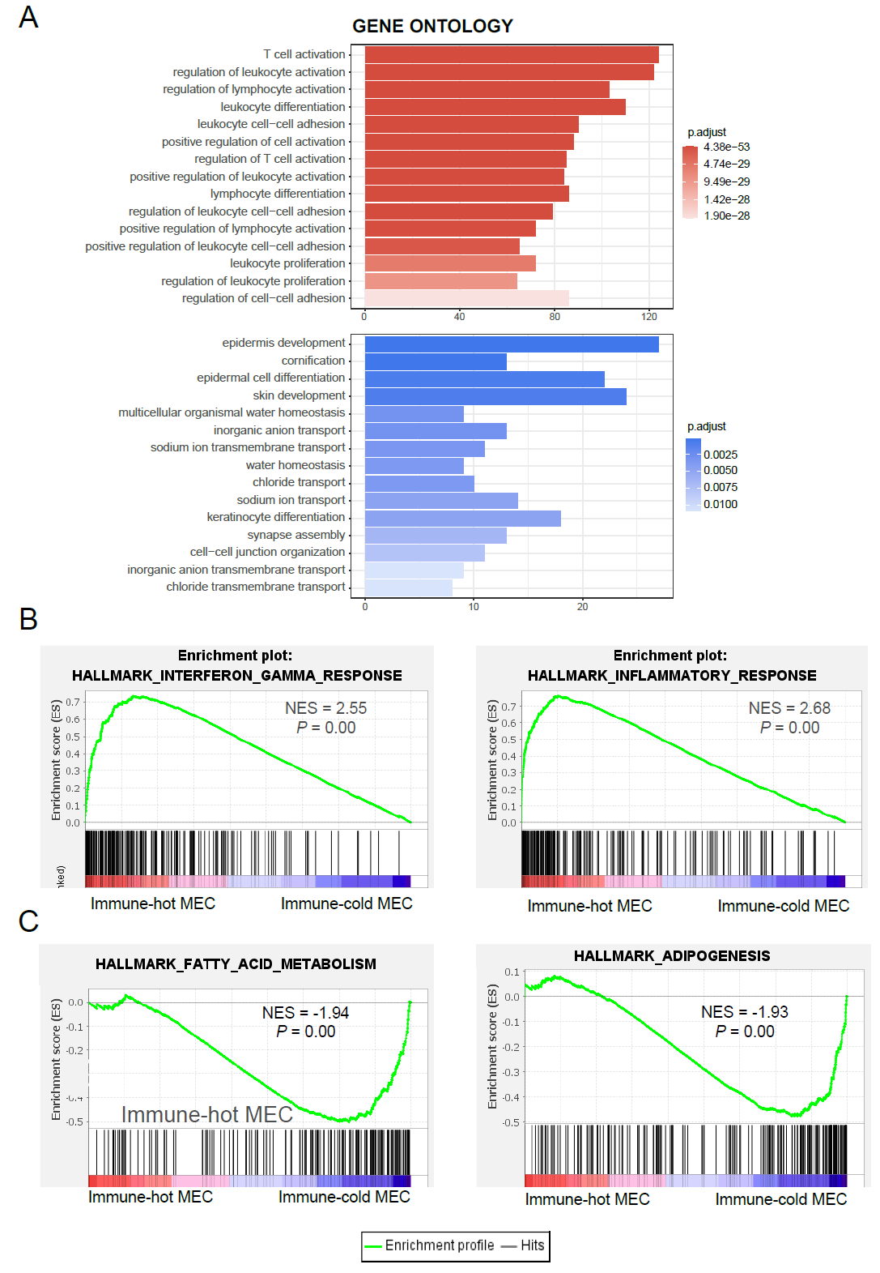
Supplementary Figure S3 – GO and gene set enrichment analysis (GSEA). (A) Bar plot depicting significantly enriched top-10 GO biological processes. Upper part represents the top-10 GO terms enriched in immune-hot MEC. Lower part represents the top-10 GO terms enriched in immune-cold MEC. Count: Number of genes mapped to the enriched terms. Colour of the bar indicates –log 10 (P-value). (B) GSEA identified significantly enriched ‘Hallmark Inflammatory’ and ‘Hallmark interferon gamma response’ which are significantly enriched in immune-hot MEC at a threshold of FDR q-value < 0.05. (C) GSEA identified significantly enriched ‘Hallmark Fatty acid metabolism’ and ‘Hallmark adipogenesis’ which are significantly enriched in immune-cold MEC at a threshold of FDR q-value < 0.05. Statistics in A: GO term analysis. All q-values for significance < 0.05 and significant fold change (FDR < 0.01).

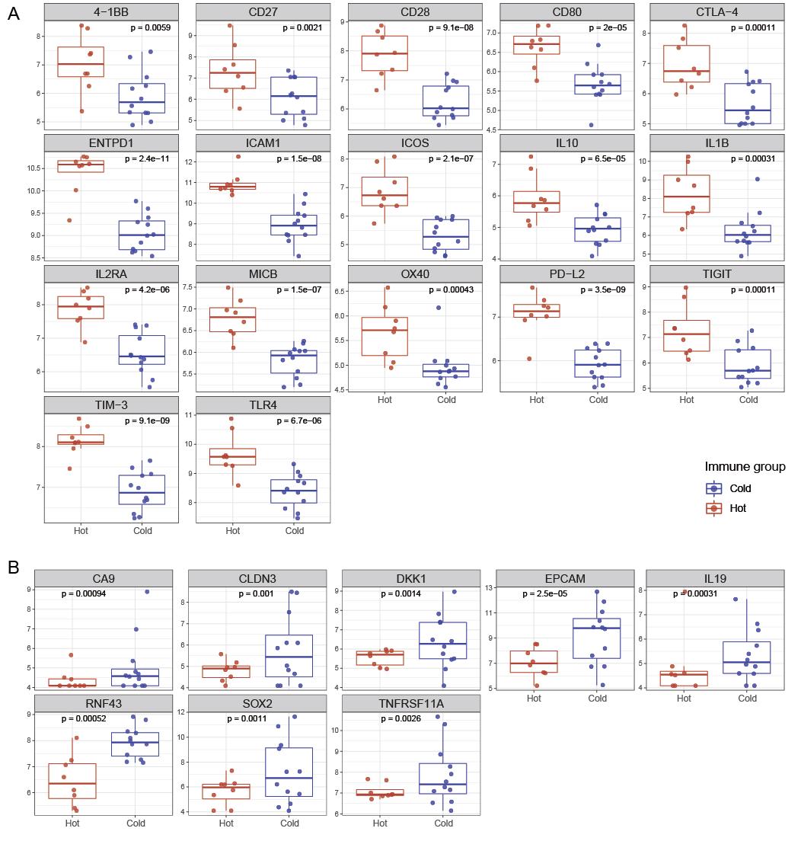
Supplementary Figure S4. Expression of immune oncological target gene between immune-hot and –cold mucoepidermoid carcinoma (MEC). (A) Differentially expressed genes with known immune oncological therapeutic targets genes that are significantly up-regulated in the immune-hot MEC. (B) Differentially expressed genes with known immune oncological therapeutic targets genes that are significantly up-regulated in the immune-cold MEC. Statistics in A and B: Wilcoxon test. All P values for significance (< 0.05).

