Effect of Ether Bond Number in Organic Solvents on the Corrosion Behavior of SnAg3.0Cu0.5 Solder Paste
Wu Xingª, Hu Guangxing^{a*}, Jing Wenjiaª, Xing Pengjuª, Sun Xiyuª

ª Yunnan Tin and Indium laboratory, Yunnan Tin Group (holding) Company Limited, Kunming, Yunnan, 650106, China;

E-mail:doc_hugx@163.com


Fig. S1 Corrosion treatment samples of copper plate

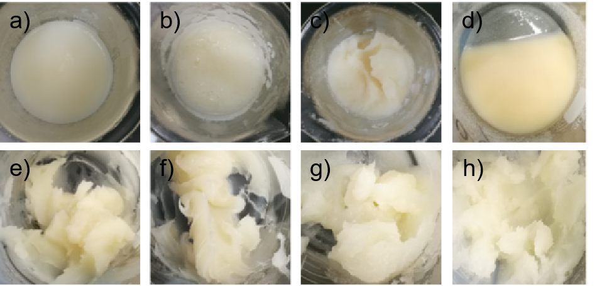
Fig. S2 Surface morphology of flux; a) Diethylene glycol hexyl ether; b) Tripropylene glycol butyl ether; c) Diethylene glycol dimethyl ether; d) Hexanediol; e) Diethylene glycol butyl ether; f) Tetrahydrofurfuryl alcohol; g) Propylene glycol; h) Pentanediol.

