SUPPLEMENTARY MATERIAL

Event-like enrichment of beryllium isotopes and rare-earth elements at ~10.2 Ma from IODP Site U1430, Ulleung Basin (East Sea)

Kyeong Ja Kim^{1*},

Yire Choi¹;

Hiroyuki Matsuzaki²,

Gilyoung Kim¹

¹Geological Research Division, Korea Institute of Geosciences & Mineral Resources, Daejeon 34132 South Korea;
²Department MALT, University of Tokyo, Tokyo 113-0033, Japan

Correspondence : Kyeong Ja Kim¹
¹Geological Research Division,
Korea Institute of Geosciences & Mineral Resources 124 Gwahak-ro, Yuseong-gu
Daejeon 34132, South Korea.
Telephone: +82 42 868 3669
Fax: +82 42 868 3413
Email: kjkim@kigam.re.kr

Supplemental Figure 1. Age model of sediment core Hole U1430A (Modified after Tada et al. 2015) and the profile of GRA bulk density (Modified after IODP 2020b).

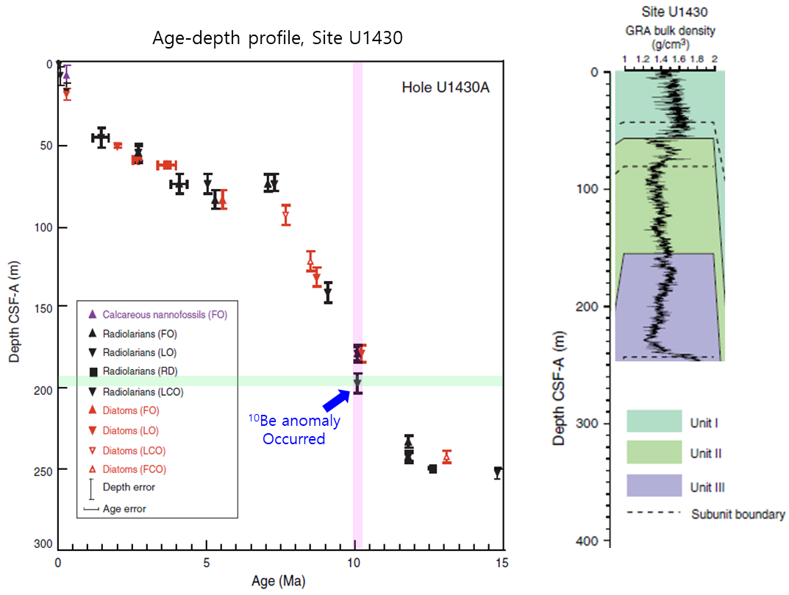

Supplemental Figure 2. ¹⁰Be concentrations at depths, along with a partial shipboard sample data set of U1430A (IODP 2020d). Two tephra deposited depths are within the ¹⁰Be anomaly section, and increases in both GRA and natural gamma radiation counts were observed in this section.

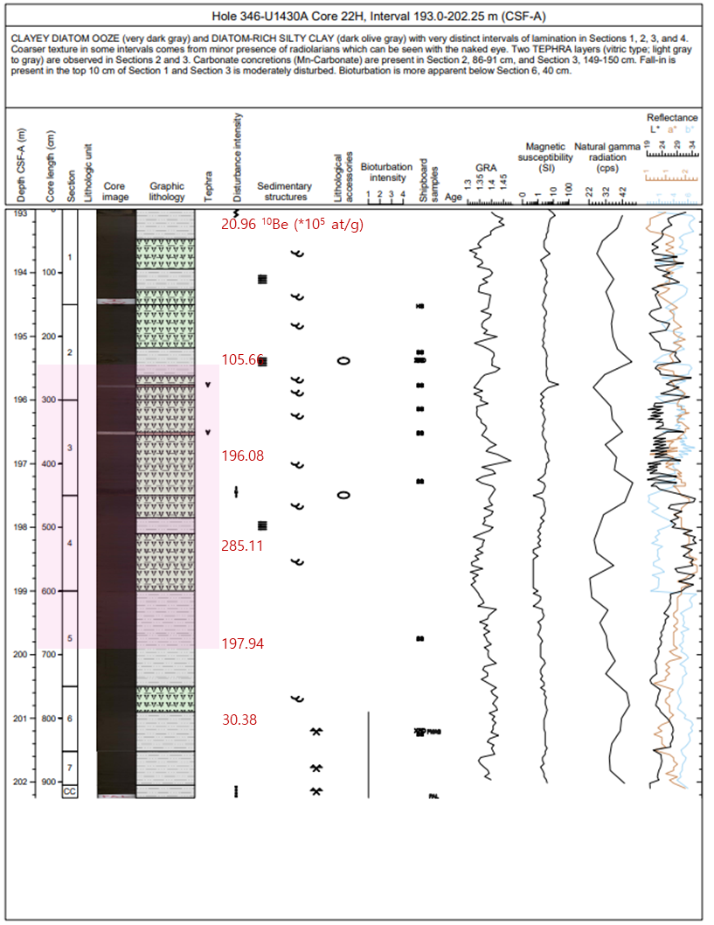

Supplemental Figure 3. ¹⁰Be concentrations at depths along with a partial shipboard sample data set of U1430B (IODP 2020d). Two tephra deposited depths were within the ¹⁰Be anomaly section, and increases in both GRA and natural gamma radiation counts were observed in this section.

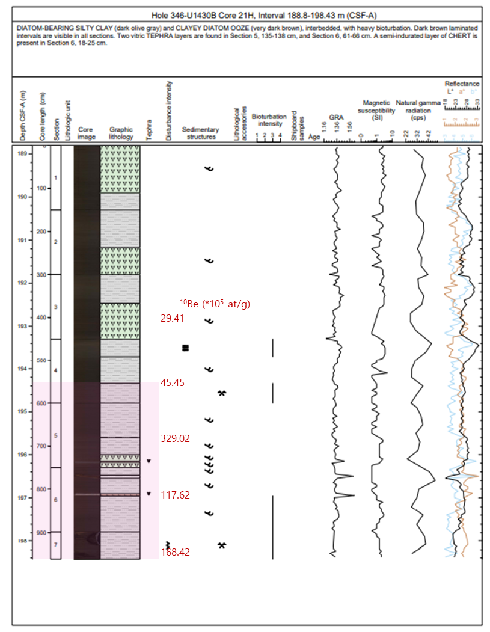

Table S1. Results of this study (¹⁰Be anomalies in sediment samples of the two cores).
Sample ID | Depth (m) | Age (Myr) | ¹⁰Be (10⁵ at/g) present | ⁹Be  (10¹⁶ at/g) | ¹⁰Be/⁹Be  (10⁻¹⁰ at/at)
B111 | 177.75 | 9.77 | 8.0±11.0 | 4.71±0.28 | 0.17±0.23
B112 | 179.08 | 9.80 | 21.4±12.5 | 4.61±0.18 | 0.46±0.27
B113 | 180.9 | 9.85 | 13.4±12.5 | 4.12±0.25 | 0.32±0.30
B114 | 182.5 | 9.89 | 18.7±11.0 | 4.47±0.36 | 0.34±0.25
B115 | 184.1 | 9.93 | 13.4±11.0 | 3.92±0.19 | 0.26±0.28
B116 | 185.7 | 9.97 | 13.4±11.0 | 5.23±0.19 | 0.12±0.21
B117 | 187.3 | 10.01 | 5.3±11.0 | 4.40±0.21 | 0.34±0.25
A04 | 188.8 | 10.04 | 0.27±* | 9.69±0.35 | 0.18±*
A05 | 190.3 | 10.08 | 79.06±12.24 | 12.19±0.29 | 0.44±0.10
A06 | 191.5 | 10.11 | 20.96±25.44 | 16.65±0.45 | 0.19±0.15
A07 | 195.3 | 10.20 | 105.66±17.18 | 9.94±0.21 | 0.68±0.17
A08 | 196.8 | 10.24 | 196.08±12.56 | 15.68±0.45 | 0.67±0.08
A09 | 198.3 | 10.28 | 285.11±18.17 | 12.36±0.50 | 1.17±0.16
A10 | 199.8 | 10.31 | 197.94±12.27 | 10.91±0.34 | 1.01±0.12
A11 | 201.0 | 10.34 | 30.38±20.60 | 12.24±0.40 | 0.32±0.17
A12 | 206.0 | 10.47 | 0.27±* | 11.80±0.31 | 0.15±*
A13 | 207.5 | 10.50 | 20.35±26.90 | 7.20±0.20 | 0.53±0.37
B118 | 188.9 | 10.05 | 18.71±11.06 | 5.46±0.27 | 0.34±0.25
B119 | 191.6 | 10.11 | 16.04±11.07 | 4.16±0.28 | 0.39±0.20
B120 | 192.9 | 10.15 | 29.41±11.32 | 3.84±0.34 | 0.77±0.27
B121 | 194.3 | 10.18 | 45.45±11.14 | 4.32±0.15 | 1.05±0.30
B122 | 195.7 | 10.21 | 329.02±18.10 | 21.37±0.70 | 1.54±0.26
B123 | 197.1 | 10.25 | 117.62±13.13 | 4.53±0.15 | 2.60±0.098
B124 | 198.4 | 10.28 | 168.42±14.26 | 4.50±0.18 | 3.75±0.30
B125 | 203.2 | 10.40 | 24.06±11.08 | 3.23±0.14 | 0.75±0.35
B126 | 204.8 | 10.44 | 5.35±11.03 | 4.21±0.30 | 0.13±0.34
B127 | 206.38 | 10.478 | 18.71±21.05 | 4.90±0.12 | 0.38±0.26
B128 | 208.00 | 10.518 | 2.67±11.02 | 4.48±0.11 | 0.06±0.43
B129 | 211.04 | 10.593 | 10.69±11.02 | 4.39±0.12 | 0.24±0.25
B130 | 212.66 | 10.633 | 10.69±11.02 | 4.80±0.30 | 0.22±0.25
B131 | 214.28 | 10.673 | 13.37±11.02 | 3.50±0.30 | 0.38±0.23
B132 | 215.90 | 10.713 | 8.02±11.02 | 5.39±0.11 | 0.15±0.32
B133 | 217.52 | 10.753 | 18.71±11.02 | 2.81±0.14 | 0.67±0.20
B134 | 222.16 | 10.867 | 16.04±11.02 | 4.33±0.25 | 0.37±0.39
B135 | 223.77 | 10.907 | 10.69±11.02 | 3.86±0.34 | 0.28±0.26
B136 | 225.39 | 10.947 | 8.02±11.02 | 3.89±0.12 | 0.21±0.29
B137 | 227.01 | 10.987 | 18.71±11.02 | 4.78±0.44 | 0.39±0.28
B138 | 237.91 | 11.256 | 21.39±11.02 | 4.44±0.26 | 0.48±0.23
B139 | 239.56 | 11.297 | 2.67±11.02 | 2.58±0.19 | 0.10±0.25
B140 | 239.56 | 11.297 | 8.02±11.02 | 4.05±0.16 | 0.20±0.43
B141 | 240.58 | 11.322 | 5.35±11.02 | 3.86±0.08 | 0.14±0.27
B142 | 243.14 | 11.385 | 16.04±11.02 | 6.67±0.20 | 0.24±0.29
B143 | 244.42 | 11.417 | 18.71±11.02 | 5.00±0.43 | 0.37±0.17
Note: The sample ID is given as sample processing ID of this study and the depths of samples used for this study can be found at the IODP Expedition 346 site (IODP 2020a). * indicates for large error associated due to the detection limit of AMS.

Table S2. Possible mechanisms for the 10.2 Ma ¹⁰Be anomaly and their expected signatures
Scenario | Expected ¹⁰Be |  | ⁹Be |  | REE | Spatial synchronicity | Consistency with U1430
Sedimentation rate change |  | ↑Concentration only |  | No ↑ | No ↑ | local | x
Redox/scavenging |  | variable |  | variable | Element-specific | local | x
Volcanic input |  | minor |  | minor | Element-dependent | regional | x
Solar variability |  | ¹⁰Be only |  | No ↑ | No ↑ | Global but short-lived | x
Astrophysical event (SN/heliosphere) |  | ↑ |  | ↑ | ↑ | Supra-regional | V

