Table 1: 1R4L active residues involved in docking interactions with the inhibitors and their dock scores.
SL. No. | Urtica compounds | IUPAC NAME | 2D Structure | Docking score | No. of hydrogen bond with 1R4L | H-bond form with Binding residues
1 | p-Hydroxybenzoic acid | 4-hydroxybenzoic acid | 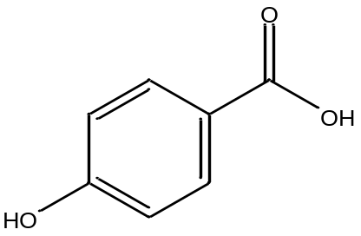 | -6.7 | 4 | Trp165, Arg 169, Trp 271, Asp 499
2 | Gentisic acid | 2,5-dihydroxybenzoic acid | 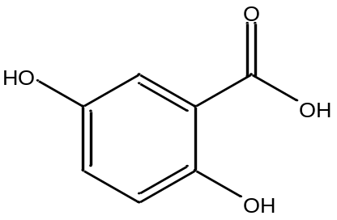 | -6.6 | 3 | Arg 169
3 | Protocatechuic acid | 3,4-dihydroxybenzoic acid | 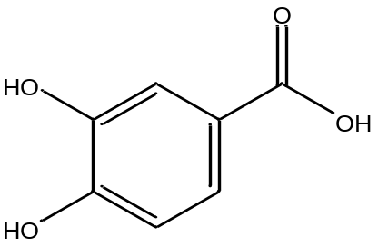 | -6.8 | 5 | Trp 165, Arg 169, Trp 477, Trp 271, Arg 499
4 | Vanillic acid | 4-hydroxy-3-methoxybenzoic acid | 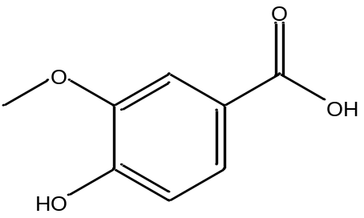 | -6.5 | 7 | Arg 273, His 345, His 374, His 378, His 505, Glu 402
5 | Ferulic acid | (E)-3-(4-hydroxy-3-methoxyphenyl)prop-2-enoic acid | 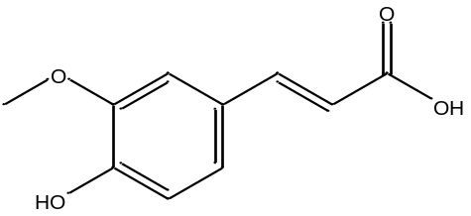 | -6.9 | 4 | Asn 149, Cys 344, His 345
6 | n- Tetracosane | tetracosane |  | -6.6 | 0 | 0
7 | Ethyl palmitate | ethylhexadecanoate | 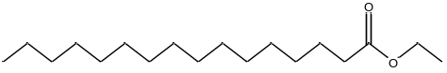 | -6.8 | 3 | Ala 342, Asp 335
8 | n- Hexacosane | hexacosane |  | -6.6 | 0 | 0
9 | Propyl palmitate | propylhexadecanoate | 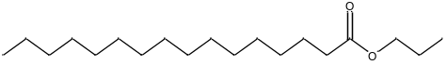 | -6.4 | 2 | Leu 144, Glu 145
10 | Ethyl stearate | ethyloctadecanoate | 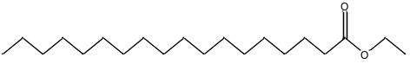 | -6.8 | 0 | 0
11 | Propyl stearate | propyloctadecanoate | 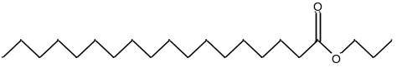 | -6.7 | 2 | Leu 144, Glu 145
12 | Alpha tocopherol (Vitamin E) | (2R)-2,5,7,8-tetramethyl-2-[(4R,8R)-4,8,12-trimethyltridecyl]-3,4-dihydrochromen-6-ol | 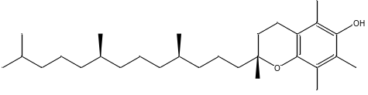 | -10.5 | 3 | Lys 562, Glu 208, Asp 206
13 | Beta sitosterol | (3S,8S,9S,10R,13R,14S,17R)-17-[(2R,5R)-5-ethyl-6-methylheptan-2-yl]-10,13-dimethyl-2,3,4,7,8,9,11,12,14,15,16,17-dodecahydro-1H-cyclopenta[a]phenanthren-3-ol | 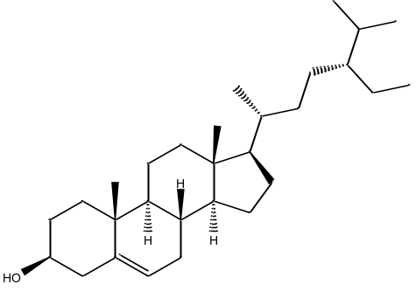 | -12.2 | 1 | Val 212
14 | 2, 6,-Nonadienal,3, 7-dimethyl | (2E,6E)-3,7-dimethylnona-2,6-dienal | 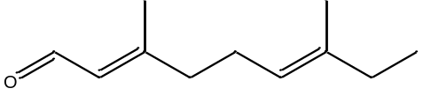 | -6.0 | 2 | His 345, Cys 344
15 | 1, 2, 3-  Butanetriol | butane-1,2,3-triol | 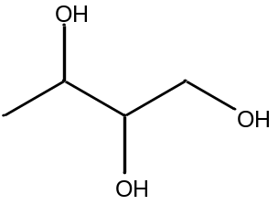 | -5.8 | 5 | Lys 481, Arg 169, Trp 477
16 | Benzofuran,2,3,-dihydro | 2,3-dihydro-1-benzofuran | 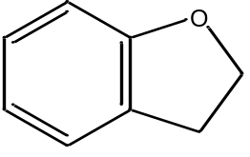 | -6.4 | 0 | 0
17 | Tetramethyl-1,2,3,5,6,7,8, 8a-  octahydronaphthalen-1-ol | 2,5,5,8a-tetramethyl-1,2,3,6,7,8-hexahydronaphthalen-1-ol | 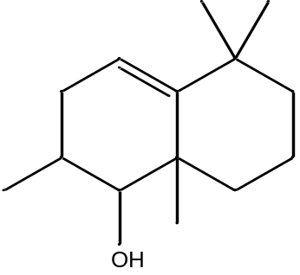 | -9.5 | 1 | Asp 350
18 | 1-Dodecanamine, N, N-dimethyl | N,N-dimethyldodecan-1-amine | 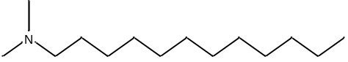 | -5.9 | 0 | 0
19 | 2(3H)-Naphthalenone, 4, 4a,5,6,7,8-  hexahydro-1-methoxy | 1-methoxy-4,4a,5,6,7,8-hexahydro-3H-naphthalen-2-one | 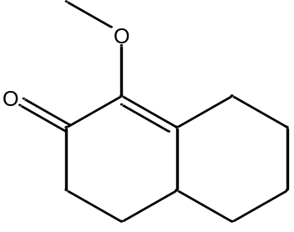 | -7.2 | 3 | His 374. His 378, Glu 375
20 | 2,2'-methylene bis (6-tert-butyl-p-cresol) | 2-tert-butyl-6-[(3-tert-butyl-2-hydroxy-5-methylphenyl)methyl]-4-methylphenol | 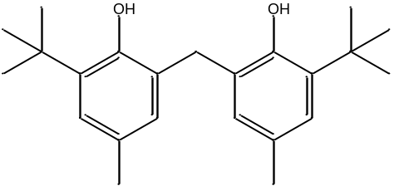 | -8.6 | 1 | Thr 371
21 | Kaempferol | 3,5,7-trihydroxy-2-(4-hydroxyphenyl)chromen-4-one | 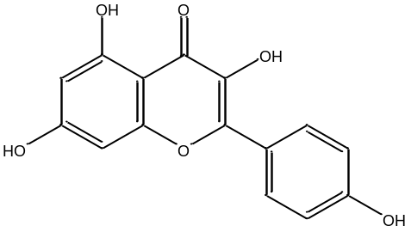 | -9.3 | 9 | Arg 273, His 345, His 378, His 505, Tyr 515
22 | Isorhamnetin | 3,5,7-trihydroxy-2-(4-hydroxy-3-methoxyphenyl)chromen-4-one | 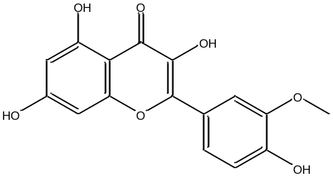 | -9.4 | 10 | Arg 273, His 345, His 378, His 505, Tyr 515
23 | Quercetin | 2-(3,4-dihydroxyphenyl)-3,5,7-trihydroxychromen-4-one | 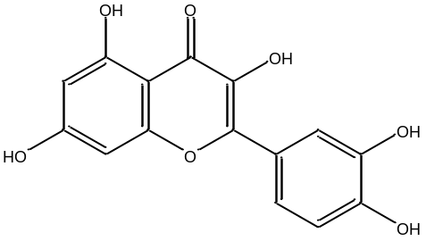 | -10.0 | 9 | Arg 273, His 345, His 378, His 374, Glu 402, Glu 375
24 | Isoquercitrin | 2-(3,4-dihydroxyphenyl)-5,7-dihydroxy-3-[(2S,3R,4S,5S,6R)-3,4,5-trihydroxy-6-(hydroxymethyl)oxan-2-yl]oxychromen-4-one | 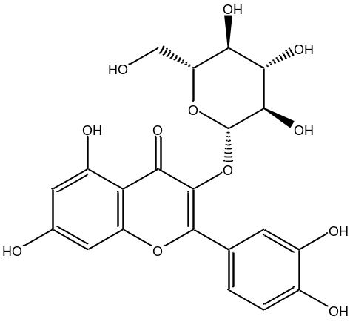 | -9.6 | 8 | Asn 394, Asp 350, Ala 348, Pro 346, Glu 375, Asn 51, His 378, Arg 514
25 | Astragalin | 5,7-dihydroxy-2-(4-hydroxyphenyl)-3-[(2S,3R,4S,5S,6R)-3,4,5-trihydroxy-6-(hydroxymethyl)oxan-2-yl]oxychromen-4-one | 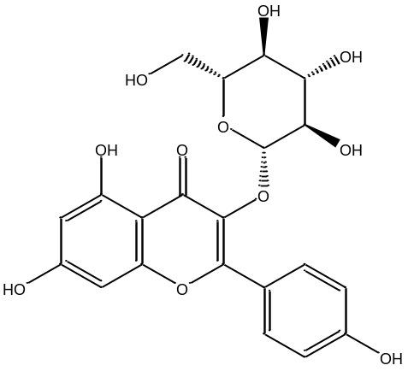 | -9.6 | 4 | His 345, Glu 145, Asn 149, Thr 371
26 | Rutin | 2-(3,4-dihydroxyphenyl)-5,7-dihydroxy-3-[(2S,3R,4S,5S,6R)-3,4,5-trihydroxy-6-[[(2R,3R,4R,5R,6S)-3,4,5-trihydroxy-6-methyloxan-2-yl]oxymethyl]oxan-2-yl]oxychromen-4-one | 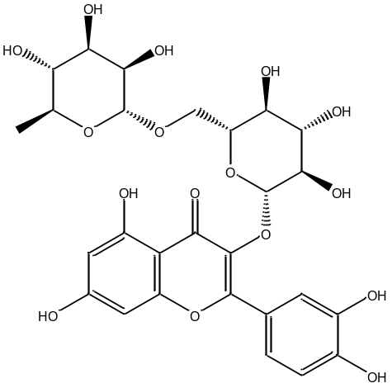 | -10.9 | 7 | His 345, Thr 445, Asp 367, Glu 402,
27 | caffeic acid | (E)-3-(3,4-dihydroxyphenyl)prop-2-enoic acid | 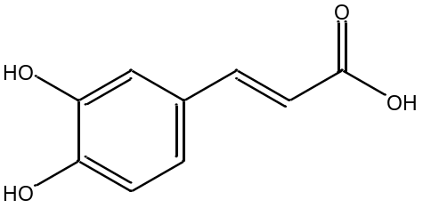 | -6.3 | 3 | Gln 522, Asp 367, Thr 371
28 | chlorogenic  acid | (1S,3R,4R,5R)-3-[(E)-3-(3,4-dihydroxyphenyl)prop-2-enoyl]oxy-1,4,5-trihydroxycyclohexane-1-carboxylic acid | 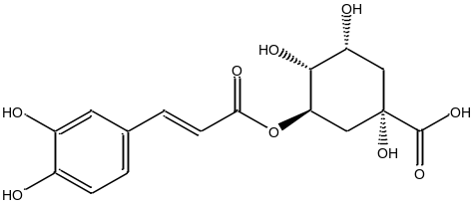 | -8.0 | 4 | His 401, Glu 375, Al 348
29 | Scopoletin | 7-hydroxy-6-methoxychromen-2-one | 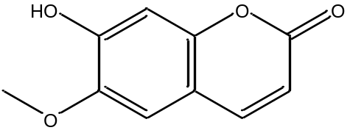 | -6.6 | 1 | Glu 406
30 | β-carotene | 1,3,3-trimethyl-2-[(1E,3E,5E,7E,9E,11E,13E,15E,17E)-3,7,12,16-tetramethyl-18-(2,6,6-trimethylcyclohexen-1-yl)octadeca-1,3,5,7,9,11,13,15,17-nonaenyl]cyclohexene | 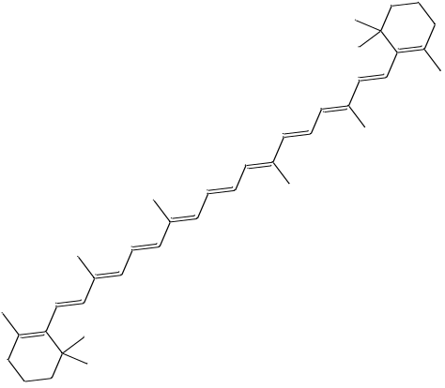 | -11.29 | 0 | 0
31 | Luteoxanthin | (6S,7aR)-2-[(2E,4E,6E,8E,10E,12E,14E,16E)-17-[(1S,4S,6R)-4-hydroxy-2,2,6-trimethyl-7-oxabicyclo[4.1.0]heptan-1-yl]-6,11,15-trimethylheptadeca-2,4,6,8,10,12,14,16-octaen-2-yl]-4,4,7a-trimethyl-2,5,6,7-tetrahydro-1-benzofuran-6-ol | 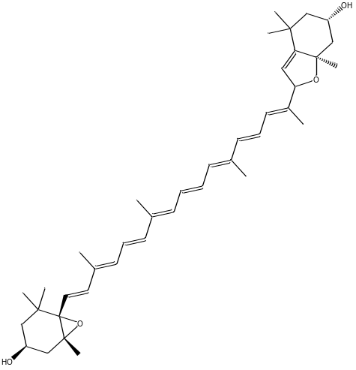 | -10.8 | 1 | Asp 350
32 | lutein epoxide | (1R,3S,6S)-6-[(1E,3E,5E,7E,9E,11E,13E,15E,17E)-18-[(1R,4R)-4-hydroxy-2,6,6-trimethylcyclohex-2-en-1-yl]-3,7,12,16-tetramethyloctadeca-1,3,5,7,9,11,13,15,17-nonaenyl]-1,5,5-trimethyl-7-oxabicyclo[4.1.0]heptan-3-ol | 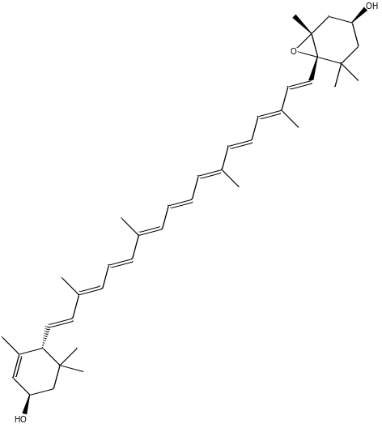 | -10.7 | 2 | Asp 367, Thr445
33 | Violaxanthin | (1R,3S,6S)-6-[(1E,3E,5E,7E,9E,11E,13E,15E,17E)-18-[(1S,4S,6R)-4-hydroxy-2,2,6-trimethyl-7-oxabicyclo[4.1.0]heptan-1-yl]-3,7,12,16-tetramethyloctadeca-1,3,5,7,9,11,13,15,17-nonaenyl]-1,5,5-trimethyl-7-oxabicyclo[4.1.0]heptan-3-ol | 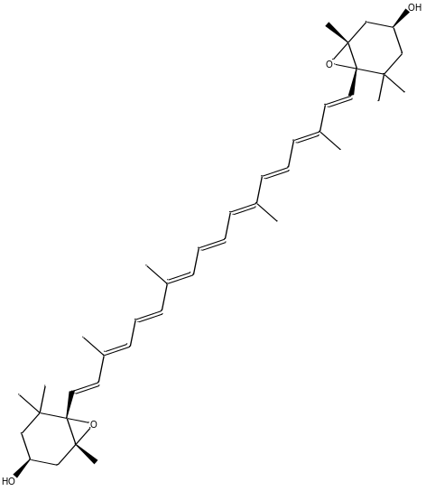 | -10.8 | 2 | Thr 371, Asp 394
34 | acetophenone | 1-phenylethanone | 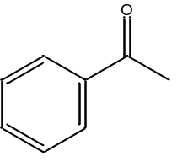 | -6.0 | 2 | Cys 344, His 345
35 | Vitamins C | (2R)-2-[(1S)-1,2-dihydroxyethyl]-3,4-dihydroxy-2H-furan-5-one | 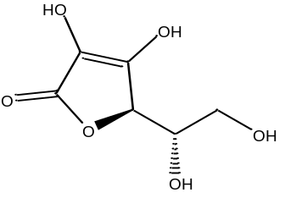 | -6.2 | 6 | Glu 402, His 374, His 505, Arg 273, His 345
36 | Vitamin B | pyridine-3-carboxamide | 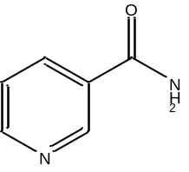 | -6.3 | 4 | Arg 169, Asp 499, Trp 271, Lys 481
37 | Vitamin K | 2-methyl-3-[(E)-3,7,11,15-tetramethylhexadec-2-enyl]naphthalene-1,4-dione | 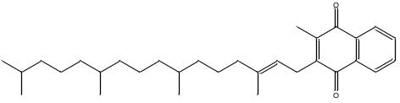 | -7.9 | 1 | Gln 98
38 | dehydrodiconiferyl alcohol | 4-[3-(hydroxymethyl)-5-[(E)-3-hydroxyprop-1-enyl]-7-methoxy-2,3-dihydro-1-benzofuran-2-yl]-2-methoxyphenol | 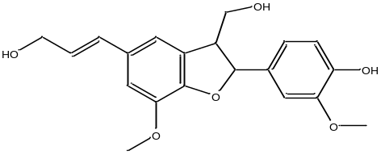 | -9.4 | 3 | Arg 518, Glu 406
39 | isolariciresinol | (6R,7R,8S)-8-(4-hydroxy-3-methoxyphenyl)-6,7-bis(hydroxymethyl)-3-methoxy-5,6,7,8-tetrahydronaphthalen-2-ol | 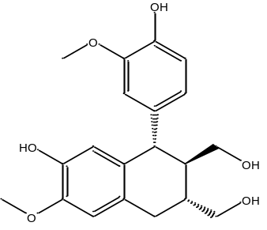 | -9.4 | 2 | Thr 371, Glu 406
40 | Pinoresinol | 4-[(3S,3aR,6S,6aR)-6-(4-hydroxy-3-methoxyphenyl)-1,3,3a,4,6,6a-hexahydrofuro[3,4-c]furan-3-yl]-2-methoxyphenol | 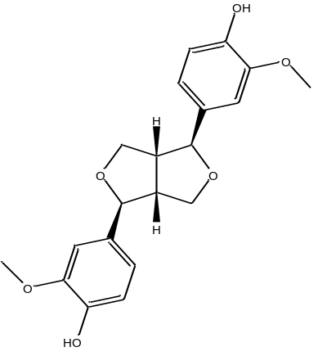 | -9.3 | 3 | His 345, His 505, Arg 518,
41 | 3, 4-divanillyltetrahydrofuran | 4-[[4-[(4-hydroxy-3-methoxyphenyl)methyl]oxolan-3-yl]methyl]-2-methoxyphenol | 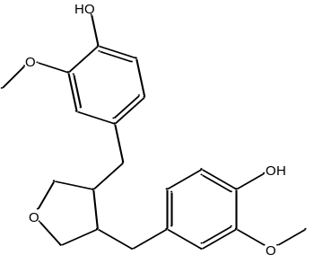 | -8.8 | 5 | Arg 273, His 345, Thr 445, Asp 367

