Sustainable synthesis of hierarchical MFI zeolite from mesoporous HMS and catalytic application
Longyang Wang ª, Zihao Yang ª, Xin Wang ª, Tong Wu ª, Changzi Jin ª*, Rui Wang ^{b}*, Heng Jiang ª
ªSchool of Petrochemical Engineering, ^{b}School of Science, Liaoning Petrochemical University, Fushun, 113001, China
E-mail address: jin_chz@163.com (Changzi Jin). wr_wrwr@163.com (Rui Wang)

Fig. S1 Small angle XRD patterns of (a) ca-HMS(DDA), (b) ca-HMS (HDA), (c) zeolite from ca-HMS(DDA) and (d) zeolite from ca-HMS(HDA)

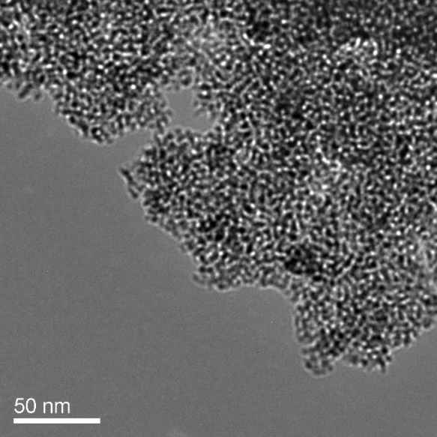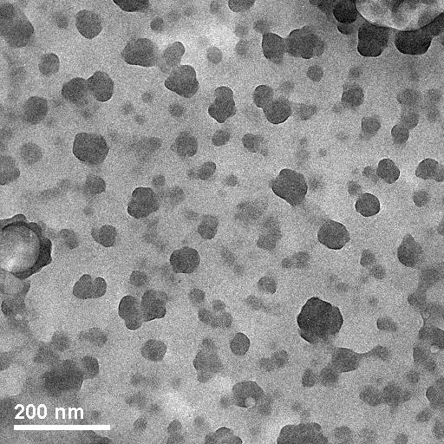
Fig. S2 TEM images of ca-HMS(DDA)

Fig. S3 N₂ physical adsorption/desorption isotherms (a) and pore size distribution (b) of ca-HMS samples.

Fig. S4 N₂ physical adsorption/desorption isotherms and pore size distribution (inset) of silica solid gel.

