Supplementary Material for Reconstruction of a global gene regulatory network for Streptomyces coelicolor: Curation, inference, and assessment
Andrea Zorro-Aranda^{1,3}, Juan Miguel Escorcia-Rodríguez¹, José Kenyi González-Kise^{1,2}, and Julio Augusto Freyre-González^{1,}*
¹Regulatory Systems Biology Research Group, Laboratory of Systems and Synthetic Biology, and ²Undergraduate Program in Genomic Sciences, Center for Genomics Sciences, Universidad Nacional Autónoma de México. Av. Universidad s/n, Col. Chamilpa, 62210. Cuernavaca, Morelos, México. ³Bioprocess Research Group, Department of Chemical Engineering, Universidad de Antioquia, Calle 70 No. 52-21, Medellín, Colombia.
*Corresponding author: jfreyre@ccg.unam.mx (JAF-G)
§Present address:
¶These authors contributed equally to this work

Supplementary results 3
Supplementary Figure 1 3
The functional architecture of the S. coelicolor GRN 4
Supplementary Figure 2 4
Global regulators 4
Intermodular genes 6
Network inference 7
Quantitative assessment and cross-validation 7
Supplementary Figure 3 7
Supplementary Figure 4 7
Supplementary Figure 5 8
Supplementary Figure 6 8
Topological assessment 9
Supplementary Figure 7 9
Supplementary Figure 8 10
Supplementary Figure 9 10
Supplementary Figure 10 11
Supplementary Figure 11 11
Supplementary Figure 12 12
Assessment of the global regulators inference 13
Supplementary Figure 13 13
Supplementary Figure 14 13
Supplementary methods 13
Details collected in the curation of the regulatory interactions 13
Friedman 14
Statmodel 14
The Natural Decomposition Approach 14
Supplementary references 15

Supplementary results

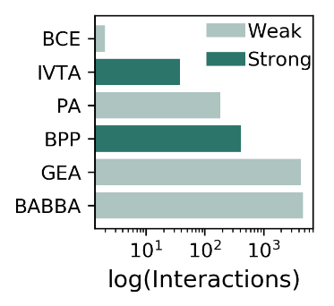

Supplementary Figure 1
The number of interactions supported by each type of experimental evidence. BCE, binding of cellular extracts; IVTA, in-vitro transcription assay; PA, proteomic analysis; BPP, binding of purified proteins; GEA, gene expression analysis; BABBA, binding affinity by bead-based assays.

The most studied TFs were the ones encoded by phoP (SCO4230) ¹⁻⁹, glnR (SCO4159) ¹⁰⁻¹⁶, and the sigma factor encoded by sigR (SCO5216) ¹⁷⁻²³. The interactions more studied are among the TF encoded by phoP (SCO4230) and its TGs pstS (SCO4142), phoU (SCO4228), phoR (SCO4229), and itself ^{1,2,4,9}; and the sigma factor encoded by sigR (SCO5216) and its TGs trxC (SCO0885) ^{19,20,22,23}, trxB (SCO3890), and itself ^{18,20,22,23} (Supplementary Table 2a).

The functional architecture of the S. coelicolor GRN
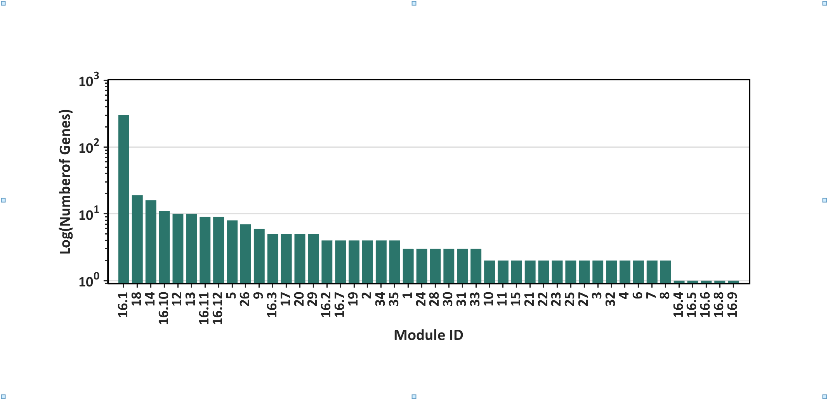
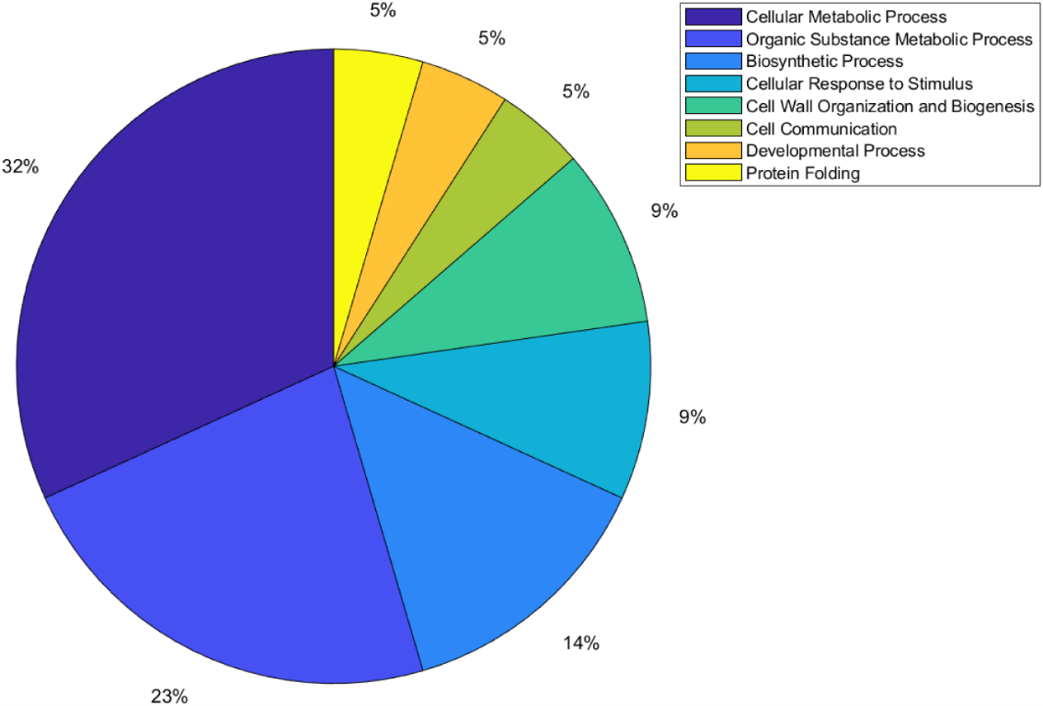
a

b

Supplementary Figure 2
a) Number of genes per module of the meta-curated network Curated_RTB-FL-DBSCR. b) Distribution of modules per function for the meta-curated network Curated_FL-DBSCR-RTB.

Global regulators
The nine GR previously reported in Martín et. Al.²⁴ are argR (SCO1576), absA2 (SCO3226), phoP (SCO4230), afsS (SCO4425), abrC3 (SCO4596), dasR (SCO5231), absC (SCO5405), ndgR (SCO5552), and scbR (SCO6265). phoP is the gene with the highest out-connectivity in the meta-curated network Curated_FL-DBSCR-RTB. PhoP is a response regulator from the TCS PhoR–PhoP. It has been experimentally identified to act as GR in vivo controlling phosphate scavenging systems and cell wall/extracellular polymer biosynthesis ⁹. The other 10 genes that were classified as GRs by Martín et. al, were not identified as such by the NDA. The reason for these false negatives is the criteria used by the author to their classification since it is done by their capability to regulate genes from multiple pathways (wide domain regulators) or the regulation of hundreds of genes. Therefore, in an incomplete GRN, TFs controlling genes from multiple pathways but with a few TGs will not be identified as GRs by the NDA, where a high out-connectivity and low clustering coefficient of the gene are, by definition, features required to be classified as GR. Moreover, the classification by Martín et. al considers GRs for Streptomyces in general, not only S. coelicolor. Therefore, genes labeled as false negatives could be acting as local regulators in S. coelicolor while being GRs in another Streptomyces.
Following, we describe the GRs or pleiotropic regulators that were reported individually (Supplementary Table 3). The sigma factor SigR (SCO5216) was recently reported as GR controlling DNA repair, protein quality control, thiol homeostasis, sulfur metabolism, ribosome modulation, and DNA repair²⁵. ScbR2 (SCO6286) has been identified to regulate morphological differentiation and stress response through a plethora of genes across the S. coelicolor genome, suggesting a global-level regulation²⁶. The ECF sigma factor SCO4117 has been previously reported as a pleiotropic regulator that controls secondary metabolism and morphogenesis ²⁷. The gene SCO5283 has just been described to encode the cognate response regulator of the TCS SCO5282/SCO5283, having a pleiotropic effect in glycolysis, gluconeogenesis, stress-signaling pathways, proteins secretion, and cell envelope metabolism ²⁸. Rok7B7 (SCO6008) has been found to control carbon catabolite repression, antibiotic biosynthesis, xylose utilization, and morphological development ²⁹. The TF encoded by SCO7173 has been reported as pleiotropic regulators of phosphate starvation response and actinorhodin biosynthesis ³⁰. The TF encoded by SCO5785 is a response regulator related to antibiotic synthesis, sporulation, and several ribosomal genes ³¹. Aor1 (SCO2281) has been recently described as a global regulator, orphan RR containing REC and HTH domains, which act as a positive regulator of antibiotic production of ACT, RED, and CDA; and of the genes involved in morphological differentiation ³². WblA (SCO3579) has been reported as a pleiotropic regulator of various antibiotic pathways, the formation of aerial hyphae, and response to oxidative stress ³³. HrdB (SCO5820) is known to be the housekeeping sigma factor of S. coelicolor and to be essential for its survival, thus affects a great number of biological processes and genes ³⁴. The only gene predicted as GR that has not been reported as such is SCO3356, which codes for the ECF sigma factor SigE and has only been reported as a coordinator of the cell wall integrity system ^{35,36}. Nevertheless, the maintenance of the wall integrity carries diverse biological functions, which might imply a pleiotropic effect on the cell.

Intermodular genes
Intermodular genes integrate the regulatory response of different modules, which means they coordinate different biological processes in the cell. Among all the curated networks, the meta-curated network Curated_RTB-FL-DBSCR has the largest number of intermodular genes, 18 (0.33% of the 5386 network genes). Some of the genes found as intermodular are: ssgB (SCO1541) a homolog of the sporulation gene ssgA, and its product has been suggested as a key regulator of the process of growth cessation before sporulation-specific cell division, affecting cell sporulation along with actinorhodin production ³⁷. Five genes are predicted as intermodular genes. Two genes glnA (SCO2198) and glnII (SCO2210) encode glutamine synthase and the amount operon, amtB-glnK-glnD (SCO5583-85), encodes an ammonium transporter, a PII protein, and an adenylyltransferase. These five genes are involved in nitrogen metabolism and are directed regulated by GlnR (SCO4159), the major regulator of nitrogen metabolism ^{6,38}. Moreover, they are also regulated by PhoP (SCO4230) the principal regulator of phosphate metabolism ^{6,38}. Moreover, glnII is also involved in the onset of mycelial differentiation, which might suggest a role in the regulation of secondary metabolism ³⁹. Additionally, an intrinsic role of glutamine synthetase in secondary metabolism has been also suggested in S. lividans ⁴⁰. This suggesting that both genes might have in role in the coordination of nitrogen and phosphate metabolism, along with the secondary metabolism. Regarding another gene cluster agl3EFG (SCO7165-67) classified as intermodular, Hillerich and Westpheling suggested it have the function of carbohydrate transport ⁴¹. This cluster appears to be regulated by GlnR (SCO4159) and Agl3R (SCO7168), a GntR family transcriptional regulator. While GlnR is known to regulate the genes involved in nitrogen metabolism ¹⁰, many GntR family regulators have been proved to have a role of repression in carbon metabolism ⁴¹. This might suggest that this cluster has a role in coordinating nitrogen and carbon metabolism, as it has been shown for other processes such as nitrogen and phosphate metabolism ⁴². Other intermodular genes are the actII-orf2 and actII-orf3 (SCO5083-84), which are part of the BCG of ACT antibiotic. Both genes are regulated by actII-orf4 (SCO5085) — the SARP of ACT —, AfsS (SCO4425) and SCO7173. -The two latter TFs are involved in phosphate metabolism and SCO7173 also affects the biosynthesis of ACT, which might be achieving through these intermodular genes ³⁰.

Network inference

Quantitative assessment and cross-validation
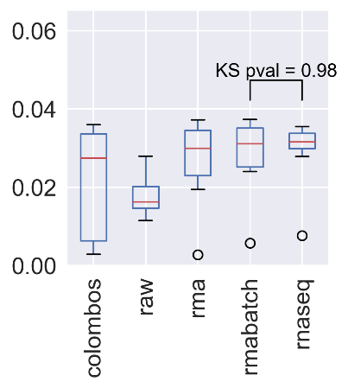
a b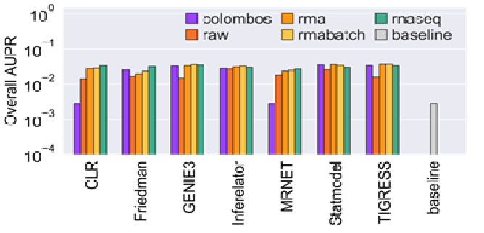

Supplementary Figure 3
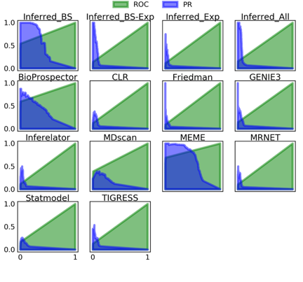
a) AUPR for the inferences from transcriptomic data. b) Distribution of the AUPR scores obtained with different datasets. KS = Kolmogorov-Smirnov between the distributions of the AUPR scores for batch-corrected RMA and RNA-seq datasets used as input for the GRNs prediction tools.

Supplementary Figure 4
ROC and PR curves for each of the inference methods and the community networks using the curated networks as GS.
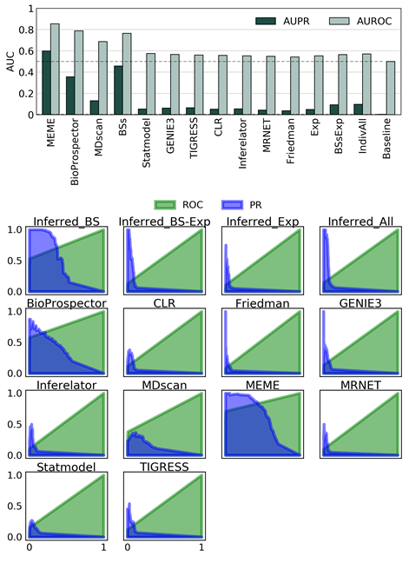

Supplementary Figure 5
AUCs for the inference methods and the community networks using the curated networks plus the statistically validated interactions as GS.

Supplementary Figure 6
ROC y PR curves for each of the inference methods and the community networks using the curated networks plus the statistically validated interactions as GS.

Topological assessment

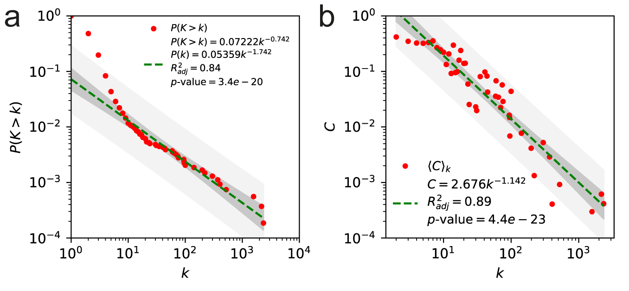

Supplementary Figure 7
a) Cumulative distribution of node connectivity and b) clustering coefficient distribution for the meta-curated network Curated_FL-DBSCR-RTB.

Some of the most relevant structural properties of the curated networks are described following. The curated networks have low network density (<1%), as have been previously reported for other bacterial regulatory networks ⁴³. Their average path lengths are smaller than the logarithm of the network size, $\ln{(ln(N))}$, which indicates that they are ultra-small world networks, as scale-free networks ⁴⁴. From the robust linear regression over the log-log data, the degree distributions ($P(k)$) follow a power-law, suggesting that they are scale-free (Supplementary Figure 7). Regarding the clustering coefficient distribution ($C(k)$), the networks seemed to be hierarchical modular. Both characteristics were previously observed in diverse bacterial networks ⁴⁵. We computed the Kolmogorov-Smirnov distance between the networks’ degree distribution and several probability functions, and a maximum likelihood estimation for their α to corroborate that the curated networks are scale-free. Except for Curated_DBSCR(S) that has a similar distance between its degree distribution to a power law and a log-normal, the degree distributions of all the curated networks have the smallest distance to a power law distribution (Supplementary Table 6a). For the α estimation values between two and three for the curated networks (Supplementary Table 6b), we can corroborate that the curated networks are scale-free as other bacterial GRNs ⁴³

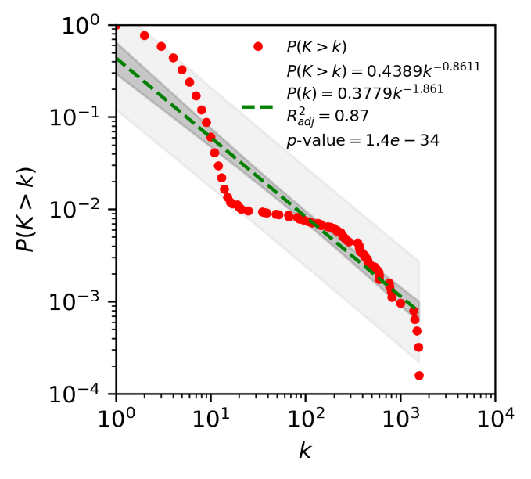
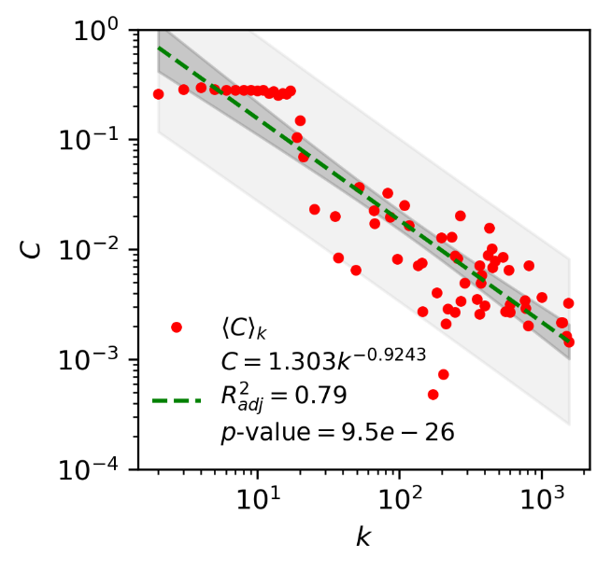

Supplementary Figure 8
Cumulative distribution of node connectivity and distribution of node clustering coefficient of community network Inferred_BS.

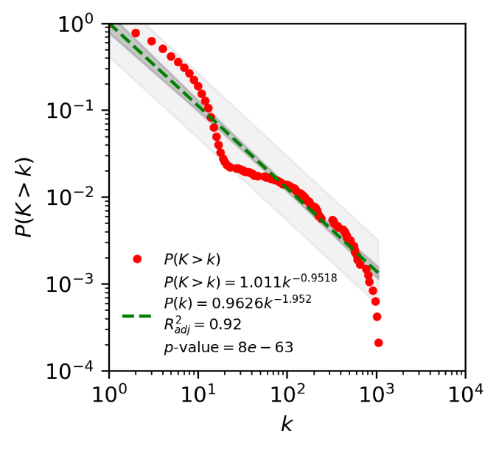
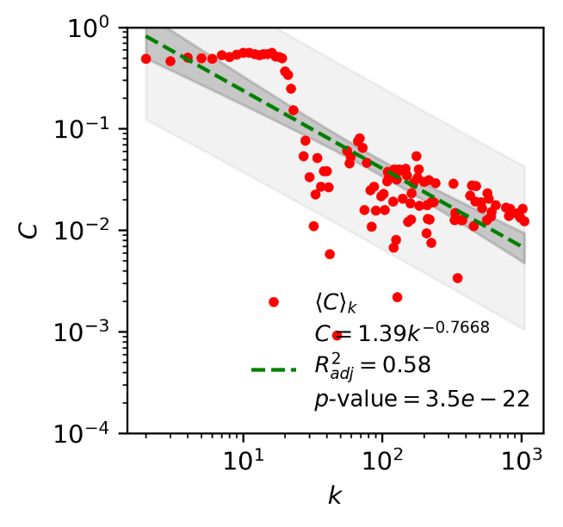

Supplementary Figure 9
Cumulative distribution of node connectivity and distribution of node clustering coefficient of community network Inferred_Exp.

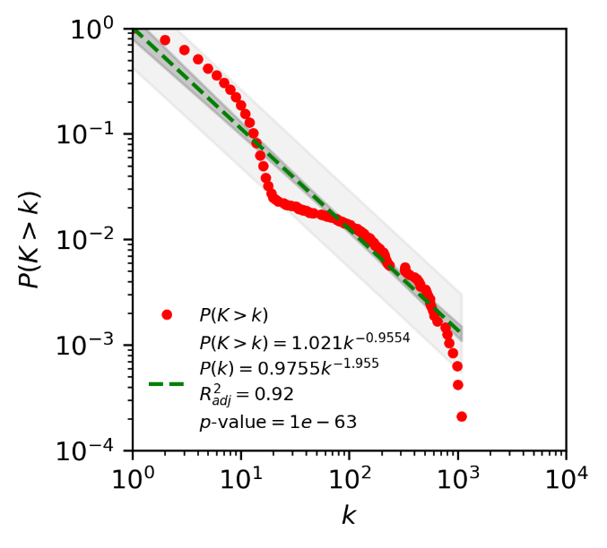
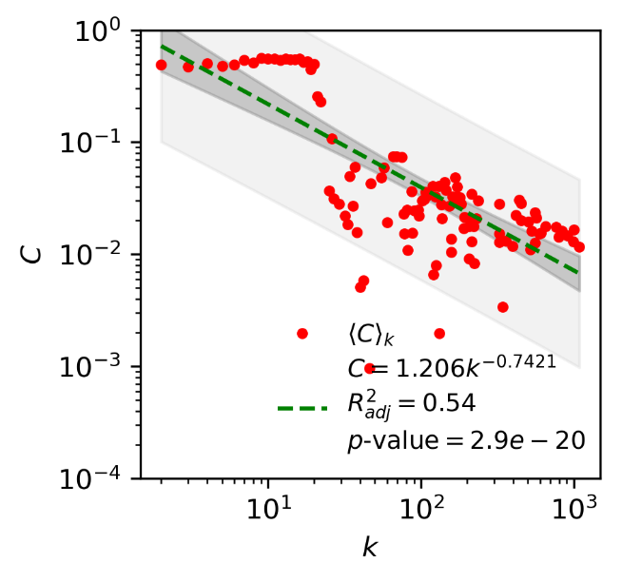

Supplementary Figure 10
Cumulative distribution of node connectivity and distribution of node clustering coefficient of community network Inferred_BS-Exp.

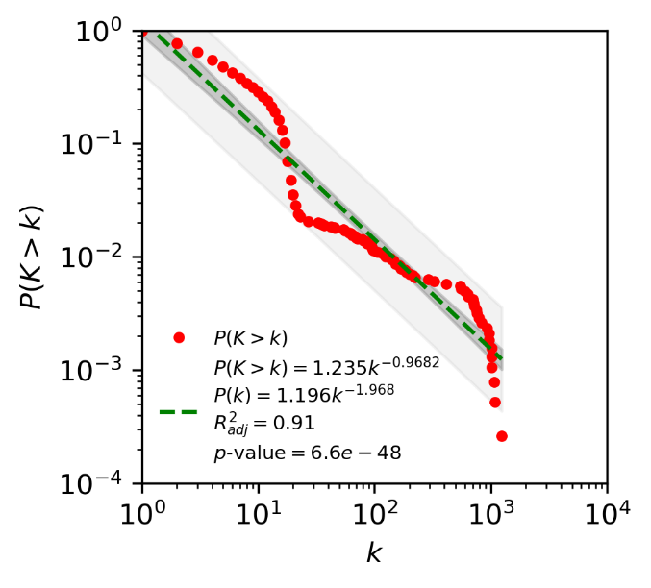
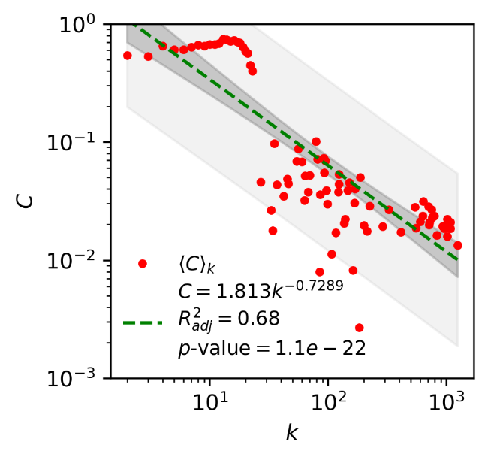

Supplementary Figure 11
Cumulative distribution of node connectivity and distribution of node clustering coefficient of community network Inferred_All.

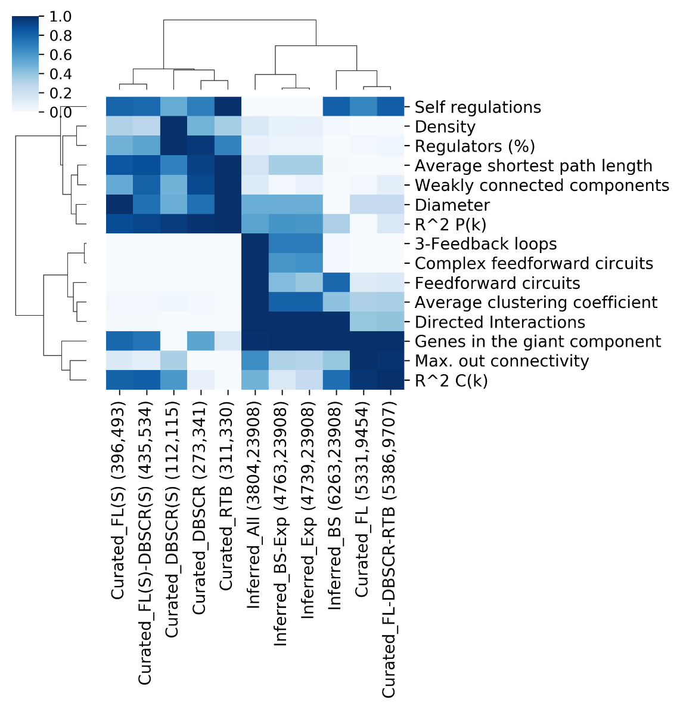

Supplementary Figure 12

Comparative of network properties. Min-max normalization was applied for each property across networks. Aside from each network is their cognate number of nodes and interactions are displayed.

Assessment of the global regulators' inference
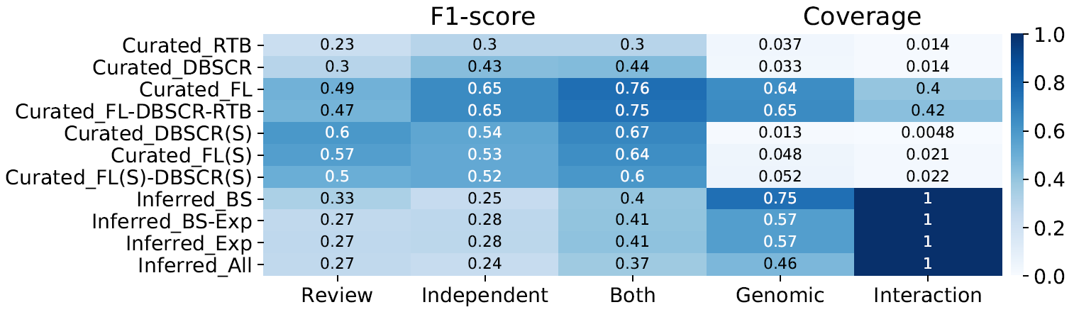

Supplementary Figure 13
F1-score for global regulators predicted by NDA for each of the curated and inferred networks. Scores ≥ 0.5 are represented in white numbers.

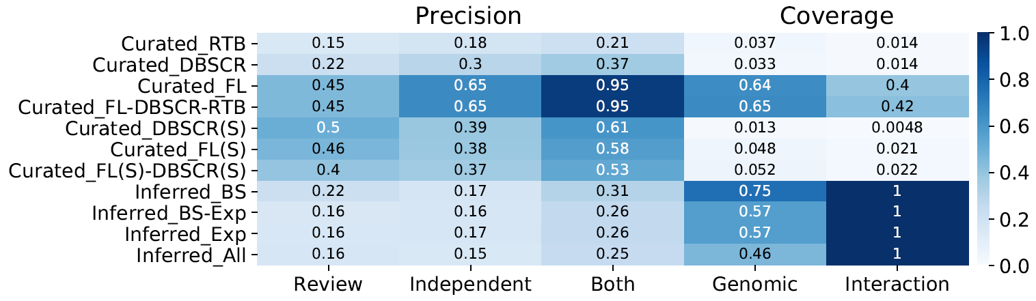

Supplementary Figure 14
Precision for global regulators predicted by NDA for each of the curated and inferred networks. Scores ≥ 0.5 are represented in white numbers.

Supplementary methods

Details collected in the curation of the regulatory interactions
- TF
- TF locus tag
- TF description
- TG
- TG locus tag
- Experiment
- evidence (methodology applied for the identification of the interaction)
- regulatory function (repression, activation, unknown)
- evidence classification, interactions were classified according to the weight of the experimental evidence supporting them as “strong” (evidence of direct TF binding) or “weak” (no evidence of direct TF binding), following the RegulonDB scheme ^{46,47} (Supplementary Figure 1)
- reference PubMed ID and DOI of the paper curated; xi) year of publication; xii) notes.
- The same information is presented in supplementary table 1.

Friedman
We proposed a modification of the method ANOVA for GRN inference. In this method, the likelihood of an interaction between a transcription factor (TF) and a target gene (TG) is given by a non-linear correlation coefficient, which is derived from an analysis of variance (two-way ANOVA). The correlation coefficient measures association as the fraction of the total variance that is explained by the differential expression across experimental conditions ⁴⁸. ANOVA has some requirements for its proper application, one of them is a normal distribution. This might not be accurate for the distributions of gene expression. Thus, we proposed a variation, deriving the non-linear correlation coefficient from a Friedman test. This is the non–parametric alternative of ANOVA since it does not make assumptions of normality ⁴⁹. A Matlab implementation for the original method (Anova) and the modification (Friedman), along with their documentation can be found at https://github.com/andreazorro/Anova. The algorithm takes as input a matrix of expression data and a list of TFs, and the output is the list of TF - TG correlation coefficients.

Statmodel
We proposed a modification for GRN inference of the method Statmodel proposed by Hernandez ⁵⁰. This is a method for Statistical Modeling and Analysis of Experiments without ANOVA, wherein its purpose is to achieve a more dependable real-world experimental analysis. This, since ANOVA, has many requirements, which if they are not fulfilled, could cause misleading conclusions. In this method, the test of the hypothesis required by the statistical analysis is performed using optimal parameter identification. After some mathematical treatment of the data, a hypothesis test is performed using parameter identification to evaluate whether the influence of a variable is significantly different from zero on the response variable. In this case, we are evaluating the influence of a TF's expression on a gene’s expression. We proposed a score for the reliability of the interaction as the $-\log{ \left(\text{p-value}\right)}$ of the hypothesis test ⁵⁰. Its Matlab implementation along with its documentation can be found at https://github.com/andreazorro/Statmodel. The algorithm takes as input a matrix of expression data and a list of TFs, and the output is the list of TF-TG reliability scores.

The Natural Decomposition Approach
First, the NDA identifies the global regulators (GRs) as genes with higher out connectivity than the κ value, the equilibrium point from the $C(k)$ distribution where the variation of the clustering coefficient is equal to the variation of the connectivity but with the opposite sign dC(k)/dk = -1. Then, the genes from the basal machinery are revealed as those regulated only by GRs. After the removal of the GRs and the genes from the basal machinery, as well as their interactions, the structural genes are removed, leaving isolated subnetworks (modules). Then, the structural genes are re-integrated as intermodular genes if their regulators belong to different modules, otherwise as modular genes belonging to the same module as their regulators.

Supplementary references
1 Sola-Landa, A., Rodriguez-Garcia, A., Franco-Dominguez, E. & Martin, J. F. Binding of PhoP to promoters of phosphate-regulated genes in Streptomyces coelicolor: identification of PHO boxes. Mol Microbiol 56, 1373-1385, doi:10.1111/j.1365-2958.2005.04631.x (2005).
2 Rodriguez-Garcia, A., Barreiro, C., Santos-Beneit, F., Sola-Landa, A. & Martin, J. F. Genome-wide transcriptomic and proteomic analysis of the primary response to phosphate limitation in Streptomyces coelicolor M145 and in a DeltaphoP mutant. Proteomics 7, 2410-2429, doi:10.1002/pmic.200600883 (2007).
3 Apel, A. K., Sola-Landa, A., Rodriguez-Garcia, A. & Martin, J. F. Phosphate control of phoA, phoC and phoD gene expression in Streptomyces coelicolor reveals significant differences in binding of PhoP to their promoter regions. Microbiology (Reading) 153, 3527-3537, doi:10.1099/mic.0.2007/007070-0 (2007).
4 Sola-Landa, A., Rodriguez-Garcia, A., Apel, A. K. & Martin, J. F. Target genes and structure of the direct repeats in the DNA-binding sequences of the response regulator PhoP in Streptomyces coelicolor. Nucleic Acids Res 36, 1358-1368, doi:10.1093/nar/gkm1150 (2008).
5 Santos-Beneit, F., Rodriguez-Garcia, A., Sola-Landa, A. & Martin, J. F. Cross-talk between two global regulators in Streptomyces: PhoP and AfsR interact in the control of afsS, pstS and phoRP transcription. Mol Microbiol 72, 53-68, doi:10.1111/j.1365-2958.2009.06624.x (2009).
6 Rodriguez-Garcia, A., Sola-Landa, A., Apel, K., Santos-Beneit, F. & Martin, J. F. Phosphate control over nitrogen metabolism in Streptomyces coelicolor: direct and indirect negative control of glnR, glnA, glnII and amtB expression by the response regulator PhoP. Nucleic Acids Res 37, 3230-3242, doi:10.1093/nar/gkp162 (2009).
7 Santos-Beneit, F., Rodriguez-Garcia, A., Apel, A. K. & Martin, J. F. Phosphate and carbon source regulation of two PhoP-dependent glycerophosphodiester phosphodiesterase genes of Streptomyces coelicolor. Microbiology (Reading) 155, 1800-1811, doi:10.1099/mic.0.026799-0 (2009).
8 Santos-Beneit, F. et al. The RNA polymerase omega factor RpoZ is regulated by PhoP and has an important role in antibiotic biosynthesis and morphological differentiation in Streptomyces coelicolor. Appl Environ Microbiol 77, 7586-7594, doi:10.1128/AEM.00465-11 (2011).
9 Allenby, N. E., Laing, E., Bucca, G., Kierzek, A. M. & Smith, C. P. Diverse control of metabolism and other cellular processes in Streptomyces coelicolor by the PhoP transcription factor: genome-wide identification of in vivo targets. Nucleic Acids Res 40, 9543-9556, doi:10.1093/nar/gks766 (2012).
10 Tiffert, Y. et al. The Streptomyces coelicolor GlnR regulon: identification of new GlnR targets and evidence for a central role of GlnR in nitrogen metabolism in actinomycetes. Mol Microbiol 67, 861-880, doi:10.1111/j.1365-2958.2007.06092.x (2008).
11 Wang, J. & Zhao, G. P. GlnR positively regulates nasA transcription in Streptomyces coelicolor. Biochem Biophys Res Commun 386, 77-81, doi:10.1016/j.bbrc.2009.05.147 (2009).
12 Amin, R., Reuther, J., Bera, A., Wohlleben, W. & Mast, Y. A novel GlnR target gene, nnaR, is involved in nitrate/nitrite assimilation in Streptomyces coelicolor. Microbiology 158, 1172-1182, doi:10.1099/mic.0.054817-0 (2012).
13 Wang, R. et al. Identification of two-component system AfsQ1/Q2 regulon and its cross-regulation with GlnR in Streptomyces coelicolor. Mol Microbiol 87, 30-48, doi:10.1111/mmi.12080 (2013).
14 Shao, Z. et al. GlnR-Mediated Regulation of ectABCD Transcription Expands the Role of the GlnR Regulon to Osmotic Stress Management. J Bacteriol 197, 3041-3047, doi:10.1128/JB.00185-15 (2015).
15 Cen, X. F., Wang, J. Z., Zhao, G. P., Wang, Y. & Wang, J. Molecular evidence for the coordination of nitrogen and carbon metabolisms, revealed by a study on the transcriptional regulation of the agl3EFG operon that encodes a putative carbohydrate transporter in Streptomyces coelicolor. Biochem Biophys Res Commun 471, 510-514, doi:10.1016/j.bbrc.2016.02.044 (2016).
16 He, J. M. et al. Direct Involvement of the Master Nitrogen Metabolism Regulator GlnR in Antibiotic Biosynthesis in Streptomyces. J Biol Chem 291, 26443-26454, doi:10.1074/jbc.M116.762476 (2016).
17 Kang, J. G., Hahn, M. Y., Ishihama, A. & Roe, J. H. Identification of sigma factors for growth phase-related promoter selectivity of RNA polymerases from Streptomyces coelicolor A3(2). Nucleic Acids Res 25, 2566-2573, doi:10.1093/nar/25.13.2566 (1997).
18 Paget, M. S., Kang, J. G., Roe, J. H. & Buttner, M. J. sigmaR, an RNA polymerase sigma factor that modulates expression of the thioredoxin system in response to oxidative stress in Streptomyces coelicolor A3(2). EMBO J 17, 5776-5782, doi:10.1093/emboj/17.19.5776 (1998).
19 Paget, M. S. et al. Mutational analysis of RsrA, a zinc-binding anti-sigma factor with a thiol-disulphide redox switch. Mol Microbiol 39, 1036-1047, doi:10.1046/j.1365-2958.2001.02298.x (2001).
20 Paget, M. S., Molle, V., Cohen, G., Aharonowitz, Y. & Buttner, M. J. Defining the disulphide stress response in Streptomyces coelicolor A3(2): identification of the sigmaR regulon. Mol Microbiol 42, 1007-1020, doi:10.1046/j.1365-2958.2001.02675.x (2001).
21 Park, J. H. & Roe, J. H. Mycothiol regulates and is regulated by a thiol-specific antisigma factor RsrA and sigma(R) in Streptomyces coelicolor. Mol Microbiol 68, 861-870, doi:10.1111/j.1365-2958.2008.06191.x (2008).
22 Kallifidas, D., Thomas, D., Doughty, P. & Paget, M. S. B. The sigmaR regulon of Streptomyces coelicolor A32 reveals a key role in protein quality control during disulphide stress. Microbiology 156, 1661-1672, doi:10.1099/mic.0.037804-0 (2010).
23 Kim, M. S. et al. Conservation of thiol-oxidative stress responses regulated by SigR orthologues in actinomycetes. Mol Microbiol 85, 326-344, doi:10.1111/j.1365-2958.2012.08115.x (2012).
24 Martín, J. F., Santos-Beneit, F., Sola-Landa, A. & Liras, P. in Stress and Environmental Regulation of Gene Expression and Adaptation in Bacteria (ed Frans J. de Bruijn) 257-267 (John Wiley & Sons, Inc., 2016).
25 Park, J. H., Lee, J. H. & Roe, J. H. SigR, a hub of multilayered regulation of redox and antibiotic stress responses. Mol Microbiol 112, 420-431, doi:10.1111/mmi.14341 (2019).
26 Li, X. et al. ScbR- and ScbR2-mediated signal transduction networks coordinate complex physiological responses in Streptomyces coelicolor. Sci Rep 5, 14831, doi:10.1038/srep14831 (2015).
27 Lopez-Garcia, M. T., Yague, P., Gonzalez-Quinonez, N., Rioseras, B. & Manteca, A. The SCO4117 ECF Sigma Factor Pleiotropically Controls Secondary Metabolism and Morphogenesis in Streptomyces coelicolor. Front Microbiol 9, 312, doi:10.3389/fmicb.2018.00312 (2018).
28 Arroyo-Perez, E. E., Gonzalez-Ceron, G., Soberon-Chavez, G., Georgellis, D. & Servin-Gonzalez, L. A Novel Two-Component System, Encoded by the sco5282/sco5283 Genes, Affects Streptomyces coelicolor Morphology in Liquid Culture. Front Microbiol 10, 1568, doi:10.3389/fmicb.2019.01568 (2019).
29 Lu, X. et al. The ROK-family regulator Rok7B7 directly controls carbon catabolite repression, antibiotic biosynthesis, and morphological development in Streptomyces avermitilis. Environmental Microbiology, doi:10.1111/1462-2920.15094 (2020).
30 Guerra, S. M. et al. LAL regulators SCO0877 and SCO7173 as pleiotropic modulators of phosphate starvation response and actinorhodin biosynthesis in Streptomyces coelicolor. PLoS One 7, e31475, doi:10.1371/journal.pone.0031475 (2012).
31 Rozas, D., Gullon, S. & Mellado, R. P. A novel two-component system involved in the transition to secondary metabolism in Streptomyces coelicolor. PLoS One 7, e31760, doi:10.1371/journal.pone.0031760 (2012).
32 Antoraz, S. et al. The Orphan Response Regulator Aor1 Is a New Relevant Piece in the Complex Puzzle of Streptomyces coelicolor Antibiotic Regulatory Network. Front Microbiol 8, 2444, doi:10.3389/fmicb.2017.02444 (2017).
33 Lee, H. N., Kim, J. S., Kim, P., Lee, H. S. & Kim, E. S. Repression of antibiotic downregulator WblA by AdpA in Streptomyces coelicolor. Appl Environ Microbiol 79, 4159-4163, doi:10.1128/AEM.00546-13 (2013).
34 Buttner, M. J., Chater, K. F. & Bibb, M. J. Cloning, disruption, and transcriptional analysis of three RNA polymerase sigma factor genes of Streptomyces coelicolor A3(2). J Bacteriol 172, 3367-3378, doi:10.1128/jb.172.6.3367-3378.1990 (1990).
35 Hong, H. J., Paget, M. S. & Buttner, M. J. A signal transduction system in Streptomyces coelicolor that activates the expression of a putative cell wall glycan operon in response to vancomycin and other cell wall-specific antibiotics. Mol Microbiol 44, 1199-1211, doi:10.1046/j.1365-2958.2002.02960.x (2002).
36 Hutchings, M. I., Hong, H. J., Leibovitz, E., Sutcliffe, I. C. & Buttner, M. J. The sigma(E) cell envelope stress response of Streptomyces coelicolor is influenced by a novel lipoprotein, CseA. J Bacteriol 188, 7222-7229, doi:10.1128/JB.00818-06 (2006).
37 Keijser, B. J., Noens, E. E., Kraal, B., Koerten, H. K. & van Wezel, G. P. The Streptomyces coelicolor ssgB gene is required for early stages of sporulation. FEMS Microbiol Lett 225, 59-67, doi:10.1016/S0378-1097(03)00481-6 (2003).
38 Wang, Y., Cen, X. F., Zhao, G. P. & Wang, J. Characterization of a new GlnR binding box in the promoter of amtB in Streptomyces coelicolor inferred a PhoP/GlnR competitive binding mechanism for transcriptional regulation of amtB. J Bacteriol 194, 5237-5244, doi:10.1128/JB.00989-12 (2012).
39 Rokem, J. S., Lantz, A. E. & Nielsen, J. Systems biology of antibiotic production by microorganisms. Nat Prod Rep 24, 1262-1287, doi:10.1039/b617765b (2007).
40 Lai, C. et al. Genetic and physiological characterization of rpoB mutations that activate antibiotic production in Streptomyces lividans. Microbiology 148, 3365-3373, doi:10.1099/00221287-148-11-3365 (2002).
41 Hillerich, B. & Westpheling, J. A new GntR family transcriptional regulator in streptomyces coelicolor is required for morphogenesis and antibiotic production and controls transcription of an ABC transporter in response to carbon source. J Bacteriol 188, 7477-7487, doi:10.1128/JB.00898-06 (2006).
42 Martin, J. F. et al. Cross-talk of global nutritional regulators in the control of primary and secondary metabolism in Streptomyces. Microb Biotechnol 4, 165-174, doi:10.1111/j.1751-7915.2010.00235.x (2011).
43 Campos, A. I. & Freyre-Gonzalez, J. A. Evolutionary constraints on the complexity of genetic regulatory networks allow predictions of the total number of genetic interactions. Sci Rep 9, 3618, doi:10.1038/s41598-019-39866-z (2019).
44 Barabasi, A. L. & Oltvai, Z. N. Network biology: understanding the cell's functional organization. Nat Rev Genet 5, 101-113, doi:10.1038/nrg1272 (2004).
45 Ibarra-Arellano, M. A., Campos-Gonzalez, A. I., Trevino-Quintanilla, L. G., Tauch, A. & Freyre-Gonzalez, J. A. Abasy Atlas: a comprehensive inventory of systems, global network properties and systems-level elements across bacteria. Database (Oxford) 2016, doi:10.1093/database/baw089 (2016).
46 Santos-Zavaleta, A. et al. RegulonDB v 10.5: tackling challenges to unify classic and high throughput knowledge of gene regulation in E. coli K-12. Nucleic Acids Res 47, D212-D220, doi:10.1093/nar/gky1077 (2019).
47 Weiss, V. et al. Evidence classification of high-throughput protocols and confidence integration in RegulonDB. Database (Oxford) 2013, bas059, doi:10.1093/database/bas059 (2013).
48 Kuffner, R., Petri, T., Tavakkolkhah, P., Windhager, L. & Zimmer, R. Inferring gene regulatory networks by ANOVA. Bioinformatics 28, 1376-1382, doi:10.1093/bioinformatics/bts143 (2012).
49 Hoffman, J. I. E. in Biostatistics for Medical and Biomedical Practitioners (ed Julien I. E. Hoffman) 421-447 (Academic Press, 2015).
50 Hernandez, H. Statistical Modeling and Analysis of Experiments without ANOVA. (2018).

