Supporting Information
Study on the Electrochemical Performance of MOF-Derived Mn₂O₃ Electrode Materials on Magnesium Ion Capacitors
Ping-Ping Sunª, Yun-Heng Liª, Bo Yang^{b}, Hai-Yan Liuª*
ª The Foundation of Liaoning Provincial Key Laboratory of Energy Storage and Utilization, Yingkou Institute of Technology, Yingkou 115014, China
^{b}Shenghong Refining & Chemical (Lianyungang) Co., Ltd. 2220651,China
Email addresses: liuhaiyan2025@foxmail.com (H.-Y. Liu)

Figure List
Figure S1 The unit cell of 26p-Mn-MOF along different view of a) a axis, b) b axis, c) c axis.
Figure S2 The unit cell of 26p-Mn-MOF along different view of a) a axis, b) b axis, c) c axis.
Figure S3 The XRD patterns of 26p-Mn-MOF
Figure S4 The morphologies of the 26p-Mn-MOF in different at different magnification levels (a) 1000 times, (b) 5000 times.
Figure S5 The morphologies of the samples after being calcined at 500℃(a-b) and 700℃ (c-d).
Figure S6 CV curves of a) Mn2O3-500 and b) Mn2O3-700.
Figure S7 Determination of the b value using the relationship between peak current and scan rate of a) Mn2O3-500 and b) Mn2O3-700.
Figure S8 a-e)The proportion of double-layer contribution and pseudo-capacitive contribution of Mn2O3-600 at different sweep rates of 10-100 mV s-1
Figure S9 a-e)The proportion of double-layer contribution and pseudo-capacitive contribution of Mn2O3-500 at different sweep rates of 10-100 mV s-1
Figure S10 a-e)The proportion of double-layer contribution and pseudo-capacitive contribution of Mn2O3-700 at different sweep rates of 10-100 mV s-1
Figure S11 Discharge time of a) Mn2O3-500 and b) Mn2O3-700 at 1-8 A g-1 current density.
Figure S12 The GCD curve of activated carbon at an current density of 1 A g-1.

Table List
Table S1 Reagent Information
Table S2 Crystallographic data and refinement parameters for 26p-Mn-MOF
Table S3 Selected bond lengths (Å) for the 26p-Mn-MOF.
Table S4 Selected bond angles for the 26p-Mn-MOF.
Table S5 Hydrogen Bonds for 26p-Mn-MOF.

Materials characterization
The structures of samples were analyzed by powder X-ray Diffraction (PXRD), implemented on MiniFlex600 diffractometer (40 kV, 15mA, Cu Kα λ=0.15405nm) in a 2-theta range from 5 to 50° by continuous scanning, with a sampling interval of 0.0200°and a scanning speed of 5° min⁻¹. The diffraction data was collected by single-crystal X-ray diffractometer on a SuperNova CCD operated at 50 kV and 0.8 mA using Mo Kɑ radiation (λ=0.071073nm) at 294 K. The specific test parameters refer to other reports .

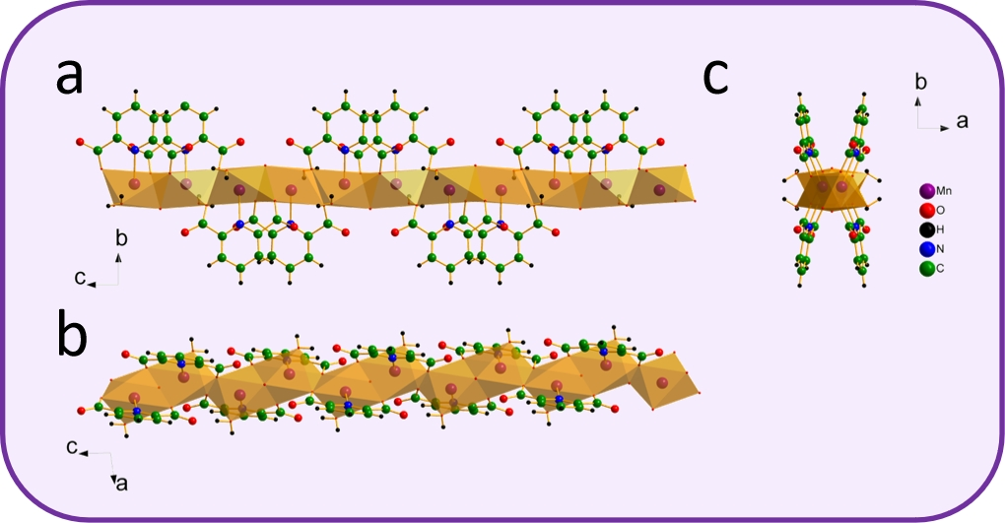
Figure S1 The unit cell of 26p-Mn-MOF along different view of a) a axis, b) b axis, c) c axis.

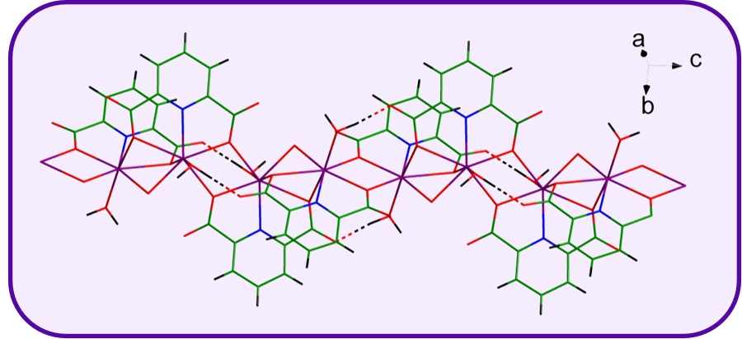
Figure S2 Wire frame view of the super cell structure of 26p-Mn-MOF, the dotted lines show H-bond.

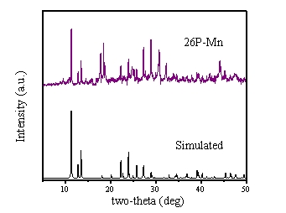
Figure S3 The XRD patterns of 26p-Mn-MOF

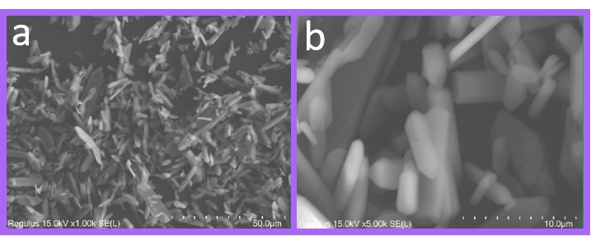
Figure S4 The morphologies of the 26p-Mn-MOF in different at different magnification levels (a) 1000 times, (b) 5000 times.

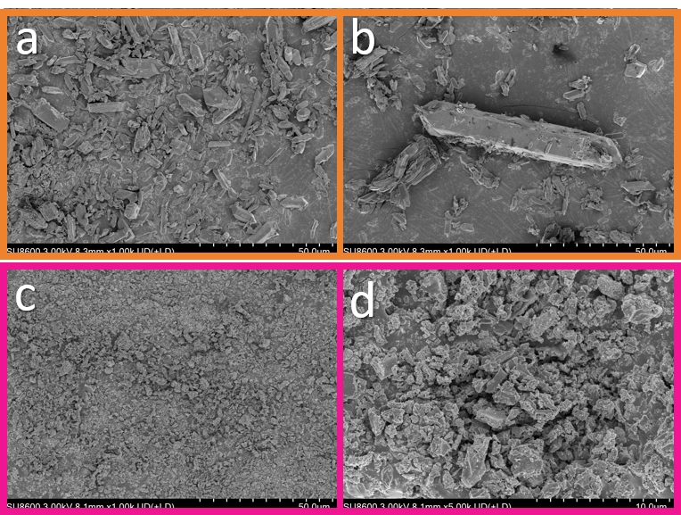
Figure S5 The morphologies of the samples after being calcined at 500℃(a-b) and 700℃ (c-d).

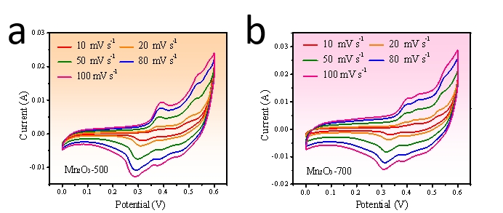
Figure S6 CV curves of a) Mn₂O₃-500 and b) Mn₂O₃-700.
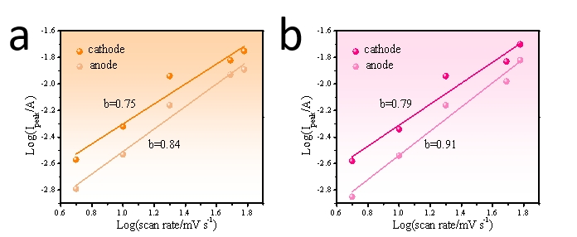
Figure S7 Determination of the b value using the relationship between peak current and scan rate of a) Mn₂O₃-500 and b) Mn₂O₃-700.

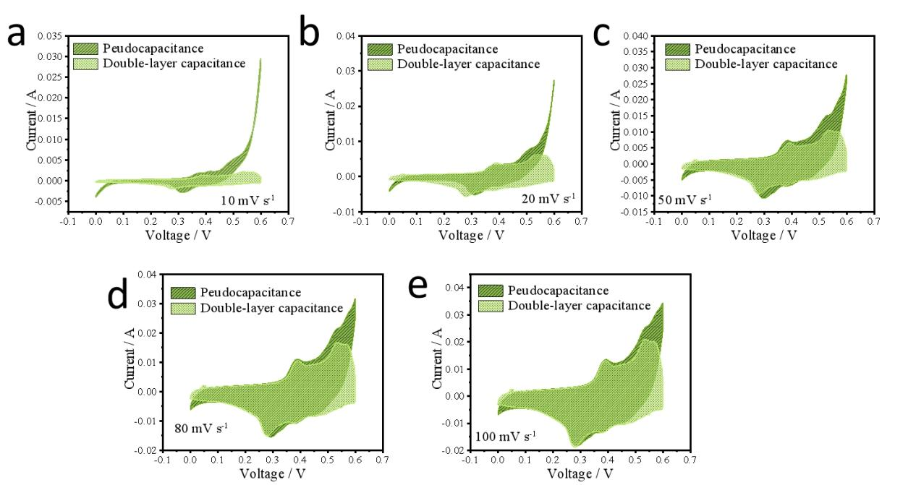
Figure S8 a-e)The proportion of double-layer contribution and pseudo-capacitive contribution of Mn₂O₃-600 at different sweep rates of 10-100 mV s⁻¹

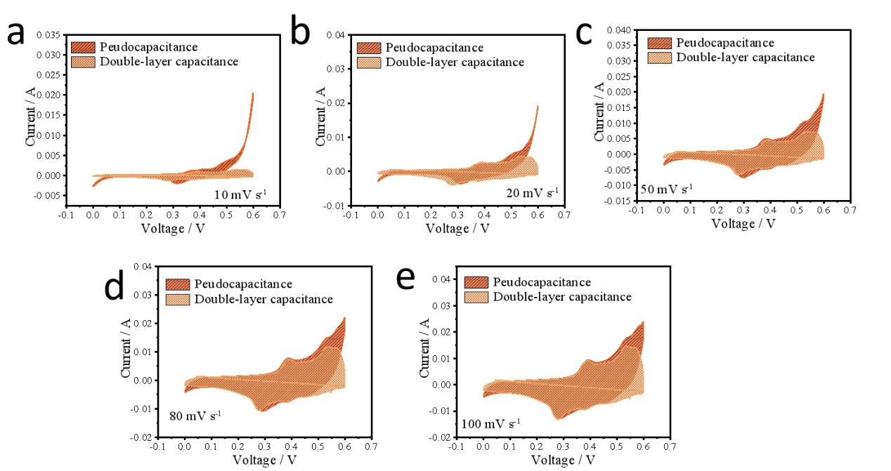
Figure S9 a-e)The proportion of double-layer contribution and pseudo-capacitive contribution of Mn₂O₃-500 at different sweep rates of 10-100 mV s⁻¹
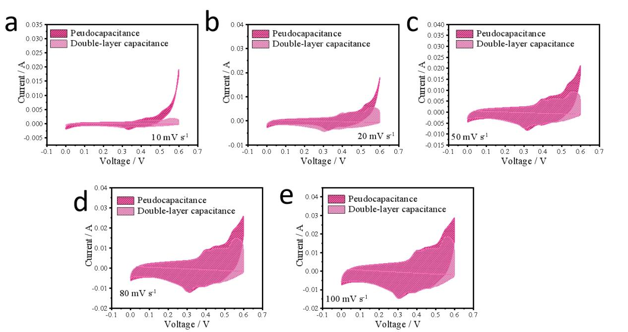
Figure S10 a-e)The proportion of double-layer contribution and pseudo-capacitive contribution of Mn₂O₃-700 at different sweep rates of 10-100 mV s⁻¹
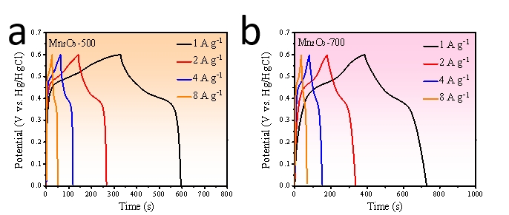
Figure S11 Discharge time of a) Mn₂O₃-500 and b) Mn₂O₃-700 at 1-8 A g⁻¹ current density.
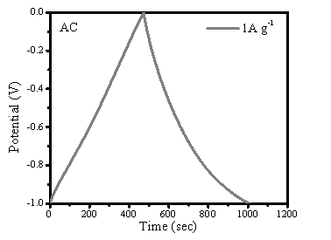
Figure S12 The GCD curve of activated carbon at an current density of 1 A g⁻¹.

Table S1 Reagent Information
Name | Purity | Manufacturer
2,6-Pyridine dicarboxylic acid | 99.0% | Afaisa reagent
Anhydrous magnesium sulfate | 99.0% | Afaisa reagent
Manganese acetate | 99.0% | Afaisa reagent
Potassium hydroxide | 99.0% | Afaisa reagent
Acetylene black | 99.0% | Afaisa reagent
Polyvinylidene fluoride (PVDF) | 99.0% | Afaisa reagent
N-Methylpyrrolidone (NMP) | 99.0% | Afaisa reagent

Table S2 Crystallographic data and refinement parameters for 26p-Mn-MOF
parameters | values
Empirical formula | C₁₄H₁₀Mn₂N₂O₁₁
Formula weight | 500.1
Temperature/K | 293(2)
Crystal system | monoclinic
Space group | C2/c
a/Å | 13.1954(10)
b/Å | 9.7333(6)
c/Å | 13.1363(9)
α/° | 90
β/° | 96.144(7)
γ/° | 90
Volume/Å³ | 1677.5(2)
Z | 4
Densityg/cm³ | 1.984
μ/mm⁻¹ | 1.615
F(000) | 1001.0
2Θ range for data collection/° | 7.872 to 65.072
Index ranges | -19 ≤ h ≤ 19, -14 ≤ k ≤ 14, -18 ≤ l ≤ 18
Reflections collected | 8232
Independent reflections | 2816 [R_{int} = 0.0581, R_{sigma} = 0.0795]
Data/restraints/parameters | 2816/0/130
Goodness-of-fit on F² | 0.975
Final R indexes [I>=2σ (I)] | R₁ = 0.0590, wR₂ = 0.1493
Final R indexes [all data] | R₁ = 0.0867, wR₂ = 0.1776
CCDC number | 2106211

Table S3 Selected bond lengths (Å) for the 26p-Mn-MOF.
 | Bond length |  | Bond length
Mn1-O2¹ | 2.268(2) | Mn1-O6 | 2.492(2)
Mn1-O2² | 2.256(2) | Mn1-O4¹ | 2.125(3)
Mn1-O4 | 2.167(2) | Mn1-N1 | 2.289(3)
Mn1-O3 | 2.274(2)
Symmetric code:¹1-X,+Y,3/2-Z; ²+X,1-Y,1/2+Z;

Table S4 Selected bond angles for the 26p-Mn-MOF.
 | Angle/˚ |  | Angle/˚
O2¹-Mn1-O2² | 70.82(9) | O4-Mn1-O4² | 78.99(9)
O2¹-Mn1-O4² | 150.95(8) | O4-Mn1-N1² | 90.73(10)
O2²-Mn1-O4² | 136.90(8) | O4-Mn1-O3 | 74.03(8)
O2¹-Mn1-N1² | 140.54(8) | O6-Mn1-O2² | 88.63(10)
O2²-Mn1-N1² | 70.78(8) | O6-Mn1-O2¹ | 83.55(10)
O2¹-Mn1-O2² | 83.43(7) | O6-Mn1-O4 | 164.31(10)
O2²-Mn1-O3 | 154.03(7) | O6-Mn1-O4² | 102.51(9)
O4-Mn1-O2¹ | 87.89(10) | O6-Mn1-N1² | 104.23(11)
O4-Mn1-O2² | 100.97(9) | O6-Mn1-O3 | 91.89(10)
N1²-Mn1-O4² | 66.14(8) | O3-Mn1-O4² | 68.12(7)
O3-Mn1-N1² | 133.73(8)
Symmetric code:¹1-X,+Y,3/2-Z; ²+X,1-Y,1/2+Z;

Table S5 Hydrogen Bonds for 26p-Mn-MOF.
D H A | d(D-H)/Å | d(H-A)/Å | d(D-A)/Å | D-H-A/°
O6 H6A O5¹ | 0.95 | 2.12 | 2.725(4) | 120.4
O6 H6B O5² | 0.95 | 1.85 | 2.789(3) | 170.2
Symmetric code:¹1-X,+Y,3/2-Z; ²+X,1-Y,1/2+Z;

Table S6 Specific fitting values of EIS.
Sample | R_{s} | R_{ct}
Mn₂O₃-500 | 0.93Ω | 2.32
Mn₂O₃-600 | 0.48 | 0.56
Mn₂O₃-700 | 1.09 | 1.98

