A Novel Approach Considering Spatial Heterogeneity in Tuberculosis Prediction of China
Xian Zhangª, Xiaohua Ni^{b}, Qianqian Zhang^{b}, Xiaowei Zheng^{b}, Nazrullozoda Sulaimon^{c}, Zengyun Hu^{b∗}
ªSchool of Public Health, Zhengzhou University, Zhengzhou 450001, China
^{b}School of Global Health, Chinese Center for Tropical Diseases Research, Shanghai Jiao Tong University School of Medicine, Shanghai 200025, China
^{c}Institute of Veterinary Medicine of the Tajik Academy of Agricultural Sciences, Dushanbe 734003, Republic of Tajikistan
*Corresponding author: Zengyun Hu
Email: hzyhjq@sjtu.edu.cn (Zengyun Hu)

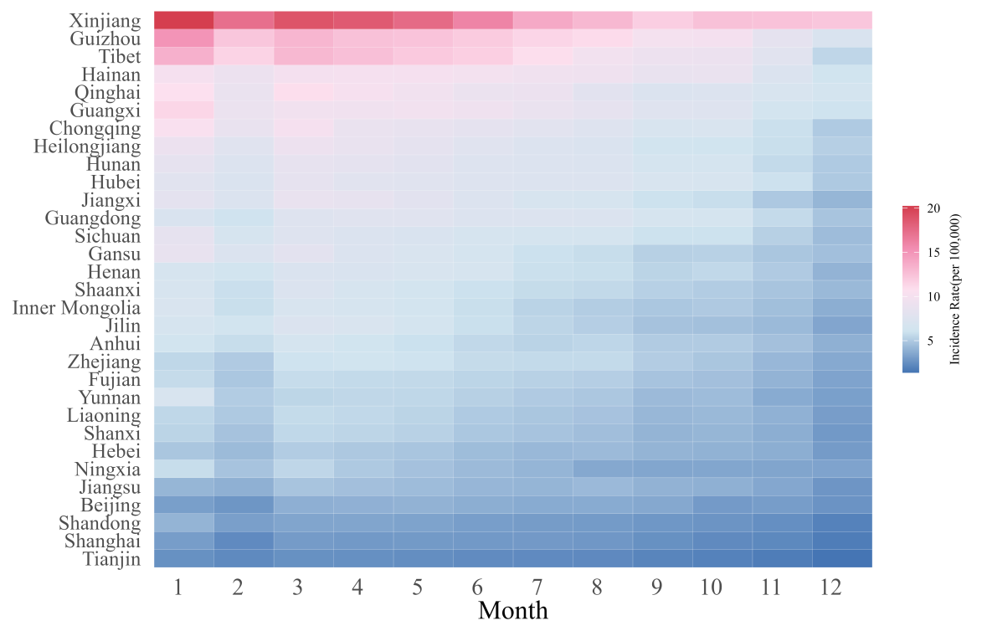
Figure S1. Spatiotemporal distribution heat map of the monthly average TB incidence in mainland China during 2004-2020

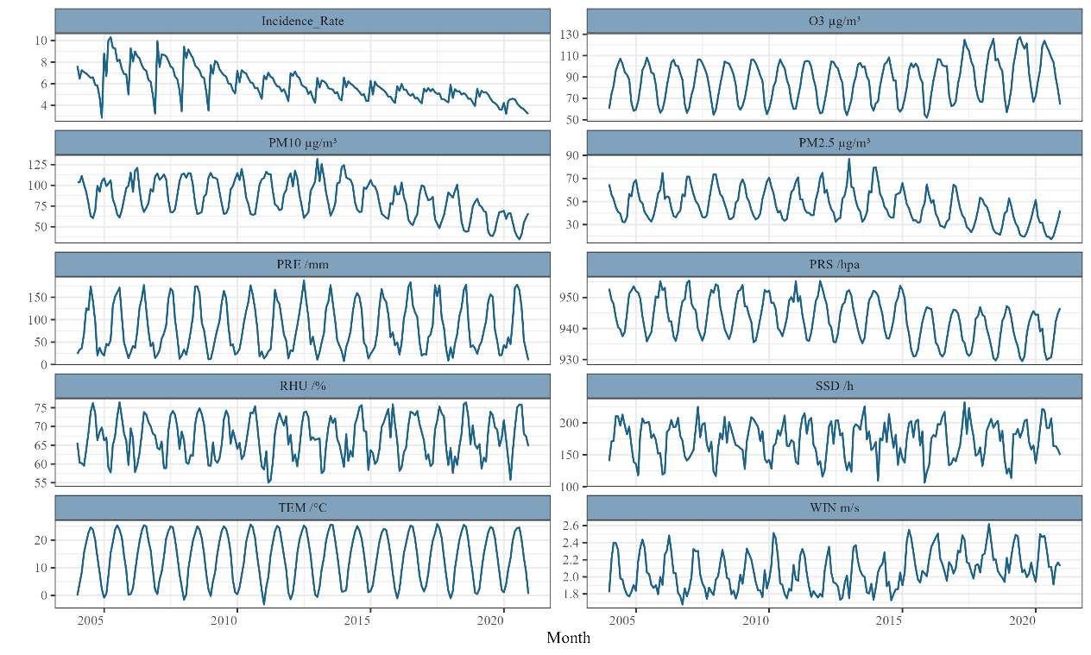
Figure S2. Temporal trends of monthly TB incidence and its associated influencing factors in mainland China

(a) | (b)
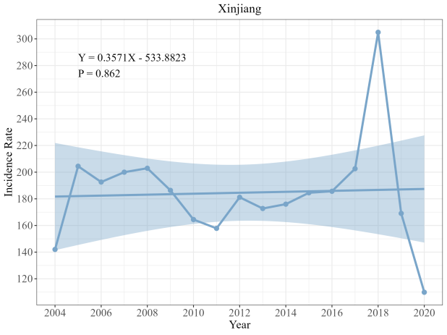 | 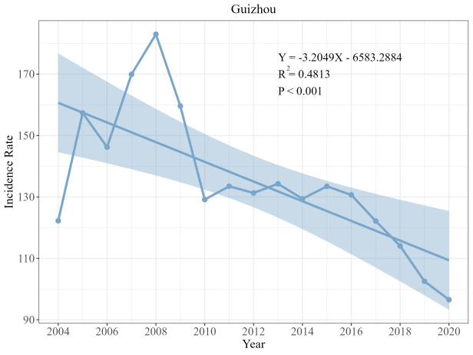
(c) | (d)
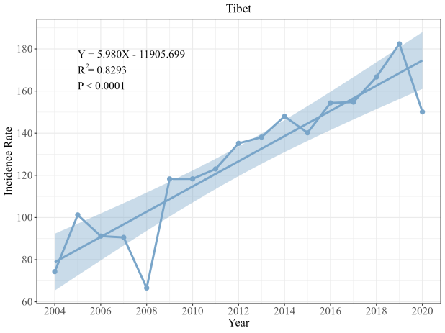 | 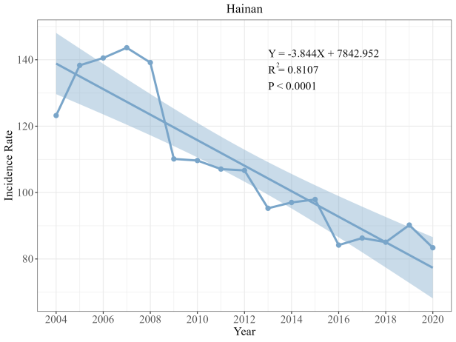
(e) | (f)
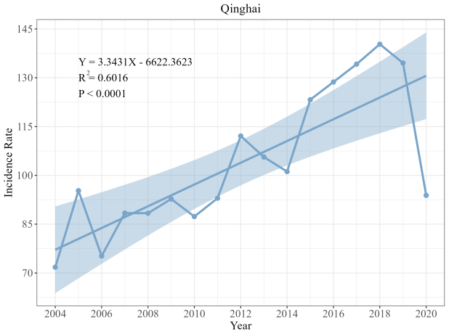 | 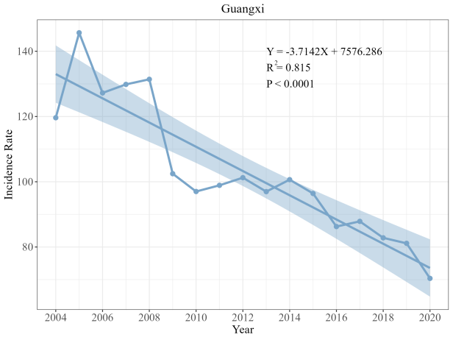
(g) | (h)
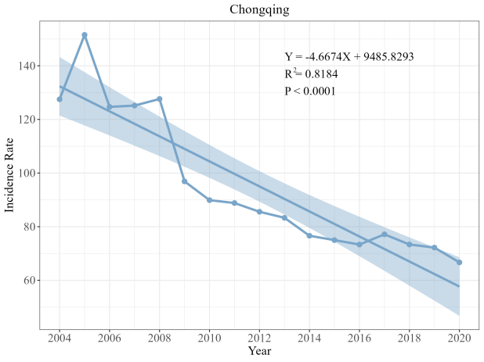 | 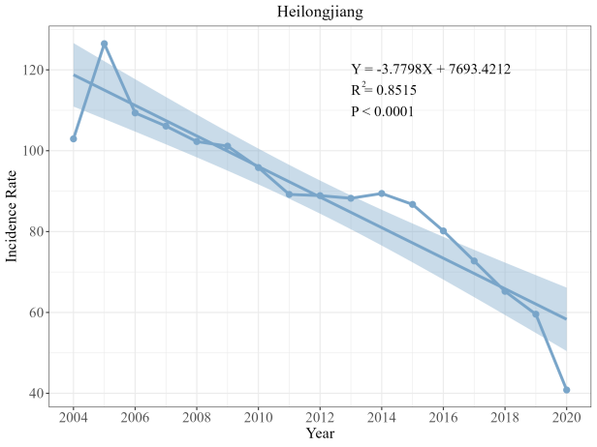
(i) | (j)
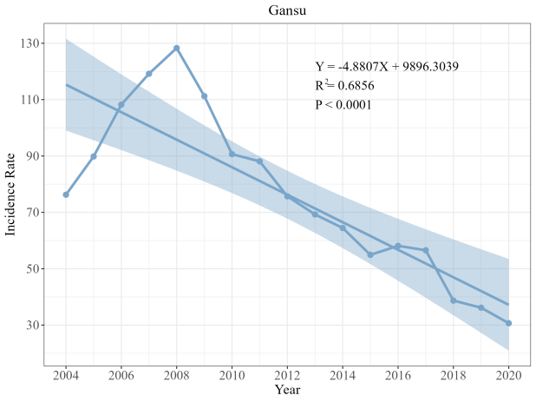 | 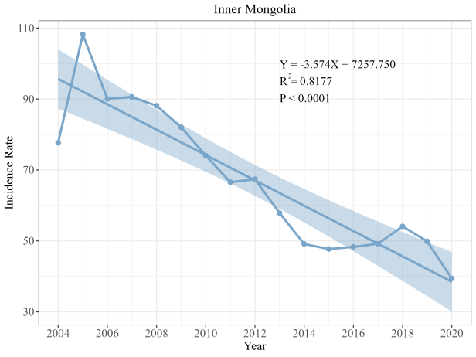
Figure S3. Linear trends in the annual incidence of TB across ten key provinces in mainland China

