Supplementary Materials
Supplementary Table 1. Comparative characteristics of Mexican mother-infant pairs.
 |  | Total  N=46 | NW  n=21 | OW/OB  n=25 | P-value
Women: n (%) or mean ± SD
Age at delivery (years) |  | 23.95 ± 5.4 | 21.86 ± 3.97 | 25.72 ± 5.91 | 0.014 ^{b}
Residence | Metropolitan area | 29 (63.0) | 11 (23.9) | 18 (39.1) | 0.170 ª
Residence | Non-Metropolitan area | 17 (37.0) | 10 (21.8) | 7 (15.2) | 0.170 ª
Maximum level of studies | Elementary School | 11 (23.91) | 6 (13.04) | 5 (10.87) | 0.391 ª
Maximum level of studies | Middle School | 27 (58.70) | 13 (28.26) | 14 (30.43) | 0.391 ª
Maximum level of studies | High school | 5 (10.87) | 2 (4.35) | 3 (6.52) | 0.391 ª
Maximum level of studies | Higher education | 3 (6.52) | 0 (0.0) | 3 (6.52) | 0.391 ª
Occupation | Workers in domestic services | 2 (4.35) | 0 (0.0) | 2 (4.35) | 0.492 ª
Occupation | Other workers with unspecified occupations | 44 (95.65) | 21 (45.65) | 23 (50.0) | 0.492 ª
High blood pressure¶ | Yes | 6 (13.04) | 0 (0.0) | 6 (13.04) | 0.016 ª
High blood pressure¶ | No | 40 (86.96) | 21 (45.65) | 19 (41.30) | 0.016 ª
Kidney disease¶ | Yes | 0 (0.0) | 0 (0.0) | 0 (0.0) | na ^{c}
Kidney disease¶ | No | 46 (100) | 21 (45.65) | 25 (54.35) | na ^{c}
Hypercholesterolemia¶ | Yes | 5 (10.87) | 0 (0.0) | 5 (10.87) | 0.030 ª
Hypercholesterolemia¶ | No | 41 (89.13) | 21 (45.65) | 20 (43.48) | 0.030 ª
Type of birth based on gestation weeks | Pre-term | 0 (0.0) | 0 (0.0) | 0 (0.0) | na ^{c}
Type of birth based on gestation weeks | Term | 46 (100) | 21 (45.65) | 25 (54.35) | na ^{c}
Initial birth type† | Spontaneous | 26 (56.52) | 14 (30.43) | 12 (26.09) | 0.203 ª
 | Induced | 20 (43.48) | 7 (15.22) | 13 (28.26)
Final birth outcome ‡ | Eutocic | 30 (65.22) | 16 (34.78) | 14 (30.43) | 0.152 ª
Final birth outcome ‡ | Dystocic | 16 (34.78) | 5 (10.87) | 11 (23.91) | 0.152 ª
Previous births (parity) |  | 1.4 ± 1.2 | 1.57 ± 1.47 | 1.28 ± 0.94 | 0.419 ^{b}
Number of children in current delivery |  | 1 ± 0.0 | 1 ± 0.0 | 1 ± 0.0 | na ^{c}
Pre-pregnancy  Systolic Blood Pressure (mmHg) |  | 114.14 ± 19.7 | 112.6 ± 14.5 | 111.3 ± 33.1 | 0.867 ^{b}
Pre-pregnancy  Diastolic Blood Pressure (mmHg) |  | 69.27 ± 10.1 | 66.43 ± 6.9 | 71.8 ± 11.8 | 0.070 ^{b}
Post-pregnancy (1stmonth)  Systolic Blood Pressure (mmHg) |  | 109.98 ± 10.9 | 106.5 ± 12.9 | 112.92 ± 8.2 | 0.057 ^{b}
Post-pregnancy (1st month)  Diastolic Blood Pressure (mmHg) |  | 74.07 ± 8.57 | 73.10 ± 9.4 | 74.88 ± 7.9 | 0.488 ^{b}
Pre-pregnancy BMI (kg/m²) |  | 27.10 ± 9.18 | 21.38 ± 2.24 | 32.3 ± 10.0 | <0.001 ^{b}
At-pregnancy BMI (kg/m²) |  | 31.52 ± 7.59 | 25.87 ± 3.11 | 36.26 ± 6.97 | <0.001 ^{b}
Post-pregnancy (1st month) BMI (kg/m²) |  | 27.85 ± 6.82 | 23.02 ± 2.54 | 31.91 ± 6.66 | <0.001 ^{b}
Infants: n (%) or mean ± SD
Sex | Female | 25 (54.35) | 11 (23.91) | 14 (30.43) | 0.806 ª
Sex | Male | 21 (45.65) | 10 (21.74) | 11 (23.91) | 0.806 ª
At birth
Weight (kg) |  | 3.23 ± 0.42 | 3.14 ± 0.43 | 3.30 ± 0.40 | 0.189 ^{b}
Weight-for-age (WA) |  | -0.170 ± 0.88 | -0.343 ± 0.95 | -0.020 ± 0.80 | 0.245 ^{b}
Weight-for-length (WL) |  | -0.515 ± 1.32 | -0.73 ± 1.25 | -0.33 ± 1.38 | 0.321 ^{b}
Weight evaluation  (N=43, n=20,23) | Risk of malnutrition§ | 9 (20.93) | 5 (11.63) | 4 (9.30) | 0.418 ª
Weight evaluation  (N=43, n=20,23) | Normal | 29 (67.44) | 14 (32.56) | 15 (34.88) | 0.418 ª
Weight evaluation  (N=43, n=20,23) | Risk of OW/OB | 5 (11.63) | 1 (2.33) | 4 (9.30) | 0.418 ª
Length (cm) |  | 49.95 ± 2.11 | 49.95 ± 2.44 | 49.96 ± 1.85 | 0.992 ^{b}
Length-for-age (LA) |  | 0.046 ± 0.98 | -0.05 ± 1.05 | 0.131 ± 0.94 | 0.552 ^{b}
Length evaluation  (N=43, n=20,23) | Stunted | 8 (18.60) | 4 (9.30) | 4 (9.30) | 0.826 ª
Length evaluation  (N=43, n=20,23) | Normal | 35 (81.40) | 16 (37.21) | 19 (44.19) | 0.826 ª
Head circumference (cm) |  | 34.0 ± 1.51 | 33.85 ± 1.09 | 34.14 ± 1.84 | 0.539 ^{b}
Head circumference-for-age (HCA) |  | -0.115 ± 1.16 | -0.266 ± 0.815 | 0.02 ± 1.42 | 0.422 ^{b}
HCA evaluation  (N=42, n=20,22) | Microcephaly | 2 (4.76) | 0 (0.0) | 2 (4.76) | 0.488 ª
HCA evaluation  (N=42, n=20,22) | Normal | 40 (95.24) | 20 (47.62) | 20 (47.62) | 0.488 ª
HCA evaluation  (N=42, n=20,22) | Macrocephaly | 0 (0.0) | 0 (0.0) | 0 (0.0) | 0.488 ª
1st month
Weight (kg) |  | 4.54 ± 0.84 | 4.40 ± 0.71 | 4.65 ± 0.94 | 0.369 ^{b}
Weight-for-age (WA) |  | -0.273 ± 1.11 | -0.40 ± 1.05 | -0.17 ± 1.18 | 0.510 ^{b}
Weight-for-length (WL) |  | -0.663 ± 1.96 | -0.75 ± 1.95 | -0.60 ± 2.01 | 0.813 ^{b}
Weight evaluation  (N=40, n=18,22) | Risk of malnutrition§ | 5 (12.50) | 1 (2.50) | 4 (10.0) | 0.018 ª
Weight evaluation  (N=40, n=18,22) | Normal | 19 (47.50) | 13 (32.50) | 6 (15.0) | 0.018 ª
Weight evaluation  (N=40, n=18,22) | Risk of OW/OB | 16 (40.0) | 4 (10.0) | 12 (30.0) | 0.018 ª
Length (cm) |  | 55.80 ± 3.79 | 55.0 ± 3.05 | 56.45 ± 4.26 | 0.232 ^{b}
Length-for-age (LA) |  | 0.251±1.51 | 0.09±1.19 | 0.38±1.75 | 0.543 ^{b}
Length evaluation  (N=40, n=18,22) | Stunted | 6 (15.0) | 2 (5.0) | 4 (10.0) | 0.533 ª
Length evaluation  (N=40, n=18,22) | Normal | 34 (85.0) | 16 (40.0) | 18 (45.0) | 0.533 ª
Head circumference (cm) |  | 37.96 ± 0.51 | 38.11 ± 4.10 | 37.84 ± 2.44 | 0.807 ^{b}
Head circumference-for-age (HCA) |  | 0.944 ± 2.76 | 1.09 ± 3.55 | 0.82 ± 1.99 | 0.776 ^{b}
HCA evaluation  (N=42, n=20,22) | Microcephaly | 4 (10.0) | 1 (2.50) | 3 (7.50) | 0.195 ª
HCA evaluation  (N=42, n=20,22) | Normal | 25 (62.50) | 14 (35.0) | 11 (27.50) | 0.195 ª
HCA evaluation  (N=42, n=20,22) | Macrocephaly | 11 (27.50) | 3 (7.50) | 8 (20.0) | 0.195 ª
Neonatal health assessments
Congenital anomalies | Yes | 1 (2.17) | 0 (0.0) | 1 (2.17) | na ^{c}
Congenital anomalies | No | 45 (97.83) | 21 (45.65) | 24 (52.17) | na ^{c}
APGAR Score | 0-3 (severe depression) | 0 (0.0) | 0 (0.0) | 0 (0.0) | na ^{c}
APGAR Score | 7-10 (normal) | 46 (100.0) | 21 (45.65) | 25 (54.34) | na ^{c}
Silverman-Andersen Score | 0 without RD | 41 (89.13) | 19 (41.30) | 22 (47.83) | na ^{c}
Silverman-Andersen Score | 1-3 RD mild | 4 (8.70) | 1 (2.17) | 3 (6.52) | na ^{c}
Silverman-Andersen Score | 7-10 RD severe | 1 (2.17) | 1 (2.17) | 0 (0.0) | na ^{c}
Hearing screening | Negative | 3 (6.52) | 0 (0.0) | 3 (6.52) | 0.236 ª
Hearing screening | Positive | 17 (36.96) | 9 (19.57) | 8 (17.39) | 0.236 ª
Hearing screening | Not Specified | 26 (56.52) | 12 (26.09) | 14 (30.43) | 0.236 ª
P-values in bold letters had significant differences (p<0.05). a Chi-Squared and Fisher's Exact test, b Student’s t-test, and c not applied.
¶ Obtained from medical records prior to pregnancy; no clinical examinations were conducted.
† Spontaneous: labor beginning naturally; Induced: labor initiated by medical intervention.
‡ Eutocic: normal vaginal delivery without intervention; Dystocic: abnormal labor requiring intervention.
§ Risk of malnutrition defined as underweight with weight-for-length z-scores below -2 SD from the WHO median.

Supplementary Table 2. Comparative analysis of high blood pressure evaluation and adipokines levels from mothers of one-month postpartum. Mann-Whitney U test was applied to evaluate significant differences between women with high blood pressure (Yes) versus women without it (No). Significant differences (p<0.05) are denoted with the bold letters. Abbreviations: HBM, Human Breast Milk; HBS, Human Blood Serum.
 |  | N total | Mean | Standard Deviation | Units | Minimum | Median | Maximum | P-Value
HBM Adiponectin | Yes | 5 | 10.06 | 12.10 | ng/mL | 0.25 | 5.38 | 30.37 | p>0.05
HBM Adiponectin | No | 34 | 12.76 | 7.80 | ng/mL | 1.00 | 11.42 | 30.91 | p>0.05
HBS Adiponectin | Yes | 2 | 10604.47 | 3123.93 | µg/mL | 8395.52 | 10604.47 | 12813.43 | p>0.05
HBS Adiponectin | No | 27 | 12994.74 | 12117.26 | µg/mL | 3955.22 | 9022.38 | 61567.16 | p>0.05
HBM  Leptin | Yes | 6 | 0.56 | 0.25 | ng/mL | 0.38 | 0.43 | 1.02 | p=0.005
HBM  Leptin | No | 35 | 0.50 | 0.95 | ng/mL | 0.18 | 0.22 | 5.42 | p=0.005
HBS  Leptin | Yes | 5 | 9.24 | 2.18 | ng/mL | 5.56 | 9.45 | 11.16 | p>0.05
HBS  Leptin | No | 32 | 6.70 | 3.51 | ng/mL | 1.10 | 5.75 | 13.98 | p>0.05
HBM  Resistin | Yes | 3 | 0.41 | 0.11 | ng/mL | 0.33 | 0.34 | 0.54 | p>0.05
HBM  Resistin | No | 34 | 0.71 | 0.87 | ng/mL | 0.11 | 0.39 | 4.07 | p>0.05
HBS  Resistin | Yes | 5 | 2.70 | 0.73 | ng/mL | 1.94 | 2.81 | 3.67 | p>0.05
HBS  Resistin | No | 34 | 2.76 | 1.82 | ng/mL | 0.37 | 2.40 | 8.42 | p>0.05
HBM  TNF-α | Yes | 6 | 9.43 | 3.63 | pg/mL | 6.09 | 8.37 | 14.21 | p>0.05
HBM  TNF-α | No | 33 | 16.56 | 13.22 | pg/mL | 1.17 | 11.00 | 48.56 | p>0.05
HBS  TNF-α | Yes | 5 | 21.96 | 6.59 | pg/mL | 14.89 | 19.96 | 30.96 | p>0.05
HBS  TNF-α | No | 34 | 30.16 | 23.76 | pg/mL | 0.16 | 29.35 | 93.14 | p>0.05
HBM  IL-6 | Yes | 5 | 4.25 | 3.23 | pg/mL | 1.95 | 3.43 | 9.78 | p>0.05
HBM  IL-6 | No | 31 | 18.74 | 25.27 | pg/mL | 0.07 | 5.86 | 111.51 | p>0.05
HBS  IL-6 | Yes | 5 | 2.94 | 1.63 | pg/mL | 1.46 | 2.19 | 5.12 | p>0.05
HBS  IL-6 | No | 33 | 12.76 | 16.34 | pg/mL | 0.73 | 3.96 | 55.88 | p>0.05

Supplementary Table 3. Comparative analysis of hypercholesterolemia evaluation and adipokines levels from mothers of one-month postpartum. Mann-Whitney U test was applied to evaluate significant differences between women with hypercholesterolemia (Yes) versus women without it (No). Significant differences (p<0.05) are denoted with bold letters. Abbreviations: HBM, Human Breast Milk; HBS, Human Blood Serum.
 |  | N total | Mean | Standard Deviation | Units | Minimum | Median | Maximum | P-Value
HBM Adiponectin | Yes | 35 | 12.56 | 8.57 | ng/mL | 0.25 | 11.36 | 30.91 | p>0.05
HBM Adiponectin | No | 4 | 11.14 | 6.31 | ng/mL | 5.38 | 9.69 | 19.80 | p>0.05
HBS Adiponectin | Yes | 27 | 13263.12 | 12026.33 | µg/mL | 3955.22 | 9410.44 | 61567.16 | p>0.05
HBS Adiponectin | No | 2 | 6981.34 | 1999.95 | µg/mL | 5567.16 | 6981.34 | 8395.52 | p>0.05
HBM  Leptin | Yes | 36 | 0.37 | 0.41 | ng/mL | 0.18 | 0.23 | 2.50 | p=0.041
HBM  Leptin | No | 5 | 1.46 | 2.22 | ng/mL | 0.21 | 0.61 | 5.42 | p=0.041
HBS  Leptin | Yes | 34 | 6.83 | 3.41 | ng/mL | 1.10 | 5.75 | 13.98 | p>0.05
HBS  Leptin | No | 3 | 9.54 | 3.48 | ng/mL | 6.10 | 9.45 | 13.07 | p>0.05
HBM Resistin | Yes | 34 | 0.71 | 0.87 | ng/mL | 0.11 | 0.38 | 4.07 | p>0.05
HBM Resistin | No | 3 | 0.43 | 0.09 | ng/mL | 0.33 | 0.44 | 0.52 | p>0.05
HBS  Resistin | Yes | 36 | 2.57 | 1.58 | ng/mL | 0.37 | 2.26 | 8.42 | p=0.022
HBS  Resistin | No | 3 | 5.02 | 1.99 | ng/mL | 2.81 | 5.55 | 6.69 | p=0.022
HBM  TNF-α | Yes | 35 | 16.32 | 12.83 | pg/mL | 2.01 | 11.00 | 48.56 | p>0.05
HBM  TNF-α | No | 4 | 8.01 | 5.11 | pg/mL | 1.17 | 8.84 | 13.20 | p>0.05
HBS  TNF-α | Yes | 36 | 29.92 | 23.00 | pg/mL | 0.16 | 26.56 | 93.14 | p>0.05
HBS  TNF-α | No | 3 | 19.45 | 11.70 | pg/mL | 8.79 | 17.59 | 31.97 | p>0.05
HBM  IL-6 | Yes | 32 | 18.36 | 24.97 | pg/mL | 0.07 | 6.11 | 111.51 | p>0.05
HBM  IL-6 | No | 4 | 3.66 | 1.39 | pg/mL | 1.95 | 3.66 | 5.37 | p>0.05
HBS  IL-6 | Yes | 34 | 12.44 | 16.20 | pg/mL | 0.73 | 3.82 | 55.88 | p>0.05
HBS  IL-6 | No | 4 | 3.21 | 1.24 | pg/mL | 1.46 | 3.57 | 4.23 | p>0.05

Supplementary Table 4. Comparative analysis of initial birth type evaluation and adipokines levels from mothers of one-month postpartum. Mann-Whitney U test was applied to evaluate significant differences between women with induced versus spontaneous type of delivery. Significant differences (p<0.05) are denoted with bold letters. Abbreviations: HBM, Human Breast Milk; HBS, Human Blood Serum.
 |  | N total | Mean | Standard Deviation | Units | Minimum | Median | Maximum | P-Value
HBM Adiponectin | Induced | 17 | 12.98 | 9.23 | ng/mL | 1.00 | 11.36 | 30.57 | p>0.05
HBM Adiponectin | Spontaneous | 22 | 11.97 | 7.72 | ng/mL | 0.25 | 10.638 | 30.91 | p>0.05
HBS Adiponectin | Induced | 11 | 9694.70 | 2613.87 | µg/mL | 5567.16 | 8716.41 | 13656.71 | p>0.05
HBS Adiponectin | Spontaneous | 18 | 14745.85 | 14542.84 | µg/mL | 3955.22 | 9518.65 | 61567.16 | p>0.05
HBM  Leptin | Induced | 18 | 0.55 | 0.55 | ng/mL | 0.19 | 0.36 | 2.50 | p=0.003
HBM  Leptin | Spontaneous | 23 | 0.47 | 1.08 | ng/mL | 0.18 | 0.21 | 5.42 | p=0.003
HBS  Leptin | Induced | 16 | 8.54 | 3.38 | ng/mL | 2.64 | 9.39 | 13.98 | p=0.022
HBS  Leptin | Spontaneous | 21 | 5.91 | 3.11 | ng/mL | 1.10 | 5.28 | 13.87 | p=0.022
HBM Resistin | Induced | 15 | 0.55 | 0.55 | ng/mL | 0.11 | 0.38 | 2.50 | p>0.05
HBM Resistin | Spontaneous | 22 | 0.78 | 0.98 | ng/mL | 0.33 | 0.39 | 4.07 | p>0.05
HBS Resistin | Induced | 17 | 3.06 | 1.73 | ng/mL | 0.37 | 2.81 | 6.69 | p>0.05
HBS Resistin | Spontaneous | 22 | 2.52 | 1.71 | ng/mL | 0.46 | 2.00 | 8.42 | p>0.05
HBM  TNF-α | Induced | 17 | 14.14 | 11.05 | pg/mL | 2.01 | 10.66 | 45.01 | p>0.05
HBM  TNF-α | Spontaneous | 22 | 16.49 | 13.65 | pg/mL | 1.17 | 10.66 | 48.56 | p>0.05
HBS  TNF-α | Induced | 17 | 29.49 | 22.60 | pg/mL | 3.01 | 22.50 | 88.83 | p>0.05
HBS  TNF-α | Spontaneous | 22 | 28.81 | 22.81 | pg/mL | 0.16 | 28.84 | 93.14 | p>0.05
HBM  IL-6 | Induced | 16 | 14.75 | 28.50 | pg/mL | 0.07 | 3.90 | 111.51 | p>0.05
HBM  IL-6 | Spontaneous | 20 | 18.30 | 20.28 | pg/mL | 0.24 | 6.60 | 62.00 | p>0.05
HBS  IL-6 | Induced | 17 | 7.66 | 12.14 | pg/mL | 0.73 | 2.91 | 50.00 | p>0.05
HBS  IL-6 | Spontaneous | 21 | 14.55 | 17.56 | pg/mL | 0.73 | 4.23 | 55.88 | p>0.05
.

Supplementary Table 5. Comparative analysis of final birth outcome evaluation and adipokines levels from mothers of one-month postpartum. Mann-Whitney U test was applied to evaluate significant differences between women with eutocic versus dystocic type of delivery. Significant differences (p<0.05) are denoted with bold letters. Abbreviations: HBM, Human Breast Milk; HBS, Human Blood Serum.
 |  | N total | Mean | Standard Deviation | Units | Minimum | Median | Maximum | P-Value
HBM Adiponectin | Eutocic | 27 | 13.74 | 7.86 | ng/mL | 2.74 | 11.49 | 30.57 | p>0.05
HBM Adiponectin | Dystocic | 12 | 9.43 | 8.86 | ng/mL | 0.25 | 6.69 | 30.91 | p>0.05
HBS Adiponectin | Eutocic | 24 | 13817.16 | 12642.41 | µg/mL | 3955.22 | 9324.62 | 61567.164 | p>0.05
HBS Adiponectin | Dystocic | 5 | 8091.04 | 2556.71 | µg/mL | 5567.16 | 8074.62 | 11641.79 | p>0.05
HBM  Leptin | Eutocic | 27 | 0.27 | 0.16 | ng/mL | 0.18 | 0.22 | 1.02 | p=0.019
HBM  Leptin | Dystocic | 14 | 0.95 | 1.41 | ng/mL | 0.19 | 0.50 | 5.42 | p=0.019
HBS  Leptin | Eutocic | 25 | 6.68 | 3.49 | ng/mL | 1.10 | 5.74 | 13.87 | p>0.05
HBS  Leptin | Dystocic | 12 | 7.81 | 3.38 | ng/mL | 3.96 | 6.89 | 13.98 | p>0.05
HBM  Resistin | Eutocic | 25 | 0.74 | 0.93 | ng/mL | 0.24 | 0.38 | 4.07 | p>0.05
HBM  Resistin | Dystocic | 12 | 0.59 | 0.61 | ng/mL | 0.11 | 0.41 | 2.5 | p>0.05
HBS  Resistin | Eutocic | 27 | 2.42 | 1.70 | ng/mL | 0.37 | 2.00 | 8.42 | p=0.028
HBS  Resistin | Dystocic | 12 | 3.50 | 1.55 | ng/mL | 1.92 | 2.83 | 6.69 | p=0.028
HBM  TNF-α | Eutocic | 25 | 15.95 | 12.74 | pg/mL | 3.38 | 10.32 | 48.56 | p>0.05
HBM  TNF-α | Dystocic | 14 | 14.60 | 12.42 | pg/mL | 1.17 | 11.67 | 45.01 | p>0.05
HBS  TNF-α | Eutocic | 27 | 27.87 | 18.23 | pg/mL | 0.16 | 26.73 | 60.65 | p>0.05
HBS  TNF-α | Dystocic | 12 | 31.89 | 30.64 | pg/mL | 3.01 | 21.91 | 93.14 | p>0.05
HBM  IL-6 | Eutocic | 22 | 17.42 | 19.61 | pg/mL | 0.07 | 7.51 | 62.00 | p>0.05
HBM  IL-6 | Dystocic | 14 | 15.64 | 30.39 | pg/mL | 0.24 | 3.55 | 111.51 | p>0.05
HBS  IL-6 | Eutocic | 26 | 13.16 | 17.53 | pg/mL | 0.73 | 3.30 | 55.88 | p>0.05
HBS  IL-6 | Dystocic | 12 | 7.80 | 9.77 | pg/mL | 0.79 | 4.23 | 33.82 | p>0.05

A)
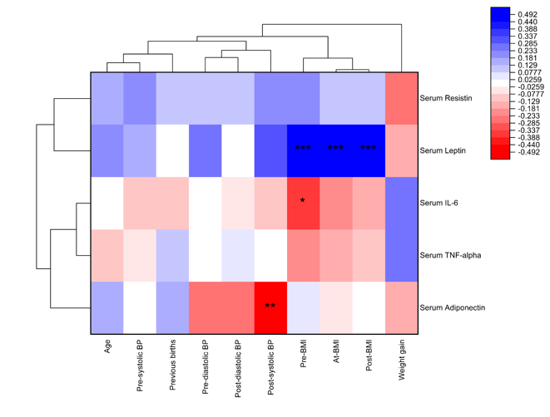
B)
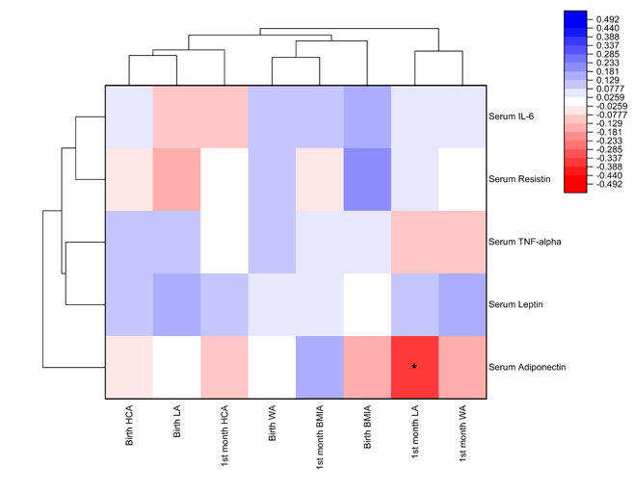
Supplementary Figure 1. Heatmaps and dendrogram of Spearman’s correlation coefficients between adipokines concentrations in HBS at one-month postpartum with mother-infant characteristics. Hierarchical clustering of variables is shown along both the vertical and horizontal axes.
Correlations of A) mother, B) Infant. Age in years and blood pressure in mmHg. Significance levels are denoted as * for p<0.05, ** for p<0.01 and *** for p<0.001. Abbreviations: HBS, Human Blood Serum; BMI, Body Mass Index; Pre-BMI, pre-pregnancy BMI; At-BMI, at birth BMI; Post-BMI, postpartum BMI; BP, Blood pressure; pre-BP, pre-delivery blood pressure; HCA, head-circumference-for-age; LA, length-for-age; WA, weight-for-age.

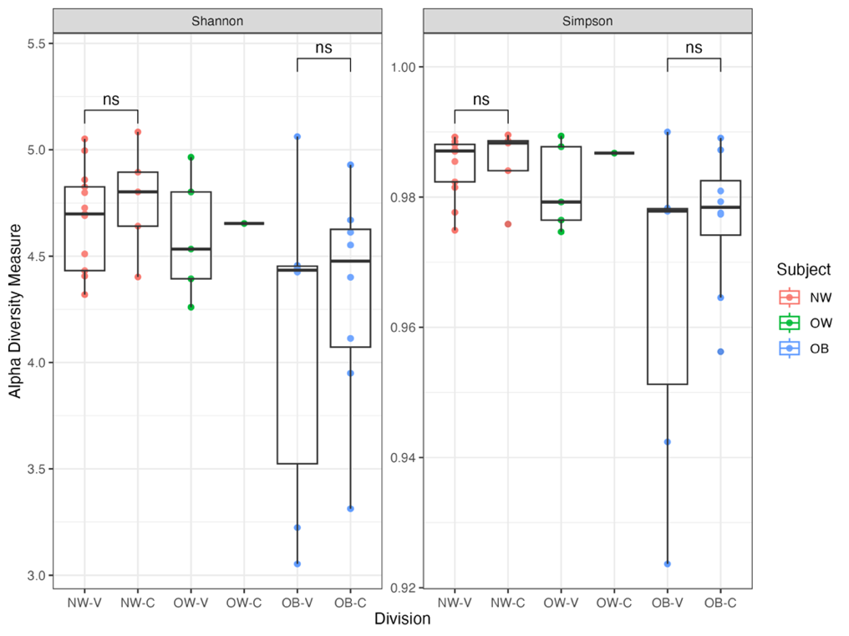
Supplementary Figure 2. Alpha diversity of infant gut microbiota of one-month-old based on mother pre-gestational BMI and delivery mode. Classification of microbial alpha diversity based on infants born to mothers with different BMI and delivery mode. Abbreviations: NW, normoweight; OW, overweight; OB, obesity; C, cesarean; V, vaginal.

A)
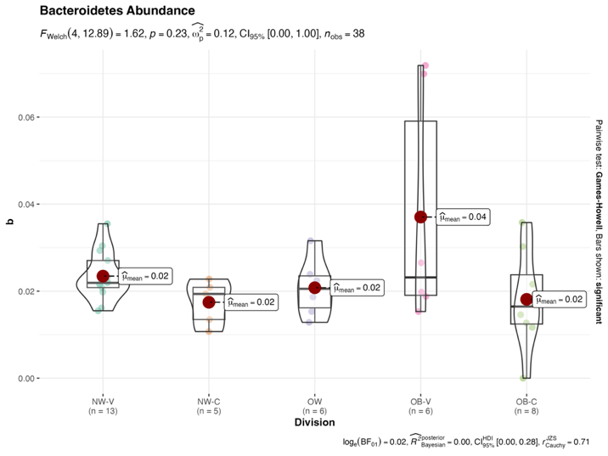
B)
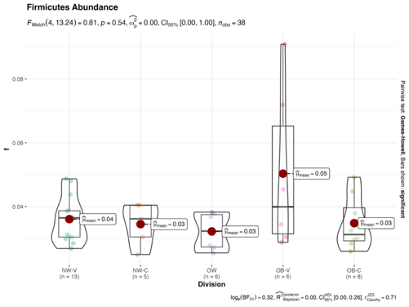
C)
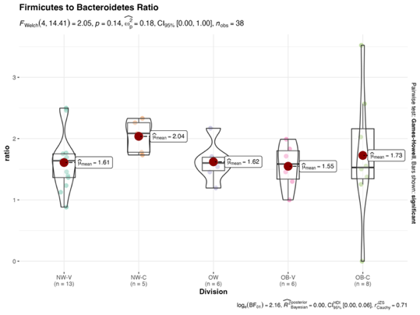
Supplementary Figure 3. Abundances and ratios of Bacteroidetes and Firmicutes in gut microbiota from breastfed infants, classified by maternal BMI and delivery modes. A) Bacteroidetes abundance, B) Firmicutes abundance and C) Firmicutes-to- Bacteroidetes Ratio. Abbreviations: NW, normoweight; OW, overweight; OB, obesity.

