Bridging Sparse Monitoring: Machine Learning Sharpens Daily PM2.5 in 12 Cities Across Two Regions

Supplementary Material
Table of contents:
- Texts S1-S2
- Figure S1-S4
- Table S1-S5

Text S1. Instrumentation at Ground-Based Stations
We analyzed long-term and seasonal PM_{2.5} concentrations in both regions. In Turkey and at U.S. embassy sites, PM_{2.5} was measured using Tapered Element Oscillating Microbalance (TEOM) instruments, specifically the BAM-1020 (Met One Instruments). In Iran, PM_{2.5} was collected with a BGI PQ200 ambient particulate sampler, and in Israel with a Thermo Scientific TEOM 1405 unit. All U.S. embassy stations employed the BAM-1020 Beta Attenuation Monitor, which is approved as a Federal Equivalent Method for reliable PM_{2.5} measurement.
For Canada, air-quality data were obtained from the National Air Pollution Surveillance (NAPS) network for the period 2008–2022. In this network, PM_{2.5} was characterized using synchronized hybrid ambient real-time analyzers (SHARP 5030) together with a Met One SuperSASS-Plus sequential speciation sampler. For all sites, we computed arithmetic means, standard deviations, standard errors, and percentile distributions of PM_{2.5} to describe temporal variability.
Text S2. Seasonal Variations in Model Skill
Season strongly modulates the relationship between column-integrated AOD and ground-level PM_{2.5} because aerosol composition and boundary-layer dynamics change through the year. We report (i) ten-fold cross-validation (CV) statistics with a temporal lag feature for every city–season combination (Table 3) and (ii) tuned test-set scores for six representative cities across the GME and Canada (Tables S4–S5).

Cross-validation results
GME. Summer now yields the strongest and most stable column–surface correspondence: mean CV-R ≈ 0.67 (tied with fall) and the lowest RMSE = 7.32 µg/m³. Fall maintains high correlation (R ≈ 0.67) but with higher RMSE = 10.27 µg/m³. Spring is moderate (R ≈ 0.63; RMSE = 10.16 µg/m³). Winter degrades most in absolute error (RMSE = 12.81 µg/m³³) despite R ≈ 0.64. The lag feature likely captures synoptic persistence in warm seasons, tightening the AOD– PM_{2.5} link even when vertical mixing intensifies
Canada. Seasonal swings remain muted: CV-R spans 0.50–0.55 with RMSE 3.17–3.65 µg/m³. Spring gives the lowest RMSE (3.17), fall the highest R (0.55), and winter the weakest overall (R = 0.50; RMSE = 3.65). Temperate meteorology, lower AOD, and dense monitoring keep AOD a comparably reliable proxy in all seasons.

Tuned test-set case studies
Tel Aviv. Best correlation in fall (XGB R = 0.71); lowest error in summer (RF RMSE = 3.98 µg/m³). Spring remains strong (EN R = 0.74; RMSE ≈ 4.85–5.85).
Istanbul. Summer is clearly best (RF R = 0.63, RMSE = 3.55). Winter weakens (R ≈ 0.48–0.50; RMSE ≈ 7.1).
Tehran. Summer dominates (EN R = 0.75; RMSE ≈ 13.2–13.9), while winter shows the largest errors (RMSE ≈ 26–27).
Montreal. Summer/fall lead by correlation (R = 0.56); summer also gives the lowest RMSE (EN 3.60). Winter is weakest (R ≈ 0.41–0.43; RMSE ≈ 4.28–4.33; N = 16).
Toronto. Summer maximizes correlation (RF R = 0.66), but spring minimizes error (RMSE ≈ 3.72–3.77).
Vancouver. Best R in fall/winter (up to 0.60); summer has the lowest RMSE (≈ 2.27–2.32).
Note that seasonal N varies widely (e.g., Istanbul winter N = 59; Montreal winter N = 16), so some winter estimates carry higher uncertainty.

Drivers of the seasonal contrast
Two mechanisms explain the stronger seasonal spread in the GME, especially in RMSE:
Aerosol regime. Warm-season dust intrusions create coherent, high-signal AOD patterns that ML models—especially with lag—exploit; cold-season humidity, mixed sources, and shallow PBLs inflate errors.
Observational support. Dense Canadian networks stabilize preprocessing and QC, anchoring coefficients across seasons. In GME cities with only one or two monitors, coefficients learned under one regime can falter as the aerosol mix shifts; expanding the footprint improves transfer across seasons.

Implications for seasonal modelling
GME. Target high-error seasons (winter; also spring/fall) with season-aware features: dust-storm flags, thermal-low indices, reanalysis dust optical depth, humidity/stability metrics, and vertical-decoupling proxies (e.g., BLH, surface–850 hPa ΔT). A first-stage aerosol-type classifier followed by season-specific regressors can reduce RMSE and regime leakage.
Canada. With uniform skill, marginal gains likely come from finer-scale predictors (sub-daily BLH; wildfire smoke tracers in summer/fall; local emission surrogates) and metric-aware tuning to balance correlation and amplitude fidelity where R and RMSE diverge.
Where R is high, but RMSE remains elevated (e.g., GME fall), consider variance-stabilizing losses, season-weighted training, or quantile calibration to improve amplitude accuracy without sacrificing correlation.

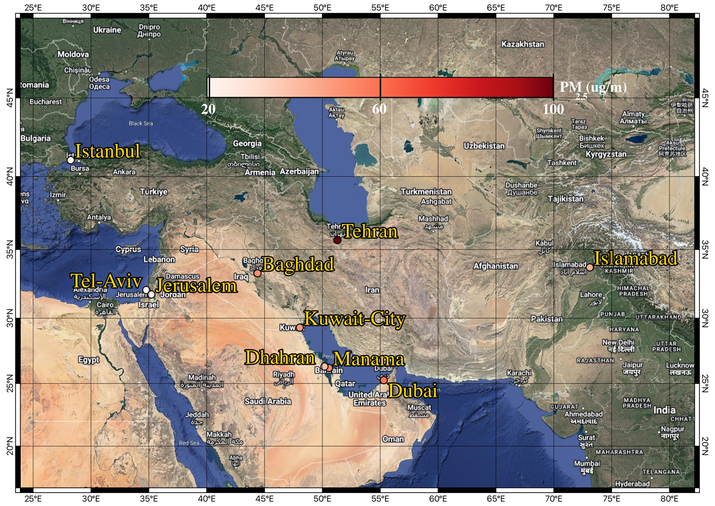
a
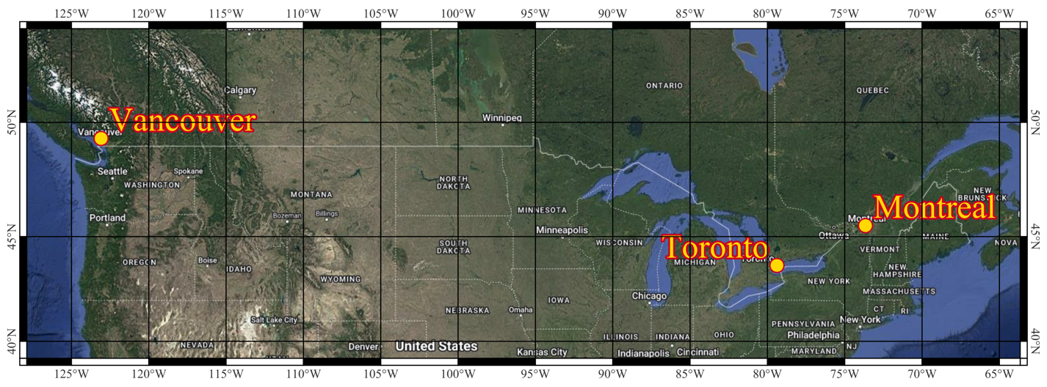
b
Figure S1 (a) Geographical map of the Middle East, in which the locations of the stations are shown by colored circles. The color map is the long-term arithmetic mean of the PM_{2.5}. (b) Geographical map of Canada.

Table S1 Location and lockdown period in our study region
 | City | LAT | LON | Köppen–Geiger Class
Israel | Tel Aviv | 32.084282 | 34.782604 | Csa (Hot‐summer Mediterranean)
Turkey | Istanbul | 41.0737 | 28.2479 | Csa (Hot‐summer Mediterranean)
Iran | Tehran | 35.70232 | 51.35091 | BSk (Cold semi‐arid)
Kuwait | Kuwait City | 29.292041 | 48.046871 | BWh (Hot desert)
UAE | Dubai | 25.258687 | 55.3091 | BWh (Hot desert)
Bahrain | Manama | 26.205447 | 50.570403 | BWh (Hot desert)
Saudi Arabia | Dhahran | 26.321221 | 50.183318 | BWh (Hot desert)
Iraq | Baghdad | 33.300424 | 44.396232 | BWh (Hot desert)
Pakistan | Islamabad | 33.7224106 | 73.118065 | Cwa (Humid subtropical)
Canada | Montreal | 45.502678 | -73.663873 | Dfb (Warm‐summer humid continental)
Canada | Toronto | 43.664233 | -79.387449 | Dfa (Hot‐summer humid continental)
Canada | Vancouver | 49.323909 | -123.083585 | Cfb (Marine west coast (oceanic))

Table S2 Comparison of the error of predicted results of three machine learning models using their RMSE. EN refers to ElasticNet, RF refers to Random Forest, and XGB refers to Extreme Gradient Boosting.
RMSE | EN | RFR | XGB
Tel Aviv | 10.28 | 9.94 | 12.10
Istanbul | 7.84 | 8.11 | 7.84
Tehran | 18.83 | 20.20 | 18.97
Kuwait City | 38.22 | 37.56 | 37.77
Dharan | 22.17 | 27.41 | 27.43
Dubai | 23.72 | 24.10 | 25.69
Baghdad | 35.57 | 29.94 | 30
Islamabad | 16.80 | 16.60 | 16.08
Manama | 41.11 | 39.10 | 38.67
Montreal | 3.15 | 3.18 | 3.11
Toronto | 4.48 | 4.19 | 4.12
Vancouver | 3.16 | 3.22 | 3.01

Table S3. Seasonal cross‐validation performance (mean R and RMSE in µg/m³) of the three machine‐learning models (with no temporal lag feature) averaged across Canadian (CA) and Greater Middle East (GME) cities.
Season | CA |  | GME
Season | R | RMSE | R | RMSE
Spring | 0.54 | 3.17 | 0.63 | 10.16
Summer | 0.53 | 3.47 | 0.67 | 7.32
Fall | 0.55 | 3.26 | 0.67 | 10.27
Winter | 0.50 | 3.65 | 0.64 | 12.81

Table S4. Seasonal performance R of the three tuned machine‐learning models across CA and GME cities.
Spring | EN | XGB | RF | N
Tel Aviv | 0.74 | 0.71 | 0.73 | 354
Istanbul | 0.59 | 0.62 | 0.63 | 237
Tehran | 0.64 | 0.61 | 0.61 | 392
Montreal | 0.44 | 0.47 | 0.45 | 209
Toronto | 0.52 | 0.51 | 0.50 | 293
Vancouver | 0.57 | 0.59 | 0.60 | 378
Sumer
Tel Aviv | 0.66 | 0.68 | 0.68 | 374
Istanbul | 0.57 | 0.61 | 0.63 | 461
Tehran | 0.75 | 0.71 | 0.74 | 596
Montreal | 0.56 | 0.46 | 0.52 | 299
Toronto | 0.63 | 0.65 | 0.66 | 327
Vancouver | 0.45 | 0.47 | 0.48 | 442
Fall
Tel Aviv | 0.61 | 0.71 | 0.58 | 365
Istanbul | 0.60 | 0.65 | 0.63 | 193
Tehran | 0.63 | 0.56 | 0.58 | 474
Montreal | 0.56 | 0.56 | 0.56 | 236
Toronto | 0.54 | 0.59 | 0.59 | 280
Vancouver | 0.55 | 0.60 | 0.58 | 205
Winter
Tel Aviv | 0.63 | 0.65 | 0.66 | 374
Istanbul | 0.50 | 0.49 | 0.48 | 59
Tehran | 0.64 | 0.60 | 0.61 | 287
Montreal | 0.41 | 0.43 | 0.41 | 16
Toronto | 0.37 | 0.50 | 0.47 | 118
Vancouver | 0.50 | 0.59 | 0.58 | 160

Table S5. Seasonal performance (RMSE in µg/m³) of the three tuned machine‐learning models across CA and GME cities.
Spring | EN | XGB | RF
Tel Aviv | 4.85 | 5.00 | 5.85
Istanbul | 7.08 | 6.86 | 6.85
Tehran | 20.71 | 21.46 | 21.52
Montreal | 3.98 | 3.92 | 3.96
Toronto | 3.72 | 3.74 | 3.77
Vancouver | 2.48 | 2.46 | 2.43
Sumer
Tel Aviv | 4.08 | 4.01 | 3.98
Istanbul | 3.74 | 3.61 | 3.55
Tehran | 13.18 | 13.89 | 13.43
Montreal | 3.60 | 4.01 | 3.74
Toronto | 4.15 | 3.98 | 3.94
Vancouver | 2.32 | 2.28 | 2.27
Fall
Tel Aviv | 5.85 | 5.93 | 5.88
Istanbul | 6.06 | 5.75 | 5.87
Tehran | 20.71 | 22.06 | 21.35
Montreal | 3.83 | 3.88 | 3.82
Toronto | 4.01 | 3.90 | 3.88
Vancouver | 2.53 | 2.43 | 2.46
Winter
Tel Aviv | 4.67 | 4.59 | 4.56
Istanbul | 7.14 | 7.10 | 7.17
Tehran | 26.03 | 27.14 | 26.77
Montreal | 4.33 | 4.28 | 4.31
Toronto | 4.12 | 3.81 | 3.87
Vancouver | 2.65 | 2.51 | 2.49

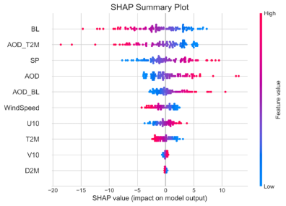 | 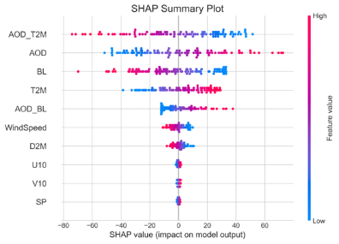
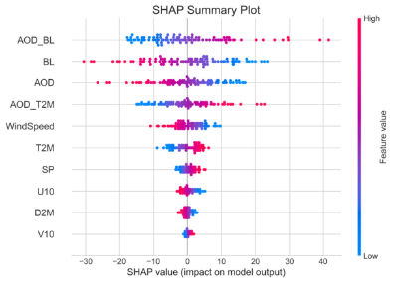 | 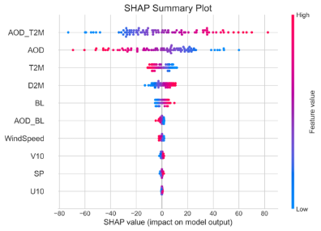
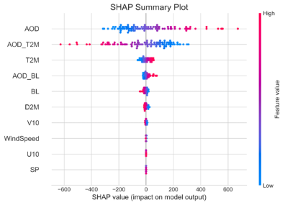 | 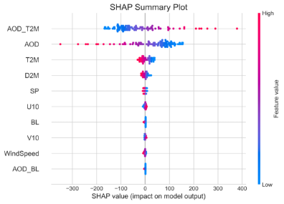
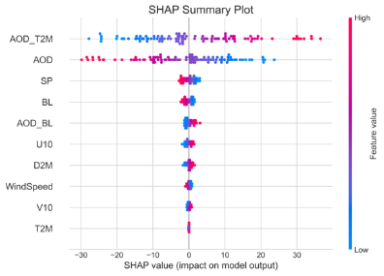 | 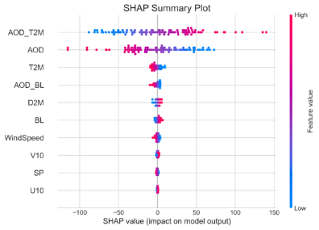
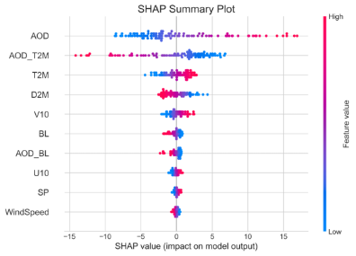 | 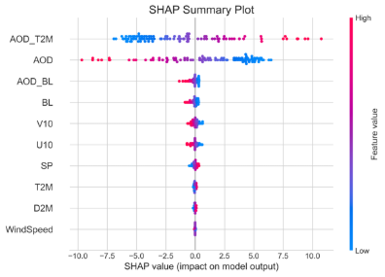
Figure S2 SHAP summary plots for the full dataset impacts on PM_{2.5} predictions in (a) Istanbul (b) Tehran (c) Baghdad (d) Dhahran (e) Dubai (f) Islamabad (g) Kuwait City (h) Manama (i) Toronto (j) Vancouver.
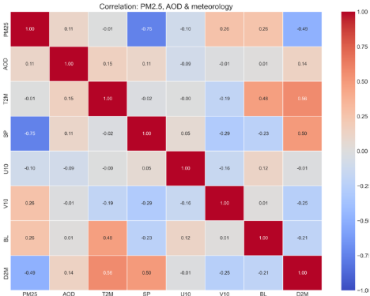
Figure S3 Correlation heat map for the pooled Middle East dataset showing pairwise Pearson correlations among PM_{2.5}, AOD, T2M, surface pressure (SP), 10-m winds (U10, V10), boundary-layer height (BL), and 2-m dew point (D2M). Cell labels report correlation coefficients: the color bar indicates sign and magnitude (blue = negative, red = positive).

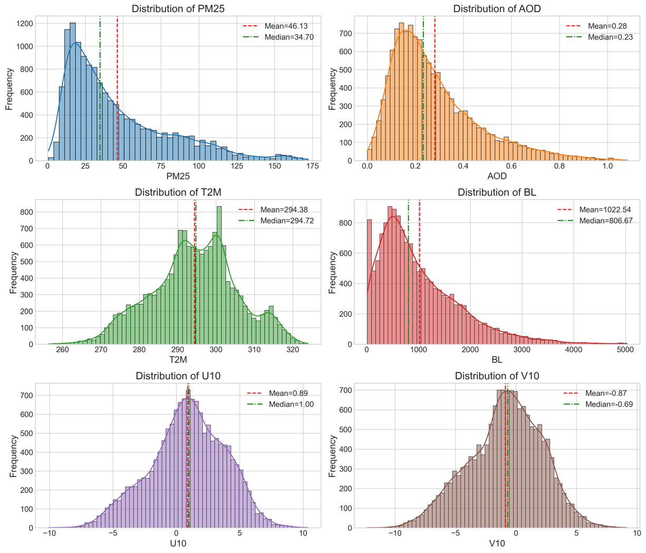
Figure S4. Distributions of daily PM_{2.5} (µg m⁻³), AOD (unitless), near-surface air temperature T2M (K), boundary-layer height BL (m), and 10-m winds U10 and V10 (m s⁻¹) for the pooled Middle East dataset. Histograms with kernel-density overlays; dashed vertical lines mark the sample mean (red) and median (green).

