Khodavirdilou, Lida^{1,2}; Zuarth Gonzalez, Julio D¹; Mukhopadhyay, Sushobhan³; Guadagnoli, Nicholas³; Obeng, Samuel¹; McCurdy, Christopher R³; McMahon, Lance R¹; and Wilkerson, Jenny L^{1,2*}
¹ Department of Pharmaceutical Sciences, Texas Tech University Health Sciences Center, Amarillo, TX, USA
² Department of Anesthesiology and Perioperative Medicine, Rutgers Biomedical and Health Sciences, Rutgers, The State University of New Jersey, Newark, NJ, USA
³ Department of Medicinal Chemistry, College of Pharmacy, University of Florida, Gainesville, FL, USA
Supplemental Methods
Apparatus
Behavioral sessions were conducted in operant conditioning chambers (Med Associates, St. Albans, VT), enclosed in sound-attenuating cubicles. Each chamber contained two retractable levers positioned on the left and right wall, each paired with a cue light above, and a house light mounted on the opposite wall. Chambers were computer-controlled, with data collection and task programming managed through Med-PC V software. For drug self-administration experiments, each chamber was equipped with an infusion pump connected to a fluid swivel and tether system, allowing for intravenous drug delivery. For food-maintained responding experiments, a pellet dispenser was centrally located between the two levers from outside, delivering 20 mg dustless food pellets (Bio-Serv, Flemington, NJ) into a receptacle following reinforced responses. The apparatus and operant-conditioning procedures were otherwise identical to those previously described (Hiranita et al. 2019; Wilkerson et al. 2019; Obeng et al. 2021).
Behavioral Procedures
Experiment 1: Effect of Mitragynine (MG) on Methamphetamine Self-Administration under Fixed Ratio Schedule
Eight implanted Sprague-Dawley rats (4 males, 4 females) were utilized for this experiment. After a one-week acclimation period, rats began training to self-administer methamphetamine, as previously established methods (Zimmer et al. 2012; Baladi et al. 2014). Initial training involved a FR1 schedule of reinforcement, conducted for 2 hours daily. Each active lever press resulted in an intravenous (i.v.) infusion of methamphetamine (0.032 mg/kg/infusion), followed by a 20-sec timeout period during which the cue lights were extinguished and levers were retracted (Zimmer et al. 2012). Up to 100 infusions per session were permitted. Responses on the inactive lever were recorded but had no programmed consequences. Rats that consistently earned more than 20 infusions per session were first advanced to a FR3 schedule, followed by progression to the final FR5 schedule (each fifth response produced a 0.032 mg/kg/injection of methamphetamine). Only animals that successfully reached the FR5 criterion were included in the study, ensuring reliable self-administration behavior. Stable responding was defined as less than 20% variability across consecutive sessions, typically achieved within 10 to 20 days of training. Animals that did not meet these criteria were excluded from further testing. During the experimental phase, rats were required to complete three consecutive days of stable responding before the first MG or vehicle injection, and two consecutive days of stable responding were required between subsequent test sessions. Pretreatment with MG (10, 17.8, 32, or 56 mg/kg, i.p.) or vehicle was administered 30 min prior the session. The order of dose administration was counterbalanced across animals to mitigate sequence effects. Active and inactive lever presses, infusions, and response rates (responses/sec) were recorded as primary behavioral measures.
Experiment 2: Food Self-Administration (Mirroring Paradigm)
This experiment included 8 Sprague-Dawley rats (4 males, 4 females), which were not implanted with a jugular catheter. Following a one-week acclimation period, rats began training to self-administer food using previously established methods (Baladi et al. 2014). Prior to lever press training, animals completed a single 60-min magazine training session in the operant chambers with levers retracted (Bullock 2018). During this session, 20 mg dustless food pellets were delivered on a fixed-time 60-sec (FT60) schedule to acclimate rats to the sound and location of pellet delivery. All animals were required to consume the dispensed pellets in order to proceed to the next training phase. Following successful magazine training, rats began operant conditioning for food reinforcement, based on previous established methods. Sessions were limited to a maximum of 100 food pellets and initially conducted under a FR1 schedule, which was gradually increased to the terminal FR5 schedule. Each session lasted 2 hours with a 20-sec time-out period following each reinforcer. Stable responding was defined as less than 20% variability across consecutive sessions and was typically achieved within 10–20 days. Before the first injection, rats were required to show stable responding over three consecutive sessions. For all subsequent treatments, a minimum of 2 days of stable responding was required between test sessions. Rats received intraperitoneal pretreatment with either vehicle or MG (10, 17.8, 32, or 56 mg/kg) 30 min prior to testing. The order of doses was counterbalanced across subjects. During test sessions, active and inactive lever presses and response rates (responses per second) were recorded.
Experiment 3: Effect of MG on Methamphetamine Self-Administration under Progressive Ratio Schedule
For the PR schedule, following established procedures (Richardson and Roberts 1996), 14 implanted Sprague–Dawley rats (7 females and 7 males) were initially utilized. After a one-week acclimation period, rats began training to self-administer methamphetamine. Similar to the first experiment, initial training involved an FR1 schedule for 2 hours daily, where an active lever press delivered an intravenous infusion of methamphetamine (0.032 mg/kg/infusion), followed by a 20-sec timeout (cue lights off, levers retracted). Inactive lever responses were recorded but produced no consequences. The FR schedule gradually increased until animals reached FR5. Of the 7 male rats, one was excluded due to loss of catheter patency, and 2 additional males were excluded for not meeting the FR5 requirement during the training phase. These exclusions ensure that all animals included in the final analysis demonstrated consistent self-administration behavior and maintained catheter patency throughout the study. All 7 female rats remained in the study. Once stable responding under FR5 was achieved, rats were transitioned to a PR schedule to assess motivation. On the PR schedule, reinforcement required an increasing number of lever presses, progressing through the sequence: 1, 2, 4, 6, 9, 12, 15, 20, 25, 32, 40, 50, 62, 77, 95, 118, 145, 178, 219, 268, 328, 402, 492, and 603, thereby reflecting progressively greater effort demands (Richardson and Roberts 1996). The breakpoint, defined as the final ratio completed, served as the primary outcome measure. Each progressive ratio session had a maximum duration of 2 hours. Stable responding on the PR schedule was defined as less than 20% variance over three consecutive sessions, mirroring the criteria used for FR acquisition. In the experimental phase, rats were pretreated with either vehicle or MG (10, 17.8, 32, or56 mg/kg, i.p.) 30 min prior to the session, with the order of doses counterbalanced. Breakpoint and active lever presses were recorded as the primary behavioral measures.

Supplemental Results
Experiment 1: Effects of MG on Responding for Methamphetamine Under a Fixed Ratio Schedule
Active vs. Inactive Lever Presses
Under vehicle pretreatment, there were more active (252.5 presses) than inactive lever responses (59.82 presses; p = 0.0046). Mixed-effects analysis revealed significant main effects of lever type (F(1.965, 23.59) = 22.38, p < 0.0001) and MG dose (F(1, 14) = 22.11, p = 0.0003), as well as a significant lever × dose interaction (F(4, 48) = 9.675, p < 0.0001). Active lever pressing was significantly greater than inactive pressing at vehicle, 10, 17.8, and 32 mg/kg, but not at 56 mg/kg, where responding was markedly reduced. Inactive lever responding remained low and unchanged across doses (Supplemental Figure 2A).
Experiment 2: Effects of MG on Responding for Food
Active vs. Inactive Lever Presses
Under vehicle pretreatment, there were more active than inactive lever presses (500.0 vs. 0.625, p < 0.0001). Analysis revealed a significant main effect of lever type (F(1, 14) = 150132, p < 0.0001), but no main effect of MG dose (F(4, 56) = 2.286, p = 0.0714) and no lever × dose interaction (F(4, 56) = 2.286, p = 0.0714). Active lever pressing was significantly greater than inactive pressing at all doses tested, and inactive lever responding remained low and unchanged across doses (Supplemental Figure 2B).

Supplemental Figures

Fig S1. 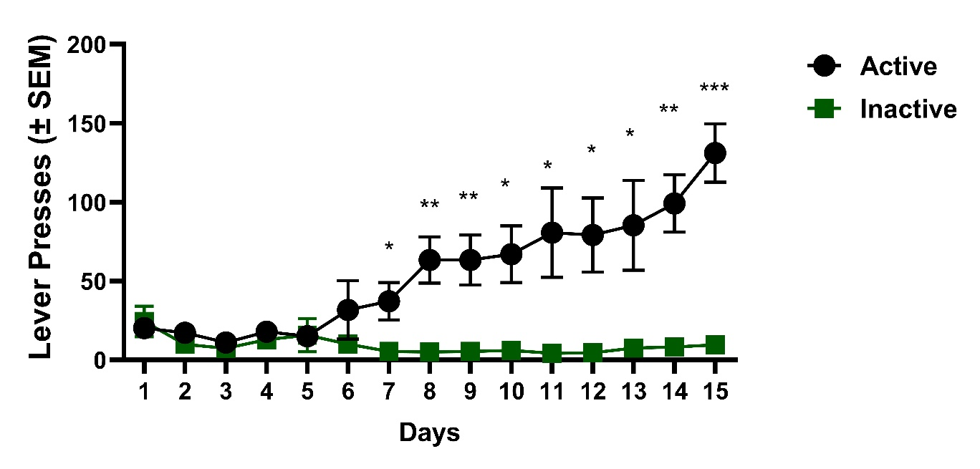
Supplemental Fig S1. Fixed Ratio (FR), Acquisition of methamphetamine self-administration.
Mean (± SEM) active and inactive lever presses during daily 2-h acquisition sessions under an FR1→FR3→FR5 schedule (0.032 mg/kg/infusion; n = 8). Two-way repeated-measures ANOVA revealed significant main effects of Lever [F(1, 14) = 12.75, p = 0.0031] and Session [F(2.506, 35.08) = 7.84, p = 0.0007], as well as a significant Lever × Session interaction [F(14, 196) = 10.19, p < 0.0001]. Post-hoc comparisons indicated that active-lever responding became significantly greater than inactive-lever responding beginning on Day 7 (p = 0.03) and remained elevated through Day 15 (p = 0.0003). These findings confirm successful acquisition of methamphetamine-maintained behavior prior to MG testing.

Fig S2.
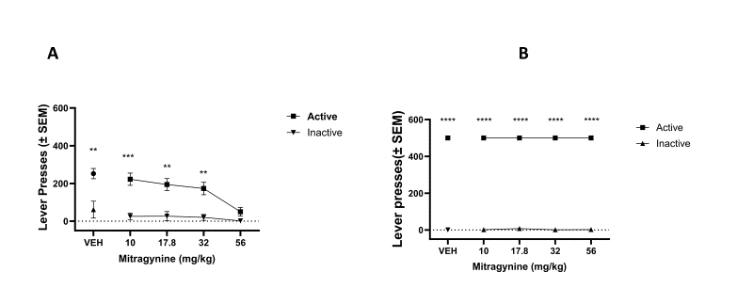
Supplemental Fig S2. Active and inactive lever responding during methamphetamine and food self-administration after MG pretreatment.
(A) Active lever presses were significantly higher than inactive lever presses across all doses. MG (10–56 mg/kg, i.p.) reduced active lever presses in a dose-dependent manner, with no significant changes in inactive lever responding. (B) Active lever presses remained significantly higher than inactive lever presses across all doses during food-maintained sessions, indicating that MG did not alter non–drug-related operant behavior.
Data are expressed as mean ± SEM. *p < .05, **p < .01, ***p < .001, ****p < .0001 vs. vehicle. (n = 4/sex)

Fig S3.
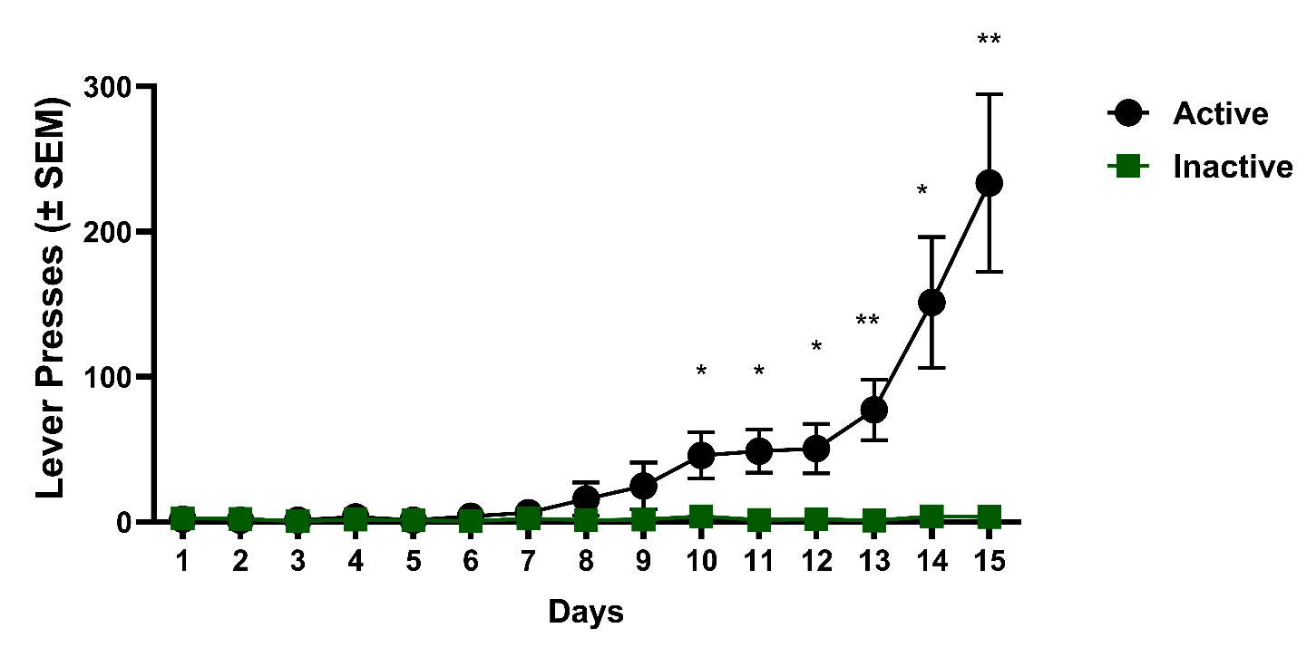

Supplemental Fig S3. Progressive ratio (PR) responding for methamphetamine.
Mean (± SEM) active and inactive lever presses across PR sessions (0.032 mg/kg/infusion; n = 8). Two-way repeated-measures ANOVA revealed significant main effects of Lever [F(1, 14) = 14.97, p = 0.0017] and Session [F(1.695, 23.73) = 11.23, p = 0.0006], as well as a significant Lever × Session interaction [F(14, 196) = 10.79, p < 0.0001]. Post-hoc comparisons indicated that active-lever responding became significantly greater than inactive-lever responding beginning on Day 10 (p = 0.035) and remained elevated through Day 15 (p = 0.007). These results confirm stable motivation to obtain methamphetamine under the progressive-ratio schedule prior to MG testing.

