Supplementary Material for:

Tectonic History of Diebold Knoll from Integration of Seismic, Gravity and Magnetic Data

Md Ariful Islam1,*,†, Irina Filina1, Anne M. Tréhu2
1University of Nebraska-Lincoln, Lincoln, NE, USA
2Oregon State University, Corvallis, OR, USA
† Now at: Indiana University Bloomington, Bloomington, IN, USA
* Corresponding author, Email: mdaislam@iu.edu

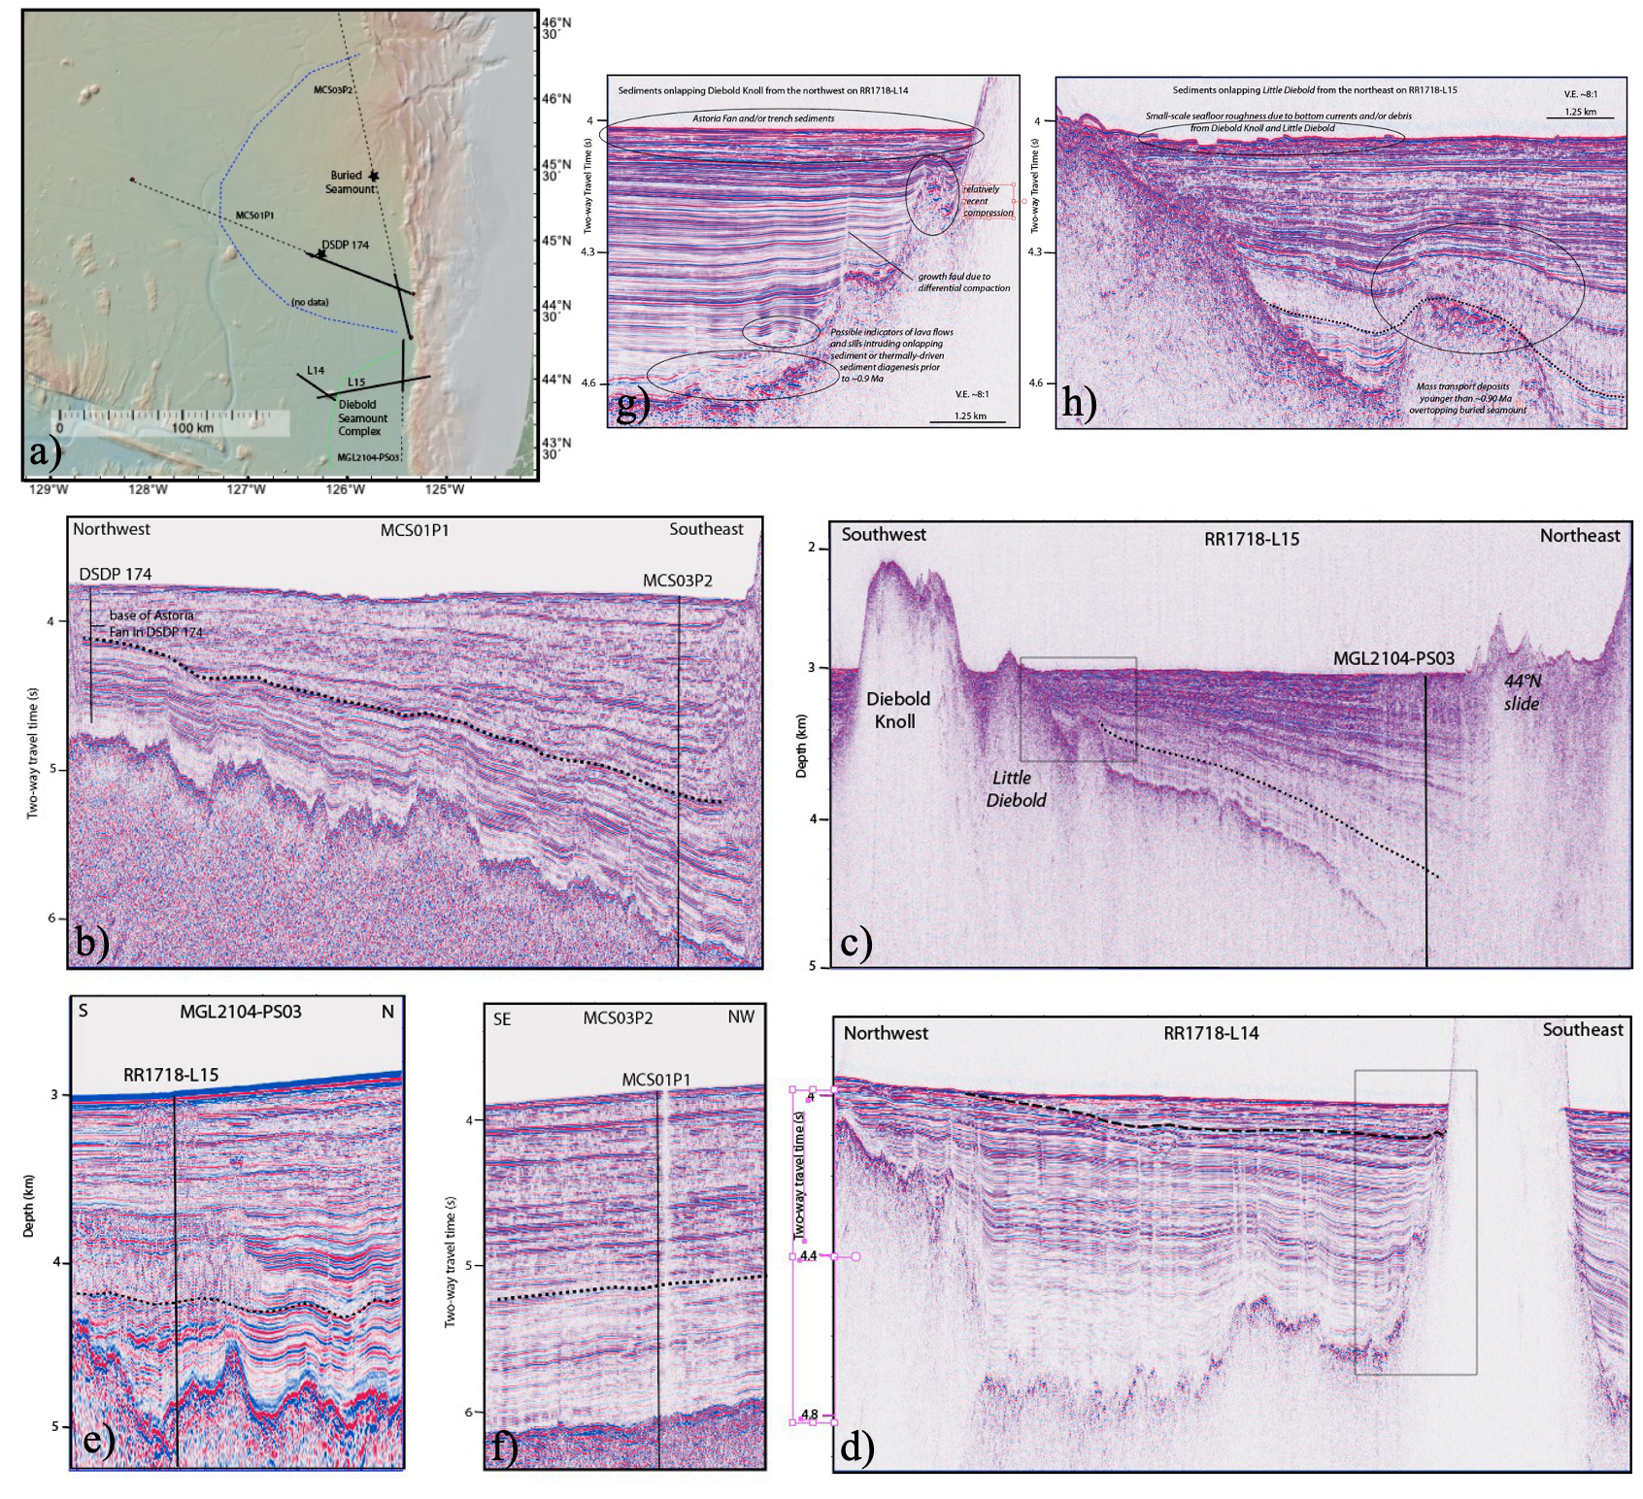
Figure S1. (a) Index map of seismic reflection profiles shown in Figure 8. Solid lines indicate the profile segments displayed. Data sources include: MCS01P1 and MCS03P2 from cruise MGL1204 (Han et al., 2016; Canales et al., 2017); L14 and L15 from cruise RR1718 (Tominaga et al., 2018; Tréhu et al., 2022); and MGL2104-PS03 from cruise MGL2104 (Carbotte et al., 2024). Dashed blue and green lines denote the approximate extent of the Astoria Fan (Nelson et al., 1995) and the seaward limit of massive trench deposits, respectively (Goldfinger et al., 2003; Tréhu et al., 2022). The location of DSDP Site 174 is marked. The Diebold volcanic complex (comprising Diebold Knoll, a smaller partially buried seamount, and a completely buried seamount) represents the seamount closest to the Cascadia deformation front; its thermal signature implies it currently acts as a seawater intake for the crustal aquifer (Norvell et al., 2023). (b–d) Seismic reflection profiles (MCS01P1, RR1718-L15, and RR1718-L14) utilized to constrain the age, tectonic setting, and sediment thickness for potential field modeling.
Panel (b) illustrates the seismic tie from DSDP Site 174 to the deformation front, showing the base of the Astoria Fan sediments and the deepest age horizon (~0.90 Ma, dotted black line) mapped by Shuck et al. (2023) and tied to IODP Site 1027 (Rohr et al., 2019). This horizon is tracked in (c) and (d).
(e–f) Intersection points of RR1718-L15 with MGL2104-PS03 (e) and MCS01P1 with MCS03P2 (f), with the interpreted 0.9 Ma horizon marked. (g–h) Stratigraphic relationships between the Diebold volcanic complex edifices and overlying sediments. Northwest of Diebold Knoll, reflection data below ~4.35 s twtt suggest tentative evidence for lava flows and subsequent intrusive sills or sediment diagenesis. Pre-Astoria Fan/trench wedge sediments exhibit evidence of recent compression and growth faulting attributed to differential compaction.

