SUPPLEMENTARY FIGURES/TABLES
(A)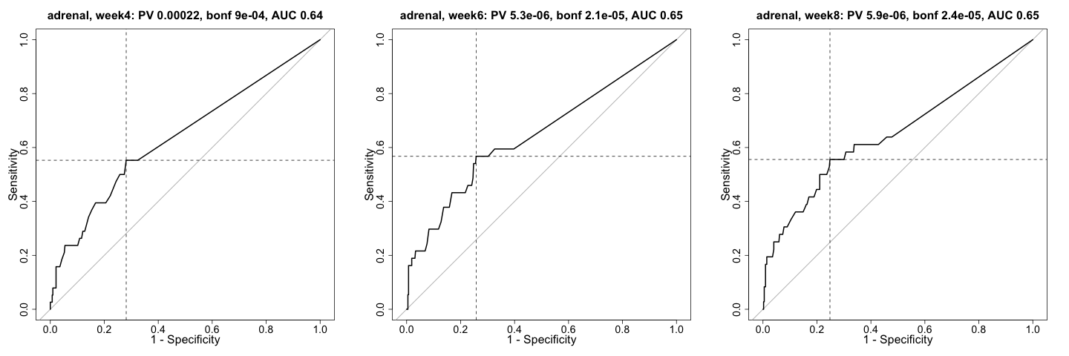
(B)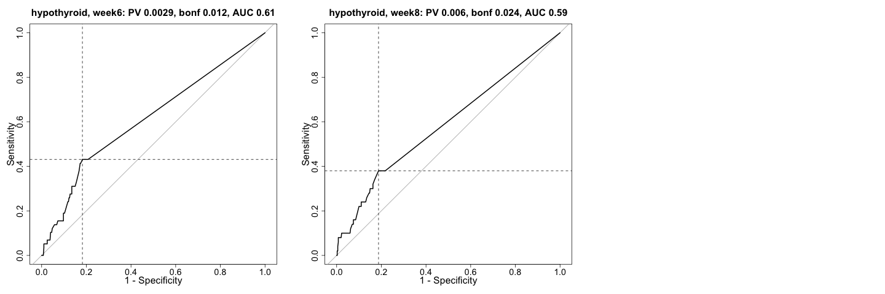
Supplementary Figure S1: ROC curves for the significant association of computed OSB with outcome for adrenal insufficiency (A) and hypothyroidism (B).
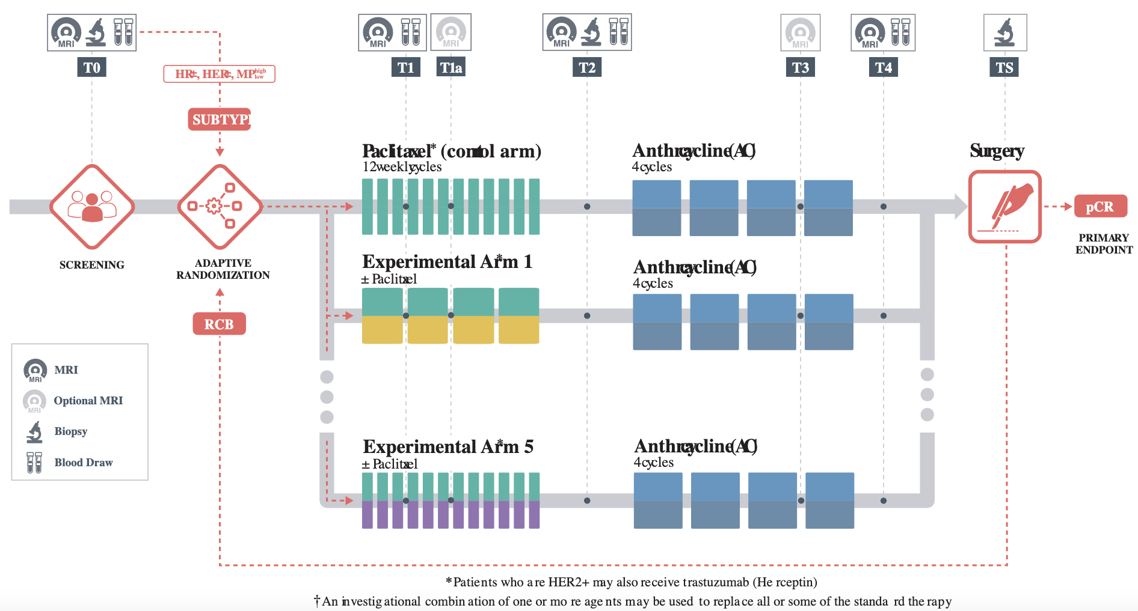
Supplementary Figure S2: I-SPY2 trial schema

