Appendix
Figure A-1: Posterior Distributions and Trace Plots for Age Group Effects on Physical Health
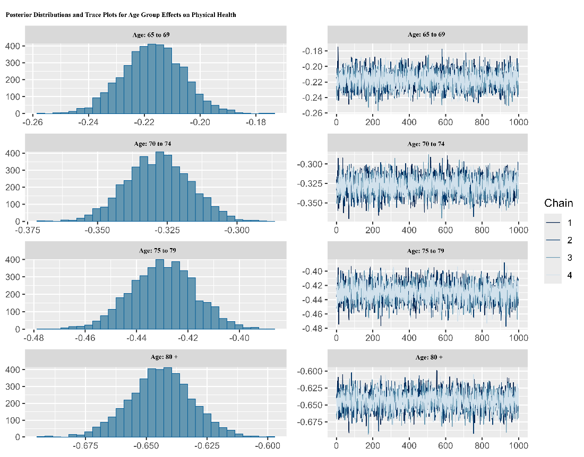

Figure A-2: Posterior Distributions and Trace Plots for Age Group Effects on Mental Health
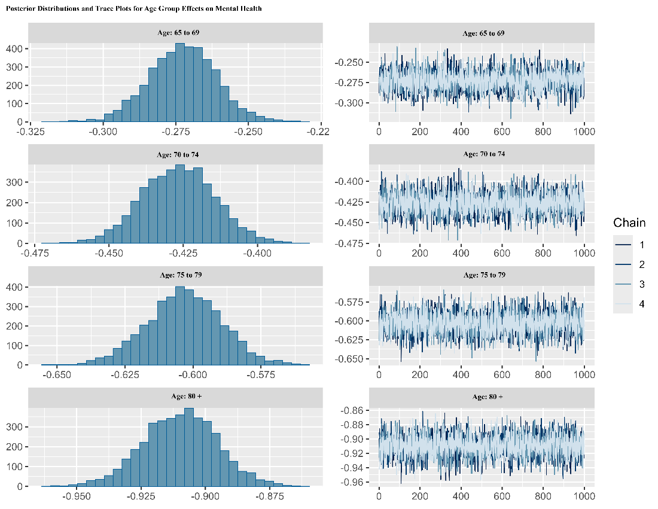
Figure A-3: Self-Reported Physical vs. Mental health Comparison by Age Group
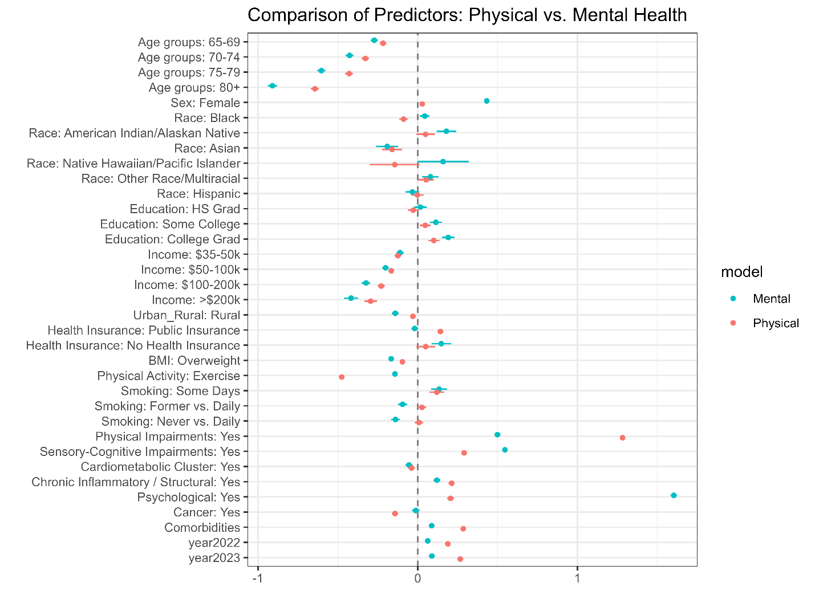

Table A-1. Generalized Ordered Logistic Regression Results: Associations between Age Groups and Self-Reported Health Outcomes (Interaction: Age Groups* Gender)
 | Outcome Measures
 | Self-reported  physical health  (β, SE) | Self-reported  mental health  (β, SE)
Predictors
Age (Ref: 60-64)
65-69 | -0.22***  (0.02) | -0.30***  (0.02)
70-74 | -0.30***  (0.02) | -0.45***  (0.02)
75-79 | -0.42***  (0.02) | -0.66***  (0.02)
80+ | -0.61***  (0.02) | -0.86***  (0.02)
Covariates
Sociodemographic characteristics
Gender (Ref: Male)
Female | 0.04***  (0.01) | 0.41***  (0.02)
Race (Ref: White -non-Hispanic)
Black-non-Hispanic | -0.09***  (0.01) | 0.04**  (0.02)
American Indian/Alaska Native | 0.05†  (0.03) | 0.18***  (0.03)
Asian-non-Hispanic | -0.16***  (0.03) | -0.19***  (0.04)
Native Hawaiian/Pacific Islander | -0.14 †  (0.08) | 0.16†  (0.08)
Others Race/Multiracial | 0.05*  (0.02) | 0.08**  (0.03)
Hispanic | -0.00  (0.02) | 0.03  (0.02)
Education (Ref: Did not graduate High School)
Graduate High School | -0.03  (0.02) | 0.02  (0.02)
Attended College or Technical School | 0.05**  (0.02) | 0.11***  (0.02)
Graduated from College or Technical School | 0.10***  (0.02) | 0.19***  (0.02)
Income (Ref: Less than $35,000)
$35,000 to < $50,000 | -0.12***  (0.01) | -0.11***  (0.01)
$50,000 to < $100,000 | -0.17***  (0.01) | -0.20***  (0.01)
$100,000 to < $200,000 | -0.23***  (0.01) | -0.33***  (0.01)
$200,000 or more | -0.30***  (0.02) | -0.42***  (0.02)
Residential setting (Ref: Urban)
Rural | -0.03**  (0.01) | -0.14***  (0.01)
Having health insurance coverage (Ref: Private)
Public | 0.14***  (0.01) | -0.01†  (0.01)
Uninsured | 0.05†  (0.03) | 0.15***  (0.03)
Health-related behavioral and clinical characteristics
Overweight (Ref: No)
Yes | -0.09***  (0.01) | -0.17***  (0.01)
Physical activity or exercise in the last 30 days (Ref: No)
Yes | -0.48***  (0.01) | -0.14***  (0.01)
Smoking behavior (Ref: Current smoker - now smokes every day)
Current smoker - now smoke some days | 0.11***  (0.02) | 0.13***  (0.03)
Former smoker | 0.03†  (0.01) | -0.10***  (0.02)
Never smoked | 0.01  (0.01) | -0.14***  (0.02)
Disease burdens
Functional physical limitations (Ref: No) | 1.28***  (0.01) | 0.50***  (0.01)
Sensory and cognitive impairments (Ref: No) | 0.29***  (0.01) | 0.55***  (0.01)
Cardiometabolic condition (Ref: No) | -0.04***  (0.01) | -0.06***  (0.01)
Chronic inflammatory conditions (Ref: No) | 0.21***  (0.01) | 0.12***  (0.01)
Psychiatric disorders (Ref: No) | 0.21***  (0.01) | 1.60***  (0.01)
Malignant neoplasms (Cancer) (Ref: No) | -0.14***  (0.01) | -0.01  (0.01)
Overall comorbidity | 0.29***  (0.01) | 0.09***  (0.01)
Year (Ref: 2021)
2022 | 0.19***  (0.01) | 0.19***  (0.01)
2023 | 0.27***  (0.01) | 0.27*  (0.01)
Interaction (Ref: Age=60-64*Female)
Age=65-69*Female | 0.01  (0.02) | 0.05*  (0.02)
Age=70-74*Female | -0.05*  (0.02) | 0.05*  (0.02)
Age=75-79*Female | -0.01  (0.03) | 0.09***  (0.03)
Age=80+*Female | -0.06**  (0.02) | -0.07**  (0.03)
Threshold [1 Good | Moderate | 1.01***  (0.03) | 1.27***  (0.03)
Threshold [21] Moderate | Poor | 2.49***  (0.03) | 2.94***  (0.03)
†p<0.1; *p<0.05; **p <0.01; ***p<0.001
β stands for coefficient; SE stands for Standard Errors

