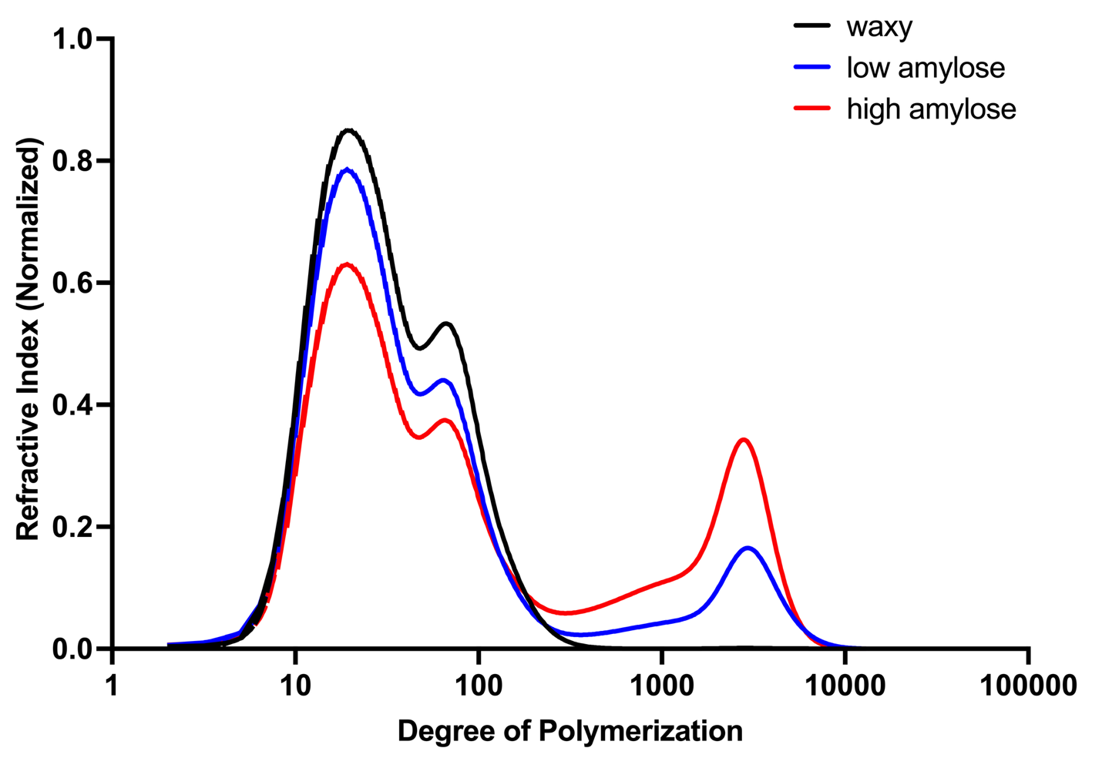
Supplementary Figure 1. SEC molecular weight distribution of debranched starch from rice with varying amylose contents

