Design and Discovery of Phthalazinone-Based Potential PARP Inhibitors: Synthesis, Molecular Docking, ADMET Profiling, and In Vitro Evaluation
Olga Mikolaichuk*ª, Andrey Khramchikhin^{a,b}, Mariia Skryl’nikova^{a,b}, Dmitrii Antonenko^{b},
Aleksei Chutko^{с,d}, Tatyana Kurgina^{e}, Mikhail Kutuzov^{e}, Kirill Timoshchukª, Olga Lavrik^{e}, Natalia Petukhova^{a,с}, Marina Samoylovichª, Oleg Molchanovª, Dmitrii Granovª
E-mail: olgamedchem@gmail.com

Experimental Section 2
General Information (Synthesis) 2
Synthesis of 2-(carboxycarbonyl)benzoic acid (2) 2
Synthesis of 4-oxo-3,4-dihydrophthalazine-1-carboxylic acid (3) 2
Synthesis of compounds 4 and 5 2
Molecular Dynamic Simulation 3
In vitro cytotoxicity 3
Molecular modeling and in-silico prediction 4
Figures 7
Figure S1. ¹H NMR spectra of 4-oxo-3,4-dihydrophthalazine-1-carboxylic acid (3) 7
Figure S2. ¹³C NMR spectra of 4-oxo-3,4-dihydrophthalazine-1-carboxylic acid (3) 8
Figure S3. ¹H NMR N-(3-(3-methylbutanamido)phenyl)-4-oxo-3,4-dihydrophthalazine-1-carboxamide (5) 9
Figure S4. ¹³C NMR N-(3-(3-methylbutanamido)phenyl)-4-oxo-3,4-dihydrophthalazine-1-carboxamide (5) 10
Figure S5. ¹H NMR N-(4-(3-methylbutanamido)phenyl)-4-oxo-3,4-dihydrophthalazine-1-carboxamide (6) 11
Figure S6. ¹³C NMR N-(4-(3-methylbutanamido)phenyl)-4-oxo-3,4-dihydrophthalazine-1-carboxamide (6) 12
Tables 13
Table S1. ADME properties predictions for the compound 4 13
Table S2. ADME properties predictions for the compound 5 15

Molecular Dynamic Simulation
Molecular dynamics simulations were performed to examine the intermolecular interactions of derivative molecules in aqueous environment. Atomic partial charges, estimated according to the Mulliken population analysis scheme, were derived from quantum chemical calculations. All molecular dynamics simulations were carried out using the GROMACS 2023 software package³. The simulation system with periodic boundary conditions consisted of 20 target molecules and approximately 1.3×10⁵ water molecules in a cubic box with dimensions of 16 nm per side. The initial configuration ensured that the minimum distance between morpholinodihydropyrimidine derivative molecules was 30 Å, and the minimum distance from any molecule to the box boundary was 15 Å. The OPLS-AA/M force field was applied for all calculations. Production simulations were run for 100 ns with an integration time step of 1 fs. Prior to production runs, the system underwent solvation, energy minimization, and equilibration procedures in GROMACS 2023 using NVT and NPT ensembles with Berendsen thermostat and barostat, respectively, for 400 ps with a time step of 0.1 fs at temperature T = 298.15 K and pressure P = 1 bar.

In vitro cytotoxicity
N-(3-(3-methylbutanamido)phenyl)-4-oxo-3,4-dihydrophthalazine-1-carboxamide and N-(4-(3-methylbutanamido)phenyl)-4-oxo-3,4-dihydrophthalazine-1-carboxamide cytotoxicity towards breast carcinoma cells with BRCA mutations Capan-1 (BRCA-2 mutation c.5946 delT), MDA-MB-436 (BRCA-1 mutation c.5396+1G>A)cell lines was carried out using cell count-assay. Methods of cytotoxicity approach be found in earlier published materials^{4,5}
Determination of IC₅₀ by Fluorescence Anisotropy
Recombinant human PARP1 was produced in insect cells using a baculovirus expression system. A suspension of Hi5 cells in serum-free medium (2∙10⁶ cells/mL) was infected with baculovirus (10 pfu/mL) carrying the PARP1 cDNA, kindly provided by V. Schreiber (Strasbourg, France). Cells were collected by centrifugation at 1000×g for 10 min. PARP1 was purified according to a previously described protocol⁶.
A fluorescein-labeled DNA duplex was used for kinetic experiments, prepared by annealing the template strand (5’-GGAAGACCCTGACGTTCCCAACTTTATCGCC-FAM-3’) to the complementary primer.
Real-time measurements of PARP1 activity were performed using a recently developed fluorescence anisotropy assay²¹. Reaction mixtures contained 25 nM DNA duplex, 50 nM PARP1, and increasing concentrations of the tested compounds (4, 5, or olaparib) in assay buffer (50 mM Tris-HCl, pH 8.0, 50 mM NaCl, 5 mM DTT, 2.5 mM MgCl₂, and 5% DMSO). Mixtures were prepared in a 384-well plate and incubated at room temperature for 5 min. Reactions were initiated by adding NAD⁺ to a final concentration of 100 µM. Fluorescence anisotropy measurements were performed at 25 °C using the CLARIOstar multifunctional microplate reader (BMG LABTECH, Germany). The fluorescent probes were excited at 495 nm, and the fluorescence intensity was detected at 520 nm. To determine the IC₅₀ value, the experiment was done in triplicate.

Molecular modeling and in-silico prediction
The crystal structure of the catalytic domain of PARP-1 in complex with the inhibitor talazoparib was downloaded from the Protein Data Bank (PDB ID: 7KK3) with a resolution of 2.06 Å and observed R-value of 0.215. For further processing, chain C was selected among chains A, B, C, and D as having the highest quality index. The protein structures were prepared using the Protein Preparation Workflow (PPW) module of the Maestro molecular modeling package⁷. PPW eliminated problems related to unacceptable types of atoms (missing hydrogens, incorrect number of bonds), alternate positions, steric clashes and other deviations. Binding orders were assigned, and hydrogen was added after the initial hydrogen was removed. Missing loops and side chains were checked in using Prime^{8,9}, possible protonation states were generated using EPIK state penalty under default parameters (pH 7.0 ± 2.0)¹⁰. No problems with the pretreated protein structures have been reported. Additionally, the quality of complexes was analyzed in the Protein Reliability Report. The prepared protein was subjected to energy minimization using the OPLS4 force field¹¹. All stages of protein modeling, docking, molecular dynamics (MD) and analytical calculations were performed using the Schrödinger molecular modeling suite (version 2021-1)¹².
The PARP inhibitors including Olaparib and Talazoparib were downloaded from Pubchem and served as controls. The ligands used for molecular docking have been structurally optimized using LigPrep from Maestro. The molecule models were also prepared by optimizing geometries through OPLS4 force field and Ionization of possible states was generated at pH 7.0 ± 2.0 using Epik. Desalting and generating tautomers were also selected, and the stereoisomer computation was checked to retain specific chiralities (vary other chiral centers) and to generate at most 32 conformations per ligand.
The Induced-Fit Docking (IFD) protocol, implemented in the Schrödinger package ¹², is based on a combination of docking stages using the Glide programme and subsequent optimisation of the resulting complexes in the Prime module. This approach ensures high accuracy in predicting ligand binding conformations and accompanying structural rearrangements of the receptor. A receptor molecule with a co-crystallised ligand was used to set the centre of the calculation cell. Dimensions for the cell were automatically selected to ensure that ligands no longer than 20 Å could be docked. The initial docking was carried out without constraints on the receptor, with sampling ring conformations of the ligands within the energy range of 2.5 kcal/mol and penalties for non-planar conformations for each ligand. The scale of van der Waals interactions for the receptor and ligand was set to 0.50, and the number of positions generated was set to 20. Next, structural optimisation of the complex was performed in Prime. Amino acid residues located within 5.0 Å of the ligand were refined, and their side chains were optimised. This step allowed the ligand structure induced by interaction with the receptor to be fixed. Then, re-docking was performed using the Glide XP method for all structures whose energy was within 30.0 kcal/mol of the best solution, as well as for twenty of the most promising complexes. An XP GScore score was calculated for each position, reflecting the quality of ligand incorporation into the receptor model. To verify the docking results, ligand binding energies were calculated for all obtained complexes using the MM/GBSA physical method^{13,14}. The free binding energy MM/GBSA (ΔG_{bind}) is calculated using the equation: ΔG_{bind} = E_{Complex} − E_{Ligand} − E_{Receptor}, where E_{Complex}, E_{Ligand}, and E_{Receptor} are energy calculations performed in simple MM/GBSA optimized complex (complex), optimized free ligand (ligand) and an optimized free receptor. The calculations were performed using the OPLS4 force field and the VSGB solvation model. The calculations were performed using the OPLS4 force field and the VSGB solvation model. The best poses with lowest ΔG_{bind} were chosen for further analysis in molecular dynamics.
To obtain more accurate data on the affinity, stability of the position of the studied inhibitors in the active center of the receptor, and significant intermolecular interactions, the obtained complexes were subjected to molecular dynamic (MD) modeling. The simulation was carried out using the Desmond package¹⁵. The system was built in the System Builder module of the Maestro environment. TIP3P¹⁶ was used as a water model, which ensures the correct reproduction of hydrogen bonds and dielectric properties of the solution. The buffer distance in orthorhombic box was set up at 10 Å. To neutralize the total charge of the system, recalculated amount of Na⁺ and Cl⁻ ions was added and placed randomly. In addition, to reproduce the physiological conditions, an additional salt concentration of up to 0.15 M was added to the solution.
Molecular dynamic simulations were conducted with the periodic boundary conditions in the NPT ensemble class using OPLS4 force field parameters¹⁷. The temperature and pressure of the system were maintained at 300 K and 1 atm, respectively, using thermostatting according to the Nosé-Hoover temperature coupling and isotropic scaling. Before modelling began, the system underwent preliminary relaxation performed according to the standard Maestro environment protocol, which includes two stages of energy minimisation (restrained and unrestrained) followed by four stages of MD runs with gradually diminishing restraints. The main molecular dynamics simulation was performed over 250 ns, with the system configurations saved every 100 ps for subsequent analysis. The MD trajectory files were analyzed by using simulation quality analysis (SQA) and simulation interaction diagram (SID) programs available within the Desmond module. The SID was employed to generate the protein and ligand’s root mean square fluctuations (RMSF) and root mean square deviation (RMSD), ligand interaction fingerprints and interaction fractions with the proteins. To estimate ligand binding energies, the Prime module of the Schrödinger Suite 2021-1 package was used, which implements the physics-based MM/GBSA method¹⁸. MM/GBSA free energy of binding (ΔG_{bind}) is calculated for the representative complex with minimal total Energy from clustered Desmond trajectories using the equation: ΔG_{bind} = E_{Complex} − E_{Ligand} − E_{Receptor}, where E_{Complex}, E_{Ligand}, and E_{Receptor} are the energy calculations done in Prime MM/GBSA of the optimized complex (complex), optimized free ligand (ligand), and optimized free receptor (receptor). All calculations used the OPLS4 force field and the VSGB solvation model.
The molecules under investigation were evaluated for their ADME properties using the QikProp module of the Schrödinger software package²⁴. Among other things, the #stars indicator was determined, reflecting the ‘drug-likenesses of the molecule, i.e., the number of properties or descriptors whose values exceed the 95% confidence interval calculated for known drugs. Full description of calculated properties available in QikProp module (https://gohom.win/ManualHom/Schrodinger/Schrodinger_2012_docs/general/qikprop_props.pdf).

Figures

Figure S1. ¹H NMR spectra of 4-oxo-3,4-dihydrophthalazine-1-carboxylic acid (3)

Figure S2. ¹³C NMR spectra of 4-oxo-3,4-dihydrophthalazine-1-carboxylic acid (3)

Figure S3. ¹H NMR N-(3-(3-methylbutanamido)phenyl)-4-oxo-3,4-dihydrophthalazine-1-carboxamide (4)

Figure S4. ¹³C NMR N-(3-(3-methylbutanamido)phenyl)-4-oxo-3,4-dihydrophthalazine-1-carboxamide (4)

Figure S5. ¹H NMR N-(4-(3-methylbutanamido)phenyl)-4-oxo-3,4-dihydrophthalazine-1-carboxamide (5)

Figure S6. ¹³C NMR N-(4-(3-methylbutanamido)phenyl)-4-oxo-3,4-dihydrophthalazine-1-carboxamide (5)

Table

Table S1. ADME properties predictions for the compound 4
Primary Metabolites & Reactive Functional Groups (FG):
Metabolism likely: alpha, beta dehydrogenation at carbonyl
Principal Descriptors: |  |  | Range 95% of Drugs
Molecular Weight |  | 364.403 | 130.0 / 725.0
Dipole Moment (D) |  | 3.809 | 1.0 / 12.5
Total SASA |  | 694.363 | 300.0 /1000.0
Hydrophobic SASA |  | 202.236 | 0.0 / 750.0
Hydrophilic SASA |  | 183.487 | 7.0 / 330.0
Carbon Pi SASA |  | 308.640 | 0.0 / 450.0
Weakly Polar SASA |  | 0.000 | 0.0 / 175.0
Molecular Volume (A^3) |  | 1188.365 | 500.0 / 2000.0
vdW Polar SA (PSA) |  | 124.469 | 7.0 / 200.0
No. of Rotatable Bonds |  | 5.000 | 0.0 / 15.0
as Donor - Hydrogen Bonds |  | 2.000 | 0.0 / 6.0
as Acceptor - Hydrogen Bonds |  | 6.000 | 2.0 / 20.0
Globularity (Sphere=1) |  | 0.781 | 0.75 / 0.95
Ionization Potential (eV) |  | 8.543 | 7.9 / 10.5
Electron Affinity (eV) |  | 1.095 | -0.9 / 1.7
Predictions for Properties:
QP Polarizability (Angstroms^3) |  | 41.141M | 13.0 / 70.0
QP log P for hexadecane/gas |  | 13.237M | 4.0 / 18.0
QP log P for octanol/gas |  | 20.067M | 8.0 / 35.0
QP log P for water/gas |  | 12.474M | 4.0 / 45.0
QP log P for octanol/water |  | 3.160 | -2.0 / 6.5
QP log S for aqueous solubility |  | -5.838 | -6.5 / 0.5*
QP log S - conformation independent |  | -5.147 | -6.5 / 0.5
QP log K hsa Serum Protein Binding |  | 0.411 | -1.5 / 1.5
QP log BB for brain/blood |  | -1.741 | -3.0 / 1.2
No. of Primary Metabolites |  | 1 | 1.0 / 8.0
Predicted CNS Activity |  | -- | (--) to (++)
HERG K+ Channel Blockage: log IC50 |  | -6.541 | concern below -5
Apparent Caco-2 Permeability (nm/sec) |  | 180 | <25 poor, >500 great
Apparent MDCK Permeability (nm/sec) |  | 77 | <25 poor, >500 great
QP log Kp for skin permeability |  | -3.334 | Kp in cm/hr
Jm, max transdermal transport rate |  | 0.000 | micrograms/cm^2-hr
Lipinski Rule of 5 Violations |  | 0 | maximum is 4
Jorgensen Rule of 3 Violations |  | 1 | maximum is 3
% Human Oral Absorption in GI (+/-20%) |  | 86 | <25% is poor
Qual. Model for Human Oral Absorption |  | high | >80% is high
A * indicates a violation of the 95% range. # stars = 1
An M indicates MW is outside training range.
5 of 1712 molecules most similar to the compound 5:
Name | Similarity (%)
Rebamipide | 93.17
Celecoxib | 89.70
Lansoprazole | 87.96
Ditazole | 87.74
Voriconazole | 86.49

Table S2. ADME properties predictions for the compound 5
Primary Metabolites & Reactive Functional Groups (FG):
Metabolism likely: para hydroxylation of aryl, alpha, beta dehydrogenation at carbonyl
Principal Descriptors: |  |  | Range 95% of Drugs
Molecular Weight |  | 364.403 | 130.0 / 725.0
Dipole Moment (D) |  | 7.813 | 1.0 / 12.5
Total SASA |  | 694.625 | 300.0 /1000.0
Hydrophobic SASA |  | 200.776 | 0.0 / 750.0
Hydrophilic SASA |  | 184.242 | 7.0 / 330.0
Carbon Pi SASA |  | 309.607 | 0.0 / 450.0
Weakly Polar SASA |  | 0.000 | 0.0 / 175.0
Molecular Volume (A^3) |  | 1187.924 | 500.0 / 2000.0
vdW Polar SA (PSA) |  | 124.509 | 7.0 / 200.0
No. of Rotatable Bonds |  | 5.000 | 0.0 / 15.0
as Donor - Hydrogen Bonds |  | 2.000 | 0.0 / 6.0
as Acceptor - Hydrogen Bonds |  | 6.000 | 2.0 / 20.0
Globularity (Sphere=1) |  | 0.781 | 0.75 / 0.95
Ionization Potential (eV) |  | 8.849 | 7.9 / 10.5
Electron Affinity (eV) |  | 1.034 | -0.9 / 1.7
Predictions for Properties:
QP Polarizability (Angstroms^3) |  | 41.133M | 13.0 / 70.0
QP log P for hexadecane/gas |  | 13.246M | 4.0 / 18.0
QP log P for octanol/gas |  | 20.605M | 8.0 / 35.0
QP log P for water/gas |  | 12.486M | 4.0 / 45.0
QP log P for octanol/water |  | 3.153 | -2.0 / 6.5
QP log S for aqueous solubility |  | -5.798 | -6.5 / 0.5*
QP log S - conformation independent |  | -5.147 | -6.5 / 0.5
QP log K hsa Serum Protein Binding |  | 0.409 | -1.5 / 1.5
QP log BB for brain/blood |  | -1.752 | -3.0 / 1.2
No. of Primary Metabolites |  | 3 | 1.0 / 8.0
Predicted CNS Activity |  | -- | (--) to (++)
HERG K+ Channel Blockage: log IC50 |  | -6.553 | concern below -5
Apparent Caco-2 Permeability (nm/sec) |  | 177 | <25 poor, >500 great
Apparent MDCK Permeability (nm/sec) |  | 76 | <25 poor, >500 great
QP log Kp for skin permeability |  | -3.334 | Kp in cm/hr
Jm, max transdermal transport rate |  | 0.000 | micrograms/cm^2-hr
Lipinski Rule of 5 Violations |  | 0 | maximum is 4
Jorgensen Rule of 3 Violations |  | 1 | maximum is 3
% Human Oral Absorption in GI (+/-20%) |  | 86 | <25% is poor
Qual. Model for Human Oral Absorption |  | high | >80% is high
A * indicates a violation of the 95% range. # stars = 1
An M indicates MW is outside training range.
5 of 1712 molecules most similar to the compound 6:
Name | Similarity (%)
Rebamipide | 93.17
Sulindac | 89.54
Voriconazole | 88.51
Phentetramine | 88.29
Lansoprazole | 87.94

Table 1. Two- and three-dimensional ligand interaction diagrams of ligands docked within the PARP1 structure. The blue and green dashed lines in the image represent pi-pi stacking and pi-cation respectively, while the yellow and cyan dashed lines represent hydrogen bonds and aromatic hydrogen bonds respectively between the compounds and the active site residues of the receptor. Pink dashed line demonstrates salt bridges.
Ligand | 2D interaction diagram | 3D interaction diagram
Compound 5 | 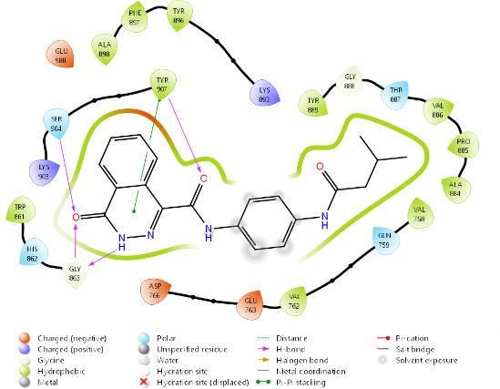 | 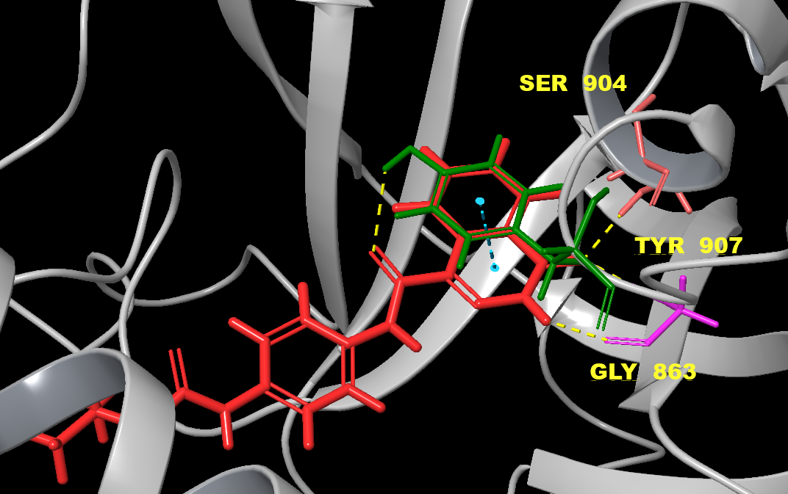
Compound 4 | 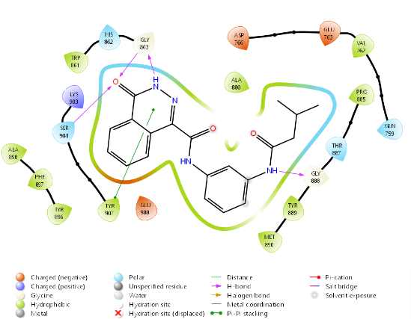 | 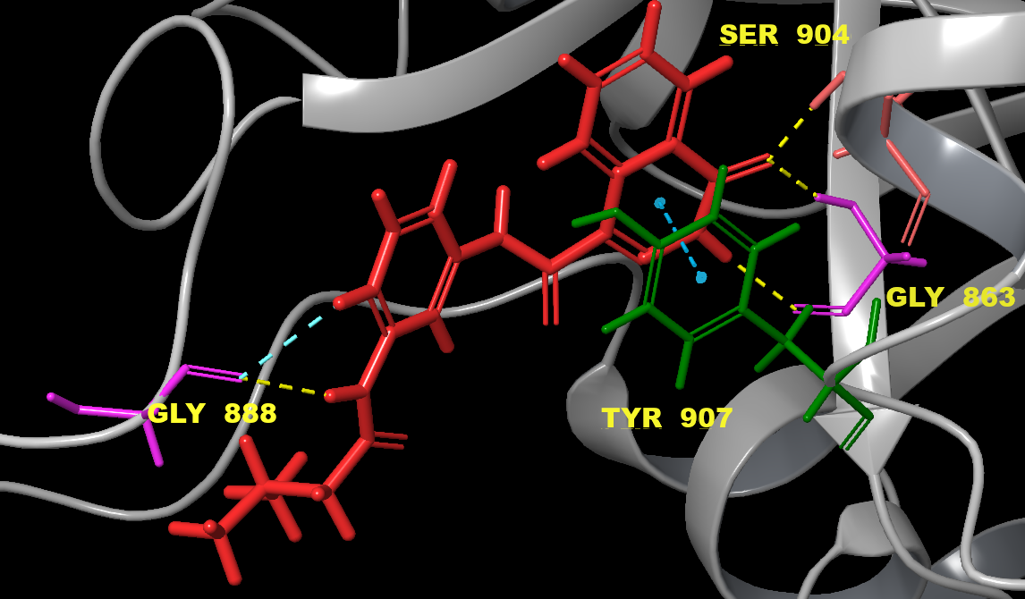
Olaparib | 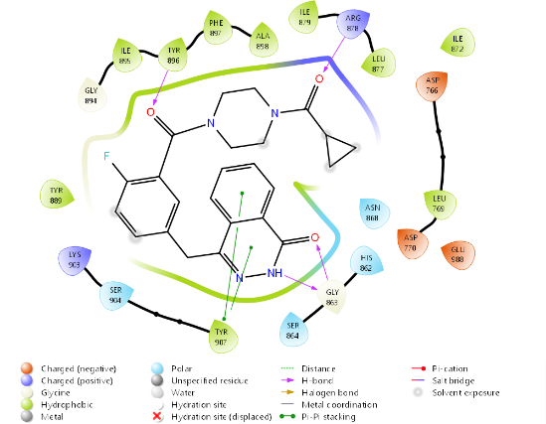 | 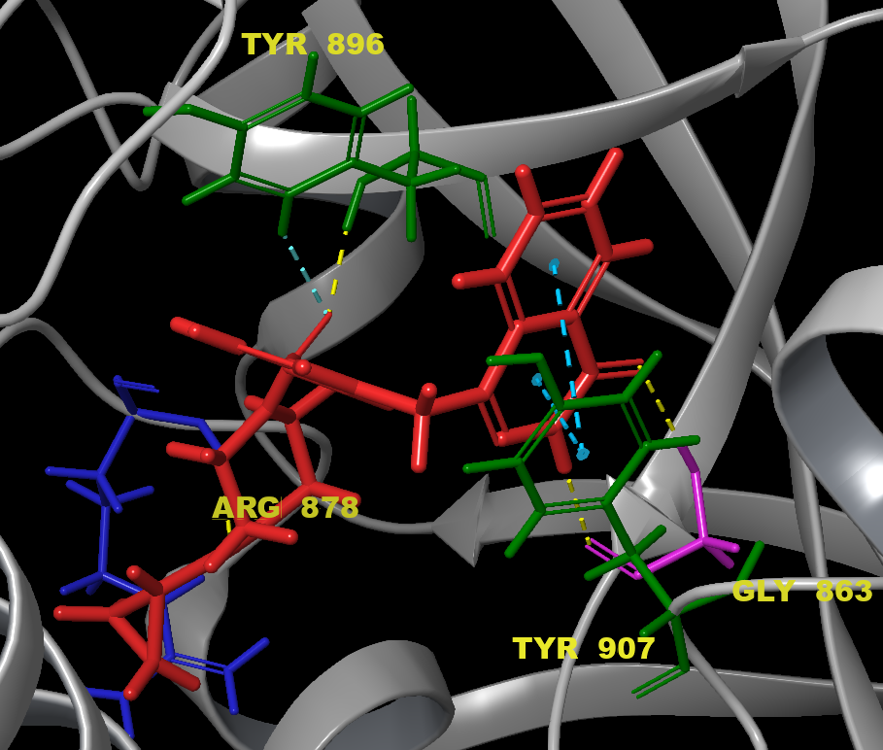
Talazoparib | 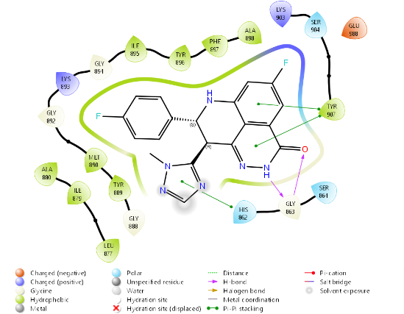 | 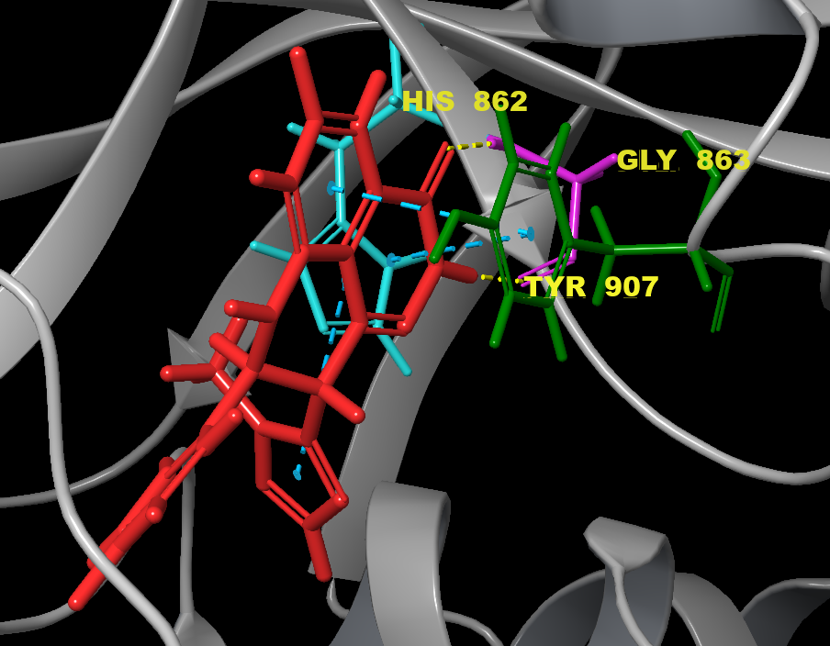

1. Qiu Q., Zhou J., Shi W., Kairuki M., Huang W., Qian H. Design, synthesis and biological evaluation of N-(4-(2-(6,7-dimethoxy-3,4-dihydroisoquinolin-2(1H)-yl)ethyl)phenyl)-4-oxo-3,4-dihydrophthalazine-1-carboxamide derivatives as novel P-glycoprotein inhibitors reversing multidrug resistance. Bioorganic Chemistry. 2019; 86: 166-175. https://doi.org/10.1016/j.bioorg.2019.01.039
2. National Center for Biotechnology Information (2025). PubChem Compound Summary for CID 776855, 4-Oxo-3,4-dihydrophthalazine-1-carboxylic acid. Retrieved December 5, 2025 from https://pubchem.ncbi.nlm.nih.gov/compound/4-Oxo-3_4-dihydrophthalazine-1-carboxylic-acid.
3. Abraham M., Berk, H., Alekseenko A., Wingbermuehle S. Learn to code in GROMACS (Edition 2023). 2023; Zenodo. https://doi.org/10.5281/zenodo.10276348
4. Meshcheriakov A.A, Iurev G.O, Luttsev M.D, Podolsky N.E., Sergei V. Ageev, Andrey V. Petrov, Lubov V. Vasina, Irina L. Solovtsova, Vladimir V. Sharoyko, Igor V. Murin, Konstantin N. Semenov Physicochemical properties, biological activity and biocompatibility of water-soluble C₆₀-Hyp adduct Colloids and Surfaces B: Biointerfaces 2020; 196: 111338. https://doi.org/10.1016/j.colsurfb.2020.111338
5. Skryl’nikova M.A, Timoshchuk K.V, Chutko A.L, Petukhova N.V, Sivtsov E.V, Shemchuk O.S, Mikolaichuk O.V, Spiridonova D.V, Khramchikhin A.V, Molchanov O.E, Granov D.A 2-(Methylthio)-4-morpholino-6-thioxo-1,6-dihydropyrimidine-5-carbaldehyde as a Scaffold for discovery of PI3K inhibitor. Journal of Molecular Structure 2026; 1350: 144069. https://doi.org/10.1016/j.molstruc.2025.144069
6. Amé J.C., Kalisch T., Dantzer F., Schreiber V. Purification of recombinant poly(ADP-ribose) polymerases. Methods Mol. Biol. 2011; 780: 135–152. https://doi.org/10.1007/978-1-61779-270-0_9.
7. Sastry GM, Adzhigirey M, Day T, Annabhimoju R, Sherman W. Protein and ligand preparation: parameters, protocols, and influence on virtual screening enrichments J Comput Aided Mol Des. 2013; 27(3): 221-34. https://doi.org/10.1007/s10822-013-9644-8
8. Jacobson MP, Friesner RA, Xiang Z, Honig B. On the role of the crystal environment in determining protein side-chain conformations. J Mol Biol. 2002; 320(3): 597–608. https://doi.org/10.1016/s0022-2836(02)00470-9
9. Jacobson M.P., Pincus D.L., Rapp C.S., Day T.J.F., Honig B., Shaw D.E., Friesner R.A. Proteins: Structure Function and Genetics 2004; 55: 351–367.
10. Greenwood JR, Calkins D, Sullivan AP, Shelley JC. Towards the comprehensive, rapid, and accurate prediction of the favorable tautomeric states of drug-like molecules in aqueous solution J Comput Aided Mol Des 2010, 24(6-7), 591-604. https://doi.org/10.1007/s10822-010-9349-1
11. Damm W., Frontera A., Tirado–Rives J. Jorgensen W.L. OPLS all-atom force field for carbohydrates. J. Comput. Chem. 1997; 18: 1955-1970. https://doi.org/10.1002/(SICI)1096-987X(199712)18:16<1955::AID-JCC1>3.0.CO;2-L
12. Schrödinger Release 2021-3: Protein Preparation Wizard; Epik, Schrödinger, LLC, New York, NY, 2021
13. Lu C, Wu C, Ghoreishi D, Chen W, Wang L, Damm W, Ross GA, Dahlgren MK, Russell E, Von Bargen CD, Abel R, Friesner RA, Harder ED. OPLS4: Improving Force Field Accuracy on Challenging Regimes of Chemical Space J Chem Theory Comput. 2021; 17(7): 4291-4300. https://doi.org/10.1021/acs.jctc.1c00302
14. Sherman W, Day T, Jacobson MP, Friesner RA, Farid R. Novel procedure for modeling ligand/receptor induced fit effects J Med Chem 2006; 49(2): 534-553.
15. María J. R. Yunta. Docking and Ligand Binding Affinity: Uses and Pitfalls American Journal of Modeling and Optimization 2016; 4(3): 74-114
16. William L. Jorgensen, Jayaraman Chandrasekhar, Jeffry D. Madura, Roger W. Impey, Michael L. Klein Comparison of simple potential functions for simulating liquid water J Chem Phys 1983; 79(2): 926–935
17. Shuichi Nosé A unified formulation of the constant temperature molecular dynamics methods J. Chem. Phys. 1984; 81(1): 511–519. https://doi.org/10.1063/1.447334
18. Greenidge PA, Kramer C, Mozziconacci JC, Wolf RM. MM/GBSA binding energy prediction on the PDBbind data set: successes, failures, and directions for further improvement. J Chem Inf Model 2013; 53(1): 201-209. https://doi.org/10.1021/ci300425v

