<Appendix A Supplementary Material>
Urban environmental and climatic determinants of pediatric respiratory infection: Microscale spatiotemporal evidence from Fuzhou, China
Yangbin Dong ^{a,#}, Yanying Rao ^{b,#}, Jie Zhang ª, Qiuyu Tang ^{c,**}, Zhanyong Wang ^{a,*}
ª College of Transportation and Civil Engineering, Fujian Agriculture and Forestry University, Fuzhou 350108, China
^{b} Department of Radiology, Fujian Children's Hospital (Fujian Branch of Shanghai Children's Medical Center), College of Clinical Medicine for Obstetrics & Gynecology and Pediatrics, Fujian Medical University, Fuzhou 350014, Fujian, China
^{c} Pediatric Intensive Care Unit‌, Fujian Children's Hospital (Fujian Branch of Shanghai Children's Medical Center), College of Clinical Medicine for Obstetrics & Gynecology and Pediatrics, Fujian Medical University, Fuzhou 350014, Fujian, China
# These authors contributed equally to this work.
*Corresponding authors: tell.rain@163.com (Q. Tang); wangzy1026@fafu.edu.cn (Z. Wang).

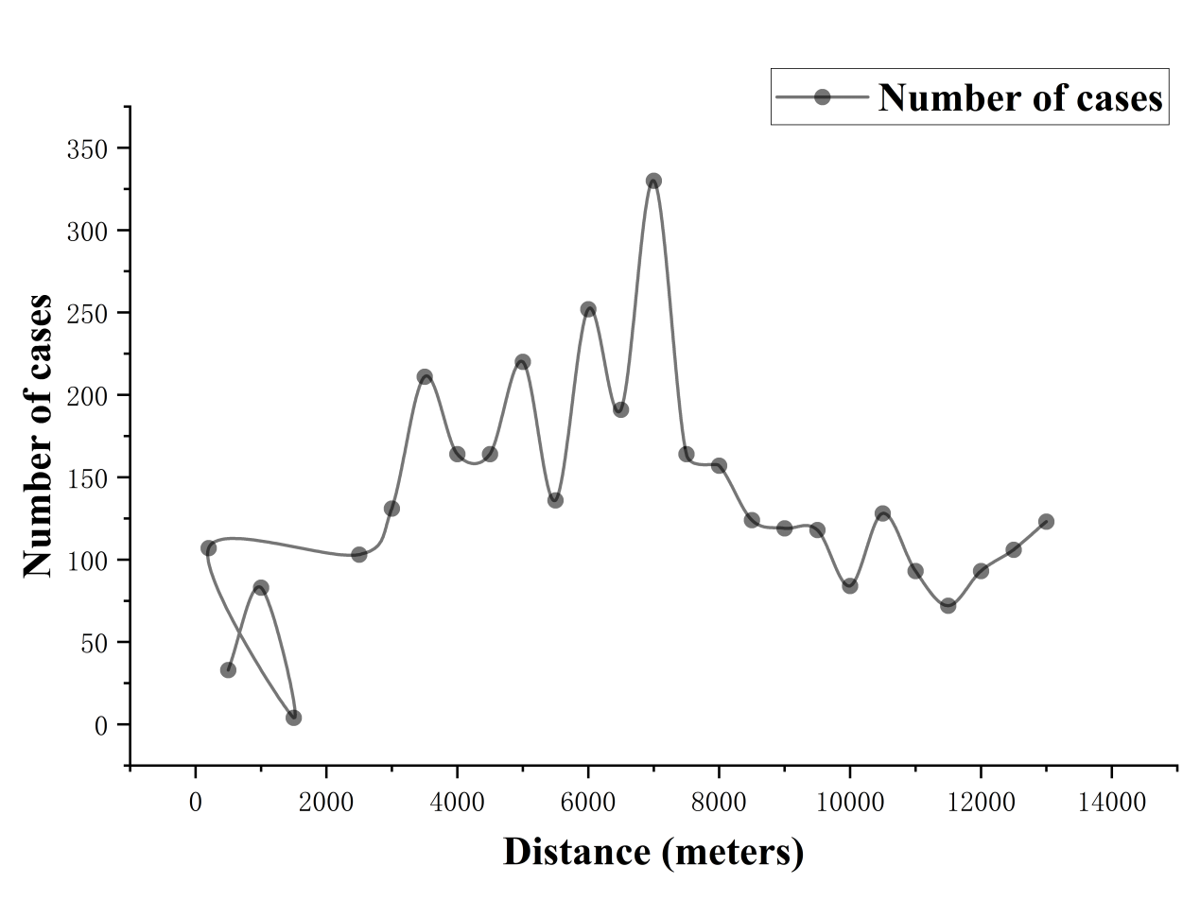
Fig.S1 Distance to hospital vs. number of cases
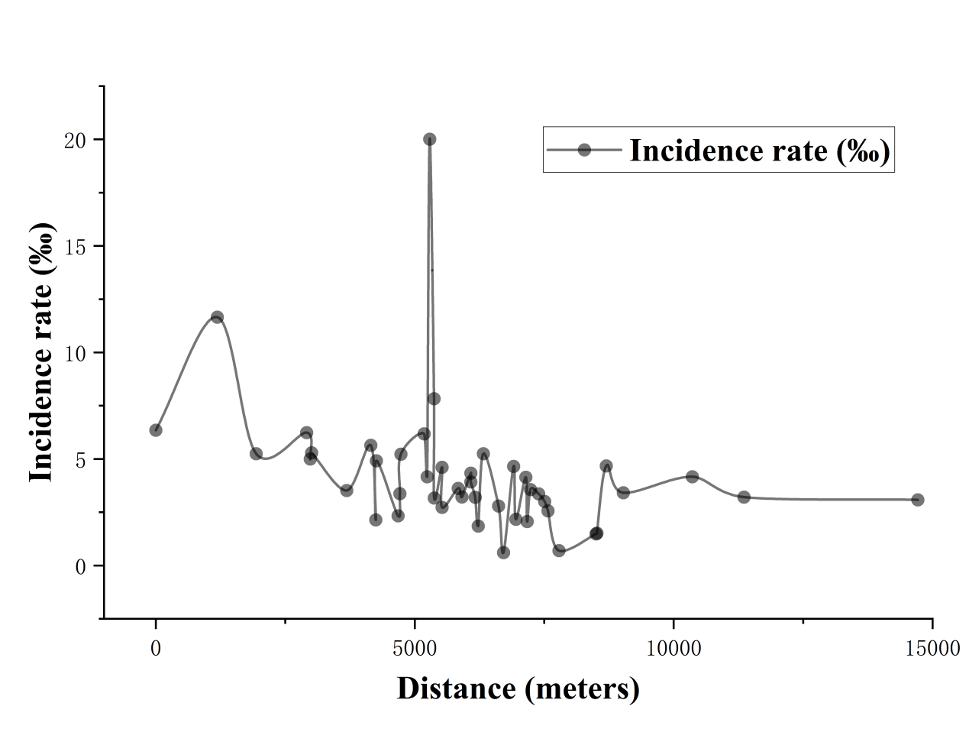
Fig.S2 Distance to hospital vs. incidence rate (‰)
Table S1 Spatial–temporal scanning results of MPP in children
Time window | Type | Scanning area | ID | Span (km) | Time frame | Number of cases | RR | LLR | p-value
3 months | Ⅰ | All | 7, 18, 37, 46, 13, 9, 36, 34, 15, 41, 1, 38, 27, 6, 40, 42, 32, 17, 45, 16, 14 | 10.25 | 2023/11/1 to 2024/1/31 | 637 | 2.63 | 183.62 | < 0.00001
3 months | Ⅱ | All | 1 | 0 | 2024/3/1 to 2024/4/30 | 15 | 6.78 | 15.89 | <0.0001
1 month | Ⅰ | All | 46, 7, 37, 36, 18, 13, 34, 14, 9, 40, 42, 1, 6, 15, 41, 45, 27, 2,17, 38 | 11.21 | 2023/12/1 to 2023/12/31 | 224 | 2.65 | 74.52 | < 0.00001
1 month | Ⅱ | All | 7, 18, 37, 46 | 4.12 | 2023/10/1 to 2023/10/31 | 50 | 2.60 | 16.81 | <0.0001
2 months | Ⅰ | All | 29, 33, 19, 41, 38, 18, 7, 46, 13, 15, 37, 16, 9, 27, 1, 34, 36, 32,6, 21 | 10.25 | 2023/11/1 to 2023/12/31 | 426 | 2.66 | 183.62 | < 0.00001
2 months | Ⅱ | All | 1 | 0 | 2024/2/1 to 2024/3/31 | 22 | 10.14 | 31.05 | <0.0001
4 months | Ⅰ | All | 46, 7, 37, 36, 18, 13, 34, 14, 9, 40, 42, 1, 6, 15, 41, 45, 27, 2,17, 38 | 11.21 | 2023/10/1 to 2024/1/31 | 742 | 2.58 | 198.34 | < 0.00001
4 months | Ⅱ | All | 1 | 0 | 2024/3/1 to 2024/4/30 | 15 | 6.78 | 15.89 | <0.0001
5 months | Ⅰ | All | 46, 7, 37, 36, 18, 13, 34, 14, 9, 40, 42, 1, 6, 15, 41, 45, 27, 2,17, 38 | 11.21 | 2023/10/1 to 2024/2/29 | 637 | 2.49 | 203.86 | < 0.00001
5 months | Ⅱ | All | 3, 23, 11, 5, 44, 39, 10 | 3.13 | 2023/10/1 to 2023/12/31 | 15 | 1.73 | 8.45 | 0.117

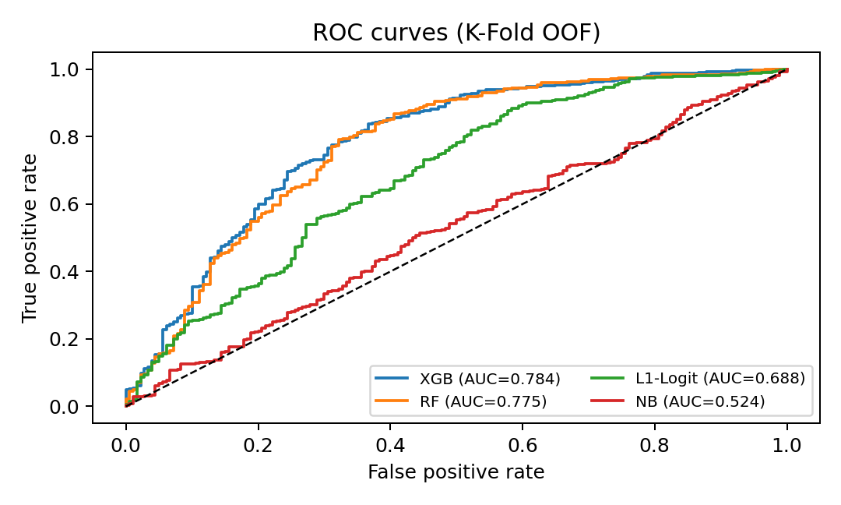
Fig.S3 ROC curves (K-fold out-of-fold) comparing models for pediatric MPP incidence
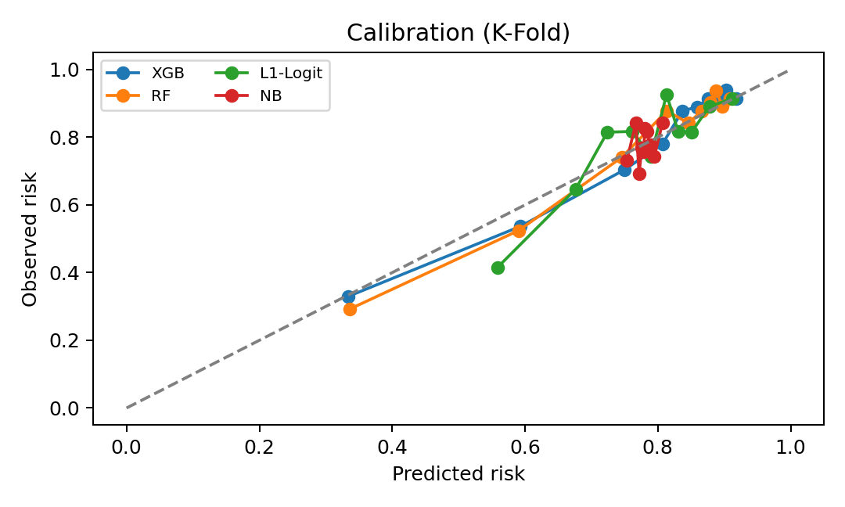
Fig.S4 Calibration curves (K-fold CV) for MPP risk models
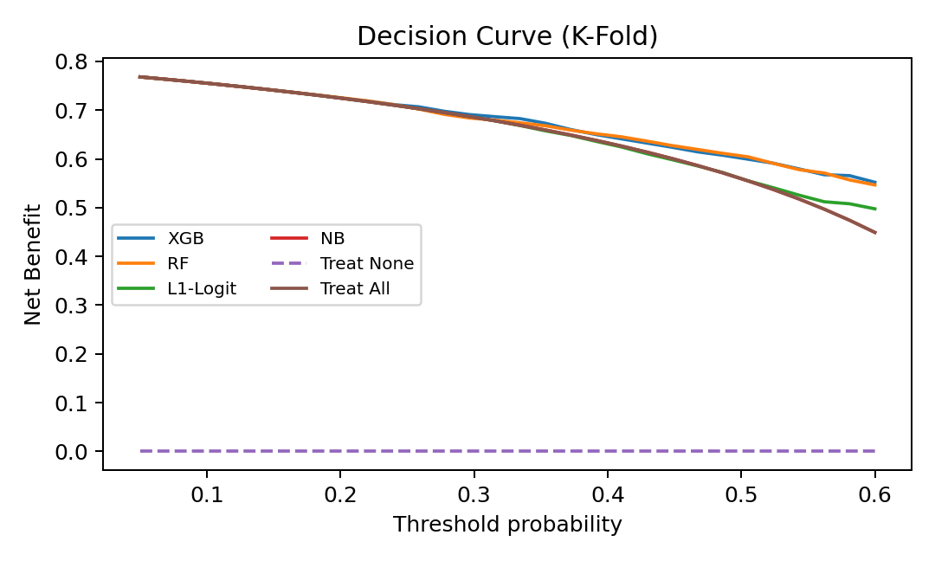
Fig.S5 Decision curve analysis (K-fold CV) for MPP risk models

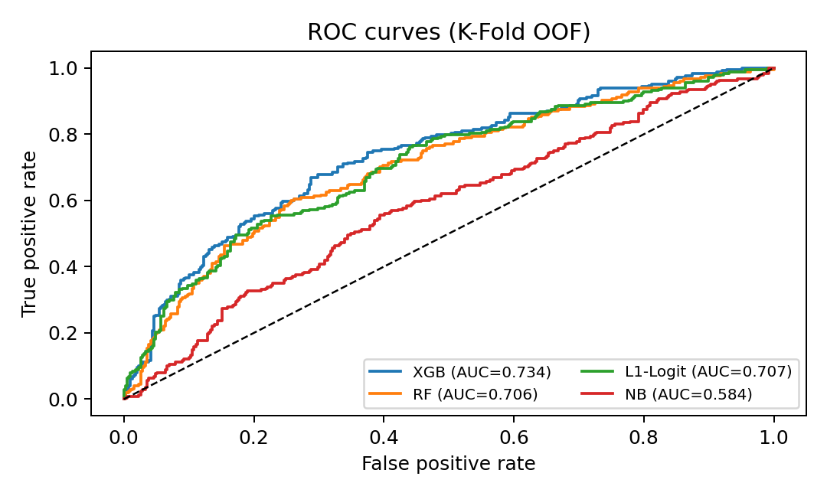
Fig.S6 ROC curves (K-fold out-of-fold) comparing models for progression from MPP to severe pneumonia

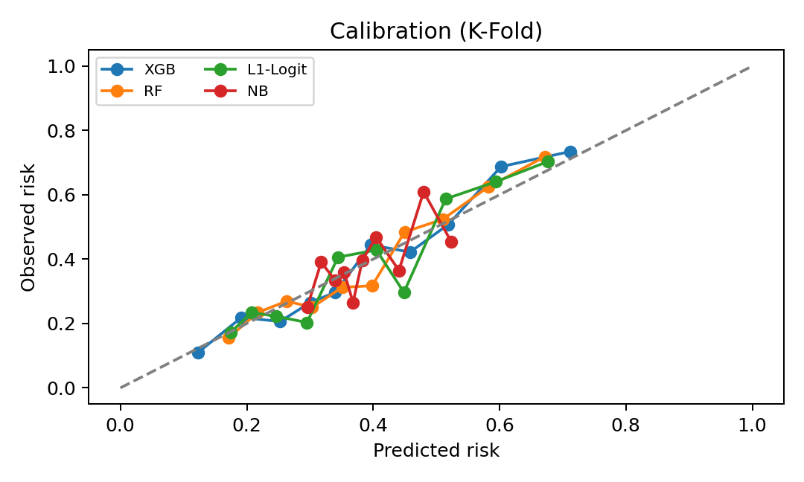
Fig.S7 Calibration curves (K-fold CV) for models predicting progression from MPP to severe pneumonia

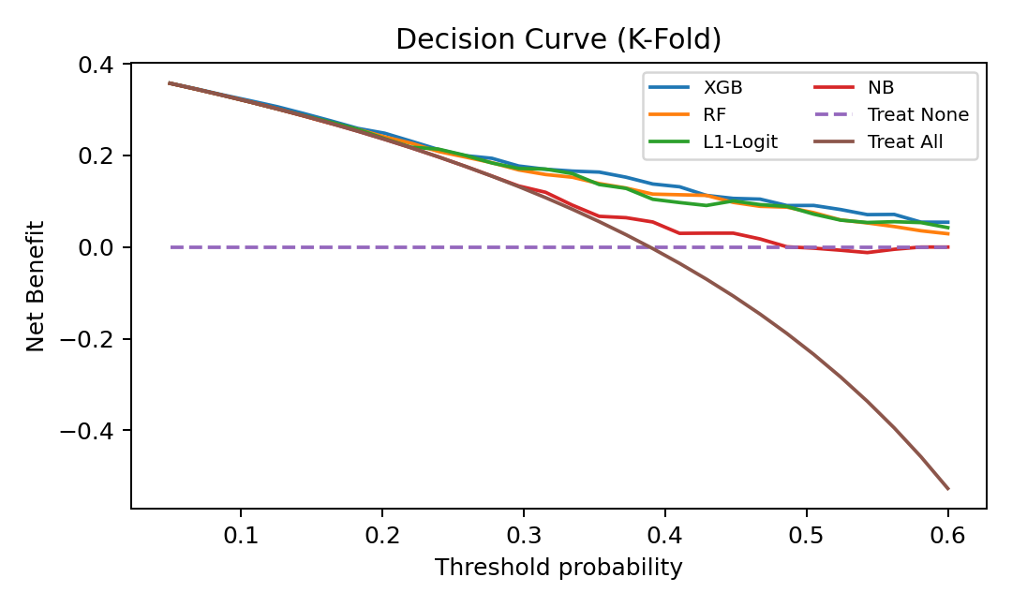
Fig.S8 Decision curve analysis (K-fold CV) for models predicting progression from MPP to severe pneumonia
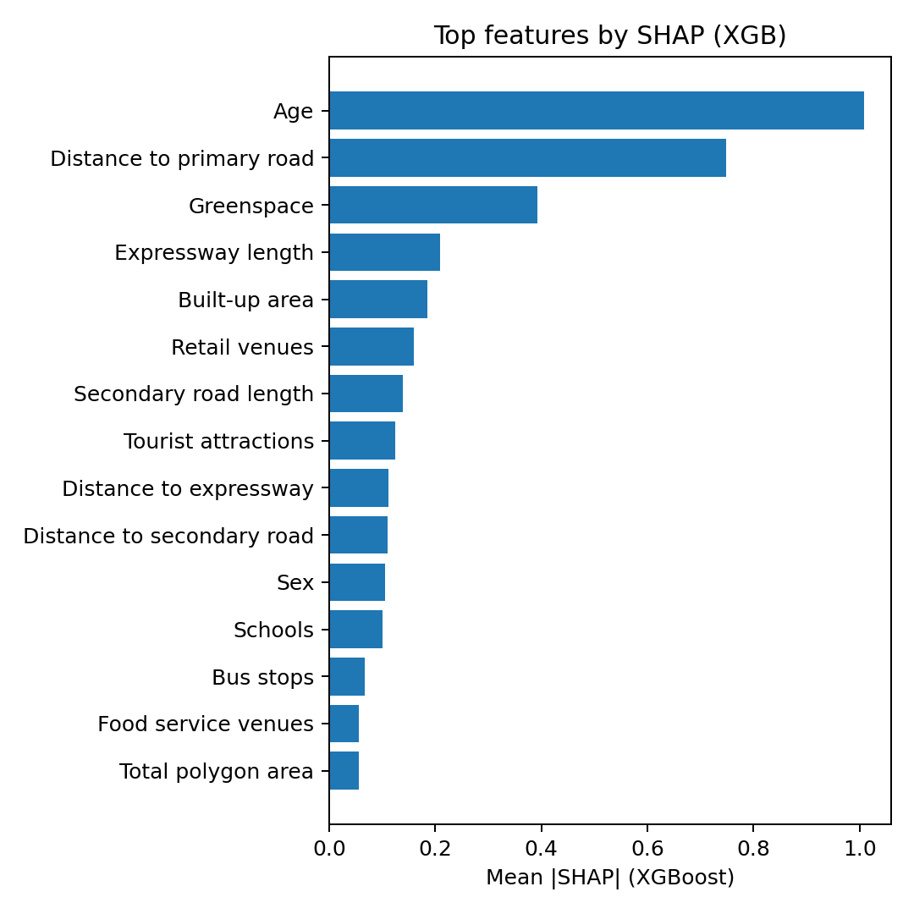
Fig.S9 Top 15 features for pediatric MPP incidence (ranked by mean |SHAP|, XGBoost)

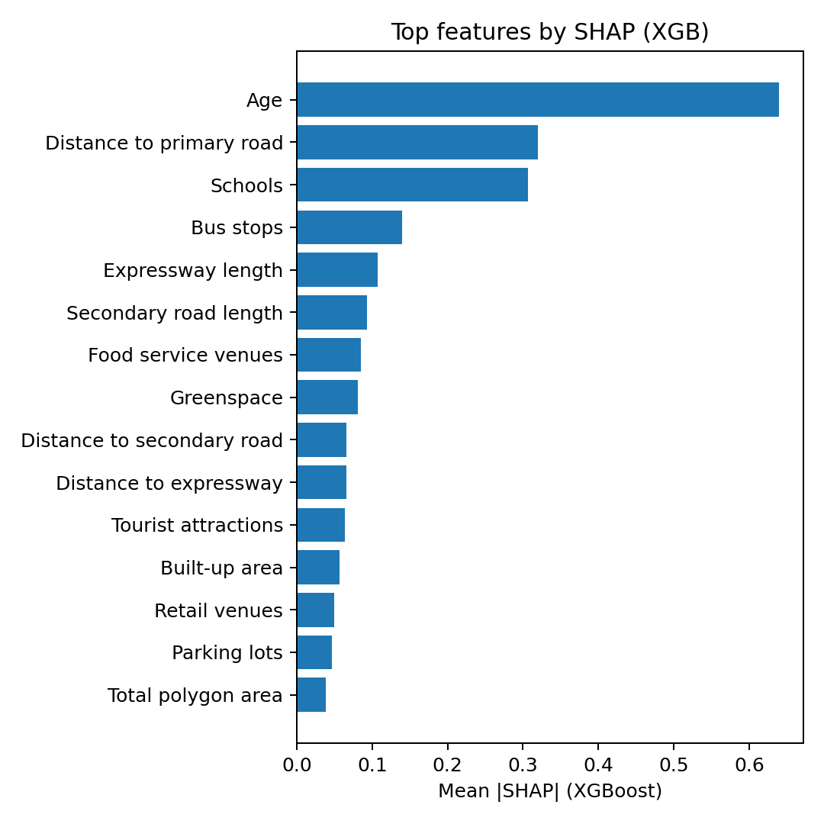
Fig.S10 Top 15 features for progression from MPP to severe pneumonia (ranked by mean |SHAP|, XGBoost)

