Supplementary Tables
Table S1. Frequency of Vgsc-L995F resistance allele in Anopheles arabiensis from Ethiopia by geographical regions. Statistical significance was determined using a chi-square test (df=1). A p-value ≤ 0.05 was considered significant.
Location |  | χ 2 | df | p-value
Northern | Central | 129.11 | 1 | <0.0001
 | Southern | 65.80 | 1 | <0.0001
 | Southwestern | 27.73 | 1 | <0.0001
 | Western | 33.70 | 1 | <0.0001
Central | Southern | 1.68 | 1 | 0.1956
 | Southwestern | 0.59 | 1 | 0.4435
 | Western | 0.01 | 1 | 0.9301
Southern | Southwestern | 2.55 | 1 | 0.1106
 | Western | 0.37 | 1 | 0.5451
Western | Southwestern | 0.41 | 1 | 0.5245

Table S2. Frequency of Cyp6aa/p, Coeae2-7g, Cyp9k1, Gste2, and Cyp6z2 copy number variation (CNVs) in Anopheles arabiensis across geographical regions in Ethiopia. Statistical significance was determined using a chi-square test (df=1). A p-value ≤ 0.05 was considered significant.

Location |  |  |  | Genes
 |  | Cyp6aa/p |  | Coeae2-7g |  | Cyp9k1 |  | Gste2 |  | Cyp6z2
 |  | χ 2 | p-value | χ 2 | p-value | χ 2 | p-value | χ 2 | p-value | χ 2 | p-value
Northern | Central | 1.442 | 0.2298 | 0.666 | 0.4144 | 27.380 | <0.0001 | 1.298 | 0.2546 | 0.006 | 0.9375
 | Southern | 8.693 | 0.0032 | 2.551 | 0.1102 | 1.051 | 0.3052 | 4.541 | 0.0331 | 0.000 | 1.0000
 | Southwestern | 0.000 | 0.9914 | 0.621 | 0.4307 | 1.940 | 0.1637 | 0.000 | 1.0000 | 0.621 | 0.4307
 | Western | 39.773 | <0.0000 | 0.611 | 0.4343 | 0.012 | 0.9113 | 33.795 | <0.0000 | 0.023 | 0.8791
Central | Southern | 32.352 | <0.0000 | 1.289 | 0.2562 | 36.386 | <0.0001 | 2.295 | 0.1298 | 0.000 | 1.0000
 | Southwestern | 0.202 | 0.6531 | 0.085 | 0.7707 | 4.304 | 0.0380 | 0.242 | 0.6225 | 1.169 | 0.2797
 | Western | 109.873 | <0.0000 | 3.289 | 0.0697 | 11.098 | 0.0009 | 42.437 | <0.0000 | 0.159 | 0.6904
Southern | Southwestern | 5.909 | <0.0151 | 0.021 | 0.8836 | 5.104 | 0.0239 | 1.931 | 0.1646 | 0.817 | 0.3660
 | Western | 10.908 | <0.0010 | 5.302 | 0.0213 | 1.008 | 0.3153 | 12.088 | 0.0005 | 0.085 | 0.7713
Western | Southwestern | 25.734 | <0.0000 | 2.172 | 0.1406 | 0.800 | 0.3711 | 18.550 | <0.0000 | 0.031 | 0.8601

Table S3. Putative genes showing increased H12 values (peaks) in the Asossa Anopheles arabiensis cohorts.
Gene ID | Conting | Start | End | Name | Description
AGAP011227 | 3L | 19635709 | 19644016 | NaN | Tartan
AGAP011229 | 3L | 19810767 | 19826552 | NaN | Tartan
AGAP011231 | 3L | 19867709 | 19868872 | NaN | fibrinogen
AGAP011242 | 3L | 19935159 | 19978825 | NaN | E3 ubiquitin ligase SMURF1/2
AGAP011243 | 3L | 19979246 | 19979846 | NaN | Ribonuclease H2 subunit
AGAP011244 | 3L | 19979876 | 19981896 | NaN | rRNA 2'-O-methyltransferase fibrillarin
AGAP011245 | 3L | 19982535 | 19983733 | NaN | chloride channel
AGAP011246 | 3L | 19984046 | 19985106 | NaN | origin recognition complex subunit 6
AGAP011247 | 3L | 19986323 | 19995087 | NaN | Longitudinals lacking protein-like
AGAP011249 | 3L | 19999770 | 20002401 | NaN | pre-mRNA-splicing factor CWC26
AGAP011251 | 3L | 20072720 | 20077159 | NaN | ubiquitin-like protein 5
AGAP011254 | 3L | 20102345 | 20111903 | Arl5 | ADP-ribosylation factor-like protein 5

Table S4. List of sample sets and accession numbers of the sequence samples. Samples with multiple run accessions are given within their respective sample sets.
Sample sets | Accession number
1270-VO-MULTI-PAMGEN-VMF00162 | ERR6045394-ERR6045422,ERR6045425-ERR6045453,ERR6045456-ERR6045484
1270-VO-MULTI-PAMGEN-VMF00162 | ERR5987917-ERR5987948,ERR5987949-ERR5987980,ERR5987981-ERR5988012
1270-VO-MULTI-PAMGEN-VMF00162 | ERR5967771-ERR5967798,ERR5967799-ERR5967826,ERR5967827-ERR5967854
1270-VO-MULTI-PAMGEN-VMF00218 | ERR10419623-ERR10419646
1270-VO-MULTI-PAMGEN-VMF00218 | ERR10419672-ERR10419694
1270-VO-MULTI-PAMGEN-VMF00218 | ERR10490762-ERR10490785
1270-VO-MULTI-PAMGEN-VMF00218 | ERR10490810-ERR10490977
1270-VO-MULTI-PAMGEN-VMF00218 | ERR10970454-ERR10970494,  ERR11041589-ERR11041629
1324-VO-ET-GOLASSA-VMF00257 | ERR12262329-ERR12262396
1324-VO-ET-GOLASSA-VMF00257 | ERR12314213-ERR12314278
1324-VO-ET-GOLASSA-VMF00257 | ERR12325996-ERR12326278
1324-VO-ET-GOLASSA-VMF00257 | ERR12547479-ERR12547495 and ERR12767674
1324-VO-ET-GOLASSA-VMF00275 | ERR12871282-ERR12871307
1324-VO-ET-GOLASSA-VMF00275 | ERR12948031-ERR12948246
1324-VO-ET-GOLASSA-VMF00275 | ERR12983126-ERR12983194
1324-VO-ET-GOLASSA-VMF00275 | ERR13101382-ERR13101590
1324-VO-ET-GOLASSA-VMF00275 | ERR13146891-ERR13146976

Supplementary Figures
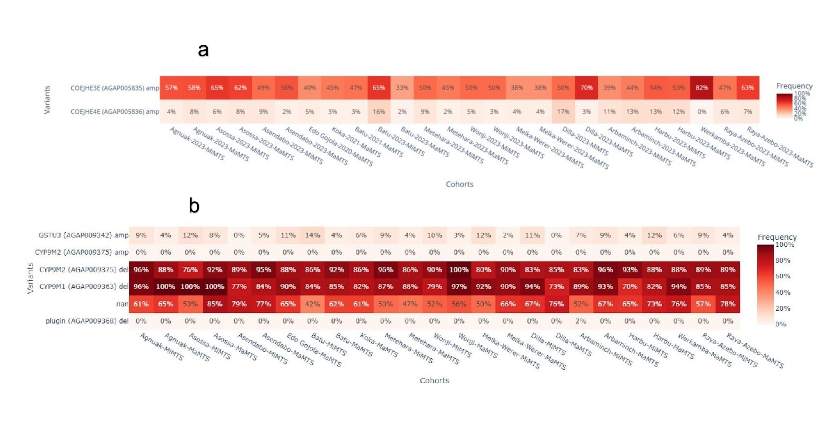
Figure S1. The CNV allele frequency: (a) the CNV allele frequency of Coejhe3e (AGAP005835), Coejhe4e (AGAP005836) genes and (b) the CNV allele frequency of Gstu3 (AGAP009347), Cyp9m2 (AGAP009375), Cyp9m1 (AGAP009363), and Plugin (AGAP009368) genes in Anopheles arabiensis across different locations of Ethiopia by malaria transmission season. Variants indicate the gene name, gene ID, and CNV type of the genome. MaMTS: major malaria transmission season; MiMTS: minor malaria transmission season.
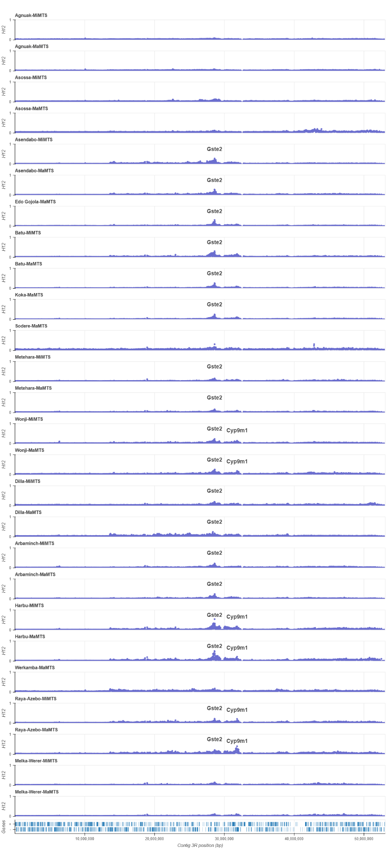

Figure S2. Genome-wide selection scan using the H12 statistic across the 3R chromosome. Peaks in H12 values are centred around the Gste2 and Cyp9m1 gene indicating the loci are potentially under selection.

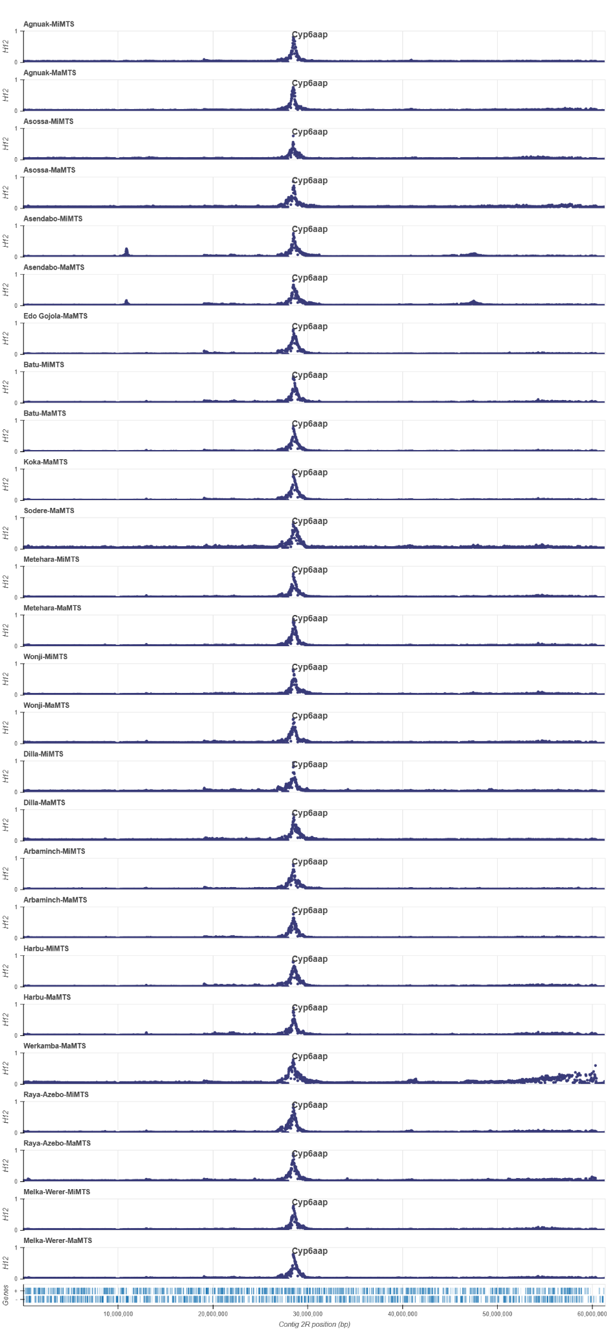

Figure S3. Genome-wide selection scan using the H12 statistic across the 2R chromosome. Peaks in H12 values centered at the Cyp6aa/p gene cluster are annotated, indicating a selection sweep.
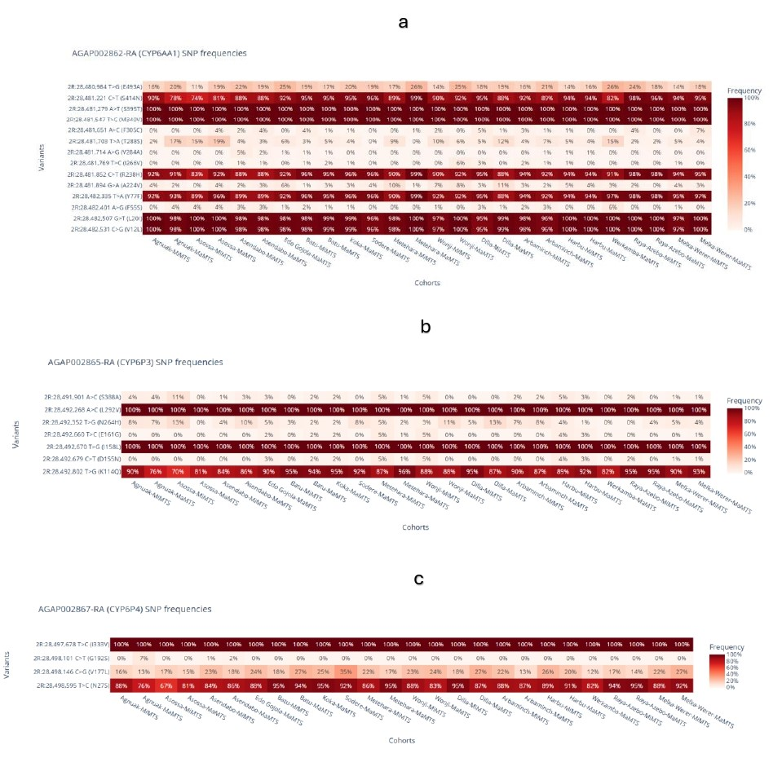
Figure S4. SNP allele frequency of a) Cyp6aa1 (AGAP002862), b) Cyp6p3 (AGAP002865), and c) Cyp6p4 (AGAP002867) genes in Anopheles arabiensis across different regions of Ethiopia by malaria transmission season. Variants indicate amino acid changes and the position of the genome. MaMTS: major malaria transmission season; MiMTS: minor malaria transmission season.

