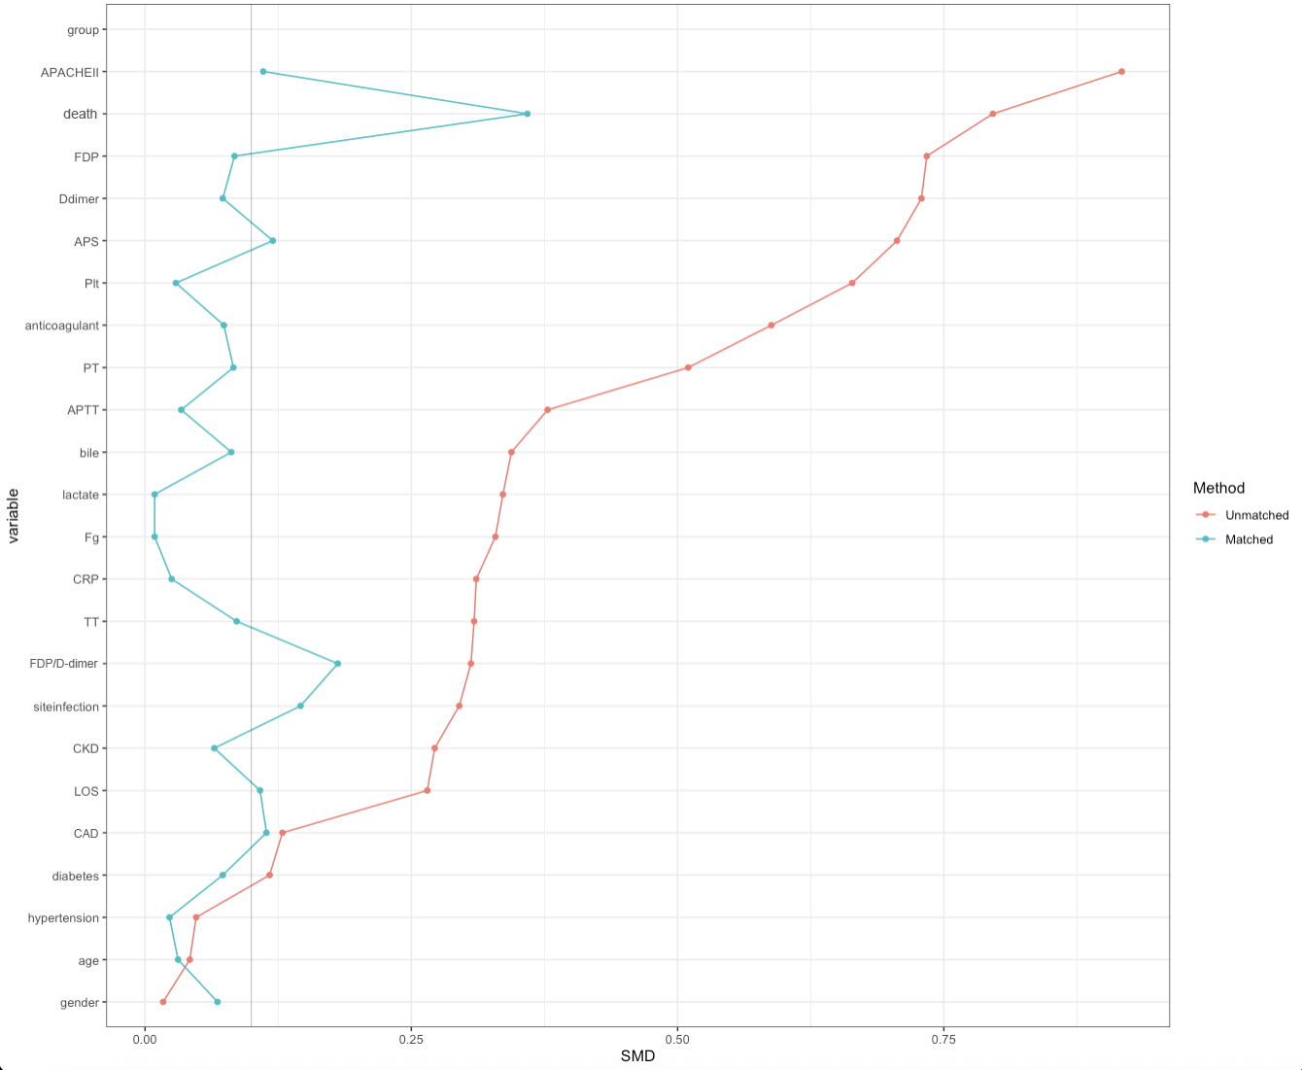
Supplementary Figure 1. Standardized Mean Differences of Biomarkers in sepsis and non-sepsis groups following propensity score matching

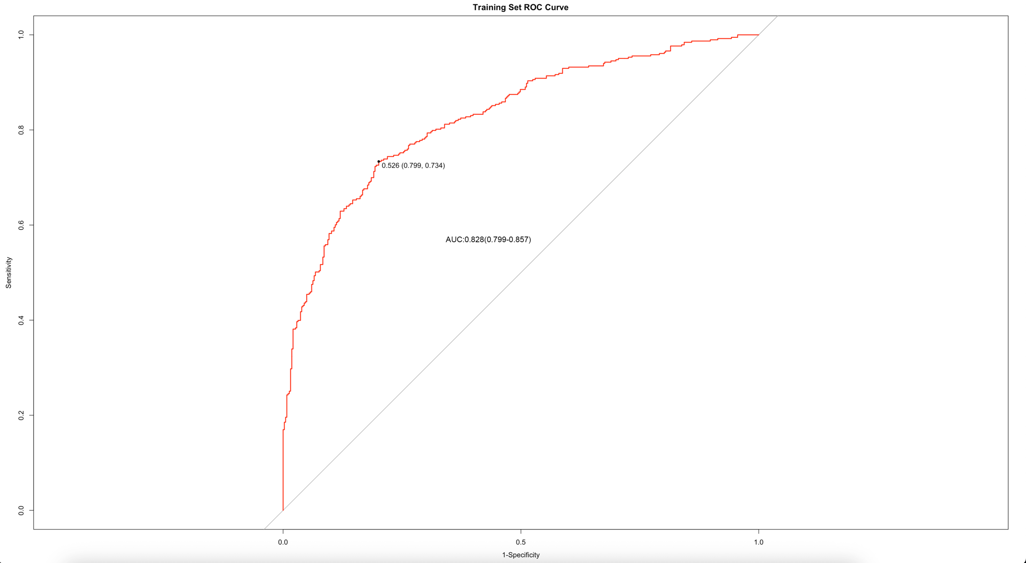
Supplementary Figure 2. ROC curve for the sepsis prediction model The cut-off value of the sepsis prediction model was 0.526 when area under the curve of 0.828, 95% confidence interval of 0.799-0.857, This indicates that the patient is diagnosed with sepsis when the model's predicted probability value exceeds 0.526, otherwise it is classified as non-sepsis. The true positive rate(TPR) was 0.734 and the false positive rate(FPR) was 0.799.

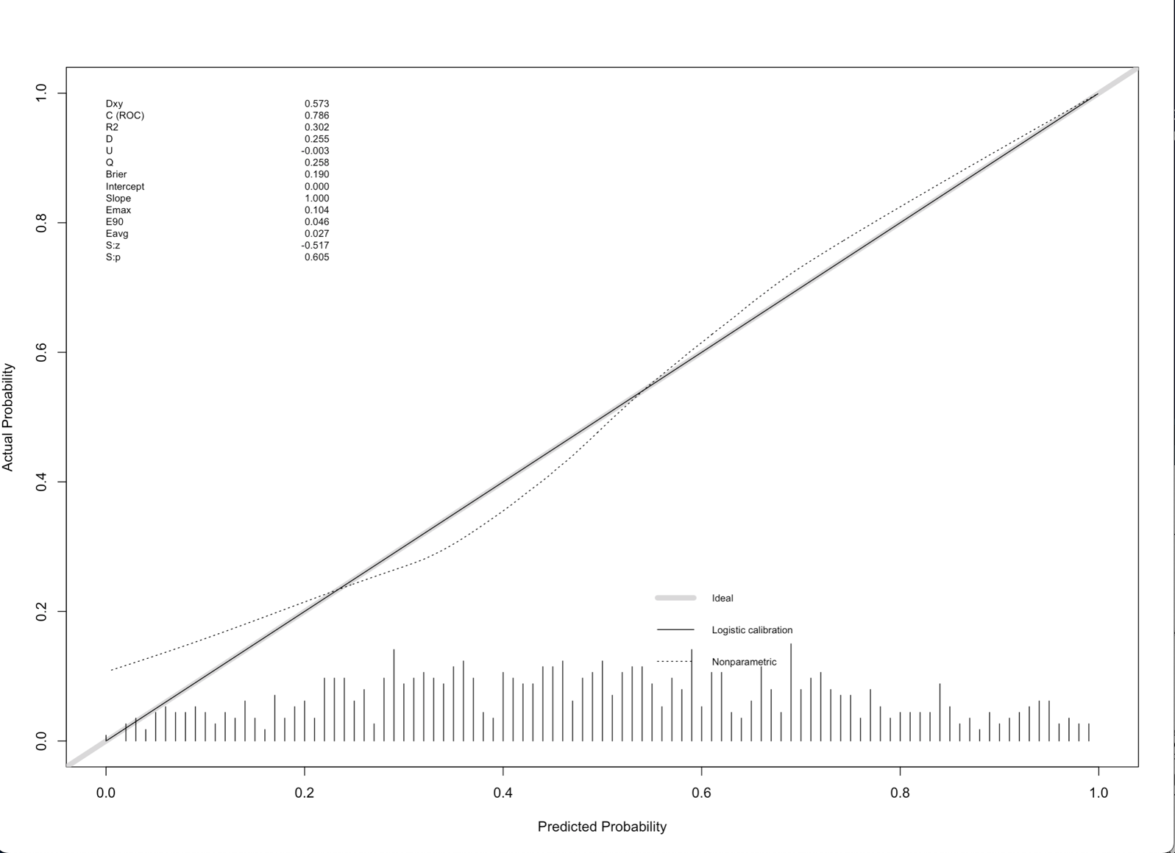
Supplementary Figure 3. The calibration plot for the sepsis prediction model The dot line (Nonparametric) represents the model's predicted fit, while the solid line (Logistic calibration) represents the bias-corrected fit from 1000 bootstrap resamples. The proximity of these curves to the reference line(ideal) indicates strong alignment between predicted and actual values. The mean absolute error was 0.027, suggesting high accuracy and good fit of the model's predictions.

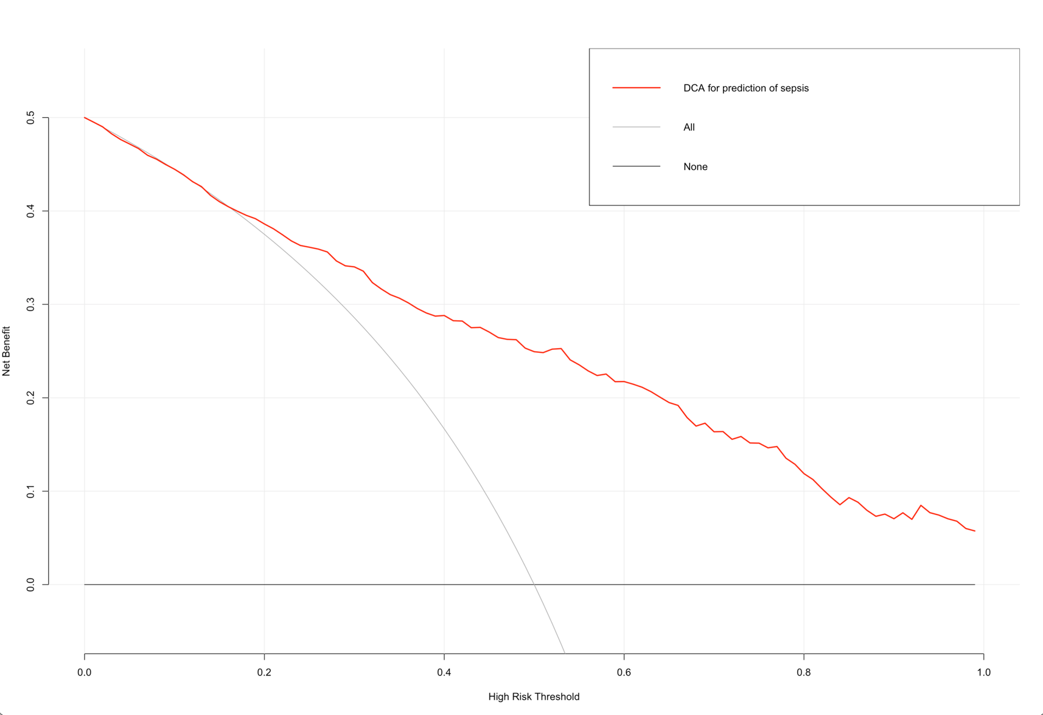
Supplementary Figure 4. DCA curve for the sepsis prediction model The x-axis represents threshold probability, while the y-axis represents the standard net benefit. The ALL line represents the net benefit of predicting that all patients will develop sepsis, while the None line represents the net benefit of predicting that none of the patients will develop sepsis. The decision curve for the sepsis prediction model lies between the ALL and None line and above the ALL line, indicating that the model's predictive ability surpasses always predicting a positive outcome and provides an enhanced clinical decision-making.

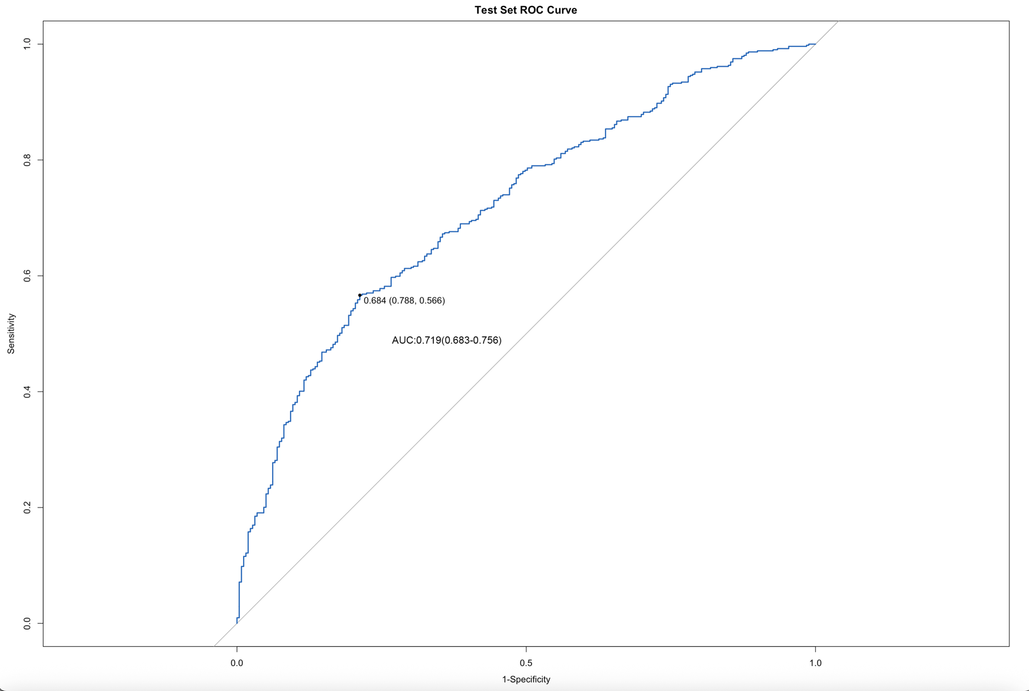
Supplementary Figure 5. ROC curve for external validation of the sepsis prediction model The cut-off value of the sepsis prediction model was 0.684 when area under the curve of 0.719, 95% confidence interval of 0.683-0.756, This indicates that the patient is diagnosed with sepsis when the model's predicted probability value exceeds 0.684, otherwise it is classified as non-sepsis. The true positive rate(TPR) was 0.566 and the false positive rate(FPR) was 0.788.

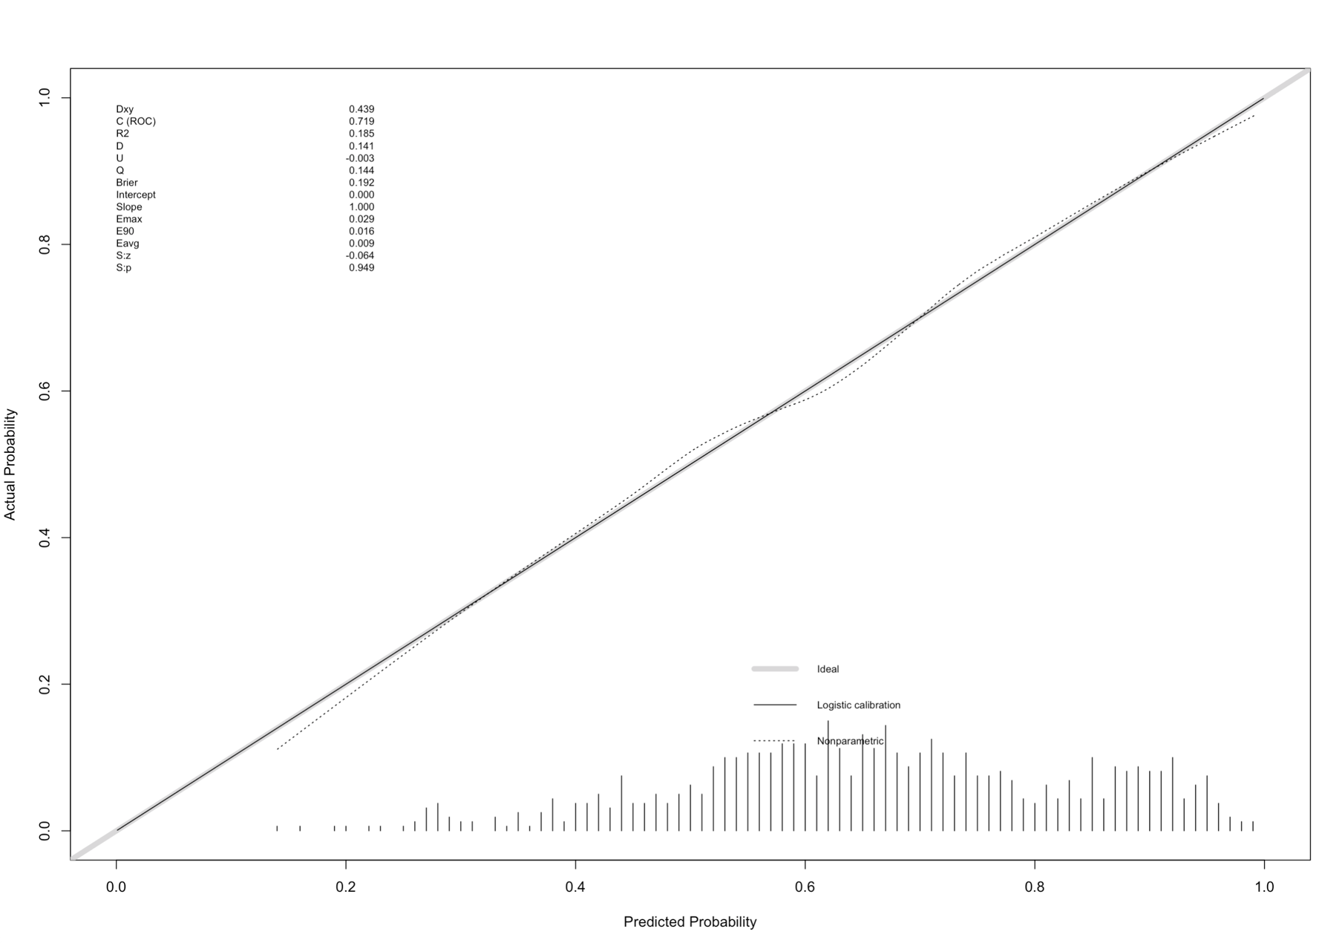
Supplementary Figure 6. The calibration plot for external validation of the sepsis prediction model The external validation prediction model of the external data of MIMIC-IV has an R2 value of 0.185 (R2 > 0.1), which is also well fitted. From the calibration plot, the dotted line (Nonparametric) and the solid line (Logistic calibration) represent the fitting lines of the model prediction and the actual situation, as well as the fitting lines after bias correction by 1000 resampling of the Bootstrap method. It can be seen from the figure that both the two curves and the standard line (ideal) are highly consistent, with an average absolute error of 0.009, indicating that the accuracy and fitting degree of the model prediction results are relatively high.

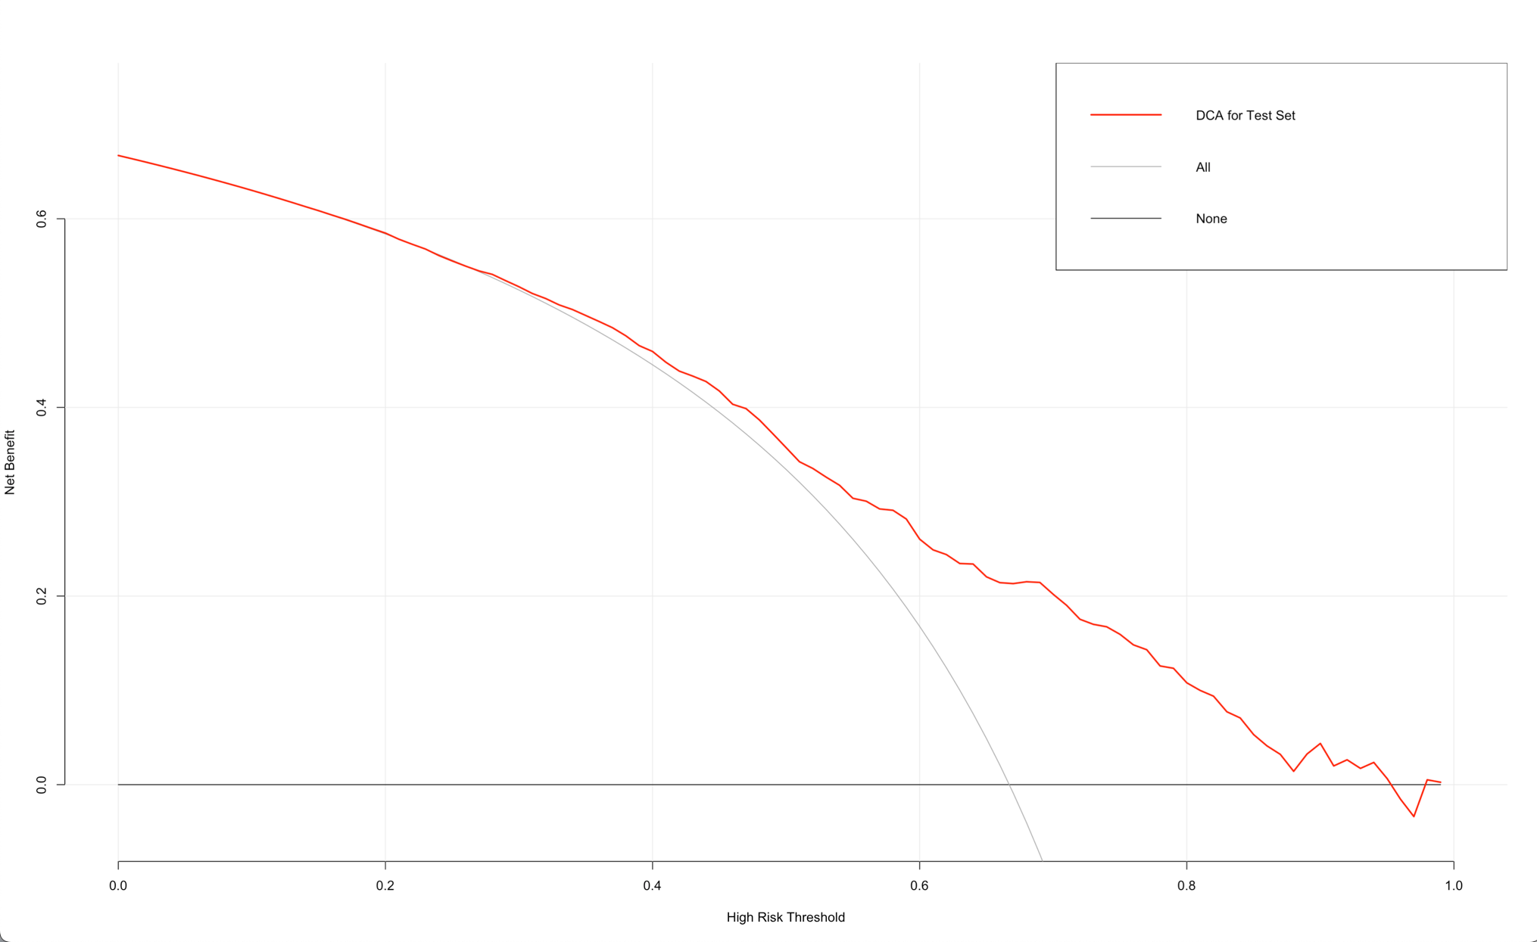
Supplementary Figure 7. DCA curve for external validation of the sepsis prediction model The x-axis represents threshold probability, while the y-axis represents the standard net benefit. The ALL line represents the net benefit of predicting that all patients will develop sepsis, while the None line represents the net benefit of predicting that none of the patients will develop sepsis. The decision curve for the sepsis prediction model lies between the ALL and None line and above the ALL line, indicating that the model's predictive ability surpasses always predicting a positive outcome and provides an enhanced clinical decision-making.

