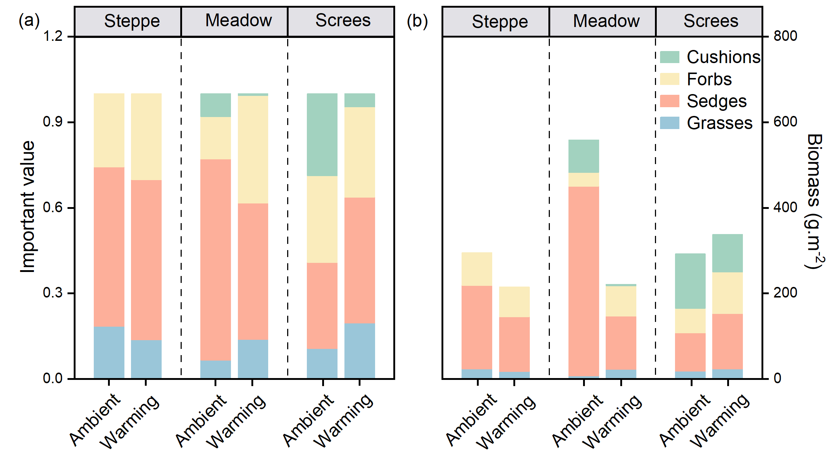
Figure S1 The importance values (a) and biomass (b) of different functional groups in the warming and ambient treatment.

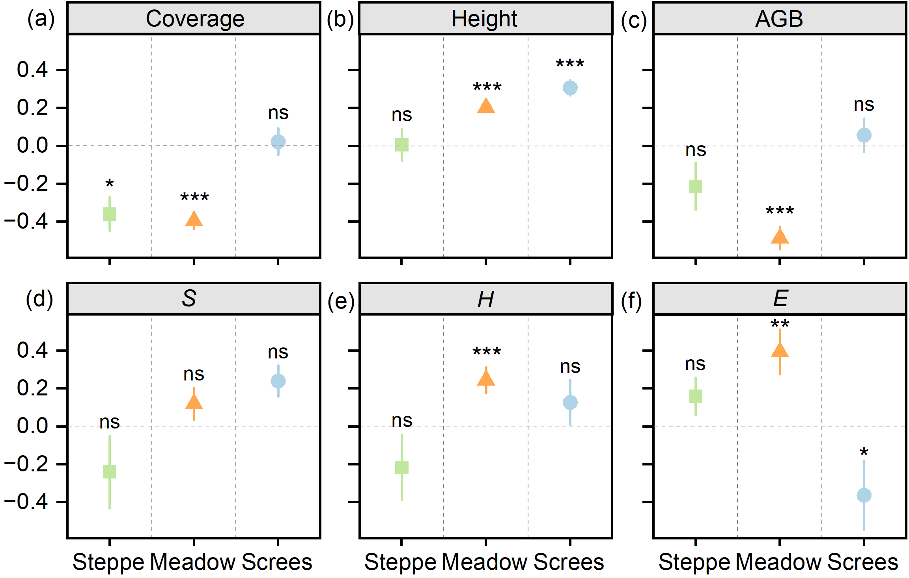
Figure S2 Effect size in vegetation productivity and plant diversity of different vegetation types between warming and ambient conditions. significance: ns no significance; * p < 0.05; ** p < 0.01; *** p < 0.001.

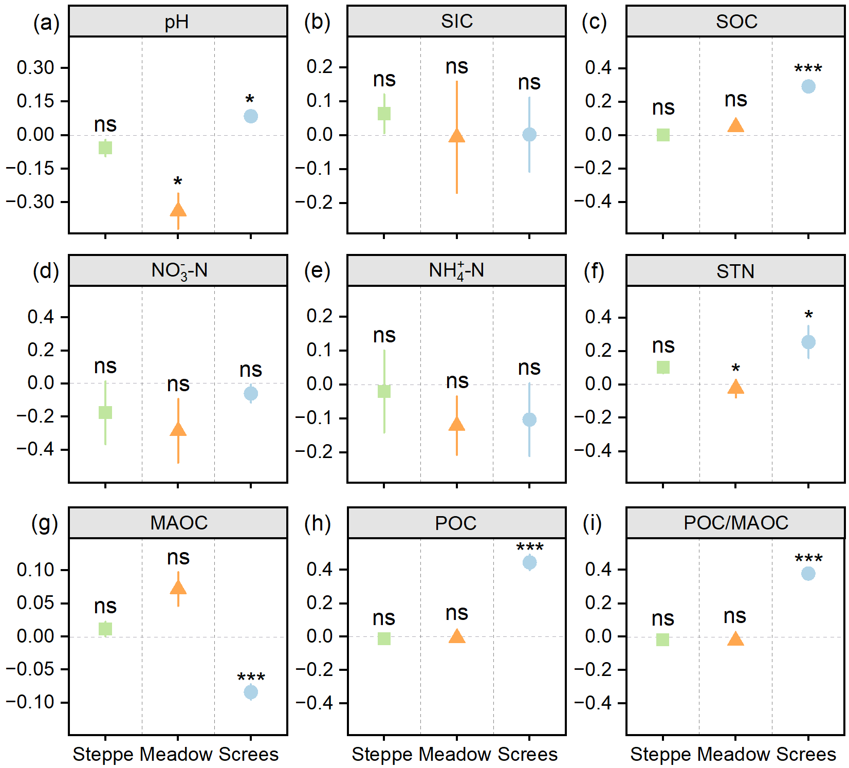
Figure S3 Effect size in soil physical and chemical properties of different vegetation types between warming and ambient conditions. significance: ns no significance; * p < 0.05; ** p < 0.01; *** p < 0.001.

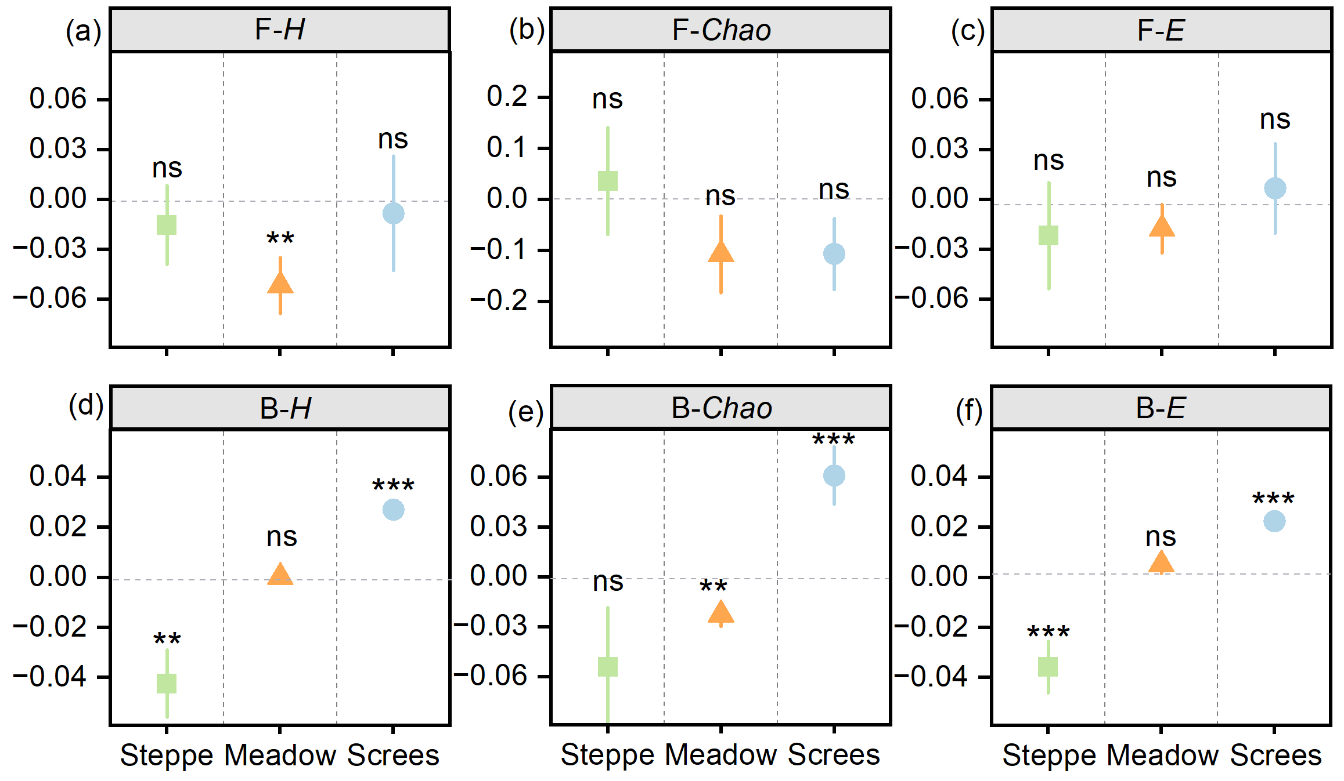
Figure S4 Effect size in soil microbial diversity of different vegetation types between warming and ambient conditions. significance: ns no significance; * p < 0.05; ** p < 0.01; *** p < 0.001.
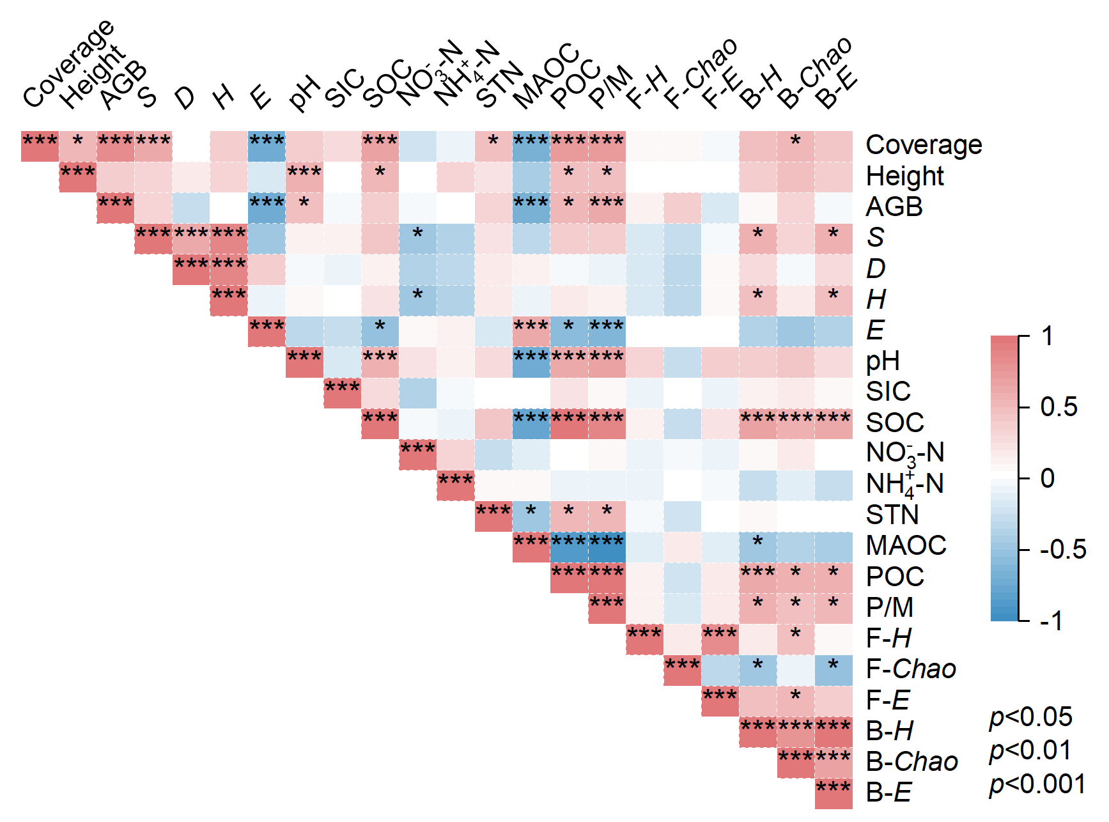
Figure S5 Correlations of RII between vegetation characteristics and soil properties.

