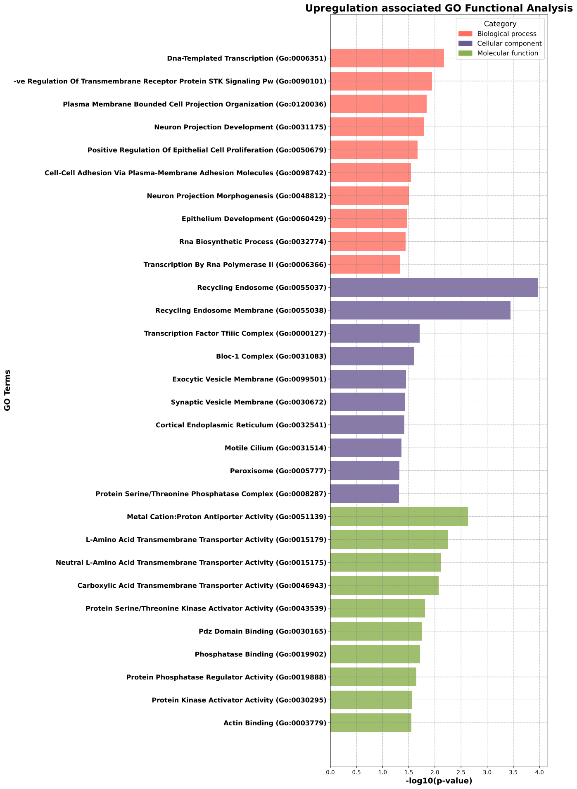
Supplementary_Fig1: Gene Ontology functional enrichment analysis of upregulated circRNA target genes. GO terms are categorized into biological processes, cellular components , and molecular functions, as depicted in the graoh above. Bar length represents statistical significance (-log10 p-value). Top enriched terms include transcription regulation, neuron projection development, recycling endosome components, and transporter activities.
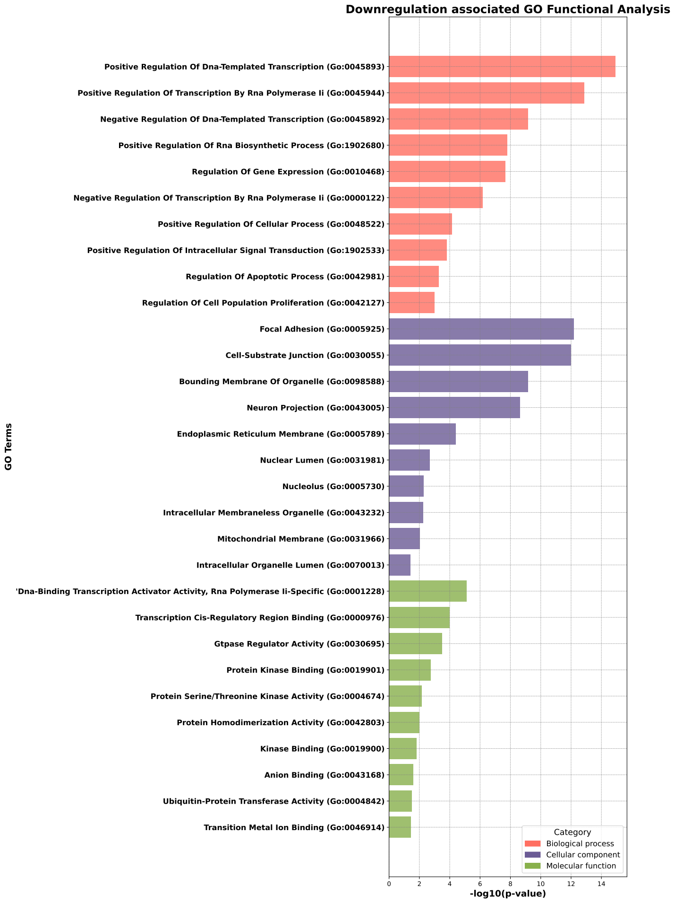

Supplementary_Fig2: Gene Ontology functional enrichment analysis of downregulated circRNA target genes. GO terms are categorized into biological processes, cellular components , and molecular functions, as depicted in the graoh above. Bar length represents statistical significance (-log10 p-value). Top enriched terms include transcription regulation (both positive and negative), apoptosis regulation, focal adhesion components, and DNA-binding transcription activator activity.

