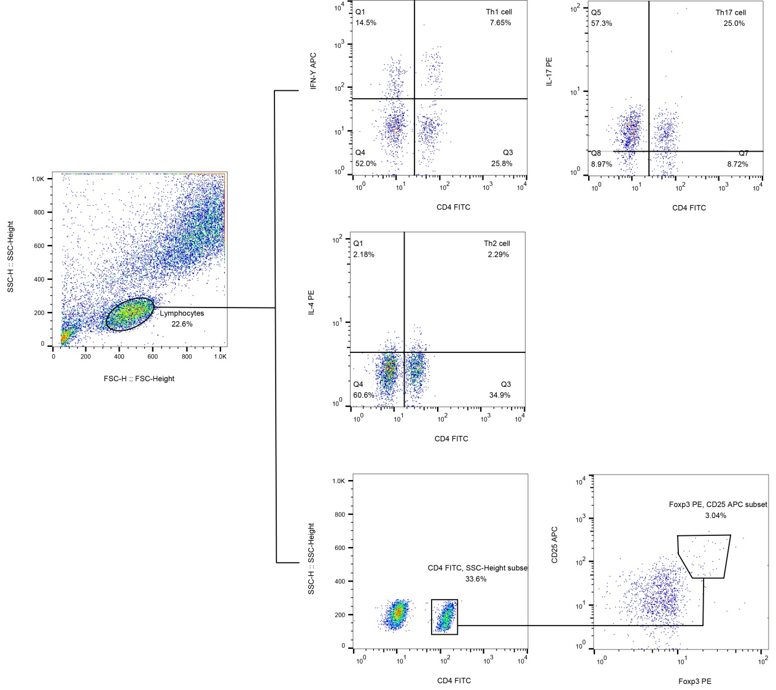
Supplement Figure 1: Representative flow cytometry analysis of peripheral blood CD4+T cell subsets. Cell types were defined as Th1 cells (CD4+IFN-γ+), Th2 cells (CD4+IL-4+), Th17 cells (CD4+IL-17+) and Treg cells (CD4+CD25+Foxp3+).

Supplement Table 1：The source of reagent
Name | Brand
FITC Mouse Anti-Human CD4 | BD Pharmingen™
PE Mouse Anti-Human FoxP3 | BD Pharmingen™
PE Mouse Anti-Human IL-17A | BD Pharmingen™
PE Anti-Human IL-4 | BD FastImmune™
APC Mouse Anti-Human IFN-γ | BD FastImmune™
APC Mouse Anti-Human CD25 | BD Pharmingen™
Leukocyte Activation Cocktail, with BD GolgiPlug™ | BD Pharmingen™

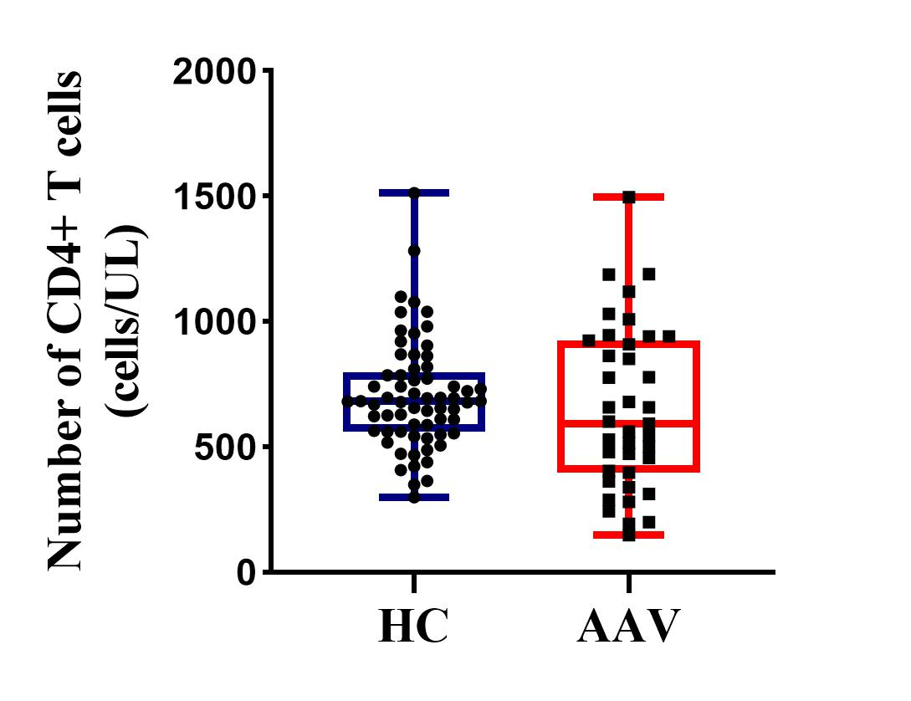
Supplement Figure 2: The absolute number of circulatory total CD4+ T cells was similar between the patients with AAV and HCs. Data were presented as median (Q1, Q3), and were analyzed by Mann–Whitney U test. (*P<0.05; **P<0.01; ***P<0.001)
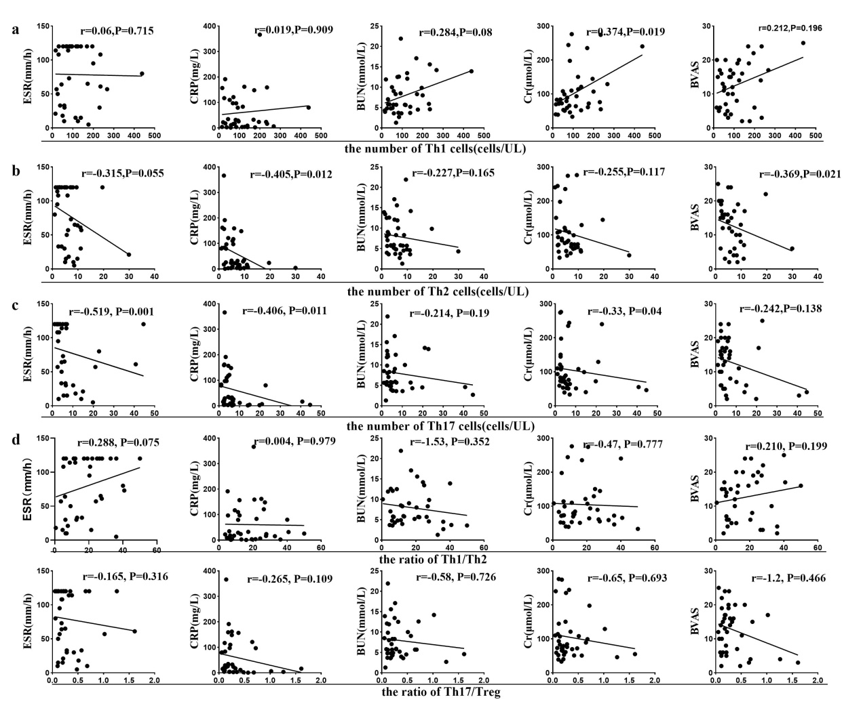
Supplement Figure 3: Correlation between the absolute number of Th1, Th2, Th17 and the ratio of Th1/Th2 and Th17/Treg with the clinical disease activity indicators including ESR, CRP, BUN, Cr and BVAS. The absolute number of Th1, Th2 and Th17 cells was related with some clinical indicators. Data were presented as median (Q1, Q3), and were analyzed by Spearman correlation test. (*P<0.05; **P<0.01; ***P<0.001)

