Molecular Recognition of Anticancer Naphthoquinones by Human Serum Albumin: Insights from NMR Binding and Molecular Dynamics
Flávio Vinícius Crizóstomo Kock^{a*+}, Erick Cirilo^{+a}, Jesús Valdiviezoª, Tiago Venâncio^{b}
ªSección Química, Departamento Académico de Ciencias, Pontificia Universidad Católica del Peru, San Miguel, Peru
^{b}Laboratory of Nuclear Magnetic Resonance, Federal University of São Carlos, Rodovia Washington Luiz, Km 235, Brazil.
*flavio.kock@pucp.edu.pe
⁺Both authors contributed equally.

Index
Figure S1. Binding poses of naphthoquinone derivatives 01 (a), 02 (b), and 03 (c) in human serum albumin (HSA) as predicted by the Boltz-2 model. The figures illustrate the relative positioning of each ligand within the binding pocket and their interactions with the surrounding residues……........................................................................................................02
Figure S2. GNINA binding score for warfarin (RWF) and naphthoquinones derivatives……………………………………………………………………………………03
Figure S3. Human serum albumin (HSA) with binding regions highlighted by color…………………………………………………………………………………………..04

(a)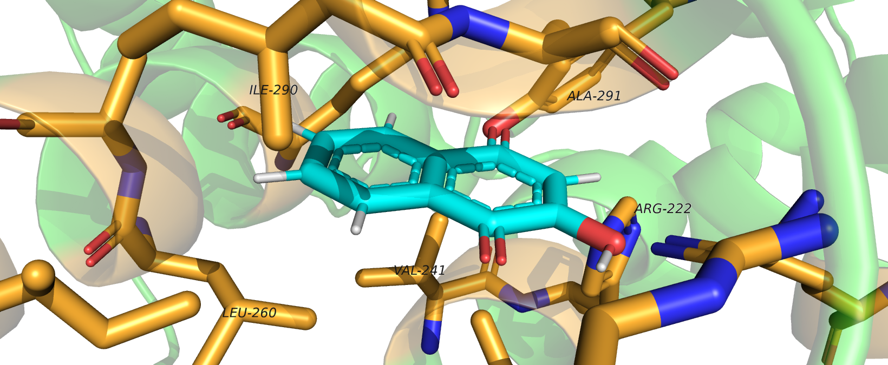
(b)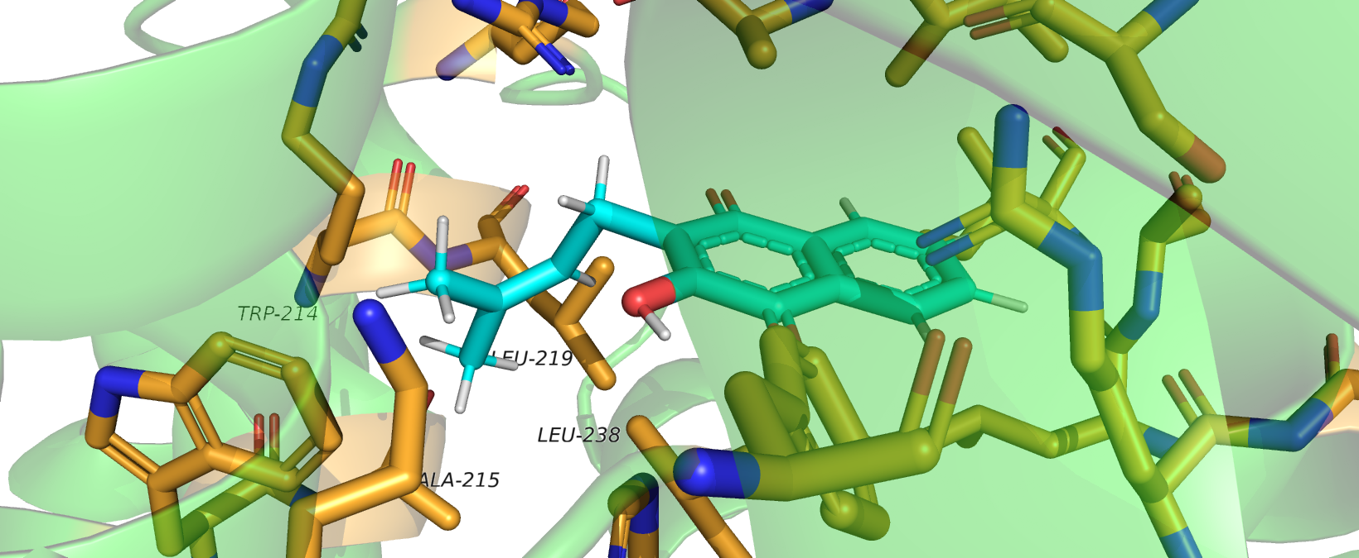
(c)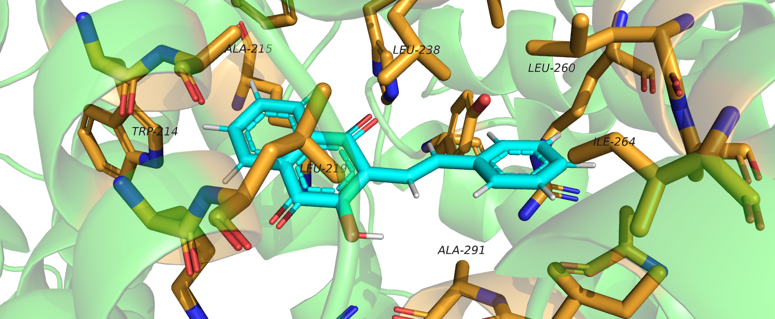
Figure S1. Binding poses of naphthoquinone derivatives 01 (a), 02 (b), and 03 (c) in human serum albumin (HSA) as predicted by the Boltz-2 model. The figures illustrate the relative positioning of each ligand within the binding pocket and their interactions with the surrounding residues.
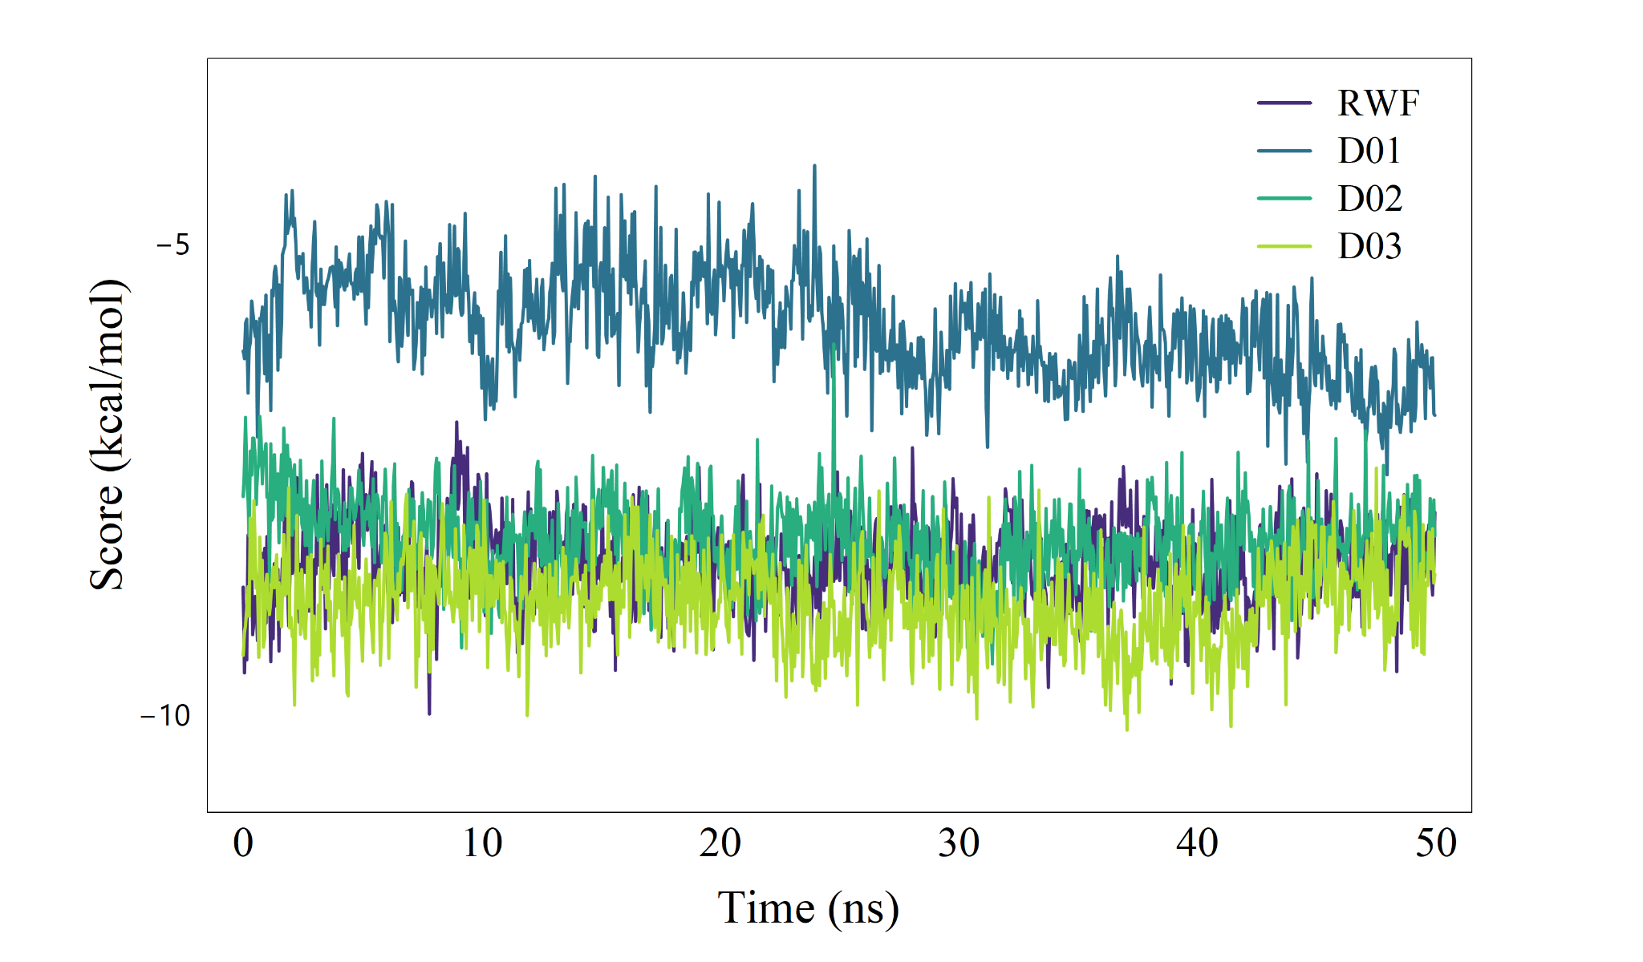
Figure S2. GNINA binding score for warfarin (RWF) and naphthoquinones derivatives.
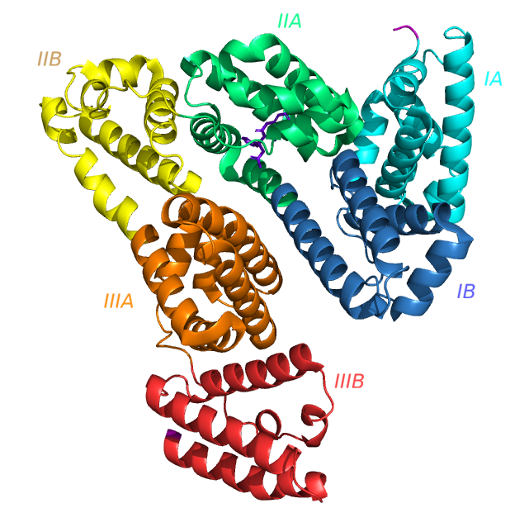
Figure S3. Human serum albumin (HSA) with binding regions highlighted by color. The purple molecule is warfarin.

