Effects of ACE2 and co-factors on the mechanism of SARS-CoV-2 infection among colorectal cancer patients

Supplementary information includes:
Supplementary Materials and Methods (Pages 2-9)
Figures S1-6 (Pages 10-15)
Tables S1-6 (Pages 16-25)

Supplementary materials and methods
Study populations and samples
A total of 60 colorectal cancer tumor tissue samples and paired adjacent normal tissue samples from September 2010 that had been diagnosed and histopathologically confirmed at the hospitals were collected from the First Affiliated Hospital of Nanjing Medical University and Nanjing First Hospital. In the case-control study stage, 1,023 colorectal cancer patients and 1,306 cancer-free controls were enrolled, and the details have been described in our previous study [1]. Among all clinical tissue samples, 45 tumor and adjacent normal tissues were used to perform RNA sequencing (RNA-Seq), and 37 tumor and adjacent normal tissues were used to perform tandem mass tag (TMT)-based global proteomics analysis.
RNA sequencing (RNA-Seq)
A total of 2 mg RNA per sample was used as the input material for RNA sample preparation for library construction. Paired-end sequencing was performed using the Illumina HiSeq 2500 platform with 150 bp sequencing based on the Standard Illumina RNA-Seq protocol. Before the RNA-Se data-filtering criteria were applied, the quality of the data was calculated using FastQC (version 0.11.7) software. The mapped reads were aligned to the GENCODE v19 genome assembly with HISAT2 and quantified with StringTie [2]. For quantification, Cufflinks was used to quantify the relative expression of genes or transcripts and calculate the corresponding fragments per kilobase per million mapped reads (FPKM) values for each sample.
Tryptic digestion of protein and tandem mass tag (TMT) analysis
All the samples were washed three times with phosphate-buffered saline (PBS) solution to remove blood and debris from the tissues. The samples were lysed in RIPA lysis buffer (Beyotime) supplemented with the protease inhibitor PMSF (Beyotime) on ice for 30 min. The lysates were sonicated for ten min on ice and centrifuged at 20,000 g for five min at 4°C to obtain the clarified lysates. The protein concentration of the lysates was then assessed with a bicinchoninic acid (BCA) protein quantitative kit (Sigma). Proteins were reduced for 1 h at 37°C using 5 mM dithiothreitol, followed by alkylation in 10 mM iodoacetamide at 25°C for 45 min in darkness. Quenching was performed at room temperature for 30 min with 30 mM cysteine. The trypsin digestion of the protein samples was performed, followed by desalting in C18 SepPak cartridges (Waters) and drying down using a Speed-Vac apparatus. Then, the desalted peptides were labelled with 10-plex TMT reagents according to the manufacturer’s instructions (ThermoScientific). Peptides were fractionated via high-pH reversed-phase liquid chromatography (RPLC) to enhance the profiling depth of the proteome. Then, liquid chromatography-tandem mass spectrometry (LC-MS/MS) analysis was conducted using a Thermo Scientific UltiMate 3000 RSLCnano system (ThermoFisher Scientific) coupled to a Q Exactive HF system (ThermoFisher Scientific), and the proteome quantification analysis was conducted with Proteome Discoverer at the protein level.
Gene expression analysis in different tissues
The Cancer Genome Atlas (TCGA) datasets were used to investigate the mRNA expression of selected genes (log2 transformed) between colorectal cancer and normal tissues. Normalized expectation-maximization read counts were available for 676 samples, including 625 colorectal cancer tumor tissues and 51 normal colorectal tissues. We also extracted the mRNA expression data of selected genes from the Gene Expression Omnibus (GEO) database (https://www.ncbi.nlm.nih.gov/geo/), including GSE21510 [3], GSE44861 [4], GSE77953 [5] and GSE71187 [6]. Furthermore, the developed interactive Gene Expression Profiling Interactive Analysis (GEPIA) web server was used for tumor/normal tissue differential expression analysis in different types of cancers. The Human Protein Atlas (HPA) database also provided immunohistochemical images and proteome profiles for different tissues and organs in the human body. In the single-cell RNA-Seq analysis, fragments per kilobase per million mapped reads (FPKM) values were obtained from GSE81861 to analyze the expression pattern of ACE2, TMPRSS2 and FURIN in the colorectal tumor cell cluster. The t-Distributed Stochastic Neighbor Embedding (t-SNE) were used to visualize tumor cell clusters. Cell clusters were annotated according to the expression of curated known cell markers.
Cell lines and cell culture
HEK293T, FHC, HCoEpiC, SW620 and LoVo cells were obtained from the Shanghai Institute of Biochemistry and Cell Biology, Chinese Academy of Sciences (Shanghai, China). All the cells were cultured in RPMI 1640 (Bionid), and the media were supplemented with 10% fetal bovine serum (Bionid) and 100 U/ml penicillin and streptomycin.
Western blotting analysis
The protein concentrations were confirmed with a bicinchoninic acid (BCA) protein quantitative kit (Sigma). Then, the protein samples were separated in a 10% polyacrylamide gel and transferred to polyvinyl difluoride (PVDF) membranes (Bio-Rad, CA, USA). Antibodies against ACE2 (1:1000) and GAPDH (1:2000) were purchased from Cell Signaling Technology (Cell Signaling Technology, USA) and Beyotime (Beyotime, China), respectively. Primary antibodies and goat anti-rabbit peroxidase-conjugated secondary antibodies (SA00001-2, Proteintech, China) were incubated with the membrane, and enhanced chemiluminescence (ECL) was utilized (Millipore, Billerica, USA) to assess the protein levels. GAPDH was employed as an internal control.
SARS-CoV-2 pseudovirus production assays
The coding sequence of the VSV-G protein was replaced with the sequence of the SARS-CoV-2 spike protein in the lentiviral packaging system to produce the SARS-CoV-2 pseudovirus. Then, the SARS-CoV-2 pseudovirus was co-transfected into HEK293T cells with the pLVX-mCherry-plasmid reporter gene using polyethyleneimine (PEI) (Polyscience, USA). After 48 h, we collected the cell supernatant containing the pseudovirus and titrated it to 10⁵ pfu/ml. The details have been described previously [7].
Luciferase activity assays
The SARS-CoV-2 pseudovirus supernatant was added to seeded colon cells in 24-well plates. The infection rate was determined by measuring luciferase activity. Luciferase activity was measured using the Dual-Luciferase Reporter Assay System (Promega, USA). Relative luminescence signals were assessed by normalizing the luciferase signals to Renilla signals. Each cell line was used in three independent transfection experiments, and each experiment was performed in triplicate.
Immunofluorescence staining
FHC, HCoEpiC, SW620 and LoVo cells were washed with phosphate-buffered saline (PBS) solution two times and fixed in 4% (w/v) paraformaldehyde (P0098, Beyotime, China) for 20 min. The cells were permeabilized with 0.25% Triton X-100 (X100, Sigma-Aldrich, Germany) in PBS solution for 30 min at 4°C and washed with PBS three times. The cells were then stained with DAPI (P0131, Beyotime, China) at room temperature for five min. Next, the cells were washed three times with PBS solution and incubated with phalloidin (CA1670, Solarbio, China) for 20 min at room temperature. Images of fluorescent staining were obtained by laser scanning confocal microscopy (LSM880, Carl Zeiss, Germany) at room temperature. The experiments were performed in triplicate.
Single-nucleotide polymorphism (SNP) selection and genotyping
Single nucleotide polymorphisms (SNPs) within genes and 2 kb upstream regions were screened from the 1000 Genomes Project (March 2012, Han Chinese in Beijing (CHB) data). The candidate SNPs were selected according to the following quality control criteria: (1) call rate ≥ 99% and (2) minor allele frequency (MAF) ≥ 10%. HaploReg v4.1 (http://archive.broadinstitute.org/mammals/haploreg/haploreg. php) and RegulomeDB (http://regulome.stanf ord.edu/index) were also used to predict the function of candidate SNPs. ChIP-Seq data for histone modification markers (H3K4me3, H3K27me3, H3K9me3 and H3K36me3) were obtained from the Encyclopedia of DNA Elements (ENCODE) and Roadmap Epigenome Projects. These data were visualized using the University of California Santa Cruz (UCSC) genome browser [8]. The processes of deriving genomic DNA and genotyping were described in our previous study [1]. Briefly, 500 μl peripheral blood samples from each subject were collected and preserved in ethylenediaminetetraacetic acid (EDTA) tubes. Genomic DNA was extracted from whole blood samples using the Qiagen Blood Kit (Qiagen).
Somatic mutation and tumor mutation burden (TMB) analysis
Whole-exome sequencing (WES) data, including somatic mutation information, was obtained from TCGA database [9]. The somatic called variants were confirmed as the raw mutation count. TMB is an emerging biomarker of immunotherapy responses and was determined as the number of somatic mutations (including SNVs and InDels per megabase (MB) of genome examined) in the evaluated coding region. In detail, synonymous mutations were counted to reduce sampling noise. All base substitutions and indels in the coding region of targeted genes were initially counted before filtering, including the type of synonymous alterations. The total number of somatic mutations counted was divided by the coding region size in the targeted territory for TMB calculation.
Statistical analysis
The χ² test was applied to evaluate the difference in frequencies between the categorical variables in the groups. Statistical comparisons between two groups were conducted via Student’s independent t-test or the Mann–Whitney U test, depending on the types of variables. Multiple comparisons were calculated by one-way analysis of variance (ANOVA). A linear regression model was used to evaluate the correlation between two factors. The survival curves of different groups were visualized via the Kaplan–Meier method. The association between candidate SNPs in selected genes and colorectal cancer risk was calculated via logistic regression with adjustment for sex, age and smoking status with PLINK (version 1.9). The association between candidate SNPs and colorectal cancer survival time was assessed by Cox regression with adjustment for sex, age and smoking status via R software (version 3.6.1).

References
1. Wang M, Gu D, Du M, Xu Z, Zhang S, Zhu L, et al. Common genetic variation in ETV6 is associated with colorectal cancer susceptibility. Nat Commun. 2016;7(11478).
2. Pertea M, Kim D, Pertea GM, Leek JT, Salzberg SL. Transcript-level expression analysis of RNA-seq experiments with HISAT, StringTie and Ballgown. Nat Protoc. 2016;11(9):1650-67.
3. Tsukamoto S, Ishikawa T, Iida S, Ishiguro M, Mogushi K, Mizushima H, et al. Clinical significance of osteoprotegerin expression in human colorectal cancer. Clin Cancer Res. 2011;17(8):2444-50.
4. Ryan BM, Zanetti KA, Robles AI, Schetter AJ, Goodman J, Hayes RB, et al. Germline variation in NCF4, an innate immunity gene, is associated with an increased risk of colorectal cancer. Int J Cancer. 2014;134(6):1399-407.
5. Qu X, Sandmann T, Frierson H, Jr., Fu L, Fuentes E, Walter K, et al. Integrated genomic analysis of colorectal cancer progression reveals activation of EGFR through demethylation of the EREG promoter. Oncogene. 2016;35(50):6403-15.
6. An N, Shi X, Zhang Y, Lv N, Feng L, Di X, et al. Discovery of a Novel Immune Gene Signature with Profound Prognostic Value in Colorectal Cancer: A Model of Cooperativity Disorientation Created in the Process from Development to Cancer. PLoS One. 2015;10(9):e0137171.
7. Liu X, Gao F, Gou L, Chen Y, Gu Y, Ao L, et al. Neutralizing Antibodies Isolated by a site-directed Screening have Potent Protection on SARS-CoV-2 Infection. bioRxiv. 2020:2020.05.03.074914.
8. Casper J, Zweig AS, Villarreal C, Tyner C, Speir ML, Rosenbloom KR, et al. The UCSC Genome Browser database: 2018 update. Nucleic Acids Res. 2018;46(D1):D762-D9.
9. Weinstein JN, Collisson EA, Mills GB, Shaw KR, Ozenberger BA, Ellrott K, et al. The Cancer Genome Atlas Pan-Cancer analysis project. Nat Genet. 2013;45(10):1113-20.

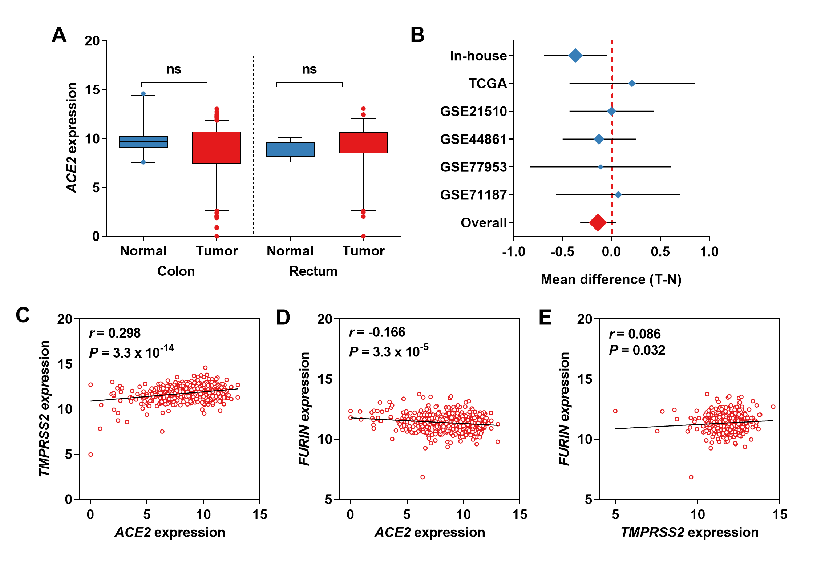
Figure S1. The mRNA expression of ACE2 and linear correlation between ACE2 and its co-factors. (A) The mRNA levels of ACE2 in colon and rectum based on TCGA database. (B) Forest plots of ACE2 mRNA expression. (C-D) Linear correlation of ACE2 with TMPRSS2 (C) and FURIN (D). Linear correlation of TMPRSS2 with FURIN (E).

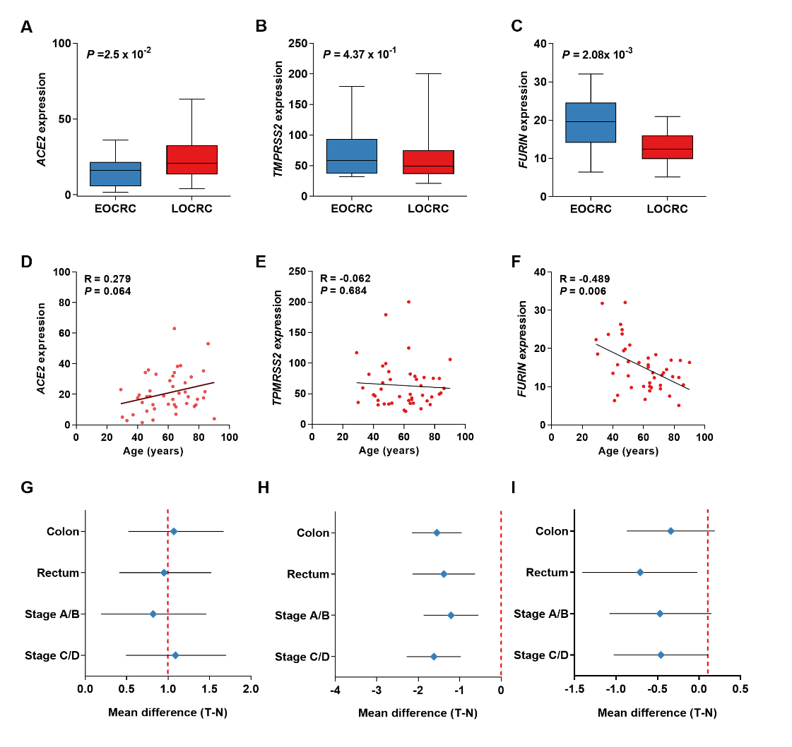
Figure S2. Stratification analyses of the expression of ACE2 and its co-factors in subgroups. (A-C) Box plot of the three genes between the EOCRC and LOCRC groups. (D-F) Linear correlation between the three genes and the age of patients. (G-I) Forest plots of ACE2 (G), TMPRSS2 (H) and FURIN (I) in clinical subgroups. EOCRC: early-onset colorectal cancer. LOCRC: late-onset colorectal cancer.

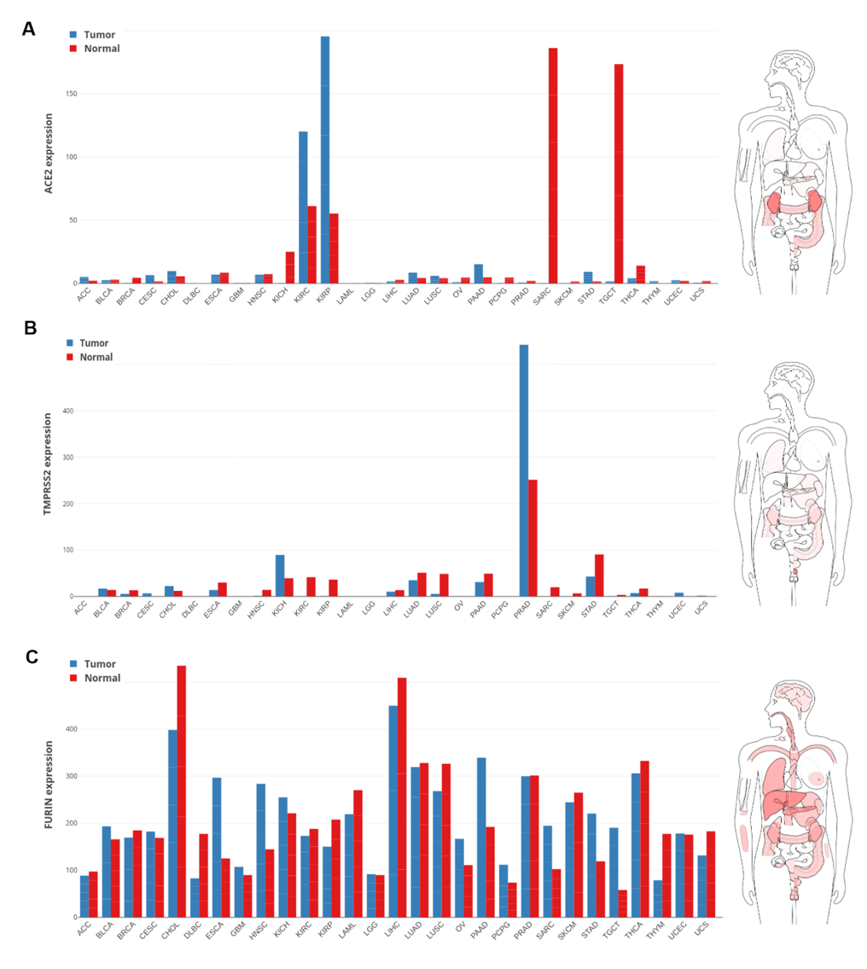
Figure S3. mRNA expression of ACE2 and its co-factors in different tumor tissues based on the GEPIA2 database. (A) ACE2. (B) TMPRSS2. (C) FURIN.

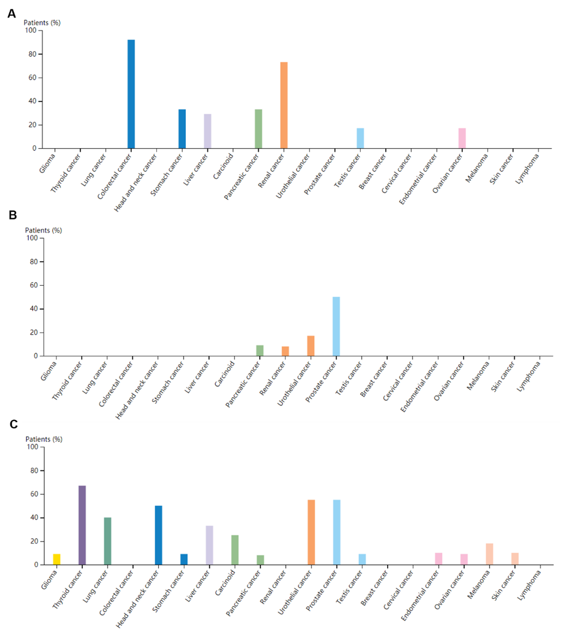
Figure S4. Protein expression of ACE2 and its co-factors in different tumor tissues based on the HPA database. (A) ACE2. (B) TMPRSS2. (C) FURIN.

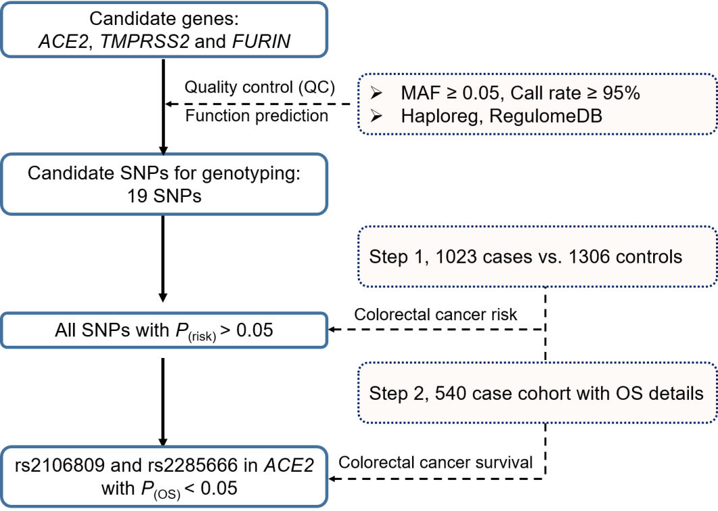
Figure S5. Summary of the design and workflow in the association study of genetic variants with colorectal risk and survival. MAF: minor allele frequency. OS: overall survival.

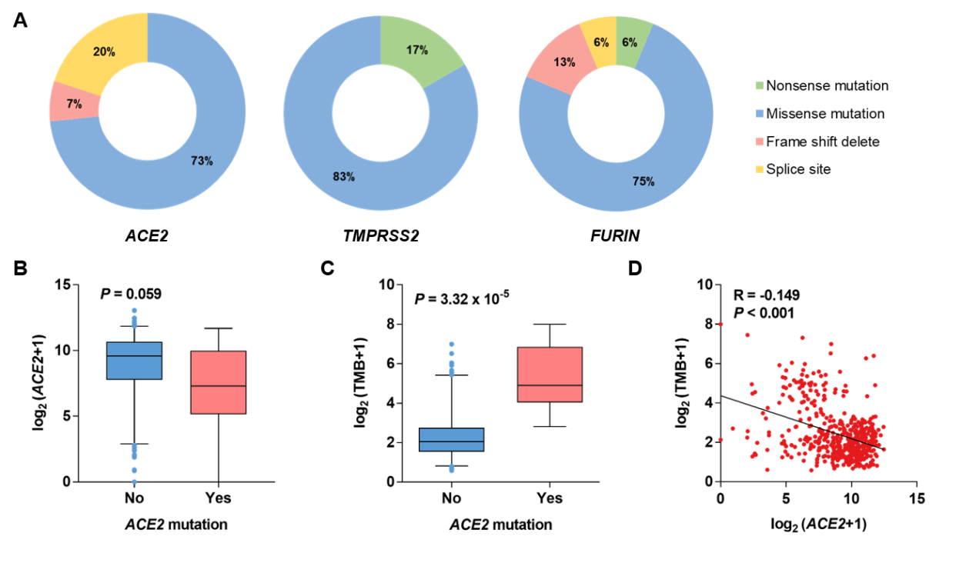 Figure S6. Somatic mutation patterns of ACE2 and its co-factors in colorectal cancer tissues. (A) Somatic mutation frequency of three genes. (B) Box plot of ACE2 expression in association with the status of ACE2 mutations. (C) Box plot of TMB in association with the status of ACE2 mutations. (D) Linear correlation between ACE2 expression and TMB.

Supplementary Table 1. Selected characteristics between colorectal cancer cases and controls
Variables | Age (mean ± SD) | Sex |  |  | Smoking status |  |  | Tumor site |  |  | Survival status
Variables | Age (mean ± SD) | Male | Female |  | Never | Ever |  | Colon | Rectum |  | Death | Alive
Cases (%), n = 1,023 | 62.5 ± 18.6 | 603 (58.9) | 420 (41.1) |  | 666 (65.1) | 357 (34.9) |  | 495 (48.4) | 528 (51.6) |  | - | -
Controls (%), n = 1,306 | 62.5 ± 18.6 | 679 (52.0) | 627 (47.0) |  | 908 (69.5) | 398 (30.5) |  | - | - |  | - | -
Cases for follow-up (%),  n = 540 | 59.7 ± 12.2 | 324 (60.0) | 216 (40.0) |  | 368 (68.1) | 172 (31.9) |  | 306 (56.7) | 234 (43.3) |  | 204 (37.8) | 336 (62.2)
SD, standard deviation.

Supplementary Table 2. Correlation analysis between ACE2, TMPRSS2, FURIN and relate genes and markers of immune cells in TIMER
Description | Gene markers | Colon cancer |  |  |  |  |  |  | Rectum cancer
Description | Gene markers | ACE2 |  | TMPRSS2 |  | FURIN |  |  | ACE2 |  | TMPRSS2 |  | FURIN
Description | Gene markers | Cor | P | Cor | P | Cor | P |  | Cor | P | Cor | P | Cor | P
CD8+ T cell | CD8A | -0.229 | 5.12E-02 | -0.024 | 6.28E-01 | 0.160 | 1.22E-03 |  | -0.043 | 6.14E-01 | -0.059 | 4.92E-01 | 0.033 | 7.00E-01
 | CD8B | -0.169 | 1.54E-01 | -0.116 | 1.91E-02 | 0.170 | 5.89E-04 |  | 0.102 | 2.30E-01 | -0.119 | 1.62E-01 | 0.103 | 2.29E-01
T cell (general) | CD3D | -0.064 | 2.01E-01 | 0.037 | 4.56E-01 | 0.126 | 1.08E-02 |  | -0.013 | 8.75E-01 | -0.034 | 0.688 | -0.008 | 9.28E-01
 | CD3E | -0.053 | 2.86E-01 | 0.060 | 2.26E-01 | 0.214 | 1.43E-05 |  | 0.039 | 6.49E-01 | 0.053 | 0.533 | 0.119 | 1.62E-01
 | CD2 | -0.027 | 5.89E-01 | 0.044 | 3.77E-01 | 0.089 | 7.27E-02 |  | 0.078 | 3.62E-01 | 0.020 | 8.15E-01 | -0.011 | 9.00E-01
B cell | CD19 | 0.118 | 1.70E-02 | 0.152 | 2.17E-03 | 0.157 | 1.55E-03 |  | 0.093 | 2.75E-01 | 0.032 | 7.09E-01 | 0.057 | 5.08E-01
 | CD22 | 0.023 | 6.44E-01 | 0.101 | 4.18E-02 | 0.267 | 4.56E-08 |  | -0.004 | 9.66E-01 | 0.039 | 6.51E-01 | 0.170 | 4.52E-02
 | CD70 | -0.154 | 1.84E-03 | -0.130 | 8.8E-03 | 0.079 | 1.11E-01 |  | 0.006 | 9.46E-01 | -0.194 | 2.23E-02 | 0.147 | 8.51E-02
 | CD79A | 0.106 | 3.23E-02 | 0.145 | 3.32E-03 | 0.166 | 8.35E-04 |  | 0.052 | 5.46E-01 | 0.140 | 1.01E-01 | 0.051 | 5.52E-01
Monocyte | CD86 | -0.150 | 2.38E-03 | -0.089 | 7.29E-02 | 0.102 | 4.06E-02 |  | 0.085 | 3.20E-01 | -0.014 | 8.67E-01 | 0.018 | 8.33E-01
 | CD115 (CSF1R) | -0.106 | 3.23E-02 | -0.049 | 3.25E-01 | 0.529 | 9.87E-12 |  | -0.028 | 7.41E-01 | -0.036 | 6.71E-01 | 0.311 | 1.96E-04
TAM | CCL2 | -0.056 | 2.61E-01 | -0.188 | 1.37E-04 | -0.001 | 9.86E-01 |  | -0.001 | 9.89E-01 | -0.162 | 5.6E-02 | 0.087 | 3.11E-01
 | CD68 | -0.126 | 1.08E-02 | 0.000 | 9.99E-01 | 0.321 | 3.73E-11 |  | 0.070 | 4.14E-01 | 0.068 | 4.28E-01 | 0.210 | 1.29E-02
 | IL10 | -0.064 | 1.95E-01 | -0.087 | 7.84E-02 | 0.078 | 1.16E-01 |  | -0.022 | 8.00E-01 | -0.098 | 2.49E-01 | 0.028 | 7.46E-01
M1 Macrophage | INOS (NOS2) | 0.135 | 6.28E-03 | 0.386 | 7.42E-16 | 0.107 | 3.05E-02 |  | 0.051 | 5.53E-01 | 0.375 | 5.29E-06 | 0.218 | 9.80E-03
 | IRF5 | 0.113 | 2.28E-02 | -0.089 | 7.45E-02 | 0.104 | 3.55E-02 |  | 0.211 | 1.26E-02 | -0.153 | 7.15E-02 | 0.207 | 1.43E-02
 | COX2(PTGS2) | -0.087 | 7.99E-02 | 0.022 | 6.53E-01 | 0.107 | 3.13E-02 |  | 0.065 | 4.44E-01 | -0.009 | 9.2E-01 | 0.159 | 6.19E-02
M2 Macrophage | CD163 | -0.180 | 2.71E-04 | -0.105 | 3.44E-02 | 0.226 | 4.08E-06 |  | -0.020 | 8.13E-01 | 0.015 | 8.63E-01 | 0.201 | 1.74E-02
 | VSIG4 | -0.187 | 1.47E-04 | -0.206 | 2.86E-05 | 0.134 | 6.75E-03 |  | -0.017 | 8.38E-01 | -0.137 | 1.08E-01 | 0.025 | 7.66E-01
 | MS4A4A | -0.170 | 5.92E-04 | -0.168 | 6.76E-04 | 0.078 | 1.17E-01 |  | -0.017 | 8.41E-01 | -0.064 | 4.55E-01 | 0.051 | 5.54E-01
 | IRF4 | 0.092 | 6.40E-02 | 0.202 | 4.03E-05 | 0.163 | 9.73E-04 |  | 0.059 | 4.88E-01 | 0.132 | 1.21E-01 | 0.098 | 2.49E-01
Neutrophils | CD66b (CEACAM8) | 0.303 | 4.32E-10 | 0.148 | 2.84E-03 | -0.152 | 2.11E-03 |  | 0.164 | 5.33E-02 | 0.087 | 3.07E-01 | 0.089 | 2.96E-01
 | CD11b (ITGAM) | -0.209 | 2.25E-05 | -0.148 | 2.77E-03 | 0.256 | 1.73E-07 |  | -0.074 | 3.89E-01 | -0.024 | 7.81E-01 | 0.263 | 1.76E-03
 | CCR7 | 0.093 | 6.04E-02 | 0.155 | 1.97E-03 | 0.302 | 5.56E-10 |  | 0.055 | 5.18E-01 | 0.068 | 4.28E-01 | 0.187 | 2.73E-02
Natural killer cell | KIR2DL1 | -0.213 | 1.54E-05 | -0.152 | 2.19E-03 | 0.030 | 5.53E-01 |  | -0.081 | 3.44E-01 | -0.015 | 8.6E-01 | -0.096 | 2.59E-01
 | KIR2DL3 | -0.274 | 2.03E-08 | -0.169 | 6.39E-04 | -0.012 | 8.04E-01 |  | -0.153 | 7.29E-02 | -0.126 | 1.41E-01 | -0.027 | 7.51E-01
 | KIR2DL4 | -0.276 | 1.65E-08 | 0.035 | 4.86E-01 | 0.016 | 1.91E-02 |  | 0.020 | 8.14E-01 | -0.023 | 7.86E-01 | -0.013 | 8.81E-01
 | KIR3DL1 | -0.248 | 4.23E-07 | -0.080 | 1.06E-01 | 0.032 | 5.18E-01 |  | -0.114 | 1.82E-01 | 0.063 | 4.6E-01 | -0.025 | 7.72E-01
 | KIR3DL2 | -0.178 | 3.18E-04 | -0.049 | 3.2E-01 | 0.146 | 3.19E-03 |  | -0.134 | 1.16E-01 | -0.015 | 8.59E-01 | 0.131 | 1.23E-01
 | KIR3DL3 | -0.117 | 1.88E-02 | 0.010 | 8.4E-01 | 0.062 | 2.14E-01 |  | -0.164 | 5.30E-02 | 0.007 | 9.34E-01 | -0.067 | 4.32E-01
 | KIR2DS4 | -0.159 | 1.35E-03 | -0.089 | 7.39E-02 | 0.052 | 2.92E-01 |  | -0.087 | 3.07E-01 | -0.060 | 4.86E-01 | 0.122 | 1.51E-01
Dendritic cell | HLA-DPB1 | -0.172 | 5.04E-04 | -0.094 | 5.95E-02 | 0.181 | 2.54E-04 |  | -0.103 | 2.28E-01 | -0.156 | 6.68E-02 | 0.131 | 1.26E-01
 | HLA-DQB1 | -0.109 | 2.82E-02 | -0.076 | 1.26E-01 | 0.091 | 6.69E-02 |  | -0.006 | 9.43E-01 | -0.088 | 3.01E-01 | 0.047 | 5.85E-01
 | HLA-DRA | -0.149 | 2.58E-03 | -0.035 | 4.79E-01 | 0.058 | 2.47E-01 |  | -0.074 | 3.90E-01 | -0.198 | 1.92E-02 | -0.083 | 3.33E-01
 | HLA-DPA1 | -0.112 | 2.38E-02 | -0.040 | 4.16E-01 | 0.103 | 3.85E-02 |  | -0.036 | 6.70E-01 | -0.151 | 7.57E-02 | 0.004 | 9.64E-01
 | BDCA-1(CD1C) | 0.198 | 5.91E-05 | 0.006 | 9.05E-01 | 0.087 | 7.98E-02 |  | -0.053 | 5.35E-01 | 0.002 | 9.84E-01 | 0.027 | 7.51E-01
 | BDCA-4(NRP1) | -0.142 | 4.09E-03 | -0.066 | 1.85E-01 | 0.237 | 1.40E-06 |  | 0.012 | 8.88E-01 | 0.015 | 8.62E-01 | 0.160 | 6.07E-02
 | CD11c (ITGAX) | -0.171 | 5.57E-04 | -0.049 | 3.62E-01 | 0.285 | 5.18E-09 |  | -0.069 | 4.20E-01 | -0.096 | 2.63E-01 | 0.257 | 2.23E-03
Th1 | T-bet (TBX21) | -0.155 | 1.68E-03 | 0.004 | 9.4E-01 | 0.229 | 3.23E-06 |  | -0.021 | 8.04E-01 | -0.021 | 8.1E-01 | 0.147 | 8.44E-02
 | STAT4 | -0.082 | 9.72E-02 | -0.011 | 8.3E-01 | 0.078 | 1.17E-01 |  | 0.012 | 8.89E-01 | -0.063 | 4.62E-01 | 0.000 | 9.96E-01
 | STAT1 | -0.099 | 4.67E-02 | 0.081 | 1.03E-01 | 0.145 | 3.41E-03 |  | 0.124 | 1.47E-01 | 0.050 | 5.59E-01 | 0.032 | 7.05E-01
 | IFN-γ (IFNG) | -0.130 | 8.97E-03 | -0.009 | 8.54E-01 | 0.034 | 4.95E-01 |  | -0.035 | 6.80E-01 | -0.005 | 9.52E-01 | -0.027 | 7.54E-01
 | TNF-α (TNF) | 0.012 | 8.13E-01 | 0.079 | 1.14E-01 | 0.057 | 2.51E-01 |  | 0.140 | 1.01E-01 | -0.012 | 8.84E-01 | 0.225 | 7.77E-03
Th2 | GATA3 | -0.011 | 8.30E-01 | 0.033 | 5.09E-01 | 0.225 | 1.88E-07 |  | -0.110 | 1.96E-01 | -0.028 | 7.47E-01 | 0.243 | 3.97E-03
 | STAT6 | 0.098 | 4.81E-02 | 0.265 | 5.67E-08 | 0.386 | 7.20E-16 |  | -0.033 | 7.01E-01 | 0.222 | 8.59E-03 | 0.417 | 3.21E-07
 | BATF | -0.105 | 3.51E-02 | -0.056 | 2.56E-01 | 0.056 | 2.64E-01 |  | -0.022 | 8.00E-01 | -0.032 | 7.12E-01 | 0.066 | 4.37E-01
 | CD294 (GPR44) | 0.018 | 7.18E-01 | 0.039 | 4.32E-01 | 0.177 | 3.64E-04 |  | -0.057 | 5.03E-01 | 0.173 | 4.16E-02 | 0.154 | 6.96E-02
 | IL13 | 0.065 | 1.89E-01 | -0.001 | 9.87E-01 | 0.091 | 6.83E-02 |  | -0.073 | 3.90E-01 | -0.109 | 2E-01 | -0.021 | 8.07E-01
Tfh | BCL6 | -0.237 | 1.35E-06 | 0.055 | 2.66E-01 | 0.277 | 1.41E-08 |  | -0.173 | 4.19E-02 | -0.003 | 9.77E-01 | 0.228 | 6.86E-03
 | IL21 | -0.053 | 2.88E-01 | -0.048 | 3.35E-01 | 0.023 | 6.42E-01 |  | 0.043 | 6.14E-01 | 0.050 | 5.6E-01 | -0.056 | 5.13E-01
 | CD185 (CXCR5) | 0.041 | 4.07E-01 | 0.100 | 4.4E-02 | 0.279 | 1.02E-08 |  | 0.010 | 9.02E-01 | 0.109 | 2.03E-01 | 0.185 | 2.95E-02
 | CD278 (ICOS) | 0.066 | 1.87E-01 | 0.068 | 1.69E-01 | 0.049 | 3.23E-01 |  | 0.182 | 3.16E-02 | 0.008 | 9.36E-01 | 0.030 | 7.29E-01
Th17 | STAT3 | 0.120 | 1.59E-02 | 0.287 | 4.1E-09 | 0.272 | 2.42E-08 |  | 0.219 | 9.45E-03 | 0.392 | 1.87E-06 | 0.323 | 1.06E-04
 | CD121a (IL1R1) | 0.038 | 4.44E-01 | 0.023 | 6.37E-01 | 0.238 | 1.11E-06 |  | 0.096 | 2.60E-01 | 0.115 | 1.79E-01 | 0.265 | 1.61E-03
 | CD194 (CCR4) | 0.162 | 1.06E-03 | 0.143 | 3.97E-03 | 0.174 | 4.32E-04 |  | 0.160 | 5.94E-02 | 0.134 | 1.15E-01 | 0.100 | 2.43E-01
 | CD196 (CCR6) | 0.292 | 1.93E-09 | 0.216 | 1.09E-05 | 0.044 | 3.76E-01 |  | 0.358 | 1.51E-05 | 0.317 | 1.45E-04 | 0.225 | 7.87E-03
 | IL17 (IL17A) | 0.317 | 6.54E-11 | 0.236 | 1.49E-06 | -0.113 | 2.23E-02 |  | 0.077 | 3.65E-01 | 0.196 | 2.09E-02 | 0.100 | 2.41E-01
 | IL21 | -0.053 | 2.88E-01 | -0.048 | 3.35E-01 | 0.023 | 6.42E-01 |  | 0.043 | 6.14E-01 | 0.050 | 5.6E-01 | -0.056 | 5.13E-01
 | IL22 | 0.302 | 5.33E-10 | 0.226 | 4.42E-06 | -0.047 | 3.41E-01 |  | 0.097 | 2.56E-01 | 0.166 | 5.08E-02 | 0.153 | 7.25E-02
 | IL23R | 0.313 | 1.15E-10 | 0.247 | 4.61E-07 | -0.040 | 4.23E-01 |  | 0.209 | 1.36E-02 | 0.435 | 8.72E-08 | 0.118 | 1.67E-01
Treg | FOXP3 | 0.047 | 3.44E-01 | 0.058 | 2.41E-01 | 0.291 | 2.35E-09 |  | 0.115 | 1.78E-01 | -0.006 | 9.4E-01 | 0.269 | 1.37E-03
 | CD25 (IL2RA) | -0.071 | 1.52E-01 | 0.038 | 4.42E-01 | 0.195 | 7.59E-05 |  | 0.041 | 6.29E-01 | 0.009 | 3.18E-01 | 0.152 | 7.40E-02
 | CCR8 | 0.063 | 2.04E-01 | 0.063 | 2.02E-01 | 0.244 | 6.52E-07 |  | 0.145 | 8.83E-02 | 0.010 | 9.08E-01 | 0.126 | 1.38E-01
 | STAT5B | 0.284 | 5.57E-09 | 0.135 | 6.6E-03 | 0.223 | 6.00E-06 |  | 0.207 | 1.46E-02 | 0.131 | 1.24E-01 | 0.242 | 4.04E-03
 | TGFβ (TGFB1) | -0.181 | 2.49E-04 | -0.117 | 1.83E-02 | 0.346 | 7.06E-13 |  | 0.028 | 7.40E-01 | -0.153 | 7.24E-02 | 0.261 | 1.88E-03
T cell exhaustion | PD-1 (PDCD1) | -0.161 | 1.16E-03 | 0.030 | 5.42E-01 | 0.256 | 1.78E-07 |  | -0.085 | 3.19E-01 | -0.046 | 5.93E-01 | 0.174 | 4.05E-02
 | CTLA4 | -0.063 | 2.07E-01 | 0.003 | 9.45E-01 | 0.199 | 5.24E-05 |  | -0.035 | 6.84E-01 | -0.064 | 4.56E-01 | 0.100 | 2.42E-01
 | LAG3 | -0.202 | 4.17E-05 | -0.011 | 8.27E-01 | 0.200 | 5.06E-05 |  | -0.074 | 3.88E-01 | -0.080 | 3.52E-01 | 0.144 | 9.15E-02
 | TIM-3 (HAVCR2) | -0.194 | 8.64E-05 | -0.119 | 1.6E-02 | 0.103 | 3.81E-02 |  | 0.032 | 7.07E-01 | -0.129 | 1.32E-01 | 0.007 | 9.33E-01
 | GZMB | 0.123 | 1.28E-02 | -0.025 | 6.2E-01 | -0.005 | 9.17E-01 |  | 0.226 | 7.49E-03 | -0.065 | 4.48E-01 | -0.036 | 6.74E-01
Cor, R value of Spearman’s correlation. TAM, tumor-correlated macrophage. Tfh, follicular helper T cell. Th, T helper cell. Treg, regulatory T cell

Supplementary Table 3. The association of genetic variants in ACE2 and the co-factors with colorectal cancer risk.
Chr. | SNP | Positionª | RA | All sex |  |  | Male |  |  | Female
 |  |  |  | OR^{b} | P^{b} |  | OR^{b} | P^{b} |  | OR^{b} | P^{b}
15 | rs75493298 | 91423825 | T | 0.87 | 0.274 |  | 0.91 | 0.560 |  | 0.84 | 0.360
15 | rs8039305 | 91422543 | C | 1.03 | 0.698 |  | 0.95 | 0.660 |  | 1.14 | 0.322
15 | rs35346340 | 91427872 | C | 1.23 | 0.085 |  | 1.11 | 0.531 |  | 1.34 | 0.085
21 | rs34256269 | 42868876 | A | 0.80 | 0.102 |  | 0.72 | 0.102 |  | 0.91 | 0.599
21 | rs112657409 | 42836672 | T | 0.85 | 0.146 |  | 0.88 | 0.391 |  | 0.79 | 0.173
21 | rs116868083 | 42834988 | A | 0.89 | 0.200 |  | 0.99 | 0.906 |  | 0.78 | 0.076
21 | rs9305744 | 42842988 | A | 0.93 | 0.263 |  | 1.00 | 0.981 |  | 0.87 | 0.122
21 | rs7283324 | 42840829 | T | 0.94 | 0.344 |  | 1.00 | 0.995 |  | 0.89 | 0.185
21 | rs2298659 | 42845374 | A | 0.95 | 0.499 |  | 0.97 | 0.737 |  | 0.94 | 0.558
21 | rs8126497 | 42879724 | A | 0.96 | 0.763 |  | 1.06 | 0.760 |  | 0.86 | 0.470
21 | rs2156300 | 42856756 | G | 0.96 | 0.546 |  | 0.92 | 0.362 |  | 1.00 | 0.975
21 | rs464431 | 42843960 | A | 0.97 | 0.616 |  | 0.93 | 0.416 |  | 1.01 | 0.934
21 | rs915823 | 42851454 | C | 0.97 | 0.643 |  | 1.00 | 0.983 |  | 0.94 | 0.557
21 | rs74749793 | 42875652 | T | 0.98 | 0.818 |  | 0.97 | 0.705 |  | 1.01 | 0.961
21 | rs743542 | 42840172 | A | 1.00 | 0.975 |  | 1.13 | 0.165 |  | 0.88 | 0.204
21 | rs9974933 | 42850977 | G | 1.06 | 0.387 |  | 1.01 | 0.949 |  | 1.14 | 0.221
23 | rs2106809 | 15618061 | A | 0.95 | 0.409 |  | 0.89 | 0.328 |  | 0.97 | 0.642
23 | rs2285666 | 15610348 | C | 0.97 | 0.617 |  | 0.89 | 0.295 |  | 1.00 | 0.998
23 | rs184697926 | 15621988 | C | 1.10 | 0.381 |  | 1.24 | 0.270 |  | 1.01 | 0.960
Chr.: chromosome. RA: risk allele.
ªBased on the NCBI database, build 37.
ªP value of additive model in the logistic regression analysis.

Supplementary Table 4. The association of genetic variants in ACE2 and the co-factors with the overall survival time of colorectal cancer patients.
Chr. | SNP | Positionª | RA | All sex |  |  | Male |  |  | Female
 |  |  |  | HR^{b} | P^{b} |  | HR^{b} | P^{b} |  | HR^{b} | P^{b}
15 | rs75493298 | 91423825 | T | 1.03 | 0.885 |  | 0.91 | 0.758 |  | 1.31 | 0.476
15 | rs8039305 | 91422543 | C | 1.18 | 0.294 |  | 1.09 | 0.678 |  | 1.37 | 0.239
15 | rs35346340 | 91427872 | C | 1.26 | 0.255 |  | 1.32 | 0.26 |  | 1.16 | 0.671
21 | rs34256269 | 42868876 | A | 0.84 | 0.457 |  | 0.86 | 0.615 |  | 0.79 | 0.549
21 | rs112657409 | 42836672 | T | 0.96 | 0.850 |  | 0.82 | 0.466 |  | 1.32 | 0.428
21 | rs116868083 | 42834988 | A | 1.19 | 0.275 |  | 1.31 | 0.154 |  | 0.94 | 0.851
21 | rs9305744 | 42842988 | A | 1.12 | 0.425 |  | 1.2 | 0.321 |  | 1.00 | 0.987
21 | rs7283324 | 42840829 | T | 1.09 | 0.579 |  | 1.17 | 0.397 |  | 0.96 | 0.875
21 | rs2298659 | 42845374 | A | 1.00 | 0.984 |  | 1.08 | 0.669 |  | 0.86 | 0.566
21 | rs8126497 | 42879724 | A | 1.32 | 0.186 |  | 1.12 | 0.665 |  | 1.83 | 0.083
21 | rs2156300 | 42856756 | G | 0.91 | 0.505 |  | 1.05 | 0.771 |  | 0.67 | 0.120
21 | rs464431 | 42843960 | A | 0.97 | 0.832 |  | 1.15 | 0.411 |  | 0.67 | 0.118
21 | rs915823 | 42851454 | C | 0.96 | 0.766 |  | 1.05 | 0.797 |  | 0.80 | 0.371
21 | rs74749793 | 42875652 | T | 0.84 | 0.223 |  | 0.76 | 0.112 |  | 1.03 | 0.898
21 | rs743542 | 42840172 | A | 1.09 | 0.554 |  | 1.20 | 0.284 |  | 0.89 | 0.645
21 | rs9974933 | 42850977 | G | 0.92 | 0.559 |  | 0.73 | 0.065 |  | 1.55 | 0.095
23 | rs2106809 | 15618061 | A | 1.40 | 0.017 |  | 1.21 | 0.286 |  | 1.93 | 0.011
23 | rs2285666 | 15610348 | C | 1.34 | 0.038 |  | 1.15 | 0.407 |  | 1.84 | 0.016
23 | rs184697926 | 15621988 | C | 1.21 | 0.409 |  | 1.20 | 0.515 |  | 1.19 | 0.641
Chr.: chromosome. RA: risk allele.
ªBased on the NCBI database, build 37.
^{b}P value of dominant model in the Cox regression analysis.
Supplementary Table 5. The mutation frequencies of ACE2 and the co-factors in colorectal cancer tissues by TCGA database.
Gene | Mutation rate (%) | Nonsense mutation (%) | Missense mutation (%) | Frame shift del (%) | Splice site (%)
ACE2 | 13/2.66 | - | 11/73.33 | 1/6.67 | 3/20.00
FURIN | 14/2.86 | 1/6.25 | 12/75.00 | 2/12.50 | 1/6.25
TMPRSS2 | 6/1.23 | 1/16.67 | 5/83.33 | - | NA

Supplementary Table 6. Stratification analyses for the association between mutation frequencies of three genes and different subgroups.
Gene | Age |  |  | Sex |  |  | Site
Gene | EOCRC (n/%) | LOCRC (n/%) | P | Male (n/%) | Female (n/%) | P | Colon (n/%) | Rectum (n/%) | P
ACE2 | 5/5.88 | 10/1.84 | 0.023 | 5/1.49 | 10/3.40 | 0.117 | 12/2.61 | 3/1.75 | 0.737
FURIN | 2/2.35 | 14/2.57 | 1 | 8/2.39 | 8/2.72 | 0.791 | 14/3.05 | 2/1.17 | 0.294
TMPRSS2 | 1/1.18 | 5/0.92 | 0.583 | 4/1.19 | 2/0.68 | 0.802 | 4/0.87 | 2/1.17 | 1
EOCRC: early-onset colorectal cancer. LOCRC: late-onset colorectal cancer.

