Supplementary information for
“Efficient Conjugation of Chelating Agents to IgG and Accurate Colorimetric Determination of the Chelate-to-IgG Molar Ratio.”

Masayuki Yokoyama¹⁾*, Kouichi Shiraishi¹⁾, Teppei Komatsu²⁾, Yasuyuki Iguchi²⁾, Hiroki Ohta³⁾, Yasuhiro Matsumura⁴⁾, Atsushi B Tsuji⁵⁾

1) Division of Medical Engineering, Research Center for Medical Sciences, The Jikei University School of Medicine

2) Department of Neurology, The Jikei University School of Medicine

3) Division of Regenerative Medicine, Research Center for Medical Sciences, The Jikei University School of Medicine

4) Laboratory of RIN Institute Inc., National Cancer Center Research Institute

5) Department of Molecular Imaging and Theranostics, National Institutes for Quantum Science and Technology

* Corresponding author

163-1, Kashiwashita, Kashiwa-shi, Chiba 277-8567 Japan

Tel.: +81-4-7164-1111 ext. 6710, Fax.: +81-4-7166-8638

E-mail: masajun2093ryo@jikei.ac.jp

Fig. S1 shows chemical structures of chelates and reactive chelating reagents.

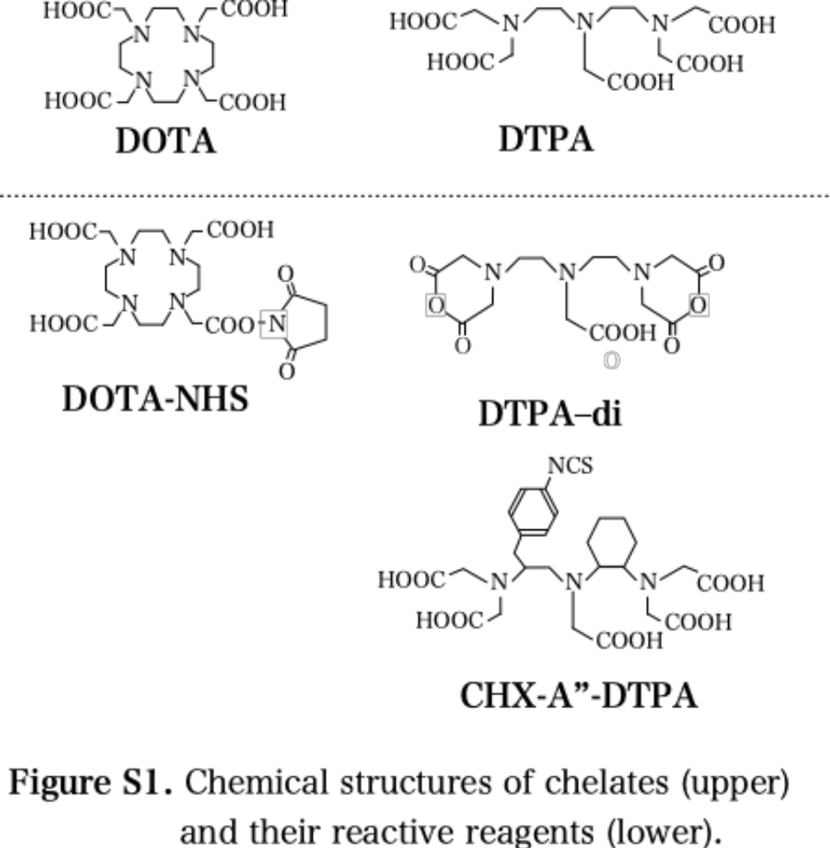

“Dry-handling technique” for 5-mM chelating-agent solutions in DMSO

We employed a standard dry-handling technique commonly used in organic chemistry to prepare and handle 5-mM solutions of three reactive chelating reagents derived from DOTA and DTPA: DOTA-NHS, DTPA-di, and CHX-A”-DTPA (their chemical structures are shown in Fig. S1). This dry-handling technique required that we (1) use dehydrated DMSO, (2) dry all pipette tips, bottles, and tubes, (3) prepare 5-mM chelating-agent stock solutions, and (4) replace ambient air with dry N₂ gas.

(1) Use of dehydrated DMSO

We used dehydrated DMSO (FUJIFILM Wako Pure Chemical Corp.) to prepare 5-mM solutions of reactive chelating reagents. This DMSO bottle was sealed with a septum rubber cap. To withdraw DMSO solvent from the bottle, we used a glass syringe and a stainless-steel needle, both of which were pre-dried at 100 °C in a drying oven and flushed with dry N2 gas.

(2) Drying all pipette tips, bottles, and tubes

Before using pipette tips, glass bottles, and Eppendorf tubes, we dried them at 100°C in a dryer.

(3) Preparation of 5-mM chelating-reagent stock solutions
To prepare 5-mM chelating-reagent stock solutions, we first prepared 50-mM chelating-reagent stock solutions. To this end, we accurately weighed chelating reagents into a dried glass bottle and then added dehydrated DMSO with an Eppendorf-type pipette so that the solution volume would equal the solvent volume. We diluted these 50-mM solutions with dehydrated DMSO to obtain 5.0-mM chelating reagent solutions. We distributed ca. 500 μL of each solution into 1.5-mL Eppendorf tubes, and filled the headspaces of the tubes with dry N2 gas. We stored these 5-mM chelating-agent stock solutions at –30°C or –80°C.

(4) Replacement of ambient air with dry N2 gas

After each use of the 5-mM chelating-reagent solutions in dehydrated DMSO, we replaced any ambient air in the tube’s headspace of with dry N2 gas. In addition, we never opened the cap of a stock solution until the solution had equilibrated to room temperature (r.t.).

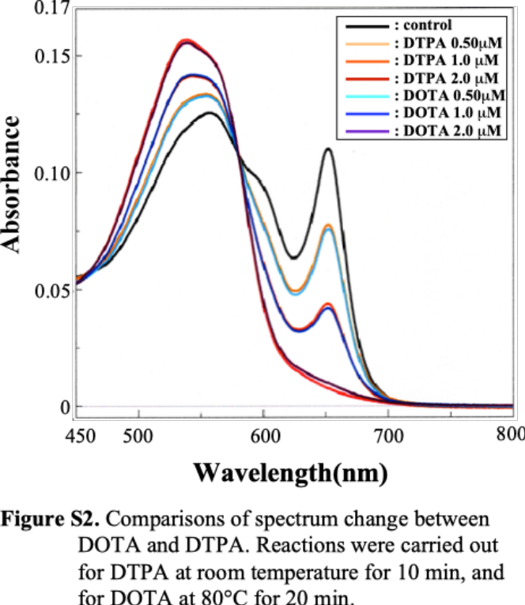
Fig. S2 presents the spectral changes of the Y(III)–Arsenazo III solution in the presence of various concentrations of DOTA and DTPA.
As shown in Fig. S2, the spectra for DOTA and DTPA were found to be nearly identical when the concentrations of the two chelating agents were identical: 0.5 μM (DTPA=yellow-orange, DOTA=sky blue), 1.0 μM (DTPA=orange, DOTA=blue), and 2.0 μM (DTPA=red, DOTA=purple).
These facts indicate that a colorimetric reaction of the
Y(III)–Arsenazo III solution was complete for DOTA when the reaction mixture was incubated at 80°C for 20 min.

Fig. S3 shows the effects of light exposure and reaction period on the spectral changes accompanying the Y(III)–Arsenazo III solution at 37 °C.
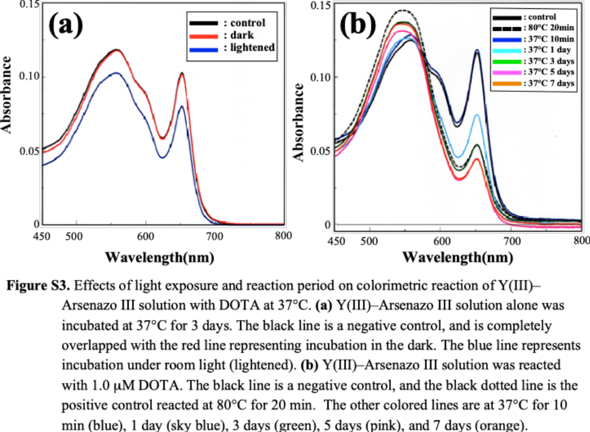
As shown in Fig. S3a, the Y(III)–Arsenazo III solution, when incubated by itself at 37°C for 3 days in the dark (red line), exhibited exactly the same VIS spectrum as did the negative control (r.t., 10 min, black line). In contrast, the Y(III)–Arsenazo III solution, when incubated by itself at 37°C for 3 days under ambient room light (blue line), exhibited substantially lower peaks at about 550 nm and at 652 nm than did the negative control. These results indicate that, in the presence of the Y(III)–Arsenazo III solution, darkened conditions are essential for a long reaction period, such as 3 days.
As shown in Fig. S3b, for the 37°C reaction period, we focused on absorbance at about the 550-nm peak and at the 652-nm peak: Absorbance at about 550 nm increased from 10 min (blue line) to 1 day (sky-blue line) to 3 days (green line), with the negative control (black solid line) exhibiting the lowest absorbance at about 550 nm of the four cases; however, A652 decreased from 10 min (blue line) to 1 day (sky-blue line) to 3 days (green line), with the negative control exhibiting the greatest A652. Regarding absorbance during the reaction period extending from 3 days (green line) to 5 days (pink line) to 7 days (orange line), both absorbance at about 550 nm and A652 decreased as time passed. Therefore, regarding the reactions extending from 0 min to 3 days, our primary observation was that the colorimetric changes were caused by the transfer of Y³⁺ ions from the Arsenazo III moiety to DOTA. By contrast, in the reactions extending from 3 days to 5 days to 7 days, the colorimetric changes that we observed were those resulting from the extinction of the Y(III)–Arsenazo III solution. We attribute this extinction to the very long incubation period (over 3 days) at 37°C.

Fig. S4 presents our optimization of the reaction temperature for the colorimetric determination of [DOTA] in the presence of IgG. Reactions of the Y(III)–Arsenazo III solution at 80°C (red and blue solid lines, Fig. S4a) and at 56°C (red solid line, Fig. S4b) in the presence of IgG resulted in a shift of the spectral peak from 652 nm toward the longer wavelength direction (red shift). In contrast, no shift of the 652-nm peak was observed when the Y(III)–Arsenazo III solution reacted at 37°C. We attribute the temperature-dependent shifts at 56°C and 80°C to IgG denaturation. Accordingly, we concluded that 37 °C was an appropriate temperature for [DOTA] determination in the presence of IgG.

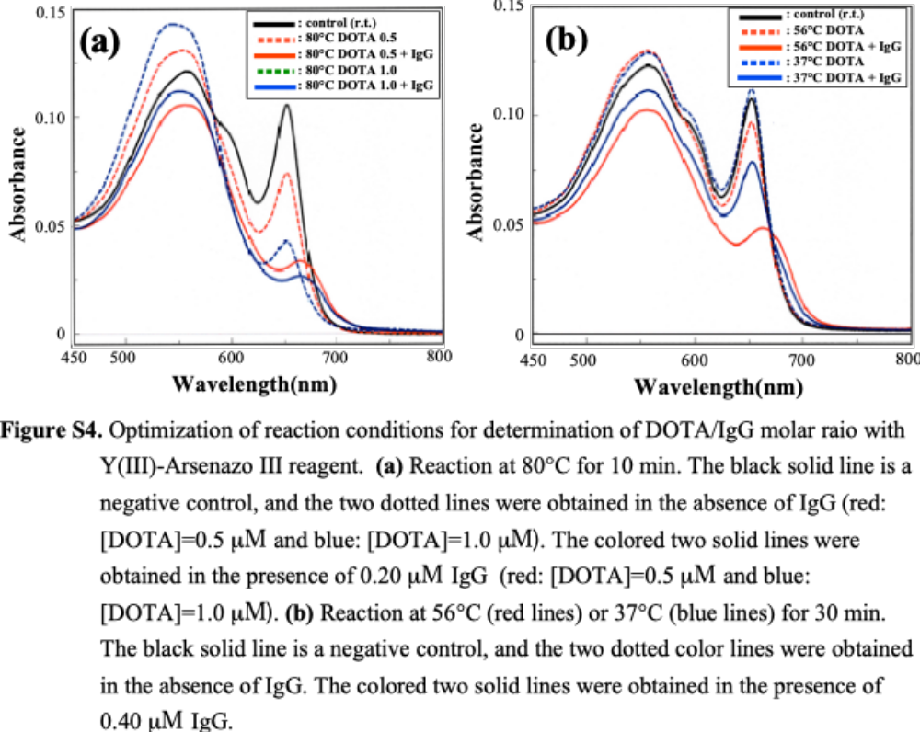
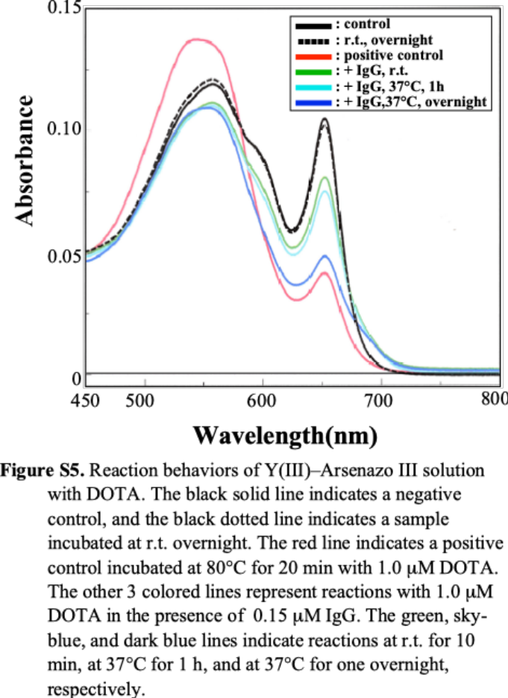
Fig. S5 compares rates of spectrum changes induced by DOTA and IgG. As explained in the main text for Fig. 2, DOTA and IgG exhibit different patterns of spectrum changes to each other. Regarding DOTA, absorbance at 652 nm (A652) was lower for DOTA-containing samples than for the control (Y(III)–Arsenazo III solution alone). Absorbance at about 550 nm, however, was higher for the DOTA-containing samples than for the control. This pattern of spectrum change was caused by Y(III)’s transfer from the Arsenazo III moiety to a chelate. Regarding IgG, both A652 and absorbance at about 550 nm were lower for the IgG-containing samples than for the control. This IgG-inducing spectrum change pattern was caused by the Y(III)–Arsenazo III reagent’s absorption to and interaction with IgG.
In Fig. S5, for the sky-blue line (DOTA+IgG, 37°C, 1h), both A652 and absorbance at about 550 nm were lower than for the control. This spectral change pattern indicates that absorption or interaction of the Y(III)–Arsenazo III reagent’s absorption to and interaction with IgG molecule was the major factor for the spectrum change, and that spectrum change owing to Y(III)’s transfer from the Arsenazo III moiety to a chelate was not observed. The same pattern and magnitude of change was also observed for the green solid line with very short reaction time (10 min) at r.t.. This indicates that the Y(III)–Arsenazo III reagent’s absorption to and interaction with IgG proceeded very quickly. When the Y(III)–Arsenazo III solution was reacted in the presence of DOTA and IgG, absorbance at 652 nm was lower for the overnight reaction (blue line) than for the 1-h reaction (sky-blue line). However, A652 of the dark blue line was not as low as A652 of the positive control (80°C, 20min, red line). This fact indicates that the Y(III)’s transfer from the Arsenazo III moiety to a chelate proceeded much slowly than did the Y(III)–Arsenazo III reagent’s absorption to and interaction with IgG.
Correction of [IgG] for the CHX-A"-DTPA reagent
We determined [IgG] values by measuring A280 for both the DOTA-NHS chelating agent and the DTPA-di chelating agent. However, regarding the CHX-A"-DTPA chelating agent, A280-based [IgG] values required a correction because a phenyl ring in the conjugated CHX-A"-DTPA moiety may have accounted for considerable absorbance at 280 nm. For this correction, we synthesized a model compound that simulated the chemical structure of the CHX-A"-DTPA moiety conjugated to IgG. Then, we measured this model’s absorbance coefficient at 280 nm and performed the correction by subtracting the CHX-A"-DTPA moiety’s contribution to A280 from the original A280 measurement.
(A) Synthesis of a model compound from CHX-A"-DTPA
To obtain the UV spectra for the simulation of the reaction products arising from the conjugation of CHX-A"-DTPA to IgG, we reacted CHX-A"-DTPA with ethylenediamine in dehydrated DMSO. The expected main product is shown in scheme (1) of Fig. S6, in which a thiourea linkage (–NH–C(=S)–NH–) formed between the CHX-A''-DTPA and the ethylenediamine.
We added an ethylenediamine solution (189 μM, 72 μL) in dehydrated DMSO to 72 μL of a 5-mM CHX-A”-DTPA solution in dehydrated DMSO. The reaction mixture was stirred at r.t. for 2.0 h. The molar ratio of CHX-A''-DTPA to ethylenediamine was 1:38. After the reaction, we added 970 μL of D-PBS to 30 μL of the reaction mixture in order to prepare a stock solution of the product. Fig. S7a shows the spectra of this product.
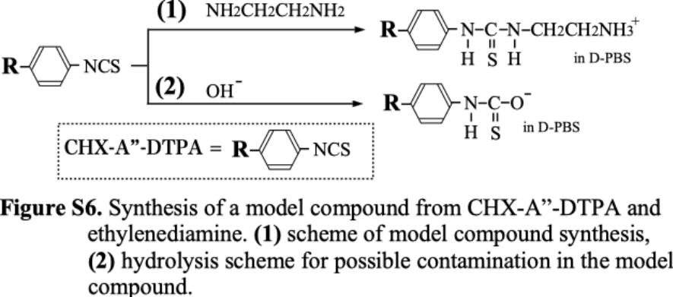
(B) UV-VIS spectroscopic analysis of the model compound
By performing a serial dilution of the model-compound stock solution with D-PBS, we prepared several product solutions ranging from 1 μM to 40 μM, assuming that one product molecule is obtained from one CHX-A”-DTPA molecule and one ethylenediamine molecule. Fig. S7a presents the UV absorption spectra of these product solutions. No peak was detected at 280 nm; however, a plot of A280 against [product] reveals that there was excellent linearity across the various μM solutions (see Fig. S7b).
To assess the purity of the model compound synthesized in Scheme (1) of Fig. S6, we carried out a reaction, shown in Scheme (2) of Fig. S6, in which we synthesized a hydrolyzed analogue that, in this text, we designated ‘Compound B’. We hydrolyzed the –NCS functional group with NaOH in an aqueous medium because, if the CHX-A"-DTPA chelating agent incompletely reacted with ethylenediamine, the most probable side reaction would be hydrolysis of the NCS group. We added 50 μL of MilliQ water and 12.5 μL of 0.10 N NaOH to 50 μL of a 5-mM CHX-A”-DTPA solution in dehydrated DMSO. In this reaction mixture, the molar ratio of NaOH to CHX-A”-DTPA was 5.0. After the reaction mixture was stirred at r.t. for 2.1 h, we added 1.25 mL of D-PBS to the mixture in order to obtain a stock solution of Compound B. By performing serial dilution with D-PBS, we prepared solutions of the Compound B at 2 μM, 4 μM, and 8 μM. Unlike the model compound’s spectra, those of the compound B possessed two peaks, one at 282.0 nm and the other at 270.5nm (see Fig. S7c). Plots of A280 against [product B] yielded a linear fit (y = 0.0109x – 0.0001, R² = 0.9999). 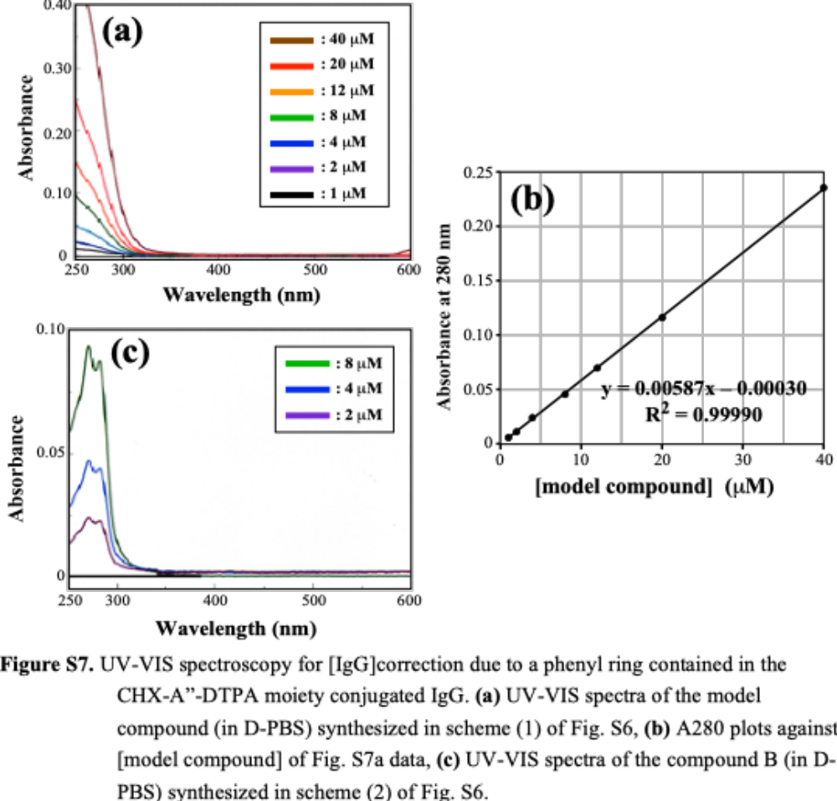
Unlike the spectra of Compound B, those of the model compound exhibited no peak in the approximate spectral region of 280 nm. Furthermore, when A280 values were plotted against concentration (μM) values, the model compound’s slope (0.00587) proved to be much smaller than Compound B’s slope (0.0109). From these facts, we concluded that the synthesis of the model compound proceeded nearly quantitatively, with negligible contamination by Compound B.

(C) Correction of [IgG] for the exact CHX-A"-DTPA/IgG molar ratio
In the colorimetric assays for the IgG–DOTA-NHS and the IgG–DTPA-di conjugates, we added various volumes of conjugate sample solutions to the Y(III)–Arsenazo (III) solution in order to obtain a constant [IgG] in the reaction mixture. This means that we determined the IgG contents in the conjugate samples by means of A280 measurements. However, unlike our colorimetric assays for the IgG–DOTA-NHS and IgG–DTPA-di conjugates, our colorimetric assays for IgG–CHX-A"-DTPA conjugates involved unknown [IgG] values because each CHX-A"-DTPA moiety bound to an IgG molecule possessed an A280 value that overlapped with the A280 value of the IgG molecule. Therefore, we could not conduct a colorimetric assay for these conjugates with a constant [IgG] value. In order to solve this problem, we added a fixed volume (24 μL) of the IgG–CHX-A"-DTPA conjugate samples to the reaction mixture (900 μL), while we fixed [IgG] at 0.080 μM in the total 900 μL of the reaction solution for a standard curve obtained with a mixture of intact IgG and DTPA. We obtained CHX-A"-DTPA/IgG ratios in the following processes.

(1) From a colorimetric assay, we obtained [CHX-A"-DTPA] values for the IgG–CHX-A"-DTPA conjugates.
(2) We obtained the A280 value derived from the CHX-A"-DTPA moiety in the IgG–CHX-A"-DTPA conjugates by using [CHX-A"-DTPA] values and the model compound’s absorbance coefficient at 280 nm.
(3) We calculated the true [IgG] in the reaction mixture by subtracting the A280 value associated with the CHX-A"-DTPA moiety from the A280 value associated with the entire sample.
(4) From [CHX-A"-DTPA] and the true [IgG], we obtained the CHX-A"-DTPA/IgG molar ratio.
(5) We calculated possible errors arising both from “not-constant [IgG]” values in the colorimetric assay and from the [IgG]-dependent nature of IgG-related colorimetric changes. These calculations revealed that each possible error was negligible.

Formula and calculations in the (1) – (4) processes for the CHX-A"-DTPA/IgG ratios are described below.

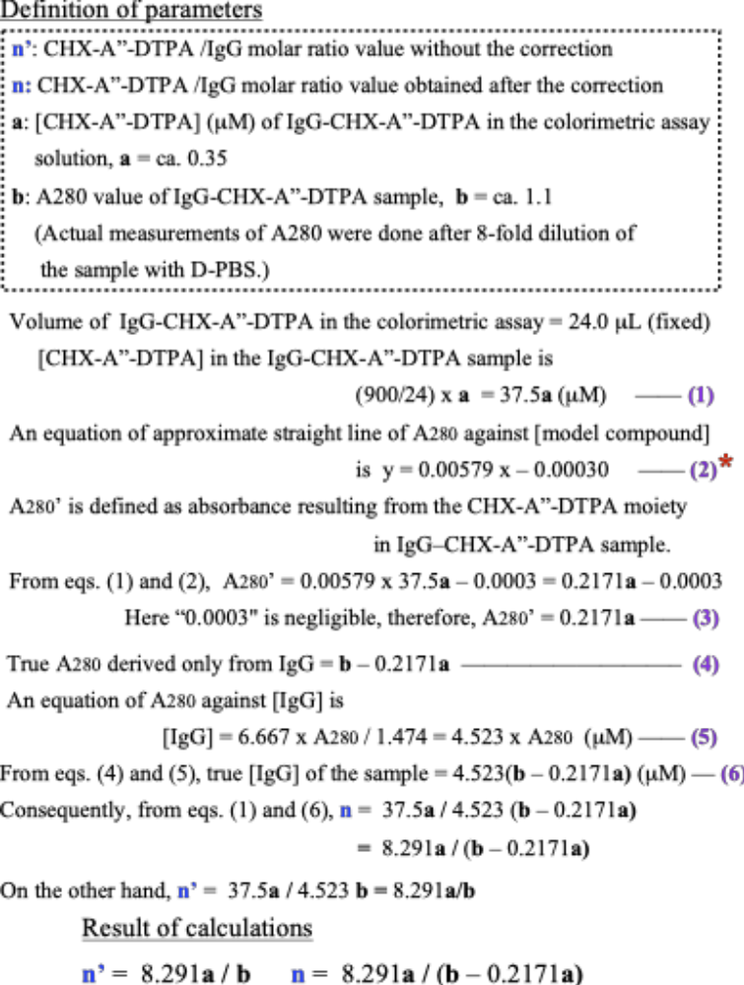
*For this equation (2), possible effects of DMSO and ethylenediamine, which were present in sample solutions for UV-VIS spectrum measurements, on A280 values were examined. Both pure DMSO and ethylenediamine do not exhibit absorption at 280 nm. However, due to impurities contaminated in these reagents, these reagents may exhibit absorption at 280 nm. For DMSO, A280 values proved to be negligible in the UV-spectrum measurements. For ethylenediamine, we found that the effects of ethylenediamine on the UV-spectrum measurements were small, but not negligible. The original equation of A280 against [model compound] was
y = 0.00587 x – 0.00030 —— (7)

Fig. S8 shows a UV-VIS spectrum of ethylenediamine solution in D-PBS. This solution was a 4,589-fold diluted (by volume) ethylenediamine solution in D-PBS. When the same dilution ratio is applied for ethylenediamine in the model compound synthesis procedure described in Fig. S6, Scheme (1), the concentration of the model compound is 177 μM. At this model compound’s concentration, A280 was calculated to be 1.0387 according to eq. (7). On the other hand, as shown in Fig. S8, the A280 value was 0.0140 for the 4,589-fold diluted ethylenediamine. Consequently, the contribution of ethylenediamine to the A280 measurement for [model compound] was 0.0140/1.0387 = 1.35 %. We judged that this contribution percentage was small, but not negligible. Then, we compensated the slope value of the standard curve with this 1.35 %; 0.00587 x (1 – 0.0135) = 0.00579, and finally obtained eq. (2).
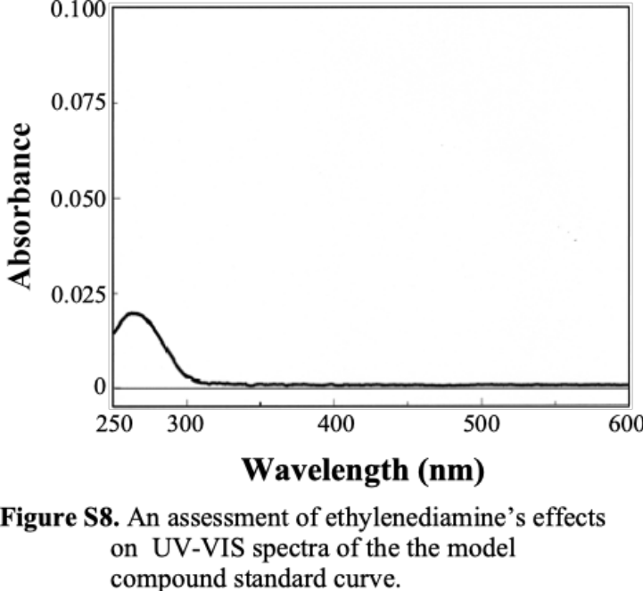

Regarding process (5), for this error estimation in the colorimetric assay, we picked Run 1 from Table S1 because all the other runs had similar CHX-A"-DTPA/IgG ratio values to the ratio value of Run 1. Thus, we reasonably assumed that estimation errors for all these other runs would be very similar to the estimation error of Run 1.
Formula and calculations of this (5) process for possible error in the CHX-A"-DTPA/IgG ratio are described below.

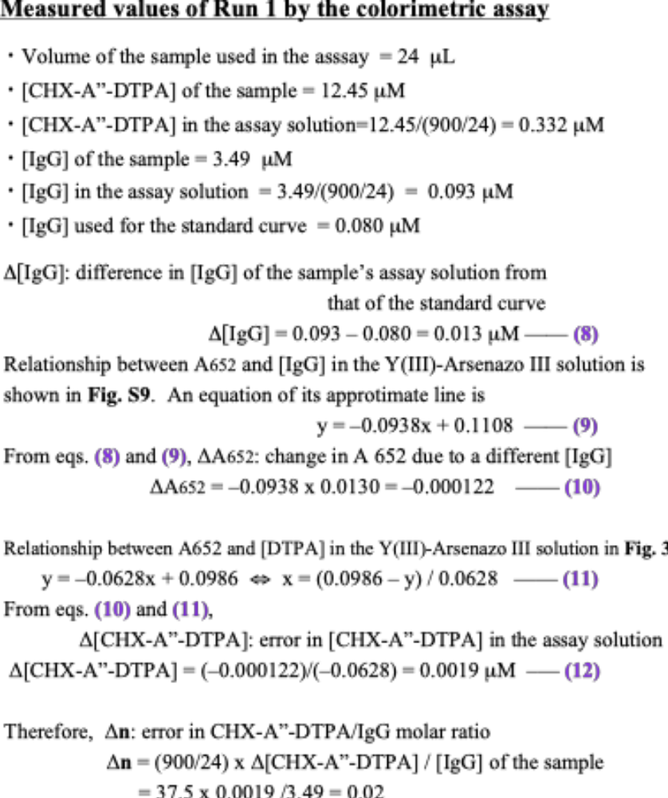

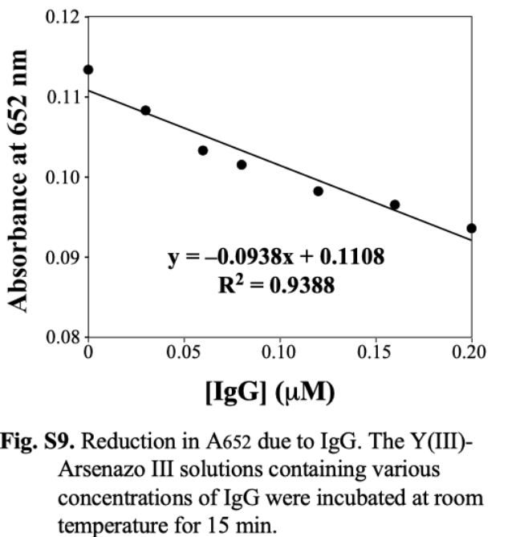
The calculated Run 1’s estimated error (Δn), 0.02, was negligible relative to the Run 1 CHX-A"-DTPA/IgG molar ratio of 3.6. Therefore, we concluded that our colorimetric assay had yielded accurate results, despite differences between the samples’ [IgG] values and the standard curve’s [IgG] values.

Table S1 compares the CHX-A''-DTPA/IgG molar ratios for case n (calculated with the above correction) and case n′ (calculated without the correction). The two sets of ratios differ substantially.

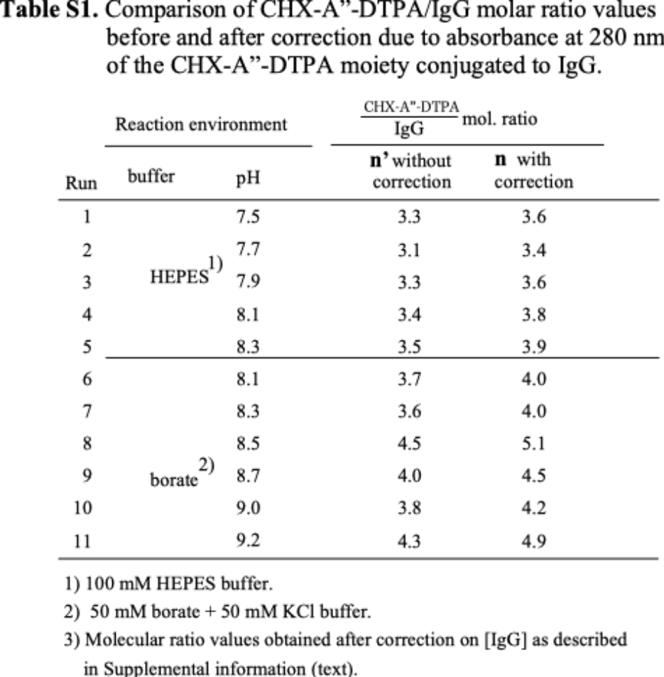

Table S2 summarizes previously reported reaction yields for the three reactive chelating agents that we studied in the present study. The previously reported reaction yields are much lower than our corresponding values, which are described in the dehydrate-system column in Table 6 in the main text. Notable exceptions in the previous research are the CHX-A"-DTPA results reported in Strand et al. (2021) and Cassels et al. (2021). This comparison between the results of our current study and the results of previous studies is very important as it highlights the clear advantage of our conjugation-reaction procedure over previously reported procedures regarding the realization of high reaction yields for chelating agents.

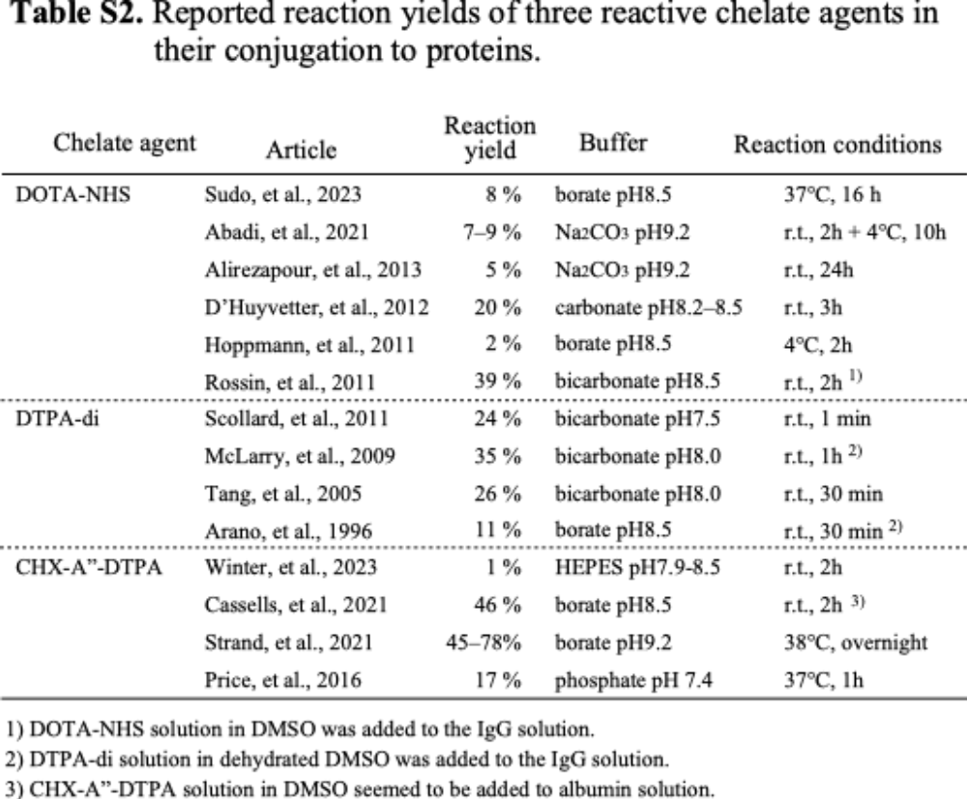

List of referenced papers in Table S2
Abadi SA, Alirezapour B, Kertész I, Rasaee MJ, Mohammadnejad J, Paknejad M, Yousefnia H, Zolghadri S. Preparation, quality control, and biodistribution assessment of [¹¹¹ In]In-DOTA-PR81 in BALB/c mice bearing breast tumors. J Labelled Comp Radiopharm. 2021; 64(4): 168-180. doi: 10.1002/jlcr.3897.

Alirezapour B, Jalilian AR, Bolourinovin F, Moradkhani S. Production and Quality Control of [(67)Ga]-DOTA-trastuzumab for Radioimmunoscintigraphy. Iran J Pharm Res. 2013; 12(2): 355-66.

Arano Y, Wakisaka K, Ohmono Y, Uezono T, Akizawa H, Nakayama M, Sakahara H, Tanaka C, Konishi J, Yokoyama A. Assessment of radiochemical design of antibodies using an ester bond as the metabolizable linkage: evaluation of maleimidoethyl 3-(tri-n-butylstannyl)hippurate as a radioiodination reagent of antibodies for diagnostic and therapeutic applications. Bioconjug Chem. 1996; 7(6): 628-37. doi: 10.1021/bc960058w.
Cassells I, Ahenkorah S, Burgoyne AR, Van de Voorde M, Deroose CM, Cardinaels T, Bormans G, Ooms M, Cleere F. Radiolabeling of Human Serum Albumin With Terbium-161 Using Mild Conditions and Evaluation of in vivo Stability. Front Med. 2021; :8: 675122. doi: 10.3389/fmed.2021.675122.

D'Huyvetter M, Aerts A, Xavier C, Vaneycken I, Devoogdt N, Gijs M, Impens N, Baatout S, Ponsard B, Serge S, Caveliers V, Lahoutte T. Development of 177Lu-nanobodies for radioimmunotherapy of HER2-positive breast cancer: evaluation of different bifunctional chelators. Contrast Media Mol Imaging. 2012; 7(2): 254-64. doi: 10.1002/cmmi.491.

Hoppmann S, Miao Z, Liu S, Liu H, Ren G, Bao A, Cheng Z. Radiolabeled affibody-albumin bioconjugates for HER2-positive cancer targeting. Bioconjug Chem. 2011;22(3):413-21. doi: 10.1021/bc100432h.

McLarty K, Cornelissen B, Cai Z, Scollard DA, Costantini DL, Done SJ, Reilly RM. Micro-SPECT/CT with 111In-DTPA-pertuzumab sensitively detects trastuzumab-mediated HER2 downregulation and tumor response in athymic mice bearing MDA-MB-361 human breast cancer xenografts. J Nucl Med. 2009;50(8):1340-8.doi: 10.2967/jnumed.109.062224.

Price EW, Edwards KJ, Carnazza KE, Carlin SD, Zeglis BM, Adam MJ, Orvig C, Lewis JS. A comparative evaluation of the chelators H4octapa and CHX-A″-DTPA with the therapeutic radiometal (90)Y. Nucl Med Biol. 2016 ; 43(9): 566-576. doi: 10.1016/j.nucmedbio.2016.06.004.

Rossin R, Kohno T, Hagooly A, Sharp T, Gliniak B, Arroll T, Chen Q, Hewig A, Kaplan-Lefko P, Friberg G, Radinsky R, Evelhoch JL, Welch MJ, Hwang D-R. A kit to prepare (111)In-DTPA-trastuzumab (Herceptin) Fab fragments injection under GMP conditions for imaging or radioimmunoguided surgery of HER2-positive breast cancer. J Nucl Med. 2011;52(6): 942-9. doi: 10.2967/jnumed.110.086157.

Scollard DA, Chan C, Holloway CMB, Reilly RM. A kit to prepare (111)In-DTPA-trastuzumab (Herceptin) Fab fragments injection under GMP conditions for imaging or radioimmunoguided surgery of HER2-positive breast cancer. Nucl Med Biol. 2011;38(1):129-36. doi: 10.1016/j.nucmedbio.2010.06.010.

Strand J, Sjöström K, Lamminmaki UJ, Timmermand OV, Strand S-E , Tran TA. Humanization, Radiolabeling and Biodistribution Studies of an IgG1-Type Antibody Targeting Uncomplexed PSA for Theranostic Applications. Pharmaceuticals (Basel). 2021; 14(12): 1251. doi: 10.3390/ph14121251.

Sudo H, Tsuji AB, Sugyo A, Harada Y, Nagayama S, Katagiri T, Nakamura Y, Higashi T. Head-to-head comparison of three chelates reveals DOTAGA promising for 225Ac labeling of anti-FZD10 antibody OTSA101. Cancer Sci. 2023; 114: 4677-4690. doi: 10.1111/cas.15978. ﻿

Tang Y, Wang J, Scollard DA, Mondal H, Holloway C, Kahn HJ, Reilly RM. Imaging of HER2/neu-positive BT-474 human breast cancer xenografts in athymic mice using (111)In-trastuzumab (Herceptin) Fab fragments. Nucl Med Biol. 2005; 32(1): 51-8.doi: 10.1016/j.nucmedbio.2004.08.003.

Winter G, Hamp-Goldstein C, Fischer G, Kletting P, Glatting G, Solbach C, Herrmann H, Sala E, Feuring M, Döhner H, Beer AJ, Bunjes D, Prasad V. Optimization of Radiolabeling of a [90Y]Y-Anti-CD66-Antibody for Radioimmunotherapy before Allogeneic Hematopoietic Cell Transplantation. Cancers (Basel). 2023; 15(14): 3660. doi: 10.3390/cancers15143660.

Abbreviations
DOTA 1,4,7,10-Detraazacyclododecane-1,4,7,10-tetraacetic acid
DTPA Diethylenetriaminepentaacetic acid
DOTA-NHS 1,4,7,10-Tetraazacyclododecane-1,4,7,10-tetraacetic acid mono-N-hydroxysuccinimide ester
DTPA-di Diethylenetriaminepentaacetic dianhydride
CHX-A"-DTPA S-2-(4-Isothiocyanatobenzyl)-1,4,7,10-tetraazacyclododecane tetraacetic acid,
D-PBS Dulbecco’s phosphate buffered saline

