Insecticide resistance is driven by distinct metabolic mechanisms across the lifespan of the major malaria vector Anopheles arabiensis

Bethanie Pelloquin, Jackline L. Martin, Judatthadei Pantaleo, Edmond Bernard, Austin J. Tang, Nancy Matowo, Ecaterina Edith Vamos, Charlotte Jessop, Noboru Minakawa, Natacha Protopopoff, Louisa A. Messenger

Supplementary Figures and Tables

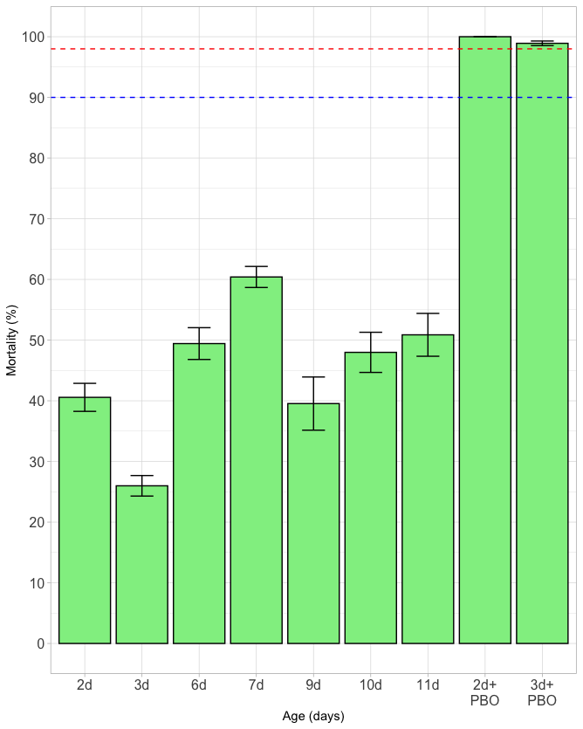

Figure S1. Average mortality of Anopheles (An.) arabiensis aged 2 to 11 days old following exposure to the diagnostic dose of permethrin in CDC bottle bioassays and of An. arabiensis aged 2-3 days old pre-exposed to PBO before permethrin bioassays. Bars indicate mean mortality after 30 minutes of insecticide exposure across bottle replicates with 95% confidence intervals. The blue dashed line indicates the World Health Organization threshold of 90% mortality, below which a population is considered resistant. The red dashed line indicates 98% mortality, above which indicates susceptibility.

Figure S2. Number of upregulated (A) and downregulated (B) genes in 11d compared with 2-3d An. arabiensis of different phenotypes.

Figure S3. Number of significantly differentially expressed genes in 2-3d (A), 6d (B) and 11d (C) Res-Sus, Res-Un and Un-Sus An. arabiensis.

Figure S4. Comparison of expression levels of differentially expressed genes measured by qRT-PCR and RNA-seq.

Table S1. Oligonucleotide primers used for qRT-PCR validation.

Gene Description | Transcript ID (VectorBase) | Forward Primer 5’-3’ | Reverse Primer 5’-3’ | Amplicon Size (bp) | Primer Efficiency (%) | Reference
40S Ribosomal protein S7 | AARA000046 | AGAACCAGCAGACCACCATC | GCTGCAAACTTCGGCTATTC | 98 | 106.7 | Jones et al. 2013; doi: 10.1186/1756-3305-6-343.
Ubiquitin | AARA016296 | CGACTCCGTGGTGGTATCAT | GCACTTGCGGCAAATCATCT | 124 | 94.2 | Jones et al. 2013; doi: 10.1186/1756-3305-6-343.
CPLCG15 | AGAP008459 | ACGCCAGAATTGTATCCCCG | CGGCTGGTAAGTGTACGGTG | 100 | 107.6 | This study
CYP6P3 | AARA015787 | CTGTCTGTACGAGCTGGCAA | GTCGTACGTCACCTCTCCAC | 99 | 108.8 | This study
CYP4H17 | AARA011200 | CAACGACTTCGGGCATTTCG | TCCGCTCCCAACATTCCATC | 99 | 106.9 | This study
CPR86 | AGAP010103 | GCACTACCATCACGAAGAGGA | CTCCTTCTGGCCGTGAACAT | 99 | 99.6 | This study
CYP6Z3 | AARA015795 | CTACCTGTTCTTCCGCCCTG | GTAGACACCGCGATCGTGAA | 99 | 93.8 | This study
GSTD7 | AARA009632 | GTGCTGTATTATCTGCCGCC | CCATCACGTTCAGCGCTTTC | 99 | 91.6 | This study

