Depth-governed ecological and evolutionary partitioning of ocean trench viromes
Yuan-Guo Xie^{1,9}, Jian-Xing Sun^{2,3,9}, Yan-Ling Qi⁴, Libo Yu⁵, Hongbo Zhou², Zhu Chen², Zhen-Hao Luo⁶, Yan-Ni Qu¹, Li Shen², Zhichao Zhou⁴, Meng Li⁴, Xinhua Chen⁷, Karthik Anantharaman^{8*}, Yuguang Wang^{2*}, Zheng-Shuang Hua^{1*}.

¹State Key Laboratory of Advanced Environmental Technology, Department of Environmental Science and Engineering, University of Science and Technology of China, Hefei, 230026, PR China
²School of Minerals Processing and Bioengineering, Central South University, Changsha, 410083, Hunan, PR China
³Department of Laboratory Medicine, Affiliated Nanhua Hospital, University of South China, Hengyang 421001, Hunan, China.
⁴Archaeal Biology Centre, Synthetic Biology Research Center, Shenzhen Key Laboratory of Marine Microbiome Engineering, Key Laboratory of Marine Microbiome Engineering of Guangdong Higher Education Institutes, Institute for Advanced Study, Shenzhen University, Shenzhen, 518060, PR China
⁵Key Laboratory of Marine Genetic Resources, Third Institute of Oceanography, Ministry of Natural Resources, Xiamen 361005, PR China
⁶Department of Functional and Evolutionary Ecology, Archaea Biology and Ecogenomics Unit, University of Vienna, Vienna, Austria
⁷College of Marine Sciences, Fujian Agriculture and Forestry University, Fuzhou, 350002, PR China
⁸Department of Bacteriology, University of Wisconsin–Madison, Madison, WI, USA
⁹These authors contributed equally: Yuan-Guo Xie, Jian-Xing Sun

Correspondence:
ZS Hua, University of Science and Technology of China, Hefei, 230026, PR China
Email: hzhengsh@ustc.edu.cn
YG Wang, Central South University, Changsha, 410083, Hunan, PR China
Email: ygwang@csu.edu.cn
K. Anantharaman, Department of Bacteriology, University of Wisconsin–Madison, Madison, WI, USA
Email: karthik@bact.wisc.edu
Supplementary Figures
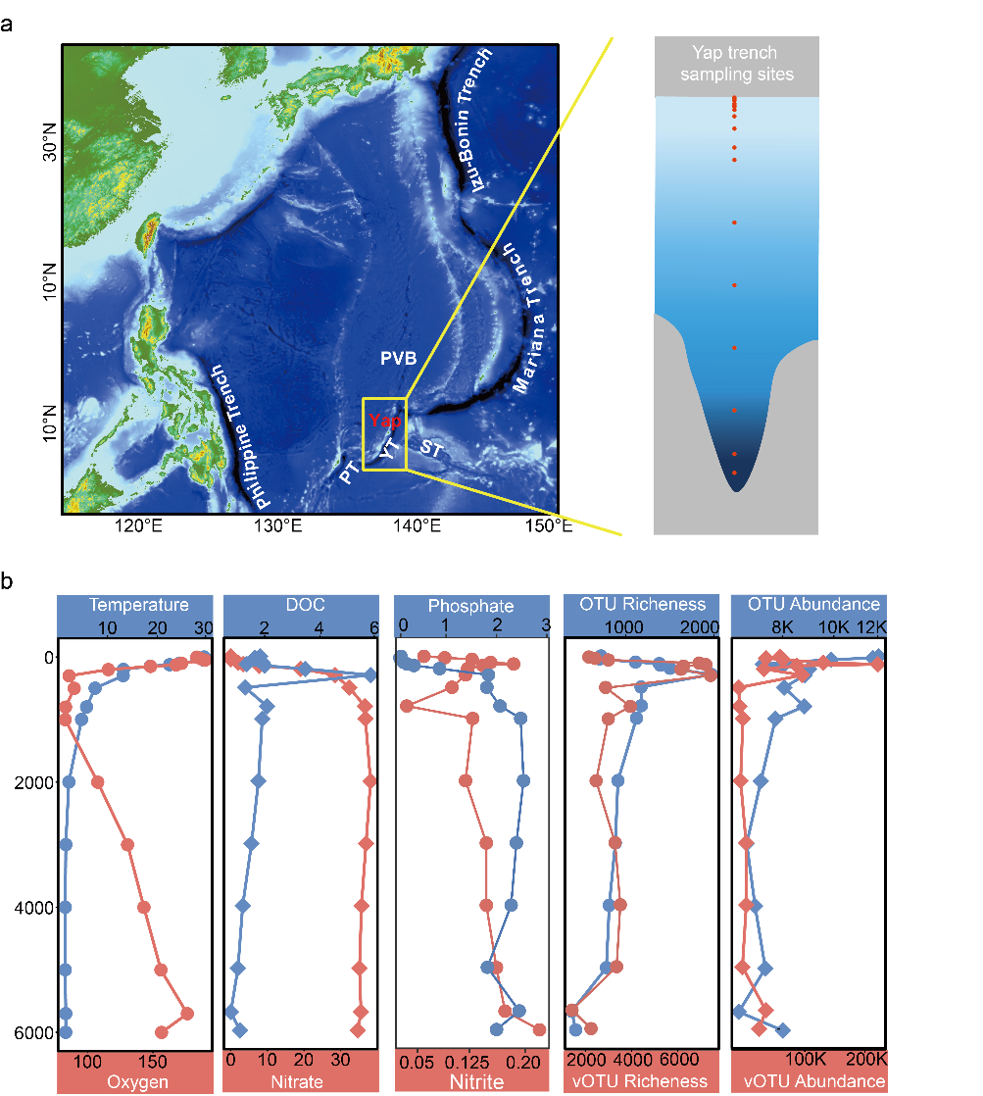
Supplementary Figure 1. Environmental gradients and microbial–viral dynamics in the Yap Trench water column. (a) Geographic location of 17 water column samples collected in the Yap Trench. (b) Changes in physicochemical conditions and the richness and abundance of microbial and viral communities along the depth gradient of the Yap Trench.
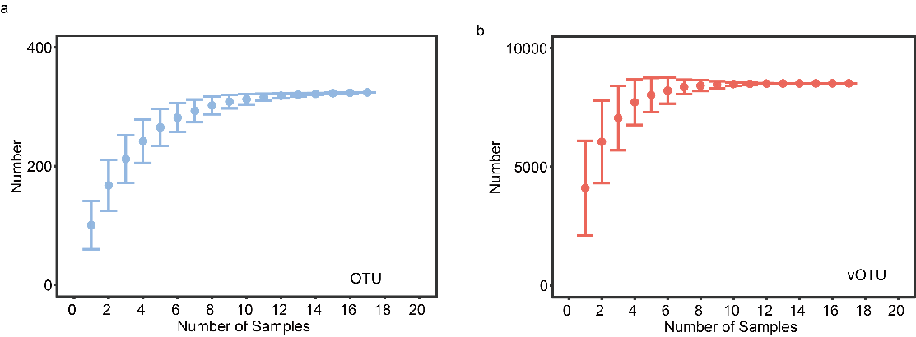Supplementary Figure 2. Accumulation curve of vOTUs and OTUs in the Yap Trench water column metagenomes. (a) Accumulation curve of OTUs in the Yap Trench water column metagenomes. (b) Accumulation curve of vOTUs in the Yap Trench water column metagenomes. Dots represent the average number of vOTUs and OTUs for all combinations of a given number of samples, and error bars represent the range. The red circle represents vOTUs and the sky-blue circle represents OTUs.

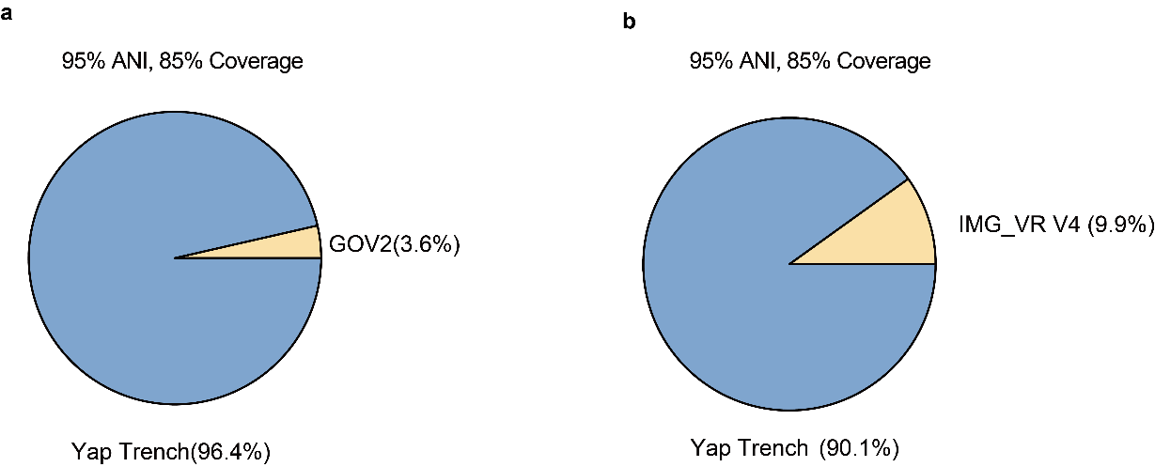 Supplementary Figure 3. Comparison of Yap Trench viral vOTUs with public marine viral databases. Pie charts show the proportion of Yap Trench viral operational taxonomic units (vOTUs) shared with (a) the Global Ocean Viromes 2.0 (GOV2) and (b) IMG/VR version 4 databases, based on 95% average nucleotide identity (ANI) and 85% alignment coverage thresholds. In both comparisons, the majority of vOTUs were unique to the Yap Trench dataset (blue), while a smaller fraction matched reference sequences in GOV2 (3.6%) and IMG/VR v4 (9.9%) (yellow), indicating a high degree of novel viral diversity in the hadal environment.

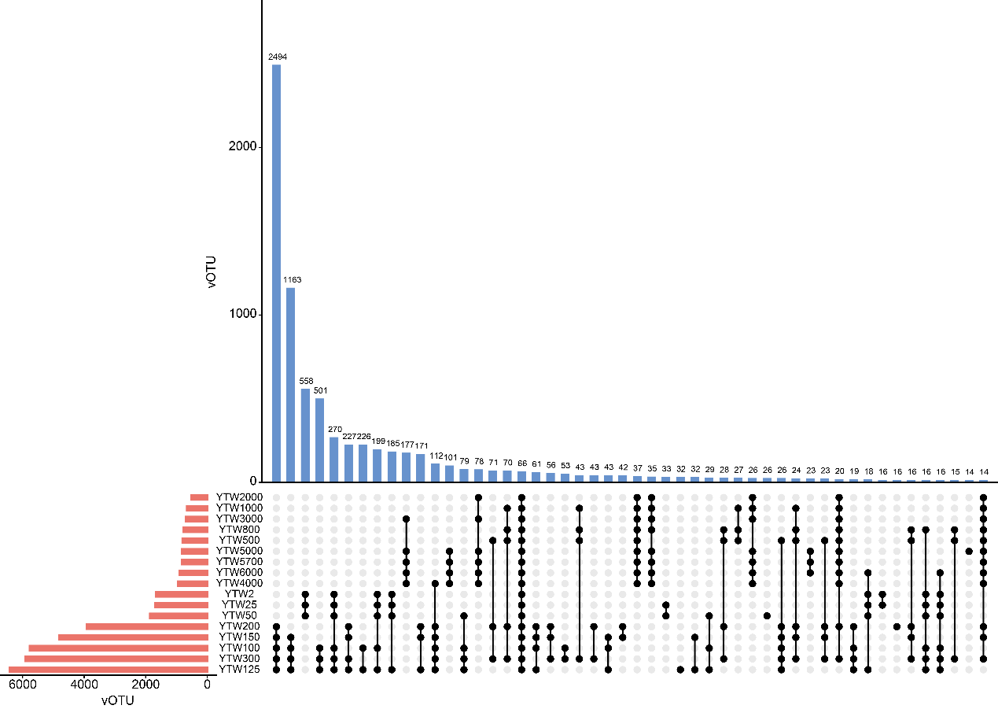 Supplementary Figure 4. Comparison of viral communities across different seawater depth layers at the vOTU level. The upset plots illustrate the shared and unique vOTUs among samples from different depths. The intersection size indicates the number of vOTU clusters present in each combination of depth layers, highlighting the extent of overlap and depth-specific viral diversity.

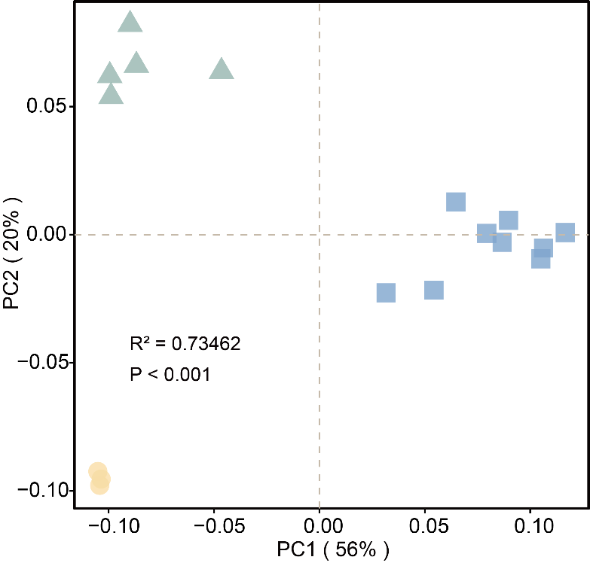
Supplementary Figure 5. Principal coordinate analysis (PCoA) of viral community composition excluding Kyanoviridae, based on Bray–Curtis dissimilarities.

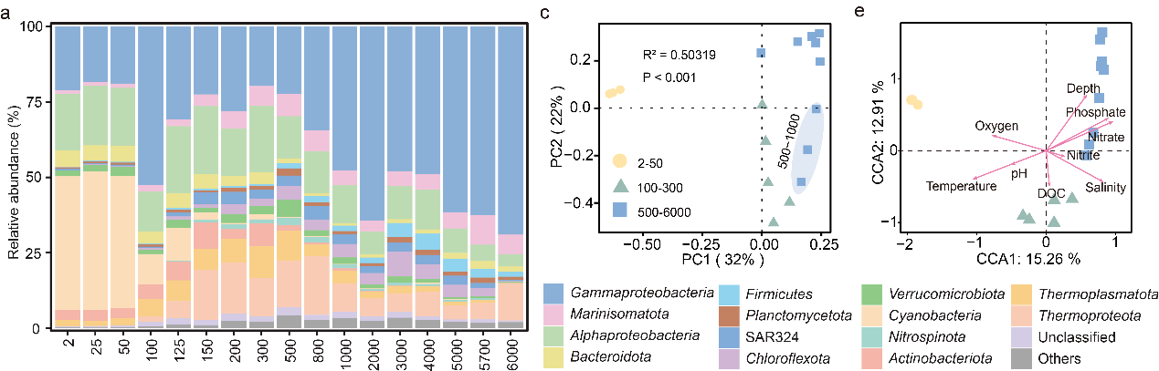 Supplementary Figure 6. Dynamics and prokaryotic communities. (a) Changes in the relative abundance of prokaryotes at the phylum level. (b) Principal coordinate analysis (PCoA) of prokaryotic community composition. Group differences were assessed using permutational multivariate analysis of variance (PERMANOVA, implemented via the adonis2 function in the vegan R package). (c) Canonical correspondence analysis (CCA) of prokaryotic community composition. Environmental variables are represented by arrows, and viral community profiles by dots; arrow length indicates the strength of the correlation with community variation.

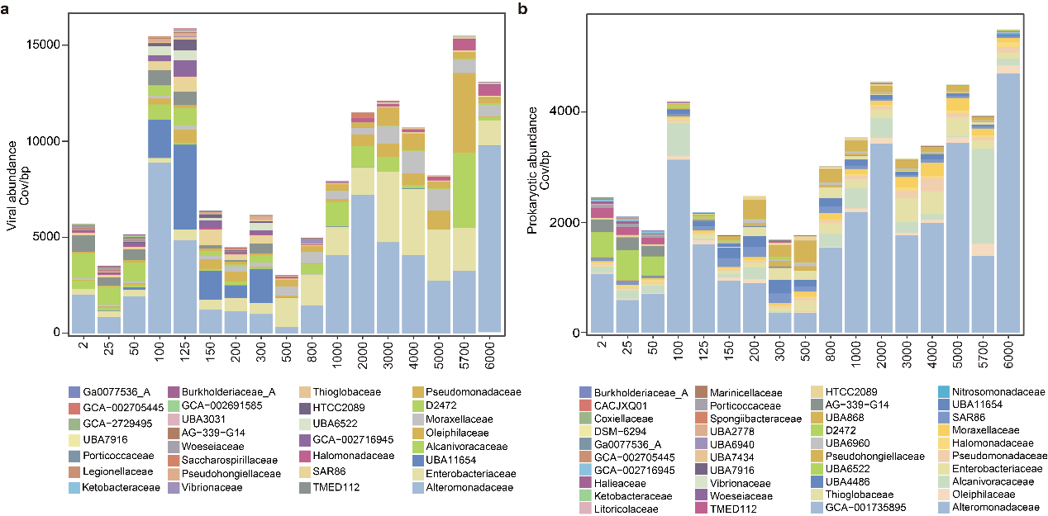Supplementary Figure 7. Family-level distribution of Gammaproteobacteria-infecting viruses and their prokaryotic hosts across different water column layers. (a) Relative abundance of Gammaproteobacteria-infecting viruses across the water column, with colors denoting host family-level taxonomy. (b) Depth-resolved distribution of Gammaproteobacteria at the family level, based on abundance across sampling depths.

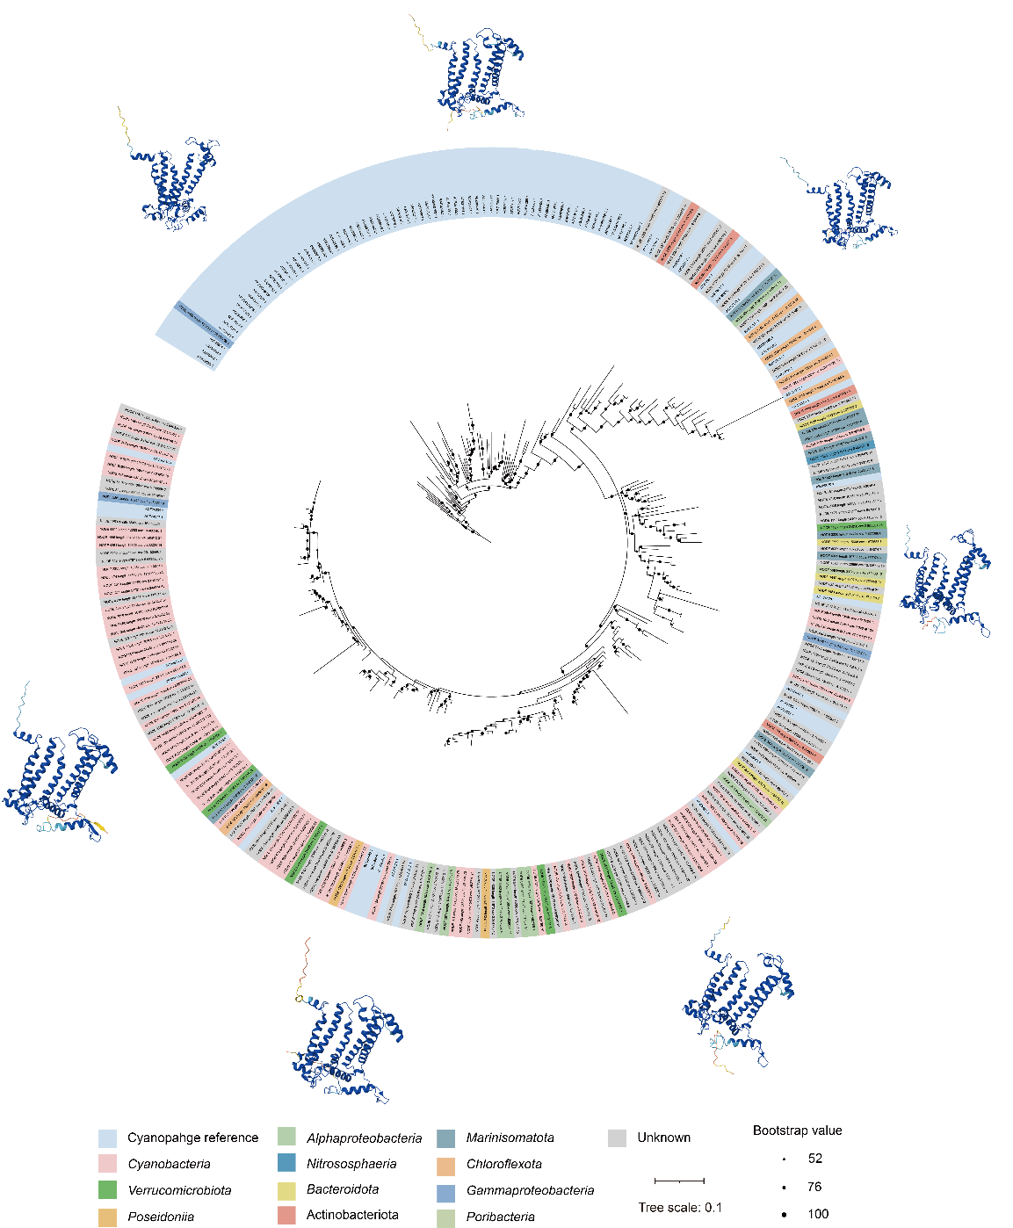
Supplementary Figure 8. Phylogenetic tree of viral psbA genes and their predicted host affiliations. Maximum-likelihood phylogeny of viral psbA sequences. Outer color strips denote the predicted host lineages of the viruses. Bootstrap support values are indicated by circle size. Representative protein structures predicted for selected psbA genes are shown around the tree.

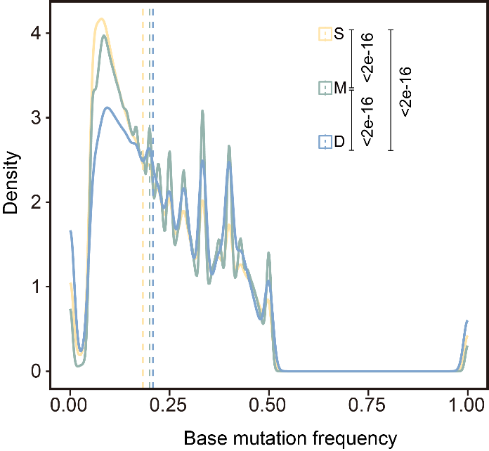
Supplementary Figure 9. Depth-dependent distributions of viral base mutation frequencies. Density plots show the distributions of base mutation frequencies across surface (S), mesopelagic (M), and deep (D) viral populations. Vertical dashed lines indicate median values for each layer. Statistical comparisons across depths are shown (all P < 2 × 10⁻¹⁶).

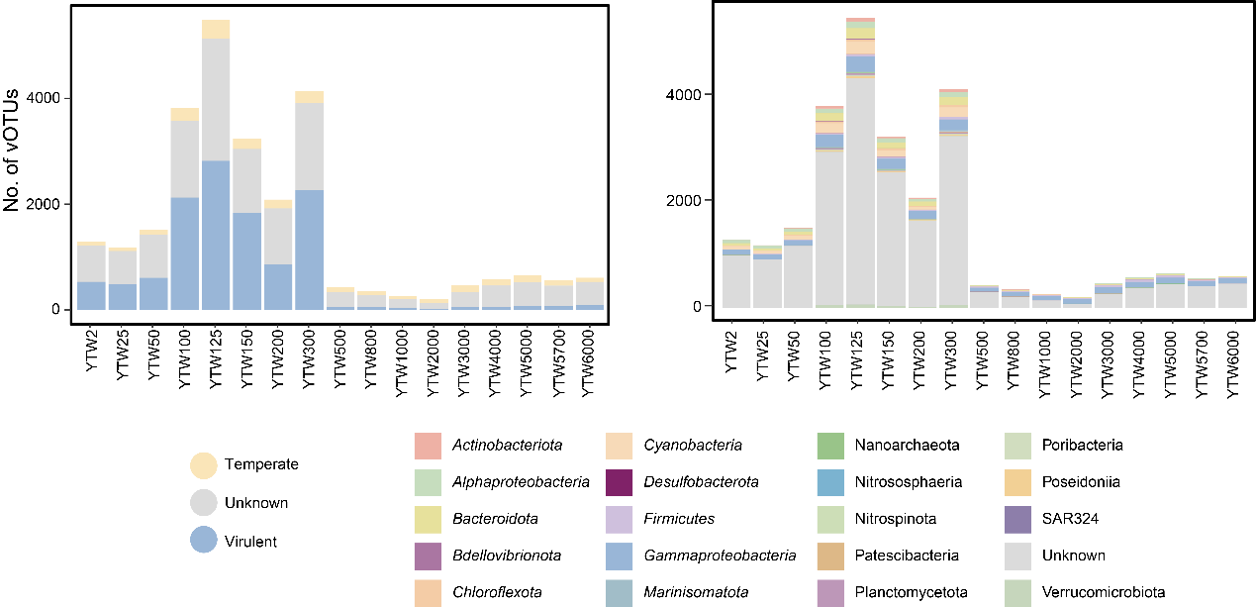 Supplementary Figure 10. Depth-associated microevolutionary dynamics of viral communities in the Yap Trench water column. (a) Diversity of viral single nucleotide variants (SNVs) across depth layers, with viruses grouped by predicted host lineage. Colors represent different host taxa. (b) Diversity of viral SNVs across depth layers, with viruses grouped by lifestyle (virulent vs. temperate). Colors indicate different viral lifestyles.

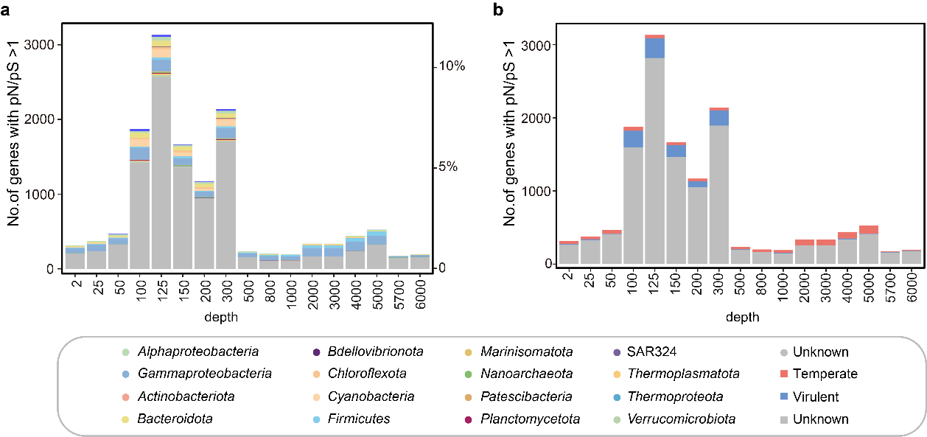 Supplementary Figure 11. Depth-associated dynamics of positively selected genes in viral communities of the Yap Trench water column. (a) Diversity of viral genes under positive selection across depth layers, with viruses grouped by predicted host lineage. Colors represent different host taxa. (b) Diversity of viral genes under positive selection across depth layers, with viruses grouped by lifestyle (virulent vs. temperate). Colors indicate different viral lifestyles.
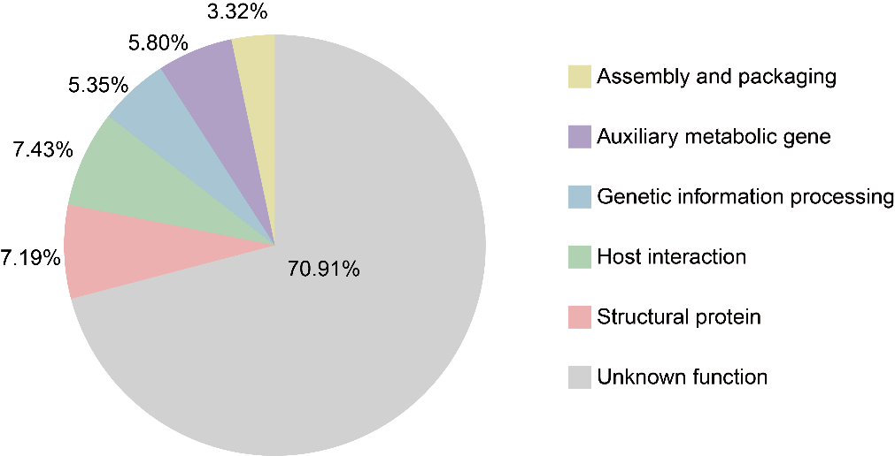
Supplementary Figure 12. Functional annotation of positively selected genes. Different colors indicating distinct functional categories.

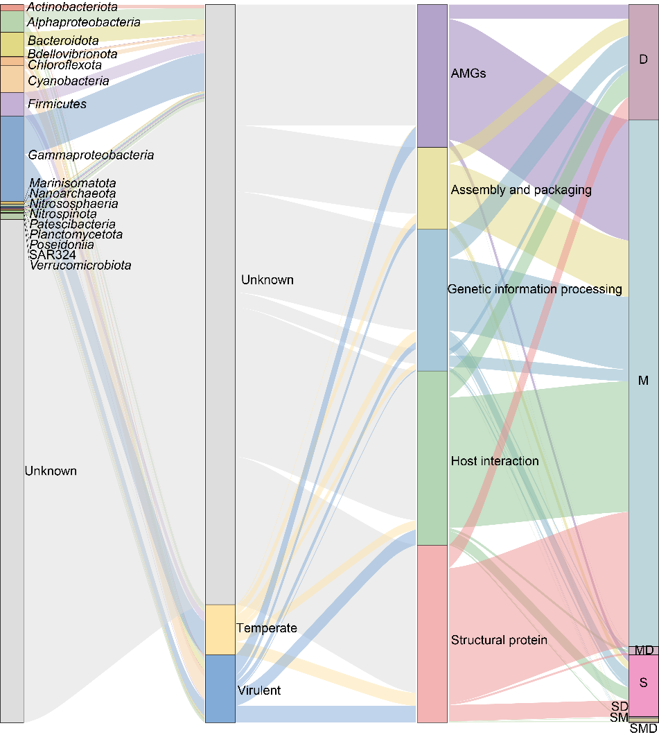
Supplementary Figure 13. Links between viral host, viral lifestyles, positively selected gene functions, and mutation patterns across depth samples. Sankey diagram linking predicted host lineages (left) with viral lifestyles (temperate vs. virulent), functional categories of positively selected genes (middle), and depth layers (surface [S], mesopelagic [M], and deep [D]). Colors correspond to host groups and functional categories, as indicated. The visualization shows that positively selected genes are distributed across diverse hosts and functions, with distinct patterns emerging between temperate and virulent viruses and among different depths.

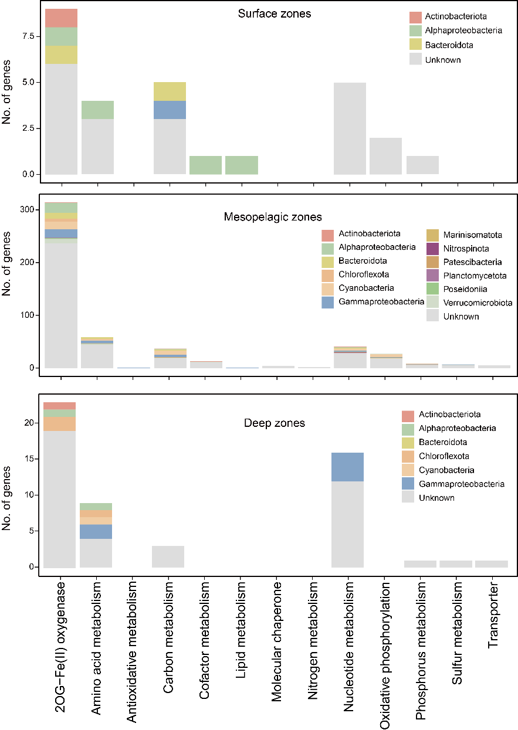
Supplementary Figure 14. Depth-resolved distribution of positively selected AMGs colored by predicted viral host taxonomy.

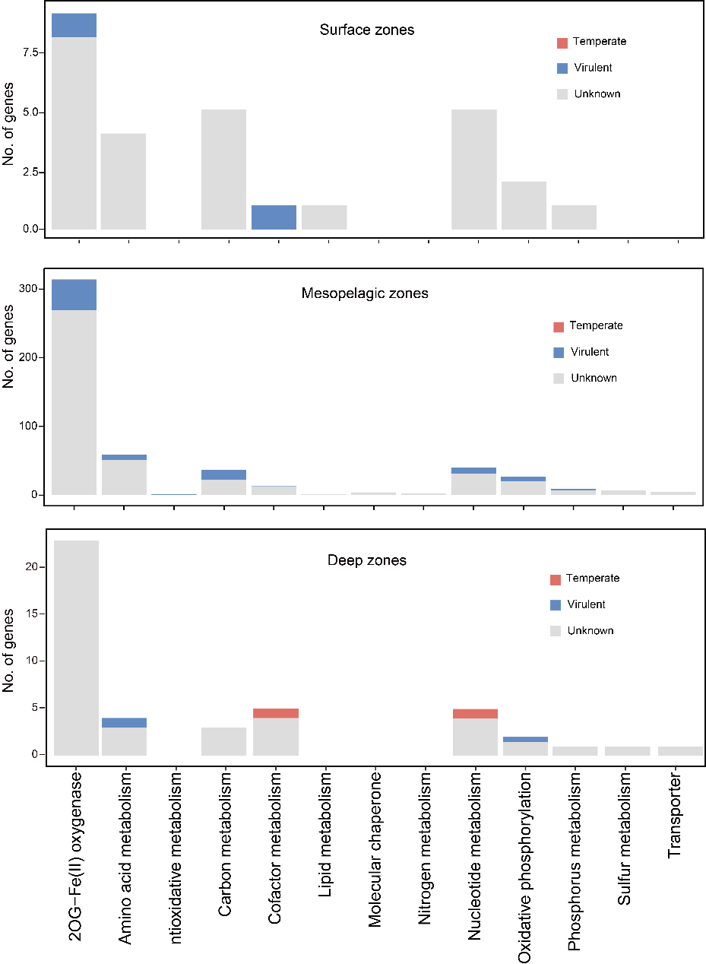
Supplementary Figure 15. Depth-resolved distribution of positively selected AMGs colored by predicted viral lifestyle.

