A New Technique for Carbon Layer Formation for Application in Capacitive Deionization
Supplementary Material

Peter Kovalsky, ^{1,}* Mathavan Tharman,¹
¹University of Waikato, Hamilton 3216, New Zealand
Email addresses: peter.kovalsky@waikato.ac.nz (Peter Kovalsky); mt1247@students.waikato.ac.nz (Mathavan Tharman)

Journal of Porous Materials
____________________________
*Corresponding authors: Dr Peter Kovalsky, peter.kovalsky@waikato.ac.nz

Introduction
Details on the stack fabrication and supporting resources will be provided here for the purpose of assisting researchers to replicate the technique described. A series of instructional videos and STL files will be provided that can be 3D printed. These parts are featured in the publication and videos. Please click on the hyperlink for videos on YouTube.

3D Printed Files
The following STL files are provided. Estimated print times on a Flashforge Adventurer 5 (using PETG filament and 0.4mm nozzle) are provided.
A total of four percolated plates is provided as 90mmpercplateby4.STL.
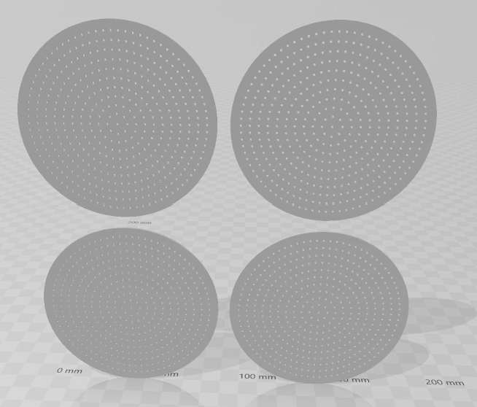
Figure A1 90mmpercplateby4.STL (3h 49m)
A filter tray with capacity for four simultaneous sheets provided as base4.STL
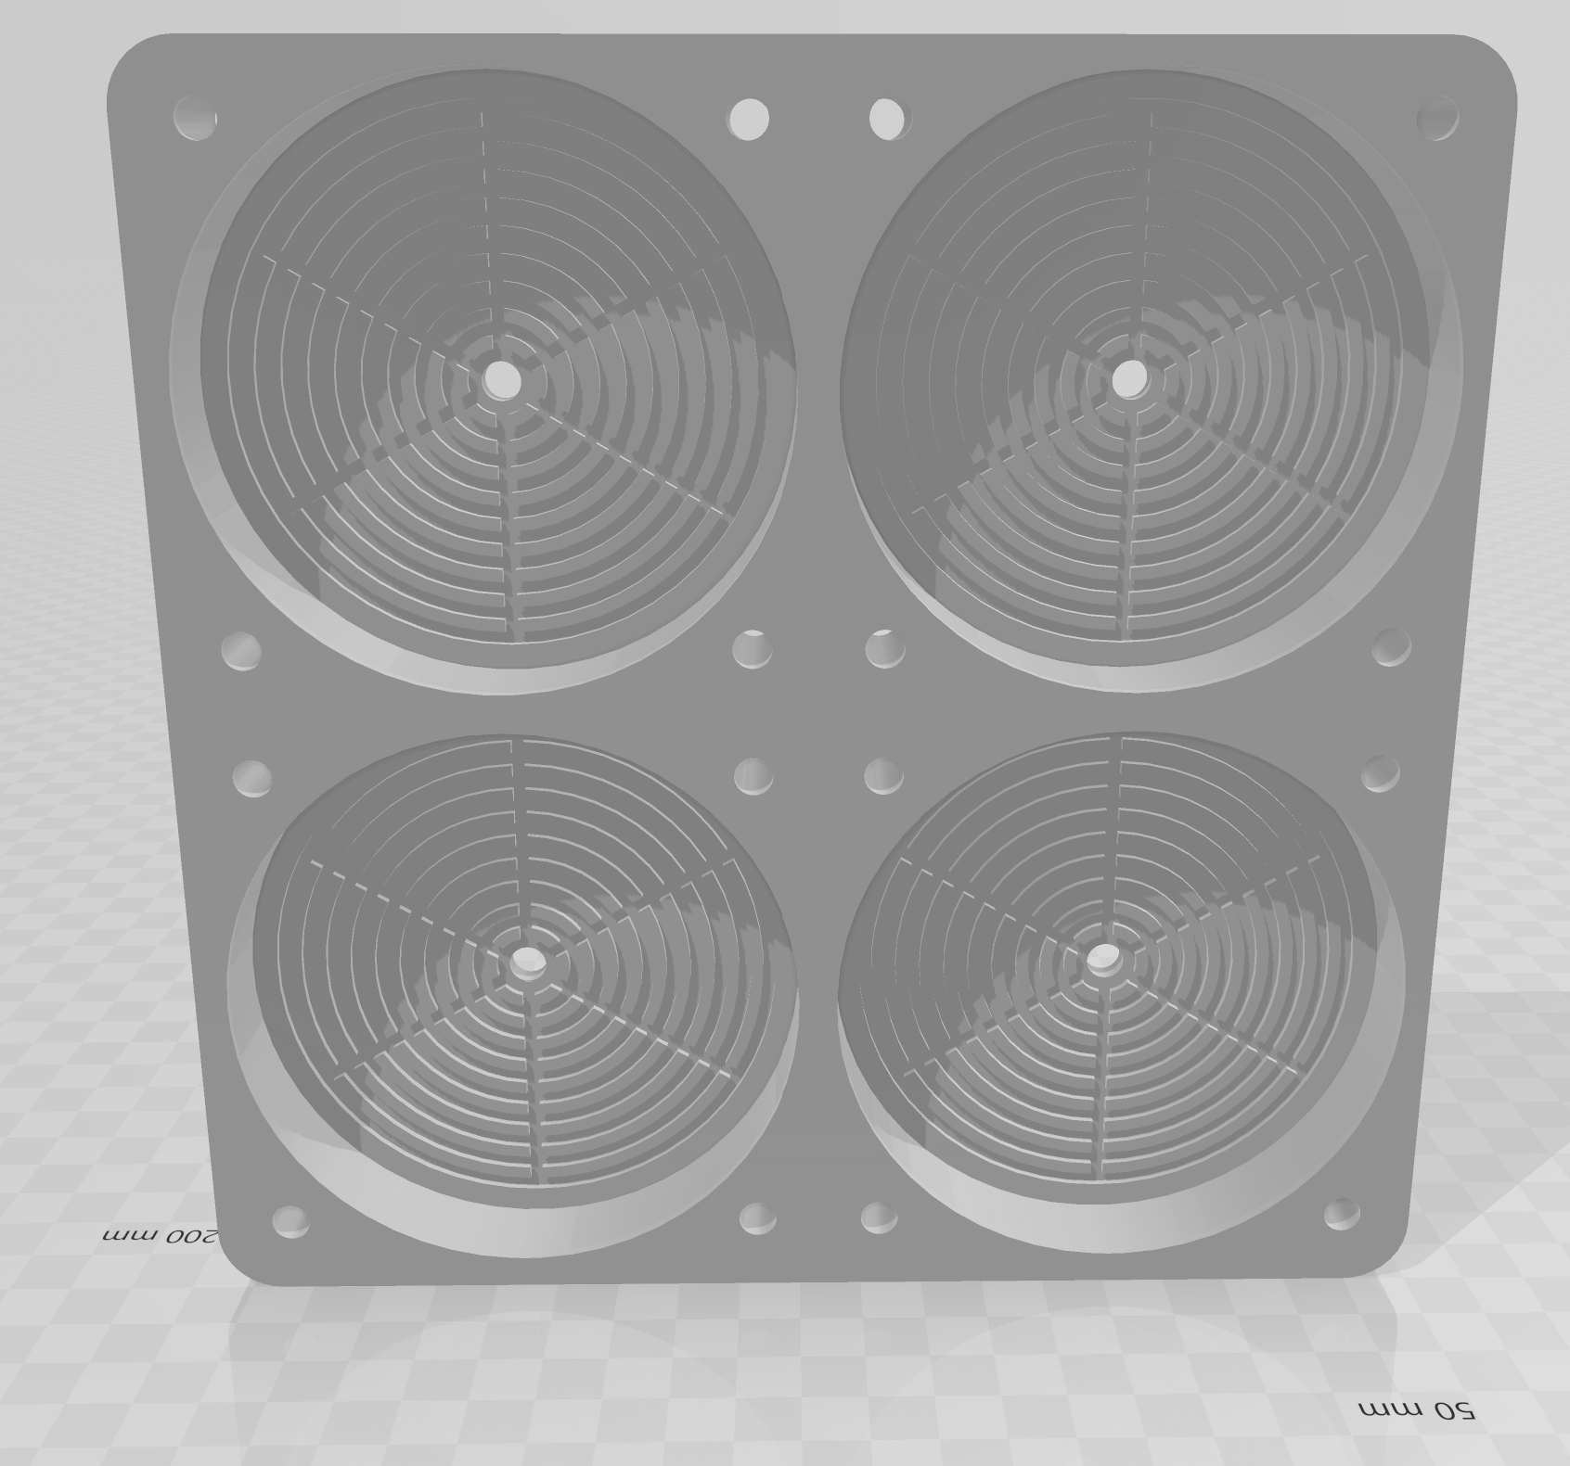
Figure A2 base4.STL (5h 28m)
Post printing, the steps to complete the filter tray is tapping the thru hole with M6 followed by affixing four M6 thread to 3mm barb connections. Three tee connections should then be used to join all four outlets to a common single outlet point. Alternatively, a 3D printed push on tube fitting can be designed and installed to achieve the same function.
An optional finishing step is to coat the printed parts with a low viscosity epoxy. This ensures that the parts are pressure tight. This can be done by mixing the respective binary components then using a brush or latex glove, and applying a light coat uniformly. Allow 24 hours to cure the epoxy.
A single 90mm ring as 90ring.STL. Please print four of these.
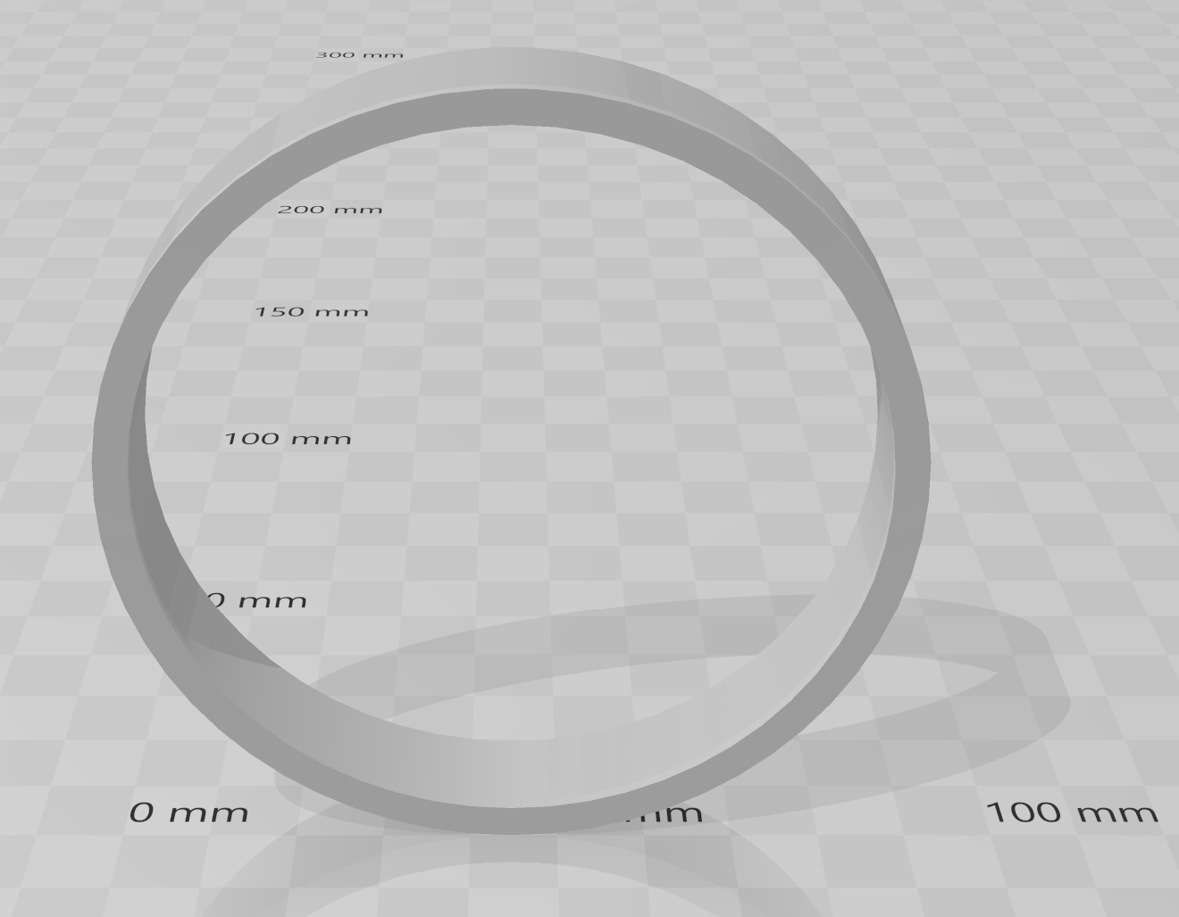
Figure A3 90ring.STL (19m 31s)
A spider as PRESSv3.STL
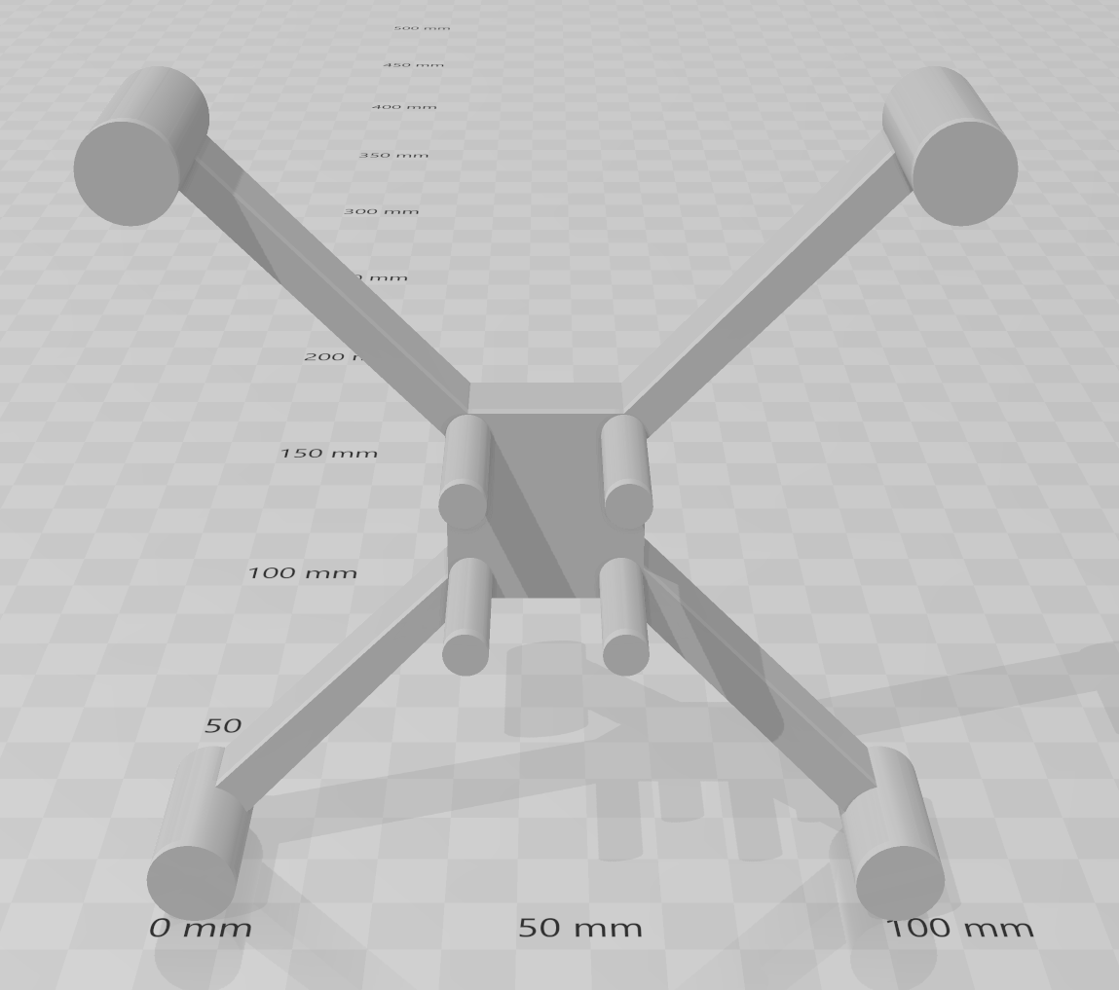
Figure A4 PRESSv3.STL (44m 22s)

Impeller
We have created an impeller that is optimized for a 500mL separatory funnel. It uses a 5mm threaded rod as the shaft that needs to be acquired separately and cut to length for motor placement.
The impeller is comprised of a minimum of three elements, two fixed and one repeating.
Element 1: This is the repeating element called impeller90.STL. Affix one or more along the length of the shaft depending on the expected depth of liquid in the vessel. A total of three is recommended. They are affixed in position by M5 nut and washer at both ends.
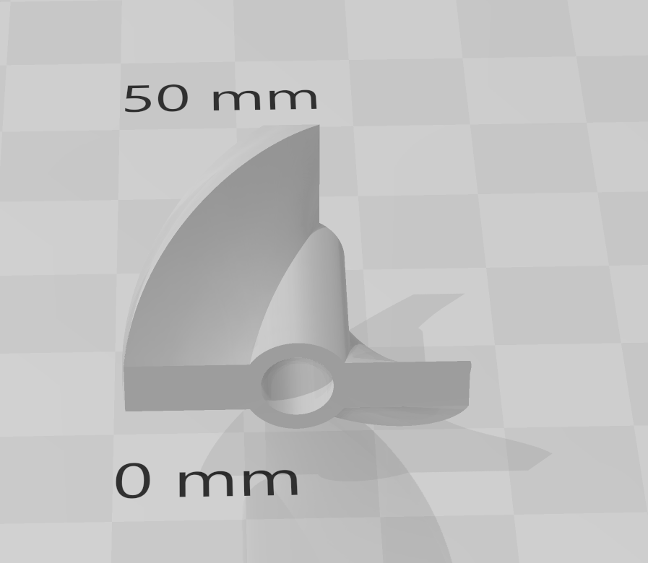
Figure A5 impeller90.STL
Element 2: This impeller called twistend.STL is designed with an angled taper to match the vessel shape. It prevents settling of flocs and a low shear zone from forming at the base of the vessel.
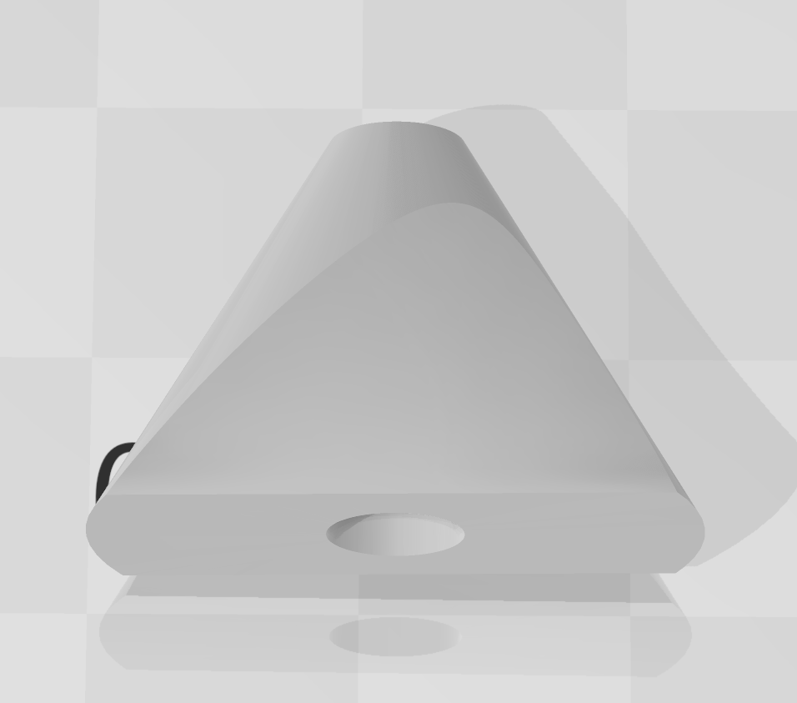
Figure A6 twistend.STL
Element 3: Twistend2.STL is the terminating element that affixes at the end of the shaft. It can be tapped M5 and then screwed on the end of the shaft at the final step.
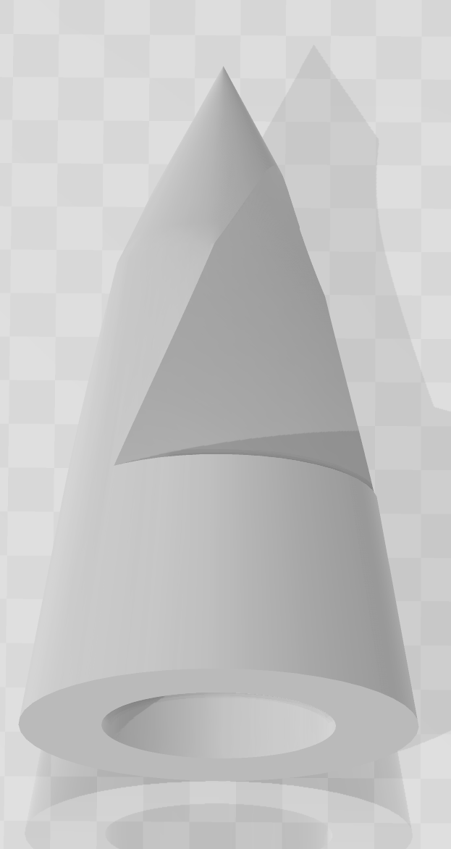
Figure A7 twistend2.STL
The assembled version of the impeller is shown in Figure A8.
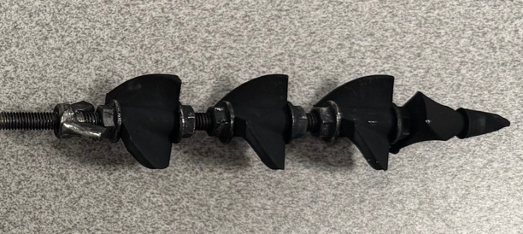
Figure A8 Impeller assembly showing three repeating impeller90 blades and twistend followed by twistend2 going from left to right

Instructions – Stack Fabrication
A series of instructional videos demonstrate how to form the carbon sheet and subsequently form the repeating cell of a stack. This is shown in 8 parts.
Step 1 - Batch Preparation and Dispensing (6:19)
In this video we see our lab assistant, Mr Mathavan, prepare the reactor by adding the carbon first, then addition of the PTFE binder followed by the alum/NaOH coagulant. The reactor vessel is stirred using a multiple blade impeller. The impeller can be 3D printed and affixed to a stainless-steel shaft. The STL files are provided. In the latter part of the video, we observe the dispensing of the carbon floc into the 4x filter tray. These STL files are also provided. The dispensing manifold is a 90 degree design used to reduce floc breakage by creating a horizontal approach. In the following video we begin dewatering.
Step 2 – Dewatering (2:09)
In this step we start the initial dewatering. A 60mL syringe is affixed at the tube connection and the first 20mL of filtrate pulled through gently. Following this the syringe is disconnected and the filter tray connected to a vacuum pump to remove as much water as possible before heat drying.
Step 3 - Vacuum Drying (0:51)
The filter tray is connected to a vacuum pump to remove any free draining filtrate. Some residual moisture remains in the pore as there is insufficient pulling force to overcome the capillary pressure.
Step 4 - Off to the Oven (0:08)
This step involves moving the tray to the oven. Ensure the oven is preheated ahead of arrival.
Step 5 - Oven Drying (0:24)
Place in dryer for 30mins at 60 degrees C.
Step 6 – Remove from Oven (0:24)
After 30 mins, remove from oven.
Step 7 - Unload carbon sheet from filter tray (1:06)
On a workbench, unload the carbon sheet from filter tray. This carbon sheet is denoted as CM or "carbon on mesh". To unload, remove the spider first. Note that no carbon is under the spider legs. Following this, remove the fastening, then remove the rings. Then using a picker tool, remove the carbon sheet and place on a clean tray.
Step 8 – Create the repeating cell subassembly (2:42)
With the CM layer or carbon layer in a tray, find an open space to create the repeating cell subassembly. Alignment guides are not used in this demonstration, but in practice we advise the use of a centre alignment tool to ensure all layers are concentric. This ensures that there is no short circuiting caused by unwanted contact between anode and cathode. To create the repeating cell:
- place MC (MC means carbon face up),
- place graphite with lip in the 6 o'clock direction (cathode),
- place CM (carbon face down),
- place a mesh layer,
- place MC (MC means carbon face up),
- lay down graphite with lip in the 12 o'clock direction (anode),
- place CM (carbon face down),
- place a mesh layer.
Thus, we have the following sequence: -MC-G(-)-CM-M-MC-G(+)-CM-M- for a repeating cell. Repeat up to as many times as practically possible. At some point the graphite sheet aggregation becomes impractical. Cell counts of around 20 can be done comfortably. If we denote the above as CELLbyn, then a N=20 stack can be; G(+)-CM-M-CELLby19-MC-G(-) This involves 19 repetitions and one end set. Note that we need to place the end-anode (as G(+)-CM-M) and end-cathode (as MC-G(-)) around the repeating structure to terminate it.

