Supplementary Material
Title: Intrinsic tumor factors and extrinsic environmental and social exposures contribute to endometrial cancer recurrence patterns

Jesus Gonzalez Bosquet, M.D., Ph.D.;^{1*} Oyomoare Osazuwa-Peters, PhD;² Vincent M. Wagner, M.D.;¹ Andrew Polio, M.D.;¹ Rebecca Hoyd, B.S.;¹⁹ Ahmad A. Tarhini, M.D., Ph.D.;³ Casey M. Cosgrove, M.D.; ⁴ Marilyn S. Huang, M.D.; ⁵ Bradley R. Corr, M.D.; ⁶ Aliza L. Leiser, M.D.; ⁷ Bodour Salhia, Ph.D.;⁸ Kathleen Darcy, Ph.D.; ^{9,10} Rob L. Dood, M.D.; ¹¹ Lauren E. Dockery, M.D.,M.S.; ¹² Michael J. Cavnar, M.D.; ¹⁴ Lisa Landrum, M.D., Ph.D.;¹⁵ Laura Chambers, M.D.;⁴ Aik Choon Tan, Ph.D.;¹⁶ Ning Jin, M.D.;¹⁷ Robert J. Rounbehler, Ph.D.;¹⁸ Michelle L. Churchman, Ph.D.;¹⁸ Dan Spakowicz, MS, PhD.¹⁹

¹ Department of Obstetrics and Gynecology, Gynecologic Oncology, University of Iowa, 200 Hawkins dr., Iowa City, IA 52242, USA. Email: jesus-gonzalezbosquet@uiowa.edu
² Department of Population Health Science, Duke University School of Medicine, 40 Duke Medicine Circle, Durham, NC 27710, USA. Email: oyomoare.osazuwapeters@duke.edu
³ Departments of Cutaneous Oncology and Immunology, H. Lee Moffit Cancer Center & Research Institute, 12902 USF Magnolia Drive, Tampa, FL 33612, USA. Email: ahmad.tarhini@moffitt.org
⁴ Gynecologic Oncology, The Ohio State University, 460 W. 10th Avenue, Columbus, OH 43210, USA. Emails: Casey.Cosgrove@osumc.edu; Laura.Chambers@osumc.edu
⁵ Gynecologic Oncology, University of Virginia, 1240 Lee St., Charlottesville, VA 22903, USA. Email: mhuang@virginia.edu
⁶ Gynecologic Oncology, University of Colorado, 1665 Aurora Court, Aurora, CO 80045, USA. Email: bradley.corr@cuanschutz.edu
⁷ Gynecologic Oncology, Rutgers, 195 Little Albany Street, New Brunswick, NJ 08901, USA. Email: all149@cinj.rutgers.edu
⁸ Department of Translational Genomics, Norris Comprehensive Cancer Center, Keck School of Medicine, University of Southern California. 1450 Biggy St. Los Angeles, CA 90033, USA. Email: salhia@usc.edu
⁹ Gynecologic Cancer Center of Excellence, Murtha Cancer Center Research Program, Department of Surgery, Uniformed Services University of the Health Sciences, Walter Reed National Military Medical Center, 8901 Wisconsin Avenue, Bethesda, MD, 20889, USA. Email: kathleen.darcy.ctr@usuhs.edu
¹⁰ Henry M Jackson Foundation for the Advancement of Military Medicine, Inc., Women’s Health Integrated Research Center (WHIRC), 3289 Woodburn Road, Suite 370, Annandale VA 22003, USA. Email: darcyk@whirc.org
¹¹ Gynecologic Oncology, Huntsman Cancer Institute, 50 North Medical Drive, Salt Lake City, Utah 84132, USA. Email: Rob.Dood@hsc.utah.edu
¹² Gynecologic Oncology, University of Oklahoma, 800 NE 10th, SCC 5050, Oklahoma City, OK 73104, USA. Email: Lauren-Dockery@ouhsc.edu
¹⁴ Surgical Oncology, University of Kentucky, 800 Rose Street, UKMC – C220, Lexington KY 40508, USA. Email: michael.cavnar@uky.edu
¹⁵ Gynecologic Oncology, Indiana University, 340 West 10th Street, Fairbanks Hall, Suite 6200, Indianapolis, IN 46202-3082, USA. Email: llandru@iu.edu
¹⁶ Departments of Oncological Sciences and Biomedical Informatics. Huntsman Cancer Institute, 2000 Circle of Hope, Rm. 4518, Salt Lake City, UT 84112. Email: aikchoon.tan@hci.utah.edu
¹⁷ Division of Medical Oncology, Department of Internal Medicine, The Ohio State University Comprehensive Cancer Center, Columbus, Ohio, USA. Email: Ning.Jin2@osumc.edu
¹⁸ Aster Insights, P.O. Box 5519, Hudson, FL 34667; Email: Rob.Rounbehler@asterinsights.com; Michelle.Churchman@asterinsights.com
¹⁹ Division of Medical Oncology, Molecular Carcinogenesis and Chemoprevention, The Ohio State University, 460 W 12th Ave, Columbus, Ohio 43210-2210 USA. Emails: Daniel.Spakowicz@osumc.edu; Rebecca.Hoyd@osumc.edu

Supplementary Table 1: Patients’ characteristics
These are the baseline variables determined at treatment completion and included in the analysis.
*Statistically significant with P-value < 0.05

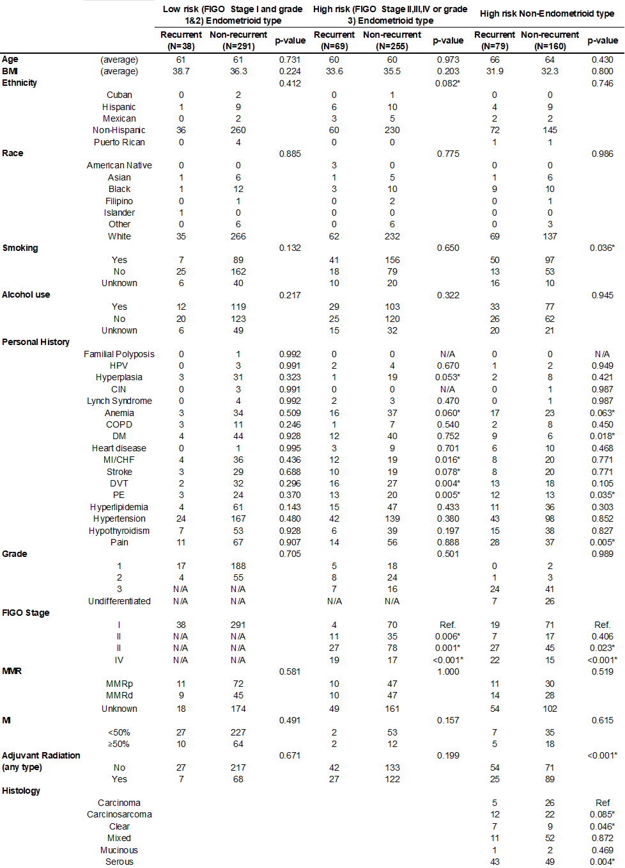

Supplementary Table 2: Validation and testing of best prediction models. Validation of best models of endometrial cancer recurrence based on risk classification. The initial model was built with a lasso regression in an R environment (left side of the table). Validation and testing were performed in two analytical platforms (right side of the table): MATLAB (machine learning - ML) and TensorFlow (deep learning - DL). The upper part of the table has patients with low-risk endometrioid EC: two of the best models include clinical data and CNVs. The only resulting variable for clinical data is BMI, other variables are not informative for recurrence in this risk group.
The middle part of the table has patients with high-risk endometrioid EC: three of the five best performing models include pseudogene expression.
The lower part of the table has patients with non-endometrioid EC: pseudogene expression and SNV were over-represented in best performance models.
mRNA: gene expression; LNC: long non-coding RNA expression, MIR: microRNA expression; ISO: gene isoform expression: PSE: Pseudogenes expression; FUS: fusion transcripts expression; SNV: single nucleotide variation; CNV: gene copy number by gene.

Supplementary Table 3. List of social and environmental determinants of health variables entered for bipartite network analysis.

Category | Data Source | Variable (in code book) | Definition | Year
Environmental | EJI | RPL_EBM_DOM1 | Percentile rank of domain consisting of ozone, PM2.5, air toxics cancer risk, and diesel particulate matter. | 2022
 | EJI | RPL_EBM_DOM2 | Percentile rank of domain consisting of proximity to national priority list sites, proximity to release inventory sites, proximity to treatment, storage, and disposal sites, proximity to risk management plan sites, proximity to coal mines, and proximity to lead mines | 2022
 | EJI | RPL_EBM_DOM3 | Percentile rank of domain consisting of proximity to recreational parks, houses built pre-1980 (lead exposure), and walkability index | 2022
 | EJI | RPL_EBM_DOM4 | Percentile rank of domain consisting of proximity to high volume roads, proximity to railways, and proximity to airports | 2022
 | EJI | RPL_EBM_DOM5 | Percentile rank of domain consisting of impaired water bodies | 2022
Social | EJI | RPL_SVM_DOM1 | Percentile rank of domain consisting of percentage of individuals who are a racial/ethnic minority | 2022
 | EJI | RPL_SVM_DOM2 | Percentile rank of domain consisting of below 200% poverty, no high school diploma, unemployed, housing tenure, housing cost, no health insurance, and not internet | 2022
 | EJI | RPL_SVM_DOM3 | Percentile rank of domain consisting of English language proficiency, aged 65 or older, aged 17 or younger, and civilian with a disability | 2022
 | EJI | RPL_SVM_DOM4 | Percentile rank of domain consisting of number of mobile homes and housing with group quarters | 2022
Health | EJI | RPL_HVM | Percentile rank of combined tertile flags indicating whether a given census tract experiences a high estimated prevalence of disease or not for chronic diseases including asthma, cancer, high blood pressure, diabetes, and poor mental health. | 2022
Food access | Food Access Research Atlas | LA1and10 | Low access tract at 1 mile for urban areas or 10 miles for rural areas | 2010
Air pollution | CACES | O₃ | Average during May through September of the daily maximum 8-hour moving average for O3 gas throughout the contiguous U.S. derived from models, in parts per billion (ppb). | 2010
 | CACES | CO | Average annual estimates of outdoor concentrations for CO gas throughout the contiguous U.S. derived from models, in parts per million (ppm). | 2010
 | CACES | SO₂ | Average annual estimates of outdoor concentrations for SO₂ gas throughout the contiguous U.S. derived from models, in ppb. | 2010
 | CACES | NO₂ | Average annual estimates of outdoor concentrations for NO₂ gas throughout the contiguous U.S. derived from models, in ppb. | 2010
 | CACES | PM₁₀ | Average annual estimates of outdoor concentrations for PM₁₀ gas throughout the contiguous U.S. derived from models, in ppb. | 2010
 | CACES | PM_{2.5} | Average annual estimates of outdoor concentrations for PM_{2.5} gas throughout the contiguous U.S. derived from models, in ppb. | 2010
Note:
EJI (Environmental Justice Index) sourced from https://www.atsdr.cdc.gov/place-health/php/eji/eji-data-download.html
Food Access Research Atlas sourced from https://www.ers.usda.gov/data-products/food-access-research-atlas/download-the-data
CACES (Center for Air, Climate and Energy Solutions) sourced from https://www.caces.us/data

Supplementary Table 4: TCGA clinical patient characteristics. These are the baseline variables determined at treatment completion and included in the analysis.
BMI: Body mass index; MI: myometrial invasion (present in <50% and >50%).
*Statistically significant with P-value < 0.05.

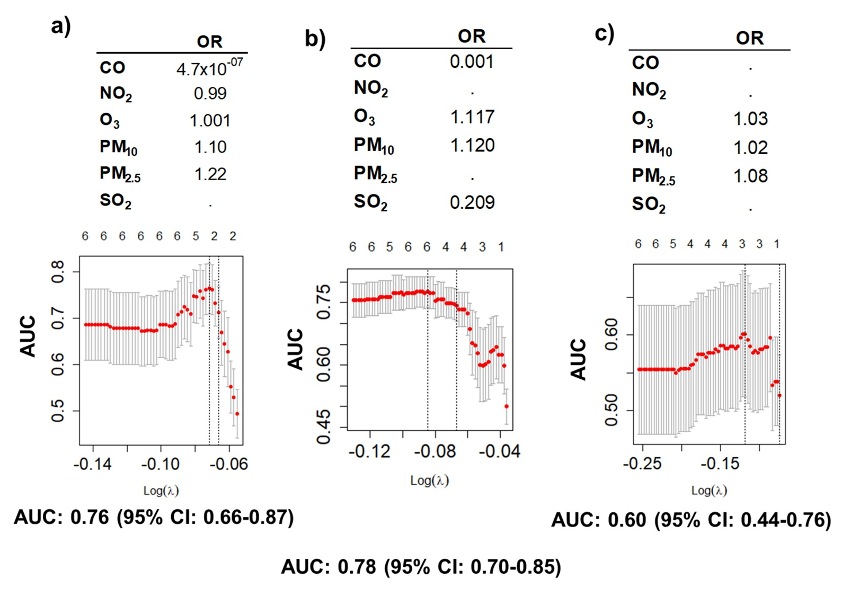

Supplementary Figure 1. Social and environmental determinants of health (SEDH) by county code.
We performed a multivariate lasso regression analysis to identify which SEDHwere associated with EC recurrence. Those selected were integrated in the final analysis including all significant variables.
Upper panels shows tables with odd ratios (OR) of selected air pollutants resulting from the lasso regression analysis for EC recurrence: a) Low risk EC; b) High risk EC; c) Non-endometrioid EC.
Lower panels represent lasso multivariate regression results (glmnet R package): the upper axis represent the number of variables included in the model; the y axis is the performance of the model measured by AUC, with the 95% confidence interval (CI): a) Low risk EC: the best performance of the model is with 6 variables; b) High risk EC: best performance with 6 variables; c) Non-endometrioid EC: best performance with 5 variables. The lower axis is the log of the λ, value used to optimize model construction. We performed 1,000 bootstrap replicates to find the most adequate λ for the model. Underneath each graphic is the performance of the model by the AUC with the 95% CI.
airpollutn_dom1: Percentile rank of domain consisting of ozone, PM_{2.5}, air toxics cancer risk, and diesel particulate matter; proxm_toxic_sites_dom: Percentile rank of the domain consisting of proximity to National Priority List sites, Toxic Release Inventory sites, Treatment, Storage, and Disposal sites, Risk Management Plan sites, coal mines, and lead mines; proxmt_parks_dom3: Percentile rank of domain consisting of proximity to recreational parks, houses built pre- 1980 (lead exposure), and the NWI; built_env_dom4: Percentile rank of the domain consisting of proximity to high volume roads, railways, and airports; impaired_water_dom5: Percentile rank of the domain consisting of impaired water bodies; racial_min_dom1: Percentile rank of domain consisting of the percentage of persons who identify as Hispanic or Latino (of any race); Black and African American, Not Hispanic or Latino; American Indian and Alaska Native, Not Hispanic or Latino; Asian, Not Hispanic or Latino; Native Hawaiian and Other Pacific Islander, Not Hispanic or Latino; Two or More Races, Not Hispanic or Latino; Other Races, Not Hispanic or Latino; poverty_dom2: Percentile rank of the domain consisting of persons below 200% of the federal poverty level, with no high school diploma, unemployed, renters, high housing cost, no health insurance, and no internet; Engprof_disablt_dom3: Percentile rank of the domain consisting of English language proficiency, aged 65 or older, aged 17 or younger, and civilian with a disability; mobile_resdseg_dom4: Percentile rank of the domain consisting of mobile homes and housing with group quarters; hlth_vulnrblt_dom: Percentile ranks of Social Vulnerability Module; low_food_access: Low access tract at 1 mile for urban areas or 10 miles for rural areas.

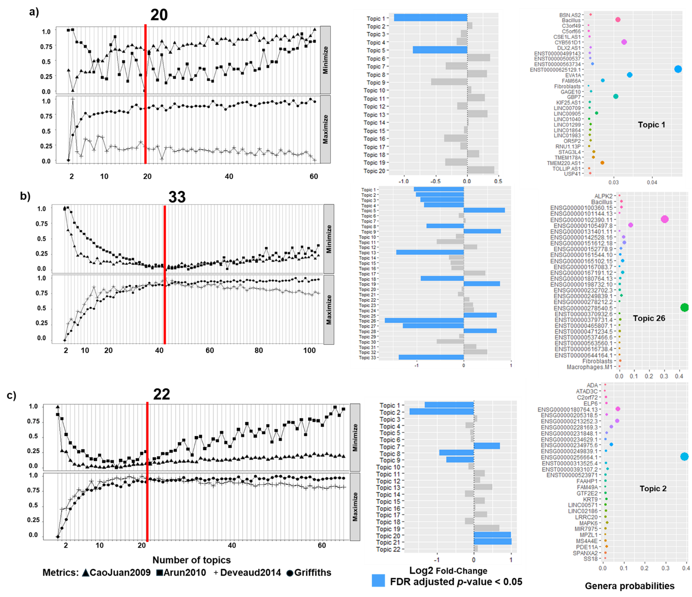
Supplementary Figure 2. Integration of clinical, genome, bacteriome, immunocompetent cells proportions with topic modelling (model Clin+Gen+Imm).
Analysis to identify optimal and significant topics in EC (left panels): To identify an optimal latent topic number for our model based on 4 different metrics: minimization for Arun2010 and CaoJuan2009, and maximization for Deveaud2014 and Griffiths2004. Optimal topic numbers are represented in left panels: a) Low risk EC; b) High risk EC; c) Non-endometrioid EC.
Selecting topics via Latent Dirichlet Allocation (LDA – Middle and Right panels): To identify differentially abundant topics between recurrent and non-recurrent cohorts (middle panels) we used LDA analyses. Selected in blue are those topics with log2 fold changes and FDR corrected p-values < 0.05: a) Low risk EC, topics 1,5; b) High risk EC, topics 1,2,3,4,5,8,9,13,18,19,25,26,27,28,33; c) Non-endometrioid EC, topics 1,2,7,8,9,20,21.
In the right panel we depict per-topic-species probabilities matrix to examine which genus have the highest probabilities of assignment to this topic/community: a) Low risk EC, topic #1; b) High risk EC, topic #26 (with highest and lowest log2 fold changes); c) Non-endometrioid EC, topic #2.

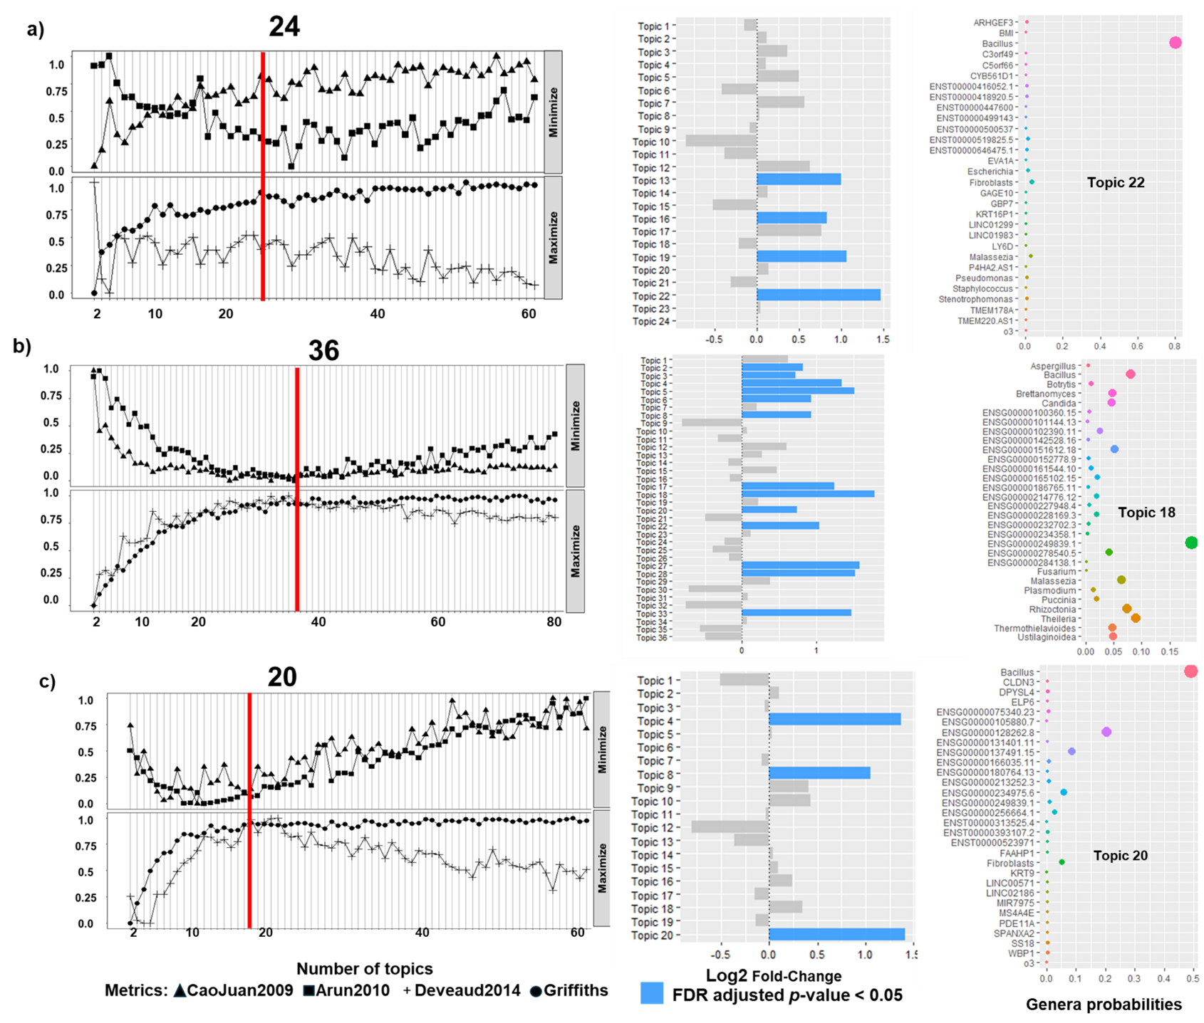

Supplementary Figure 3. Integration of clinical, genome, bacteriome, immunocompetent cells proportions and air pollution with topic models (model Clin+Gen+Imm+Pol).
Analysis to identify an optimal and significant topics in EC (left panels): To identify an optimal latent topic number for our model based on 4 different metrics: minimization for Arun2010 and CaoJuan2009, and maximization for Deveaud2014 and Griffiths2004. Optimal topic numbers are represented in left panels: a) Low risk EC; b) High risk EC; c) Non-endometrioid EC.
Selecting topics via Latent Dirichlet Allocation (LDA – Middle and Right panels): To identify differentially abundant topics between recurrent and non-recurrent cohorts (middle panels) we used LDA analyses. Selected in blue are those topics with log2 fold changes and FDR corrected p-values < 0.05: a) Low risk EC, topics 13,16,19,22; b) High risk EC, topics 2,3,4,5,6,8,17,18,20,22,27,28,33; c) Non-endometrioid EC, topic 4,8,20.
In the right panel we depict per-topic-species probabilities matrix to examine which specie have the highest probabilities of assignment to this topic/community: a) Low risk EC, topic #22; b) High risk EC, topic #18 (with highest and lowest log2 fold changes); c) Non-endometrioid EC, topic #20.
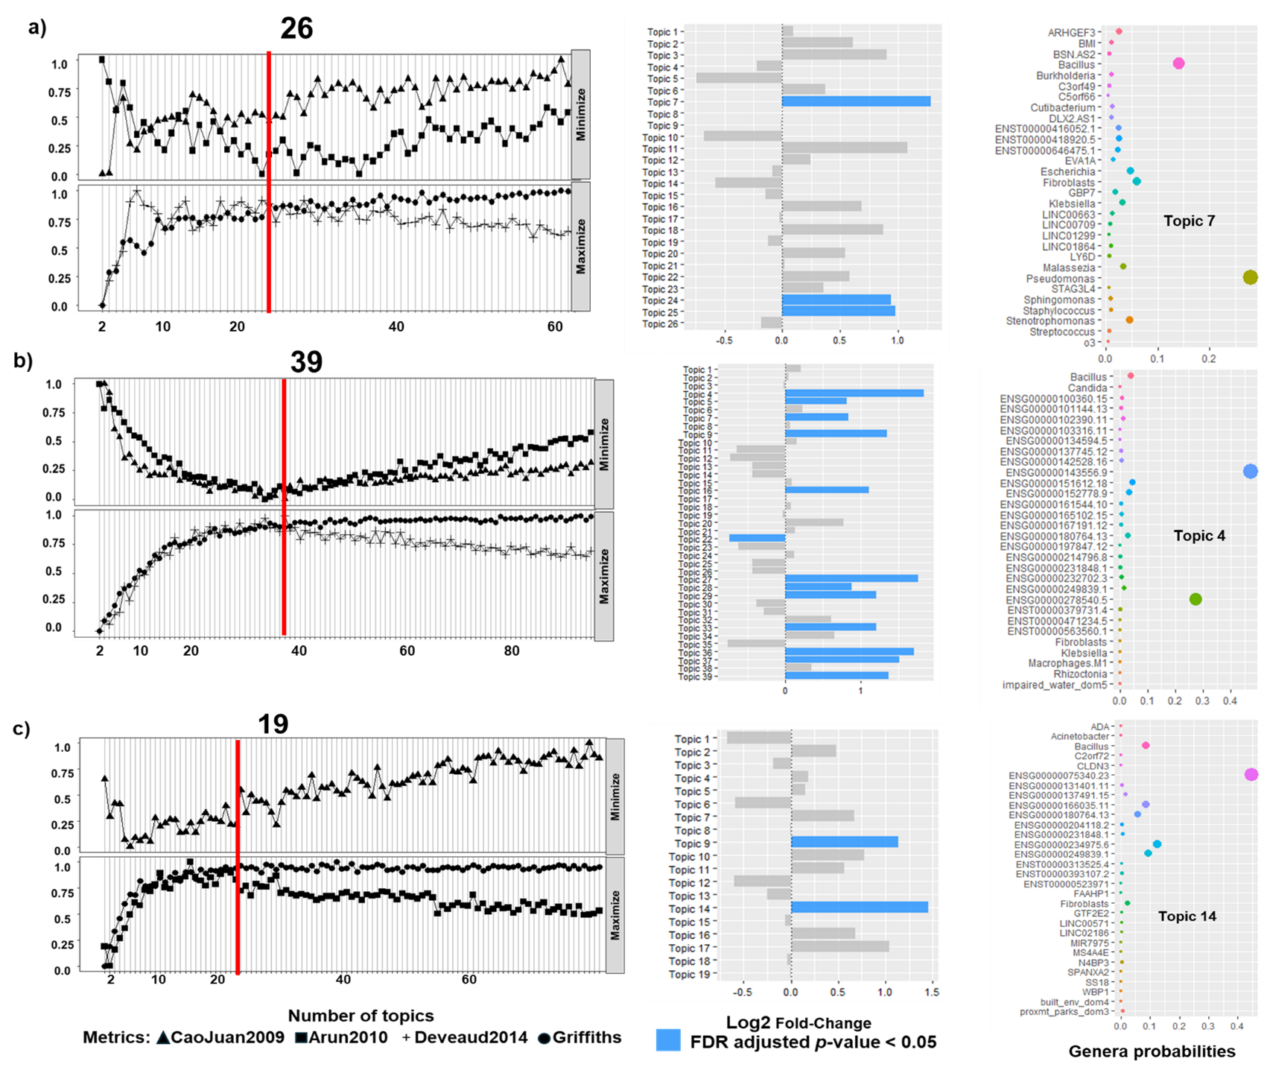
Supplementary Figure 4. Integration of clinical, genome, bacteriome, immunocompetent cells proportions and all environmental data with topic modelling (model Clin+Gen+Imm+Env).
Analysis to identify an optimal and significant topics in EC (left panels): To identify an optimal latent topic number for our model based on 4 different metrics: minimization for Arun2010 and CaoJuan2009, and maximization for Deveaud2014 and Griffiths2004. Optimal topic numbers are represented in left panels: a) Low risk EC; b) High risk EC; c) Non-endometrioid EC.
Selecting topics via Latent Dirichlet Allocation (LDA – Middle and Right panels): To identify differentially abundant topics between recurrent and non-recurrent cohorts (middle panels) we used LDA analyses. Selected in blue are those topics with log2 fold changes and FDR corrected p-values < 0.05: a) Low risk EC, topics 7,24,25; b) High risk EC, topics 4,5,7,9,16,22,27,28,29,33,36,37,39; c) Non-endometrioid EC, topic 9,14.
In the right panel we depict per-topic-species probabilities matrix to examine which specie have the highest probabilities of assignment to this topic/community: a) Low risk EC, topic #7; b) High risk EC, topic #4(with highest and lowest log2 fold changes); c) Non-endometrioid EC, topic #14.

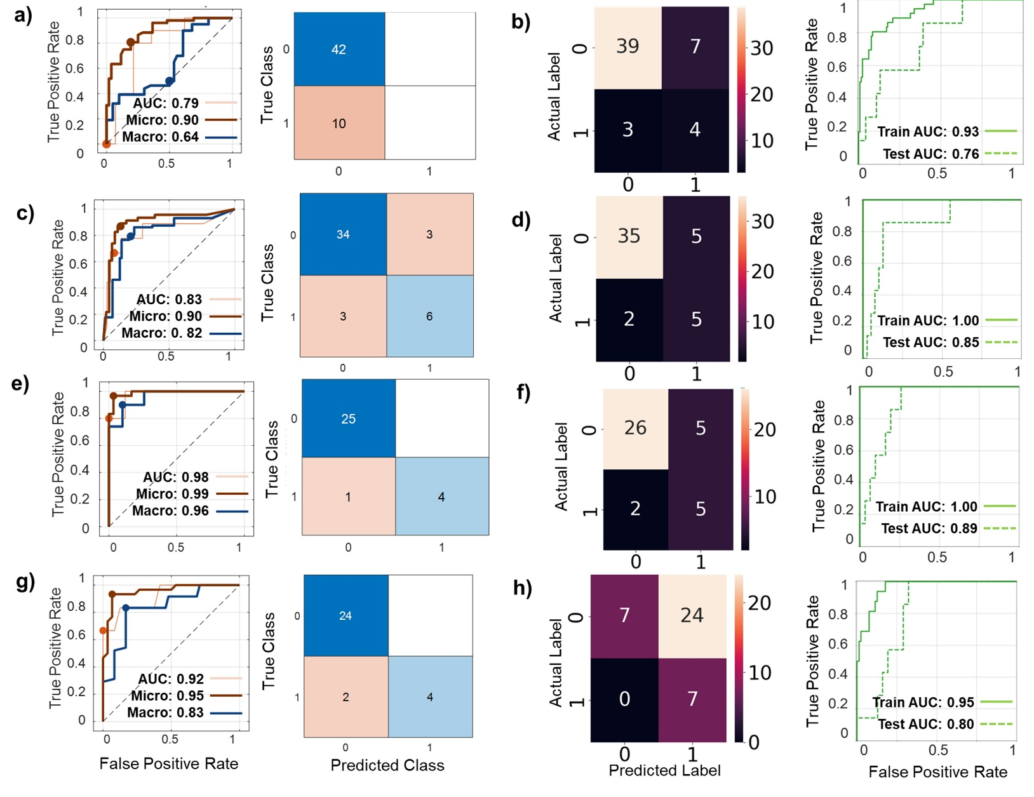

Supplementary Figure 5. Training, validation and testing of prediction models of high-risk EC recurrence using components of significant topics from the LDA analyses done with machine learning (ML - MatLab) and with deep learning (DL - TensorFlow).
a) Training, validation and testing of a high-risk EC recurrence model using MatLab (fine gaussian SVM) and components from the significant topics integrating clinic and microbiome data: the left panel shows the testing ROC curves with AUC, micro-average AUC and macro-average AUC. Micro-average takes imbalance into account in the sense that the resulting performance is based on the proportion of every class; the right panel shows the model testing confusion matrix.
b) Training, validation and testing of a high-risk EC recurrence model using TensorFlow (modified tutorial: Classification on imbalanced data) and components from the significant topics integrating clinic and microbiome data: the left panel shows the model testing confusion matrix; the right panel shows training and testing ROC curves with AUC.
c) Training, validation and testing of a high-risk EC recurrence model using MatLab (medium neural network) and components from the significant topics integrating clinic, microbiome, genomic and cell immunocompetent infiltration data: the left panel shows the testing ROC curves with AUC, micro-average AUC and macro-average AUC; the right panel shows the model testing confusion matrix.
d) Training, validation and testing of a high-risk EC recurrence model using TensorFlow and components from the significant topics integrating clinic, microbiome, genomic and cell immunocompetent infiltration data: the left panel shows the model testing confusion matrix; the right panel shows training and testing ROC curves with AUC.
e) Training, validation and testing of a high-risk EC recurrence model using MatLab (quadratic SVM) and components from the significant topics integrating clinic, microbiome, genomic, cell immunocompetent infiltration, and air pollution data: the left panel shows the testing ROC curves with AUC, micro-average AUC and macro-average AUC; the right panel shows the model testing confusion matrix.
f) Training, validation and testing of a high-risk EC recurrence model using TensorFlow and components from the significant topics integrating clinic, microbiome, genomic, cell immunocompetent infiltration, and air pollution data: the left panel shows the model testing confusion matrix; the right panel shows training and testing ROC curves with AUC.
g) Training, validation and testing of a high-risk EC recurrence model using MatLab (ensemble) and components from the significant topics integrating clinic, microbiome, genomic, cell immunocompetent infiltration, and all social and environmental determinants of health data: the left panel shows the testing ROC curves with AUC, micro-average AUC and macro-average AUC; the right panel shows the model testing confusion matrix.
h) Training, validation and testing of a high-risk EC recurrence model using TensorFlow and components from the significant topics integrating clinic, microbiome, genomic, cell immunocompetent infiltration, and all environmental data: the left panel shows the model testing confusion matrix; the right panel shows training and testing ROC curves with AUC.

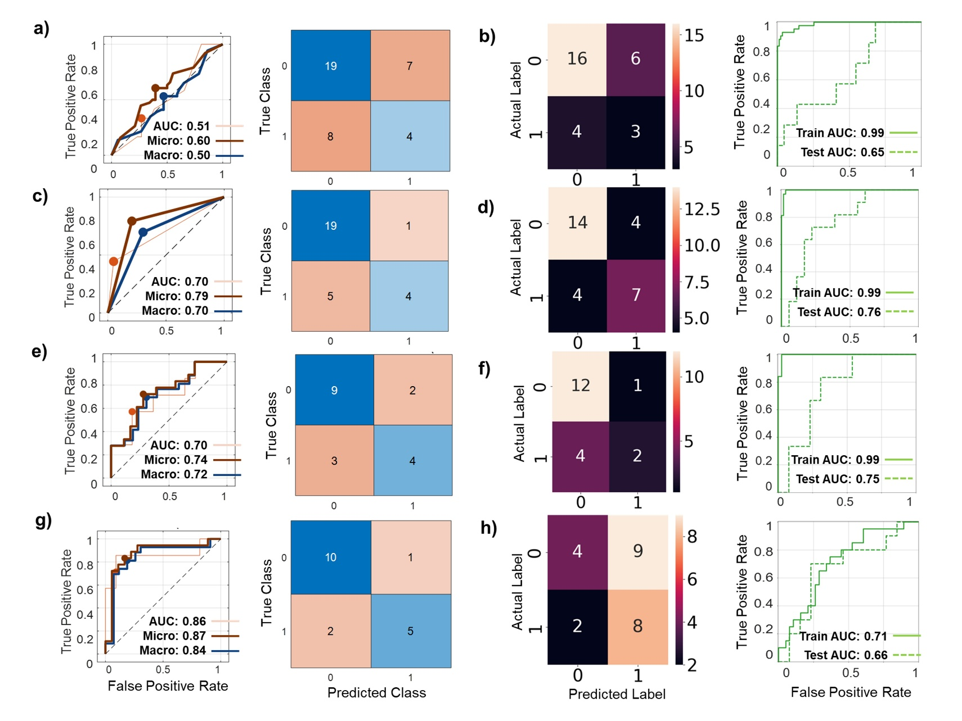

Supplementary Figure 6. Training, validation and testing of prediction models of non-endometrioid EC recurrence using components of significant topics from the LDA analyses done with machine learning (ML - MatLab) and with deep learning (DL - TensorFlow).
a) Training, validation and testing of a non-endometrioid EC recurrence model using MatLab (fine tree) and components from the significant topics integrating clinic and microbiome data: the left panel shows the testing ROC curves with AUC, micro-average AUC and macro-average AUC. Micro-average takes imbalance into account in the sense that the resulting performance is based on the proportion of every class; the right panel shows the model testing confusion matrix.
b) Training, validation and testing of a non-endometrioid EC recurrence model using TensorFlow and components from the significant topics integrating clinic and microbiome data: the left panel shows the model testing confusion matrix; the right panel shows training and testing ROC curves with AUC.
c) Training, validation and testing of a non-endometrioid EC recurrence model using MatLab (fine KNN) and components from the significant topics integrating clinic, microbiome, genomic and cell immunocompetent infiltration data: the left panel shows the testing ROC curves with AUC, micro-average AUC and macro-average AUC; the right panel shows the model testing confusion matrix.
d) Training, validation and testing of a non-endometrioid EC recurrence model using TensorFlow and components from the significant topics integrating clinic, microbiome, genomic and cell immunocompetent infiltration data: the left panel shows the model testing confusion matrix; the right panel shows training and testing ROC curves with AUC.
e) Training, validation and testing of a non-endometrioid EC recurrence model using MatLab (quadratic SVM) and components from the significant topics integrating clinic, microbiome, genomic, cell immunocompetent infiltration, and air pollution data: the left panel shows the testing ROC curves with AUC, micro-average AUC and macro-average AUC; the right panel shows the model testing confusion matrix.
f) Training, validation and testing of a non-endometrioid EC recurrence model using TensorFlow and components from the significant topics integrating clinic, microbiome, genomic, cell immunocompetent infiltration, and air pollution data: the left panel shows the model testing confusion matrix; the right panel shows training and testing ROC curves with AUC.
g) Training, validation and testing of a low-risk EC recurrence model using MatLab (medium neural network) and components from the significant topics integrating clinic, microbiome, genomic, cell immunocompetent infiltration, and all social and environmental determinants of health data: the left panel shows the testing ROC curves with AUC, micro-average AUC and macro-average AUC; the right panel shows the model testing confusion matrix.
h) Training, validation and testing of a low-risk EC recurrence model using TensorFlow and components from the significant topics integrating clinic, microbiome, genomic, cell immunocompetent infiltration, and all environmental data: the left panel shows the model testing confusion matrix; the right panel shows training and testing ROC curves with AUC.

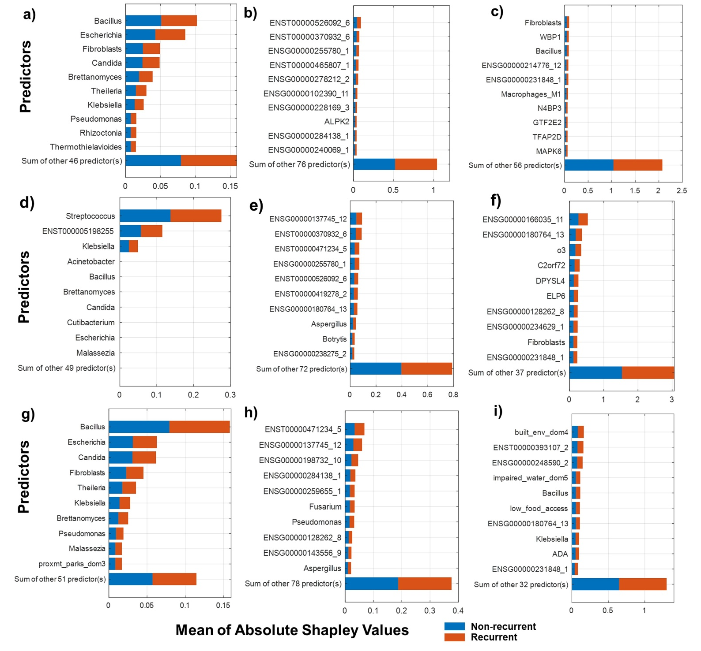

Supplementary Figure 7. Best performing model explanations. We use the Shapley values to interpret which predictors have the largest (or smallest) average impact on EC recurrence prediction model.
a), d), g) Representation of the Shapley values of the predictors with the largest average impact on the resulting model for low-risk EC recurrence: a) including clinic, microbiome, genomic and cell immunocompetent data; d) adding air pollution data; g) adding social and environmental determinants of health data.
b), e), h) Representation of the Shapley values of the predictors with the largest average impact on the resulting model for high-risk EC relapses: b) including clinic, microbiome, genomic and cell immunocompetent data; e) adding air pollution data; h) adding social/environmental data.
c), f), i) Representation of the Shapley values of the predictors with the largest average impact on the resulting model for non-endometrioid EC relapses: c) including clinic, microbiome, genomic and cell immune context data; f) adding air pollution data; i) adding social/environmental data.
As we see in all lower panels, introducing air pollution and environmental determinants of health data modifies the composition of the most impactful predictors for all three risk groups. Blue and orange colors represent the impact for non-recurrent and recurrent status, respectively.
o3 (O₃) Ozone; proxmt_parks_dom3: Proximity old housing (lead exposure)/walkability; built_env_dom4: Proximity to high volume roads, airports; impaired_water_dom5: Proximity to impaired water bodies; low_food_access: Low food access

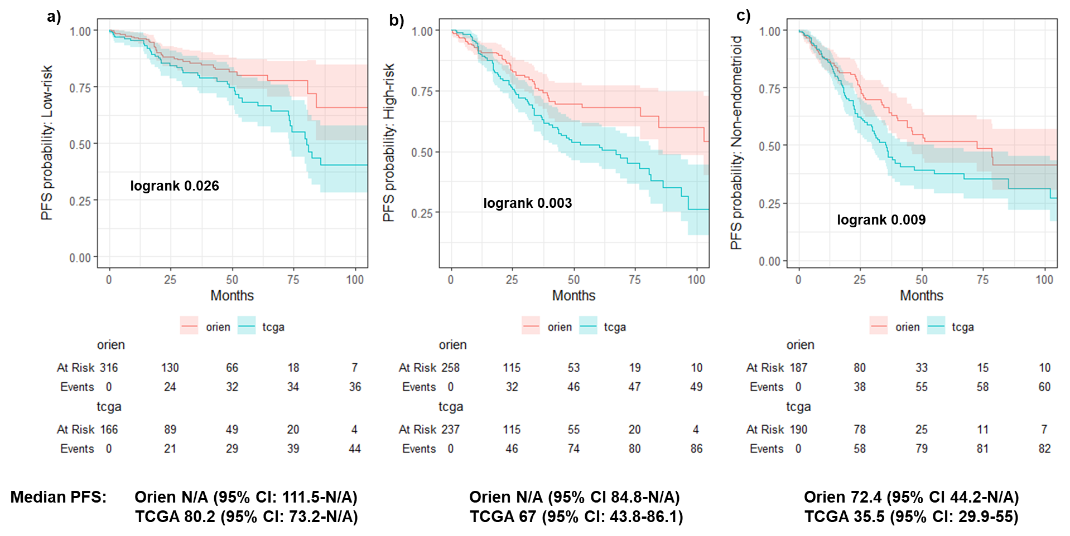

Supplementary Figure 8. Progression-free survival (PFS) for all three risk groups in ORIEN and TCGA datasets. Survival analysis prediction with Cox proportional hazard ratios and Kaplan-Meir survival curves were performed in R with survival and ggsurvfit packages.
a) Representation of PFS survival curves for ORIEN and TCGA low-risk EC datasets. Orange line is ORIEN PFS curve, and the shaded orange area is the 95% CI. Blue is TCGA PFS curve with a shaded orange as the 95% CI. Below is the risk table over time for both groups. At the bottom is the median PFS with 95% CIs, also for both groups.
b) Same for high-risk EC for both groups: on top PFS curves with corresponding 95% CI area (orange for ORIEN and blue for TCGA), below is the risk table for both groups, and at the bottom the median PFS with 95% CIs.
c) Same for non-endometrioid EC for both groups: on top PFS curves with corresponding 95% CI area (orange for ORIEN and blue for TCGA), below is the risk table for both groups, and at the bottom the median PFS with 95% CIs.
Although there were some differences in PFS, all three groups had overlapping 95% CIs survival curves, especially at the beginning of the follow-up (first 2-3 years). Differences in follow-up and case status reporting may explain PFS curve separation at later surveillance.

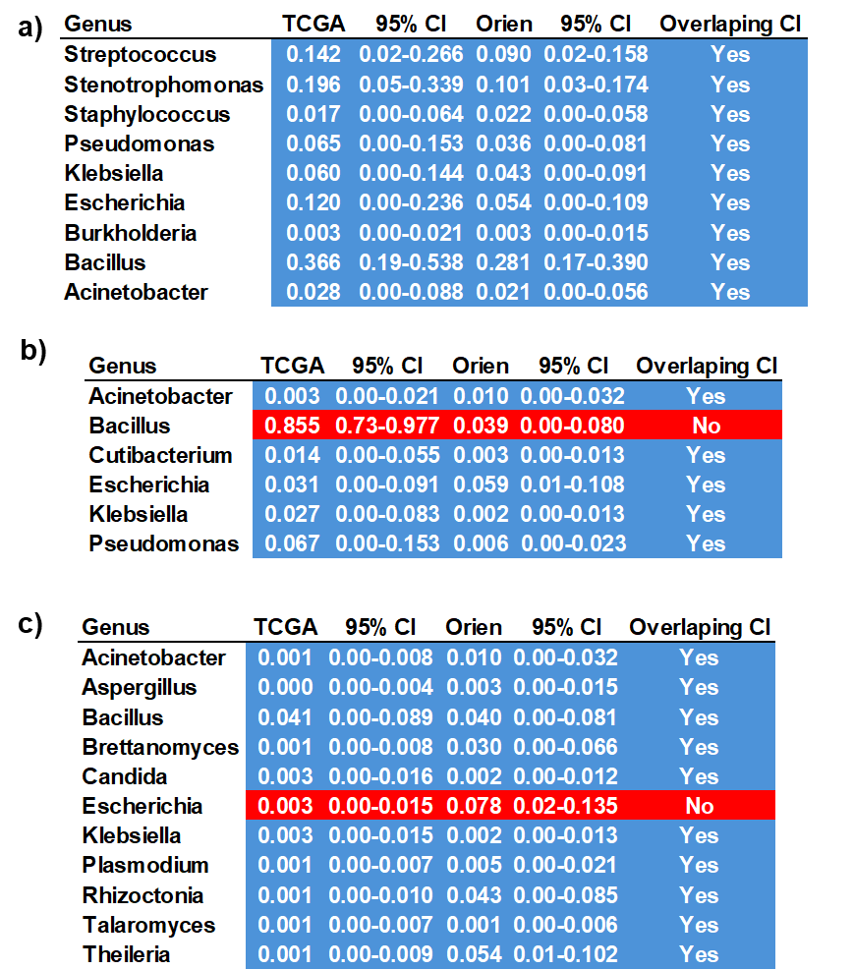

Supplementary Figure 9. Proportions and 95% CI of microbiome components of significant topics for Orien and TCGHA databases.
a) Low risk EC (N=165); b) High risk EC (N=227); c) Non-endometrioid EC (N=192).
The genera that had not overlapping 95% CI proportions between Orien and TCGA databases was Escherichia, for high-risk, and Bacillus for non-endometrioid groups.
CI: Confidence interval

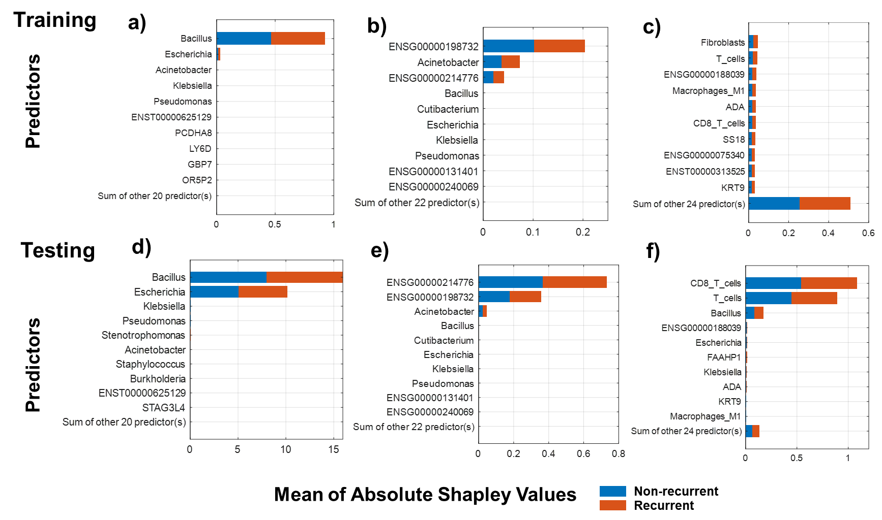

Supplementary Table 10. External validation training and testing model explanation. We use the Shapley values to interpret which predictors have the largest (or smallest) average impact on EC recurrence prediction model.
a) b) and c) Are the representation of the Shapley values for training models in the OREIN dataset for low-risk EC (a), high-risk EC (b), and non-endometrioid EC (c), respectively
d) e) and f) Represent Shapley values for testing model in TCGA dataset for low-risk EC (d), high-risk EC (e), and non-endometrioid EC (f), respectively
In both, low-risk and high-risk testing models the principal contributor to the prediction model (or classifiers) are the same that for the training models: Bacillus and Escherichia for low-risk, and ENSG00000198732 (SMOC1) gene expression, ENSG00000214776 pseudogene expression and Acinetobacter for high-risk EC. For non-endometrioid EC several factors contribute to the model on both training and testing settings: like T Cells, CD8+ T Cells, CNVs in ADA and KRT9 genes, and Bacillus and Escherichia. Blue and orange colors represent the impact for non-recurrent and recurrent status, respectively.

