Heemskerk et al., 2026 Supplemental Figures and Captions.
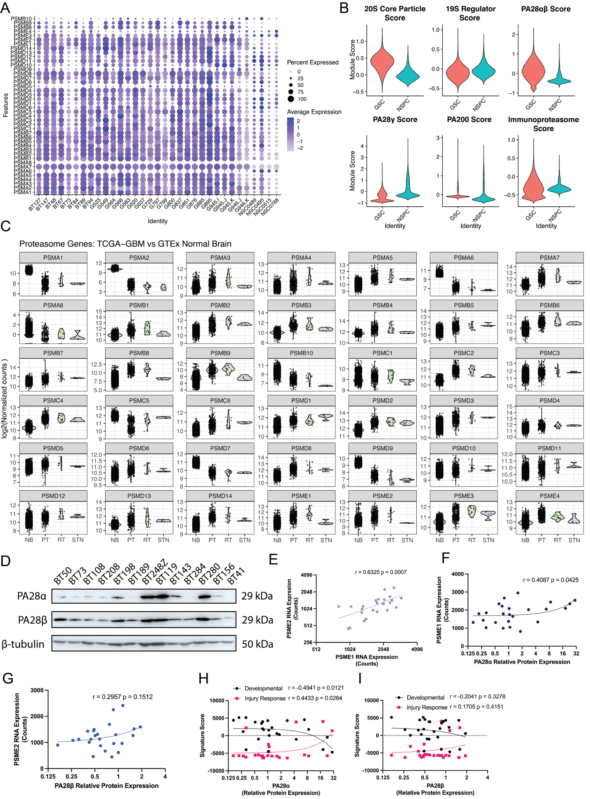
Supplemental Figure 1. Proteasome subunit expression in GSCs.
- Proteasome subunit expression in single-cell RNA-seq data in patient-derived GSC cultures and NSPC isolates (n=29 GSC, n=4 NSPC).
- Proteasome species gene family module scores in single cells from GSCs and NSPC isolates (n=29 GSC, n=4 NSPC)
- Expression of proteasome genes in GBM tumours compared to normal solid tissue and brain tissue (primary GBM (PT): n=372, recurrent GBM (RT): n =14, solid tissue normal (STN): n=5, normal brain (NB) (GTEx): n = 300, 2931 tissues).
- PA28α and β protein levels in additional GSCs (n=13).
- Correlation between PSME1 and PSME2 RNA expression in GSCs (Pearson correlation P = 0.0007; n=25).
- Correlation between PA28α protein levels and PSME1 RNA expression in GSCs (Pearson correlation P = 0.0425; n=25).
- Lack of Correlation between PA28β protein levels and PSME2 RNA expression in GSCs (Pearson correlation P = 0.1512; n=25).
- Correlation between PA28α protein levels and Developmental and Injury Response signatures in GSCs (Developmental: Pearson correlation P = 0.0121, Injury Response: Pearson correlation P = 0.0264; n=25).
- Lack of correlation between PA28β protein levels and Developmental and Injury Response signatures in GSCs (Developmental: Pearson correlation P = 0.3278, Injury Response: Pearson correlation P = 0.4151; n=25).
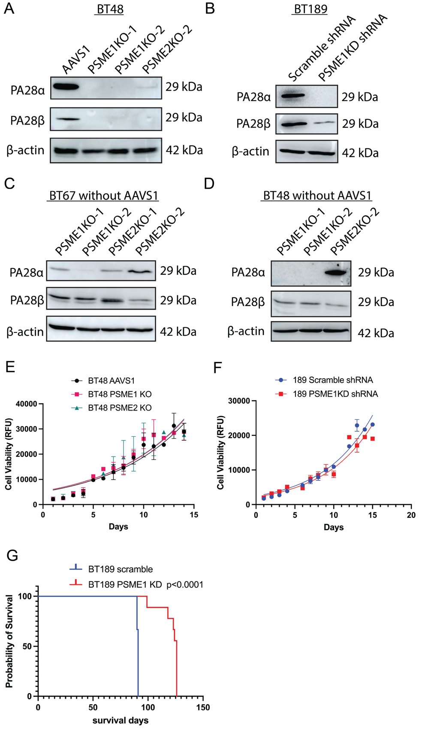
Supplemental Figure 2. PA28αβ KO/KD and growth analysis in additional GSCs.
- PA28αβ protein levels in BT48 CRISPR/Cas9 KOs with two guide RNAs for PSME1 and one guide RNA for PSME2 (Representative of n=3).
- PA28αβ protein levels in BT189 PSME1KD shRNA compared to scramble controls (Representative of n=3).
- PA28αβ protein levels in BT67 CRISPR/Cas9 KOs with two guide RNAs for PSME1 and PSME2 resolved and developed without AAVS1 controls (Representative of n=2).
- PA28αβ protein levels in BT48 CRISPR/Cas9 KOs with two guide RNAs for PSME1 and one guide RNA for PSME2 resolved and developed without AAVS1 controls (Representative of n=2).
- Growth curves of BT48 PA28αβ KOs (PSME1 guide RNA 1 and PSME2 guide RNA 2) and AAVS1 controls (n=3; bars indicate mean +/- SEM).
- Growth curves of BT189 PA28αβ KDs and scramble shRNA controls (n=3; bars indicate mean +/- SEM).
- Kaplan–Meier survival curve of mice orthotopically xenografted BT189 PSME1 KD GSCs compared to scramble controls (n=9 mice per group; Log-rank test; P<0.0001).
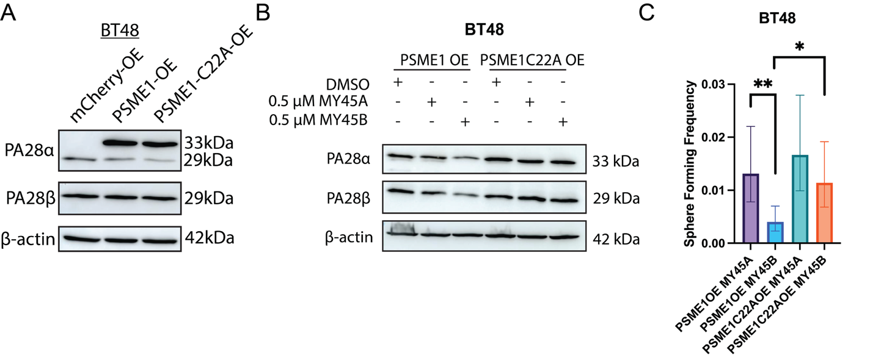
Supplemental Figure 3. Small molecule targeting of PA28αβ reduces sphere formation in an additional GSC line.
- PA28αβ expression in FLAG-PSME1 and FLAG-PSME1-C22A transduced BT48 compared to mCherry controls (representative of n=3).
- PA28αβ expression in MY45A (negative probe control) and MY45B treated FLAG-PSME1-OE and FLAG-PSME1-C22A-OE BT48 (representative of n=2).
- Sphere-forming frequency of PSME1-OE and FLAG-PSME1-C22A-OE BT48 treated with MY45A (0.5 μM) or MY45B (0.5 μM) (6 limiting dilutions per condition; bars indicate estimate of sphere-forming frequency +/- upper and lower limits; χ²; *P<0.05, **P<0.01).

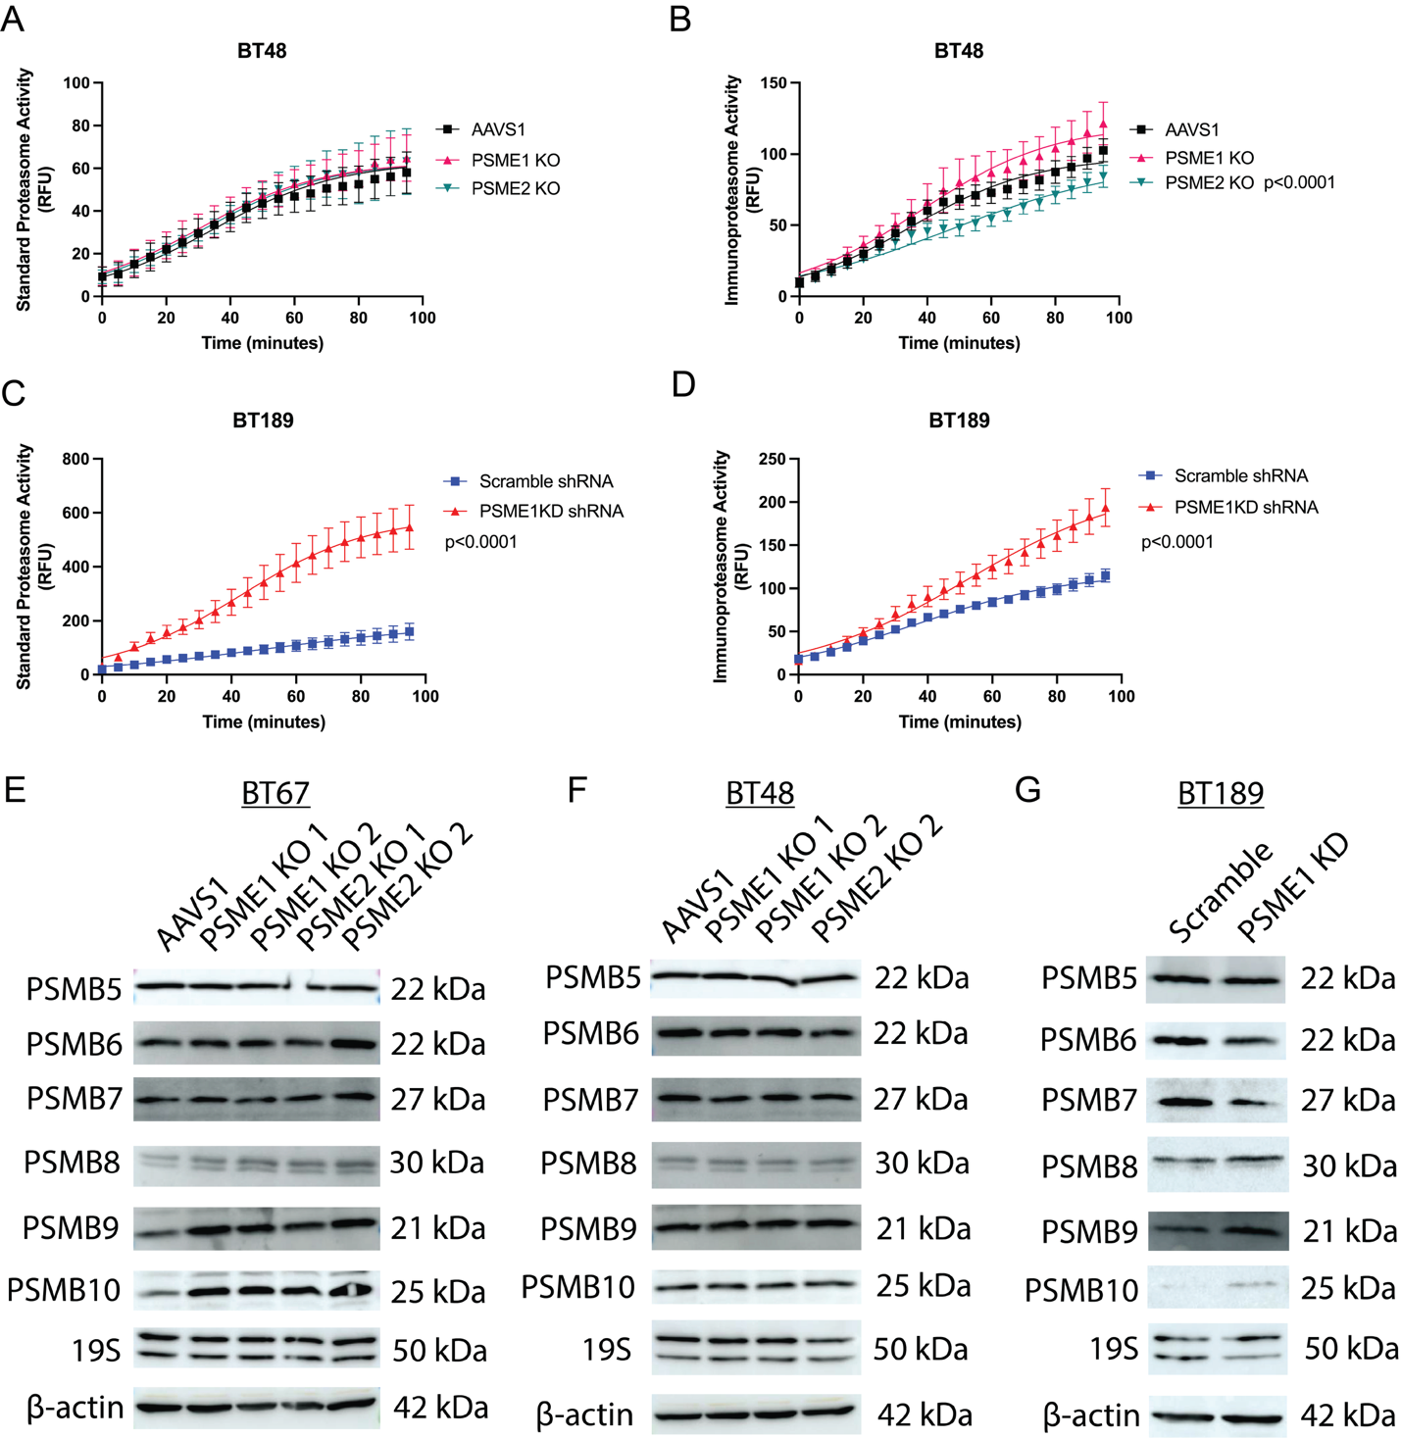
Supplemental Figure 4. Proteasome activity and proteasome subunit expression in PA28αβ genetically targeted GSCs.
- Standard 20S core particle proteasome activity measured over time in BT48 PSME1 KO and PSME2 KO GSCs (n=3; bars indicate mean +/- SEM; Extra sum-of-squares F-test; logistic growth model).
- Immunoproteasome core particle proteasome activity measured over time in BT48 PSME1 KO and PSME2 KO GSCs (n=3; bars indicate mean +/- SEM; Extra sum-of-squares F-test; logistic growth model).
- Standard 20S core particle proteasome activity measured over time in BT189 PSME1 KD GSCs (n=3; bars indicate mean +/- SEM; Extra sum-of-squares F-test; logistic growth model).
- Immunoproteasome core particle proteasome activity measured over time in BT189 PSME1 KD GSCs (n=3; bars indicate mean +/- SEM; Extra sum-of-squares F-test; logistic growth model).
- Protein levels of proteasome subunits in BT67 PSME1 KOs and PSME2 KOs compared to AAVS1 controls (representative of n=2).
- Protein levels of proteasome subunits in BT48 PSME1 KOs and PSME2 KOs compared to AAVS1 controls (representative of n=2).
- Protein levels of proteasome subunits in BT189 PSME1 KDs compared to scramble controls (representative of n=2).
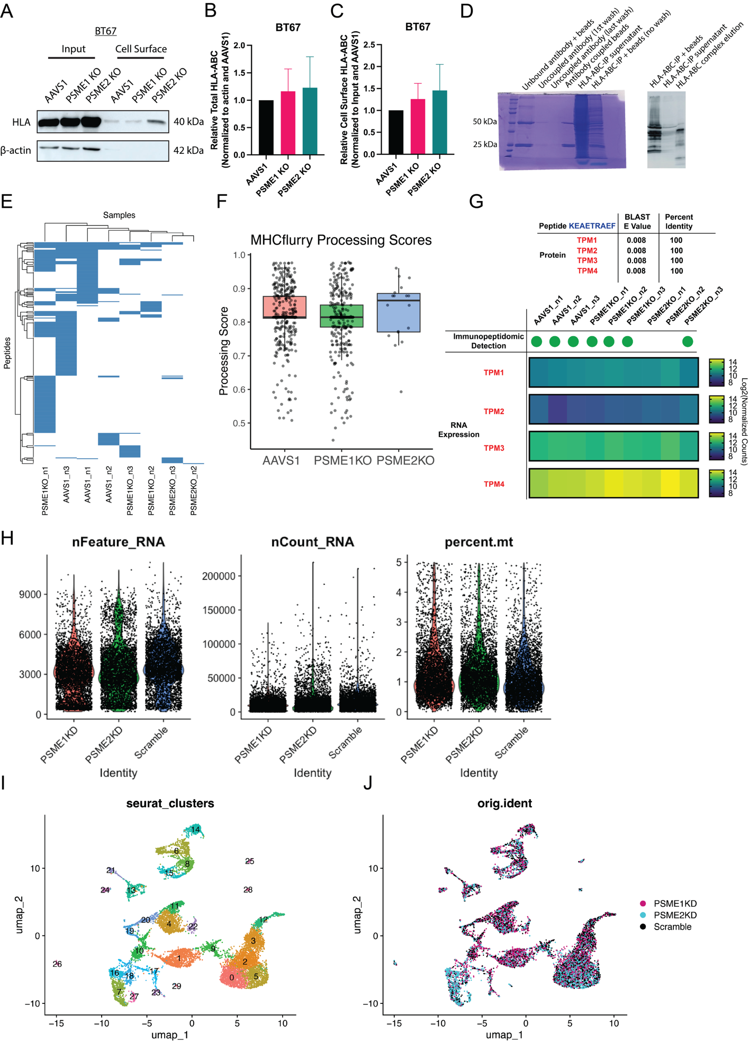
Supplemental Figure 5. Supporting data for immunopeptidomics and GL261 single-cell RNA-seq.
- Total and cell surface expression of HLA class I ABC in BT67 PSME1 KOs and PSME2 KOs compared to AAVS1 controls (representative of n=3).
- Relative levels of total HLA-ABC in BT67 PSME1 KOs and PSME2 KOs compared to AAVS1 controls (n=3).
- Relative levels of cell surface HLA-ABC in BT67 PSME1 KOs and PSME2 KOs compared to AAVS1 controls (n=3).
- Coomassie blue-stained gel and immunoblot of W6/32 HLA class I ABC antibody coupling to beads and HLA complex elution from antibody-coupled beads for quality control test before immunopeptidomics (n=1).
- Peptides identified from MHC (HLA) class I ABC immunopeptide elution in AAVS1, PSME1 KO, and PSME2 KO BT67 (n=3 per condition; peptide q<0.05 cutoff, MHC class I presentation prediction top 5th percentile cutoff). No peptides passed the cutoffs in PSME2KO_n1.
- MHCFlurry peptide processing scores for peptides passing cutoffs in immunopeptidomic analysis of AAVS1, PSME1 KO, and PSME2 KO BT67 (n=3 per group).
- Peptide KEAETRAEF BLAST E values and percent identity for Tropomyosin gene family members with the peptide’s detection in immunopetidomics and RNA expression of the genes in AAVS1, PSME1 KO and PSME2 KO BT67.
- Quality control metrics of GL261 single-cell RNA-seq post-filtering for mitochondrial RNA < 5% (n=5 pooled mice per condition).
- Dimensionality reduction of single-cell RNA-seq on GL261 Scramble, PSME1KD, and PSME2 KD orthotopic tumours grouped by original Seurat clusters (n=5 mice pooled per condition).
- Dimensionality reduction of single-cell RNA-seq on GL261 Scramble, PSME1KD, and PSME2 KD orthotopic tumours grouped by original identity (n=5 mice pooled per condition).
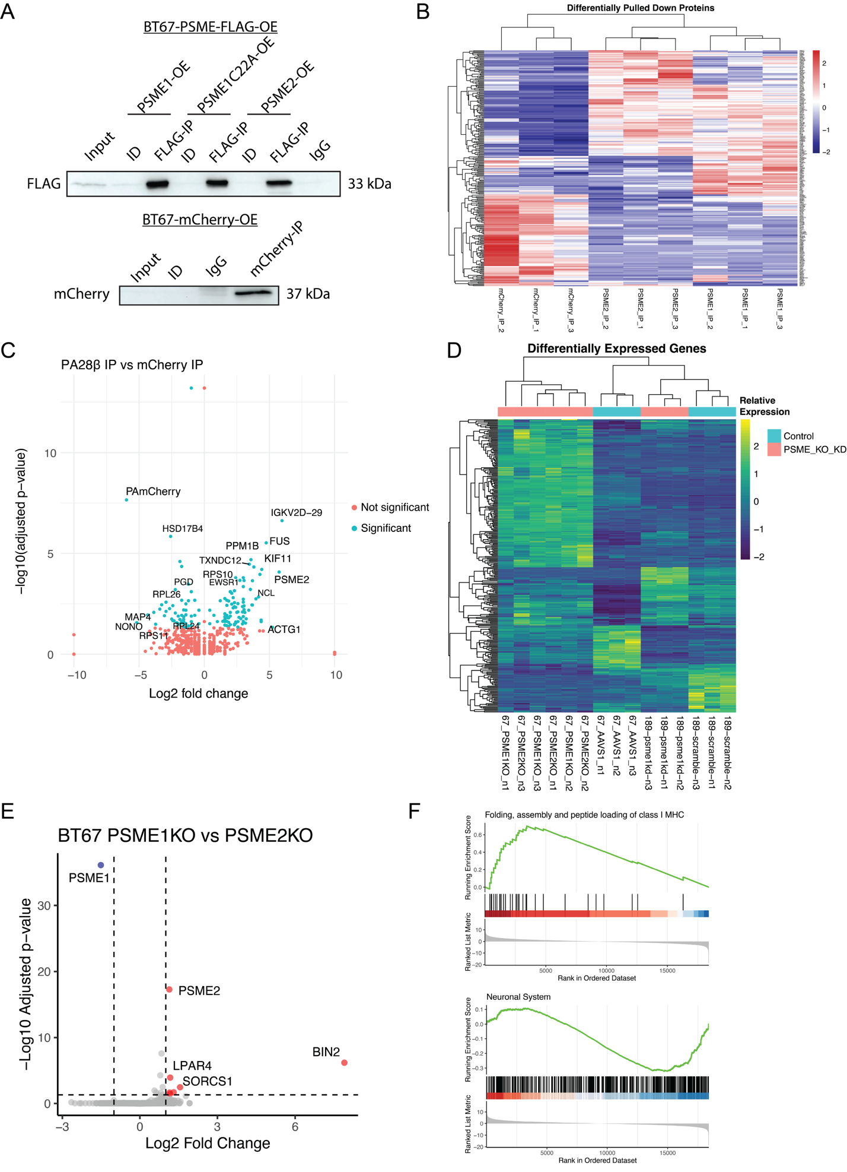
Supplemental Figure 6. Interactome analysis of the PA28αβ complex in BT67 and RNA-seq in PA28αβ KO/KD GSCs.
- Immunoprecipitation of FLAG-tagged PA28α and β subunits, and mCherry in BT67 (representative of n=3).
- Differentially pulled-down proteins with FLAG-tagged PA28α and β subunits, and mCherry in BT67 (n=3 per condition; ANOVA; P<0.05 cutoff).
- Differentially enriched proteins in FLAG-PA28β pull-down compared to mCherry pull-down (top proteins labelled) (n=3 per condition).
- Differentially expressed genes and hierarchical clustering of PA28αβ KO/KD GSC RNA-seq (n=3 per condition; Wald test; Padj<0.05, |Log2FC|>2 cutoff).
- Differentially expressed genes between BT67 PSME1 KO and PSME2 KO (n=3 per condition; Wald test; Padj<0.05, |Log2FC|>1cutoff).
- GSEA pathway enrichment plots of the Folding, assembly and peptide loading of class I MHC pathway (upper) and Neuronal System pathway (lower) in PA28αβ KO/KD GSCs compared to controls (upregulated left, downregulated right) (GSEA Padj=8.828366e-04 for upper; Padj=1.181113e-03 for lower).
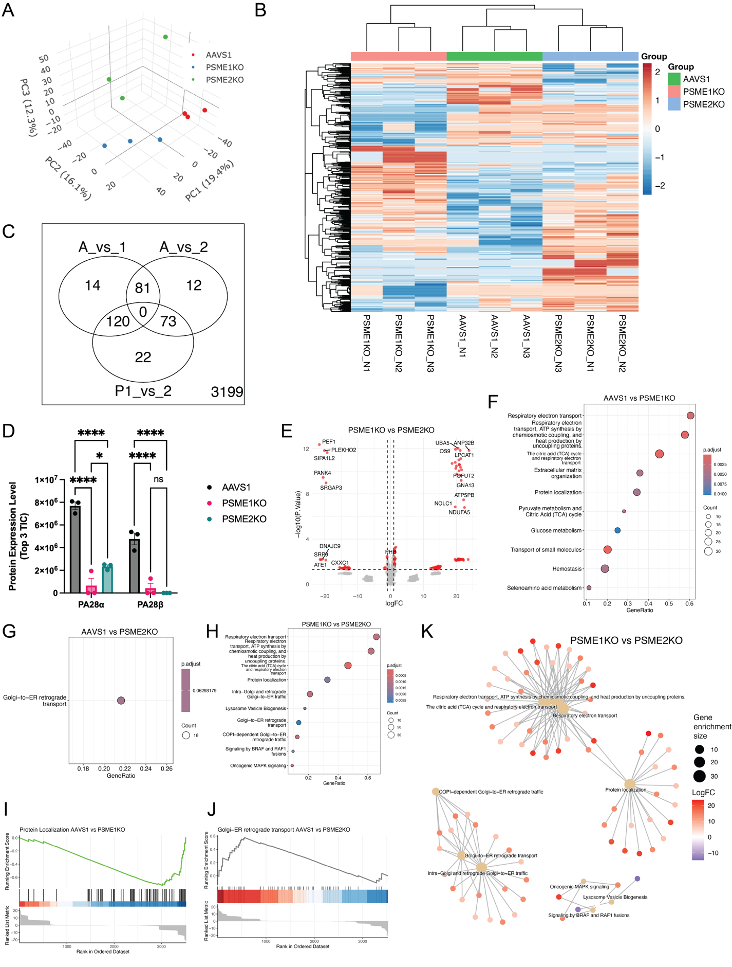

Supplemental Figure 7. Supporting data for BT67αβ KO LFQ proteomics.
- PCA plot of AAVS1, PSME1KO, and PSME2KO BT67 proteomics data (n=3 per condition).
- Heatmap of differentially expressed proteins in AAVS1, PSME1KO, and PSME2KO BT67 (n=3 per condition; limma moderated t-test; P<0.05, |Log2FC|>1 cutoff).
- Venn diagram of differentially expressed proteins in AAVS1, PSME1KO, and PSME2KO BT67 showing unique and overlapping proteins by comparison. A_vs_1 indicates AAVS1 vs PSME1KO; A_vs_2 indicates AAVS1 vs PSME2KO; P1_vs_2 indicates PSME1KO vs PSME2KO (n=3 per condition; limma moderated t-test; P<0.05, |Log2FC|>1 cutoff).
- Expression level of PA28α and PA28β proteins in AAVS1, PSME1KO, and PSME2KO BT67 (n=3; bars represent mean +/- SEM; ANOVA; *P<0.05, **** P<0.0001).
- Differentially expressed proteins in PSME2KO compared to PSME1KO GSCs (n=3 per condition; limma moderated t-test; P<0.05, |Log2FC|>1 cutoff).
- Top altered GSEA pathways from differentially expressed proteins in PSME1KO compared to AAVS1 controls (up- and down-regulated) (GSEA Padj<0.1 cutoff).
- Top altered GSEA pathways from differentially expressed proteins in PSME2KO compared to AAVS1 controls (up- and down-regulated) (GSEA Padj<0.1 cutoff).
- Top altered GSEA pathways from differentially expressed proteins in PSME2KO compared to PSME1KO (up- and down-regulated) (GSEA Padj<0.1 cutoff).
- GSEA pathway enrichment plot of the Protein localization pathway in PSME1KO compared to AAVS1 (GSEA Padj= 5.253096e-3).
- GSEA pathway enrichment plot of the Golgi-ER retrograde transport pathway in PSME2KO compared to AAVS1 (GSEA Padj= 6.293179e-2).
- GSEA enrichment network of differentially enriched pathways and proteins in PSME2KO vs PSME1KO BT67. Large nodes represent pathways and small nodes represent differentially expressed proteins within the pathways (GSEA FDR q<0.1 cutoff).
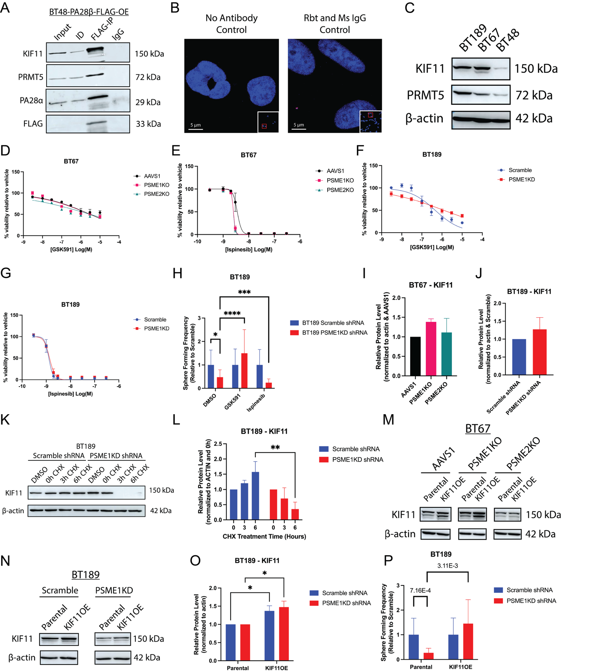
Supplemental Figure 8. Supporting data for PA28αβ interaction with and stabilization of KIF11 in GSCs.
- Immunoprecipitation of FLAG-PA28β and western blotting for KIF11, PRMT5, PA28β, and FLAG in BT48-FLAG- PA28β-OE (representative of n=3).
- PLA no antibody (left) and IgG (right) controls (representative of n=2; 3 ROIs per well).
- Basal KIF11 and PRMT5 protein levels in BT189, BT67, and BT48 (representative of n=2 per GSC line).
- Cell viability of PA28αβ KO and AAVS1 control BT67s in response to increasing doses of GSK591 (n=3; bars represent mean +/- SEM).
- Cell viability of PA28αβ KO and AAVS1 control BT67s in response to increasing doses of Ispinesib (n=3; bars represent mean +/- SEM).
- Cell viability of PSME1-KD and Scramble control BT189 in response to increasing doses of GSK591 (n=3; bars represent mean +/- SEM).
- Cell viability of PSME1KD and Scramble control BT189 in response to increasing doses of Ispinesib (n=3; bars represent mean +/- SEM).
- Sphere-forming frequency of PSME1KD and Scramble control BT189 treated with DMSO, GSK591, or Ispinesib normalized to Scramble control (6 limiting dilutions per condition; bars indicate estimate of sphere-forming frequency +/- upper and lower limits; χ²; *P<0.05, ***P<0.001, ****P<0.0001).
- Basal KIF11 protein levels in PA28αβ KO and AAVS1 control BT67s normalized to AAVS1 (n=3).
- Basal KIF11 protein levels in PSME1KD and Scramble control BT189 normalized to Scramble (n=3).
- KIF11 protein levels in cycloheximide (CHX) treated PSME1KD and Scramble control BT189 (representative of n=3).
- Quantification of KIF11 protein levels in cycloheximide (CHX) treated PSME1KD and Scramble control BT189 (n=3; ANOVA; **P<0.01).
- KIF11 protein levels in KIF11OE PA28αβ KO and AAVS1 control BT67s compared to parental untransduced BT67s (representative of n=3).
- KIF11 protein levels in KIF11OE PSME1KD and Scramble control BT189s compared to parental untransduced BT189s (representative of n=3).
- Quantification of KIF11 protein level in KIF11OE PSME1KD and Scramble control BT189s compared to parental untransduced BT189s (n=3; bars represent mean +/- SEM; ANOVA; *P<0.05).
- Sphere-forming frequency of KIF11OE PSME1KD and Scramble control BT189s and parental untransduced BT189s normalized to Scramble control (6 limiting dilutions per condition; bars indicate estimate of sphere-forming frequency +/- upper and lower limits; χ² P values depicted).
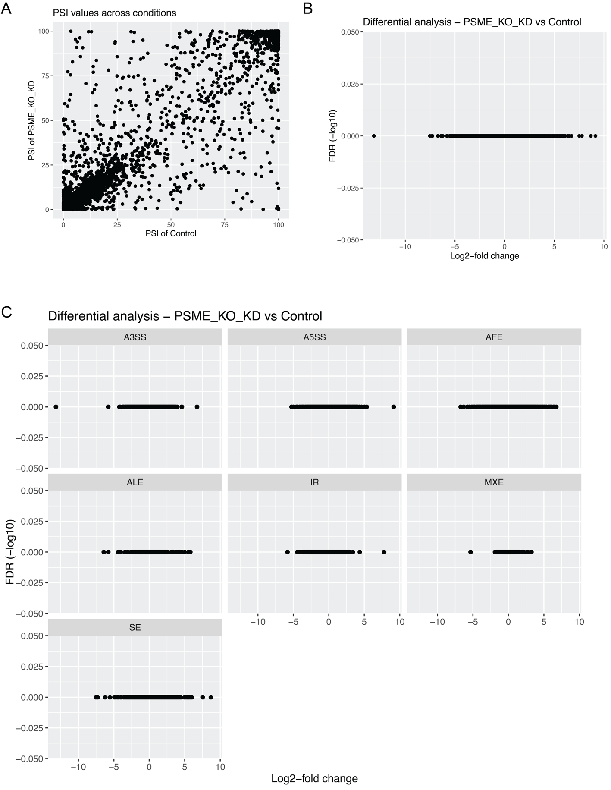

Supplemental Figure 9. Alternative splicing analysis of PA28αβ KO/KD GSC mRNA-seq.
- Percent spliced in (PSI) values in PA28αβ KO/KD GSCs compared to controls (BT67 AAVS1, PSME1KO, and PSME2KO; and BT189 Scramble and PSME1KD shRNA; n=3 per condition).
- Lack of differentially alternatively spliced transcripts in PA28αβ KO/KD GSCs compared to controls (n=3 per condition).
- Lack of differentially spliced transcripts of all forms in PA28αβ KO/KD GSCs compared to controls (A3SS=alternative 3’ splice site; A5SS=alternative 5’ splice site; AFE=alternative first exon; ALE=alternative last exon; IR=intron retention; MXE=mutually exclusive exon; SE=skipped exon) (n=3 per condition).

