Global Hypomethylation in Cell-free DNA Enables Non-invasive Colorectal Cancer Screening: Results from a Retrospective Validation Study

Shahdeep Kaur^{a,#}, Shefali Lathwal^{b,#}, Smita Agrawal^{b}, Tina Mahmoudiª and Shalini Gupta^{a,*}

Supplementary Information

Table S1. The list of public methylation datasets analyzed in this study.
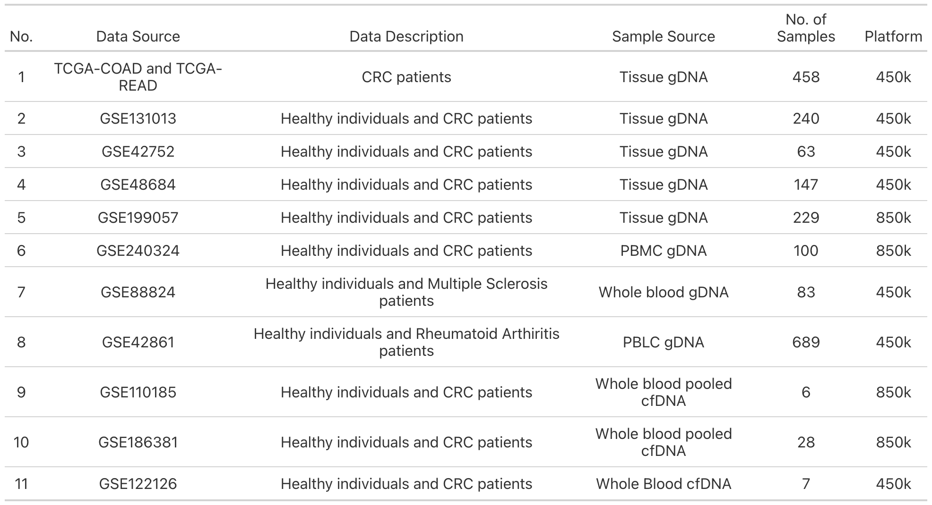

Table S2. Clinical information of CRC patient samples used for cfDNA extraction. Information where not available is left blank.
Sample ID | Cancer stage | Site of primary  cancer | Age  (yrs) | Sex | cfDNA stock conc. measured using Nanodrop (ng/µL) | cfDNA stock conc. measured using Qubit  (ng/µL) | |ΔZ| at 100 kHz  (ohms) | |Δθ| at 100 kHz  (deg)
C1 | III | Colon | 65-69 | F | 2.2 | 0.354 | 19.71 ± 0.71 | 0.02
C2 | IV | Colon | 45-49 | F | 2.5 | 0.434 | 25.95 ± 2.83 | 0.00
C3 | IV | Colon | 65-69 | M | 4.2 | 0.583 | 24.84 ± 2.12 | 0.01
C4 | III | Colon | 70-74 | M | 3.1 | 0.206 | 20.04 ± 7.07 | 0.04
C5 | III | Colon | 50-59 | M | 2.6 | 0.196 | 17.05 ± 2.83 | 0.01
C6 | III | Colon | 60-64 | F | 3.1 | 0.519 | 20.17 ± 0.71 | 0.01
C7 | I | Rectum | 65-69 | M | 2.9 | 0.298 | 22.29 ± 0.00 | 0.00
C9 | II | Colon | 60-64 | M | 2.2 | 0.141 | 15.15 ± 0.00 | 0.01
C10 | II | Colon | 50-54 | F | 2.4 | 0.398 | 24.42 ± 0.00 | 0.02
C11 | IV | Colon | 60-64 | M | 12 | 0.472 | 26.59 ± 0.71 | 0.03
C12 | II | Colon | 65-69 | F | 2.1 | 0.24 | 17.16 | 0
C13 | III | Colon | 50-54 | F | 2.4 | 0.672 | 18.79 | 0
C14 | IV | Colon | 65-69 | M | 2.6 | 1.64 | 28.05 | 0.02
C15 | III | Rectum | 65-69 | M | 2.3 | 0.568 | 37.72 | 0.02
C16 | III | Colon | 50-54 | M | 2.9 | 1.44 | 16.57 | 0.01
C17 | I | Colon | 65-69 | F | 2.7 | 0.688 | 17.91 | 0.01
C18 | III | Rectum | 60-64 | M | 5.7 | 2.18 | 15.59 | 0.04
C19 | II | Colon | 55-59 | F | 2.1 | 0.25 | 15.02 | 0
C20 | I | Colon | 70-74 | F | 3.1 | 0.618 | 37.86 | 0.01
C21 | IV | Colon | 50-54 | F | 2.8 | 1.48 | 10.37 | 0.01
C22 | IV | Colon | 55-59 | M | 3.0 | 0.38 | 15.58 | 0.03
C23 | II | Colon | 55-59 | F | 2.3 | 0.421 | 12.21 | 0.01
C24 | IV | Colon | 75-79 | F | 3.2 | 1.18 | 13.5 | 0.01
C25 | III | Colon | 60-64 | F | 3.3 | 1.36 | 13.7 | 0.03
C26 | II | Colon | 76 | M | 1.3 |  | 7.78 ± 1.07
C27 | IV | Colon | 57 | F | 3.6 |  | 13.39 ± 0.18
C28 | III | Colon | 53 | M | 1.8 |  | 1.72 ± 0.02
C29 | II | Colon | 72 | M | 5.7 |  | 18.23 ± 0.54
C35 | IV | Colon | 55 | F | 36.4 | 21.5 | 12.02 | 0.05
C36 | II | Rectum | 60 | F | 3.3 | 0.509 | 17.15 | 0.02
C37 | I | Colon | 75 | F | 2.3 | 0.389 | 27.19 | 0.02
C38 | IV | Colon | 53 | F | 3.9 | 0.943 | 3.89 | 0.01
C39 | II | Colon | 65 | M | 2.2 | 0.718 | 11.97 | 0.02
C40 | IV | Colon | 75 | M | 2.3 | 0.756 | 23.87 | 0.01
C41 | IV | Colon | 70 | M | 2.5 | 0.626 | 9.14 | 0.01
C42 | IV | Rectum | 65 | M | 2.7 | 0.719 | 17.54 | 0
C43 | II | Colon | 71 | M | 4.4 | 1.55 | 22.22 | 0.04
C44 | I | Rectum | 63 | F | 4.6 | 1.14 | 28.53 | 0.01
C45 | III | Rectum | 57 | M | 6.9 | 2.19 | 15.84 | 0.02
C46 | II | Colon | 47 | F | 4.5 | 1.47 | 12.6 | 0.02
L1 | II | Colon | 54 | F | 4.9 | 0.955 | 23.2 | 0.03
L2 | III | Rectum | 61 | M | 2.7 | 0.484 | 5.8 | 0.04
L3 | II | Colon | 70 | M | 5.7 | 1.13 | 12.36 | 0.02
L4 | I | Rectum | 62 | F | 2.2 | 0.611 | 15.15 | 0.01
L5 | III | Rectum | 73 | M | 4.2 | 0.493 | 14.6 | 0.10
L6 | II | Colon | 59 | M | 8.6 | 5.78 | 13.74 | 0.11

Table S3. Clinical information of healthy individual samples used for cfDNA extraction. Information where not available is left blank.

Sample ID | Age (yrs) | Sex | cfDNA stock conc. measured using Nanodrop (ng/µL) | cfDNA stock conc. measured using Qubit (ng/µL) | |ΔZ| at 100 kHz (ohms) | |Δθ| at 100 kHz (deg)
H1 | 56 | M | 4.6 | 0.144 | 52.5 ± 2.83 | 0.01
H2 | 63 | F | 3.3 | 0.238 | 45.17 ± 0.71 | 0.01
H3 | 68 | F | 4.8 | 0.418 | 30.36 ± 0.71 | 0.02
H4 | 59 | F | 3.8 | 0.336 | 31.62 ± 1.41 | 0.01
H5 | 58 | M | 3.9 | 0.809 | 34.69 ± 0.71 | 0.02
H6 | 54 | F | 3.2 | 0.287 | 32.69 ± 0.22 | 0.05
H7 | 45 | M | 2.9 | 0.223 | 35.99 ± 0.71 | 0.01
H8 | 60 | M | 3.1 | 0.368 | 38.27 ± 0.00 | 0.02
H9 | 57 | M | 3.1 | 0.479 | 46.97 ± 5.66 | 0.01
H11 | 71 | M | 3.6 | 0.362 | 49.85 ± 6.36 | 0.05
H12 | 55 | F | 2.6 | 0.421 | 24.82 ± 0.71 | 0.03
H13 | 54 | F | 3.8 | 0.246 | 41.06 ± 1.41 | 0.08
H14 | 62 | M | 3.4 | 0.481 | 37.47 ± 0.71 | 0.02
H15 | 48 | F | 3.5 | 0.318 | 46.14 ± 2.83 | 0.03
H16 | 60 | F | 1.5 | 0.247 | 29.15 ± 0.00 | 0.03
H17 | 63 | M | 5.2 | 0.497 | 35.41 ± 2.12 | 0.03
H18 | 48 | F | 4.0 | 0.217 | 47.7 ± 5.66 | 0.04
H19 | 51 | F | 4.8 | 0.193 | 58.33 ± 1.41 | 0.04
H20 | 50 | M | 2.9 | 0.387 | 40.53 ± 1.41 | 0.04
H21 | 54 | F | 1.7 | 0.417 | 32.94 ± 1.41 | 0.01
H22 | 57 | M | 2.4 | 0.435 | 43.14 ± 2.83 | 0.03
H23 | 44 | F | 3.0 | 0.297 | 34.81 ± 0.71 | 0.02
H24 | 35 | F | 3.9 | 0.319 | 48.71 ± 0.71 | 0.04
H25 | 50 | F | 1.4 |  | 42.97 ± 0.96
H26 | 47 | M | 1.2 |  | 35.76 ± 1.39
H27 | 77 | M | 2.1 |  | 34.44 ± 1.71
H28 | 55 | F | 3.1 |  | 40.36 ± 0.60
H29 | 75 | F | 2.8 |  | 34.51 ± 0.94
H30 | 62 | F | 4.3 |  | 36.82 ± 0.94
H31 | 66 | F | 3.3 |  | 33.53 ± 0.74
H32 | 68 | M | 2.3 |  | 37.18 ± 1.29
H33 | 57 | M | 2.6 |  | 41.08 ± 0.68
H34 | 53 | M | 5.0 |  | 18.09 ± 0.74

Table S4. Samples with history of cancer.
Patient clinical status | No. of patients with history of cancer | Past cancer type | Asima Rev outcome
Healthy | 0 | N/A | -
CRC stage I | C20 | Leukemia | FN
CRC stage II | 0 | N/A | -
CRC stage III | C1 | Skin | TP
CRC stage IV | C3, C14, C38, C41 | Lung (C3),  CRC (C14, C38, C41) | TP

Table S5. Demographic and clinical characteristics of CRC patients in TCGA.
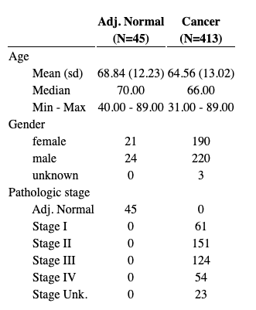

Table S6. Process of analysis of TEM images using ImageJ to calculate cfDNA aggregates in CRC surveillance.
- Open TEM Image in Fiji (ImageJ). | (2) Subtract image background to make image more uniform given varying background fluorescence. | (3) Adjust image threshold to create a binary mask (all values set to either 0 or 1, black or white).
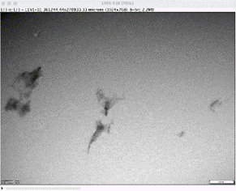 | 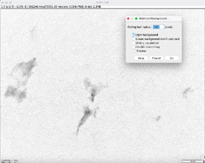 | 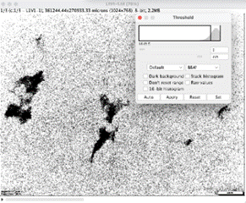
(3) Erode then dilate the binary mask to remove the salt and pepper noise, then enhance the large pixel aggregates. | (4) Get an image histogram to derive the number of pixels at each binary value (0 and 1, black or white). | (5) Derive percentage of black pixels relative to all pixels, representing the percent area of the total image covered by aggregates.
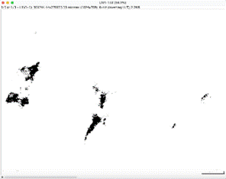 | 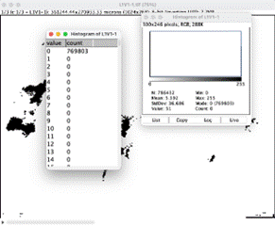
  No. white pixels: 769803
  No. black pixels: 16629
  No. total pixels: 786432
  Percentage black pixels or aggregates: 2.11

Table S7. Number of probes available and used for analysis in each dataset. 125111 OpenSea probes were common across all datasets.

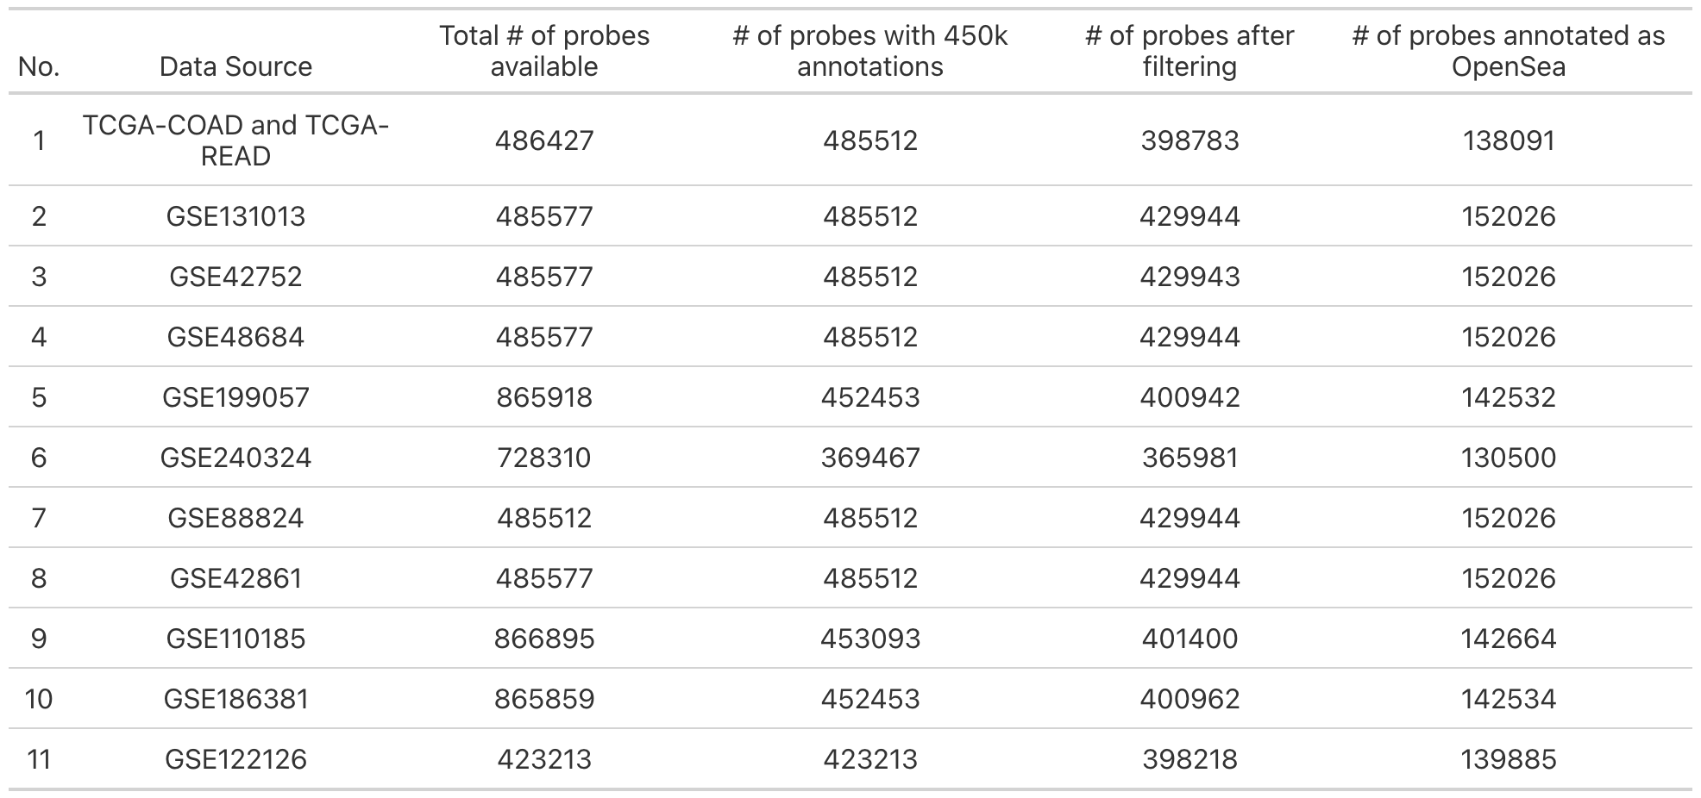

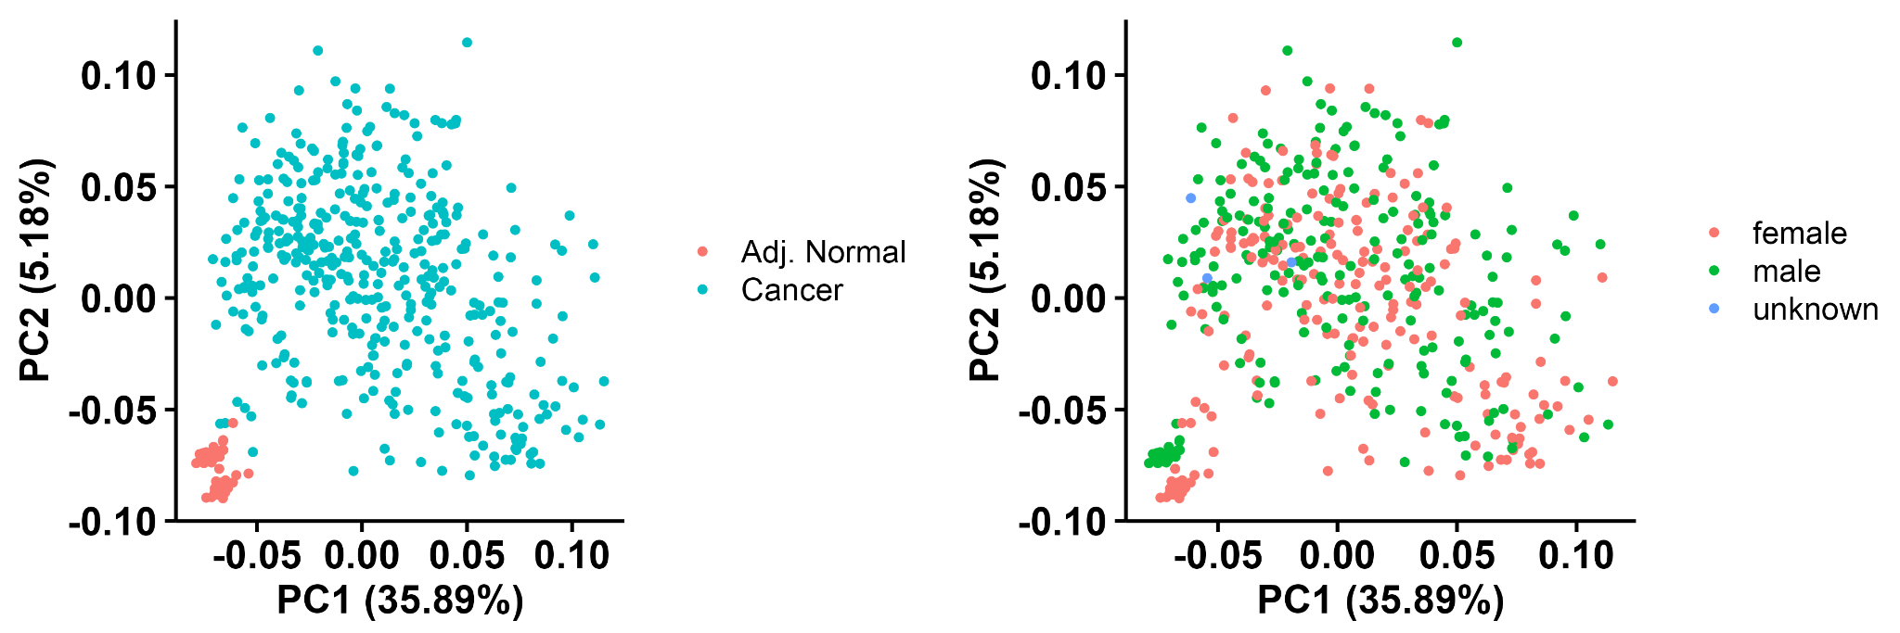

Fig. S1. Principal Components Analysis (PCA) plot of top 1000 most variable probes from 486, 427 total probes in TCGA without any filtering, colored by (a) cancer status and (b) gender.

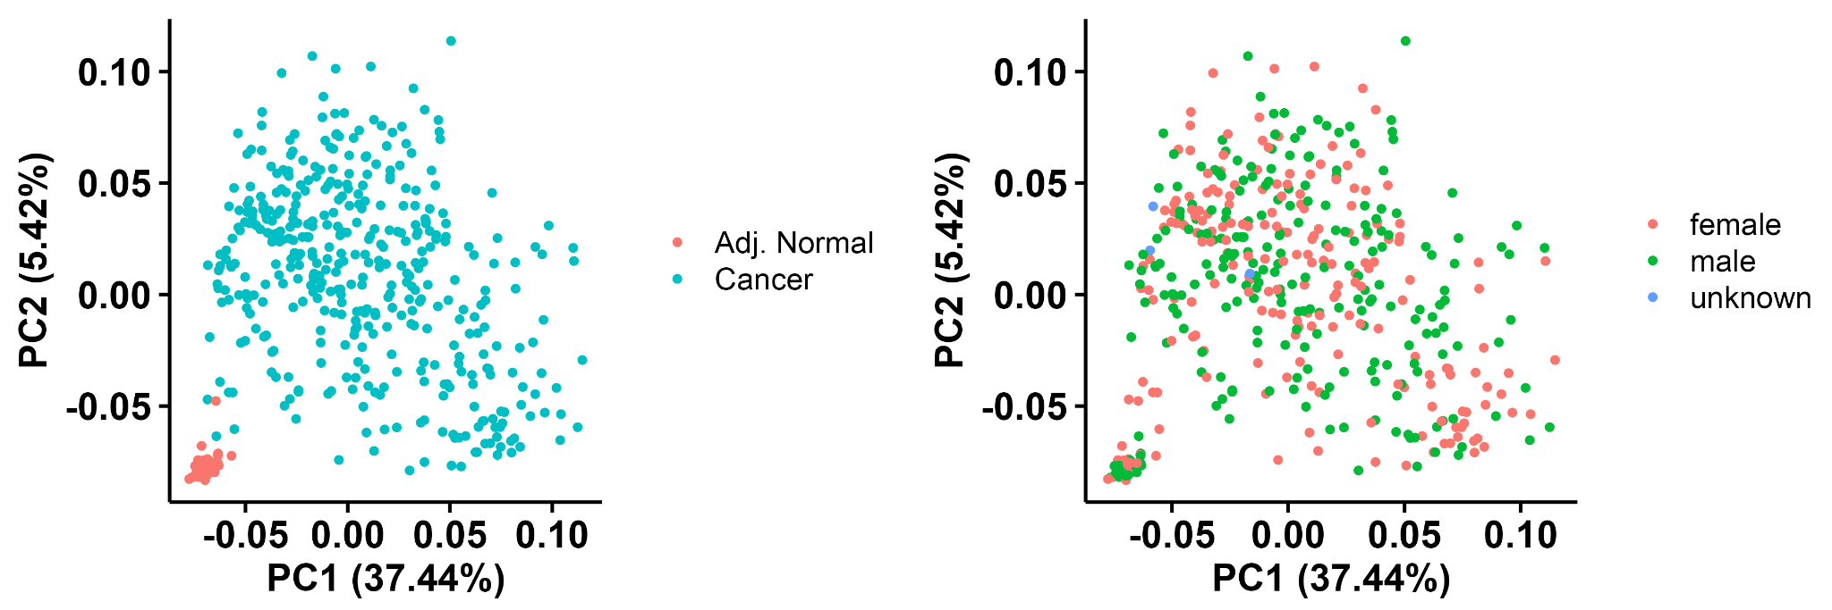
Fig. S2. PCA plot of top 1000 most variable probes from 398,783 total probes in TCGA after filtering, colored by (a) cancer status and (b) gender.

Note S1. A discussion on why filtering of probes is required for Illumina Infinium methylation arrays. Illumina Infinium methylation arrays use 50bp probes to query methylation status at various sites on the genome at a single base resolution. Before performing analysis on these data, it is common practice to filter out probes whose detection p-values are greater than a threshold, probes that occur in commonly known regions with single nucleotide polymorphisms (SNPs) that may affect CpG sites and probes that have shown to be cross-reactive. In addition, the PCA plots without removing probes on X and Y chromosomes showed that adjacent normal tissue samples cluster based on gender (Fig. S1), indicating that gender is a significant source of variation. Removing the probes from X and Y chromosomes led to cancer status being the main source of variance in the data (Fig. S2), enabling us to draw conclusions applicable to all samples.
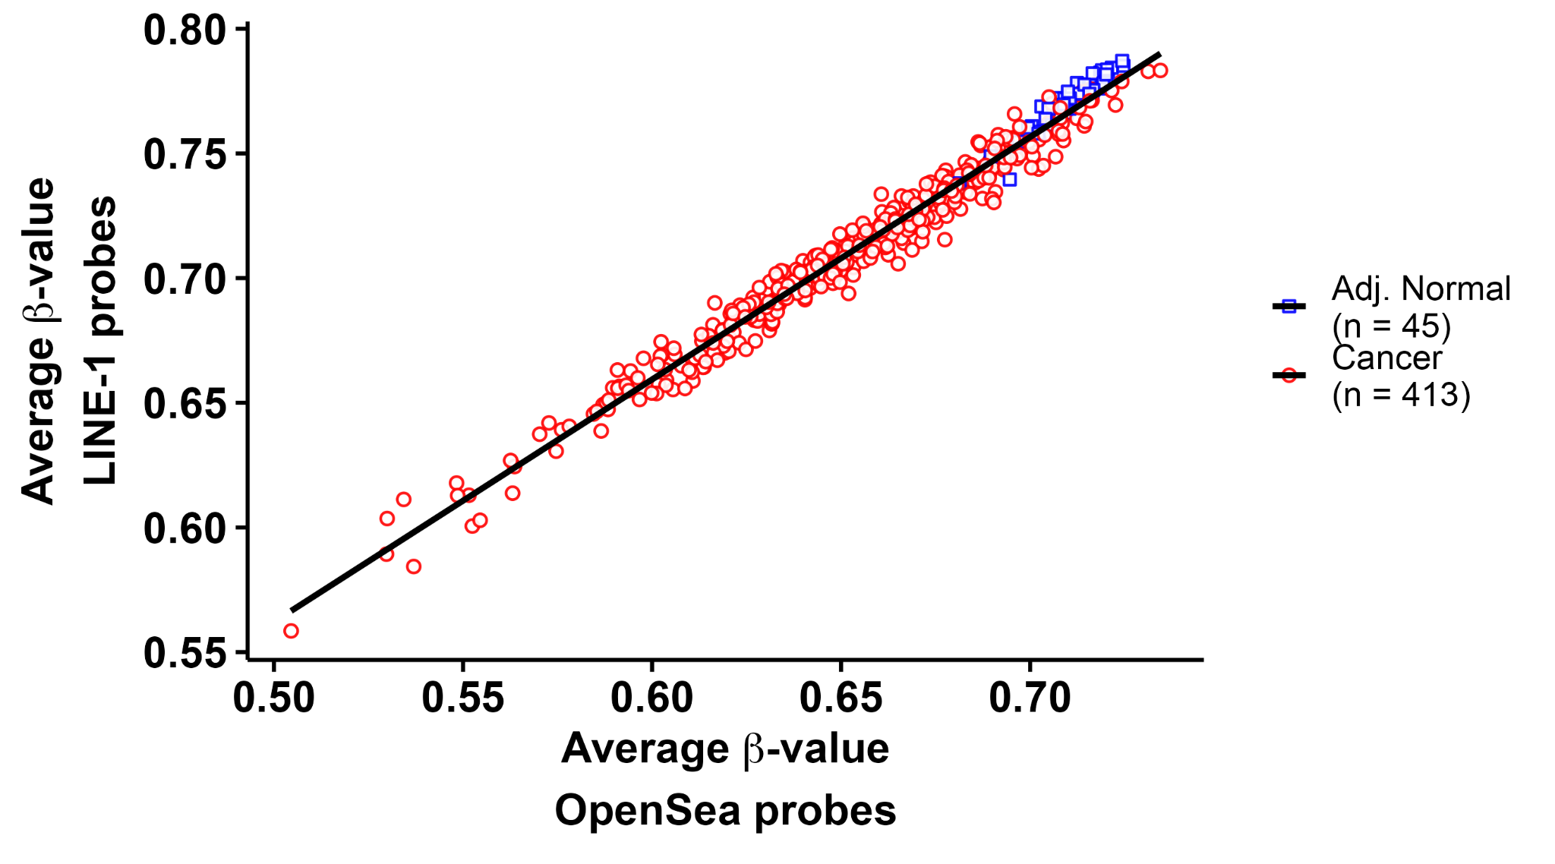
Fig. S3. Correlation between average β-value of LINE-1 probes and average β-value of OpenSea probes in TCGA.

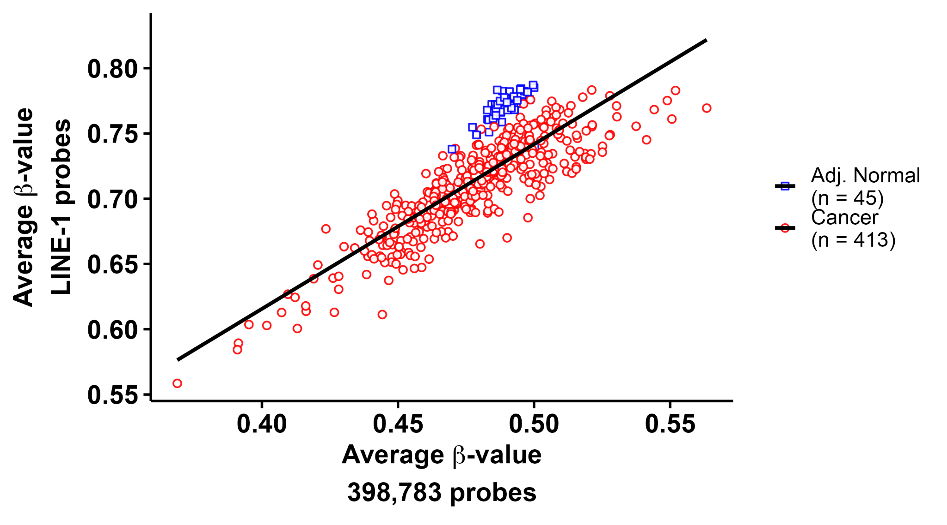

Fig. S4. Correlation between average β-value of all probes after filtering and average β-value of LINE-1 probes in TCGA.

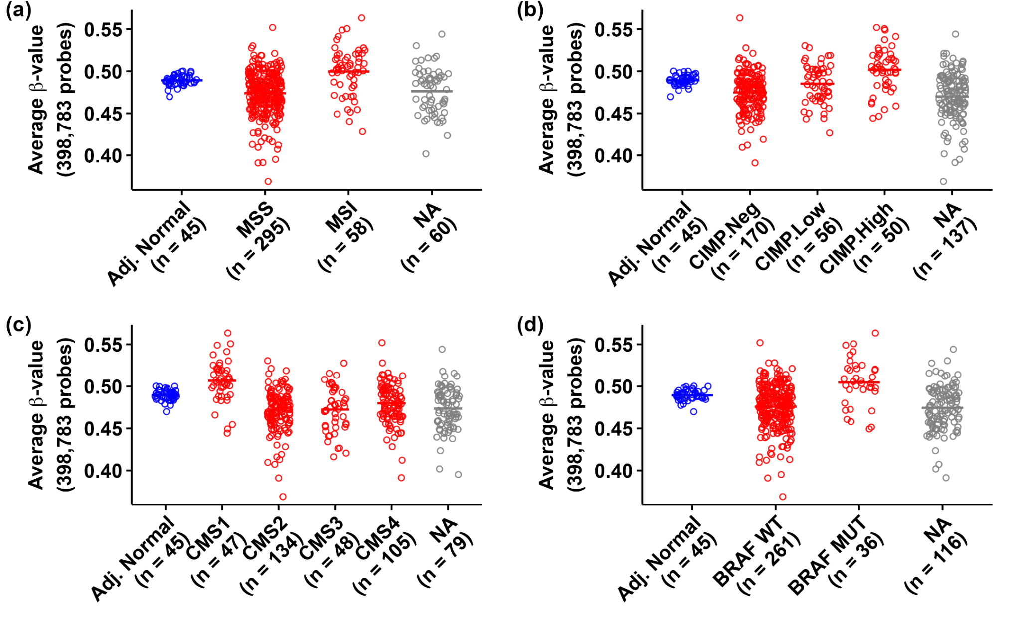Fig. S5. Average β-value for all probes (β_{av, all}) in CRC patients with (a) microsatellite stability (MSS) and microsatellite instability (MSI); (b) CpG Island Methylator Phenotypes - High (CIMP.High), Low (CIMP.Low) and Negative (CIMP.Neg); (c) Consensus Molecular Subtypes (CMS) 1-4, and; (d) wild type (BRAF WT) and mutated (BRAF MUT) BRAF gene compared to adjacent normal tissue (Adj. Normal). NA refers to samples for which molecular subtype annotation was unavailable.

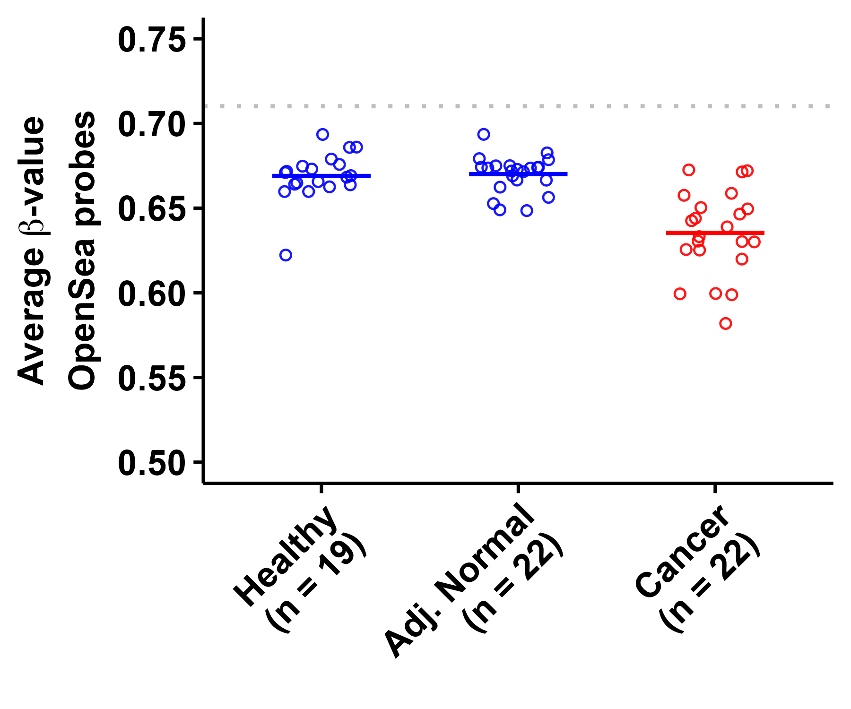
Fig. S6. Comparison of average β-values across OpenSea probes (β_{av, OS}) in healthy individuals (Healthy), adjacent normal tissue (Adj. Normal) from CRC patients, and CRC tissue (Cancer) in GSE42752. The gray line represents β_{av, OS} in adjacent normal tissue from the TCGA study.

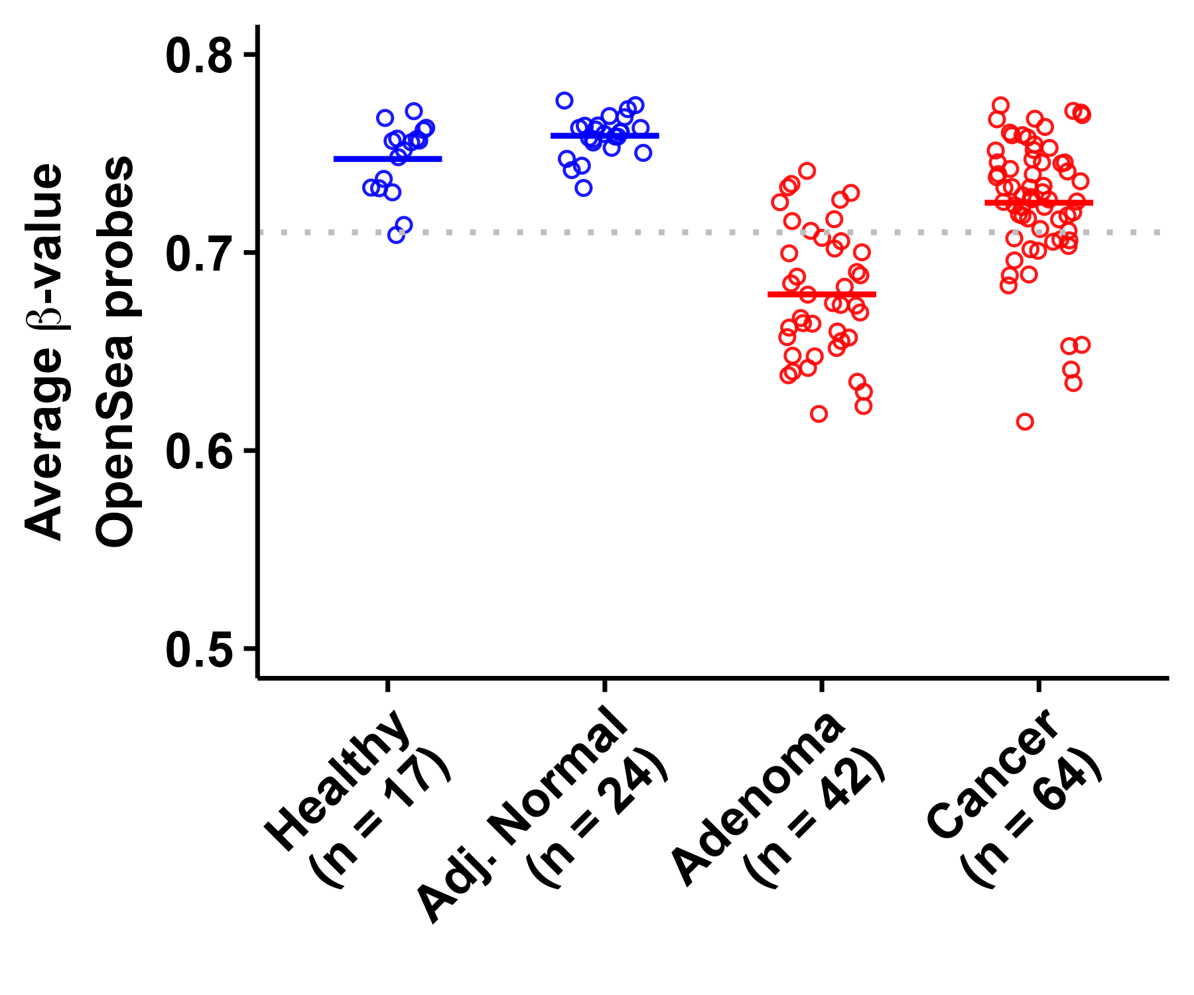
Fig. S7. Comparison of average β-values across OpenSea probes (β_{av, OS}) in healthy individuals (Healthy), adjacent normal tissue (Adj. Normal) from CRC patients, Adenoma patients (Adenoma) and CRC tissue (Cancer) in GSE48684. The gray line represents β_{av, OS} in adjacent normal tissue from the TCGA study.

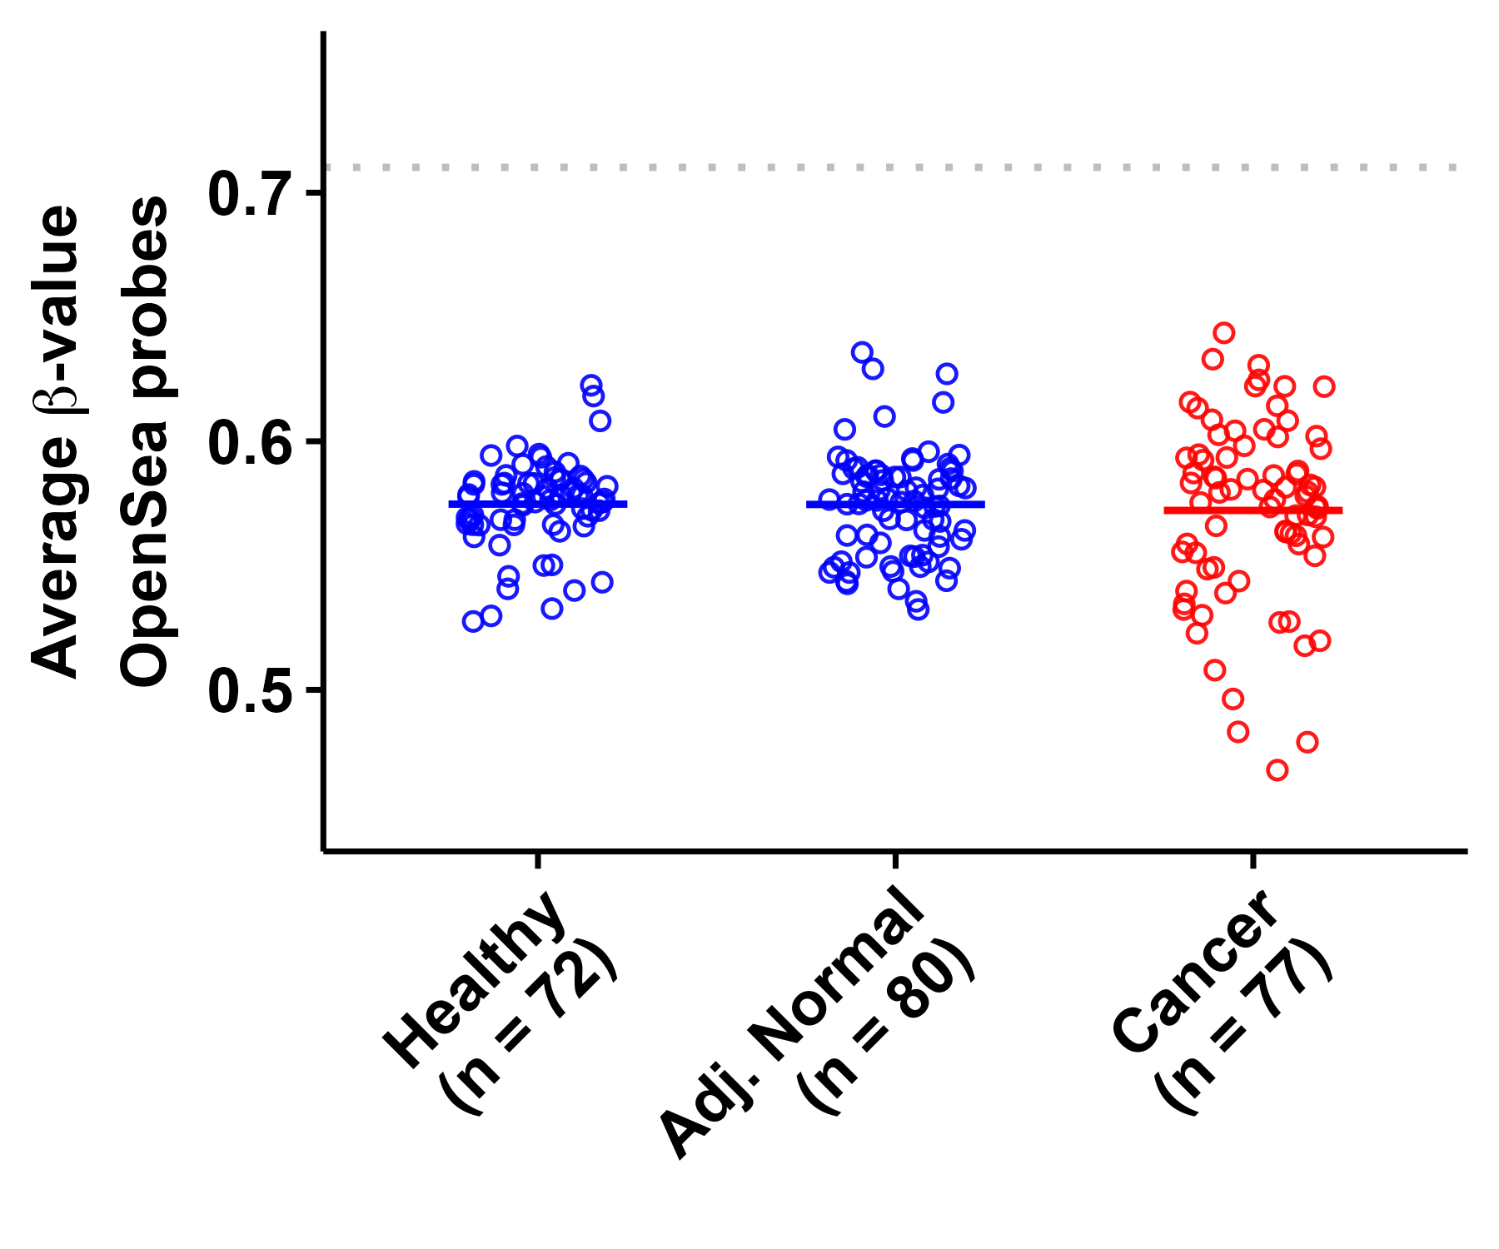
Fig. S8. Comparison of average β-values across OpenSea probes (β_{av, OS}) in healthy individuals (Healthy), adjacent normal tissue (Adj. Normal) from CRC patients, and CRC tissue (Cancer) in GSE199057. The gray line represents β_{av, OS} in adjacent normal tissue from the TCGA study.

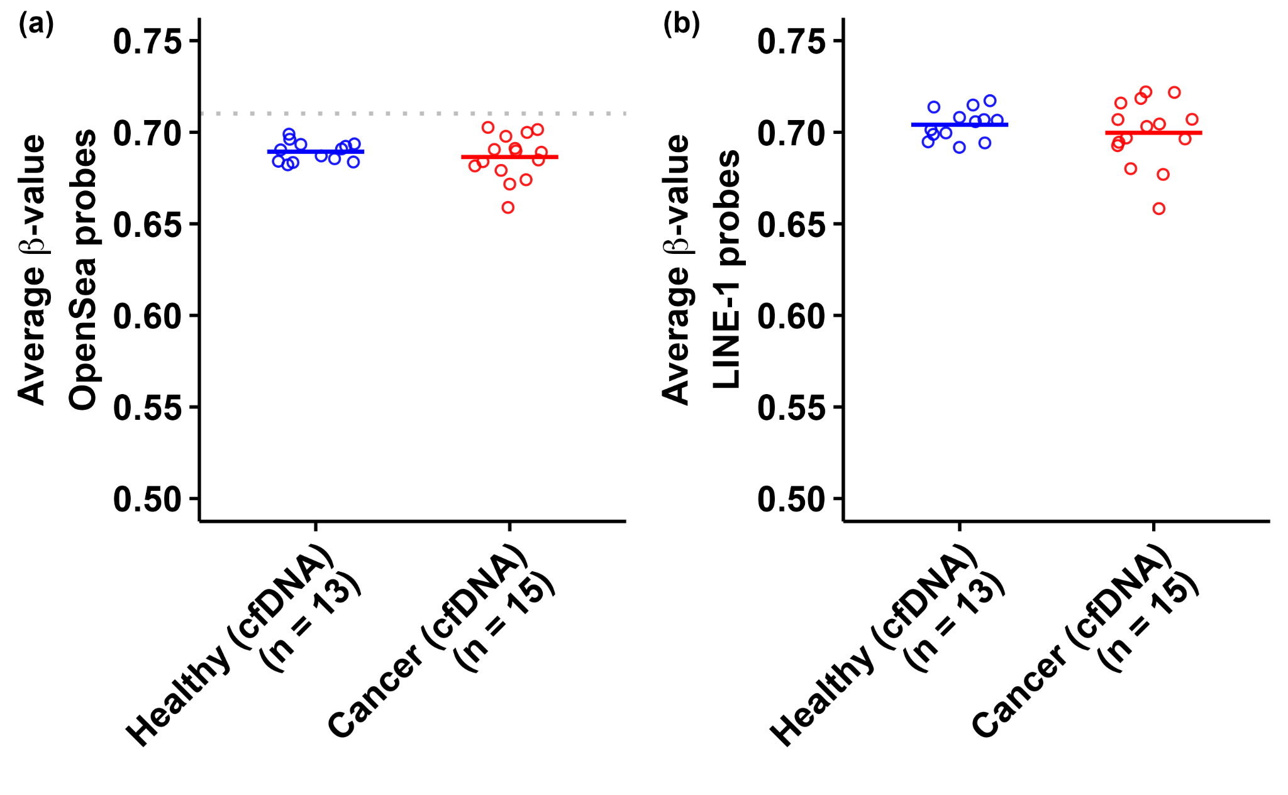
Fig. S9. Comparison of (a) average β-value across OpenSea probes (β_{av, OS}) and (b) average β-value across LINE-1 probes (β_{av, LINE-1}) in pooled cfDNA samples from healthy individuals and pooled cfDNA samples from CRC patients in GSE186381. The gray line represents β_{av, OS} in adjacent normal tissue from the TCGA study.

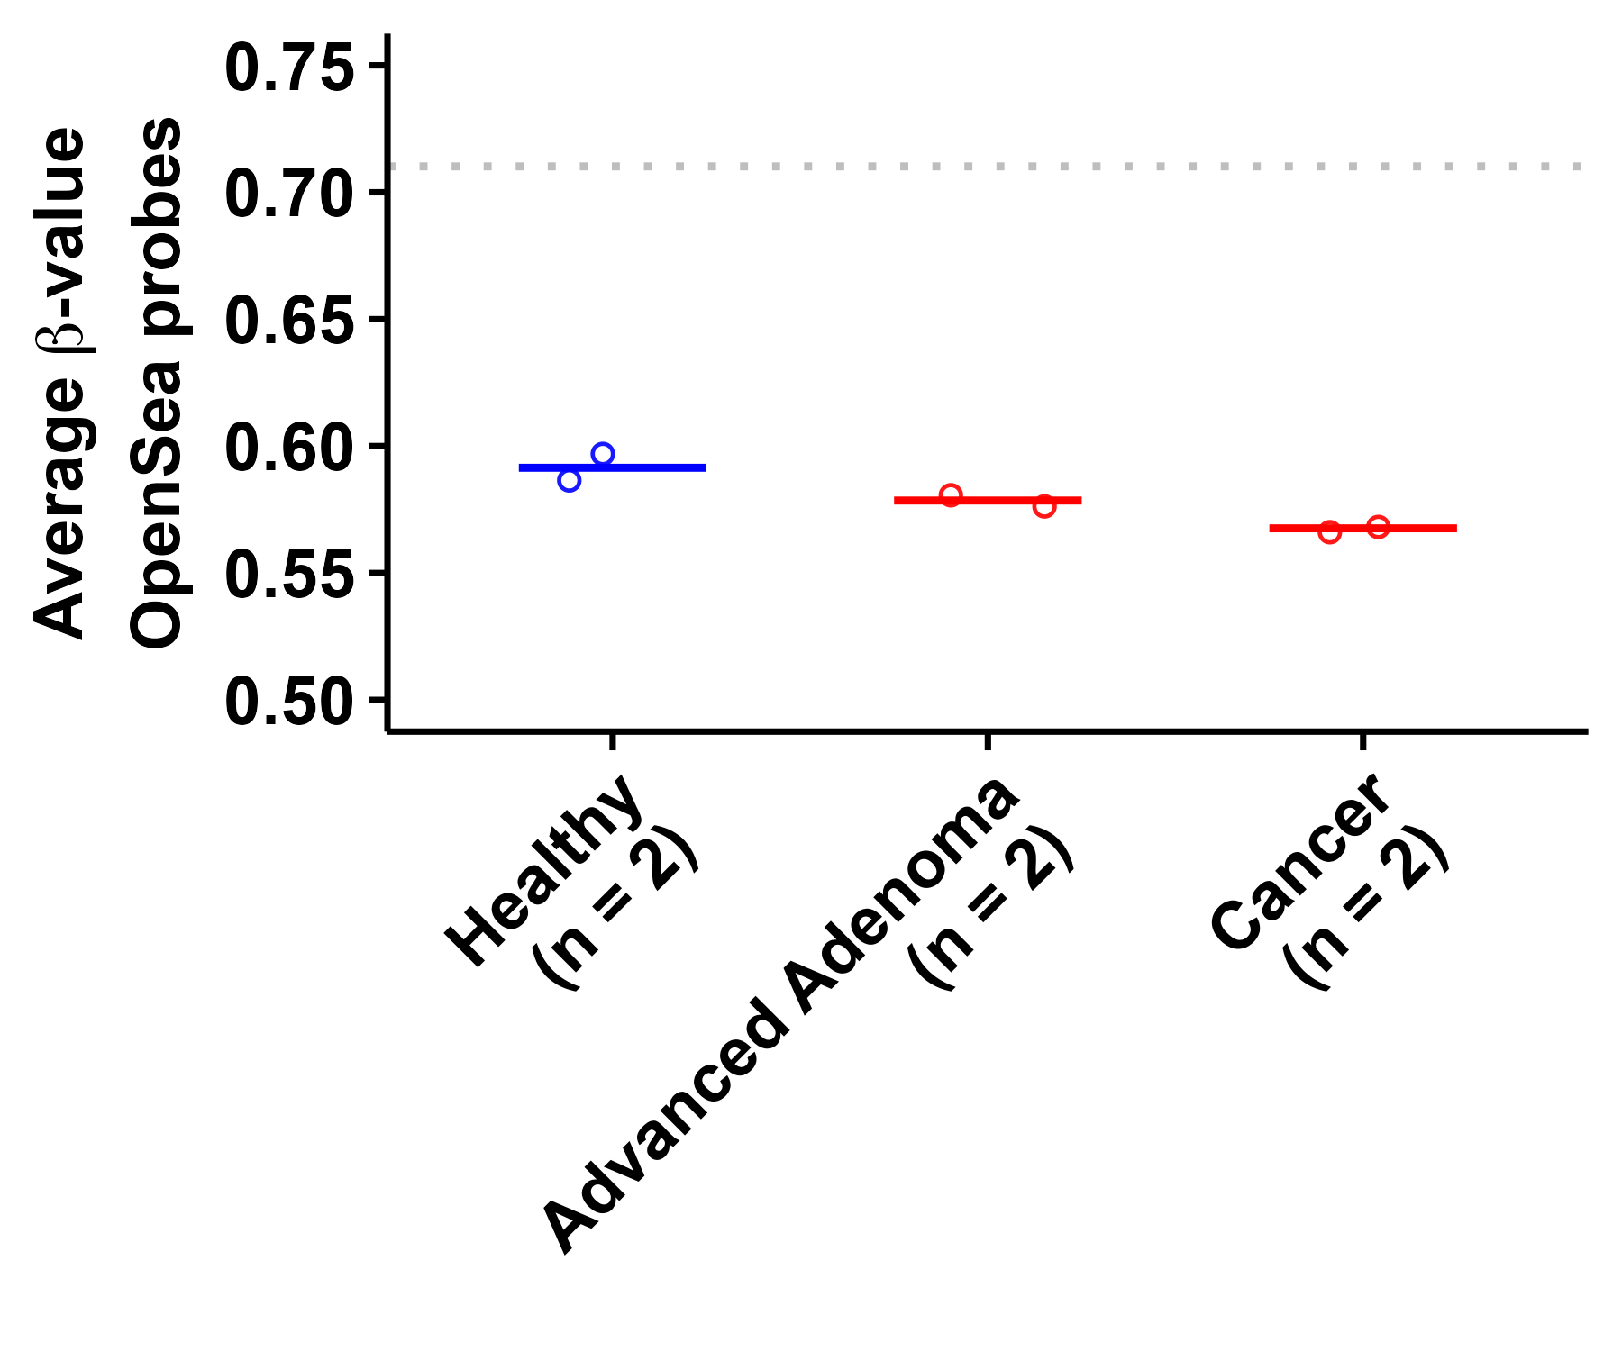
Fig. S10. Comparison of average β-value across OpenSea probes (β_{av, OS}) in pooled cfDNA samples from healthy individuals, pooled cfDNA samples from patients with advanced adenoma, and pooled cfDNA samples from CRC patients in GSE110185. The gray line represents β_{av, OS} in adjacent normal tissue from the TCGA study.

