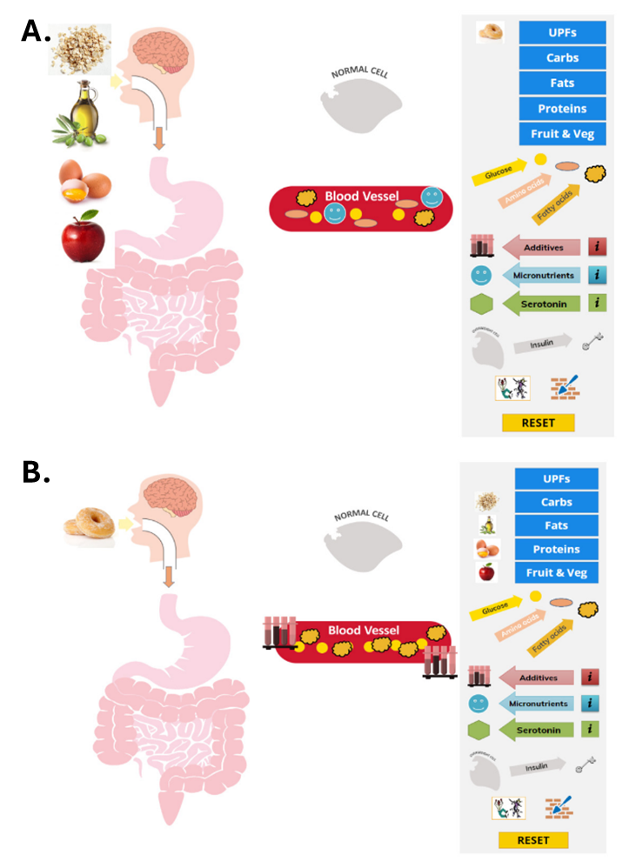
Figure 1. Example of Interactive Digital Board slides. A. Interactive image of the human digestive system when consuming a real and natural food. The educator drags across micronutrient, glucose, amino acid and fatty acid icons into the blood vessel indicating when the real and natural food is digested and what has been absorbed by the body. Once finished, the educator clicks on the reset button. B. Interactive image of the human digestive system when consuming ultra-processed foods. The educator drags across additives, many fatty acid, and many glucose icons into the blood vessel indicating when the ultra-processed food is digested and what has been absorbed by the body. Once finished, the educator clicks on the reset button.

Module Name | KEy Learning Outcomes
What happens when we eat and how does it make us feel? | 1. Describe the basics of how the body digests food  2. Describe the differences between real natural and ultra-processed food  3. Describe what serotonin is and its effect on mood and how serotonin levels are affected by food
The importance of sleep | 1. Describe the benefits of sleep  2. Understand the importance of a proper sleep schedule  3. Understanding the effects of consuming ultra-processed foods, sugar and caffeine to improve sleep quality
Building a healthy brain | 1. Understanding the importance of eating a balanced and varied diet  2. Minimising the consumption of ultra-processed food in the diet  3. Understand the effect of sugar and excess carbohydrates on the brain  4. Understand the addictive quality of ultra-processed foods  5. Give examples of sources of pollutants and toxins and how to avoid them
The gut microbiome | 1. Understand the health benefits of physical activity towards the gut microbiome, mental and physical wellbeing  2. Capable of selecting a variety of MPFs over ultra-processed foods  3. Identify which foods nourish the gut microbiome
understanding food labels | 1. Describe the information that food labels provide  2. Review the information on food labels before purchase  3. Identify food labels of ingredients that indicate ultra-processed foods  4. Describe the benefits of the food labelling systems and identify the important nutritional information  5. Describe the misleading quotes and terminology food manufacturers use
Beyond the food | 1. Describe how different foods affect their mental wellbeing and external environmental factors  2. Describe how ultra-processed foods cause cravings and addiction  3. Describe the difference between habitual eating and hunger
Table 1. Module name and key learning outcomes for sessions 1-6 in pilot intervention.

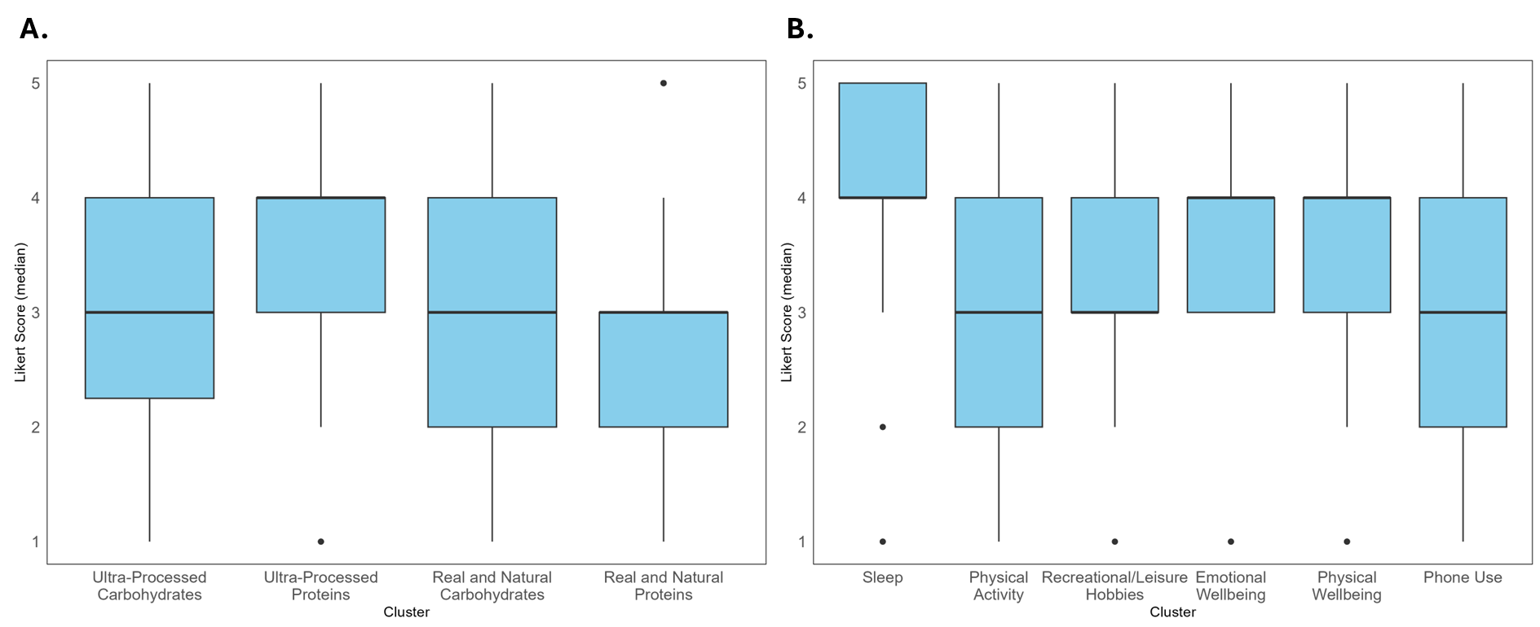
Figure 2. Likert-Scale Ordinal Scoring of Pre- and Post-Intervention Physical Health and Food Intake.

