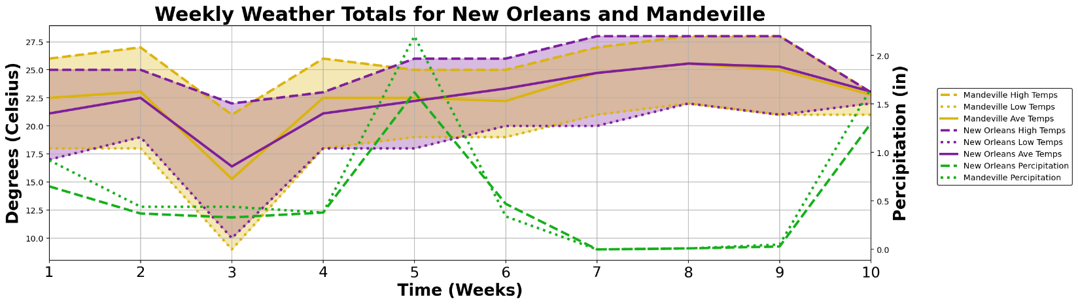
Supp Figure 1: Sample site comparison.
Figure 1: Weekly values for temperature and precipitation throughout the sampling period during 2023 Carnival season.

Supp Table 1: Correlation and significance of weather at both wastewater ample sites
Metric | High Temp | Low Temp | Ave Temp | Rain
Pearson R | 0.845 | 0.969 | 0.952 | 0.991
p-value | 2.08E-3 | 3.88E-6 | 2.12E-5 | 3.21E-8

Supp. Table 2: Weekly change in diversity among dominant taxa.
Measure | wk2 | wk3 | wk4 | wk5 | wk6 | wk7 | wk8 | wk9 | wk10
New Orleans Weekly | 0.553 | 0.625 | 0.585 | 0.674 | 0.358 | 0.593 | 0.364 | 0.634 | 0.642
North Shore Weekly | 0.258 | 0.105 | 0.245 | 0.272 | 0.310 | 0.402 | 0.204 | 0.410 | 0.628
New Orleans v. Week 1 | 0.553 | 0.865 | 0.709 | 0.298 | 0.492 | 0.547 | 0.628 | 0.465 | 0.771
North Shore v. Week 1 | 0.258 | 0.263 | 0.160 | 0.251 | 0.437 | 0.264 | 0.235 | 0.280 | 0.440

Supp. Table 2: Bray-Curtis dissimilarity for the diversity found at each weekly time point (top rows) against the previous week or (bottom rows) against the week one diversity from that site.

Supp. Table 3: Alpha Diversity Results
Time Point | OTUs | Pielou’s Evenness | Simpson’s  Evenness | Shannon Entropy | Simpson’s  Diversity
Week 1 | 157 | -0.13751 | -0.24849 | 0.13091 | -0.04113
Week 2 | 155 | -0.05131 | -0.11996 | 0.5004 | 0.010671
Week 3 | 153 | -0.06587 | -0.14857 | 0.390336 | -0.00185
Week 4 | 201 | -0.10702 | -0.23852 | 0.418953 | -0.00791
Week 5 | 108 | -0.10636 | -0.21495 | 0.036909 | -0.02966
Week 6 | 135 | -0.09175 | -0.29531 | 0.477187 | 0.000976
Week 7 | 129 | -0.10495 | -0.26992 | 0.226745 | -0.00777
Week 8 | 179 | -0.06801 | -0.15473 | 0.596305 | 0.013731
Week 9 | 151 | -0.01683 | -0.06686 | 0.763218 | 0.028281
Week 10 | 143 | -0.11639 | -0.30087 | 0.414162 | 0.003474

Supp Table 4: Correlation between alpha diversity and progression through Mardi Gras: weeks five through nine

 | OTU Count | Pielou’s  Evenness | Simpson’s  Evenness | Shannon  Entropy | Simpson’s  Diversity
Pearson R | 0.775 | 0.860 | 0.749 | 0.857 | 0.928
p-value | 0.123 | 0.0615 | 0.145 | 0.0634 | 0.0231

Supp. Table 5: Significant periods of species wastewater concentration-Carnivale progression correlation
Taxon | Sig. Time Periods (weeks) | Pearson Correlation (R) | Linear Regression (p-value)
Pathogens
S. enterica | 6-9 | -0.85 | 0.145
S. haemolyticus | 1-6*, 1-7* | 0.88, 0.81 | 0.020, 0.027
P. aeruginosa | 5-10* | 0.84 | 0.037
K. pneumoniae | 1-8 | 0.74 | 0.037
A. baumannii | 6-9* | 0.95 | 0.054,
E. coli | 3-10*, 3-9*, 4-10*, 5-10* | 0.88, 0.81, 0.82, 0.88 | 0.004, 0.026, 0.026, 0.021
Microbiota
F. prausnitzii | 3-8** | -0.82 | 0.046
A. muciniphila | 2-6* | 0.95 | 0.013
R. torques | 4-10*, 7-10* | 0.83, 0.95 | 0.021, 0.048
B. obeum | 4-10* | 0.81 | 0.027
B. adolescentis | 1-10 | 0.63 | 0.051
C. aerofaciens | 4-10 | 0.79 | 0.036
Environmental
T. carbonis | 5-8 | -0.87 | 0.127
R. fluvialis | 5-8* | 0.95 | 0.048
F. channae | 3-7 | 0.77 | 0.131
T. radiovictrix | 5-10 | -0.74 | 0.095
N. multipartita | 7-10 | 0.88 | 0.116
M. glycogenica | 4-9 | 0.70 | 0.124

Supp. Table 5: Peak Pearson correlation and linear regression significance of selected species’ wastewater concentration with progression through Carnivale. * Indicates time periods that achieved both a strong, positive correlation with progression through Carnivale (R>=0.8) and statistical significance via linear regression (p<=0.05). ** Indicates the same for a negative correlation. If the species did not surpass both significance and correlation thresholds over any time interval, the interval of its most significant correlation with progression though Mardi Gras is used.

