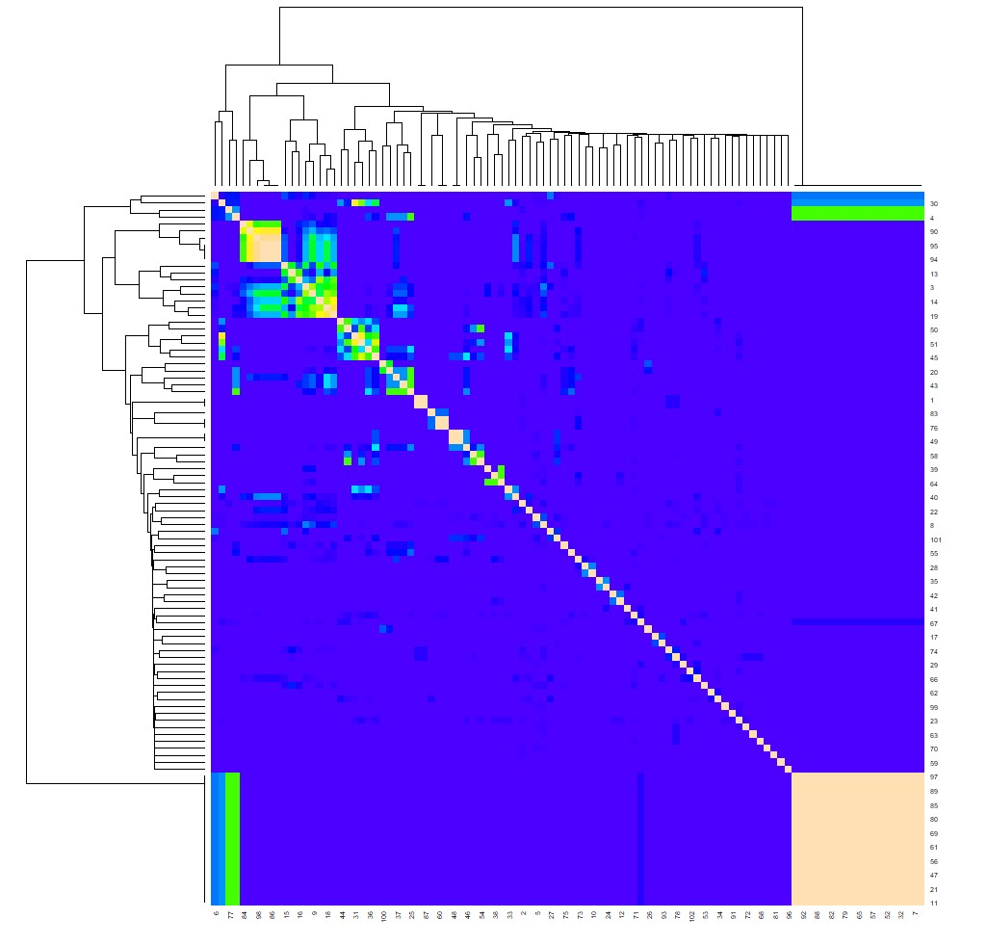
Figure S1.Heirarchical clustering heat map of 154 Ethiopian bread wheat genotypes under salt stress conditions of 200mM.The dendrograms indicate the clustering based on the genetic distance of genotypes. The colour difference indicates the genotypes pairwise similarity. The yellow and light green indicate high similarity, blue and purple represents moderate similarity and dark blue indicates the lower similarity based on their response.

